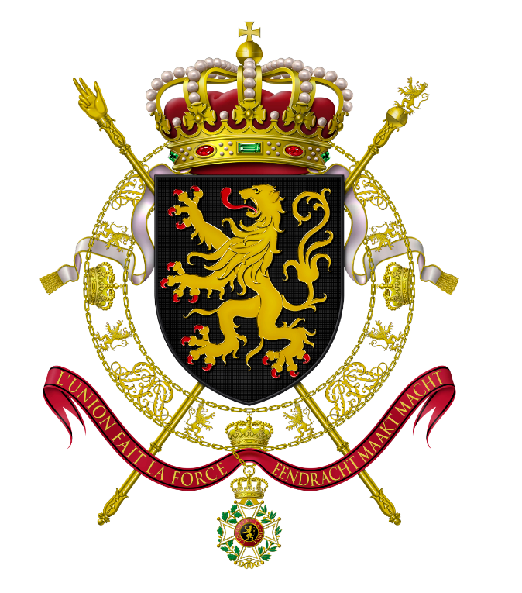 | KINGDOM OF BELGIUM  Deputy Prime Minister and Minister of Foreign Affairs,  European Affairs and Development Cooperation
Ms. Ane Katrine Havsteen
Chief, People Programmes and Partnerships
Office of Human Resources,
Bureau for Management Services
United Nations Development Programme
Marmorvej 51, 2100 Copenhagen Ø
DENMARK

No. D2.1/JV/DEV.O5/06.04.2026/4312/1

Subject: Belgium JPO programme – financing of JPOs in 2026

Dear Ms. Havsteen,

I have the pleasure to inform you that the Government of Belgium through its Federal Public Service of Foreign Affairs, Foreign Trade and Development Cooperation - Directorate-General for Development Cooperation (DGD) has decided in the context of its JPO-Programme to make available an initial contribution of 494.209 USD to finance 1 JPO position assigned to the United Nations Entity for Gender Equality and the Empowerment of Women (UN Women) in Burundi administered by the United Nations Development Programme. This contribution is to be used under the Terms and Conditions as stated in this letter.

I would be grateful if you could acknowledge receipt of this letter.

Sincerely,

Maxime Prévot

