TECHNICAL NOTE

JOINT HEALTH SECTOR SUPPORT IIIc

RWANDA

CODE DGD: NN 3017779
CODE NAVISION: RWA15 099 11



Basic Data of the Belgian Contribution

Title of the program | Joint Health Sector Support III – JHSS III C
Earmarking | Sector Budget Support (non-earmarked)
Country | Rwanda
Financial data | Belgian contribution |  | Other donors’ contributions
Financial data | 2016 – 2017 | 2017 – 2018 | N/A
Financial data | € 12M | € 6M | N/A
DAC – Code /Sector | 12110 (health, general)
NI – Code | NN 3017779 (intervention)
NAV – Code | RWA 1509911

Calendar / Instalments in Euro

Instalments |  | 2016 | 2017 | Total
 |  | €12M | €6M | €18M

Table of contents

Basic Data of the Belgian Contribution 2

List of acronyms 4

1 Executive Summary 8

2 Country Context 11

2.1 General Context 11

2.2 Sectoral and Institutional Context 15

2.3 PFM context and Sector Budget 25

3 External Support to the Sector 36

3.1 Health sector program (direct bilateral cooperation) 36

3.2 Belgian support to the health sector 36

3.3 Other donors’support to the Sector 37

4 Belgian Support to HSSP III 40

4.1 HSSPIII 40

4.2 Belgian Contribution 40

4.3 Set-up of the Policy Dialogue (‘the how’) 42

4.4 Focus of the Policy Dialogue (‘the what’) 43

5 Policy dialogue & Donor Coordination arrangements 45

6 Risk assessment and Mitigating Measures 48

7 Disbursements 52

7.1 Conditionalities 52

7.2 Financial Planning 54

8 Annexes 57

8.1 Specific Agreement Draft 57

8.2 Implementation Agreement 64

8.3 ToRs of the Belgian Technical Expertise 70

8.4 Reporting Obligations 74

8.5 summary table of Health sector policies and strategic plans 76

8.6 Updated structure of TWG, Chairs&co-chairs 77

8.7 Bibliographic References 79

8.8 List of people me 81

List of acronyms
ANC | Antenatal Care
BCC | Budget Call Circular
Bln | Billion
BSHG | Budget Support Harmonisation Group
BTC-CTB | Belgian Technical Cooperation – Coopération Technique belge
CAAC | Cellulle d’Appui à l’Approche Contractuelle/Performance -Based Financing Department (MoH)
CBHI | Community-Based Health Insurance
CDPF | Capacity Development Pooled Fund
CHAI | Clinton Health Access Initiative
CHW | Community Health Workers
CMO | Convention de Mise en Oeuvre
CoK | City of Kigali
CPAF | Common Performance Assessment Framework
CPI | Corruption Perception Index
DFID | Department For International Development
DG | Director General
DGD | Directorate-General for Development Cooperation and Humanitarian Aid
DH | District Hospital
DHIS | District Health Information System
DHMT | District Health Management Team
DHS | Demographic and Health Survey
DHU | District Health Unit
DoL | Division of Labour
DOTS | Direct Observed Treatment Scheme
DP | Development Partner
DPAF | Development Performance Assessment Framework
DPCG | Development Partners’ Coordination Group
DPG | Development Partners’ Group
EAC | East African Community
EDPRS | Economic Development and Poverty Reduction Strategy
EICV | ‘Enquête Intégrale sur les Conditions de Vie des Ménages’- Integrated Household Living Conditions Survey
EMONC | Emergency Obstetric and Neonatal Care
EU | European Union
EUR | Euro
FMS | Financial Management System
FRA | Fiduciary Risk Assessment
FY | Financial Year
GBS | General Budget Support
GDP | Gross Domestic Product
GFATM | Global Fund to Fight AIDS, Tuberculosis and Malaria
GIZ | Deutsche Gesellschaft für Internationale Zusammenarbeit
GoR | Government of Rwanda
GRB | Gender Responsive Budgeting
HDI | Health Development Index
HIS | Health Information System
HMIS | Health Management Information System
HRH | Human Resources for Health
HRTT | Health Resource Tracking Tool
HSS | Health System Strengthening
HSSP | Health Sector Strategic Plan
HSWG | Health Sector Working Group
ICP | Indicative Cooperation Program
IDA | International Development Association
IDCP | Indicative Development Cooperation Programme
IFMIS | Integrated Financial Management Information System
IHDPC | Institute of HIV, Disease Prevention and Control
IHP+ | International Health Partnership
iHRIS | Integrated Human Resources Information System
IMF | International Monetary Fund
IRAI | International Development Assistance Resource Allocation Index
ISS | Integrated Supportive Supervision
JADF | Joint Action Development Forum
JHSR | Joint Health Sector Review
JHSS | Joint Health Sector Support
KfW | Kreditanstalt für Wiederaufbau
M&E | Monitoring and Evaluation
MDGs | Millennium Development Goals
MEMMS | Medical Equipment Management & Maintenance System
MIFOTRA | Ministry of Labour and Public Service
MIGEPROF | Ministry of Gender and Family Promotion
MINALOC | Ministry of Local Government
MINECOFIN | Ministry of Finance and Economic Planning
Mio | Million
MPPD | Medical Procurement and Production Division
MoH | Ministry of Health
MoU | Memorandum of Understanding
MSH | Management Sciences for Health
MTEF | Medium Term Expenditure Framework
MTR | Mid Term Review
NB | National Budget
NGO | Non-Governmental Organisation
NHA | National Health Accounts
NISR | National Institute of Statistics of Rwanda
OAG | Office of Auditor General
ODA | Official Development Assistance
OECD-DAC | Organisation for Economic Cooperation and Development – Development Assistance Committee
OOP | Out of Pocket
OPD | Outpatient Department
PBF | Performance-Based Financing
PEFA | Public Expenditure and Financial Accountability
PER | Public Expenditure Review
PFM | Public Finance Management
PFM SSP | Public Finance Management Sector Strategic Plan
PHC | Primary Health Care
PMTCT | Prevention of Mother To Child Transmission
PPP | Public Private Partnership
PS | Permanent Secretary
PSCBS | Public Sector Capacity Building Secretariat
PSI | Policy Support Instrument
QAG | Quality Assurance Group
RBC | Rwanda Biomedical Centre
RBF | Result Based Financing
RDSF | Rwanda Decentralization Strategic Framework
RH | ‘Ressources Humaines’
RHCC | Rwanda Health Communication Centre Division
RRA | Rwanda Revenue Authority
RSSB | Rwanda Social Security Board
RWF | Rwandan Franc
SAI | Supreme Audit Institution
SBS | Sector Budget Support
SDG | Sustainable Development Goals
SEAS | Subsidiary Entities Accounting & Reporting System
SEF | Study and Expertise Fund
SIDA | Swedish International Development Agency
SPIU | Single Project Implementation Unit
SSP | Sector Strategic Plan
SWAp | Sector Wide Approach
SWG | Sector Working Group
SWOT | Strengths, Weaknesses, Opportunities, Threats
TA | Technical Assistance
TB | Tuberculosis
TN | Technical Note
ToR | Terms of Reference
TWG | Technical Working Group
UN | United Nations
UNFPA | United Nations Fund for Population Activities
USA | United States of America
USAID | United States Agency for International Development
USD | United States Dollars
USG | United States Government
WB | World Bank
WHO | World Health Organisation

Executive Summary
Rwanda has made tremendous progress in terms of rebuilding its core public sector institutions in the past 20 years. The Government has been successful in maintaining the rule of law, sustaining high-levels of economic growth (with an annual GDP growth rate of 8.5% on average over the past fifteen years), and ensuring poverty reduction and increased access to services. It is one of the few countries which have achieved the Health MDGs. These developments are backed by strong leadership. There remains however a concern about the degree of power centralization, restrictions on political space, the degree of domestic accountability, equity, and citizen participation in the decisions that affect and concern them.
Rwanda has benefited from substantial financial aid from Development Partners in the past twenty years, which has supported Government’s expansionary policy. The Government has been successful in mobilizing and efficiently managing these resources, reflecting sound and stronger Public Finance Management (PFM) systems and practices over time. However, with the significant reduction of external aid, Rwanda is facing the enormous challenge of mobilizing more domestic resources in order to sustain the current results for its population on the short term and to meet longer term goals such as the development of a service and more private-sector led economy. In that context the Rwandan health sector is currently at a cross-roads, trying to find a balance between consolidating the results at the level of the decentralised health system and further developing the secondary/tertiary care in the long run. A concerted strategic policy dialogue between the Ministry of Health and the DPs, based on evidence and costing of the long-term strategies, is below par at the moment. There are major concerns that equity, quality, sustainability within the (health) system are not assured.
Through the current Indicative Cooperation Program (ICP) 2011-2014, the Belgian Cooperation initially allocated 55 M € for providing support to the health sector through a comprehensive program approach, consisting of:
- An institutional support program (Ubuzima Burambye Program: “Improving the quality of primary health care and services in Rwanda” – RWA 13 092 11) of 21 M € which started mid-2015.
- Sector Budget Support (under the current Joint Health Sector Support-JHSS III – RWA 13 093 11) of 32 M € including financial support, expertise and policy dialogue. The last remaining disbursement of 9 M € was completed in December of 2015.
- Basket Funding (‘Capacity Development Pooled Fund’ – CDPF – RWA 12 087 11) of 2 M € launched in 2013 (of which 1 M € remains to be disbursed) focusing on a coordinated approach to Human Resource for Health in planning, production and retention of Health workforce across the sector
The objective of this health program is to support Rwanda in the implementation of:
- the three outcomes of the Rwandan Health Sector Policy (2015): ‘people-centred, integrated and sustainable health services’.
- the 4 components of the Rwandan Health Sector Strategic Plan (2012-2018): Leadership & governance, Health Support Systems, Programs and Service Delivery Systems.
The anchorage of the program at different levels of the health system stimulates a unique dynamic of interaction between operational and strategic levels. It allows a consistent follow-up of results in terms of access to quality services and development of adequate policies.
Apart from Belgium, only two other donors are involved in Budget Support to the Health sector: the Global Fund (with Sector Budget Support earmarked for HIV since 2014 followed by a similar model applied for TB and Malaria as from 2015) and the European Union (with a Budget Support focusing on the fight against malnutrition which aims to support the Ministry of Agriculture, the Ministry of Health and the Ministry of Education). This Technical Note JHSS IIIC is to be considered as an extension of the Belgian Sector Budget Support decided upon in the ICP 2011-2014. .
In view of the current results and challenges faced by the Rwandan health sector, and in order to ensure continuous and coherent support from Belgium to the health sector, an additional envelope of 18 M € for SBS has been foreseen in complement to the other ongoing interventions in the Belgian-Rwandan bilateral cooperation’s health program. This envelope is the object of this Technical Note.
Two disbursements, respectively of 12M € and 6 M € for the Financial Years 2016/17 and 2017/18 are planned, with the following conditionalities:
1/ a satisfactory evaluation of the target values of the Health Sector EDPRSII Policy Matrix Indicators on Year N-2,
2/ technical and financial sector reports on Year N-2,
3/ audits of the Ministry of Health and the Rwanda Biomedical Centre on Year N-2,
4/ annual reports from the Health Resource Tracking Tool,
5/ annual work plan and budgets on Year N,
6/ at least one new National Health Accounts report validated after January 2016, and
7/ minutes of the bilateral Monitoring Committee meetings addressing Belgium’s specific areas of focus in policy dialogue.
The disbursement calendar accommodates the frontloading request addressed by MINECOFIN to budget support donors in general, and Belgium specifically, since 2014 in view of Rwanda’s challenging fiscal position in the short to medium term.
Belgium’s focus in policy dialogue will be on the following themes:
- The development of a people-centred, integrated, resilient and sustainable health system: (key elements: updated sustainable financing plan for the health sector for the next 5-10 years, Health Resources Tracking Tool / National Health Accounts, Mid-Term Review of HSSP III recommendations);
- The development of an inclusive health system for the entire Rwandan population : (key elements: utilisation rate of health services – Outpatient Department; Health Management Information System, Demographic Health Survey, District Health Plans);
- Consultative, transparent, evidence-based and costed strategy and policy making for the sector: (key elements: recent costing of the health sector and perspectives on medium term);
- Transparent costing of the health insurance packages at the level of Community Based Health Insurance (CBHI): (key elements: updated analysis of the CBHI scheme regarding costing of packages, contributions, enrolment, public subsidies or evolution of the scheme);
- The implementation of the national reforms on Public Finance Management and Decentralization: (key elements: updated analysis of health service delivery or planning by district level);
- A regular, constructive policy dialogue around strategic issues based on the Memorandum of Understanding between the Government of Rwanda and the Development Partners;
- Transparency in access to disaggregated health sector data including for districts and Development Partners: (key elements: digital information platforms/portals, computerised real time HMIS, knowledge management, linkages between academia and policy makers).
The quality of the policy dialogue and the progress made with regard to these areas of attention will be an important element of evaluation of the health sector.
Crucial in this next phase of Sector Budget Support is extending the presence of a Public health expert and a Public Finance Management expert, for several reasons:
- the follow-up of the implementation of the recommendations made in the recent MTR of HSSP III is key in the current policy dialogue;
- ii) being the only the SBS donor with a sector wide perspective, it is important that Belgium acts as a constructive but critical sounding board in the policy dialogue, in particular with regard to equity and sustainability issues;
- iii) there is need for expertise with a helicopter-view and long term perspective with regard to the Rwandan Health system;
- iv) the mandate of the current chair of the DPG (USAID) is likely to end in the foreseeable future. Belgium is well-placed to take up the role of the DPG chair not only because of the volume of its aid but also because of its longstanding experience and its approach towards comprehensive health system strengthening and use of country systems;
- v) the logic of the Belgian health program requires expertise at the level of the budget support component in order to feed the policy dialogue based on the reality at the operational level;
There is a specific need to maintain PFM expertise for the following reasons:
- Belgium’s dialogue on the sustainability of Rwanda’s health system and health financing requires continued and close follow-up of the country’s macro-economic context, particularly in view of the current and growing concerns on Rwanda’s external sector;
- Belgium’s focus on the development of a people-centred, integrated, resilient and sustainable health system also requires continued and detailed budget analysis to identify and dialogue on medium-term budgetary trends effectively reflecting strategic choices made at national and sector levels;
- The current engagement in the dialogue on PFM reform is highly relevant to Belgium’s bilateral cooperation portfolio, and much appreciated by other Development Partners. It should be sustained, in particular in view of the PFM reform program’s prioritised focus on domestic revenue mobilisation and PFM systems and capacity at sub-national level (hospitals and health centres), as well as the limited resources available for dialogue on PFM reforms amongst Development Partners;
- The composition of Belgium’s bilateral portfolio provides a high potential for synergetic engagement on PFM and Decentralization reforms, both at the strategic level (through the provision of PFM expertise linked to budget support) and at the operational level (through the decentralisation program’s component on ‘Enhancing the capacities of districts’).
- 6 out of the 8 risk categories identified in the Technical Note are associated with the deployment of a PFM expert as part of the related mitigating measures (see chapter 6);

Country Context
  - General Context
    - Political stability
Rwanda has a history of violent conflict and is still contending with the legacy of the 1994 genocide. It is situated in a volatile and conflict-affected region and, since 1994 in particular, has been involved in and/or affected by ongoing regional conflicts.
Against this backdrop, Rwanda has made tremendous progress in terms of bringing national peace and security and rebuilding core public sector institutions. The Government has been successful in maintaining the rule of law, sustaining high-levels of economic growth, and ensuring dividends to citizens in terms of increased access to services and poverty reduction. Rwanda’s short to medium term political stability is rooted in these achievements and backed by the strong leadership provided by the President and ruling party.
There is however concern about the degree of power centralization, restrictions on political space, and the degree of domestic accountability and citizen participation in the decisions that affect and concern them. This is compounded by a weak civil society and media that can only marginally contribute to pluralism, oversight and accountability. Continued real or perceived levels of inequalities are further risks to the longer term social cohesion and political stability.
    - Macroeconomic stability
Rwanda has been one of the best-performing economies over the past fifteen years, with annual GDP growth rate averaging 8.5% over the period, supported by strong contributions from agriculture, construction and services. There are few, if any, examples of countries that have maintained such a high growth rate for such an extended period. Rwanda’s aim has been to achieve an economic transition from a poor, post-conflict nation, to a thriving, middle income, regional trade and investment hub by 2020.
Rwanda’s success has been underpinned by sound macroeconomic policies, large aid inflows, and fairly robust governance. Fiscal and monetary policies have focused on maintaining macroeconomic stability, maintaining fiscal deficits and inflation at low levels in recent years. Rwanda has benefited from substantial financial aid from Development Partners, which has supported Government’s expansionary policy and its ability to manage the balance of payments. The Government has been successful in mobilizing and efficiently managing these resources, notably in view of improving its Public Finance Management (PFM) systems and practices (See section 3.3). Further success has been achieved in improving the business environment to foster private sector investment. Rwanda ranked 46th out of 189 countries on the World Bank’s 2015 ease of doing business index.
Rwanda’s economic growth has been accompanied by a remarkable reduction in poverty, albeit from a baseline, reflecting the Government’s strong commitment and leadership for poverty reduction. Income poverty fell sharply from 59% in the early 2000s to 39.1% in 2014 (national poverty line), while the reduction of inequality, as measured by the Gini coefficient, has been more modest from 0.520 in 2001 to 0.448 in 2014. Rwanda stands out as having achieved impressive progress towards most of the Millenium Development Goals (MDGs). Between 2000 and 2013, Rwanda’s Human Development Index (HDI) value increased from 0.329 to 0.506, an increase of 53.7%.

Figure 1: Trends in poverty and extreme poverty reduction (Source: MINECOFIN, September 2015)
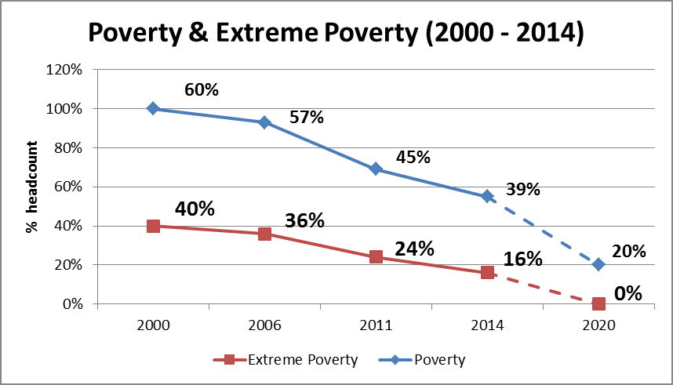

Rwanda is facing structural challenges to sustaining its good economic performance. As a small, landlocked country with limited natural resources, its export sector is small, with exports covering less than a third of imports. Energy shortages, instability in neighbouring states and the lack of adequate transportation linkages to other countries continue to handicap private sector growth. Rwanda remains overly aid-dependant, and the country’s economy is only gradually recovering from the aid dip in Financial Year 2012/13, which saw the suspension or delays of aid commitments and budget support disbursements by a number of Development Partners.
Figure 2: Trends in real GDP growth and trade deficit (source: IMF PSI report, June 2015)
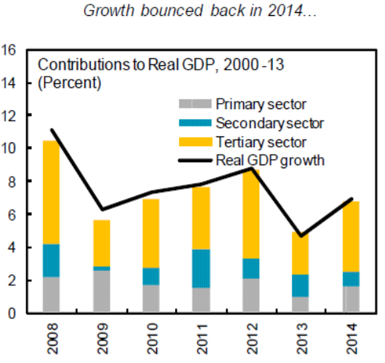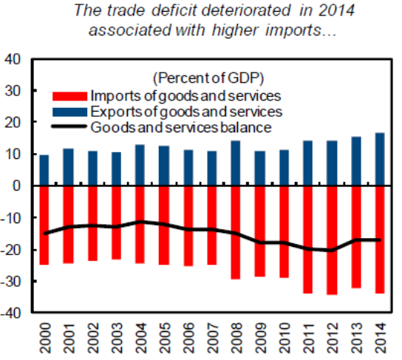
The country has limited fiscal space with which to ensure the fiscal sustainability of its ambitious development agenda. Since Financial Year 2012/13, lower than expected resources (tax and ODA) have led to increasing fiscal deficits and necessitated that the government contain its investment and priority spending on social sectors.

Figure 3: Trends in fiscal deficits, external grants and tax revenues (source: IMF PSI report, June 2015)
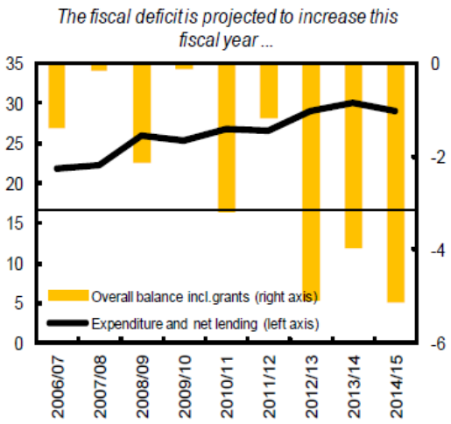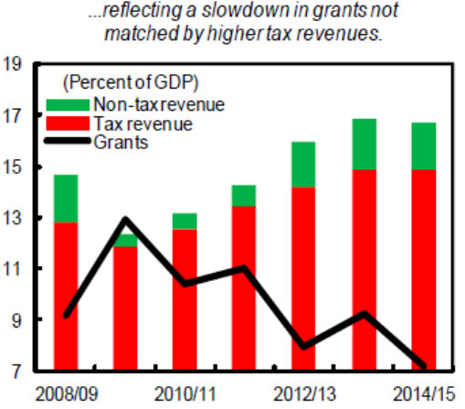

In December 2013, Rwanda embarked on a new three-year Policy Support Instrument (PSI) cycle with the IMF following a satisfactory seventh and final review under the former PSI. Rwanda’s PSI supports the government’s programme to achieve sustainable broad-based high growth and poverty reduction, in line with the objectives outlined in the government’s Economic Development and Poverty Reduction Strategy (EDPRS II) and Vision 2020. Dialogue under the current PSI programme adequately centres around four key pillars:
- Private sector development: Investment in strategic infrastructure to reduce the cost of doing business and enhancing reforms to improve the business climate;
- Export promotion: increasing export earnings by broadening the export base;
- Fiscal consolidation: creation of fiscal space through accelerated domestic resource mobilization and rationalization of spending while protecting pro-poor investments. This pillar is linked to the Government’s ambitions to reduce dependence on external aid;
- Financial sector development: ensuring connection of the population to the market while increasing monetization of the economy.
On 15th January 2016, the IMF Executive Board completed the fourth review under the current Policy Support Instrument. The review confirmed Rwanda’s track record of strong policy performance, sustained high growth, progress in reducing poverty, and a stable macroeconomic situation, but highlighted a more uncertain growth outlook for 2016-17, downward pressures on exports receipts and the exchange rate in view of the decline in international commodity prices. The review further provided insights and recommendations on GoR’s policy responses in the short and medium term:
“The authorities' planned policy response is to continue to allow exchange rate flexibility to function as the central tool for adjustment, supported by modest tightening of the monetary stance, with frontloaded provision of donor assistance and some additional use of international reserves to cushion the immediate impact. However, the authorities should consider contingency plans for further fiscal and monetary adjustment, should the shock persist longer or intensify more than expected. Careful monitoring will be needed over the next months to determine whether additional tightening may be needed, including to avoid undue pressure on the exchange rate or depleting reserve buffers. Re-building reserve buffers will be critical to enhance the country's resilience to future shocks.
"Over the medium term, policies should remain focused on sustaining high growth through growth-enhancing public investment, encouraging private investment, and diversifying exports. The authorities plan to restore fiscal buffers by reducing the deficit via higher revenue collection, improved public spending efficiency and cautious borrowing, underpinned by medium-term fiscal consolidation. In addition, reforms to expand access to financial services and deepen financial markets will provide needed capital for private sector-led growth and enable Rwanda's integration in larger markets within the East African Community."
    - Policy and institutional framework
The quality of Rwanda’s policy and institutional framework has been instrumental in ensuring that public resources, including those provided by donors, are put to effective use. Rwanda’s overall score on the IDA Resource Allocation Index has been steadily improving over the years and reached 4.0 in 2014. This new IDA ranking puts Rwanda in the position of single top performer in Sub-Saharan Africa for the year 2014 as well as globally alongside Samoa. Rwanda has recorded steady progress in the past ten years in respect of the Public Sector Management and Institutions Cluster (also known as Cluster D), reaching a score of 3.6 in 2014. Rwanda’s strong performance on IRAI’s Cluster D is of particular interest to the Belgian Cooperation as the Vade Mecum for Budget Support (2008) requires for a recipient country to have a score of at least 2.5 to be eligible for Budget Support.
Figure 4. IDA Resource Allocation Index for Rwanda 2014
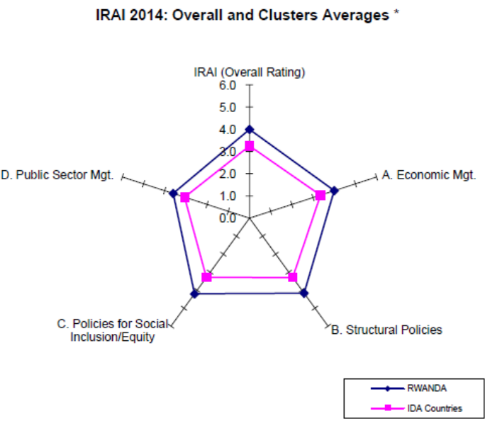

    - Corruption and fraud
Most stakeholders agree that Rwanda has a strong commitment as well as robust legal, institutional and organizational frameworks for controlling and prosecuting fraud and corruption. There is, however, limited concrete evidence to serve as a basis for making a comprehensive assessment of the nature, incidence, level or causes of corruption in the country. Indicative sources of information on the level of corruption, such as Transparency International’s Corruption Perception Index (CPI) suggest comparatively low and steadily improving perceptions on corruption in Rwanda. Most stakeholders agree, however, that occurrences of corruptive practices are likely under-reported owing to fear and the relatively weak media. According to the CPI ranking, Rwanda features among the top performers in Sub-Saharan Africa.
Transparency International Corruption Perception Index (CPI) – Rwanda’s ranking
2006 | 2007 | 2008 | 2009 | 2010 | 2011 | 2012 | 2013 | 2014
121 | 111 | 102 | 89 | 66 | 49 | 50 | 49 | 55

  - Sectoral and Institutional Context
    - EDPRS II
Rwanda’s Second Economic Development and Poverty Reduction Strategy (EDPRS) is the country’s medium term development plan (2013 – 2018) for achieving the country’s long term goals and aspirations embodied in Rwanda Vision 2020. Rwanda’s vision is to become a lower middle income economy (US$ 900 per capita) operating as knowledge based service hub by 2020.

EDPRS II takes into account the challenges and opportunities of the country identified during the self-assessment of the implementation of the first EDPRS. Under EDPRS II, these challenges are being addressed and opportunities will be pursued through four Thematic Strategies:
- Economic Transformation: accelerated economic growth (11.5%) and restructuring the economy towards more services and industry as they move towards a Middle Income Country status.
- Rural Development: ensuring that poverty is reduced from 44.9 % to below 30% by 2018 through focus on increased productivity of agriculture and enhanced linkages of social protection programs.
- Productivity and Youth Employment : ensuring that growth and rural development are underpinned by appropriate skills and productive employment, especially for the growing cohort of youth (200,000 new jobs annually)
- Accountable Governance: improve the overall level of service delivery and ensure citizens satisfaction above 80% and ensure increased citizen participation to increase ownership.

Foundational Issues embedded in EDPRS II reflect long-term on-going priorities and entail as 5th issue: Quality, demand and accessibility of primary health care. EDPRS II is about improving the quality of health care services, including the management of hospitals, while continuing to expand geographical and financial accessibility.(EDPRS 2 2013).

A Mid-Term review of EDPRS II was initiated with the backward-looking Joint Sector Reviews conducted in November 2015 and will be further guided by the Planning Directorate of MINECOFIN in the first few months of 2016. The objective of the review is not to change or revise any targets but rather to assess progress made against mid-term targets and adjust interventions to fast track implementation, where necessary. At the same time, a Millennium Development Goal progress report and a roadmap for the domestication of Sustainable Development Goals have been prepared and will be submitted to Cabinet for further discussion. An in-depth analysis to assess the extent to which SDG’s are covered by the current national planning framework is ongoing.
    - Sector Policy & sector Strategy
The Health Sector Policy
The mission of the Rwandan health sector, as retained in the new Rwandan National Health Sector Policy (January 2015) is “to provide and continually improve affordable promotional, preventive, curative and rehabilitative health care services of the highest quality, thereby contributing to the reduction of poverty and enhancing the general well-being of the population.”
Three guiding principles to achieve are defined in the National Health Sector Policy:
- People-centred services:“i) ensuring universal demand and access to affordable quality services, ii) focusing on the well-being of individuals and communities in particular women and children, iii) encouraging and valuing community inputs to identify health priorities and needs expressed by the population; iv) fostering equity and inclusion and integrates marginalized groups.“
- Integrated services :“i) aligning the health system with national goals, among which Vision 2020 and EDPRS overarching goal of poverty alleviation; ii) leveraging and building on existing assets in terms of infrastructures and human resources, but also on cultural values and institutional bodies; iii) developing and strengthening decentralized services whenever possible while remaining coordinated (between actors, between levels of care); iv) involving all sectors of the Rwandan population, including the private sector and civil society.”
- Sustainable services: “i) building the capacity of people, communities and institutions to assure the quality of services, ii) prioritizing value for investment, seeking cost effectiveness, using appropriate technology and adopting creative innovations to maintain the achievement of outcomes in a context of scarce resources, and prioritizing health promotion, communication and prevention, iii) promoting rigor and transparency of outcomes and ensuring the collection and dissemination of quality information so that decisions and choices are based on evidence, iv) developing self-reliance of organizations and individuals by mobilizing domestic resources, advocating for greater financial ownership by the public sector and promoting investment and involvement by the private sector and civil society.”
These three guiding principles are the basis for a rational, inclusive and pro-poor health system and have therefore been taken as the three outcomes in the Belgian institutional support program ‘Ubuzima Burambye’. They will also be used as a focus in the policy dialogue for the JHSS III c to monitor whether strategic decisions of the GoR are coherent with these principles. This will also strengthen the program approach, reinforcing the complementarity between interventions of the Belgian Cooperation in health in Rwanda.
Challenges in practice
There is a gap in the outcome with regard to the 3 guiding principles described above:
  - people-centred services: i) procedural and high-tech quality is confounded with genuine, comprehensive quality assurance; ii) there is still substantial inequity (current GINI index of 46.8), in particular in regards to ‘poor, rural, vulnerable groups’ which might be aggravated in of context of decreasing external funding and the political will to invest in high-tech secondary and tertiary health care.
  - integrated services: i) multiple parallel initiatives at community level fragment first line health services, ii) there are gaps in the flow of patients and information between health centres and hospitals, iii) the secondary and tertiary level hospitals are insufficiently coaching (‘waterfall mentorship’) the primary level hospitals, iv) parallel vertical programs fragment planning and M&E and increase transaction costs.
  - sustainable services: i) high dependency on (fragmented) external aid (around 60%) ii) lack of open dialogue concerning long-term strategies, their costing and mechanisms to mobilise domestic resources, iii) decreased coverage by Community Based Health Insurance (CBHI) coverage because of the system of voluntary contribution and increasing fees, iv) gaps in asset management (standardization of equipment, appropriate technology & design, maintenance, v) insufficient institutionalisation of quality assurance

The Health Sector Strategic Plan III
The Third Rwandan Health Sector Strategic Plan (HSSP III) provides strategic guidance to the health sector for six years, between July 2012 and June 2018. HSSP III has been inspired and guided by VISION 2020, which aims at making Rwanda a lower-middle-income country by 2020. In this spirit, the MTR of HSSP III was conducted in August 2015 in order for the health sector to further align to the priorities set out by the Economic Development and Poverty Reduction Strategy (EDPRS II 2013–2018) and the new Health Sector Policy (2015).
The strategic framework of the health sector is based on 4 components: Leadership & Governance, Health Support Systems, Programs and Service Delivery Systems as shown in Figure 5. The HSSP III document insists on the fact that the “the interrelated components together will improve the desired outcomes of the Health Sector Policy.
Figure 5: The strategic framework of HSSP III
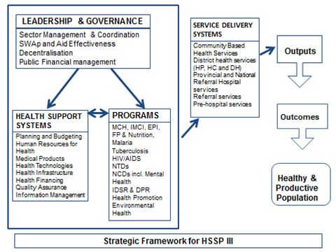
Analysis by the MTR of HSSPIII
The consultants that undertook the MTR in August 2015 concluded that in general HSSP III has been effective in delivering the set targets in terms of outputs, outcomes and impacts as documented in the recent DHS results and various sector performance reports. The overall summary of the findings and recommendations are described in Table 1.

Table 1: Summary of Preliminary findings & recommendations quoted from the MTR of HSSP III (2015)
EFFECTIVENESS
Strengths: HSSP III was effective in delivering the set targets in terms of outputs, outcomes and impacts as documented in the recent DHS results and various sector performance reports.
Challenges: The ultimate results of HSSP III achieving the 2018 targets will depend on the harmonious inter-relationships between all the five components. The tendency observed by this MTR indicates that the impressive expansion of secondary care could well affect negatively the primary care achievements of the past.
Recommendations: Ensure strengthening and sustainability of the CHW network, as it is the basis for any future improvement in the public health performance of the country. Revise HSSP III targets in view of its achievements and upcoming SDG commitments

Comparative advantage Belgium’s current holistic health portfolio vis-à-vis effectiveness: Through internal creation of synergies between the UB, CDPF and SBS through internal (BTC) coordination, direct feedback and bidirectional links between experience, lessons learned, policy and strategy formulation and capacity development for implementation is facilitated and enhanced.

RELEVANCE
Strengths: HSSP III priorities and strategies by and large remain relevant for the remaining period of the plan. With the emerging international commitments (SDGs) and challenges associated with the declining external resources, the relevance of some of the strategies in each of the components need to be reviewed and sharpened.
Challenges: Some of the strategies in the HSSP III are not congruent with the emerging context.
Recommendations: Each component needs to review the relevance of each of its strategies and interventions in view of constrained resourcing, status of the achievement of HSSP III targets and international commitments.

Comparative advantage Belgium’s current holistic health portfolio vis-à-vis relevance: Participation in the sector debate – Technical Working Groups, Health Sector Working and Joint Sector Reviews – allows introducing Belgium priorities of poverty alleviation and MCH. UB offers opportunities to study and measure Impact of policies and strategies on the emerging context.

EFFICIENCY
Strengths: Rwanda is stepping up its efforts to enhance efficiency through rationalization of expenditures by each of the programs; health facilities focusing mainly on rationalization of human resources deployment as well as strengthening decentralization.
Challenges: The scopes with which the sector can enhance allocative, technical and operational efficiencies in each of the program areas have not yet been well explored.
Recommendations: In terms of allocative efficiency, there is a need to continue prioritizing PHC, balancing it with the higher referral systems; continue investing in subsidizing essential services and prioritize human resource development on skills that benefit the majority of the people. The sector can also enhance operational efficiencies through exploring the use of PBF as main payment mechanism; investing more on rational use of medicines, maintenance systems and rationalization of management of the different programs.

Comparative advantage Belgium’s current holistic health portfolio vis-à-vis efficiency: UB’s focus on decentralized structures and health sector planning at the district level will inform the SBS component on allocative efficiencies, diagnosing imbalances and bias. Depending on the future of the CDPF, Belgium would have the instruments to address capacity for planning at peripheral levels.

SUSTAINABILITY
Strengths: Rwanda has achieved most of its MDG targets and need to ensure that the gains made so far are sustained in an environment of declining external resources. Challenges of sustainability are recognized and strategies for domestic financing have been charted out, as part of new health financing sustainability plan (introduction of sin taxes and levies, private sector engagement, self-financing strategies for health facilities and enhancing risk polling and purchasing arrangements).
Challenges: the move towards self-financing and higher tariffs is likely to have a negative impact on affordability and might negatively affect the gains made so far, such as those in Family Planning. Programs are trying to come up with sustainability strategies that might fragment and reduce the effectiveness of the approach to be used.
Recommendations: Implement the Health Sustainable Financing Policy and approve the draft Health Care Financing Strategy. Fast track the implementation of the domestic financing strategies in general, and the innovative financing schemes in particular. The revision of essential package’s list and its thorough costing should drive the sustainability agenda. There is a need to ensure that tariff revisions are based on stratified service costing exercise and to balance the need to ensure financial sustainability with affordability and sustaining the gains made so far. The MOH should work towards developing and implementing a sector wide sustainability strategy supported by proactive and adequate policy dialogue with MINECOFIN and DPs.

Comparative advantage Belgium’s current holistic health portfolio vis-à-vis sustainability: The availability within the SBS team of a PFM adviser will provide high level (macro) analysis of the public/private health financing sustainability in Rwanda, while in support to UB providing analysis of the effects of private out of pocket and pre-payment mechanisms on affordability.

QUALITY
Strengths: There are clear policies and strategic guidance on quality assurance and accreditation at primary and secondary levels of care, including capacity building.
Challenges: There is absence of an independent accreditation agency and inadequate budget and capacity for the institutionalization of quality assurance. Given the high service coverage achieved, quality at primary and secondary levels becomes the more critical issue to address.
Recommendations: Expedite establishment of the Accreditation Agency and institutionalize quality assurance at all levels with adequate budgets and capacity.

Comparative advantage Belgium’s current holistic health portfolio vis-à-vis quality: While delivery of technical quality will be a focus for UB, , the intended diversification of payment for services (including the expansion of CBHI under management of the RSSB, direct co-payment for services, limitation of basic health services package, OOP, and the implementation of performance incentives for health care suppliers, etc.) could affect the purpose of accreditation (e.g. utilisation as a financial control as opposed to quality control). SBS provides a direct loop to be able to address this with direct contact to the strategic (MoH), operational (RBC) and insurance (RSSB) arm of the governmental health sector in Rwanda.

Specific Sector Policies & Strategies
A summary table of more specific sector policies and strategies is available in annex (8.5). They are linked to the HSSPIII. The process of elaboration of these policies and strategies is participative, with involvement of the Technical Working Groups. In their design, the sector policies are inclusive, pro-poor, gender-sensitive and in line with the national policies (Vision 2020 and EDPRS II) as well as international policies and principles.
Worth mentioning is the elaboration of Rwanda’s first Health Financing Strategic Plan since 2014. This plan has been developed in close consultation with the DPs and contains strategies for increasing domestic resources. There is however a delay in the validation of the document.
    - Sector Performance
Rwanda is one of the few countries which have met almost all MDG targets. In particular the health MDG goals have been achieved.

Table 2: MDG targets and results GoR
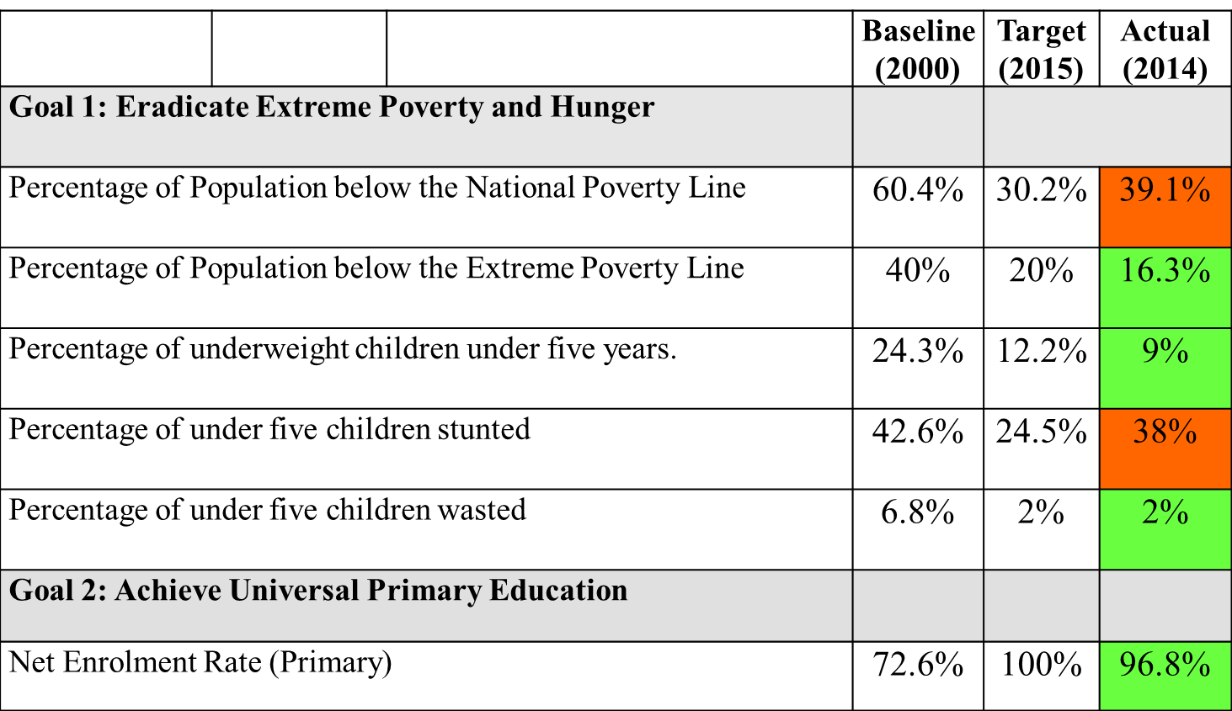
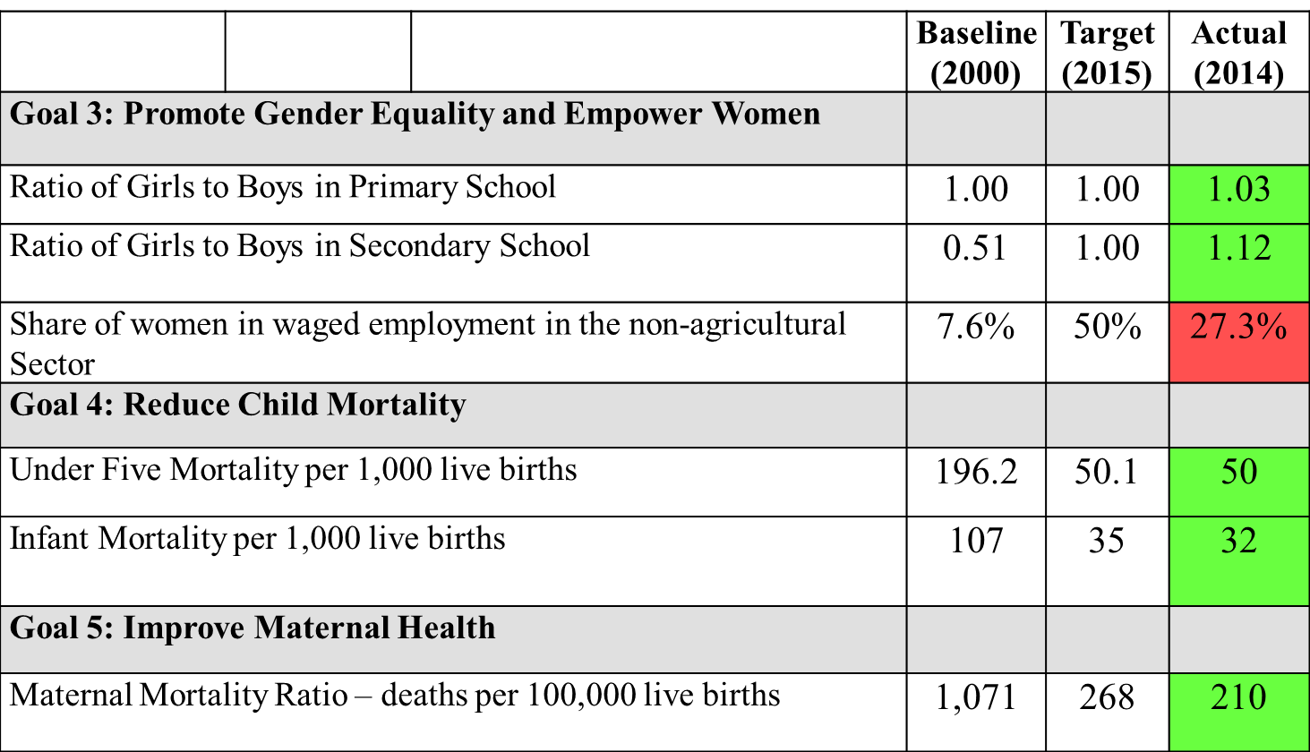
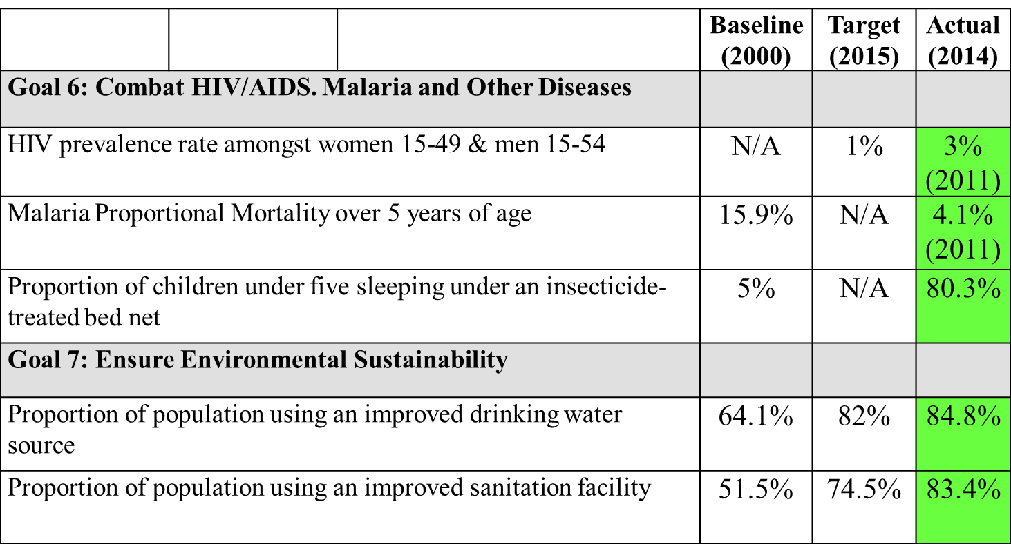
A comparison with two other countries in the region (Uganda and Mozambique) for Maternal and Under Five Mortality Rates shows the remarkable progress of Rwanda.
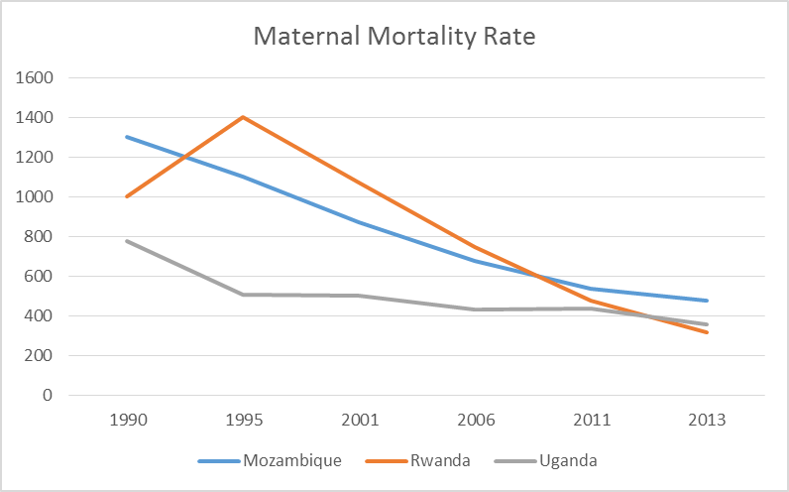
Figure 6: Maternal Mortality Rate (for 100,000 Live Births)

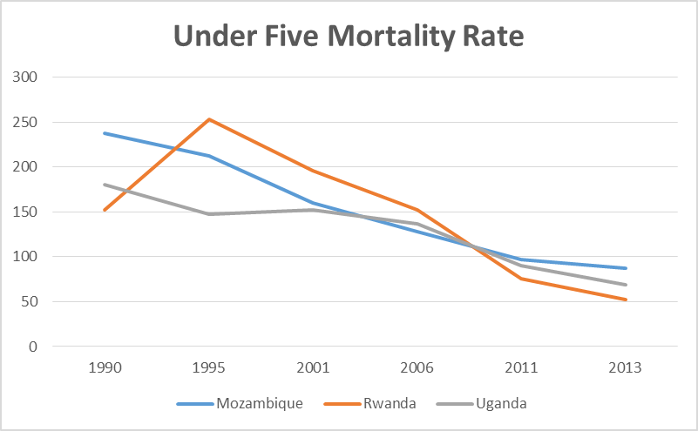
Figure 7: Under 5 Mortality Rate (1/100 live births dying before reaching the age of five)

For more information on high key-performance indicators in the health sector see section on M&E (2.2.5).
    - Sector institutional setting and capacity
At national level
The health sector is led by the Ministry of Health (MoH). It has the mandate of developing, monitoring and evaluating policies & strategies; regulating the sector; assuring capacity building of its implementing entities and mobilizing resources for the sector.
RBC is the main public implementation body of sector policies and strategies. It also assures the coordination between operational stakeholders including NGOs, private sector and development partners. In 2014, the organisational structures of MoH and RBC were revised and saw the transfer of the Maternal and Child Health Programme as well as the Health Management Information System unit from MoH to RBC, in order to further emphasise the Ministry’s role in policy making, planning, oversight and coordination within the sector. The Single project implementation unit (SPIU) manages externally funded projects and has also been integrated into the Rwanda Biomedical Centre in the recent restructuring process.
The internal coordination between the MoH departments, RBC (incorporating the programs) and training institutions takes place through the weekly Inner Senior Management Meetings chaired by the Minister of Health as well as the monthly General Senior Management Meetings.
Rwanda is divided into five administrative regions: Four provinces and the City of Kigali (CoK). The four provinces do not have a health coordination structure, but CoK, as a decentralised entity, has a health and environment unit.
At decentralised level (Districts)
Each District administration, under the leadership of a Mayor, has a District Health Unit (DHU) composed of four staff as per the new organisational district structures adopted in 2014.
The District Health Management Team (DHMT) is composed of the district director of health, the hospital director (chair of the DHU), the director of CBHI, the director of pharmacy, and a representative of the health centre managers. It is chaired by the vice-mayor for social affairs. The collaboration and coordination with other sectors, DPs and civil society is assured through the Joint Action Development Forum (JADF).
At the sector level, Health Centre committees provide oversight of the work of the health centres.
At the village level, there are several types of community health workers (CHWs), mostly centred around vertical programs.
SWOT-analysis of the institutional capacity
Strengths:
- There is strong, result-oriented leadership at national level.
- The second generation Imihigo performance contracts has introduced the concept of Joint Imihigo, which is expected to strengthen collaboration to achieve results.
- The new division of responsibilities & tasks between the central MoH and RBC may lead to an increased effectiveness and efficiency in the system.
- The management of the Community-Based Health Insurance has recently been transferred from the MOH to RSSB. In future also the accreditation process will be outsourced to a National Accreditation Body This is a sound evolution since it’s expected to reinforce division of responsibilities and internal control mechanisms.

Weaknesses:
- There is a gap in technical, managerial and governance capacities at the decentralised level with the risk of an insufficient integrate approach and subsequently a decreased cost-effectiveness.
- There is still a lot of fragmentation at the level of health services provision: i) existence of parallel vertical programs though the accreditation process aims at a better integration,; ii) existence of Health Posts run by A2 nurses adding a supplementary layer to the health care system with a risk of delayed access to the appropriate level of care; iii) multiplication of community health workers (CHWs), mostly centred around vertical programs with a risk of fragmentation of the first line services.
Opportunities:
- The existence of inter-sector coordination among social Ministries through the Social Cluster (GoR) may lead to more effective joint action to influence the social determinants of health.
- There are ongoing efforts to seek private sector involvement in the health sector with a clear willingness to collaborate.
Threats:
- In spite of efforts to decentralise, most of the decision-making power is still at central level.
    - M&E
Set-up
The HSSP III (2013-2018) presents a detailed Results Framework, which links goals and objectives of the new strategy with impact, outcomes, outputs and targets. For each component of the HSSP III (programmes, support systems, service delivery, governance and M&E of HSSP III) a series of output, input and process indicators are defined and linked to the MDGs, EDPRS II and Vision 2020.
The following table shows the progress of key HSSP performance indicators as measured by the recent MTR of HSSPIII (August 2015). These indicators are used at the level of MOH.
Table 3. Key HSSP Performance Indicator trends against HSSP Targets (Aug 2015)
INDICATORS | Baseline  VISION 2020 | HSSP I  2005 | MTR  Aug 2011 | MTR  Aug 2015 | TARGET  Mid 2015 | TARGET  June 2018
Source of Information* | 2000 | DHS 2005 | DHS 2010  HMIS 2011 | DHS  HMIS 2015 | MDG 2015** | HSSP III
IMPACT INDICATORS
Population (NISR) (in millions) | 7.7 | 8.6 | 10.5 | 11.2 | 11.3 | 11.5
Life Expectancy (NISR) | 49 |  | 55 | 65.7 | 58 | 68
Infant Mortality Rate / 1,000 (DHS 2014-15) | 107 | 86 | 50 | 32 | 28 | 22
Under-5 Mortality Rate / 1,000 (DHS 2014-15) |  | 152 | 76 | 50 | 30 | 42
Maternal Mortality Ratio / 100,000 (same) | 1,070 | 750 | 476 | 210 | 287 | 220
Total Fertility Rate (TFR), DHS 2014-15 | 6.5 | 6.1 | 4.6 | 4.2 | 4.5 | 3.4
HIV Prevalence Rate among PW 15–49 yrs | 1.3 | 1.0 | 3.0 | 1  (RBC) | 3.0 | 3.0
OUTCOME / OUTPUT INDICATORS
Prev of Underweight (Wt/Age) among children 6–59 months | 30 | 18 | 11 | 9 | 8 | 4
Prevalence of Stunting (Ht/Age) among children 6–59 months |  | 51 | 44 | 38 | 24.5 | 18
Prevalence of Wasting (Height t/Weight) |  | 5 | 3 | 2 | 2 | 2
% Births Attended in Health Facilities |  | 39 | 69 | 91 | 78 | 90
% PW Receiving 4 ANC Visits |  | 13 | 35 | 44 | 50 | 65
% Children <1 yr. immunized for measles |  | 75 | 95 | 99 | 97 | 97
# Districts with One-Stop Center (Gender Based Violence) |  |  | 4 | 17 | 19 | 42
% Contraceptive Utilization Rate for modern methods |  |  | 31 | 41.5 | 36 | 40
% Modern Contraceptive among married women 15-49 | NA | 17 | 45 | 47.5 | 62 | 72
% HF with VCT / PMTCT Services |  |  | 94 | 96 | 96 | 96
% Malaria Prevalence Women / Children |  | NA | 0.7 / 1.4 | NA | <1 / 1.2 | <1 / 1
% Households with at Least One Long Lasting Impreg Net |  | 18 | 82 | 81 | 85 | >85
% TB Treatment Success Rate / DOTS |  | 58 | 87.6 | 90 | 89 | 90
% TB/HIV Patients Receiving ART |  |  | 67 | 90 | 85 | 90
Diarrhea prevalence among the under-five (% U5 with diarrhea in last 2 weeks before survey) |  |  | 13 | 12 | 11 | 9
INPUT INDICATORS
% GoR Budget Allocated to Health |  | 8.2 | 11 | 17 / 14% | 12 | 15
Per Capita Total Annual Health Expend (USD) |  | NA | $ 39.10 | $ NA | $ 42.00 | $ 45.00
% Population Covered by CBHI |  | 12 | 91 | 76.3% | 91 | 91
Doctor / population ratio  Nurse / population ratio  Midw / population ratio | 1 / 75,000  1 / 6,250  NA | 1 / 50,000  1 / 3,900  NA | 1 / 16,001  1 / 1,291  1 / 66,749 | 1 /10,055  1 / 1,142  1 / 4,037 | 1 / 13,748  1 / 1,291  1 / 45,000 | 1 / 11,993  1 / 1,000  1 / 25,000
* Note: For Impact indicators the recent DHS (2014-15) has been used. HMIS figures have been used for outcome and output indicators in the various sections of the document. Other figures come from annual reports of various MOH departments / units.
** The HSSP III document (page 4) gives as MDG target for 2015 a value of 30/1000LB, while DHS 2014/15 gives a result value of 50/1000LB, hence the conclusion in the text that this MDG has not been achieved.

For more focused and effective follow-up in the framework of the Joint Health Sector Reviews and with the dissolution of the Budget Support Harmonization Group and disappearance of CPAF indicators previously used as triggers by different budget support donors, a selection of ten high level indicators have been agreed upon between MoH and DPs since 2013 (with some adjustments made in the list as from FY 2014/15):
- % of pregnant woman receiving four ANC standard visits
- % of deliveries in health facilities
- Contraceptive utilization rate with modern methods by women aged 15-49 years
- Under 5 mortality rate by 1,000 live births
- Prevalence of underweight in children under 5 (6-59 months)
- % of infants born of HIV infected mothers who are infected at 18 months
- % of HIV/ TB infected who receive both treatments
- % of budget allocated to health sector (including domestic and SBS )
- Number of health facilities (RH, PH, DH) under accreditation and on track as planned
- Number of quarterly meetings conducted by MoH, DP’s and all Districts, through videoconference.

Achievements
The HMIS & M&E unit previously located within the Planning and HIS Directorate of MoH has been able to initiate and implement an impressive number of interventions:
- Since January 2012, the HMIS has been redesigned and transferred to a web-based open source platform called DHIS-2 (District Health Information System). A national data warehouse and the HMIS software platform have been launched. This web-based, integrated system improves access to data at all levels of the health system and serves as a sustainable platform for integrating additional modules. HMIS collects and covers all routine data of all the sector information on all the four components of the HSSP III
- Access to internet is increasing in the country. 96% of the health facilities are now reporting using the new HMIS monthly reports and data entry is done through the internet. Use of mobile phones by CHW has contributed to improve reporting.
- The District Administration (DA) Office is more engaged in the national HMIS, as the DA Office now prepares quarterly reports interpreting trends of key district indicators, using the HMIS data that are reported to the national level quarterly. Since the fiscal year 2013/2014, HMIS is publishing also a quarterly bulletin.
- Data Quality Assessment and Verification systems are in place, data managers at each health facility are recruited, and guidelines are used during the six-monthly integrated supportive supervision (ISS) to check the available information at district and lower levels. Many of the HMIS indicator calculations are within the accepted margin of - 5 and +5%, when triangulated with the data from the population-based DHS figures. This is a strong indication of the reliability of the data.
- A gender approach is integrated in M&E by the Gender Monitoring Office (GMO).

Challenges
- The current Health Data Sharing Policy Is too strict: there is a limited access for DPs and districts to up to date & disaggregated information of the data-warehouse. On the other hand, the policy doesn't include provisions to protect individual patient data (from the Electronic Medical Record – EMR).
- The disaggregation of data is incomplete in order to monitor whether the system is equitable. The Rwanda Demographic Health Survey provides disaggregated data not only per age or sex but also on the basis of the income quintiles and is only conducted every 5 years at the moment.
- There is insufficient downward accountability.
- The results framework of the HSSP III is too much influenced by indicators from vertical programs and is not using the most appropriate set of indicators to allow proper strategic management and to monitor the upcoming SDG indicators and targets.
- There is an under-utilization of data for decision-making and action-research, both at the district and central level.
- There are still caps in competence, in particular at the district level, in relation to use of M&E tools, data quality and utilization of data. E-learning should be expanded.
- Some health information systems, particularly the electronic medical records system, MEMMS (for asset management), the Health Resource Tracking Tool, other e-health systems, information of the private actors, as well as non-routine data are not yet integrated into the national data warehouse and linked together.
- Various systems are facing operational problems. An example is iHRIS that has problems to keep the information about staff movements updated.

  - PFM context and Sector Budget
    - PFM Context
Overview
The Government of Rwanda has demonstrated commitment and achieved a positive track record in developing and implementing effective reforms in Public Finance Management (PFM). The PFM sector has been recognized as a foundational sector under the EDPRS II, with the mission to ’ensure efficient, effective and accountable use of public resources as a basis for economic development and poverty eradication through improved service delivery.’ Since 2008, PFM reforms have been designed and implemented based on a comprehensive, structured and reasonably sequenced approach defined in two PFM Sector Strategies (2008-2012, 2013-2018). This has been translated in steady improvements of the PFM system. Rwanda’s progress is documented by (i) the Public Expenditure and Financial Accountability (PEFA), with 12 out of the 28 PEFA indicators having improved between 2007 and 2010; and (ii) DFID’s 2012 Fiduciary Risk Assessment (FRA) which concluded on a positive trajectory of change for 5 of the 6 PEFA dimensions. Initial findings from the 2015 PEFA assessment (Nov 2015) are indicative of further improvements in terms of Rwanda’s PFM system performance.
Rwanda’s overall PFM system performance compares favourably with that of other countries in the region. The performance at central level is as good as, or better than, that of neighbouring countries in all PEFA dimensions except accounting, recording and reporting. At subnational level, the 2010 PEFA report assessed four districts and indicated an overall good or acceptable level of performance. To be noted, the assessment of the district level performance will be updated in the context of the ongoing 2015 PEFA assessment.

Figure 8: Rwanda’s PEFA Performance, 2007 and 2010 + Comparative PEFA Performance of Rwanda and Neighbouring Countries. Source: PEFA reports (2010-2013) and WB staff calculations
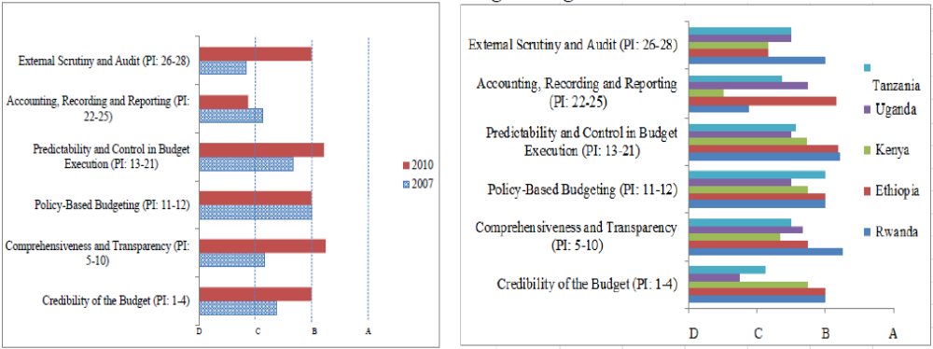

Upstream PFM processes (strategic planning and budgeting) are generally stronger in Rwanda than downstream processes (accounting, reporting and oversight). Areas of strength include a robust legal and regulatory framework as well as an orderly, participatory and transparent budget preparation process. Rwanda is performing well in terms of defining and executing credible and predictable annual budgets in line with national policy objectives and a robust Medium Term and Expenditure Framework (MTEF). In spite of significant recent improvements in legislation, systems and procedures, the accounting, recording and reporting function remains a major weakness in Rwanda’s PFM System in particular at the subnational level. This is due to the scarcity in suitably qualified officials to handle PFM functions as well as an incomplete roll-out of the Integrated Financial Management Information System (IFMIS). External scrutiny has been improving in recent years with substantial improvements in the coverage, scope, methods and follow-up of external audits; as well as the improved Parliament’s scrutiny of the annual budget and audit processes. The timeliness of the submissions of audit reports to Parliament, though, remains a challenge.
Rwanda’s current PFM reform agenda has adequately prioritized the implementation of key reforms to address the country’s salient PFM system weaknesses. The PFM Sector Strategic Plan (SSP, 2013-2018) builds on the achievements of the initial PFM Reform Strategy (2008-2012) and identifies four key priorities for urgent implementation:
- Increased resource mobilisation: domestic tax and non-tax revenue mobilisation to ensure Rwanda becomes self-reliant in the medium to long term;
- Scaling up of the implementation of IFMIS: extend IFMIS to remaining government agencies both at central and local government levels as well as initiate the process for the use of a full-fledged and integrated IFMIS with a comprehensive set of functionalities;
- Strengthen PFM systems at sub-national level: integrate sub-national service delivery units such as schools and primary healthcare institutions into IFMIS; deliver joint staff training programmes for both district councils and local service delivery units;
- Enhance training, professionalization and capacity building across all PFM disciplines: provide professional training to augment staff to ensure sustainability.

Rwanda’s PFM reform agenda has received significant buy-in and support from Development Partners. The SSP is costed at USD 92 Million and has been supported by DFID, the EU and KW through a basket fund. The World Bank is also providing support to the SSP to the tune of USD 100 million through a Public Sector Governance ‘Programme-for-Results’. GIZ has designed dedicated support to PFM systems and capacity building at decentralized level. The necessary institutional arrangements for Development Partners to participate in policy dialogue are in place, although the room for meaningful and qualitative policy dialogue on PFM sector reforms has so far remained limited (see chapter 5 for more detail).
Rwanda’s current PFM reform agenda is highly relevant to Belgium’s ongoing Development Cooperation Programme. The focus on revenue mobilization and PFM systems and capacity at sub-national level are particularly relevant to Belgium’s engagement in Health Sector Budget Support as well as in the BTC Rwanda Decentralization Support Programme (formulated in two components: ‘Enhancing the Capacities of Districts’ and ‘Support to District Development Plans’) which kicked off in April 2015 and the ‘Ubuzima Burambye’ Health intervention which was launched in July 2015 according to the ‘National Execution’ modality for procurement and financial management. Belgium’s participation in PFM Sector dialogue through Embassy and BTC staff has been appreciated and should continue.
Recent developments in Planning and Budgeting
Some important developments occurred in the upward PFM cycle in 2014 and 2015, with the revision of the budget and planning calendar and its integration with the Imihigo (performance contracts) process.
Firstly, in 2014 the planning and budgeting calendar was brought forward to kick off as early as October. Whereas sectors were previously granted budget ceilings on the basis of which they designed their respective plans the situation has now been reversed with line Ministries now starting by drawing their priorities and plans which are presented at the level of MINECOFIN. Ceilings are established subsequently taking into account the different sector priorities and needs as well as commitments made by DPs across the different areas of the development agenda.
Secondly, 2015 saw the integration of the Imihigo process in the planning and budgeting calendar as well as the development of the second generation Imihigo which, among other things, puts more emphasis on joint responsibilities among Ministries and sectors for reaching development goals.
Recent Developments in Accounting, Recording and Reporting
A mission of international experts (‘Quality Assurance Group’) visited Kigali in June 2015 to conduct an external review of the quality of the Integrated Financial Management and Information System (IFMIS) – also known as SmartFMS – and give further guidance to GoR following the recent decision to start developing the future generation of the software.
The draft QAG report concludes that the current SmartFMS roll-out has been implemented successfully and within a reasonable budget envelope. The SmartFMS provides core functionality in budget preparation, budget execution, accounting and reporting in line with the Organic Budget Law. The mission welcomes the decision taken by MINECOFIN to commence the development of the future SmartFMS taking into account existing challenges and future requirements. The mission warns MINECOFIN against the temptation to go for a ‘big bang’ approach, and instead recommends to opt for an ‘agile development approach’ by incrementally adding new modules and functionalities into the existing IFMIS. MINECOFIN is further advised to foresee more frequent quality assurance reviews at every step of the process.
To date, the roll-out of SmartFMS has reached, among other, 60 central government entities, 30 districts and the City of Kigali, 30 district pharmacies and 30 mutuelles de santé. Meanwhile, MINECOFIN has been speeding up the roll-out of an accounting and reporting system designed as a temporary “easy-to-use” solution for sub-district level / subsidiary entities. Thus far, the simplified system has reached most of the country’s administrative sectors and the next step is to pilot the tool in 10 health centres (FY 2015/16). At the same time, MoH and DPs (BTC and MSH) have been engaging with MINECOFIN on the issue of information systems requirements in hospitals, as these have a complex business processes and will need a more elaborate solution than the SEAS. From the perspective of the health sector, the IFMS roll-out and related initiatives will require continued attention in the coming years to ensure that the legitimate medium term ambition to complete the roll-out of a fully-fledged Integrated Financial Management System is managed with due consideration to the business requirements and/or capacity of health sector system users.
    - Sector Budget & Expenditures
Rwanda’s health sector is financed through four major sources: (i) GoR revenues which include revenue generated from tax, grants such as general budget support and sector budget support, donations and loans; (ii) health insurance pooled funds (subsidised by households and GoR); (iii) private funds and internally generated revenues from health facilities; (iv) donor funds chanelled through specific porgrammes or projects (partly on-budget and reflected in the development budget of the National budget, and partly off-budget).
External resources for the health sector have been decreasing and are set to decline more substantially as from the ongoing FY 2015/16. In view of the Government’s general fiscal constraints (see section 2.1.2), it is unlikely that the decrease in external resources can be fully compensated by Government. MINECOFIN does not expect the national health budget to increase as much as it did in the past. All of this will make it challenging to consolidate current results (cf. MDGs) and to face future issues and emerging needs (such as the gradual increase in prevalence of non-communicable diseases).
GoR is very concerned about sustaining health results and is stepping up efforts to enhance efficiency through rationalization of expenditures by each of the programs (focusing mainly on human resources deployment and strengthening decentralization. A number of innovative initiatives are being explored (e.g.: collaboration with the private sector in the fight against malnutrition; sin taxes; social development bonds) aiming at decreasing dependency on external funding.
In the same spirit, an extensive study on the ‘sustainability for Rwandan health services’ was initiated by Oxford Policy Management in May 2015 with financial support of UNAIDS to look at medium and long-term scenarios for health financing in Rwanda. Preliminary findings were shared during a broad consultation in August 2015 and the final report, which is expected to include clear recommendations for policy options and distribution of funds among different health programmes, is yet to be finalised and shared.
Trends in budget allocations
This section analyses the trends in budget allocations for health over the past three years. The figures include on-budget resources (i.e. budget support and the externally funded programmes or projects captured in the National budget).

Table 4. Health sector budget as a share of the total State budget (source: Finance Law)
 | Budget allocation FY 13/14 (RwF) | Budget allocation FY 14/15 (RwF) | Budget allocation FY 15/16 (RwF)
Central Govt Health Sector Budget | 127,642,972,458 | 157,695,388,630 | 141,134,753,590
District Health Budget | 29,869,087,313 | 31,773,582,414 | 39,296,576,089
Total Health Budget | 157,512,059,771 | 189,468,971,044 | 180,431,329,679
Total Health Budget as % of total State budget | 9.5% | 10.8% | 10.2%
Total State budget | 1,653,467,462,173 | 1,753,256,377,958 | 1,768,183,628,463

In spite of recent concerns of declining external (on- and off-budget) resources specifically allocated to health, GoR has been able to maintain stable allocations overall as a percentage of the National Budget thus far. In FY 2015/16, the health sector budget suffered a major decline of the on-budget HIV Global Fund grant (down to USD 59 million from USD 102 million allocated in FY 2014/15), which partly explains the decline in the central government allocation to health. However, with the ongoing Decentralisation process more responsibilities and funds are being allocated to the districts over time which enables the sector to keep a steady balance as a share of the National budget. In relative terms, the share of the total health budget allocated to district has grown from 18.9% (FY 2013/14) to 21.7% (FY 2015/16).
Figure 9. Health sector budget allocation by level of government (in billion RwF)

Figure 10. Cumulative budget allocations to health (in billion RwF)

Budget distribution
At the central level, as from the mid-year budget revision of FY 2014/15 RBC has been absorbing 60% of the envelope allocated to the health sector, reflecting the restructuring that occurred in both MoH and RBC at the end of 2014 (seeing the transfer of last remaining programmes such as MCH as well as key units such as HMIS to RBC) which was complemented by the relocation of SPIU from MoH to RBC (along with the Global Fund allocations).

Figure 11. Budget distribution by budget agency at central level (FY 2015/16)

Traditionally, the financial and geographical accessibility programme has been one of the largest in terms of budget as it encompassed four major sub-programmes managed by MoH, which are: (i) insurance system organisation, (ii) health services subsidization through the mutuelles de santé (payment of premiums for poor and vulnerable households), (iii) Performance-Based Financing incentives (consisting of transfers to district hospitals and health centres) and (iv) health infrastructure, equipment and transport. As seen in Figure 12, the budget for this programme has reduced this year which can be explained by (1) the effective shift of the management of the health insurance system to RSSB leading to the deletion of the ‘insurance system organisation sub-programme’ from the MoH budget and most importantly, (2) a substantial decrease in infrastructure, equipment and transport overall. The other major programme is health quality improvement which covers health communication, medical research, medical infrastructure and equipment maintenance, medical procurement and distribution as well as blood transfusion services and laboratory diagnostic quality assurance and is mostly managed by RBC. While the Health Communication sub-programme has suffered a decrease in budget allocation from RwF 2.2 billion to RwF 0.4 billion between FY 2014/15 and FY 2015/16, budget increases can be observed in the sub-programmes (iii) Medical infrastructure and equipment maintenance and (iv) Medical procurement and distribution (with a doubling of the health and hygiene supplies component i.e. drugs and consumables), which explains the general increase under this programme observed in Figure 12.
As reflected in the figure below, several programmes have been affected by the decline in the central government health budget allocation in FY 2015/16. MoH has opted for cutting in the recurrent budget of the policy development and health service regulation by saving operating costs and bringing more meetings in-house (e.g. several offices at MoH were recently converted into a conference room with a capacity to host more than 50 people) as well as putting more emphasis on integrated supportive supervisions (by mobilising staff from different programmes for field visits conducted in a joint fashion which was not the case previously).
On the other hand, the administrative support and services programme had to absorb the salaries and streamline the contracts of a number of staff (i.e. paid on Global Fund budget through the new Result-Based Financing Model) onto the national payroll. Although 50% of the 2,700 staff who were financed by the Global Fund did not have their contract renewed in this FY, it is estimated that the GF still continues to cover a large share of salaries of health workers deployed at different levels of the health system. As a mitigating measure, MoH have encouraged health facilities to re-hire staff on their own internally generated revenue to further compensate for this shortage. (Note: the Health Human Resources programme in the budget mainly deals with health professional development i.e. training and career development opportunities).

Figure 12. Budget allocation by programme (in billion RwF)

Budget integration
Budget analysis remains a challenge in Rwanda due to the fact that all (earmarked) donor funds are listed in the development budget of the concerned sector where domestic funds are also listed for specific (investment) projects. Nevertheless, many of these donor funds are actually financing recurrent expenditures as well, such as salaries. One should therefore apply caution when comparing the recurrent and development budget. This weakeness finds an explanation in the fact that many donors want to be able to trace their funds and require therefore a certain amount of visibility of their contribution in the National budget documents. While traditional SBS such as Health SBS delivered by Belgium is not reflected in the development budget of the health sector (as it is considered as a source of domestic revenue and is not specifically earmarked), the Global Fund’s new financing model remains visible as it is destined to support specific programmes and sub-programmes in different budget agencies (MoH, RBC, referral hospitals).

Figure 13. Recurrent budget vs Development budget at central level (in billion RwF)

Overall, the current estimation is that at least 60% of the total health sector budget is externally financed. This figure does not include off-budget funds which would mostly consist of USAID and PEPFAR support and amount to more than USD 100 million annually (although a small portion of PEPFAR financing channelled through CDC is often found to be reflected in the National budget). The Health Resource Tracking Tool, which was developed by MoH with support from CHAI, UNAIDS and USAID in 2011/12, underwent an upgrade between 2013 and 2015. The new version of the tool was presented in June 2015 and a comprehensive round of data collection was undertaken by MoH in collaboration with SPIU, DP’s and district hospitals between June and September 2015. Results are yet to be communicated but the expectation is that the report will give a resonably accurate picture of the current health financing situation.
District funds
The earmarked health sector grants allocated at the district level are mostly destined to pay salaries in health facilities and mutuelles staff as well as to cover operating costs of health faclities and fund community level PBF incentives. As from FY 2015/16, some additional funding has also been allocated to Districts for the construction of health infrastructure.

Table 5. District health budget composition
Program & Subprogram | Outputs | Activities
Health
Health Staff Management (85-90%) | Output 1 | Activity 1
Health Staff Management (85-90%) | Staff of Health facilities remunerated on time | Pay salaries on time for all staff of Health centers and Districts Hospitals
Health Staff Management (85-90%) | Output 2 | Activity 1
Health Staff Management (85-90%) | Organization and regulation of Mutuelles Insurance System ensured | Pay salaries for Mutuelle staff at district level on time
Health Staff Management (85-90%) |  | Activity 2
Health Staff Management (85-90%) |  | Facilitate mutuelle staff through financing operating costs to supervise and mobilize at least one mutuelle section per quarter
Health Infrastructure, Equipment and Goods (10-15%) | Output 1 | Activity 1
Health Infrastructure, Equipment and Goods (10-15%) | All Districts Hospitals are financially supported to pay overheads expenses | Financially support quarterly operating costs of the District Hospitals
Health Infrastructure, Equipment and Goods (10-15%) | Output 2 | Activity 1
Health Infrastructure, Equipment and Goods (10-15%) | Health Facilities constructed | Construct health facilities
Disease Control <5% | Output 1 | Activity 1
Disease Control <5% | All CHW cooperatives are given performance incentives | Give performance incentives to CHW cooperatives

Budget execution and reporting
Financial reporting remains a real challenge because of the complex nature of the funding of the health sector which comes from multiple sources. At health facility level, there is no single financial management system in place and different accounting systems often co-exist for managing and reporting on the use of funds to different stakeholders (e.g. the TOMPRO accounting system is in place in 80% of district hospitals and to date has been used to report on Global Fund expenditures only). Financial information on projects are often consolidated at the level of SPIU (when funds are on-budget) whereas MoH and RBC will produce separate reports for funds allocated through the ordinary (domestic) budget and integrated into IFMIS. For reporting on FY 2014/15 some improvements are expected to be found given that a large part of the Global Fund support is now channelled through the Treasury and integrated into IFMIS (reports are not yeat available and will be presented at the Joint Health Sector Review in November 2015).
At present time, there is not even a standard system in place for accounting and reporting on GoR funds (ordinary budget) at facility level and efforts are under way to streamline these processes and strengthen the upward accountability of health facilities towards districts through the roll-out of SEAS in health centres (which will likely be complemented by a more elaborate electronic financial management system at district hospital level).
Until 2013/14 the health sector had sound budget execution in each of its agencies and programmes reaching between 85 and 100%. Some overspending was sometimes observed but this is also due to the fact that MoH reports on expenditure based on the original budget instead of the revised budget. As from 2014/15, a substantially larger amount of the health budget has been captured in IFMIS and hence reported upon through the national budget execution channels (as reflected in the table below) following the set-up of the Global Fund’s Result-based Financing (RBF) model, which is apparent to earmarked SBS. Lower budget execution rate were observed at 87% (or 84% if only the central level is considered), which may be explained by factors such as: (i) the managerial adjustments related to the set-up of the Global Fund RBF, with the application of IFMIS as well as the oversight role taken on by MINECOFIN in the management of the funds, and (ii) the important restructuring of central government agencies in 2014/15 (including MoH and RBC) which lasted several months and may have led to a slower pace of implementation of programmes and activities. More speficially, the lowest level of execution were found in RBC programmes on the grounds of delays in tendering for infrastructure and equipment and nutrition food, delays in delivery of medical products and equipments and delays in payment for equipment maintenance.
Figure 14: Budget execution in the health sector, 2012/13 – 2014/15
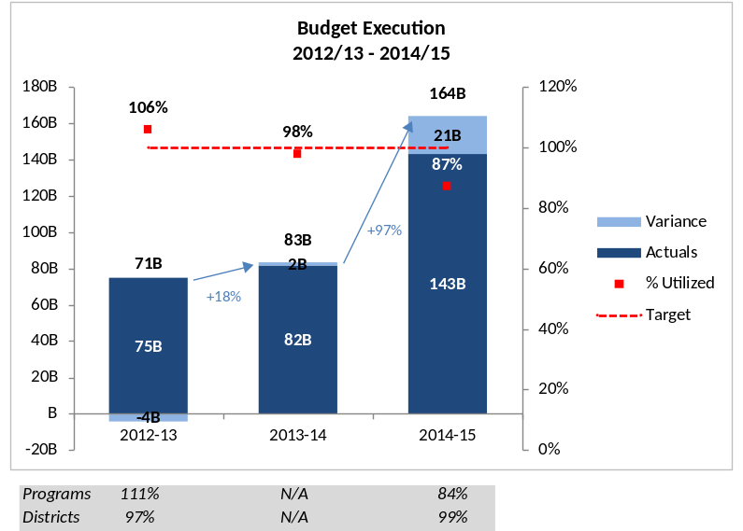
Source: MINECOFIN report for the JSR Review. These figures represent the budget and expenditures captured in the IFMIS system.
    - External Audit - Health Sector
The Office of the Auditor General has gained more administrative and financial autonomy following the adoption of Law n° 79/2013 in November 2013. However its budget is still determined by MINECOFIN and the executive still makes key decisions regarding the appointment of the Auditor General, staff remuneration and staff rules and regulations.
Although the OAG’s capacity remains limited, coverage, scope and methods and follow-up of external audits nation-wide have gradually improved over the years. The timeliness of the submissions of audit reports to Parliament, though, remains a challenge. Meanwhile, the percentage of entities with unqualified audit opinion has been increasing steadily.

Table 6: GoR Audit analysis
 | FY 2011/12 | FY 2012/13 | FY 2013/14
Audit coverage (% of Government. expenditures) | 75% | 79% | 81%
% entities with unqualified opinions | 28% | 32% | 36%
Follow-up of audit recommendations (% implemented) | 49% | 60% | 60%

The Public Accounts Committee (PAC) of Parliament, established in April 2011, has proven to provide robust oversight of financial management. The PAC analyses OAG audit reports and conducts public hearings with chief budget managers, accountants and other officers being regularly called to accounts.
The Ministry of Health was given a ‘Qualified Opinion’ from the OAG in the past two financial years (FY 2012/13 and FY 2013/14), while it had received ‘Unqualified Opinions’ in the three previous fiscal years. The main recurring challenges identified in MoH’s last two OAG reports can be summarized as follows:
- Procurement: some irregularities in tender evaluation. Irregularities and delays in the execution of contracts;
- Asset Management: a wide range of medical equipment purchased and supplied but not working or not in use; or not supplied due to non-availability of structures to host it;
- Wasteful expenditures associated with penalties for example on failure to retrieve imported goods from customs or delayed settlement of invoices;
- Payables & Receivables: a total of RwF 11.3 million was owed by the SAMU (Service et Aide Médicale d’Urgence) to MoH for more than 18 months. A difference of RwF 392.6 million was noted between the balance of tax liability confirmed by Rwandan Revenue Authority (RRA) and the liability reported in the books of MoH.
In October 2014, the action plan related to the implementation of recommendations of the 2012/13 OAG report was presented and discussed at the JHSR and validated by the Chair and Co-chair along with the JHSR summary report. The 2013/14 OAG report released in May 2015 evaluated the status of implementation of audit recommendations formulated on the OAG audit covering FY 2012/13 and noted that five recommendations were fully implemented, three were partially implemented and one was non implemented (relating to the difference between balance of payables confirmed by RRA and that found in financial statements).
In addition, the OAG national summary report on FY 2013/14 contained a specific chapter dedicated to issues of “weaknesses in management in the health sector”. The chapter covers a number of challenges summarized in four points:
- Procurement and distribution of substandard mosquito nets, drugs and medical consumables at MPPD;
- Unreconciled stock of drugs, high levels of expired drugs and damage stock of drugs managed by MMPD;
- Weaknesses in management in the ‘mutuelles de santé’ system;
- Weak financial management and lack of reliable accounting records in district hospitals (which is part of a more general problem found in all subsidiary entities reporting to districts).
At the end of March 2015 the Social Affairs Committee and Public Accounts Committee of Parliament called in the Ministry of Health to answer questions on financial management raised in OAG’s 2013/14 summary report as well as operational issues which were found to be undermining the performance of the health sector at the March 2015 Leadership Retreat. These discussions resulted in an in-depth inquiry of the health sector conducted by a team of Members of Parliament between April and May 2015. Whilst the results and outcome of the inquiry have not been published, the process has been given a high level of attention in the national media.
OAG audit reports are presented and briefly discussed at the backward-looking Joint Sector Reviews conducted in all sectors during the period September-October of each year.

Case of misused funds in RBC – Maternal & Child Health programme

At the end of 2015 allegations on the embezzlement of external funds destined to support activities in the area of nutrition came into the public domain following the issuance of an international arrest warrant against the director of the Maternal and Child Health (MCH) program of the Rwanda Biomedical Centre (RBC). The funds were received from a philanthropic organization (Children’s Investment Fund Foundation - www.ciff.org) and channeled through the SPIU of RBC. The allegations have targeted a number of staff from the MCH programme team and district hospitals, some of which are currently in custody (including the MCH director who returned to Rwanda in January 2016) and the investigation is still ongoing. In January and February 2016, the Embassy of Belgium and BTC consulted other DPs involved directly or indirectly in the health sector (USAID, EU, DFID) to gather more information and understand their respective positions on the related matter. The Embassy of Belgium also engaged with the outgoing and incoming Permanent Secretaries of the Ministry of Health in February and March 2016 and reassurance was given that the case of fraud did not involve Belgian funds. It is thought that this specific issue may have been picked up through the ongoing annual auditing process and that more information may become available at a later stage (for e.g. when the OAG presents its annual report to Parliament in May 2016).

External Support to the Sector
  - Health sector program (direct bilateral cooperation)
Through the current Indicative Cooperation Program (ICP) 2011-2014 the Belgian Cooperation has allocated 55 M € for providing support to the health sector through a comprehensive program approach. The anchorage of the program at different levels stimulates a unique dynamic of interaction between operational and strategic levels. It allows a consistent follow-up of results in terms of access to quality services and development of adequate policies. This program consists of:
- Sector Budget Support (Joint Health Sector Support-JHSS): 32 M € financial contribution focusing on the policy dialogue relating to sector priorities and the two other programs.
- Basket Funding ‘Capacity Development Pooled Fund ‘ (CDPF until 2017): 2 M € focusing on a coordinated approach to Human Resource for Health in planning, production and retention of Health workforce across the sector by increasing the numbers and quality of trained HRH and their equitable distribution.
- Improving the quality of primary health care and services in Rwanda (Ubuzima Burambye Program 2015-2019): 21 M €.
The Sector Budget Support operation of 32 M € provided by Belgium to the Rwandan health sector in the current ICP is expected to release its final disbursement of a value of 9 M € by December 2015. In order to ensure continuous and coherent support to the health sector, in complementary with the other interventions in the health program, an additional envelope of 18 M € is foreseen for the Fiscal Years 2016/17 and 2017/18.
  - Belgian support to the health sector
The following table provides an overview of the Belgian support to the health sector and the synergy with the Health program. The values promoted are the 3 guiding principles of the Rwandan Health Sector Policy (people-centred, integrated and sustainable care). The priorities which are supported are the ones of the HSSP III strategy (see section 4.1).
Table 7: Belgian support to the Rwandan health sector
Belgian actors | Areas of Synergy
BC (Belgian Cooperation) -Rwanda Decentralization Support Program  RWA 1308911 (ECD)  RWA 1309011 (DDP) | - Use of common approaches for cross cutting issues (gender SRHR/HIV and environment) in both sectors - Decentralization and Health.  - Harmonization of capacity building approaches at national and sub-national levels regarding training, coaching and interpersonal and management skills  - Cross-sectoral dialogue for Evidence based, Planning and M&E in Local Government through participation in SWG and TWGs
BC Study and Expertise Fund | - Can provide funding for studies linked to the health program
Other bilateral interventions of the Belgian Cooperation in the health Sector  (Ubuzima Burambye Program and Capacity Development Pooled Fund) | - Institutional support to the health sector (Ubuzima Burambye) with 6 axes: quality assurance, mental health, urban health service coverage, leadership and governance particular at district, data use, asset management  - Joint action research and capitalization focusing on ‘top down’ and ‘bottom up’ approaches (Link with the learning cycle for sustainable sector development)  - Advocacy for adequate resources allocation for continued training/upgrading of health workforce (Midwives, Nurses, Lab Technicians, Hospital Managers, Medical Maintenance Technicians) in Rwamagana, Kabgayi, Byumba, Nyagatare and Kibungo Schools of Midwifery and Nursing, Kigali Health Institute and University of Rwanda  - Use of the CDPF Monitoring Committee as a forum for dialogue with Ministry of Education for integration of ‘People Centred Care’ in training Curriculum development and equitable redeployment of trained staff
Handicap International | - Training of occupational therapists and taking into account quality of care for vulnerable groups in accreditation  - Community based Mental Health program with focus on Gender based Violence prevention and management for Persons with a Disability, in Rutsiro, Rubavu and Gasabo districts  - Accessibility norms & standards in infrastructure for people with disability  - Disability disaggregated data collection and use
Médecins Sans Vacances (MSV) | - Capacity strengthening in MSV partner-hospitals (Kabgayi, Gatagara, Rilima, Murunda,Cyangugu, Ndera in relation to (para)medical services  - Support services (maintenance, laboratory, radiology) and hospital management –auto-evaluation
Fracarita | - Management of Mental health cases at Ndera Referral Hospital  - Clinical Training of Health workforce in Mental Health and formative supervision-Opportunity for integration of ‘People Centred Care’
COOPAMI (INAMI-RIZIV) | - Training in Social Health Protection Management for Rwanda Social Security Board and MoH staff
QUAMED | - International Platform for quality procurement of medicines especially psychotropic drugs where Rwanda can become a registered member
Coopération universitaire au Développement (CUD) | - Reinforcement of capacities of the University of Rwanda (UR) through i) reinforcing masters/doctorate thesis’s, ii) improving the quality of training of teachers and technicians, iii) reinforcing UR revenue, iv) improving laboratory equipment and their use, v) improving quality of services, vi) support to training and research activities.  - In particular, there is the clinical mentoring of paediatricians by Rwandan, American and Belgian (through CUD)
‘Lumière pour le monde’ | - Eye Care Prevention and Treatment in 15 districts

  - Other donors’support to the Sector
Table 8: Mapping of other Technical & Financial Partners (TSFs) and their focus
Other Principal Development Partners | Areas of Synergy
EU | - untargeted budget support to the Treasury in relation to the fight against malnutrition  - active participation in the PFM dialogue structures and preparation of a new phase of support to the PFM basket fund under 11th EDF
Swiss Development Cooperation (SDC) | - Strengthening the use of HMIS, action-research and the functioning of the District Health Management team in Karongi, Nyamasheke and Rutsiro Districts  - Funding Integrated approach towards Gender Based Violence
MSH (for US Government) | - Program of Health System Support-Implementing agency focusing on: i) Leadership, Advocacy, Governance and Policy and Planning (Central and decentralization); ii) Management, Coordination and implementation in Health financing for revenue generation and mobilization and strengthening regulatory bodies for quality assurance; iii) M&E, learning and Knowledge-based practices; iv) Quality improvement
Rwanda Family Health Project | - Quality Assurance and accreditation  - Planning, M&E, Management
UNICEF | - Technical Support for new-born and paediatric care, Integrated Management of Child Infections and PMTCT and training on EMONC.
UNFPA | - Technical Support to Reproductive Health services and Family Planning  - Technical support to Adolescent Reproductive Health Services specifically  - Support to action research (Link with learning cycle)
UNAIDS | - Support to Health Resource tracking Tool upgrade
GFATM | - Support to HIV, TB, Malaria programs & Health System Support
GAVI | - Support to immunization program and introduction of new vaccines
WHO | Support the Ministry of Health through technical assistance for:  - strengthening capacity in health system governance and stewardship, quality assurance service delivery, Human Res. for Health production & management  - Developing an Integrated Disease Surveillance and Response (IDSR) strategy  - Promotion of Health and Social Determinants of Health including healthy lifestyles addressing risk factors of Non Communicable Diseases such as tobacco, alcohol, substance abuse, physical inactivity and proper nutrition in school institutions, and targeting other vulnerable groups  - Promotion of health system information and evidence, monitoring of trends, data generation and analysis of health priorities, e- Health, research for health and knowledge sharing  - Promotion of access to health products and health-care technologies based on primary health care needs
Partners in  Health | - Primary Health Care and Community health  - Quality Assurance in District Hospitals at Burera and Kirehe  - Clinical Training- Medical Education of health professionals and Research
CHAI | - Technical Assistance for Medical Equipment Management and Maintenance Tool development  - Support to RBC leadership

The expertise made available at level of the DPs is rarely (except MSH, WHO and BTC) oriented to support the health sector in general but mostly targeting specific vertical programs, specific districts or specific health professionals. There is a need for expertise with a helicopter-view and long-term vision of the system in order to reduce the risk of fragmentation and unsustainable strategies.

MORE DETAILS IN RELATION TO OTHER DONORS PROVIDING BUDGET SUPPORT
Global Fund support
In 2014, the HIV grant of the Global Fund adopted a new Result-Based Financing Model channelled as earmarked Sector Budget Support through the Treasury. In 2015, the Malaria and TB grants embarked on the same approach. Funds are integrated and reported upon through IFMIS and whilst the implementation of GF grants still falls under the responsibility of the SPIU of MoH/RBC, MINECOFIN has become a key player in the budget execution process (overseeing and approving payments).
Table 9. Summary of Global Fund financial allocations (in US Dollars)
Disbursements | FY 2013/14  (received) | FY 2014/15  (received) | FY 2015/16  (expected)
HIV | 94,220,487 | 102,194,865 | 59,411,276
MALARIA | 30,702,231 | 14,724,189 | 24,562,538
TB | 10,187,444 | 9,248,088 | 9,193,265
Total | 135,110,162 | 126,167,142 | 93,167,079
Source: MoH/RBC SPIU, September 2015
European Union: Nutrition SBS
In April 2014 the European Union (EU) delegation launched a Sector Reform Contract worth € 28 million focusing on the fight against malnutrition which aims to support the Ministry of Agriculture, the Ministry of Health and the Ministry of Education. This support is provided through direct untargeted budget support to the Treasury on the basis of general conditions related to a favorable macro PFM assessment as well as specific conditions such as reports related to the implementation of the National Strategy to Eliminate Malnutrition (for the fixed tranche), on the one hand, and on the achievement of targets associated with a set of performance indicators related to the fight against malnutrition (for the variable tranche), on the other hand.
The final tranche of the EU budget support is (partially) being disbursed in the 2nd week of April 2016 (with the value of the disbursement determined by the achievement of set targets) but was postponed due to delays in accessing performance reports related to the PFM basket fund.
Table 10. EU disbursement calendar in millions of Euro under the Sector Reform Contract to Support Rwanda's National Multi-sectoral Strategy to Eliminate Malnutrition (NSEM)
Rwandan FY |  | 2013/14  (received) |  |  |  | 2014/15  (received) |  |  |  | 2015/16  (delayed) |  |  |  | Total
 |  | Q1 | Q2 | Q3 | Q4 | Q1 | Q2 | Q3 | Q4 | Q1 | Q2 | Q3 | Q4 | Total
Base tranche |  |  |  |  | 10 |  | 6 |  |  |  |  |  |  | 16
Variable tranche |  |  |  |  |  |  | 4 |  |  |  | 8 |  |  | 12
Total |  |  |  |  | 10 |  | 10 |  |  |  | 8 |  |  | 28
Source: EU delegation in Rwanda, September 2015

Belgian Support to HSSP III
  - HSSPIII
HSSP III has already been described and assessed under sections 3.2.1 and 3.2.2.
Figure 15 : The strategic framework of HSSP III

An MTR of the HSSP III was conducted in August 2015 which will lead to an update of the HSSPIII.
  - Belgian Contribution
    - Belgian Health Program
See section 3.1
    - Belgian contribution to the Joint Health Sector Support III C
The Belgian contribution for the health budget support for the period 2016 - (mid) 2019 consists of the inputs listed below. The financial planning in annexe 2 includes the related necessary provisions, taking into account the actual expenditures incurred as well as the remaining resources available under the budget of JHSS IIIb.
- A Sector budget support of 18 million €:
This budget will be channelled through the national Treasury and PFM system.
- A Public Health expert and a Public Finance Management expert:
The experts will assure technical inputs in the political/policy dialogue through the SWAp mechanisms. They will collaborate closely with the Belgian Embassy (who is responsible to decide on Belgium’s position in the policy dialogue), and with the others experts within the Belgian health program and with the other DPs.
Their presence is imperative for several reasons:
- it is a crucial period for policy dialogue in the health sector. The MTR report of HSSP III states that the Rwandan health system “is now at a cross-roads, as it is facing the challenge, while responding to the significant reduction in external financing, to sustain on the short run the current level of service provision, and develop at longer-term the secondary/tertiary care”;
- being the only donor providing SBS from a sector-wide perspective, it is important that Belgium acts as a constructive but critical sounding board in the policy dialogue, in particular with regard to equity and sustainability issues;
- there is need for expertise with a helicopter-view and long term perspective with regard to the Rwandan Health system;
- the mandate of the current chair of the DPG (USAID) is likely to end in the foreseeable future. Belgium is well placed to take up the role of the DPG chair not only because of the volume of its aid but also because of its longstanding experience and its health system perspective;
- the logic of the Belgian health program (see section 3.1) requires expertise at the level of the budget support component in order to feed into the policy dialogue based on the reality at the operational level;
There is a specific need to maintain PFM expertise for the following reasons:
- Belgium’s dialogue on the sustainability of Rwanda’s health system and health financing requires continued and close follow-up of the country’s macro-economic context, particularly in view of the current and growing concerns on Rwanda’s external sector;
- Belgium’s focus on the development of a people-centred, integrated, resilient and sustainable health system also requires continued and detailed budget analysis to identify and dialogue on medium-term budgetary trends effectively reflecting strategic choices made at national and sector levels;
- The current engagement in the dialogue on PFM reform is highly relevant to Belgium’s bilateral cooperation portfolio, and much appreciated by other Development Partners. It should be sustained, in particular in view of the PFM reform program’s prioritised focus on domestic revenue mobilisation, PFM systems and capacity at sub-national level (hospitals and health centres), as well as the limited resources available for dialogue on PFM reforms amongst Development Partners;
The tasks, work modality and profile for the experts are described in their ToR (see annex 8.3). Their focus in the policy dialogue is explained under sections 4.4 and 7.1.2.
The expertise is foreseen until the end of the Rwandese Financial Year 2018/19 (July 2019). This is to ensure follow up and dialogue on the OAG audits of Financial Year 2017/18 (financial year of the last Belgian disbursement), and ensure continuity in expertise in case of a new phase of Health Sector Budget Support under the next ICP.
A Public Health expert and a Public Finance Management expert are already in place in Kigali. Provisions are included in the financial planning for JHSS IIIc, starting the second semester of 2016 (see 8.2 annex 2) to cover the period until mid-2019:
- Salaries (‘hommes habillés’):15,000 Euro per expert/month from July 2016, for a total amount of 540,000 euro per expert;
- Missions of the experts: 4,000 euro per semester for international missions from July 2016, for a total amount of 24,000 euro;
- Investment budget to replace and maintain one vehicle and purchase two laptops for the experts of need arises: 35,000 euro.
- Running costs (Service Level Agreement with the BTC representation, communication, insurance and fuel for vehicles, costs for local missions, etc.) from July 2016: 15,000 euro per semester, for a total of 90,000 euro.
- Technical follow-up from BTC Brussels (Sectoral & Thematic Expertise department):
This will be assured through the (bi-) annual technical backstopping missions (based on ToR), preferably combined with an annual participation in the Health Sector Joint Review or Health Sector Working Group. An envelope of 21,000 euro is foreseen to cover the costs related to these missions.
- Additional financial support for studies and consultancies:
A total consultancy budget of 75,000 euro will be at the disposal of the experts to support specific studies or workshops, planned in consultation with the Embassy of Belgium, Health DPG and MoH and complementary to the Ubuzima Burambye program. There will be a link with the focus of the policy dialogue and/or the identified risks.
Through the Belgian-Rwandan Study and Expertise Fund (SEF), other studies can be financed, upon the request of the Rwandan partner and approval by the Steering Committee of the SEF.
  - Set-up of the Policy Dialogue (‘the how’)
Learning (loops)
The specific purpose of the Belgian health program is to strengthen the policy cycle in the Health Sector of Rwanda by promoting learning (loops) (cf. Figure 15) within the health sector, linking policy development with the reality at operational level. This is done through the reinforcement of 4 capacities both at strategic and operational level, more precisely the capacities to 1) analyze the design and the implementation of HSSPIII and related subsector policies in a constructive and critical way, 2) document experiences (particularly in the context of the Ubuzima Burambye program) using the approach of Reflective Action and Action Research in order to generate evidence for policy, 3) contribute to a structured feedback to the decision makers at strategic level, 4) contribute to the continuous adaptation of the policies and strategies in order to develop a health system assuring the access to quality health services responsive to the needs of the population.
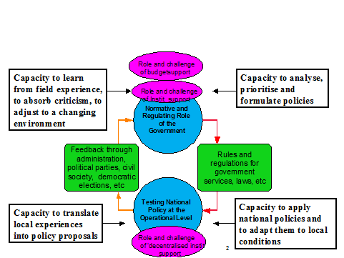
Figure 16: learning (loops) within the health sector
Conceptual framework
It is necessary to have an explicit and shared understanding of the models and references used by the Belgian Cooperation to analyse the system engage in a policy dialogue:
- The Belgian support to the health sector in Rwanda is based on a systemic approach. A system, in its essence, can be defined as ‘actors and their interactions’. Reinforcing the system could therefore be translated as ‘contributing to the quality of the dialogue between all actors in the (Rwandan) health system taking context into consideration’.
- For the decentralised operational level, the reference model to assure equitable access to quality health services to the population is the ‘Local Health System’ (Sylos: ‘Système Local de Santé’), based on the principles of a pluralistic integrated district.
The Policy Notes of the Belgian Cooperation use these models as a basis:
- The Health Policy Note of the Belgian Cooperation ‘The Right to Health and Health care’ (2009) and its addendum on ‘Universal Health Coverage’ (2012).
- The Conceptual framework of Because Health ‘Investing in Health for a greater well-being (2008).
  - Focus of the Policy Dialogue (‘the what’)
    - The general focus
The overall focus is on the implementation of the HSSPIII strategy, in line with the 3 guiding principles of the Health sector policy and taking into account the recommendations of the recent MTR of HSSPIII.
    - The specific focus
1/ The specific focus of the policy dialogue will be linked to the critical risks & challenges mentioned under chapter 6. Main areas of attention are:
1/ The development of a people-centred, integrated, resilient and sustainable health system;
2/ the development of an inclusive health system for the entire Rwandan population;
3/ consultative, transparent, evidence-based and costed strategy and policy making for the sector;
4/ transparent costing of the health insurance packages at the level of CBHI;
5/ the implementation of the national reforms on Public Finance Management and Decentralization;
6/ a regular, constructive policy dialogue around strategic issues based on the MoU between the GoR and the DPs;
7/ transparency in access to disaggregated health sector data including for districts and Development Partners.
More specific areas of concern in relation to those challenges are described in chapter 6 (see table with risks and mitigating measures). The technical and policy dialogue is one of the mitigating measures to tackle these risks & challenges. The aim is to encourage behavioural change within the health system, expressed in the box below.

Box 1: 6 mind-shifts for behavioural change
- A movement from technical quality towards more comprehensive quality (‘people centred care’): this means adapting a more holistic attitude towards patients and communities using health services.
- A movement from a hierarchical style of management towards a coaching style of management: this means incorporating the modern principles of people management and stewardship.
- A movement from an institutional approach (focused on public health service) towards a systemic approach (focused on interaction between stakeholders related to health): this means supporting the SWAp mechanisms with the involvement of all relevant stakeholders.
- A movement from a vertical approach towards an approach on the principles of an integrated district: this means avoiding parallel systems at the operational level and constructing a functional Local Health System.
- A movement from arbitrary decision-making towards evidence-based decision-making: this means introducing learning cycles within the functioning of teams of health providers and health managers at various levels.
- A movement from the focus on ‘offer’ towards a more balanced focus on both ‘offer’ and ‘demand’ of health services (development of internal regulation mechanisms).

2/ Within the set of national indicators related to HSSPIII, some indicators will be monitored in particular. The 10 high level sector indicators monitored during the JHSR (cf. 3.2.4) are currently the basis for the joint monitoring between the MOH and the DPs. The DPs will check whether there is an overall positive trend of these indicators. An effort will be made in the TWG planning to work on a consensus between the Senior Management Team of MOH and the DPs on a limited set of existing indicators relevant for strategic decision-management and allowing to appreciate progress with regard to the 3 guiding principles of the health sector policy relevant. The progress of these indicators could be assessed during the HSWG. Easy access for districts and DPs to up-to-date and disaggregated (where possible) data will be a point of attention.
3/ Policy dialogue is a dynamic process. Therefore new entry points for dialogue might come in according to the changing context & needs, and new opportunities and questions arising. The identification of entry points and opportunities for policy dialogue should relate to: i) national (sub) sector policies and strategies, ii) district action plans, iii) priorities of the MoH, iv) conclusions and issues raised during the Development Partners Coordination Group, Health Sector Working Group meetings, Joint Health Sector Reviews and Technical Working Groups (including the cross-sector working groups such as the PFM sector Working Group and the Decentralization Working Group), v) conclusions of studies, evaluations and audits analyzing the sector, vi) issues raised through action-research at operational level, vii) results presented through the sector M&E systems.
4/ A particular focus will be on the process and quality of the policy dialogue. In the ‘table with risks and mitigating measures’ under chapter 6 a few challenges are described.

Policy dialogue & Donor Coordination arrangements
The Development Partners’ Coordination Group
The Development Partners’ Coordination Group (DPCG) conveys on a quarterly basis under the chairmanship of the PS/ST of MINECOFIN. Following the adoption of EDPRS II in 2013 and the dissolution of the Budget Support Harmonization Group, the DPCG absorbed some of the discussions on the overall planning and budgeting process while more emphasis was also put on Sector Working Groups to lead on sector specific issues. New ToR for the DPCG were adopted in 2014, giving it the following functions: i) serve as a forum for dialogue on coordination of development aid to Rwanda; ii) harmonize the Development Partners’ interventions; iii) monitor the implementation of the EDPRS; iv) serve as a forum for dialogue on the country’s macro-economic situation and national budget execution; v) foster the alignment of Development Partners’ interventions with Government of Rwanda sector strategic and action plans; vi) review the progress made with regard to the DPAF; vii) address any outstanding issue emerging from SWGs.
The PFM Coordination Forum
In 2014 a new level of dialogue on the PFM reform emerged with the establishment of a PFM Coordination Forum under the leadership of PS/ST of MINECOFIN and conveys twice a year for the purpose of backward and forward-looking reviews. The Belgian Cooperation (Embassy and BTC) is a member of the PFM Coordination Forum which held its first meeting in December 2014. The other DPs involved in the Coordination Forum are those contributing to the implementation of PFM reforms either through the PFM basket fund (DFID, EU and KfW) or through other support as in the case of the World Bank (co-Chair) with its “Performance-For-Results” programme.
The PFM Coordination Forum represents the most strategic level of dialogue around PFM reforms and complements working arrangements which exist under the PFM TWG, which is focused on the implementation of the operations of the PFM basket fund and WB support. The TWG meets once per quarter, is chaired by the Accountant General of MINECOFIN and co-chaired by the World Bank. BTC was invited to participate in the (quarterly) TWG held on 29 January 2016, which is the most adequate forum to review documents and address technical issues with different players of the PFM reform and serves to feed into the agenda of the PFM Coordination Forum (usually held shortly thereafter).
Although the structures are in place, there is an opportunity to strengthen the utilization of the PFM Coordination Forum and make it more strategic in practice as current agenda items have been quite focused on processes such as validating progress reports. The second PFM Coordination Forum took place in June 2015 however no PFM backward-looking review on FY 2014/15 was held during the second semester of 2015 (and no TWG meeting was held between May and December 2015). The third PFM Coordination Forum was held on 4th February 2016 following the TWG organized on 29th January. The overall impression from the DP group is that GoR appears to be quite satisfied with key PFM goals achieved (at central level). However, considerable gaps remain at the local level and coordination of efforts in this regard require to be strengthened.
The BTC PFM expert (Health SBS) and Finance Advisor (Ubuzima Burambye) were actively engaged in the PFM dialogue in 2015, which was a critical year for taking stock of progress in PFM with the launch of the 2015 PEFA assessment, the IFMIS QAG mission and other assessments such as the pilot of the Tax Assessment Diagnostic Tool (TADAT). While the PFM SBS expert keeps a helicopter view on the PFM reform agenda and performance, the Health Finance Advisor through his hands-on exposure to the IFMIS system has been bringing very valuable substance into the discussions which has been highly appreciated by GoR and by the DP group especially given the limited resources of the participating agencies (most of them having either technical staff with a broader Governance profile not specialized in PFM and/or a large portfolio of projects to oversee and hence limited resources to allocate to the PFM dialogue).
Currently a discussion within the PFM DP group is ongoing regarding the rotation of co-Chair due to growing dissatisfaction vis-à-vis the limited efforts of the WB to lead on donor coordination over the past year. As mentioned above, the limited resources of DP agencies is a challenge and there is no clarity on who might take the lead at this point in time.
Sector Working Groups
In September 2014 a discussion emerged in the DPCG forum on the quality and added value of Sector Working Groups for both GoR and DPs. The new aid architecture under EDPRS II puts more emphasis on the role of SWG to discuss sector specific issues including budgets, expenditure, audits, capacity building and other cross-cutting themes. While a number of SWG are well established and produce valuable outputs, some long-standing SWG seem to be less active (or proactive) while others are still in the process of setting up their SWAp secretariat and coordination. An independent assessment, piloted by MINECOFIN with financial support from DfID, was completed in June 2015. The assessment has documented good practices and lessons learned from SWG in terms of policy dialogue and policy development, budgeting, reporting, planning and management of JSR, positive leadership styles of Chairs and Co-chair as well as the effectiveness of DoL and other measures undertaken to reduce aid fragmentation. A discussion on the way forward is still expected to take place at the DPCG level. The Belgian Cooperation (Embassy and BTC) has been engaged in the task force that has been overseeing the exercise as well as engaging with MINECOFIN in a related discussion on the revision of the JSR calendar in order to attain a level of more effective input from DPs into the GoR planning and budgeting processes (with a proposal currently under discussion within the DP group).
Health Sector Working Group (HSWG)
The creation of the HSWG brings together the MoH and DPs, including civil society, to support the implementation of the Health Sector Strategic Plan (HSSPIII). The HSWG meets formally quarterly, but ad hoc thematic meetings are not uncommon (e.g. around the MTR). The HSWG is chaired ex officio by the PS of the MoH, assisted by a co-chair from the DP community, normally a representative of the lead DP and chair of the Development Partners Group (see further). The HSWG is the highest organ in the sector for the policy debate between stakeholders, importantly the DPs, and the government. Belgium is both represented in this meeting by representatives from the Embassy in Rwanda and BTC.
Technical Working Groups (TWGs)
Since 2009, several TWGs are operating under the authority of and report to the HSWG with the objective of supporting and advising the MoH on the design and implementation of sub-sector strategies and policies and the development of relevant guidelines and tools to be used. The MINECOFIN SWAp Assessment (2012) highlighted the fact that "there were too many Technical Working Groups (TWGs) in the health sector, only a small portion of which were active and useful". It was recommended to reduce the number of TWGs to make them more relevant to the components of HSSPIII. The rationalised list of TWGs that are currently active and reporting to the HSWG with their chairs and, when applicable, BTC participation are summarized in the table in annex 8.6. TWG are expected to meet formally once a month and ad hoc when instructed by the DG Planning.
The MTR 2015 of the HSSP III has positively appreciated the overall results obtained within the health sector. It observed that here is currently strong leadership of government in delivering results and managing different actors in the health sector. The coordination mechanisms at sector and sub-sector levels (Joint Sector reviews, health sector working group and technical working groups) are functioning (with different levels of effectiveness) to facilitate joint decision making on policies strategies, priorities and overcome implementation challenges). However, after the GoR and DPs implemented a division of labour for external assistance from 2010 to 2013. The policy dialogue has become more process oriented.. Moreover, the policy dialogue is not embedded in a relation of trust and open dialogue between the Ministry of Health and the DPs. The MoU (2007) between MoH and DPs is not up-to-date with the framework of HSSP III (2012-2018) but provides a basic framework to engage in dialogue.
The MTR further comments that there seems to be an over-delegation by HSWG on policy dialogue issues to the technical working groups when in fact strong policy dialogue is required due to a changing environment, characterized by (i) a reduction of external resources; (ii) a serious concern over the sustainability of the gains made; (iii) the increase in specialised care that might reduce the attention and resource allocation for PHC; (iv) the need to set new targets in line with the upcoming of SDGs and the realization of some of the HSSP III targets.
Development Partners Group (DPG)
The DPG, under the chair of USAID, meets to coordinate DPs response(s), in the spirit of the “Paris’ aid effectiveness agenda, to points of attention raised by the DPs involved in the different TWGs, to address some specific concerns, to prepare the HSWG, JHSR, joint assessments, field visits as well as to harmonize their position, share information, etc. In spite of the existing structure, many DPs are maintaining bilateral relations with the MoH to address strategic issues, partly caused by different pre-occupations of different DPs (e.g. budget support versus ‘project’ support). Arguably, this situation puts MoH in a powerful position and undermines efforts made by donors to generate more leverage through the SWAp. The DPG used to meet once a month but since mid-2014 has only conveyed about once a quarter.
The MTR 2015 observes that communication and harmonization among development partners is reported to be inadequate. Progress is limited in bringing more off-budget resources into on-budget. There are a lot of transaction and administrative costs on vertical M&E processes when implementation is managed through the Civil Society Organisations and international NGOs. There is a lack of alignment of fiscal years by some development partners hindering predictability during the budgeting process. It is reported that there is also some divergence in expenditure figures between what is reported by implementers at the ground level and reported by the implementing NGO at national level when off-budget finances are reported.
Joint Health Sector Reviews (JHSR)
Two JHSR are held every year on instigation of MINECOFIN, one backward looking review in October to assess performance during the previous financial year (July/June) and one forward looking review in April to discuss planning and budgets for the following financial year. These exercises focus on broad cross-sector issues such as PFM and Decentralization as well as on trends in a selection of 10 high level sector indicators agreed upon at the Joint Health Sector Review. In the last few years the JHSRs have tended to become procedural with little discussion on policy decisions. After a review in 2015 of the mechanisms, new guidelines for conducting Joint Sector Reviews (across all sectors) have been drafted and disseminated by MINECOFIN.

Risk assessment and Mitigating Measures
Category Risk | Description | Rating  Impact | Rating  Likelihood | Mitigating Measure
Political | Short to medium term political stability is rooted in strong political leadership and Government’s achievements in terms of peace and security, rule of law, economic growth and poverty reduction.  Longer term stability remains fragile in view of Rwanda’s legacy of violent conflict; limited levels of political space and domestic accountability; weak civil society and media, real and perceived levels of inequalities; and the volatility of a conflict-affected region. | Substantial | Moderate | - Through the wider donor coordination, sustain engagement in policy dialogue on political space, domestic accountability, poverty reduction and equitable development.
Macroeconomic | In spite of robust macroeconomic policies, Rwanda is facing structural challenges to sustaining its strong economic performance owing to a small export sector, inadequate infrastructure and energy as well as declining donor support. Rwanda has limited fiscal space with which to ensure the fiscal sustainability of its ambitious development agenda. Since Financial Year 2012/13, lower than expected resources (tax and ODA) have led to recurrent fiscal deficits and necessitated that the government contain its investment spending. | Substantial | Moderate | -Government’s program under the IMF Policy Support Instrument is adequately targeting Rwanda’s structural weaknesses through the promotion of private sector development, exports, fiscal consolidation, and financial sector development.  -Contribute to enhancing Rwanda’s fiscal space through Sector Budget Support’s financial contribution.  -Sustain engagement in policy dialogue on increased domestic resource mobilisation in the context of PFM sector reforms. This theme is one of the 4 key priorities of Rwanda’s PFM Sector Strategic Plan (2013-2018).  -Keep the presence of a PFM expert to support the engagement in dialogue on domestic resource mobilisation and factor macro-economic considerations in the dialogue on the sustainability of the health sector system and health sector financing. for such policy dialogue
Sector Policy’s Quality | The 3 guiding principles of the National Health Sector Policy (2015) are under pressure:  1/ people-centred services: i) the national accreditation process focuses on procedural quality with as risk the lack of comprehensive care and ii) there is a focus on secondary and tertiary health care in the logic of developing an economy based on service-delivery (also in the field of health) for the region and international tourism. The risk is investing in high-technological care compared to Primary Health Care which may also increase existing inequity (actual GINI index of 46,8)  2/ integrated services: i) the first line health risks to be fragmented and cause ‘doctor’s delay’ due to multiple parallel initiatives at community level, ii) persisting vertical programs are mostly off-budget and cause fragmented planning, high transaction costs, large quantities of indicators non-relevant for strategic management, iii) there are gaps in the articulation between the first line health services and the district/ referral hospitals (in terms of referral & counter-referral, training & formative supervision).  3/ sustainable services (in order to sustain both current achievements such as the MDG and future challenges & strategic choices): i) substantial decrease in external funds combined with a high dependency (around 60%) dependency from external funding entails the risk of financial gaps, ii) no shared, evidence-based analysis of cost-effective planning of resources, allocative efficiency and appropriate use of technology with the risk of increasing even more the financial gap. | Substantial | Substantial | -Monitor the progress in relation to the 3 guiding principles using the indicators & progress-markers described in section 3.5.3 of the Ubuzima Burambye program  -Reinforce i) on the spot practice-oriented training for health staff and ii) user feedback mechanisms on quality of care, both aiming at improving the real quality of care (see improvement projects in UB program)  -Focus policy dialogue on i) improving the transparency with regard to costing of long term strategies in health and to financial reporting, ii) access to disaggregated data in order to be able to monitor equity in the system  -Reinforce, through the UB program, stewardship at district-level with a focus on the complementarity of the different levels and actors in the local district health system  - Promote, through participation in the accreditation taskforce, the further integration of vertical programs into the accreditation system  - Focus policy dialogue on i) the balance between short-term and long-term strategies, ii) the balance between PHC and 2nd/3rd level care, iii) the costing of the insurance packages at the level of the CBHI (leverage for sustainable, endogenous cost-control), iv) analytical work on financial sustainability of the sector through allocative efficiencies and rationalisations (right sizing) that not only consolidate but build further on current health achievements, and v) the validation and implementation of the health financing strategic plan  - Support the implementation of strategies, through the collaboration with RBC in the UB program, focusing on a more cost-effective use of resources and a technology adapted to the level of care  - Support, in the Technical Working group Planning, Health Financing & HIS and together with MINECOFIN and the Business Development Unit of RBC, the further evidence-based analysis on innovative ways of financing (rationalisation of CBHI, pooling mechanisms for health insurance, strategic public-private partnerships, tax income….)  - Mobilise the combined and complementary expertise of a Public Health expert and PFM advisors at the service of the Belgian Cooperation to support policy dialogue on the compliance to the National Health Policy guiding principles.
Sector Dialogue’s Quality* | The policy dialogue is well-structured but irregular (HSWG irregular, some TWG are not active), superficial (no debate during JHSR and HSWG), insufficiently effective (no adequate preparation of HSWG and JHSR with inputs from the TWG; some TWG are too large to reach an effective output; no actualised MoU between MOH and DP) and not embedded in a relation of trust between the Ministry of Health and the DP. The risk is a decreased commitment and coordination of DP, and insufficient use of the existing potential for joint reflexion on the longer term strategies and their costing.  The Ministry of Health does not systematically share information or is transparent about long term strategies and in particular the costing of those strategies, and the strategy and capacity for mobilizing domestic resources to finance these strategies. Possible risks are growing financial gaps and growing inequity.  The health authorities have trouble in accepting critical analysis during evaluation exercises which hampers a sound and evidence-based debate on major challenges in the sector.  The DPG coordination is weak: communication and transparency is insufficient, competition between some DP, not all DP nor civil society are involved in the policy dialogue. This may result in a persistent weak policy dialogue.  Belgium is the only sector budget support donor with the risk of limited leverage in the policy dialogue. | Moderate | Moderate | - Submit the Belgian candidacy to take up the role again as DPG chair and HSWG co-chair  - Keep the presence of a Public Health expert and PFM expert at the service of the Belgian Cooperation to i) support an effective policy-dialogue, ii) assure the complementarity within the Belgian health program (JHSS IIIc, UB program and CPDF)  - Link further support to the health sector in the next Indicative Programme for Development Cooperation to the regularity & quality of the health sector (at least 2 JHSR, 2 HSWG and 2 video-conferences with the districts per year) and the participation in the six-monthly integrated supportive supervision (ISS) visits  - Support a better preparation of the HSWG by the TWG and the DPG in order to develop a strategic agenda for debate during the HSWG  - Monitor the quality of policy dialogue at the level of the TWG, HSWG using the criteria described by the outcome related indicator ‘quality of meetings’ under paragraph 3.5.3.3 in the Ubuzima Burambye program  - To ensure the prominence of specific Belgian pre-occupations and priorities for health sector development, support is made conditional to a bilateral Monitoring Committee that would – with reference to the ongoing reorganisation of the formal health sector – include from the GoR side representation from the MoH, RBC and RSSB.  - Link disbursements to conditionalities enhancing transparency by sharing work-plans, budgets, audits, HRTT reports, National Health Accounts,  - Follow-up as DPG the validation of the MTR report of HSSPIII, the subsequent adaptation of the HSSP III and the start of the implementation of the recommendations of the MTR  - Request systematically for the inclusion of costing exercises of strategies in ToR of sector-wide evaluations
M&E of the sector | There is too much focus on indicators imposed by vertical programs preventing a monitoring & evaluation appropriate for strategic decision-making.  Free access to the information of the data-warehouse is limited by a restricted approval policy from the central Ministry of Health, not allowing for evidence-based info to be generated.  The available information is insufficiently disaggregated, in particular related to the different quintiles in the population and detailed information per district. This may contribute to inequity. | Moderate | Moderate | -At the level of the DPG, work on reducing ‘vertical indicators’ imposed on the system and promote use of relevant, locally owned indicators for strategic decision-making.  - Work on a clear policy on access to data, through the policy dialogue and through the ITA working on Result 5 (data use) in the UB program  - Support, through the same mechanisms, the availability of more disaggregated data & support in particular the availability of information per category of users at the level of the CBHI
Effectiveness of Public Administration** | Rwanda is the second top performer country in Sub-Saharan Africa on the IDA Index Cluster D: Public Sector Management and Institutions.  The leadership at the MOH is directive and oriented towards results but would be more cost-effective if there would be more openness towards critical, evidence-based analysis.  There remains a gap in technical and governance capacities at the decentralised level with the risk of decreased cost-effectiveness. | Moderate | Moderate | -Enhance the capacities of districts and support district development plans through the BTC Rwanda Decentralisation Support Programme.  - Sustain engagement in policy dialogue on strengthening PFM systems at sub-national level and enhancing training, professionalization and capacity building across all PFM disciplines. These are 2 of the 4 key priorities of Rwanda’s PFM Sector Strategic Plan (2013-2018).  -Keep the presence of a Public Health and a PFM expert for such policy dialogue.
Budget of the Sector | The health sector budget is and will remain under significant pressure in the medium term, in view of:  -the ongoing fiscal contraction at national level linked to reducing donor financial support and stagnating revenue mobilization;  -reducing donor financial support to the health sector.  The risk is substantial, although to some extent mitigated by Rwanda’s general commitment to consolidate its past achievements in health sector outcomes. | Substantial | Substantial | - Sustain engagement in policy dialogue on health financing, specifically with regards to:  - Sector share of the national budget;  - Sector financial resource mapping + access to disaggregated data;  - Costing of health sector strategies and policies;  - Potential for innovative health financing mechanisms (CBHI, Health Insurance, Public-Private Partnerships, dedicated sector taxes, etc)  - Potential for cost-efficiency gains in the use of resources (resource allocations, health system organization, use of technology, etc.);  -Keep the presence of a PFM expert for such policy dialogue.  - Link disbursements to conditionality on the validation of an annual HRTT reports and a NHA report.
Corruption and Fraud | Rwanda has a strong commitment as well as robust legal, institutional and organizational frameworks for controlling and prosecuting fraud and corruption. As per Sub-Saharan African standards, there are comparatively low and steadily improving perceptions on corruption in Rwanda. Occurrences of corruptive practices, however, are likely under-reported owing to fear and the relatively weak media. | Moderate | Moderate | -Link disbursements to conditionality on the audit of the Ministry of Health and the Rwanda Biomedical Centre.  - Keep the presence of a PFM expert to monitor audit findings and dialogue with the authorities on adequate responses to identified compliance and accountability challenges.
Overall Risk | Rwanda has a robust institutional framework, though there are points of attention regarding long-term stability as well as equity, quality, sustainability, and transparency within the (health) system | Moderate | Moderate | The provision of technical expertise, the complementarity of the Belgian health program, the partnership with the other DPs and the various measures to stimulate the policy dialogue help to mitigate the risks
* This risk includes the ‘Programme’s Technical and Financial partners coordination’ which relates to the risks that lack of clear coordination mechanisms, division of labour, and conflicting interests among DPs might lead to unbalanced decision making and inefficient use of the programme’s resources.
** This risk includes the ‘Partner’s implementing capacity’, which relates to the weaknesses in the technical and the institutional capacity of the partners (Ministry/ other central or local partners) to execute the programme (skills, competences, leadership, human resources, etc.).

The risks above will be monitored by BTC on a periodical basis in order to: i) Check that identified risks are being adequately managed, ii) Assess the implementation progress of the mitigating measures, and iii) Identify any new risks or changes in circumstances. This work will be summarised in the Annual Report produced by the Public Health and PFM experts as well as documented in other quarterly (progress or disbursement) reports.

Disbursements
  - Conditionalities
The proposal on disbursement conditionalities is based on the Memorandum of Understanding (MoU) between the Government of Rwanda and the Health Sector Development Partners (2007), the Vademecum for Belgian Budget Support (2008) and its Annexes (2011), and the 2014 Note of the Inspection of Finance on audit related conditionalities. The proposal reflects the following underlying principles:
- Coherence with risk assessment: in view of the risks identified with the health sector strategy, the health financing strategy and the quality of sector policy dialogue, the conditionality framework focuses on a minimum of pre-requisites for a qualitative evidence-based policy dialogue at sector level: i) an annual general assessment of the health sector performance; ii) sector wide planning, performance monitoring and auditing processes, and iii) institutional processes for evidence generation on health financing.
- Predictability of disbursements: is a key operational principle for Budget Support in general, and of particular significance in view of Rwanda’s structurally fragile fiscal situation (See section 2.1.2). Disbursement triggers are therefore limited to a restrained number of clear, precise, measurable and realistic conditions, defined at an adequate institutional level and conducive to follow-up in case of default.
- Alignment to Rwanda’s fiscal year and planning and reporting systems.
- Realistic expectations as to the ability to leverage policy level actions, orientations and dialogue through disbursement conditionalities.
Furthermore, it is proposed to make explicit reference in the Specific Agreement (under article 3, Monitoring, Control and Evaluation), to specific points of attention in the policy dialogue (cf. 6 points mentioned in the next section 7.1.2), which may not be easily translated into disbursement conditionalities under the above-defined criteria. Nevertheless, they are considered critical in view of the Technical Note’s assessment. In addition to being addressed through the SWAp fora for dialogue, such points of attention will also be discussed on a bilateral basis through a bilateral Budget Support Monitoring Committee, to be held at least twice per year, and consisting of at least the Belgian Embassy, the Ministry of Health Rwanda, the Rwanda Biomedical Centre, the Ministry of Finance and Economic Planning and the Rwanda Social Security Board.
    - Conditionality framework (Specific Agreement, art. 3)

A Monitoring Committee, to be established, consisting of at least the Belgian Embassy, BTC, the Ministry of Health Rwanda, the Rwanda Biomedical Centre, the Ministry of Finance and Economic Planning and the Rwanda Social Security Board - will sit twice a year during the foreseen period of support (and for at least one more year following the year of the final disbursement), to discuss mutual priorities and the Belgian focus for the policy dialogue outlined in article 4.4.
A first instalment of 12,000,000 Euro for the Rwandan Financial Year 2016/17 will be transferred after:
- General satisfactory evaluation of the Health Sector EDPRSII Policy Matrix Indicators for the Financial Year 2014/15;
- Approved annual Health Sector technical and financial report for Financial Year 2014/15 by GoR;
- Approved annual report from the Health Resource Tracking Tool on the 2013/14 budget and 2012/13 expenditures by GoR;
- Unqualified audit reports for both MoH and RBC for Financial Year 2014/15. In the event of (a) qualified opinion(s), (a) management response(s) approved by the Development Partners will need to accompany the audit report(s);
- Approved Health Sector annual work plan and budget for Financial Year 2016/17 by GoR.
- Minutes of at least one Monitoring Committee.

A second instalment of 6,000,000 Euro for the Rwandan Financial Year 2017/18 will be transferred after:
- General satisfactory evaluation of the Health Sector EDPRSII Policy Matrix Indicators for Financial Year 2015/16;
- Approved annual Health Sector technical and financial report for Financial Year 2015/16 by GoR;
- Approved annual report from Health Resource Tracking Tool on the 2014/15 budget and 2013/14 expenditures by GoR;
- At least one National Health Accounts report validated after January 2016 by GoR;
- Unqualified audit reports for both MoH and RBC for Financial Year 2015/16. In the event of (a) qualified opinion(s), (a) management response(s) approved by the Development Partners will need to accompany the audit report(s);
- Approved Health Sector Annual work plan and budget for Financial Year 2017/18 by GoR;
- Minutes of two Monitoring Committee meetings. . The last of the two validating policy focus indicators as per article 4.4, accepted by the Monitoring Committee..
In the case of an adverse or disclaimer of audit opinion, Belgium’s Sector Budget Support will be suspended provisionally and consultations will take place on the conditions for the resumption of disbursements.
The Ministry of Health is responsible for availing all disbursement-related documents to the Belgian authorities. The Ministry of Health will further avail to the Belgian authorities the OAG annual audit report of the Ministry of Health and Rwanda Biomedical Centre for the Financial Years of the Belgian Budget Support contributions (2016/17 and 2017/18).
    - Partnership principles (Specific Agreement, art. 4)
The parties designated in the Specific Agreement shall take all necessary administrative and budgetary measures to achieve the objectives of this Specific Agreement, including joint or separate technical, administrative and financial control and evaluations as mentioned in the MoU. The parties shall inform each other about the results and possible recommendations of these control and evaluation exercises.
Satisfactory coordination and implementation of SWAp mechanisms will be assured: i) the Joint Health Sector Review will be held twice a year to review the performance of the sector during the previous year and agree on sector priorities and resource allocation for the next financial year; ii) the Health Sector Working Group will convene at least twice a year to advise on strategic policy orientations for the sector; iii) integrated supportive supervision (ISS) visits to the districts as well as videoconference monitoring meetings will be held respectively on a bi-annual basis to monitor and evaluate the implementation of health sector activities.
BTC is responsible for the Belgian participation in the monitoring of the implementation of the program in close collaboration with the Embassy of Belgium in Kigali. The Belgian technical expertise, provided by BTC and based in Kigali will work closely with the other Development Partners and within the existing framework of monitoring mechanisms. To this effect, BTC technical experts for budget support will be invited to participate in all meetings of the forums mentioned under art. 4.2.
A Budget Support Monitoring Committee - consisting of at least the Belgian Embassy, BTC, the Ministry of Health Rwanda, the Rwanda Biomedical Centre, the Ministry of Finance and Economic Planning and the Rwanda Social Security Board - will sit twice a year during the foreseen period of support, to discuss mutual priorities and the Belgian focus for the policy dialogue. The meetings of the committee should carry on for at least one more year following the year of the last disbursement.

Belgium’s focus in policy dialogue will be on the following:
- The development of a people-centred, integrated, resilient and sustainable health system (key elements : updated sustainable financing plan for the health sector for the next 5-10 years, Health Resources Tracking Tool / National Health Accounts, Mid-Term Review of HSSP III recommendations);
- The development of an inclusive health system (for the entire Rwandan population which is measured and monitored (key elements : utilisation rate of health services – Outpatient Department, Health Management Information System and Demographic Health Survey with disaggregated data, access to District Health Plans);
- Consultative, transparent, evidence-based and costed strategy and policy making for the sector (key elements: recent costing of the health sector and perspectives on medium term);
- Transparent costing of the health insurance packages at the level of Community Based Health Insurance (key elements: updated analysis of the Community Based Health Insurance scheme regarding costing of packages, contributions, enrolment, public subsidies or evolution of the scheme );
- The implementation of the national reforms on Public Finance Management and Decentralization (key elements: updated analysis of health service delivery or planning by district level);
- A regular, constructive policy dialogue around strategic issues based on the Memorandum of Understanding between the Government of Rwanda and the Development Partners;
- Transparency in access to disaggregated health sector data including for districts and Development Partners, in particular disaggregated data on the 10 Health Sector EDPRS II indicators as well as transparency on the definition and calculation of these. (key elements: access to digital information platforms/portals, computerised real time Health Management Information Systems, knowledge management to make informed choices on best practices, linkages between academia and policy makers for evidence based policy formulation).
The engagement in this dialogue on Belgian areas of focus will be appreciated through the detailed minutes of Monitoring Committee meetings.
The definition of the next Indicative Programme for Development Cooperation will be informed by a general assessment on progress in these areas of focus.
  - Financial Planning
The table below shows the timing of Belgian health sector budget support disbursements according to the Rwandese and Belgian Financial Years. The disbursement calendar is meant to facilitate predictable disbursements to the GoR Treasury. It further accommodates MINECOFIN’s formal request to frontload health sector budget support instalments, which was formulated to the Belgian Cooperation during the Country Portfolio Performance Review of December 2014.
Instalments in Euro
Rwandese Fiscal Year |  | 2016/17 (Q1) | 2017/18 (Q1)
Belgian Fiscal Year |  | 2016 (Q3) | 2017 (Q3)
Instalments |  | €12M | €6M | €18M (Total)

Since 2014, MINECOFIN has been requesting Budget Support donors to frontload their financial contributions in a context broadly characterised by a slowdown in economic growth, declining donor inflows, increasing trade and fiscal deficits, and reducing forex reserves. While not explicitly or systematically articulated by the Government in formal terms, the rationale for such frontloading requests is to enhance Government’s ability to support growth in the short to medium term through sustaining levels of imports and public sector investments without depleting national forex reserves or threatening fiscal sustainability. While donor response has until now remained mixed in view of the real or perceived risk that frontloading budget support disbursements might merely result in postponing rather than solving Government’s current fiscal challenges, recent analysis and communications by the IMF and WB in the context of the IMF 4th PSI review have proven supportive of Government’s stance on frontloading.
At a meeting attended by EU member states Heads of Cooperation on 18th November 2015, the IMF resident representative and World Bank country economist gave a joint presentation on macroeconomic prospects, highlighting growing concerns on Rwanda’s external sector and the balance of payments and the importance of donor flows in Rwanda. The elements of the presentation related to the rationale for frontloading budget support disbursements are summarized below:
- There is a great need for foreign currency at present time as forex reserves are under pressure due to declining donor inflows (in GDP terms), a shift from budget support to project financing, and low exports. Less foreign currency has a direct impact on imports and growth. Currently, Rwanda’s low export base provides insufficient foreign exchange for imports. If imports remain flat, investment and consumption will be badly affected.
- In Rwanda public investment accounts for 16.9% of GDP which is substantially higher than in any other country of the region (as illustrated in the slides presented by IMF-WB). If public investment declines, growth is expected to decline significantly.
- GoR has been digging into its national reserves, with a limited buffer left of forex holdings projected to be “below 4 months of imports” at end 2015 which is little compared to the big investment projects going on at the moment.
- As additional background, it is worth noting that for the IMF a structural deficit of balance of payment is not a problem as such if well managed. It always has been the case in Rwanda, and it was well managed in the past. There are many countries with a structural deficit in Africa, which is easier to manage with a growing economy. The IMF thinks Rwanda will keep it in balance but that it may have no choice but to limit imports if exports and forex reserves continue to decline, with negative impact on economic growth.
These arguments are deemed sufficient reasons to accommodate GoR’s request for frontloading Belgium’s health sector budget support disbursements.

Annexes
  - Specific Agreement Draft

SPECIFIC AGREEMENT

Between

The Kingdom of Belgium

and

The Republic of Rwanda

on

“Joint Health Sector Support IIIc (JHSS IIIc)”

The Kingdom of Belgium, hereinafter referred to as “Belgium”,
and
The Republic of Rwanda, hereinafter referred to as “Rwanda”,
hereinafter jointly referred to as “the Parties”;

- Considering the “General Agreement on Direct Bilateral Co-operation between Rwanda and Belgium,” signed in Kigali, on May 18th 2004;
- Considering the agreed minutes of the Joint Commission on Development Co-operation between the parties, held in Kigali on May 18th 2011, Annex 8 “Belgium-country Indicative Development cooperation Program (IDCP) 2011-2014”;
- Considering the Memorandum of Understanding (MoU) for joint monitoring between the Government of Rwanda and the Health Sector Development Partners, Regarding Partnership Principles for Support to the Health Sector, signed on the 17th October 2007;
- Considering the Economic Development and Poverty Reduction Strategy (EDPRSII) Performance and Policy Matrix agreed between the Government of Rwanda and the Development Partners.

AGREE AS FOLLOWS:

Article 1: Definition and object of the agreement
The Specific Agreement concerns the participation of Belgium in the realization of the objectives of the Health Sector Strategic Plan III (HSSP III), developed for the period 2012-2018.
The overall goal of HSSP III is to universal accessibility (in geographical and financial terms) of quality health services for all Rwandans.
This objective will be attained through the implementation of the HSSP III 4 components: Leadership and Governance, Programs, Health Support Systems, Service Delivery Systems.

Article 2: Responsibilities of both Parties
2.1 The Belgian Party designates:
2.1.1 The “Directorate General for Development Cooperation”, of the Federal Public Service Foreign Affairs, Foreign Trade and Development Cooperation, hereinafter called DGD, as the Belgian administrative entity, responsible for the Belgian contribution. DGD is represented in Rwanda by the Belgian Embassy in Kigali.
2.1.2 The "Belgian Technical Cooperation", hereinafter referred to as BTC, as the Belgian entity responsible for the Belgian participation in the monitoring of the implementation of the Joint Health Sector Support IIIc (JHSS IIIc) and the transfer of funds. BTC is represented in country by its Resident Representative in Kigali.
2.2. The Rwandan Party designates:
2.2.1. The Ministry of Finance and Economic Planning (MINECOFIN) as the country administrative entity, responsible for the Rwandan contribution to the HSSP III.
2.2.2. The Ministry of Health (MINISANTE) as the Rwandan entity responsible for the implementation of the HSSP III.

Article 3: Contribution of the Parties
3.1 The Belgian grant contribution to the HSSP III is 18,000,000 € over the financial years 2016/17 and 2017/18. The Belgian contribution to the sector budget will contribute to an annual increase in the allocation to the Health budget, during this period.
Satisfactory coordination and implementation of the Sector Wide Approach (SWAp) mechanisms will be assured:
- The Joint Health Sector Review shall be held twice per year to review the performance of the sector during the previous year and agree on sector priorities and resource allocation for the next financial year.
- The Health Sector Working Group will convene at least twice per year to advise on strategic policy orientations for the sector.
- ‘Integrated supportive supervision’ visits to the districts as well as videoconference monitoring meetings will be held respectively on a semi-annual basis to monitor and evaluate the implementation of health sector activities.
- A Monitoring Committee, to be established, consisting of at least the Belgian Embassy, BTC, the Ministry of Health Rwanda, the Rwanda Biomedical Centre, the Ministry of Finance and Economic Planning and the Rwanda Social Security Board - will sit twice a year during the foreseen period of support (and for at least one more year following the year of the final disbursement), to discuss mutual priorities and the Belgian focus for the policy dialogue outlined in article 4.4.

A first instalment of 12,000,000 € for the Rwandan budget year 2016/17 will be transferred after:
- General satisfactory evaluation of the Health Sector EDPRSII Policy Matrix Indicators for the Financial Year 2014/15;
- Approved annual Health Sector technical and financial report for Financial Year 2014/15 by the Government of Rwanda;
- Approved annual report from the Health Resource Tracking Tool on the 2013/2014 budget and 2012/13 expenditures by the Government of Rwanda;
- Unqualified audit reports for both Ministry of Health and Rwanda Biomedical Centre (RBC) for Financial Year 2014/15. In the event of (a) qualified opinion(s), (a) management response(s) approved by the Development Partners will need to accompany the audit report(s);
- Approved Health Sector annual work plan and budget for Financial Year 2016/17 by Government of Rwanda.
- Minutes of at least one Monitoring Committee meeting.

A second instalment of 6,000,000 € for the Rwandan budget year 2017/18 will be transferred after:
- General satisfactory evaluation of the Health Sector EDPRSII Policy Matrix Indicators for Financial Year 2015/16;
- Approved annual Health Sector technical and financial sector report for Financial Year 2015/16 by Government of Rwanda;
- Approved annual report from Health Resource Tracking Tool on the 2014/2015 budget and 2013/14 expenditures by Government of Rwanda;
- Approved ( at least one) National Health Accounts report by Government of Rwanda;
- Unqualified audit reports for both the Ministry of Health and Rwanda Biomedical Centre (RBC) for Financial Year 2015/16. In the event of (a) qualified opinion(s), (a) management response(s) approved by the Development Partners will need to accompany the audit report(s);
- Approved Health Sector annual work plan and budget for Financial Year 2017/18 by Government of Rwanda;
Minutes of two Monitoring Committee meetings. The last of the two validating policy focus indicators as per article 4.4, accepted by the Monitoring Committee .
The Ministry of Health is responsible for availing all disbursement-related documents to the Belgian authorities. The Ministry of Health will further avail to the Belgian authorities the Office of Auditor General (OAG) annual audit report of the Ministry of Health and Rwanda Biomedical Centre for the Financial Years of the Belgian Budget Support contributions (2016/17 and 2017/18).
For each disbursement, BTC will produce a report analysing the achievement of the above-mentioned conditions and formulate an advice which will be submitted to the Embassy of Belgium.
Belgium will transfer its contribution to the Sector Budget Support foreign Exchange account at the National Bank of Rwanda as will be specified by the Ministry of Finance and Economic Planning (MINECOFIN).
Within a month of the transfer being made by Belgium, the bank of county will issue a receipt to the BTC Resident Representative in Kigali, confirming the amount received and the bank account to which it was lodged.

3.2 In the case of an adverse or disclaimer of audit opinion, Belgium’s Sector Budget Support will be suspended provisionally and consultations will take place on the conditions for the resumption of disbursements.

3.3 The planned disbursements can be delayed or even cancelled, in an evident case of fraud, in case not sufficiently corrected, after being detected and notified. In the case of serious misappropriation of misuse of transferred funds, Belgium reserves the right to unilaterally or jointly claim repayment in full or in part of the funds.

Article 4: Monitoring, Control and evaluation
4.1 The parties shall take all necessary administrative and budgetary measures to achieve the objectives of this Specific Agreement, including joint or separate technical, administrative and financial control and evaluations as mentioned in the Memorandum of Understanding (MoU). The Parties shall inform each other about the results and possible recommendations of these control and evaluation exercises.
4.2 BTC is responsible for the Belgian participation in the monitoring of the implementation of the programme in close collaboration with the Embassy of Belgium in Kigali. The Belgian technical expertise, provided by BTC and based in Kigali will work closely with the other Development Partners and within the existing framework of monitoring mechanisms. To this effect, the Embassy of Belgium and BTC technical experts appointed to this budget support operation will be invited to participate in all field or supervision visits and meetings of the fora mentioned under art. 3.1.
4.3 This Specific Agreement encourages a constructive dialogue between the Belgian and Rwanda governments on the development of the health service delivery systems in Rwanda in alignment with the priorities formulated in the EDPRS II and HSSP III.
4.4 Belgian focus in policy dialogue will be on the following topics, including discussion around the following matters:
- The development of a people-centred, integrated, resilient and sustainable health system (key elements : updated sustainable financing plan for the health sector for the next 5-10 years, Health Resources Tracking Tool / National Health Accounts, Mid-Term Review of HSSP III recommendations);
- The development of an inclusive health system (for the entire Rwandan population which is measured and monitored (key elements : utilisation rate of health services – Outpatient Department, Health Management Information System and Demographic Health Survey with disaggregated data, access to District Health Plans);
- Consultative, transparent, evidence-based and costed strategy and policy making for the sector (key elements: recent costing of the health sector and perspectives on medium term);
- Transparent costing of the health insurance packages at the level of Community Based Health Insurance (key elements: updated analysis of the Community Based Health Insurance scheme regarding costing of packages, contributions, enrolment, public subsidies or evolution of the scheme );
- The implementation of the national reforms on Public Finance Management and Decentralization (key elements: updated analysis of health service delivery or planning by district level);
- A regular, constructive policy dialogue around strategic issues based on the Memorandum of Understanding between the Government of Rwanda and the Development Partners;
- Transparency in access to disaggregated health sector data including for districts and Development Partners, in particular disaggregated data on the 10 Health Sector EDPRS II indicators as well as transparency on the definition and calculation of these. (key elements: access to digital information platforms/portals, computerised real time Health Management Information Systems, knowledge management to make informed choices on best practices, linkages between academia and policy makers for evidence based policy formulation).
4.5 Policy dialogue will be based on documents shared or presentations made by the Ministry of Health with adequate level of information to have an informed discussion.

4.6. The quality of engagement in this dialogue on Belgian areas of focus will be documented in minutes of Monitoring Committee meetings.
4.7 All studies and costing documents undertaken in the health sector will be made available to the representatives of the Belgian Cooperation in Kigali.

Article 5: Entry into force, Duration, Modifications and Termination

5.1. This Specific Agreement will enter into force on the date of its signature by both parties.

5.2. This Specific Agreement is valid for a period of 36 months starting from its date of signing.

5.3. The provisions of this Specific Agreement may be modified by mutual agreement between the Parties, through exchange of letters.

5.4. Either Party may suspend the implementation of the present Agreement. If one of the Parties deems that the other has failed to respect one of its fundamental obligations under the present Agreement, an obligation arising from the respect of human rights, democratic principles or the rule of law, as well as in cases of corruption, it shall notify the other Party of the relevant information required for a thorough examination of the situation, as well as of its intention to suspend the present Agreement in case of absence of an acceptable solution within three months. The Parties shall consult and determine the appropriate actions to be taken, within three months of the notification.

5.5. Either Party may suspend the implementation of the present Agreement in case of force majeure during the duration of this force majeure. The Party invoking a case of force majeure shall notify the other Party of the relevant information required for a thorough examination of the situation in order to find an acceptable solution for the Parties. The Parties shall consult and determine the appropriate actions to be taken, within three months of the notification.

5.6. Any disputes related to the application and interpretation of this Specific Agreement shall be settled through bilateral negotiation.

5.7. This Specific Agreement may be denounced by each of the Parties, through verbal note, subject to a three months’ notice.

Article 6: Notifications

All notifications related to this Specific Agreement and more specifically modifications and interpretations of this Agreement, shall be communicated through diplomatic channels at the following addresses:

for Rwanda, to for Belgium, to
The Permanent Secretary and Secretary to the Treasury Embassy of Belgium
Ministry of Finance and Economic Planning P.O. Box 81
P.O. Box 158 Kigali
Kigali

All notifications related to the execution of this Agreement shall be addressed at following institutions:

for Rwanda, to for Belgium, to
Ministry of Health BTC Rwanda
P.O. Box 84 P.O. Box 6089
Kigali Kigali

Article 7: Final dispositions

In witness whereof, the undersigned, duly authorized thereto, have signed the present Specific Agreement.

Done in duplicate at Kigali, on the …………………
in the English language, both copies being equally authentic.

for the Republic of Rwanda | For the Kingdom of Belgium
Name  Minister of Finance and Economic Planning | Name  Ambassador

  - Implementation Agreement

RWANDA
CONVENTION DE MISE EN OEUVRE
relative au suivi et à la mise en œuvre financière de

« Joint Health Sector Support IIIc (JHSS IIIc)»

NN : 3017779
N° CTB : RWA 15 099 11
Allocation de base: 54 10 54 52 45

Entre :

L'Etat belge, représenté par le Vice-Premier Ministre et Ministre de la Coopération au Développement, de l'Agenda numérique, des Télécommunications et de la Poste ou son délégué ;

D'une part,

Et :

La Coopération Technique Belge, société anonyme de droit public à finalité sociale, ayant son siège social rue Haute 147, 1000 Bruxelles, représentée par _______________________ et ____________________________, Administrateurs;

Ci-après dénommée « la CTB »,

D’autre part,

Vu la loi du 21 décembre 1998 portant création de la « Coopération Technique Belge » sous la forme d'une société anonyme de droit public à finalité sociale, ci-après dénommée « la Loi portant création de la CTB »;

Vu l’arrêté royal du 10 avril 2014 portant assentiment au quatrième contrat de gestion entre l'Etat belge et la société anonyme de droit public à finalité sociale « Coopération technique belge », ci-après dénommé « le Contrat de gestion » ;

Vu le « Vade-mecum pour l’aide budgétaire belge » approuvé par le Ministre de la Coopération au Développement et le Ministre du Budget par échange de lettres daté du 10/04/2008, ci-après dénommé « Vade-mecum »;

Vu la Convention spécifique dénommée « Joint Health Sector Support IIIc (JHSS IIIc) » conclue entre le Royaume de Belgique et la République du Rwanda en date du ______ ci-après dénommée « la Convention spécifique »;

Vu le Memorandum of Understanding (MoU) entre « Le Gouvernement de Rwanda » et « les partenaires au développement » relatif au « Partnership Principles for Support to the Rwandan Health Sector » signé le 17 octobre 2007 à Kigali;

Vu le « Dossier de Base » et la « Note Technique » approuvés le ______________ et le _____________ par le Vice-Premier Ministre et Ministre de la Coopération au Développement, de l'Agenda numérique, des Télécommunications et de la Poste ou son délégué ;

IL EST CONVENU CE QUI SUIT :

Article 1er
Objet de la Convention

L'Etat charge la CTB du suivi et de la mise en œuvre financière relatifs au « Joint Health Sector Support IIIc (JHSS IIIc) », selon les dispositions reprises dans les annexes de la présente Convention de mise en oeuvre, ci-après dénommée « la Convention de mise en œuvre ».

Ladite Convention de mise en œuvre définit:

1. L’expertise fournie par la CTB pour le suivi financier et technique du « Joint Health Sector Support IIIc (JHSS IIIc) » selon les dispositions de l’annexe 1. Pour assurer cette expertise, la CTB :
- fournira :
  - un(e) conseiller(ère) technique en santé publique pour une période de maximum 36 hommes/mois.
  - un(e) conseiller(ère) technique en gestion des finances publiques pour une période de maximum 36 hommes/mois.
Si ces experts n’ont pas été recrutés dans les 6 mois après la signature de cette convention, la CTB assurera le suivi temporaire du dossier sur base d’expertise de courte durée. Les conseillers techniques seront engagés au plus tard six mois après la signature de ladite convention de mise en œuvre et pour la durée de la Convention de Mise en œuvre;
2. la contribution financière de l’Etat belge au « Joint Health Sector Support IIIc (JHSS IIIc) » aura lieu selon les modalités de versement décrites à l’article 3 de la Convention spécifique et les dispositions de l’article 2 de la Convention de mise en œuvre.

Afin d’assurer le suivi de l’expertise ECT en appui au « Joint Health Sector Support IIIc (JHSS IIIc) » et le backstopping technique du programme, la CTB :
- participera aux Missions de Revues Conjointes si l’organisation de ces missions le permet par l’intermédiaire des experts sectoriels du siège de la CTB. Sinon en cas de nécessité, une mission de suivi sera réalisée annuellement ;
- réalisera conjointement avec des autres partenaires de développement des études techniques et si nécessaires des audits externes.

Article 2
Prix, don et financement

2.1. Prix de l’expertise
Le prix pour l’exécution du suivi du « Joint Health Sector Support IIIc (JHSS IIIc) » est de 1.325.000 € (un million trois cent vingt-cinq mille euros).

La composition indicative de ce prix figure dans le plan financier de synthèse qui se trouve en annexe 2, laquelle fait partie intégrante de la présente Convention de mise en œuvre.

2.2. Don de la Belgique

Le don de la Belgique pour le « Joint Health Sector Support IIIc (JHSS IIIc) » est de 18.000.000 € (dix-huit millions d’euros) conformément à l’art. 3 de la Convention spécifique.

La composition de ce don figure dans le plan financier de synthèse qui se trouve en annexe 2, laquelle fait partie intégrante de la présente Convention de mise en œuvre.

2.3. Financement

2.3.1. Expertise

Appel de fonds
Dès signature de la présente Convention de mise en œuvre, la CTB introduira à la DGD une demande d’avance, égale à 100 % du montant du coût estimé par la CTB pour le premier semestre. Cette avance constituera un fond de roulement.

Ensuite, chaque trimestre, la CTB introduira, à la DGD, une facture sur base des dépenses réellement encourues.

Chaque facture sera payable par la DGD à la CTB au plus tard 56 jours calendriers après réception.

La demande d’avance viendra en déduction des factures de frais réels à la fin du projet.

Justification
Au plus tard, six mois après l’échéance de la Convention de mise en oeuvre et de ses annexes, la CTB introduira un récapitulatif à la DGD, sur base des dépenses réellement encourues pendant toute la période reprenant la clôture financière de la prestation.
Le relevé de toutes les dépenses sera joint au récapitulatif et sera attesté par un membre du Collège des Commissaires comme des coûts enregistrés dans la comptabilité de la CTB.

Un remboursement à l’Etat belge des montants non dépensés par la CTB se fait au plus tard 56 jours après introduction du récapitulatif.

2.3.2. Don de la Belgique

Appel de fonds
Comme prévu à l’article 3 de la Convention spécifique, les tranches destinées au « Joint Health Sector Support IIIc (JHSS IIIc) » seront libérées par la CTB au partenaire, pendant la période 2016-2018:
- une première tranche de 12,000,000 € pour l’année budgétaire 2016-2017;
- une deuxième tranche de 6,000,000 € pour l’année budgétaire 2017-2018;

Dès la signature de la présente Convention de mise en œuvre, la CTB introduit à l’Etat belge une facture pour le versement de la première tranche, tel que stipulé à l’annexe 2 de la présente Convention de mise en œuvre. Les factures pour les tranches suivantes seront introduites par la CTB auprès de la DGD avec preuve de la réception de l’avance précédente et du versement au partenaire de la tranche précédente ainsi que le rapport du versement de la tranche précédente avec l’avis de l’Ambassade.

Les factures seront honorées au plus tard à la CTB 56 jours après réception de la facture.

La CTB n’effectuera aucun versement au partenaire, si le paiement de la facture n’a pas été effectué.

Mécanisme de paiement des tranches au partenaire
Les conditionnalités pour les versements sont décrites dans la Convention spécifique à l’article 3.

En cas de non-objection de l’Ambassade et l’Inspection de Finances dans les délais décrits dans le Vade-mecum (et annexe 1.1), la CTB notifie cette décision au partenaire et effectue le paiement.

Article 3
Modalités de suivi de la mise en œuvre financière relative au « Joint Health Sector Support IIIc (JHSS IIIc) »

Les deux parties signataires de la présente Convention de mise en œuvre s’engagent à exécuter leurs obligations de bonne foi et à se porter mutuellement assistance pour la bonne exécution de la Convention de mise en oeuvre.

L’Etat belge notifiera au partenaire et aux autres bailleurs de fonds appuyant le « Joint Health Sector Support IIIc (JHSS IIIc) » les tâches et rôles dévolus à la CTB par la présente Convention de mise en œuvre.

Les deux parties signataires de la présente Convention de mise en œuvre s’engagent à informer l’autre partie sans délai de toute correspondance ou modification relatives aux dispositions de la Convention spécifique ou toute autre information relative à la bonne exécution de la Convention de mise en oeuvre.

Article 4
Procédure de modification

Toute modification de cette Convention de mise en œuvre se fera par simple avenant entre les parties.

Article 5
Rapports

La CTB établira les rapports conformément au contenu et au timing décrits dans le Vade-mecum (inclus les annexes).

Article 6
Réception de la prestation

La réception de la prestation consiste en l'approbation par l’Etat belge du rapport final de la prestation de coopération mentionné dans le Vade-mecum annexe 14.3. Cette réception intervient dans les 60 jours à dater de l'introduction du rapport final auprès de l’Etat belge et, le cas échéant, dans les 60 jours de la transmission à l’Etat belge des réponses aux questions que ce dernier aurait formulées sur le rapport final.

Article 7
Durée de la Convention

La présente Convention de mise en œuvre entre en vigueur le jour de sa notification et vient à échéance trois mois après la fin de l’expertise prévue en article 1 de la présente Convention de mise en œuvre.
La durée de la présente Convention de mise en œuvre n'est pas affectée par l'échéance du Contrat de Gestion.
Le Ministre dont relève la CTB peut suspendre la Convention de mise en œuvre ou y mettre fin dans les conditions prévues à l’article 19 du Contrat de Gestion.

Article 8
Dispositions finales

Toutes les notifications prévues par la présente Convention de mise en œuvre sont adressées, moyennant accusé de réception, pour la CTB à Monsieur le Président du Comité de Direction et pour l’Etat au Ministre ou à son délégué.

La présente Convention de mise en œuvre est soumise au droit belge.

Fait à ________________, le ___________________ , en deux exemplaires originaux, chacune des parties reconnaissant avoir reçu le sien.

Pour la CTB, Pour l’Etat belge,

………………….……… Alexander DE CROO
Administrateur Vice-Premier Ministre et Ministre de la Coopération au Développement, de l'Agenda numérique, des Télécommunications et de la Poste ou son délégué
et

………………….………
Administrateur

Annexe 1 : Termes de Référence de l’expertise

Annexe 2 : Plan financier en Euro
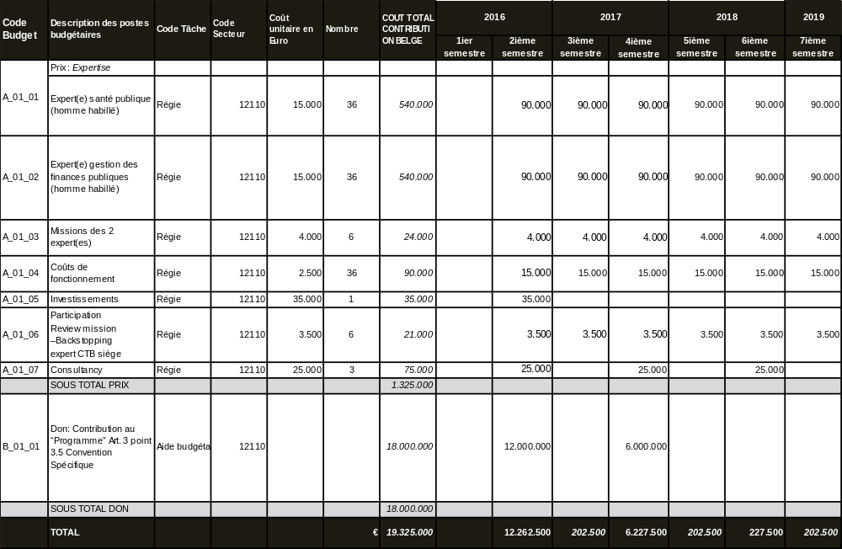
  - ToRs of the Belgian Technical Expertise
The Technical Cooperation Experts will assure technical input in the political/policy dialogue through the SWAp mechanisms. They will collaborate closely with the Belgian Embassy (who is responsible to decide on Belgium’s position in the policy dialogue), the others experts within the Belgian health program and with the other DPs.
    - ToRs of the International Public Health Expert

Tasks

As technical advisor:
- Provide technical and policy advice to the Embassy:
  - Provide the Embassy with an analysis of the health sector performance
  - Make sure that the new policies and/or critical issues raised are brought up to the attention of the Embassy.
- Advise the Embassy and other DPs contributing to the Capacity Development Pooled Fund and actively participate in the CDPF DP meetings and Monitoring Committee meetings
- Promote a shared vision and a coherent approach to the existing technical coordination mechanisms of the Health program of the Belgian support
- Give feedback to the DPs on matters pertaining to health development in Rwanda, paying particular attention to the health-related cross-cutting issues, in particular those which are key for Belgium
As manager:
- Check the conditions for disbursement as defined in the Specific Agreement are met and formulate a clear advice to the Embassy in this respect.
- Support the implementation of the health bilateral program as defined in the ICP 2011-2014, taking into account the evolution of international context.
- Assure the follow-up and analysis of the implementation of the Health Sector Strategic Plan (HSSP III) and the MTR report regarding HSSP III.
- Monitor identified risk factors and constructively collaborate with the partner authorities within the framework of the policy dialogue to implement mitigation actions, with a strong emphasis on the quality of health care at decentralized level.
- Provide quarterly reports (2 progress reports, 1 annual report and a disbursement report) with regard to programme implementation and policy dialogue, as provided in the Vademecum for Budget Support.
As public relation/networker:
- Identify opportunities and create specific entry points for dialogue in view of reinforcing the health system.
- Support coherence and linkage of the JHSS programme with the experience and outputs of partners as well as other relevant programmes and projects from other donors.
- Establish, develop and maintain good working relations with the Government ministries (namely MINISANTE, RBC, MINECOFIN, MINALOC, Local Governments), institutions and all partners involved in the sector.
- Develop, maintain and share an in-depth knowledge and understanding of the programme, including through field visits and networking with local actors.
- Occasionally provide support upon request to health programmes within other partner countries of the Belgian Cooperation.
- Occasionally participate in international seminars, conditioned by the approval of the ResRep of BTC and in consultation with the Embassy.
- Contribute to the achievement of more effective aid to the health sector through improved harmonisation, coordination of DPs and their alignment to the Sector Strategic Plan and policies.
- Contribute to the sector-wide approach implementation at district level and strengthen this approach at central level through the SWAp Committee meetings, Technical Working Groups (TWG) meetings relevant for the JHSS IIIc program follow-up, the bi-annual integrated supportive supervision visits, the Development Partners Group (DPG) meetings and any other relevant working group.
As knowledge manager/broker:
- Follow, together with development partners, evolutions in international policies and discuss consequences and opportunities for the health sector in Rwanda.
- Promote action research and capitalisation of experiences that are relevant to further develop national policy. Where possible, take initiative for research and empirical studies in the sector and/or accompany them.
- In collaboration with other donors, initiate a political economy analysis on the SWAp process.
- Monitor transformation within the health sector based on the six mind-shifts described in the technical note
Work modalities
Work under the leadership of the BTC Resident Representative (ResRep) and in collaboration with the PFM expert, other Technical Experts and the Embassy in order to ensure the overall coherence of the Belgian health program. The BTC ResRep represents the BTC in the field and is therefore the hierarchical superior of the experts.
Profile :
- Medical Doctor with a Master degree in Public health and/or related field
- Professional experience of minimum 10 years,
- At least 4 years of proven experience working with health sector reforms or public sector management, budget support and donor coordination in low-income countries, preferably in Anglophone Africa
- Cooperative and networking attitude
- Experience of working in multi-disciplinary team settings.
- Ability to work independently with minimum supervision
- Demonstrated interpersonal, coordination, organizational, negotiation, reporting and diplomatic skills
- Analytical and critical attitude
- Experience with working in Monitoring and Evaluation methods and Action-research
- Prepared to undertake periodic field trips;
- Knowledge in institutional assessment and capacity building; Excellent command of English and good knowledge of French
    - ToRs of the International Public Finance Management Expert

Tasks

As technical advisor:
- Provide technical and policy advice to the Embassy:
  - Provide the Embassy with an analysis of the budget planning/execution and make sure budgetary concerns are addressed
  - Make sure that the new policies and/or critical issues raised are brought up to the attention of the Embassy.
  - When required provide the embassy with information and advice on PFM matters arising within the PFM Coordination Forum or related fora
- Advise the Embassy and other DPs contributing to the Capacity Development Pooled Fund and actively participate in the CDPF DP meetings and Monitoring Committee meetings
- Promote a shared vision and a coherent approach to the existing technical coordination mechanisms of the Health program of the Belgian support
- Analyse budget planning, budget execution, financial reporting, internal and external control systems in the health sector at central and local level and support the actors in the health sector in these matters.
- Present recommendations on planning, budget allocations and expenditures and PFM issues at sector level to the HSWG and Health financing TWG.
- Support the development, effective financing and implementation of strategies that will increase the likelihood of achieving the Health-related SDGs within the framework of the SWAp, long-term financing scenarios for the sector, and the EDPRS.
- Support the Government of Rwanda in strengthening overall monitoring and evaluation in the health sector, ensuring that GoR systems – in particular the bi-annual Joint Health Sector Review – meet the needs of all stakeholders, including Development Partners.
- Look at the integration and use of Gender-Responsive Budgeting (GRB) for health
As manager:
- Check the conditions for disbursement as defined in the Specific Agreement are met and formulate a clear advice to the Embassy in this respect.
- Support the implementation of the health bilateral program as defined in the ICP 2011-2014, taking into account the evolution of international context.
- Assure the follow-up and analysis of the implementation of the Health Sector Strategic Plan (HSSP III) and the MTR report regarding HSSP III.
- Monitor identified risk factors and constructively collaborate with the partner authorities within the framework of the policy dialogue to implement mitigation actions, with a strong emphasis on the quality of health care at decentralized level.
- Analyse annual audit reports available at the time of contract, share and discuss findings with DPG, MoH and MINECOFIN and follow up on recommendations and issues addressed in the reports.
- Provide quarterly reports (2 progress reports, 1 annual report and a disbursement report) with regard to programme implementation and policy dialogue, as provided in the Vademecum for Budget Support.
- Analyse the annual report of the Office of the Auditor General (OAG), share findings with DPG (in particular with SBS donors) and follow up on the recommendations and corrective measures with MoH.
As public relation/networker:
- Develop, maintain and share an in-depth knowledge and understanding of the programme, including through field visits and networking with local actors.
- Identify opportunities and create specific entry points for dialogue in view of reinforcing the health system.
- Support coherence and linkage of the JHSS programme with the experience and outputs of partners as well as other relevant programmes and projects from other donors.
- Establish, develop and maintain good working relations with the Government ministries (namely MINISANTE, RBC, MINECOFIN, MINALOC, Local Governments), institutions and all partners involved in the sector.
- Contribute to the achievement of more effective aid to the health sector through improved harmonisation, coordination of DPs and their alignment to the Sector Strategic Plan and policies.
- Contribute to the sector-wide approach implementation at district level and strengthen this approach at central level through the SWAp Committee meetings, Technical Working Groups (TWG) meetings relevant for the JHSS IIIc program follow-up, the bi-annual integrated supportive supervision trips, the Development Partners Group (DPG) meetings, meetings at the level of MINECOFIN and any other relevant working group.
- Actively participate in the PFM Coordination Forum and in relevant preparatory meetings, strengthening the link between PFM at sector level and macro level.
- Liaise with other DPs engaged in Sector Budget Support and PFM reforms and participate in the PFM-related joint missions (eg: PEFA, FRA etc.) when appropriate.
- Occasionally provide support upon request to health programmes within other partner countries of the Belgian Cooperation.>
- Occasionally participate in international seminars, conditioned by the approval of the ResRep of BTC and in consultation with the Embassy.
As knowledge manager/broker:
- Follow, together with development partners, evolutions in international policies and discuss consequences and opportunities for the health sector in Rwanda.
- Contribute with evidence and analysis from health sector level including the functioning of the PFM-system within the sector at district level. Coordinate with evidence and experiences of the Belgian program in support of the decentralisation process (fiscal decentralisation).
- Follow up on development of the PFM system at hospital and health service level.
Work modalities
Work under the leadership of the BTC Resident Representative (ResRep) and in collaboration with the Public Health expert, other Technical Assistants and the Embassy in order to ensure the overall coherence of the Belgian health program. The BTC ResRep represents the BTC in the field and is therefore the hierarchical superior of the experts.
Profile
- Master degree in economics, public management, public administration, law, political science or related;
- A minimum of 3 years of experience in public finance management– all or partly in the field in developing countries or transitional countries;
- Extensive professional experience in a multicultural context;
- Ability to work independently with minimum supervision;
- Prepared to undertake periodic field trips;
- Cooperative and networking attitude and experience of working in multi-disciplinary team settings;
- Demonstrated interpersonal, communication, organizational, reporting, diplomatic and negotiation skills;
- Analytical skills and critical thinking;
- Negotiation and diplomatic skills;
- Knowledge in institutional assessment and capacity building;
- Excellent command of English and good knowledge of French

  - Reporting Obligations
The Technical Cooperation experts associated to the BS-BF programme will deliver the following reports:
Quarterly Progress Reports: these reports are intended to provide an overview of the technical/policy work that is being carried out by the expert(s) during the previous quarter. The main aim is to list the key inputs provided by the expert and the key topics of the current policy dialogue.
The report is a collection of key selected documents (inputs) produced by the expert for the Embassy (Consulate), for the other technical and financial partners, for the Ministry, for the sector group or the thematic working group (s).
The quarterly progress reports are submitted by the BTC Representation to the Embassy before the 15th of the following month closing the quarter (15 April; 15 July, 15 October, 15 January)
The reports are structured as follows:
- A main volume including: i) the BTC cover page , ii) the table of contents listing all the key inputs provided by the expert
- A folder attached containing the inputs mentioned in the table of contents
Annual Report: this report is intended to provide a comprehensive picture of the sector and to assess to what extent the programme is achieving (or not) its development objective (s). A specific section of the report is dedicated to the analysis of the disbursement conditions with a technical advice on the disbursement of the Belgian financial instalments..
The report is produced on a yearly basis, preferably following the backward-looking Joint Annual Sector Review (or the Programme Annual Review), after which the disbursement usually takes place. In the absence of an annual review, the report will be done according to the disbursement calendar.
The annual report is submitted by the BTC Representation to the Embassy (Consulate).
Template (to be adapted to the context):
- Executive Summary (1 page)
- Country Context Insights (Brief overview on the major recent political and economic developments- 1 page)
- Programme’s Development Objective (progress in the achievement of the objective, lessons learnt)
2.1 Sector and Programme’s Performance
2.2 Financial Management
2.3 Monitoring & Evaluation
2.4 Policy Dialogue & Donor Coordination
- Key Risks & Mitigating Measures Assessment (This section summarises the work carried out in terms of risk monitoring:
- Check that the risks identified in the TN are being adequately managed,
- Assess the implementation progress of the mitigating measures, and
- Identify any new risks or changes in circumstances)
- Disbursement of the Belgian Financial Contribution
- Overview of Conditions
- Evaluation of the Conditions
- Other donors’ decisions
- Advice
Final Report: the purpose of the final report is to document key lessons learnt, the effectiveness of the components chosen to achieve the development objective, the added value of the Belgian support.
Template:
- Brief overview of the programme
- Assessment of the programme’s development objective achievement:
  - Evolution in policy and planning institutional and technical capacity
  - Evolution in M&E institutional and technical capacity
  - Evolution in sector PFM aspect
  - Evolution in external support to the sector
  - Others….
- Effectiveness of the components chosen to achieve the development objective
- Added value of the Belgian support
- Key lessons learnt (critical analysis of what did not work & why, unexpected results, .)
- Recommendations for future support of the sector

  - summary table of Health sector policies and strategic plans
Health sector Policy (2014) | Health Sector Strategic Plan (HSSP III 2012-2018) Health Sector M&E Strategic Plan (HSSPIII 2014-2018)
Maternal and Child Health Policy  Child Health Policy (April 2009)  National reproductive health policy (July 2003)  Family Planning Policy (2012)  National ASRH&R Policy (2011) | Roadmap to reduce Maternal and new-born mortality  (2013-2018)  Child Health SP (2013-2018)  Family Planning strategic plan (2012-2016)  ASRH&R SP (2012-2018)  National Accelerated Plan for Women Girls Gender Equality and HIV (2010 to 2014)  National Manual for ASRH in Rwanda (2010)  Ministry of Health. Standards des services de santé sexuelle et de la reproduction adaptés aux adolescents et aux jeunes du Rwanda (s.d.)  National Guidelines for HIV Prevention Interventions among Sex Workers (2011)  City of Kigali. Strategic Plan for HIV and AIDS Response in the City of Kigali (2013-2016)
Nutrition Policy (2007) | Nutrition Strategic Plan (2013-2018)
Infectious disease policy (in finalization process)  National HIV/AIDS Policy (2005)  TB/HIV Policy (2005) | HIV/AIDS strategic plan (2013-2018)  TB strategic plan (2014-2018)  Malaria strategic plan (2012-2017)  Strategic plan for the control of neglected tropical diseases 2012-2017  Vaccine and preventable diseases Strategic Plan (2013-2017)
Vector Control Policy (ready for validation) | Integrated Vector Management Strategic Plan (2012-2017)
Non Communicable Diseases Policy (2014) | NCD SP (draft ready for approval)
Mental Health Policy (2014) | Mental health SP (2013-2018)
Health Care services Access Policy (draft ready for validation)  National Blood Transfusion Policy (May 2006)  National Medical Laboratory Policy (July 2005)  National Policy for Quality Management (2012) | National Reference Laboratory Strategic Plan (2010- 2014)  SAMU Strategic Plan (2010-2013)  National Strategy for Quality Management (2008-2012)  Rwanda Healthcare Accreditation Strategic Plan ( 2013-2018)
Pharmaceutical Policy (draft ready for approval) | National Pharmaceutical Strategic Plan (2012- 2017)  National Supply Chain SP (draft ready for approval)
Human Resources for Health (HRH) Policy (2011) | HRH strategic plan (2011-2016)
Community Health Policy (Draft ready for approval) | Community health strategic plan (2013-2018)
Health Financing Policy (2009) is currently updated  National Health Insurance Policy (April 2010) | Health Financing Strategic Plan (draft ready for approval)
Health Promotion Policy (2010)
Health Research and Information Policy (2012) | Medical Research Centre Strategic Plan (2012-2017)

  - Updated structure of TWG, Chairs&co-chairs
No | (Technical) Working Group | Chairs |  | Co-chairs |  | BTC members  (Embassy)
No | (Technical) Working Group | MOH/Division/Unit | Names | Institution | Names | BTC members  (Embassy)
Health Sector Working Group (HSWG)  2 x per year |  | PS MoH | Dr Solange Hakiba | WHO | Dr Olushayo Oluseun OLU | Charlotte Taylor, Jan Borg, , Vincent Tihon, Achour Ait MoHand, Sankaran Narayanan depending on agenda, Benoit Piret depending on agenda, Anne Pierre Mingelbier depending on agenda.  Embassy:Astrid de Laminne de Bex, Bart Lippens depending on agenda
Joint Health Sector Review (JHSR)  2 x per year |  | PS MoH | Dr Solange Hakiba | WHO | Dr Olushayo Oluseun OLU | Charlotte Taylor, Jan Borg, , Vincent Tihon, Achour Ait MoHand, Sankaran Narayanan, Benoit Piret depending on agenda, Anne Pierre Mingelbier depending on agenda.  Embassy:Astrid de Laminne de Bex, Bart Lippens depending on agenda
Preparation of HSWG / JHSR (task force)  4 x per year |  | DG Planning & Health Financing & HMIS MoH | Dr Parfait Uwaliraye |  |  | Charlotte Taylor, Jan Borg, Vincent Tihon depending on agenda
DPG health meeting |  | USG/USAID | Marie Ahmed |  |  | Charlotte Taylor, Jan Borg, , Vincent Tihon depending on agenda  Embassy:Astrid de Laminne de Bex, Bart Lippens depending on agenda
Monitoring Committee CDPF  2x per year |  | PS MoH | Dr Solange Hakiba |  |  | Charlotte Taylor depending on agenda, Jan Borg  Embassy:Astrid de Laminne de Bex, Bart Lippens depending on agenda
 | Maternal & Child Health | MCH Department | Dr Ngabo Fidele - ngabog@gmail.com | UNICEF | Friday Nwaigwe-Fnwaigwe@unicef.org | Jan Borg
 | Planning, Financing, M&E, and HIS | Planning &HIS | Dr Parfait Uwaliraye - parfait81@gmail.com | BTC* | Jan Borg - jan.borg@btcctb.org | Charlotte Taylor, Vincent Tihon
 | Human Resources for Health | HRH | Baligira Hamada /  baligira@gmail.com | USG | Emma Mtiro - wyi5@cdc.gov | Jan Borg, Charlotte Taylor depending on agenda, Vincent Tihon depending on agenda
 | Quality &Standards | Clinical Services | Dr Theophile DUSHIME - theophile.dushime@gmail.com | BTC | Vincent Tihon - Vincent.Tihon@btcctb.org | Jan Borg depending on agenda, Sankaran Narayanan depending on agenda
 | Health Research &Health Knowledge Management | Planning &HIS | Dr Parfait UWALIRAYE parfait81@gmail.com, | SDC | Tommaso Tabet -tommaso.tabet@eda.admin.ch | Jan Borg, Vincent Tihon depending on agenda
 | Community Health | Community Health Department | Cathy MUGENI  cmugeni@gmail.com | UNICEF | Emmanuel Manzi -emanzi@unicef.org
 | Diseases Prevention and control/Infectious Diseases | IH Diseases, Prevention & Control | Dr Ngirabega Jean De Dieu - moonhuro@gmail.com | USG | Eugenie Kayirangwa - hqr0@cdc.gov
 | Diseases Prevention and control/NCD | NCD | Dr MUHIMPUNDU Marie Aimee  mmuhimpundu@gamail.com | WHO | mailto: Andre RUSANGANWA - rusanganwaa@who.int | Achour Ait MoHand depending on agenda
 | Mental Health | Mental Health | Dr Yvonne Kayiteshonga  ykayiteshonga@gmail.com | BTC | Achour Ait MoHand - achour.aitMoHand@btcctb.org
 | Infrastructure and Supply Chain | MPPD | Jean-Baptiste Mazarati - jmazarati@gmail.com | WHO | Stella Tuyisenge - tuyisenges@who.int | Sankaran Narayanan alternate co-chair
 | Health Promotion | RHCC | Nathan MUGUME  nathanmugume@gmail.com | UNICEF | Siddartha Shrestha-  sidshrestha@unicef.org
*Co-chair and Alternate to rotate annually, based on TWG action plan.

  - Bibliographic References
Title | Author / Institution | Date
BEL-RWA DOCUMENTS
PIC 2011 – 2014 | RWA – BEL | 2011
BELGO-BELGIAN DOCUMENTS
Note de Base for new PIC | DGD | 2011
Health Policy Note Belgian Cooperation | DGD | 2009
Concept note ‘Invest in Health for a better well-being’ | Because Health | 2008
Note Sexual and Reproductive Health | DGD | 2007
HIV policy note | DGD | 2006
BTC DOCUMENTS
Technical Note, JHSS III B | BTC | 2013
Technical Note, CDPF | BTC | 2013
Techn. & Fin. File /Form Report Ubuzima Burambye | BTC | 2013
Overall assessment | BTC HQ - Finance Dept. | 2011
JHSS III quarterly and annual progress reports | BTC – Belgian Embassy | 2014-2015
BTC CDPF annual report | BTC – Belgian Embassy | 2015
RWANDAN STRATEGIC DOCUMENTS
Vision 2020 | MINECOFIN | 2000
EDPRS, 2008 – 2012 | Republic of Rwanda | 2007
EDPRS II, 2013 – 2018 | Republic of Rwanda | 2013
National Gender Policy | MIGEPROF | 2010
KEY SECTOR DOCUMENTS
HSSP III (2012-2018) | MoH | 2012
Health sector policy | MoH | 2015
Health sector M&E strategic plan (final draft) | MoH | 2012
Health Financing Strategic Plan | MoH | 2015
Human Resources for Health Sustainability Agenda (draft) | MoH | 2015
Updated Human Resources for Health Strategy 2012-2018 | MoH | 2015
Health Financing & Sustainability Policy | MoH | 2015
Health Sector Budget 2015/16 (finance law) | MINECOFIN | 2015
PFM Sector Strategic Plan 2013-2018 | MINECOFIN | 2013
AID COORDINATION DOCUMENTS
MoU between MoH and HDP | MoH | 2007
Roadmap to Health SWAp | MoH | 2010
Joint Health Sector Review Reports | MoH
Rwanda Health Sector Wide Approach (SWAp) Procedures Manual | MoH | 2010
Sectoral Decentralisation in Rwanda | Rwanda Governance Board | 2013
DEVELOPMENT PARTNERS PROGRAMME DOCUMENTS
World Bank Programme-for-Results (PFM) | World Bank | 2014
EU Nutrition Sector Reform Contract (SBS: Agriculture, Education & Health) | EU | 2014
Management Sciences for Health: outline of health systems strengthening programme | MSH (USAID) | 2015
WHO country cooperation strategy 2014/18 | WHO | 2014
Social Protection Support to the Poorest in Rwanda | DFID | 2013
Rwanda Learning for All education programme | DFID | 2015
EXTERNAL ASSESSMENTS
MTR HSSP III report (second draft) |  | 2015
Demographic & Health Survey: press release and key findings | National Insitute of Statistics of Rwanda | 2015
Sector M&E systems – the case of Rwanda’s health sector | IOB (Instituut voor Ontwikkelingsbeleid) | 2010
PPP study (draft) | MSH | 2015
HIV-AIDS and Health financing sustainability study (draft) | UNAIDS-RBC-Oxford Policy Management | 2015
Community Based Health Insurance Deficit & Strategies for Sustainability study (draft) | USAID-MoH/RSSB with Micro Insurance Academy | 2015
Sector M&E systems – the case of Rwanda’s health sector | IOB | 2010
Sector Working Group Assessment | DfID - MINECOFIN | 2015
Imihigo Evaluation FY 2014/15 | IPAR-Rwanda | 2015
Fiduciary Risk Assessment – Public Sector Governance Program-for-Results | World Bank | 2014
Organizational assessment MoH, RBC, SPIU & City of Kigali | Stoop Consultants for BTC | 2014
Overall PFM Assessment | SIDA / Indevelop. | 2012
Fiduciary Risk Assessment | DFID | 2012
PEFA (2007 & 2010, 2015 draft report) | MINECOFIN | 2007-2015
IFMIS Quality Assurance Group report (draft) | QAG | 2015
PFM stocktaking assessment at Local Government level | GIZ-MINALOC | 2015
Annual Audit Reports | OAG
Health financing mechanisms to districts | Sven Baeten | 2011
IMF 3rd review report under PSI | IMF | 2015
IMF Working paper, Introducing a Semi-Structural Macroeconomic Model for Rwanda | IMF | 2014
IMF Working paper, Surging Investment and Declining Aid: Evaluating Debt Sustainability in Rwanda | IMF | 2014
Annual Macroeconomic Assessment | EU | 2015
Rwanda – Country Report | Economist Intelligence Unit | 2015
Rwanda Economic Update, Managing Uncertainty for Growth and Poverty Reduction | World Bank | 2015
Rwanda Economic Update, Financing Development | World Bank | 2015

  - List of people met
Name | Position | Institution
GOVERNMENT OF RWANDA
Hon. Agnès Binagwaho | Minister of Health | MINISANTE
Hon. Patrick Ndimubanzi | Minister of State in charge of Public Health and Primary Health Care | MINISANTE
Dr Solange Hakiba | Permanent Secretary | MINISANTE
Dr Parfait Uwaliraye | Director General of Planning, Health Financing & Information Systems | MINISANTE
Dr Theophile Dushime | Director General of Clinical Services | MINISANTE
Fidele Karangwa | Head of Budget | MINISANTE
James Kamanzi | Ag. Director General | Rwanda Biomedical Center (RBC)
Dr Daniel Ngamije | Coordinator | SPIU / RBC
Dr Jean-Pierre Nyemazi | Division Head, Planning, M&E and Business Strategy Division | RBC
Donatien Ntagara Ngabo | Director of M&E, PMEBS Division | RBC
Albert Tuyishime | Director of Planning, PMEBS Division | RBC
Sabine Umuhire | Director of HMIS, PMEBS Division | RBC
Leonard Rugwabiza | Chief Economist | MINECOFIN
Godfrey Kabera | Director General of Planning | MINECOFIN
Caleb Rwamuganza | Director General of Budget | MINECOFIN
Amin Miramago | PFM Reform Manager | MINECOFIN

BELGIAN COOPERATION
Erwin De Wandel | Minister Counsellor | Embassy of Belgium
Astrid de Laminne de Bex | Belgian Embassy (focal point Health) | Embassy of Belgium
Benoit Piret | Resident Representative | BTC
Anne-Pierre Mingelbier | Programme Officer | BTC
Jan Borg | Public Health Expert, JHSS-CDPF | BTC
Charlotte Taylor | PFM Expert, JHSS-CDPF | BTC
Vincent Tihon | Programme Co-manager, Ubuzima Burambye | BTC
Achour Ait-MoHand | TA Mental Health | BTC
Sankaran Narayanan | TA Maintenance & Infrastructure | BTC
DEVELOPMENT PARTNERS
Leif Jensen | PFM Expert | World Bank
Dr Olushayo Olu | Representative | WHO
Diane Muhongerwa | Health Financing Expert | WHO
Stella Tuyisenge | HRH and Commodities | WHO
Arnaud De Vanssay | Head of Section, Rural Development | EU delegation
Mugeni Kayitenkore | Programme Officer | EU delegation
Siôn Morton | Programme Officer Public Finance, Economics, Trade | EU delegation
Samantha Yates | Social Sector Team Leader | DFID
Marie Ahmed | Deputy Health Office Director | USAID
Michael Karangwa | Health Systems Specialist | USAID
Jozef Maerien | Representative | UNFPA
Justus Kamwesigye | Strategic Information Officer | UNAIDS
Tommaso Tabet | Head of Health program | SDC
Theoneste Twahirwa | National Programme Officer | SDC
Pierre Dongier | Governance Team Leader | MSH
Randy Wilson | M&E and Knowledge Management Team Leader | MSH
Anne Martin-Staple | Health Finance Team Leader | MSH
Enrique Cabrera | PPP Specialist | MSH

Other Development Partners providing Sector Budget Support in health-related areas are the Global Fund (new funding models earmarked towards HIV, TB and Malaria) and the EU (through a multi-sector programme targeting malnutrition) however Belgium remains the only bilateral donor providing Health SBS from a sector-wide perspective.
Specific details are provided under Chapter 7.1. of this Technical Note.
An external assessment of the SWG in 2015 recommended that Co-chair should not remain for more than 2 years in office
Key factors that contribute to explaining the low performance in revenue collection are: (i) the EAC integration with increasing trade imports coming in for free, (ii) electronic billing machines for VAT which are facing lower implementation than expected, and (iii) weak ‘pay-as-you-earn’ tax earnings given the limited developments in the employment sector. Moreover, a number of large projects (which were expected to lead to resource generating activities) did not come on board in 2014 as anticipated.
IMF Press release No. 16/09, IMF Executive Board completes fourth PSI review for Rwanda, 15th January 2016.
The IRAI assesses the quality of a country’s policy and institutional framework using 16 development indicators in four cluster areas: economic management, structural policies, policies for social inclusion and equity, and public sector management and institutions. The index ranges from 1.0 (low) to 6.0 (high).
Estimates developed by the UN Inter-agency Group for Child Mortality Estimation (UNICEF, WHO, World Bank, UN DESA Population Division) at www.childmortality.org., and based on from the Demographic Health Survey
idem
A director, a health promotion and disease prevention officer, a hygiene and sanitation officer and a community-based health insurance officer.
Not only public health providers but in the City of Kigali also the private health providers
The ambition is to have it every 3 years as per an announcement made by GoR last year
The 2015 PEFA assessment brings some level of innovation on two fronts: (i) a total of eight districts are being assessed (of which the same 4 districts assessed in the PEFA 2010 districts and 4 new districts); and (ii) a new methodology for assessing central government is being piloted, alongside the old methodology to guarantee comparability with the 2010 PEFA. The new methodology proposes new indicators while some indicators from the previous methodology are dropped. One of the main innovations is the addition of a pillar on asset and liability management. New indicators also cover items such as the credibility of the country’s fiscal strategy, public investment programming and the revenue side of the budget.
The SSP is a comprehensive plan composed of seven programmes: Economic planning and budgeting; Resource mobilisation; Budget execution, internal control, accounting and reporting; External oversight and Accountability; Electronic service delivery and IFMIS; Fiscal Decentralisation; and PFM Sector coordination and management.
The Ministry of Local Government (MINALOC) recently finalised a comprehensive stocktaking assessment of PFM systems and procedures at sub-national level (including in health facilities) with the support of GIZ. The study has informed the conceptualisation of 5-year Capacity Building Projects for Districts.
QAG missions are planned on a needs basis following a mutual agreement among GoR and DPs supporting the PFM reform. This QAG mission is the fourth of its kind. The first three QAG reviews were conducted in 2009, 2010 and 2011.
The system is commonly known as SEAS = Subsidiary Entities Accounting & Reporting System.
Further analysis on this particular topic will be provided in the JHSS III b Annual Report (February 2016).
On a related note, GoR has announced that the mid-year budget revision will see an increase of 15.6 bln RwF for the health sector budget following the decision of the Global Fund to carry over to 2015/16 the funds that remained unspent under its HIV RBF grant in 2014/15.
The next backward-looking JHSR is due to take place in the course of November 2015 and will discuss audit findings on FY 2013/14 as well as the related management response.
DFID is no longer active in the health sector but supports a Gender project managed by the SPIU of RBC. The EU provides (multi-)sector budget support in the area of nutrition with the Ministry of Agriculture as first entry point and complementary technical support provided to the health sector.
For more detail on the PFM dialogue, see chapter 5 of this Technical Note.
Other Development Partners providing Sector Budget Support in health-related areas are the Global Fund (new funding model earmarked towards HIV) and the EU (through a multi-sector programme targeting malnutrition).
In principle bi-annual backstopping missions are planned for the whole health program in each of the partner countries. However, the exact frequency will depend on the need and the context in Rwanda.
Comme dans chaque appui budgétaire par la Coopération belge, cette évaluation est réalisée par les experts de l’appui budgétaire et intégrée dans leur système de rapportage
Official denomination.
Technical Note p 43.

