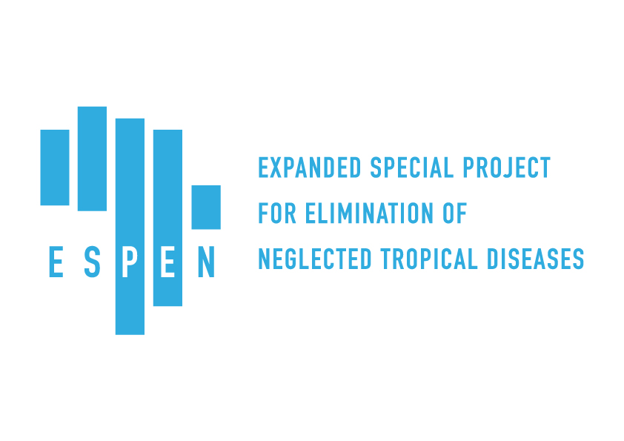
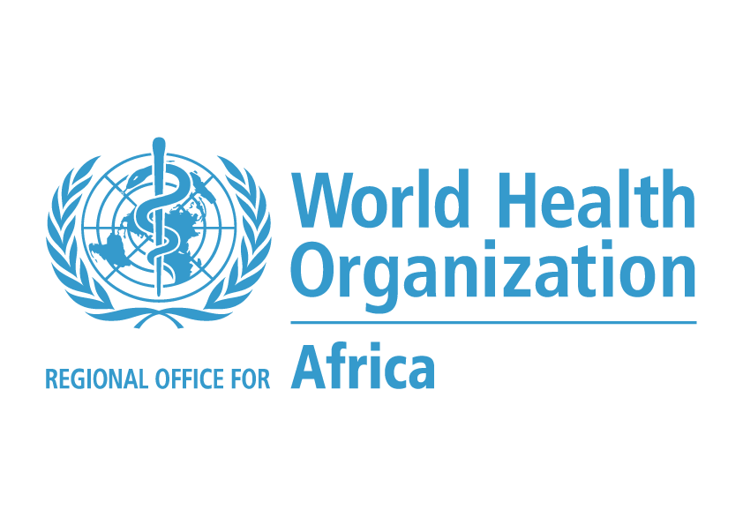

Project Proposal Narrative
General Information
Proposal Title | Strengthening the ESPEN partnership to accelerate control/elimination of 5 NTDs amenable to preventive chemotherapy (PC)
Requested Amount (U.S.$) | $5,000,000 | Investment Duration (Months) | 24
Total Project Cost (U.S.$) | $5,000,000
Contact Information
Organization Legal Name | World Health Organization Regional Office for Africa
Organization Doing Business as | World Health Organization Regional Office for Africa
Primary Contact Name | Dr. Maria Rebollo | Mailing Address
Primary Contact Title | ESPEN Team Leader | Street Address 1 | WHO/AFRO, Cite Djoue
Primary Contact Email | rebollopolom@who.int | Street Address 2 | PO Box 06
Primary Contact Phone | +4724139905 | Street Address 3 | Brazzaville
Feedback Contact | +4724139905 | City | Brazzaville
Feedback Email | rebollopolom@who.int | State / Province
Authorized Signer Name | Dr. Matshidiso Moeti | Zip / Postal Code
Authorized Signer Title | Regional Director, WHO AFRO | Country | Congo
Authorized Signer Email | moetim@who.int
Website (if applicable) | www.who.int

Proposal Details
- Executive Summary
Provide a brief summary of the investment.
This grant will be used to support the ESPEN in its next two years of operation to execute against its primary goal and accelerate the reduction of burden of the 5 PC-NTDs.
The Expanded Special Project for Elimination of Neglected Tropical Diseases (ESPEN) was established in the spirit of partnership between WHO Regional Office for Africa (AFRO), Member States and NTD partners in an effort to mobilize political, technical and financial resources to reduce the burden of the five most prevalent Neglected Tropical Diseases (NTDs) in Africa amenable to preventive chemotherapy (PC) through Mass Drug Administration (MDA): lymphatic filariasis (LF), onchocerciasis (oncho), soil-transmitted helminths (STH), schistosomiasis (SCH) and trachoma (TRA). Bound by the principles of transparency and accountability, ESPEN is positioned to serve as a coordinating entity among partners and stakeholders and add value to partner investments through technical and operational support to endemic countries for the control and elimination of these disfiguring and debilitating diseases. ESPEN’s remit covers 47 countries in Africa and five countries in the WHO Regional Eastern Mediterranean Office (EMRO): Sudan, Egypt, Somalia, Djibouti and Yemen.
ESPEN’s primary goal is to significantly reduce the prevalence of five NTDs between 2016 and 2020, in concert with the WHO’s Roadmap for NTDs. To guide this investment, we propose the following outcomes:
Primary investment outcome: Accelerate the reduction of the burden of disease for the five PC-NTDs by 2020 through the control and elimination of targeted NTDs.
Intermediate investment outcomes (IOs): Based on ESPEN’s guiding priorities
- Scale up treatments to reach 100% geographical coverage
- Scale down; stop treatments once elimination target has been achieved
- Strengthen access and quality of information to enable evidence-based action
- Improve the efficient and effective use of donated medicines

To achieve these outcomes, ESPEN will work directly with countries and partners, providing both technical and operational support to enable NTD country programs to achieve their control and elimination goals.

The main beneficiaries of this investment will be populations afflicted by NTDs in the Member States of the Africa region, and selected EMRO countries (Djibouti, Egypt, Somalia, Sudan and Yemen). For every dollar invested, two treatments are delivered with ESPEN support. With this investment, we will deliver 10 Million treatments in the 2 year timeframe. With unlocking of an additional 5M USD support from BMGF matching fund that would be 20 Million treatments

.

- Problem Statement
Describe the problem, why it is a problem, and who is impacted by the problem. What specific elements of the problem is this investment trying to address?
NTDs are a diverse group of communicable diseases with devastating consequences for health and economic development in affected regions. One out of six people worldwide are affected. Despite being entirely preventable with low-cost treatments, NTDs continue to kill an estimated 170,000 people per year and are a leading cause of blindness and other disabilities. The WHO Africa Region bears about half of the global burden of NTDs which contribute to the vicious cycle of poverty-disease-poverty. NTDs have a particularly negative affect on post-conflict areas and other areas that are challenging to access, such as in Darfur, Sudan or Central Africa Republic. Women, adolescent girls, and children in the poorest and most marginalized communities have not been specifically targeted. There are multiple challenges to reducing the NTD burden across these areas and societies.

Inspired by the World Health Organization’s 2020 Roadmap on NTDs, in January 2012 a coalition of philanthropic organizations, donor countries, governments of NTD endemic countries and pharmaceutical companies signed the London Declaration, committing to control, eliminate or eradicate 10 NTDs. Through the CEO Roundtable, major pharmaceutical companies have committed to donate all the drugs needed to eradicate NTDs. These companies have thus far pledged more than US $ 17.8 billion in drug donations. For every $1 million invested in ESPEN, the Government of Belgium would leverage $26 million in donated drugs to expand access and improve the lives and economic opportunities of more than 2 million people in Africa.
As the world has come together against a common set of goals, and has begun mobilizing essential financial resources, and donating needed drugs, the World Health Organization (WHO) stepped up with a unique solution to mobilizing essential political will in Africa. In an unprecedented organizational move, WHO created a special project: The Expanded Special Project for Elimination of Neglected Tropical Diseases (ESPEN) in order to mobilize political, technical and financial resources to meet the London Declaration goals.

Implementation: ESPEN puts the power to move to elimination in the hands of African countries and their national programs. However countries have limited human resources and capacity to implement all aspects of a comprehensive NTD program, particularly in the scale up and scale down of MDA programs. As guidelines are updated, new tools and strategies rolled out, and information sharing is improved, countries will need AFRO and its partners to support the strengthening of capacity and technical expertise in country. Although high quality donated drugs for MDA are available, there is a critical need for additional strengthening of the last mile of the supply chain to ensure drugs are utilized and tracked appropriately. Continuous innovation, development and adaptation will be required to ensure that no one is left behind and to accelerate sustainable country progress. These problems will be addressed in IOs 1, 2, and 4.
Coordination: Historically, the Africa region has lacked a coordinated platform to convene partners, including national governments, pharmaceutical companies, philanthropic organizations, and multilateral and bilateral donors to sustain progress against NTD control and elimination targets at the country level. This requires having a clear view into the country, partner and donor activities, as well as hosting and sharing all available sub-national NTD prevalence mapping data to guide MDA implementation planning activities across the region. Prior to ESPEN, such data were stored in various databases, spreadsheets, and laptops with no open access to stakeholders. This problem will be addressed in IO 3.
Working directly with Ministries of Health (MoHs) and key stakeholders, ESPEN plays a unique role as a WHO entity with direct links to each country in the region. In 2017, ESPEN demonstrated its ability to operationally and financially support 34 countries, launch a data sharing platform, recover 132M donated tablets, and convene key trainings and coordination meetings to build capacity and enable information sharing.

- Scope and Approach

The proposed partnership between ESPEN and Belgium will focus on four IOs which are aligned with the ESPEN goal towards reaching the WHO 2020 Roadmap targets. As ESPEN is under the WHO umbrella, it is uniquely positioned to work directly with countries. The model of financial support does not require an NGO partner, but rather utilizes WHO country offices (WCOs), located in each country to bridge the flow of funds, drug donations, and other critical health program linkages in country.
Intermediate Outcome 1: Scale up treatments to reach 100% geographical coverage

The aim of this IO is to ensure full scale-up of MDA to all endemic communities in need, encouraging integration where it makes sense. Within the cycle of MDA, ESPEN will focus its approach in three areas of support.

- Scaling up of MDA, including planning, implementation, M&E, and supervision
- Developing country work plans and budgets

Scale up:
ESPEN is working to reach 100% geographical scale-up of MDA and strengthen country ownership and capacity to implement the program. ESPEN will work directly with countries to target MDA implementation to reach at least 80% geographical coverage of the population in implementation units receiving treatment for trachoma, LF and oncho and at least 75% of the school age children and other risk groups population for STH and schistosomiasis. ESPEN staff/consultants will support MoHs to strengthen program data collection, analysis and use for action.

While ESPEN evaluates country needs on an annual basis, please see an example table which illustrates a country break down of eligible populations for treatments according to endemic disease. Countries receiving support from this proposed investment are still to be determined.
Country | Population (Districts) |  |  |  |  | Total population at risk (source: ESPEN Portal)
 | Oncho | LF | SCH | STH | Trachoma
Comoros | - | 935,759 (17) | - | 334,066 (17) | - | 527,919 in 17 Districts
DRC | 37 M (266) | 245 M (35) | 9 M (145) | 15 M (272) | 5,028,280 (39) | 49,900,757 in 505 Districts
Eritrea | - | 71,587 (2) | 269,069 (27) | - | 970,489 (16) | 1,497,725 in 41 sub-Zobas
Madagascar | - | 18,863,123 (62) | 7,803,826 (62) | 5,080,447 (62) | - | 18,863,123 in 114 Districts
Sao Tome Principe | - | 188,134 (7) | 38,140 (7) | 77,429 (7) | - | 206,000 in 7 Districts
South Sudan |  | 3,732,245 (22: Integrated SCH/STH/LF) |  |  | 2,037,403 (34) | 9,991,337 in 79 Districts
Sudan |  | 13,393,890 | 8,948,450 | 17,181,009 | 4,067,620 (17) | 25,572,200 (WHO-GHO PC Portal 2016 data.)

Country Plans:
An integral part of NTD programs is detailed planning. ESPEN will support countries to update their five-yearMaster Plans as well as assist with the development of annual work plans and budgets. Additionally, a core function of ESPEN will be to: review and approve country PC plans and applications for donated medicines, and provide guidance on their adequacy vis‐a‐vis the national program implementation capacity and expected targets and goals, the safe and rational use of NTD medicines, and the monitoring of severe adverse events reported by countries.

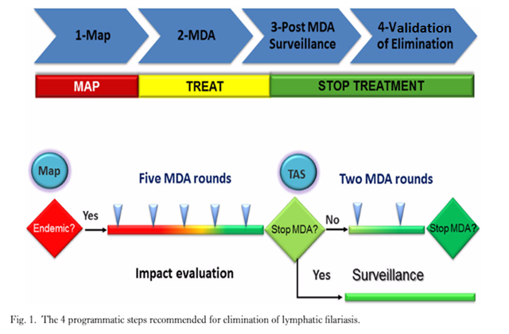

Intermediate Outcome 2: Scale-down and stop treatments once elimination target has been achieved
Once transmission of a NTD has been interrupted or control has been achieved, it is important to successfully stop treatment. Due to the integrated nature of MDA, the planning and timing of reductions in MDA are demanding, and collateral impacts on other disease programs must be considered. This is the case for STH, which responds to the drugs for LF. Thus, as LF MDA programmes are scaled-down or stopped, STH infections could become more prevalent again. Therefore, it will be critical to invest in guided technical assistance to countries during post-MDA and post-validation surveillance periods.
ESPEN is dedicated to ensuring that countries have the training, expertise, tools, and resources they need to verify elimination. ESPEN will focus its approach in two areas of support:
- Monitoring and Evaluation
- Dossier preparation
M&E:
For countries to stop MDA and avoid resurgence following years of annual MDA, monitoring and evaluation of the program is critical to inform the decision to correctly halt the administration of PC during post-MDA and post-validation surveillance periods. ESPEN will support countries in planning, survey implementation, and compilation and analysis of data. Assessments would include transmission assessment surveys (TAS) for LF and STH, epidemiological and entomological assessments for Oncho, impact evaluations for SCH, and trachoma impact surveys (TIS). ESPEN will host regional workshops on integrated monitoring and epidemiological assessments of LF, oncho and STH following completion of MDA for LF. These trainings include representation from the MoH NTD program officers together with their WHO National Professional Officers (WHO-NPOs) from WCOs. Following these workshops, integrated TAS (iTAS) action plans and budgets will be developed by each country.

Dossier preparation:
To be officially recognized as eliminating disease, a detailed dossier must be prepared by the country for submission to WHO. ESPEN will play a role in supporting countries in the data collection and collation for a complete dossier and establish links to the appropriate WHO NTD Strategic and Advisory Group and the WHO Regional Director for Africa.
Intermediate Outcome 3: Strengthen access and quality of information to enable evidence-based action
Demonstrating progress towards the NTD targets for 2020 and the 2030 SDGs will depend in part on ensuring better use of available data and on developing new information tools and systems to improve outcomes and demonstrate impact. As the regional data aggregator, ESPEN is invested heavily in improving the management of NTD data at subnational, national and regional levels. ESPEN will focus its approach in two areas for this IO:
- Enhanced ESPEN portal use to enable information sharing
- Strengthened use and coordination of data tools
Access to quality data will improve planning and resource allocation at regional and country levels, coordination among partners, timely planning of impact assessments to avoid unnecessary MDA, identify opportunities of integrated treatment, allow site level decision making including identification of hotspots for LF and sub-district level treatment for SCH, and improve cross border collaboration. This IO will aim to strengthen data storage, sharing and management at the country level, as well as robust tracking of progress in the control and elimination of NTDs in Africa. The generation of reports will help improve the timeliness and completeness of reporting from the national level to regional and global levels. In supporting such data systems, ESPEN will provide technical support to national NTD programs in implementing the database and utilization of the ESPEN portal to increase its use and uptake by national programs.
ESPEN Portal:
The portal was launched in 2017 as a platform to enable MOHs and stakeholders to share subnational program data in support of their own NTD control and elimination goals. With a centralized open access database, the ESPEN Portal empowers countries and their partners to make informed decisions to accelerate the elimination of the five PC-NTDs. Analytics are now made available in the form of thousands of maps, accurately illustrating district-level data that can be aggregated by disease and country. These maps, along with option to download underlying data sets, are tools to aid health officials in boosting and developing NTD interventions and strategies to reach targeted communities. ESPEN also continues work to ensure the completeness and quality of mapping data, as well as provide descriptive information for historical mapping data. Previously, multiple NTD databases existed, collected from MoHs or maintained by different partners in various formats. Technical partners and the ESPEN data manager are now successfully working to integrate all available data sources into the portal, including trachoma data. Support will continue to countries to use the Country Integrated NTD Database (CIND) to complete the Joint Application Package (JAP) in order to improve reporting of quality data from peripheral to national levels and onward to regional level.
ESPEN also aims to focus on supporting technical capacity building within country programs to consolidate all data on NTDs into a single repository that standardizes data pathways, promotes countries’ ownership of their program data and enables policymakers to make rational, effective and timely decisions based on available data. Countries are encouraged to use the integrated database, particularly in instances where no consolidated database exists at the national level.
The ESPEN portal provides a unique opportunity of transparency and visibility of the impact achieved through this investment.
Data resulting from this project will be shared openly in the ESPEN portal.
Intermediate Outcome 4: Improve the efficient and effective use of donated medicines
Donated medicines require delicate and complex management throughout the supply chain management (SCM) cascade: timely submission of the JAP to WHO; shipment and receipt of donated medications by countries; clearance of medication through customs; and the storage and distribution of medicines to the target population. As part of its role in the coordination of the supply of donated medicines, ESPEN and WHO Headquarters (WHO-HQ) have the responsibility to support and strengthen the capacity of NTD National Programs in management of PC medicine supply chains. This will be the primary focus of this IO. A major identified challenge is the gap between the quantity of PC medicines supplied, and the reported treatments distributed resulting in significant amounts of unaccounted for medicines. Drawing upon the trachoma program’s exemplary experience with SCM, ESPEN will work on improving SCM for all donated PC medications at country level, thereby optimizing medicine utilization and reduced waste. At the regional level, ESPEN will work in strengthening medicine forecasting to support timely production and delivery to countries.
ESPEN aims to ensure that tools are available to support programs towards the achievement of the targets in the WHO Roadmap. Three tools have been developed to help coordinate the application of medicines needed in countries for MDA, as well as the supply chain management of donated medicines: The Joint Application Package (JAP) to facilitate the process of application, review and reporting as well as to improve coordination and integration among different programs; the Country Integrated NTD Database (CIND) to help standardize the data management process; and the Data Quality Assessment (DQA) tool to track indicators from across multiple reporting forms. ESPEN will encourage the use of these tools and host capacity-building training workshops to support accurate tracking and reporting of NTD donated medicines.
ESPEN, in partnership with WHO-HQ, will conduct select country medicine inventory missions with the intention of supporting medicine SCM for PC-NTDs, identifying gaps, and making full use of donated medicines. During such missions, ESPEN conducts rapid analysis of the NTD SCM, and reconciles existing unaccounted PC medicines with Ministry of Health as well as addresses the challenges in NTD medicine supply chain management. ESPEN intends to work closely with pharma partners in the NTD SCM Forum for information sharing and to develop joint solutions to ongoing challenges .

- Activities

 | Activities | Key Indicators
IO 1: Scale up treatments to reach 100% geographical coverage
Scaling Up MDA | - Geographic coverage gap analysis conducted annually  - Provide direct funding to countries to carry out MDA  - Providing direct technical assistance or link to a partner, to carry out MDA | - Number of people targeted  - Number of people treated  - Number of countries achieving 100% geographical coverage  - % increase of geographical coverage per disease  - Number of countries receiving financial support from ESPEN to scale up MDA
Country Planning | - Provide technical support missions (ESPEN staff or consultants) to countries and capacity- building workshops with MOH to develop collaborative work plans (annual or master) and budgets, ensuring plans have technical, logistical and financial support available and are aligned with the national priorities and regional strategic plans.  - Identify research issues arising from implementation of national programs and liaise with COR NTD to provide appropriate mentoring and technical guidance  - ESPEN to review work plans and budgets and assess country requests, identify from within or outside WHO the required support and mobilize it. | - Number of country plans completed and uploaded to portal  - Number of country missions completed
IO 2: Scale down and stop treatments once elimination target has been achieved
M&E | - Provide technical support the countries to conduct assessments through training, supervision, links to partners  - Provide financial support to countries to carry out assessments  - Assist in collection, compilation and analysis of data, and reporting on NTD interventions  - Participate in periodic review meetings of the NTD program | - Number of districts no longer requiring MDA  - Number of districts conducting impact assessments  - Number of countries receiving financial support form ESPEN for assessments  - Number of trainings held  - Number of materials/tools/resources for assessments on portal  - Number of dossiers submitted
Dossiers and validation of elimination | - Provide technical support the countries in the preparation and submission of the dossier  - Support the monitoring and evaluation of NTD program interventions by:
IO 3: Strengthen access and quality of information to enable evidence-based action
Portal | - Develop and provide relevant data and input for maps, dashboards, and other products for the portal  - Provide technical assistance and information to countries about the portal, particularly around JAP updates  - Communicate with countries to obtain relevant data and permissions to share data | - Number of countries sharing data through the portal  - Number of maps and resources available on the portal  - Number of trained consultants in data specific content  - Number of country missions related to data
Data Use & Tool | - Conduct data analysis and cleaning to support countries and enhance data quality  - Ensure coordination and harmonization of existing data management tools already approved by WHO and where they have been already introduced at a country level (e.g. NTD Portal, CIND, DHIS2, Tropical Data, NTDeliver, NTD Mapping, GAHI, LINKS, WHO-HQ PC databank  - Participate in and help plan data training for consultants and PMs and support country missions as needed  - Provide technical assistance and roll out tools that enable data collection, analysis, and quality
IO 4: Improve the efficient and effective use of donated medicines
Strengthened supply chain management: | - Provide direct link of in country tracking systems with ESPEN portal  - Provide direct technical support to countries in areas of drug tracking, storage, safe distribution, reverse logistics  - Conduct supply chain missions to track medicines and provide guidance  - Ensure coordination between WCO Essential Medicines focal points and NTD programs  - Maintain link with pharma to co-develop solutions and SOPs (Supply Chain Forum)  - Provide guidance on data input into CIND – timely, quality, use this to export to JAP. Ensure official signing of JAP (submits to WCO, then ESPEN)  - Review accuracy of data submitted in the JAP and ensure the timely application process for WHO-donated medicines for PC-NTDs and results reporting to WHO using the JAP | - Number of countries completing JAP  - Number of countries completing on time  - Number of countries accounting for drugs within 20% of donation  - Number of countries using new online JAP  - Number of SOPs available on portal  - Number of SCM country missions

- Organizational Capacity

During its first two years of implementation, ESPEN built on the success and lessons learnt from the African Program for Onchocerciasis Control (APOC).
To ensure that ESPEN can adapt rapidly to evolving needs, it is proposed to rely on a light and flexible institutional framework which will be placed under the overall direct responsibility of Director, Communicable Diseases Cluster of WHO/AFRO. This should enable it to play its technical supportive role of ensuring the capacity of endemic countries to effectively implement the spectrum of NTD activities, while at the same time ensuring that the views of stakeholders are taken into consideration.
ESPEN operates under the coordination and the leadership of the CDS Director who reports directly to the Director of Programme Management and to the Regional Director. There are clear lines of communication between RD, DPM and CDS for rapid decision-making pertaining to ESPEN. As part of the CDS Cluster, ESPEN collaborates closely with other programs such as the Public Health and Environment programme, which addresses Water Sanitation and Hygiene (WASH) interventions.
At the country level, there are focal points at the WCO who will ensure that ESPEN is linked to the Country NTD Program and coordination mechanisms. WCOs will support the national programs in resource mobilization to fill the budget gaps and also strengthen national coordination mechanisms to ensure resources are utilized in an efficient, effective and well-coordinated manner. In addition, country offices will support the national program to apply for funding from ESPEN.

ESPEN is increasingly staffed with a lean, effective and responsive workforce comprising of subject matter experts in the relevant technical fields, data management, finance, and minimal administrative support staff. Appropriate and transparent recruitment processes will be conducted to ensure the best available experts are recruited for ESPEN.

- Sustainability

ESPEN is strengthening country ownership and leadership of national control and elimination programs, contributing to the broader WHO target of long-term sustainability and strengthening of health systems. Resource mobilization, with a focus on domestic resources, is critical for sustaining programs to control and eliminate NTDs. In this regard, key tenets of ESPEN’s vision of long-term sustainability include:
- Strengthening government ownership and building capacity for increased advocacy, coordination and partnership will be achieved by:
  - Enhancing high-level analysis and reviews of NTD program performance and the use of lessons learnt to foster government ownership and strengthening of advocacy, awareness and effective implementation of targeted interventions.
  - Undertaking joint missions between WHO, consultants and partner institutions to improve coordination and overall efficiency.
  - Strengthening high-level advocacy of NTD prevention, control, elimination and eradication interventions at national levels to increase political support among key stakeholders.
  - Building technical capacity and coordination mechanisms at a national level for the NTD program management and implementation through research, training, laboratory diagnosis, reviewing NTD master plans, impact assessments, planning, and budgetary support.
  - Supporting and fostering partnerships for the prevention, control, elimination and eradication of targeted NTDs at national levels.
  - Documenting the financial contributions of Ministries of Health to increase ownership, domestic resource mobilization and the sustainability of NTD programs.
  - Enhancing resource mobilization approaches and strategies at international, national and sub-national levels for NTD interventions.
  - Strengthening the integration/linkages of NTD program and financial plans into sector-wide budget and financial mechanisms.
  - Strengthening information systems to support active policymaking, program implementation, and resource mobilization.
  - Equipping health officials with the evidence, district-level data, and tools needed to successfully tackle each disease, and share best practices to efficiently mobilize resources and target interventions appropriately.

Budget Narrative
- Summary

There will be five major cost drivers for this investment as follows:
- Scaling up: Direct cost to MDA implementation will represent the major cost driver. Continued technical support to countries which will include support by expert consultants travel and consultative meetings at regional and country level scaling up MDA
- Scaling down: This will also involve direct support to conduct field surveys and continued technical support to countries which will includes consultants, travels and consultative meetings
- Data systems strengthening: the cost drivers will include country missions by ESPEN staff and consultants to train and review the country’s data system and piloting.
- Strengthening supply chain management which involves onsite support to NTD programmes and country missions by ESPEN staff and consultants
- Personnel costs for key ESPEN staff reflected in the budget

- Personnel and Benefits

This investment will be used to contribute to 20% the ESPEN HR budget plan as follows:
Grade | Position number | Salary | Post adjustment | WHO benefits (indirect) | Occupancy costs | Total per year
P5 | Team Leader | 98,375 | 49,115 | 125,590 | 18,920 | 292,000
P5 | Laboratory Team Leader | 99,685 | 33,880 | 109,410 | 17,025 | 260,000
P4 | Technical Officer LF/Oncho | 84,055 | 41,965 | 107,310 | 16,170 | 249,500
P4 | Technical Officer SCH/STH | 84,055 | 41,965 | 107,310 | 16,170 | 249,500
P4 | Technical Officer Trachoma | 84,055 | 41,965 | 107,310 | 16,170 | 249,500
P4 | Data Analyst | 84,055 | 41,965 | 107,310 | 16,170 | 249,500
P3 | Data Manager | 70,580 | 35,240 | 90,105 | 13,575 | 209,500
P3 | Finance Officer | 70,580 | 35,240 | 90,105 | 13,575 | 209,500
P3 | Supply Chain Officer | 70,580 | 35,240 | 90,105 | 13,575 | 209,500
P3 | Project Manager | 70,580 | 35,240 | 90,105 | 13,575 | 209,500
G7 | Administrative | 22,460 | 0 | 13,205 | 2,835 | 38,500

Benefits: Describe the components of the benefits (column R of the “Budget Details” sheet) included with the salary costs. For example: pension, health insurance, expatriate costs, etc.
Position descriptions for each staff member are available if needed. Benefits for the positions include post adjustment costs for Brazzaville, medical cover, education grant and occupancy costs as follows:
Post adjustment: The net base salaries of staff in the professional and higher categories shall be adjusted for cost of living variations in relation to a base index of 100 points. The post adjustment index for each official station and corresponding multiplier shall be determined at regular intervals based on statistical procedures agreed among the international organizations concerned.
Employment benefits is in the organizations in the UN common system of salaries and allowances should help expatriate staff to meet the extra costs which they may for education of their children, health insurance, home leave transport, evacuation (including in case of death or insecurity) and relocation grants.
Dependent allowance: Staff members appointed to the professional or higher categories, are entitled to a dependent’s allowance for dependents as defined in Rule.
Hardship allowance: The staff members shall receive a non-pensionable allowance designed to recognize varying degrees of hardship at different official stations and provide incentives for mobility, in accordance with conditions established by the Director General.

- Consultants
Provide a brief description of the work to be performed by consultants in support of the overall project and describe any expenses that have been included.
Consultants will be engaged at different times as needed during this investment. On average, a consultant may spend up to 10 days in a country to provide the needed support, however longer consultancies for a number of months may be required depending on the task. Average rate for the consultant is $250-450 daily, per diem allowance rate $220-350, and average travel 1000 USD in economy class if traveling within Africa. Consultancy rates are based on the term of reference. Each consultant will submit a trip report which will be available to donors if requested.

- Other Direct Costs
Provide a brief description and rationale for other direct costs required, including cost assumptions used to develop the budget for these costs.
Funds that will be channeled to the MOH for direct support of implementation efforts for: MDA, sentinel sites, impact assessments, post MDA surveillance, and dossier preparation. Unit costs ($10,000) have been averaged based on previous experience in estimating cost per district/IU with the understanding that the cost of doing business in some countries is higher than others.

- Indirect Cost Rate
Briefly explain the indirect cost rate being charged on this project and the rationale and assumptions behind it.
A special reduced rate of 7% project support cost (less than the usual WHO rate of 15%) has been approved by the Director General for ESPEN, and will be applied to this investment.

- Currency Exchange
Briefly describe any foreign currency exchange exposure with this investment. Which costs included in the budget are exposed to exchange risk? How much do these costs total?
WHO will transact this investment in dollars, and direct exposure to foreign exchange is not anticipated. However, the activities carried out in countries are subject to exchange rate fluctuation and represent a potential risk.

- Other Sources of Support for this Project

Donor | Contribution | Timeframe
Bill & Melinda Gates Foundation | $6,000,000 | 2018-2020
USAID | $4,000,000 | 2016-17
Kuwait Fund for Arab Economic Development | $2,000,000 | 2016-17
 | $3,000,000 | 2018-20
Department for International Development (DFID), UK | $673,482 | 2017
 | $400,000 | 2018***
Reaching the Last Mile Fund (Abu Dhabi) | $1,000,000 | 2018**
 | $5,000,000 | 2019-20**
APOC (remainder funds) - WORLD BANK | $4,168,727 | 2016-17
Christoffel-Blindenmission | $101,585 | 2017
 | $101,585 | 2018
MSD | $229,368 | 2016-17*
GSK LF | $163,111 | 2016-17*
GSK STH | $50,000 | 2016-17*
J & J | $50,000 | 2016-17*
Arab Bank for Economic Development in Africa (BADEA) | $280,374 | 2017-18
Sightsavers | $100,000 | 2017
 | $100,000 | 2018
END Fund | $420,561 | 2016-18
OPEC Fund for International Development (OFID) | $1,000,000 | 2018
Qatar Fund for Development | $3,000,000 | 2018-20
TOTAL ALL DONORS CONTRIBUTIONS (INCLUDING POTENTIAL) | $31,838,793
*Funding through WHO-HQ
** Anticipated contribution, TBC
*** Pending request

Uniting to Combat NTDs (2017), World Leaders Recommit to Ending Neglected Tropical Diseases, Citing Remarkable Progress Since 2012, http://unitingtocombatntds.org/news/world-leaders-recommit-ending-ntds/
Watts C (2017) Neglected tropical diseases: A DFID perspective. PLoS Negl Trop Dis 11(4): e0005492. https://doi.org/10.1371/journal.pntd.0005492

