sustainable agriculture
kigoma regional project
sakirp
Annual result report 2018

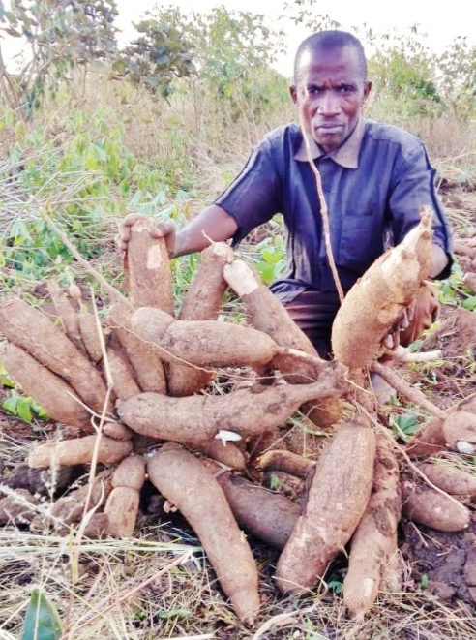
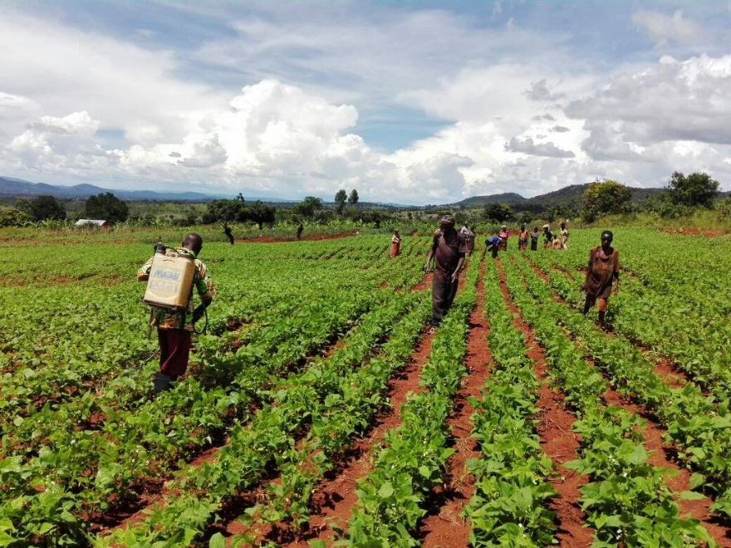

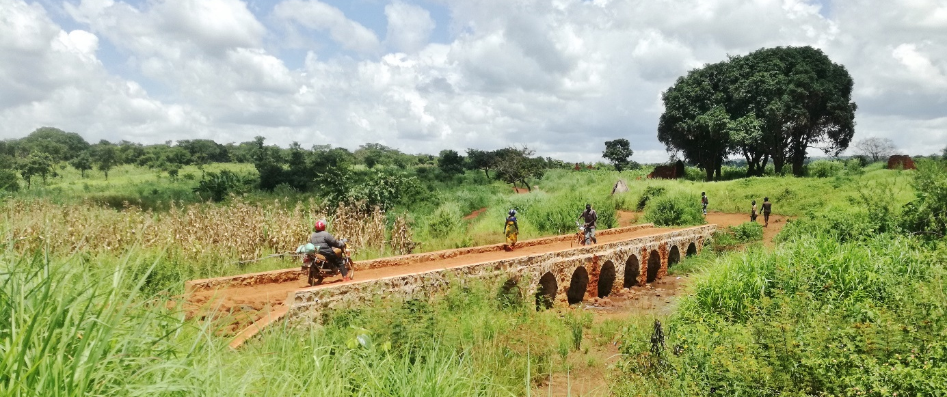

DGD code: 3016473
Navision code: TAN 14 031 11

Contents
Acronyms 3
1 Intervention at a glance 5
1.1 Intervention form 5
1.2 Budget execution 6
1.3 Self-assessment performance 7
1.3.1 Relevance 7
1.3.1 Efficiency 8
1.3.3 Effectiveness 9
1.3.4 Potential sustainability 9
1.4 Conclusion 10
2 Results Monitoring 12
2.1 Evolution of the context 12
2.1.1 General context 12
2.1.2 Institutional context 12
2.1.3 Management context: execution modalities 13
2.1.4 Harmo context 14
2.2 Performance outcome 15
2.2.1 Progress of indicators 15
2.2.2 Analysis of progress made 15
2.2.3 Potential Impact 17
2.3 Performance output 1: value chain coordination. 18
2.4 Performance output 2: value chain financial services. 21
2.5 Performance output 3: chain supporters render effective services. 26
2.6 Performance output 4: smallholder farmers strengthened. 30
2.7 Performance output 5: marketing & trade. 39
2.8 Transversal Themes 45
2.8.1 Gender 45
2.8.2 Environment and climate change 48
2.8.3 Other 49
2.9 Risk management 50
3 Steering and Learning 60
3.1 Strategic re-orientations 60
3.2 Recommendations 61
3.3 Lessons Learned 62
4 Annexes 64
4.1 Quality criteria 64
4.2 Decisions taken by the steering committee and follow-up 67
4.3 Updated Logical framework 70
4.4 MoRe Results at a glance 70
4.5 “Budget versus current (y – m)” Report 71
4.6 Communication resources 73

Acronyms
AAS | Assistant Administrative Secretary
AFM | Administration and Finance Manual
AFO | Administrative and Financial Officer
AGRA | Association for Green Revolution in Africa
AIDS | Acquired Immunes Deficiency Development Syndrome
AMCO | Agricultural Marketing Cooperative Organisation
ANO | Announce of No Objection
ARDI | Agricultural Research and development Organisation
ASARECA | Association for Strengthening Agricultural Research in Eastern and Central Africa
ASDP | Agricultural Sector Development Plan
ASDS | Agricultural Sector Development Strategy
BIO | Belgian Investment Organisation
BDSP | Business Development Service providers
BFFS | Belgium Fund for Food Security
BLS | Baseline Survey
BTC | Belgium Technical Cooperation
CAADP | Comprehensive Africa Agricultural Development Programme
CB | Capacity Building
CBO | Community Based Organisation
CBODP | Capacity Building & Organizational Development Plan
CBSV | Cassava Brown Streak Virus
CBTNA | Capacity Building Training Need Assessment
CMO | Implementation Agreement
CMV | Cassava Mosaic Virus
CRS | Catholic Relief Services
CRDB | Cooperative Rural Development Bank
CSO | Civil Society Organisation
CSP | Chain Service Provider
DADP | District Agricultural Development Plan
DAICO | District Agriculture, Irrigation and Cooperative Officer
DED | District Executive Director
DFP | District Focal Point
DFT | District Facilitation Team
DRC | Democratic Republic of Congo
EPC-LGAP | Enhancement of Procurement Capacity of Local Government Authorities Project
ETR | End Term Review
FANRPAN | Food Agriculture and Natural Resources Policy Analysis Network
FAO | Food and Agriculture Organisation of UN
FEWSNET | Famine Early Warning Systems Network
FO | Farmers Organisation
GAFCO | Good African Food Company
GEWE | Gender Equality and Women Empowerment
GIS | Geographic Information System
GoT | Government of Tanzania
HR | Human Resources
IFAD | International Funds for Agriculture Development
IITA | International Institute for Tropical Agriculture
JGI | Jane Goodall Institute
JLPC | Joint Local Partner Committee
LGA | Local Government Authority
LIC | Local investment climate
M&E | Monitoring and evaluation
MATI | Ministry of Agriculture - Training Institute
MEDA | Mennonite Development Association
MFI | Micro finance institution
MIS | Market Information System
MIVARF | Market Infrastructure Value Addition and rural Finance Support Programme
MoCoU | Moshi Cooperative University
MoF | Ministry of Finance
MoU | Memorandum of Understanding
MTR | Mid Term Review
MVIWATA | Mtandao wa Vikundi vya Wakulima Tanzania
NGO | Non-governmental Organisation
NMB | National Microfinance Bank
NRM | Natural Resources Management
NRM-LED | Natural Resources Management for Local Economic Development
NTA | National Technical Adviser
O&OD | Opportunities & Obstacles for Development
PASS | Private Agriculture Sector Support
PIU | Project Implementation Unit
PO-RALG | President’s Office – Regional Administration and Local Government
PPP | Public Private Partnership
PSC | Project Steering Committee
PSO | Private Sector Organisation
QFP | Quality Food Products Ltd
RAS | Regional Administrative Secretary
RFT | Regional Facilitation Team
RR | Resident Representative (ENABEL)
RS | Regional Secretary
RS | Regional Secretariat
RSM | Regional Stakeholder Meeting
SA | Specific Agreement
SACCAS | Saving and Credit Cooperative Association
SACCOS | Saving and Credit Cooperative Organisation
SAKIRP | Sustainable Agriculture Kigoma Regional Project
SIDO | Small Industries Development Organization
TAFSIP | Tanzanian Agriculture and Food Security Investment plan
TBS | Tanzania Bureau of Standards
TCRS | Tanganyika Christian Refugee Service
TFF | Technical and Financial File
TOC | Theory of Change
TOR | Terms of Reference
TOSCI | Tanzania Official Seed Certification Institute
VC | Value Chain
VCA | Value Chain Assessment
VCD | Value Chain Development
VCDF | Value Chain Development Fund
VCF | Value Chain Finance
VICOBA | Village Community Bank
WRS | Warehouse Receipt System

Intervention at a glance

Intervention form
Intervention title | Sustainable Agriculture Kigoma Regional Project SAKIRP
Intervention code | TAN 14 031 01
Location | Kigoma Region Tanzania
Sector (CAD codes) | 31120: Agricultural development
Total budget | € 8.000.000 Enabel + 800.000 Tanzania
Partner Institution | MAFC, PMO-RALG / Regional Secretariat Kigoma
Start date Specific Agreement | 25th November 2015
Date intervention start | 1st June 2016
Planned end date of execution period | 24/05/2021
End date Specific Agreement | 24/11/2021
Target groups | Direct beneficiaries: smallholder farmers, especially women and other chain actors of cassava & beans value chains. Secondary beneficiaries: local chain supporters private & public.
Impact | Local economic development and wellbeing of smallholders is improved in Kigoma Region through sustainable agriculture development
Outcome | Smallholders’ income is increased and diversified in Kigoma region, especially for women, through pro-poor value chains development.
Outputs | R1: Value chains management and coordination mechanisms are installed and steer cassava and beans value chain development.
Outputs | R2: Sound financial mechanisms are developed and financial organisations are strengthened to support value chains development.
Outputs | R3: Public and private chain supporters provide effective services to value chains actors.
Outputs | R4: Stronger position of small holders, especially women, in the value chain through improved integration and empowerment.
Outputs | R5: Improved market access and sustainable trade
Period covered by the report | January - December 2018

Budget execution
euro | Budget | TOT previous Years | TOT 2018 | Balance | Disbursement Rate end 2018
Total | 8,000,000 | 1,269,625 | 870,558 | 5,859,817 | 27%
A - Activities | 4,260,000 | 346,980 | 367,787 | 3,545,233 | 17%
Result 1 | 312,000 | 113,705 | 15,865 | 182,429 | 42%
Result 2 | 2,030,000 | 26,850 | 26,538 | 1,976,612 | 3%
Result 3 | 585,000 | 86,330 | 147,968 | 350,702 | 40%
Result 4 | 852,000 | 41,380 | 162,536 | 648,084 | 24%
Result 5 | 481,000 | 78,715 | 14,880 | 387,406 | 19%
B - NTAs/ITAs | 2,054,400 | 489,147 | 350,218 | 1,215,035 | 41%
X - Reserve | 93,050 | 0 | 0 | 93,050 | 0%
Z - General Means | 1,592,550 | 433,498 | 152,553 | 1,006,499 | 37%

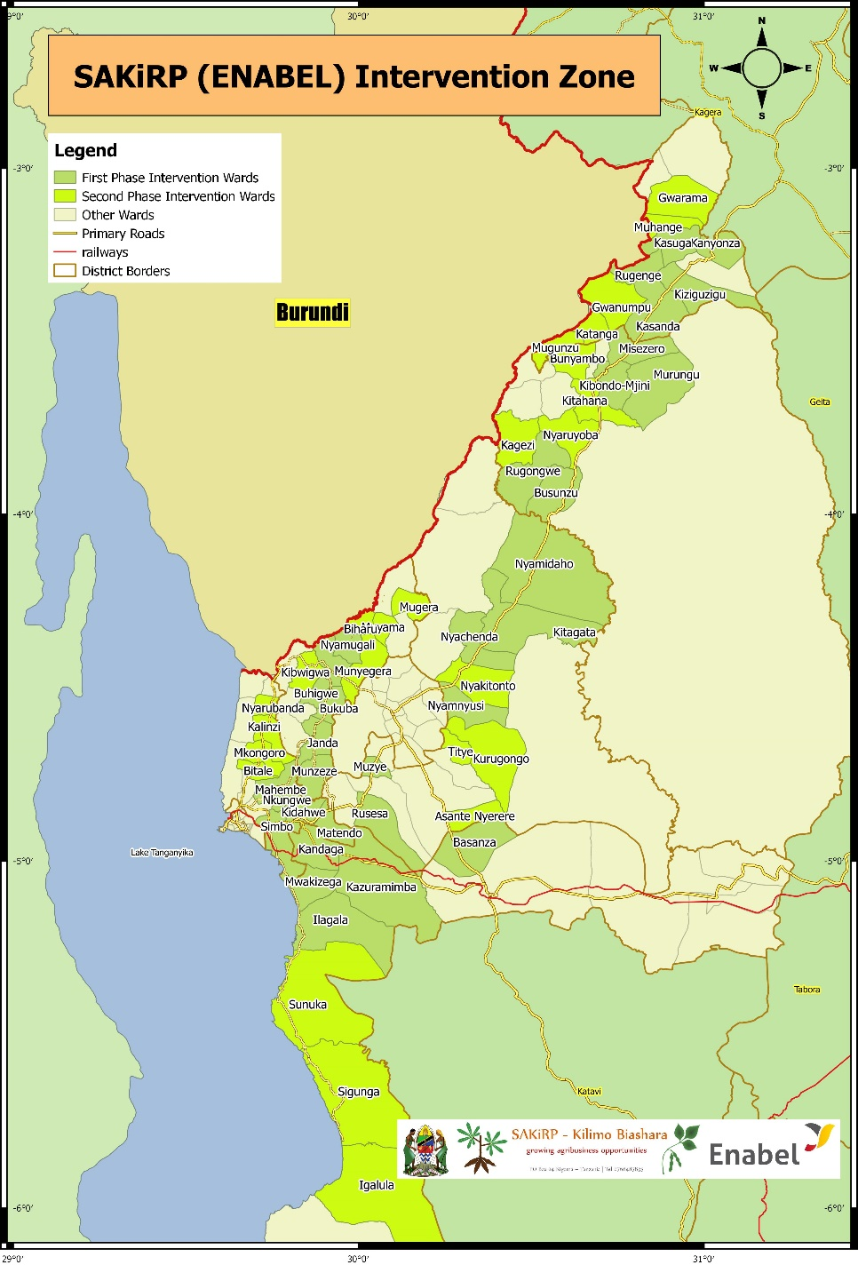

Self-assessment performance

Relevance
 | Performance
Relevance | A

Cassava and beans are important crops cultivated and traded in large volumes by the majority of smallholder farmers in Kigoma region. Value chain development to alleviate poverty and boost economic development remains high on the national and regional EA agenda. The Tanzanian government emphasises value addition in the agricultural sector through local processing to spur industrialisation. With the absence of DASIPS, this project is seen as relevant by local government authorities in order to support smallholder agriculture and boost crop cess revenue. Tackling the production node bottlenecks increased the project’s relevance in light of the low productivity currently prevailing in the region.

The feedback of project partners and the value chain assessments indicate that the overall intervention’s logic remains consistent. However, the following issues remain
- In Kigoma region, both value chains are dominated by the informal sector with limited scope for growth and capacity to uplift smallholder agriculture. In cassava trade there are no lead firms. In beans, the few formal firms are withdrawing because of the narrow margins and difficult business environment.
- Huge gaps in value chain financing persist for smallholder farmers. Unfortunately, the proposed value chain financing grant with Vision Fund was not approved by DGD, reducing and economic impact and the relevance of SAKIRP.
- Beans contributed to the income and cash flow of rural households. However due to the price slump of cassava, the economic profitability of this crop was negative. Contrary to the market dynamics during the formulation, conditions are not ripe for cassava for full development of the cassava value chain
- The TFF assumption that farmer field schools will be the building blocks for dynamic farmer organisations is contradicted by the reality on the ground. The project made an inventory of the best performing groups and VICOBAS emerged as the best albeit the small scale of their operations. A flexible and more diverse approach was opted for in function of the most dynamic groups.
- For equity reasons, the technical and financial file emphasises the empowerment of farmer groups and collective marketing. It is also the government’s desire to revive the collapsed cooperative system. In addition, formal agricultural commodity firms also have a strong interest in having well-organised smallholder farmers in order to reduce transaction costs. However, the socio-economic dynamics on the ground favour the model of individual producer marketing through a set of agents funded by individual traders. The latter system seems to cope better with the existing constraints. The viability and sustainability of the smallholder collective marketing system remains in doubt.
- The assumption of free trade in East Africa is challenged by the developments on the ground. Food export bans have disrupted the results of the cassava value chain as 90% of marketable volume is exported to neighbouring countries. The political situation in Burundi remains very volatile and will influence the trading patterns with its neighbours. In Kigoma, the transit trade of cassava through Burundi to Rwanda was suspended thereby affecting trade flows and increasing costs for sourcing from Kigoma.
- Given the institutional anchoring of the project within the regional government, there is a strong pull towards the local government authorities and a “direct implementation” style; whereas a value chain advocates a facilitation role with more reliance on market dynamics and a competitive private sector to drive value chain transformation.
- The new Belgian cooperation policy focuses stronger on the private sector and the role of Belgian firms. In the context of Tanzania, Kigoma has rather a juvenile private sector with limited absorption capacity. SAKIRP is currently working with the Belgian company Casibeans for the implementation of a pilot of linking smallholder bean producers to export markets.

Efficiency
 | Performance
Efficiency | B

Factors that contributed to efficiency:
- The cost efficiency of project procurement is good – prices are aligned with market prices.
- The mobile data management allows for more efficient data collection, 2-way communication and better performance monitoring of extension staff.
- The 2 cluster offices are operational and allow for a closer follow-up at grassroots level and improved communication with VC stakeholders.
- Selection of wards for project interventions has followed a clustering approach to create a critical mass of farmers and also to reduce logistical costs associated with supporting geographically dispersed farmers. The phased approach of expansion to a limited number of wards, allowed for on-the-job capacity building and the testing of approaches. Ward Agricultural Extension Officers have been strategically selected to provide extension support to farmer groups and this minimizes the cost of extension provision. Additional investment was done in the motorcycles for extension staff which improved the outreach.

Factors that reduced efficiency
- The 2018 disbursement restrictions created a lot of uncertainty and loss of credibility for SAKIRP. The effective project lifespan was reduced. Some staff left to look for alternative employment. The budget squeeze also contributed to the low financial turn-over of 17% versus the implementation period of 40%.
- Some districts lobbied a lot for the expansion to remote wards. While it is clear that additional assistance is required in these wards, the efficiency is low when the agricultural department cannot provide effective supervision given the long distances.
- The absence of producer organisations that can mobilise a large membership and the fragmented trade of cassava and beans mean that there are no economies of scale for value chain development. The VC development work is therefore tedious and transaction costs are high.
- The quality of cassava cuttings remains a challenge. Commercial seed entrepreneurs (CSEs) supplied cuttings from fields that were infected. SAKIRP had to recall all cuttings of some batches, destroy them and order again. The official seed agency TOSCI does the not have the resources to ensure the quality of QDS seeds in the vast area of Western Tanzania. The large amounts of cuttings that are moved between regions are a risk for the spread of brown streak virus and other diseases if no quality controls are imposed. The efficiency of the logistics of getting cutting supplies from ARI Maruku needs to be improved so that planting material is available in time and with good vigour.
- Enabel does not have modalities to work directly with the private sector. Large commercial farmers would be able to create economies of scale in terms of input supply and commodity aggregation: there were smallholder producer groups are generally failing.
- The opportunities for better collaboration between agricultural projects in Kigoma have not been fully materialised. The aim is to get economies of scale and reduce administrative costs. Unfortunately, major agricultural projects focus on the same crops. With the current situation, the implementation modalities are guided by avoiding overlap rather than pooling resources.
- There was a high staff turn-over in 2018. Human resource management met with a number of obstacles: limited number of candidates that meet the appropriate skill requirements, Kigoma is not seen as an attractive duty station for professionals.
- The relative remoteness of Kigoma region comes inherently with increased cost of project implementation.

Effectiveness
 | Performance
Effectiveness | B

As a consequence of the value chain assessment and risk analysis, agricultural production and support to extension were prioritised next to market linkages and trade. Adding those components improved the effectiveness of direct poverty alleviation. The project has been particularly effective in its data collection and analysis as reliable data is timely collected and analysed by the project.

The non-approval of the proposed financing grant facility had a knock-on effect on SMEs’ aggregation capacities and farmers’ ability to access loans for input financing. To deal with the challenge, the project has put in place an in-kind loan scheme which directly provides farmers with improved seed and fertiliser. This in-kind scheme is inefficient and does not offer opportunities for scaling up.

In face of the budget restrictions and lacking Enabel modalities to support the private sector, the construction of low cost but strong stone arch bridges contributed to tangible improved access to agricultural markets. The construction of bridges is strongly appreciated by Tanzanian stakeholders as an effort to improve the economic infrastructure in a cost-efficient way.

The value chain development model has many merits but certain pre-conditions have to be in place so that the model is effective. Demonstrating the model with agricultural value chains in a remote region with a fragmented and informal sector, no producer associations that can mobilise a large membership and hardly any lead firms is a difficult undertaking.

There was poor rainfall in the November season. In quite some wards, rains only started in late December and stopped early. The bean yields will be affected during a critical time of experimenting with export market linkages.

Value chain development projects focus on the private sector. Unfortunately, Enabel procedures do not have yet the instruments to support partnerships with companies. Only commercial tendering is available for firms which is an inadequate tool if there is limited competition and private sector presence in the region and partnerships are the objective. Enabel is working on new modalities to improve the collaboration with the private sector.

On a macro-scale, food export bans interfere in market dynamics and are affecting the effectiveness as the cassava value chain relies almost entirely on the markets in Rwanda and Burundi.

Potential sustainability
 | Performance
Potential sustainability | B

Financial & economic sustainability
The Kigoma regional context is dominated by refugee support activities and many aid agencies are targeting the same implementing partners and beneficiaries. As a consequence, and because of the humanitarian aid situation, there is a risk that hard commercial requirements for investments and capacity building will be compromised by the prevailing preference for subsidies and free hand-outs.

The local contribution concept pursued by SAKIRP aims at improving ownership and financial & economic sustainability. Data on production costs and yields are collected to assess the economic viability of promoted technologies. As the micro finance grant was not approved, SAKIRP shifted to an in-kind revolving fund for inputs as a stop-gap measure in absence of an optimal and market-friendly solution. The sustainability of the latter depends on successful roll-over of roles to financial service providers and agribusiness firms. Profit margins for the bean pilot in collaboration with 2 formal firms are very narrow while expectations of farmers are high. Only if the red kidney bean export market will provide for larger margins will structured marketing arrangements scale-up and allow for coordinated value chain upgrading.

The profitable export opportunities of cassava in Burundi and Rwanda were related to temporary events. In Burundi, the political instability is a disincentive to local production. In Rwanda, the production collapsed after an outbreak of cassava brown streak virus. The Rwandese and Burundian governments are working on mitigation efforts and both countries will become more self-sufficient for cassava again. The current price slump of cassava might therefore be structural. Current farming methods of cassava depend on further cutting the miombo forest and soil degradation. More sustainable farming methods are required including the use of fertilizer and erosion control. The economics of the domestic bean market are sound.

Ownership and capacity building
To avoid donor dependency, the starting point was to work with existing producer groups that have a track record on the ground and not to create specific project related groups. A lot of efforts are invested in the capacity building of producer groups, extension workers and lead farmers. These efforts foster local ownership and post-project sustainability.

Ownership by the private sector (farmers, aggregators, processors and traders) still needs to be developed. Both the informal traders and small producer groups do not provide for an institutional framework that can easily absorb and sustain project interventions after closure. The continued involvement of traders depends a lot on the profitability of the value chain.

Policy support
The agricultural policy documents aim at job creation, intensification of agriculture, commercialisation of smallholder farms, value addition and the promotion of agricultural commodities as raw materials for the industrialisation drive. Nevertheless, recent sudden changes in policy with more emphasis on price controls of fertilizer & produce, food export regulation, marketing through cooperative unions and general protectionist tendencies have made an impact on the private investment that is needed to achieve the set agricultural development objectives. Given its geographical position, economic growth opportunities of Kigoma rely strongly on the export business with East African countries. Free trade principles foster that trade. SAKIRP only has a linkage to the Ministry of Agriculture through the steering committee. It is hoped that regular agricultural sector coordination meetings will provide a platform for policy dialogue.

Contribution to institutional and management capacity
SAKIRP has been spearheading mobile data collection in the agricultural sector in Kigoma. The region and districts are keen to roll Kobo toolbox out as a management tool. TARURA is supporting the appropriate technology of stone arch bridges.

Conclusion
In sum, the project is on track to achieve results 1,3 and moderately on track to achieve result 4 and 5. The absence of producer organisations that can mobilise a large membership and the fragmented trade of cassava and beans mean that there are general no economies of scale to make a regional wide impact on poverty alleviation. The absorption capacity of most smallholder producer groups is limited. The rejection of the value chain financing facility (result 2) will significantly affect the development of the value chain and aggregation capacity. The non-availability of Enabel modalities to support the private sector curtailed the implementation of the investment fund. Facilitation of structured marketing relationship (result 5) will depend on the willingness of financial service providers to modify their products and exporters to compete with the domestic market. Value chain actors’ continued commitment to the cassava value chain will depend on the discovery of new markets that can provide competitive returns.
The year 2018 was challenging. The project had to deal with a number of important events:
- The cassava experienced a drastic price decline making investments in this sector unprofitable. Cassava processing and Chinese firms in the coastal area do not offer better alternatives than the Burundi dried cassava market. Smallholder income can only be improved through increased yields
- The non-approval of the value chain financing grant that had immediate repercussions on the

Results Monitoring

Evolution of the context

General context
The reporting period saw some significant shifts in the economic conditions around beans and cassava value chains. An oversupply of maize grain and the recovery of cassava production in Rwanda and Burundi triggered a decline in prices of both fresh and dried cassava in Kigoma. In Burundi, price cassava prices dropped by up to 45% on the back of strong local production. This has led to a marked drop in cassava export volumes from Kigoma to Burundi. On the other hand, dry beans prices have also experienced a downward spiral against a background of weak global prices that are closely linked to India’s hike on tariffs for pulses. In Tanzania, surplus bean production has led to atypically low prices and reduced margins for farmers. With weak global demand, most bean exporting companies are hesitant to enter into long-term sourcing arrangements citing price volatility risks. Meanwhile, the Tanzanian government’s trade policies have continued to be a major source of concern for export traders. Export permit requirements and often unpredictable export bans have seen trading firms shifting their businesses to more favourable sourcing environments such as Zambia. Tanzania is considered a high cost sourcing area when compared to other source countries such as Uganda, Zambia and Malawi. In a nutshell, the changed supply conditions in Burundi and Rwanda together with a general market surplus for both beans and cassava have impacted the project’s operations and called for adjustment in strategies. The government price control of fertilizer caused a silent shortage of supplies in 2018-Q1 as agro-dealers feared not being able to recover their costs.

Meanwhile, weather conditions in the region have been variable. Some wards faced excessive rains in 2018-Q2 leading to a poor bean crop. Quite some wards were only to plant in December 2018 because of late rains. It is expected that the masika bean and maize crop in these areas will be poor. Unpredictable weather had a direct impact on the bean contract farming initiatives conducted by the project’s private sector partner, GAFCO, in Kakonko district.

The danger for cassava brown streak virus lingers on as the virus is established in some wards of Uvinza, Kasulu and Kakonko and was even detected in officially approved commercial seed multiplication plots.

On the whole, the context of Kigoma region has remained the same. The region’s link to the national economy is still weak thereby elevating the importance of trade with regional EA neighbours, Burundi in particular. The presence of refugees continues to attract humanitarian assistance and attention. The latter has led to a proliferation of loosely connected but related interventions thereby posing a coordination challenge and market distortion.

BTC changed to Enabel with a new mandate focusing more on coordination and networking. The restructuring of the organisation was the focus in 2018. New financial management and reporting tools have been adopted.

Institutional context
SAKIRP is anchored in the Kigoma Regional Secretariat. This is relevant for a bilateral project and offers opportunities for networking with local government authorities and the collaboration with new agricultural projects. The Project Coordinator is the regional agricultural adviser with a clear mandate for coordination of agriculture-related activities.

In line with Enabel procedures, the steering committee is the governance oversight body. The ministry of finance, agriculture, local government are represented in the steering committee. The Kigoma RAS is the chairperson. The Agricultural Market Development Trust (AMDT) was added to the steering committee as it comes with an agribusiness background and mandate. In the districts, the DFP is responsible for coordinating activities of extension staff and has direct oversight from the DED.

The major partner of a value chain project is the private sector. The private sector is, unfortunately, very informal and hardly organised in Kigoma region. SAKIRP participates as a member in the regional business council facilitated by LIC.

Management context: execution modalities

Offices are provided by the Regional Secretariat and the Tanganyika Basin Authority in Kigoma and by the respective district councils in Kakonko and Kasulu. Two cluster offices (Kasulu/ Buhigwe and Kibondo/ Kakonko) have been operational to allow for better grassroots presence and monitoring of field activities.

There was a high turn-over of project staff but all technical positions have been filled with committed personnel except M&E. At district level, a district focal point has been appointed by the DED. For each of the operating wards, the DED also appointed a ward extension officer. The DFPs and WAEOs are crucial staffs for the implementation of result 1,3 and 4. Their coordination is done by the SAKIRP project coordinator who is delegated by the regional secretariat. As end of December 2018, the Administration staff team has been upscaled as follows: 1 new Procurement Officer (joined in Oct 2018 and trained for 3 months) after the termination of the former PO probation period (June 2018). An additional driver was recruited for PIU. The Admin Assistant was not renewed after the end date of her contract in August 2018. The Waskirp Admin Assistant supported the project to cover the gap, until a new one be recruited in 2019. The AFO (50%) was renewed for one year. The IFO (50%) is shared with Waskirp.

A Car tracking System was put in place in order to record the fleet itineraries and fuel consumption for cost efficiency. The new Enabel tool for reporting and monitoring “Pilot” was adopted.

SAKIRP follows the financial management and procurement regulations of the donor (regie management). Tanzanian staff has been familiarised with those procedures. The project is using a cashless financial system based on Mpesa, in addition to the internet Banking system. The migration to UBW new financial tool was postponed to 2019, yet team received a basic training to prepare them to the transition, and the IFO was invited in Brussels to capture the basic knowledge of the tool
The steering committee met twice in line with the statutory requirements.

The self-assessment sheet of the project is maintained on a semester basis to cover any gaps identified in the Support Services functioning, systems and procedures. The Belgian court of audit audited the Project in January and correctives measures were taken accordingly with the recommendations. The Regional Controller visited the project in March 2018. A logistics & procurement action plan were developed in March 2018, By the end of 2018, 70% of the actions were undertaken. All compulsory reporting (HR, Log, Accounting, Fit Plan, Cash flow) are run in a timely and compliant manner. Financial planning was reviewed periodically due to 2 consecutive treasury restrictions by HQ, yet remained accurate and reliable. No amendment to the Project Implementation Manual is recorded.

Harmo context

Harmonisation
Kigoma region hosts several agricultural and economic development projects targeting both refugees and their host communities. The main projects with a link to value chain development are the Local Investment Climate (LIC), AGRA and UN Kigoma Joint Programme. SAKIRP has systematically reached out to new projects to agree collaboration mechanisms. A challenge encountered in this process is that implementation is often outsourced to different local partners who do not have sufficient appreciation of the modalities for collaborating in a complimentary way. There is an overlap in the value chains (beans & cassava) and in some districts the targeting of smallholder farmer groups.

The project actively works to leverage local capacity and an example of this are the two MoUs entered with TCCIA and SIDO. The project works with TCCIA to promote cross-border business coordination and works with SIDO to promote adoption and utilisation of value adding technologies.

Ownership
Traders and processors have been mobilised to champion value chain upgrading and coordination efforts. Their biggest interest was the value chain financing module that will unfortunately not materialise. The ownership by the informal sector is limited to direct benefits. The traders, producer organisations, aggregators and processors in the cassava sector are an example. The ownership of the formal private firms (QFP, Casibeans and Third Man) in the bean value chain is excellent with a strong lead and own investments.

SAKIRP applies the concept of local contribution which is an important tool to enhance ownership, improve communication and identify core priorities. Examples are the grater technology, storage facilities and bridges that require the mobilisation of locally available resources. Community contribution will, however, slow down implementation and increase the need for monitoring.

A key institutional partner is the Kigoma Regional Secretariat and the affiliated rural local governments. The project coordinator is the regional agricultural adviser and staff from the district agricultural departments play an essential role in supervising and coordinating activities at district level. The regional stakeholders’ platform is used to engender of ownership of project results by various stakeholders involved and interested in agricultural development within the region.

Performance outcome
This section describes progress made at performance outcome level by linking the outputs with the outcome as visualized below:



Progress of indicators

Specific Objective: Smallholders income is increased and diversified in Kigoma region, especially for women, through pro-poor value chains development
INDICATORS | Project  Baseline |  | Overall Target | 2018 |  | 2019 | 2020
INDICATORS | Date | Value | Overall Target | Actual | Target | Target | Target
I0.1a - % Increase in smallholders’ total income derived from cassava | 2017 | 0% | 25% | 1% | 5% | 10% | 25%
MALE |  | 0% |  | 6%
FEMALE |  | 0% |  | -4%
I0.1b - % Increase in smallholders’ total income derived from beans | 2017 | 0% | 30% | 8% | 10% | 20% | 30%
MALE |  | 0% |  | 10%
FEMALE |  | 0% |  | 8%
I0.2a - Added value in cassava by smallholders [Billion TZS] | 2017-2018 | 4 | 45 | 10 | 10 | 20 | 45
MALE |  | 1 |  | 3
FEMALE |  | 3 |  | 7
I0.2b - Added value in beans by smallholders [Billion TZS] | 2017-2018 | 4 | 45 | 12 | 15 | 35 | 45
MALE |  | 1 |  | 4
FEMALE |  | 3 |  | 8

Analysis of progress made
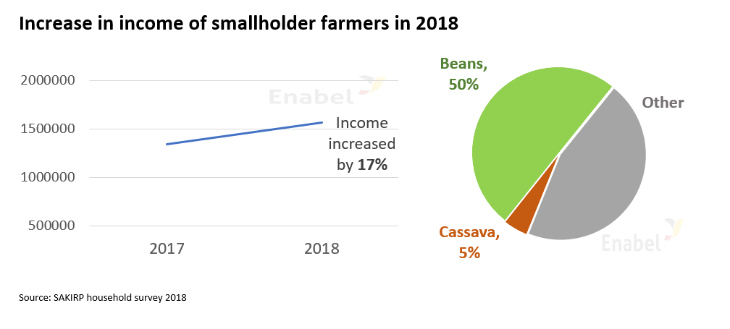

Output indicators contributing to 17% income increase in 2018 :

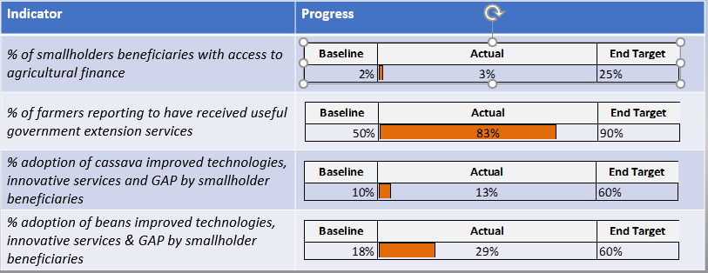

Analysis of progress made towards outcome:
Relation between outputs and the Outcome. (How) Are outputs (still) contributing to the achievement of the outcome: | - Result 1: Cooperation is increasing amongst chain actors. The proportion of farmers that perceive their business relationships with bean and cassava traders as trustful increased from a baseline figure of 14 to 28%. The use of mobile data collection has provided more reliable and timely data for steering interventions.  - Result 2: Value chain financing & support to the private sector did not materialise as planned. Important opportunities for the scaling up of good agronomic practices and trade were missed. Only 2% of smallholders have access to credits.  - Result 3: The SAKIRP assistance enabled local government authorities to have better extension services. 83% of beneficiary farmers appreciate the services rendered by ward extension workers.  - Result 4: Strengthening producer groups and productivity has had a modest contribution to the income of smallholder farmers. Bean yields have improved through adoption of good agronomic practices. The adoption in the bean value chain is 29% and in cassava only 13%. Cassava processing technology uptake has been slow due to weak market linkages. “Farming as a business” laid the foundation prepared farmers for transition to market-oriented production.  - Result 5: Market linkages have been slowed down by lack of lead firms such as GAFCO in the bean value chain. Structured linkages to bean export markets are in a pilot phase. Low productivity remains a key bottleneck to competitiveness of local farmers nationally and internationally. The successful completion and eventual scale-up of the structured marketing arrangements will significantly contribute to increased incomes for farmers.
Progress made towards the achievement of the outcome (on the basis of indicators): | The 8% income increase from beans was substantial in a year with adverse weather conditions and generally falling prices of agricultural commodities. There was only a 1% income increase of cassava due to the price slump that might be structural. Based on the indicators, the added value created by smallholder farmers is on track. By the end of 2018, about 14.000 smallholder farmers have been reached – amongst them are 68% women.

Issues that arose, influencing factors (positive or negative): | - Non-approval of the value chain financing grant facility with knock-on effects on other result areas.  - Budget squeeze in 2018 with consequences for implementation, staff turn-over and the effective project lifespan.  - Government interference in agricultural commodity market dynamics.  - Cassava price slump due to production recovery in Rwanda and Burundi.  - Pull-out of bean lead firm (GAFCO) due to the difficult business context.  - Unfavourable weather conditions (too much rain in 2018-Q2 and not enough rain in 2018-Q4).  - The support to public infrastructure is strongly appreciated by the grassroots and government. The shift to public infrastructure was done after difficulties with the implementation the value chain financing grant and investment fund.
Unexpected results: | Local demand for bean varieties targeted for export has been quicker than anticipated. This put price pressure on buyers.

Potential Impact
The tangible footprint of SAKIRP in Kigoma is expected to be the following:

- Farming as a business training and the accompanying technical interventions will orientate both beans and cassava value chains towards commercial farming and competitiveness
- The demonstration of the strengths and weaknesses of the value chain development concept for smallholder farming in a remote region.
- Through the introduction of new varieties and the promotion of good agronomic practices, improved productivity of smallholder farmers. At this stage, the low production is a bigger constraint to commercial transformation.
- Enhancing the performance of the local government extension system in some of the wards of Kigoma region through better training, supervision and working tools.
- The introduction of Kobo-toolbox set an example of mobile data collection and 2-way communication to improve the management of agricultural departments.
- A pilot of the construction of stone arch bridges to improve the access to markets for agricultural commodities was successful in 2018. If this technology and the approach are scaled up then access to markets in the region will be improved with a modest budget.
Currently, the bean market linkage pilot in collaboration with 2 commodity firms is underway. If this venture is successful then the activity will be scaled up and there will a strong impact on improving the quality of the beans and the diversification of the markets for smallholder farmers. However, margins are narrow for both farmers and the local aggregating company. Successful scaling-up of the market linkages will depend on increased crop productivity, efficient transactions with the aim of reducing the reject percentage, the adoption of the red kidney varieties that have better international market and exploring local opportunities (WFP tenders).

The potential impact of the project has been curtailed considerably by the rejection of the micro -finance grant for Vision fund. The non-approval of this proposed financing grant facility had a knock-on effect on SMEs’ aggregation capacities and farmers’ ability to access loans for input financing. In the meantime, VisionFund has scaled down on its portfolio allocation to smallholder farmers to a maximum of 25%.

The absence of producer organisations that can mobilise a large membership and the fragmented trade of cassava and beans means that the potential impact of SAKIRP is reduced. The VC development work is therefore tedious and transaction costs are high. So far about 14.000 farmers are reached but the target of 20.000 farmers is feasible in 2 more years to come.

Performance output 1: value chain coordination.


Progress of indicators
Result 1: VC management & coordination mechanisms are installed & steer VCD
INDICATORS | Project  Baseline |  | Overall Target | 2018 |  | 2019 | 2020
INDICATORS | Date | Value | Overall Target | Actual | Target | Target | Target
I1.1a - % of farmers reporting/perceiving cassava buyers as trustful business partners | 2017-2018 | 24% | 75% | 28% | 30% | 50% | 75%
MALE |  | 27% |  | 26%
FEMALE |  | 22% |  | 30%
I1.1b - % of farmers reporting/perceiving bean buyers as trustful business partners | 2017-2018 | 24% | 75% | 27% | 30% | 50% | 75%
MALE |  | 25% |  | 28%
FEMALE |  | 24% |  | 27%
I1.2a - % of trader reporting/perceiving cassava farmers as reliable suppliers | - | - | 75% | 100% | 25% | 50% | 75%
I1.2b - % of trader reporting/perceiving beans farmers as reliable suppliers | - | - | 75% | 100% | 25% | 50% | 75%

The farmers that are perceiving buyers as trustful business partners increased slightly from 24% to 27%.

Progress of main activities
Progress of main activities | A | B | C | D
1. Value chain development strategies elaborated
Facilitate coordination meetings for agricultural projects at regional level |  |  | x
2. M&E & capitalization framework for VCD are elaborated
Conduct annual household survey |  | x
Develop monitoring matrix and data collection tools |  | x
-Train agricultural extension officers on data collection |  | x
Periodic data collection, analysis and progress tracking. |  | x
3. Forums for enhancing VC management & coordination are conducted
Establish innovation platforms |  |  |  | x
Regional stakeholders meeting |  | x
Project steering committee |  | x
4. Project capitalisation products are produced & disseminated
Develop capitalization products and channels for use of mass media (radio, video, website, brochure etc.) |  |  | X

Analysis of progress made
The technology enabled M&E system (see diagram below) is designed so that both improved extension services are delivered to smallholder farmers, as well as feed-back from beneficiaries is taken into account for decision-making by the PIU. Through the use of smartphone applications such as WhatsApp and KoBo Toolbox (a free and open-source tool for mobile data collection), extension officers are strengthened by:
- improved access to information (internet, KoBo toolbox),
- ability of real-time qualitative data reporting (e.g. pictures of crop diseases),
- WhatsApp groups per district serving as effective agronomic question - answer forums,

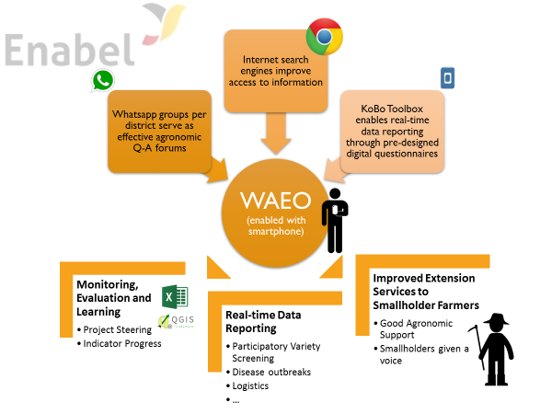

KoBo Toolbox enables extension officers to report data from the field on a daily basis through digital questionnaires. This data is automatically aggregated into an Excel-file by KoBo Toolbox, which allows for easy data analysis and real-time feed-back from the beneficiaries. Screening data allows us to steer seed purchases for next seasons, weekly commodity price data allow us to predict price fluctuations and are helpful during structured market linkage negotiations.

The KoBo Toolbox served its main purpose during the Annual Household Survey, a repetition of the baseline household survey, exactly one year later. This year’s data was collected by 56 Ward Extension Officers, covering 1087 households, evenly distributed geographically and balanced in terms of gender. Baseline values were revised using the data from this year’s added 25 wards, whilst actual 2018 data was derived from the 31 first phase intervention wards. Analysed data from this survey provides the lion’s share of information for the indicator progress tracking. Other indicators are tracked through regular digital data collection of production and income of 560 selected rural households, phone call-backs of Household Survey interviewees and through Trader Surveys.

KoBo Toolbox is a multi-functional tool. Apart from monitoring and evaluation purposes, the KoBo Toolbox technology also comes in handy when planning for logistics in large area counting 56 intervention wards at present (e.g. planning input distribution). Moreover, the tool’s GPS functionality allows for georeferenced soil sample mapping, georeferenced imagery, ... Even its function as a self-learning platform was explored through the design of self-evaluating quizzes.

The positive experiences with technology-enabled M&E system are being scaled up.
SAKIRP is running a trial of digitalization data collection for the government agriculture monitoring system (ARDS) in 1 district.

More and more agricultural and SME programmes are coming to Kigoma region (DANIDA, AGRA, World Vision, UNDP, Gatsby fund, BIO, MEDA, GAFCO) and coordination becomes important. The challenges of poverty alleviation are important and more funding is required. However, there are equally problems of absorption capacity as the same organisations and producer groups are targeted. SAKIRP has been pro-active to reach out to new projects and look into the question of regional/district coordination to improve synergies and avoid overlap. An agreement with Local Investment Climate/ Danida was reached with delegation of functional tasks for the cassava value chain. With MEDA, there is the market linkage for cassava cuttings. With AGRA there is an excellent coordination at senior level but better agreements are required at local level One regional coordination meeting was organised in collaboration with AGRA. Innovation platforms are an important concept outlined in the TFF and are supposed to drive the value chain development. Half-yearly district coordination meetings with AGRA, UNDP, the local government and private sector representatives, are planned to serve the purpose of innovation platforms. Eleven ambassadors from EU countries were introduced to Enabel projects in Kigoma.

Considerable capitalization efforts have been carried out through quarterly review meetings, 2 radio broadcasts and the 2018 household survey highlights report which is a popular data source for the participating local governments. Stakeholder and steering committee meetings were conducted as planned. They provided a better insight in potential partners, critical drivers in the value chain and market dynamics for cassava and beans.

Performance output 2: value chain financial services.

Progress of indicators

Result 2 on strengthening value chain financing mechanisms was strategically intended to be an enabler for activities of the SAKIRP results 4 and 5. The vetoing of the value chain financing grant has left the project with no scalable financial solution for supporting farmers and other chain actors. The project has no leverage in engagements with financial service providers as its risk mitigation capacity is severely curtailed. Meanwhile, the project is piloting a revolving in-kind input credit scheme which is aimed at expediting smallholder inclusion in structured market linkage arrangements. The pilot achieves that by resolving the lack of access to production input credit. The pilot provides a learning platform for testing the creditworthiness of farmers and will provide insights into the measures that are needed to promote value chain financing by financial service providers.

Progress has been made in the execution of value chain investment fund. So far emphasis has been placed on the construction of stone arch bridges on market feeder roads. These investments are important for easing the challenge of accessibility between farming areas and market trading points. The connection of farmers’ fields and trading centres help to reduce the cost of transporting produce and help increase market efficiency. Further direct investments are planned for village-level bean aggregation centres to service farmers participating in structured marketing arrangements.

Result 2: Financial mechanisms are developed & financial organizations are strengthened to support VCD
INDICATORS | Project  Baseline |  | Overall Target | 2018 |  | 2019 | 2020
INDICATORS | Date | Value | Overall Target | Actual | Target | Target | Target
I2.1 - % of smallholders’ beneficiaries with access to agricultural finance by gender | 2017-2018 | 2% | 25% | 3% | 5% | 15% | 25%
MALE |  | 3% |  | 4%
FEMALE |  | 2% |  | 1%
I2.2 - % of groups with access to agricultural finance | 2017 | 1% | 25% | - | 10% | 20% | 25%
I2.3 - % of participating traders with access to agricultural finance | 2017 | 30% | 80% | - | 40% | 60% | 80%
I2.4 - % of participating farmer groups with access to improved market infrastructure | 2017 | 0 | 20% | - | 0% | 0% | 20%
I2.5 - % of participating local traders utilising improved market/storage infrastructure | 2017 | 0 | 25% | 58% | 0% | 0% | 25%
I2.6 - % of defaulters (calculated from those who accessed loan) | 2017 | - | <5% | - | <5% | <5% | <5%

Progress of main activities
Planned activities | Progress status
Planned activities | A | B | C | D
Elaborating and supporting a comprehensive value chain development financing strategy | X
Development of a value chain financing strategy for both value chains | X
Improving financial products and services for chain actors by banks and improving access to finance by chain actors
Promote and support financial service providers to adopt a value chain financing approach |  |  |  | X
Promote service linkages between FSPs and chain actors |  |  | X
Improving financial products and services for chain actors by banks and improving access to finance by chain actors
Training and capacity development for VICOBA and SACCOs leadership |  | X
Direct investments to support value chain development
Market access infrastructural investments |  | X
Construction and rehabilitation of village commodity aggregation centres |  |  | X

Analysis of progress made
Value chain financing remains a major challenge for both farmers and traders. The blockage of a grant to catalyse value chain financing left the project with limited options for expanding credit access for farmers. A revolving agricultural credit input scheme was introduced in 2018/2019 and, as a result, 200 smallholder farmers have accessed inputs to participate in a structured marketing linkage.

Agricultural input credit for farmers
A revolving agricultural input credit scheme was deployed to fast-track the integration of smallholder farmers into structured been marketing arrangements was deployed covering 200 farmers. The sustainability of this scheme is hinged on VisionFund Microfinance Bank’s ability to offer direct credit to farmers in subsequent seasons.

Graphic representation of the integrated structured bean market linkage with Casibeans

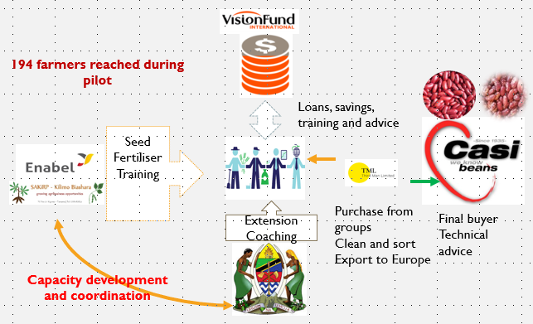

NB: In the above graph, Third Man serves as a local aggregation firm that intermediates between smallholder farmer groups and Casibeans

The following table summarises the reach of the structured market linkage pilot
Item | unit
Total number of smallholder farmers supported | 194
Total number of smallholder farmers supported as a percentage of target | 52%
Acreage to be planted per farmer | 0.95
Input support package on a per acre basis
Cost seed with transport per 40 kg in TZS | 140.000
Cost of fertiliser per acre (@50 kg bag) in TZS | 65.000
Cost of fungicides and insecticides per acre | 28.750
Total inputs investment per acre | 233.750

Table: Revolving In-kind input Scheme Modalities
Step
- The project identifies off-takers/large-scale buyers for specific varieties of beans and letters of intent for the purchase of beans are signed
- SAKIRP uses its own project funds to procure improved seed from accredited seed companies
- Farmer groups are mobilised to open group savings accounts with VisionFund Microfinance Bank
- Each farmer pays a deposit amount to access an input package of 20 kg seed, 25 kg fertiliser, 5oo ml of fungicide and 500 ml of insecticide (enough to plant 0.5 acres of beans
- During aggregation the process, farmers will be required to repay for the seed loan in-kind through grain beans that will be marketed collectively. For every 0.5 acres’ worth of inputs, the farmer repays 60 kg
- Upon marketing of the aggregated produce, the proceeds from the grain collected as seed loan repayments is deposited in the group savings account. Group members will be paid for beans delivered for collective marketing less any advances
- During the following season, will have the option to withdraw a portion of group savings to jointly purchase seeds or to use the accumulated savings as cash collateral to guarantee members to obtain production loans from VisionFund Tanzania
- By the end of the project, supported groups will have demonstrated their bankability and accumulated enough cash collateral to continue accessing loans

Financial service linkages creditworthiness for farmer groups
The project leveraged the revolving input credit to create a financial service linkage for 12 smallholder farmer groups. These groups opened group savings accounts which make them eligible to receive group wholesale loans for on-lending to their members.

Direct infrastructural investments to improve market access
To address the difficulties of transportation and accessibility between farmers’ fields and key produce aggregation points, the project embarked on an initiative to build bridges on feeder roads. Arch bridges have been constructed in Kasulu and Kigoma districts.

The value chain investment fund
The TTF component of an investment innovation fund for the private sector met a number of challenges:
- Enabel has currently no operational modalities to support the private sector. It can only support public and community organisations.
- The demand for processing equipment has been limited. For example, the promotion of cassava grating technology has not taken off albeit more than 10 years of support by various projects. The bean cleaning and threshing technology is seen as too expensive to be used on a wide scale.
- Budget restrictions in 2018 did not allow for large investments.

As a consequence, the investment fund focuses now on public market infrastructure. This prioritisation considered the potential that such infrastructure has in promoting organised marketing activities and meeting the needs of both farmers and traders.

The original idea was to support public market infrastructure as refurbishment and construction of public market infrastructure have emerged as a priority next to roads. However, the following issues emerged from the market survey:
- UNCDF targeted market infrastructure in the refugee affected zone of Kigoma region.
- The important markets in Kigoma region have no master development plan. There is no land for expansion. The construction would involve the demolishing existing structures with demands for compensation. The alternative of shifting markets is not best practice as businessmen will resent the closure of existing markets and being relocated.
- Markets are primarily seen as tax, price and regulatory enforcement tools and not as an instrument to promote trade and (self) employment. As a consequence, many new markets have remained underused in rural areas.

To improve the access to markets for agricultural commodities with a limited budget, SAKIRP embarked on a pilot of construction stone arch bridges. Four bridges were constructed with community resource mobilisation and a cost-efficient approach (70% lower cost than reinforced concrete bridges). The Tanzanian Rural and Urban Road Agency (TARURA) Kigoma spearheaded to adoption of the appropriate technology in Kigoma district. If the same implementation modality shall be continued more than 50 bridges can be constructed over the next 2-3 years with a modest budget.

Value chain financing challenges and prospects
The value chain financing result has suffered some setbacks since the start of the project. Financial service providers continue to be risk averse and biased against smallholder farmers producing staple food crops. The specific challenges encountered are as follows:

Access to formal value chain financing remains a major bottleneck

Limited understanding of value chain financing
- Most financial service providers are stuck in the traditional model of dealing with farmers. Lending to farmers is often on the basis of the availability of a non-agricultural source of income.

Rigid loan repayment terms
- The biggest challenge posed by existing loans is the repayment structure which does not align with the agricultural production and marketing cycle. Monthly repayments are not appealing to farmers that forces them to dispose of other assets to service their loans before harvesting and selling.

Informality of business operations
- The informal nature of traders and processors makes it difficult for credit providers to grant loans. In cases where business viability can be proven, the formalisation process often delays the loan-making process.

Lessons
- The demand for credit by farmers is not baked by their potential on the ground
  - Though most farmers are demanding credit, their creditworthiness
  - Farmers’ capacity to absorb credit is too low and vulnerable to a distorted cost structure
- There is growing aversion to agricultural production risk
  - Despite increasing calls for increasing lending to smallholder farmers, the reality is that lenders are striving to scale back and limit their exposure to this category of lenders. Where lending is done, it is normally done based on non-agricultural considerations
  - VisionFund reduced its portfolio allocation to agriculture from a target of 50% to 25%
  - Private companies are shying away from contract farming to avoid exposure to production risk

Recommendations
- Credit provision should be limited to farmers that demonstrate willingness and capacity to produce for structured markets. Outside that framework, value chain financing efforts should focus on re-orienting informal group financing to support agricultural activities.
- More emphasis should be placed on financial literacy training and re-orienting informal loan provision to include agricultural production activities.

Performance output 3: chain supporters render effective services.
The focus of this result area is on mobilising and developing the capacity of value chain services to farmers, processors and traders. Chain supporters working with the project fall into two main categories: public service providers and private service providers. Local government agricultural extension departments are the major public service partner working with the project to mobilise and technically support farmers. The private service providers have been mainly engaged through consultancy service agreements to provide service on specific requirements. In-between these categories are organisations with a quasi-public mandate. The project has entered into MoU agreements with such organisations (SIDO and TCCIA) to strengthen collaboration and service delivery on a cost-recovery basis

Progress of indicators
Result 3: Public and private chain supporters provide functional services to value chains actors
INDICATORS | Project  Baseline |  |  | Overall Target |  | 2018 |  |  | 2019 |  | 2020
INDICATORS | Date | Value |  |  | Actual |  | Target | Target |  | Target
I3.1 - % of farmers reporting to have received useful government extension services | 2017 | 50% | 90% |  | 83% |  | 70% | 80% |  | 90%
MALE |  | 60% |  |  | 81%
FEMALE |  | 40% |  |  | 85%
I3.2 - % of farmers reporting to have received useful agronomic support from their lead farmers | 2018 | 71% | 85% |  | 74% |  | 75% | 80% |  | 85%
MALE |  | 75% |  |  | 76%
FEMALE |  | 65% |  |  | 72%
I3.3 - % of traders satisfied with business development support services | 2017 | 0% | 80% |  | 100% |  | 80% | 80% |  | 80%

Progress of main activities

Implementation Progress | Progress
Implementation Progress | A | B | C | D
1.Assessing service needs for chain actors and need for capacity building and supporting models for chain supporters
Due diligence analysis of potential partners & new wards |  | X
2.Strengthening chain supporters for functional service provision to chain actors of selected value chains
Facilitate TOT on farming as a business to the WAEOs, DFPs and BDS providers |  | X
Supervision and on the job coaching for members of the business development services panel by PIU team |  | X
Organize learning and review workshops for BDS panel |  |  | X
Train extension officers, DFPs and PIU team on gender mainstreaming |  | X
Supervision on-the-job coaching for LGA extension staff by PIU team/DFPs |  | X
GAP TOT for field extension staff by the outsourced expertise (New wards) | X
TOSCI certification training of WAEOs |  | X
Refresher training WAEOs | X
3.Supporting the Districts to play their role for facilitating VCD
Provide monthly on-the-job support to WAEOs + DFPs |  | X
Equipping DFPs and ward extension workers with transport facilities and working tools (New wards) |  | X
Quarterly monitoring DED/DC & DAICO |  | X
Quarterly DFP meetings |  | X

Analysis of progress made
Several service providers have been engaged as outlined in the table below:

Service provider | Area of expertise | Located in Kigoma | involvement
SIDO | Enterprise development, Cassava grating technology & marketing campaigns | yes | MoU  4 market campaigns
Intermech | Manufacturing of appropriate technology for cassava & bean processing | no | Procurement tender
Consultants | Farming as a business | Yes /no | Consultancy tender  Roll out farming as a business training
TCCIA | Lobbying private sector interest | yes | MoU
Faida Mali | Market linkage | yes | Consultancy tender

The main service provider is the local government extension service as improved production remains the critical bottleneck to the improvement of smallholders’ income. Based on the results of the random call-back survey, the strong SAKIRP investment in the LG extension system has paid off. Smallholder beneficiaries reporting to have received useful extension services increased significantly from the baseline value of 50 to 83% in December 2018. Moreover, also the range of services received per year increased significantly. The improvement is even larger for benefitting female farmers: from the baseline value of 40% to 85% in 2018 and this is linked to the selection of VICOBAs as benefiting groups.

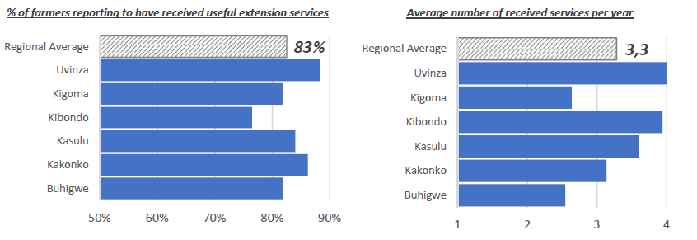

SAKIRP support to local government extension
Item | Units
Tools - equipment | - 25 motorcycles issued in 2018 (total number 62 – SAKIRP provides 70% of the functional motorcycles in the intervention zone)  - 25 smart phones for mobile monitoring & data collection (total number 62 – SAKIRP provides 100% of the available smart phones for extension workers)  - Extension gear (coats, boots, weighing scales, extension materials…)  - Demo equipment: bean cleaners 3, threshers 3, cassava graters 3, moisture meters 6
Trainings | - Good agricultural practices 62 extension officers trained  - Farming as a business - 37 extension officers trained  - Kobo toolbox for data collection extension officers trained 32 new extension officers trained  - Post-harvest management - 37 extension officers trained  - Field training - disease scan cassava in collaboration ARI Maruku 24 extension officers trained  - Gender mainstreaming – 37 extension officers trained  - Training of trainers for lead farmers – 62 extension officers trained  - Quality declared seed production by TOSCI – 6 extension officers trained  - Kobo Toolbox for Data Collection  - Soil and Yield Assessments - 32 new extension officers trained.  - Disease scouting & integrated pest management field training – 41 extension officers trained
Facilitation | - fuel, airtime and top up allowance  - district monitoring of SAKRP activities
Output | - 563 lead farmers coached & 14.017 farmers supported  - 321 on-farm demos and 367 multiplication plots planted  - Better grassroot data collection of agricultural data  - Annual Household Survey 2018

In 2018, the SAKIRP coverage increased with 25 additional wards. The total coverage is now 56 wards or about 54% of the rural wards in Kigoma region (excluding municipality and town council). Other wards are often covered by AGRA and UN one. The performance of supported staff has so far been satisfactory and on-the-job coaching efforts are continuing.

SAKIRP Intervention Wards in Kigoma Region
 | Total | SAKIRP | SAKIRP coverage
Buhigwe | 20 | 10 | 50%
Kakonko | 13 | 10 | 77%
Kasulu | 21 | 10 | 48%
Kibondo | 19 | 9 | 47%
Kigoma | 14 | 9 | 64%
Uvinza | 16 | 8 | 50%
Regional | 103 | 56 | 54%
District | # WAEOs | # groups | Group Members | av farmers/ WAEO
Buhigwe | 10 | 92 | 2260 | 226
Kasulu | 10 | 110 | 2841 | 284
Kakonko | 10 | 102 | 2216 | 222
Kibondo | 9 | 79 | 2332 | 259
Kigoma | 9 | 79 | 1894 | 210
Uvinza | 8 | 99 | 2474 | 309
Total | 56 | 563 | 14017 | 250

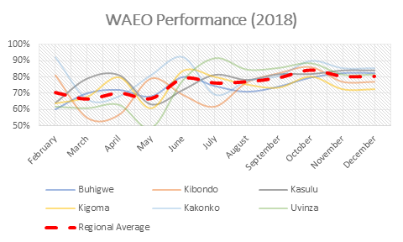

On average an extension worker is coaching 10 farmers groups and 250 farmers. There are 6 female WAEOs (11%).

Challenges that remain under this result area include the following:
- Lack of effective demand for agribusiness development services. This discourages experienced service providers from locating in Kigoma region.
- Local service providers’ inexperience with the implementation of a value chain approach
- Limited government budgets impact on provision of services as mobility is limited
- Limited human resources are available at the district agricultural departments. The majority of districts is headed by an acting DAICO and staffs have to combine several functions to deal with the workload and on the job backstopping of WAEOs. Some agricultural extension officers double as ward executive officers. The quality of district reporting needs improvement.
- The quality of the services rendered by consultants needs constant supervision. It is difficult to delegate the entire service provision.

Performance output 4: smallholder farmers strengthened.

Progress of indicators
Result 4: Stronger position of smallholder’s farmers in VC is enhanced through improved productivity, economic integration & empowerment
INDICATORS | Project  Baseline |  | Overall Target | 2018 |  | 2019 | 2020
INDICATORS | Date | Value | Overall Target | Actual | Target | Target | Target
I4.1a - Smallholder gross margin per hectare of cassava | 2017 | 657.007 | 1.300.000 | 106.386 | 400.000 | 800.000 | 1.300.000
I4.1b - Smallholder gross margin per hectare of beans | 2017 | -146.830 | 950.000 | 19.857 | 400.000 | 700.000 | 950.000
I4.2a - Value of incremental sales of cassava by smallholder beneficiaries | 2017-2018 | 304.950 | 1.500.000 | 371.916 | 600.000 | 900.000 | 1.500.000
MALE |  | 326.174 |  | 507.146
FEMALE |  | 272.243 |  | 262.754
I4.2b - Value of incremental sales of beans by smallholder beneficiaries | 2017-2018 | 291.314 | 1.800.000 | 199.457 | 900.000 | 1.300.000 | 1.800.000
MALE |  | 312.444 |  | 208.327
FEMALE |  | 272.196 |  | 187.297
I4.3a - % adoption of cassava improved technologies and GAP by smallholder beneficiaries | 2017-2018 | 10% | 60% | 13% | 20% | 40% | 60%
MALE |  | - |  | 15%
FEMALE |  | - |  | 11%
I4.3b - % adoption of beans improved technologies and GAP by smallholder beneficiaries | 2017-2018 | 18% | 60% | 29% | 20% | 40% | 60%
MALE |  | - |  | 33%
FEMALE |  | - |  | 21%
I4.4a - Yield of cassava [MT/Ha] | 2017-2018 | 2,9 | 6 | 3,7 | 3,5 | 4,5 | 6
MALE |  | 3,1 |  | 4,0
FEMALE |  | 2,7 |  | 3,4
I4.4b - Yield of beans [Kg/ha] | 2017-2018 | 456 | 1.200 | 570 | 600 | 850 | 1.200
MALE |  | 442 |  | 568
FEMALE |  | 471 |  | 588
I4.5a - % of beneficiaries engaging in collective cassava marketing | 2017-2018 | 7% | 25% | 10% | 10% | 15% | 25%
MALE |  | 7% |  | 12%
FEMALE |  | 7% |  | 8%
I4.5b - % of beneficiaries engaging in collective bean marketing | 2017-2018 | 5% | 20% | 10% | 10% | 15% | 20%
MALE |  | 4% |  | 13%
FEMALE |  | 5% |  | 8%
I4.6 - % of farmer groups transitioned to professional organisations | 2017 | 12% | 60% | 13% | 5% | 20% | 60%
I4.7 - Number of producers involved in contract farming | 2017 | 123 | 2.000 | 558 | 500 | 1.200 | 2.000
Source: SAKIRP household survey 2018 & quarterly beneficiary monitoring

Progress of main activities
Progress of main activities | Progress:
Progress of main activities | A | B | C | D
- Empowering farmers through farmer business schools |  | X
Capacity assessment of farmers' organisations CPI tool |  | X
Train farmer groups on farming as a business |  | X
Train farmer groups on contract farming, crop insurance and collective marketing |  | X
- Supporting farmers’ organisations for improved integration and empowerment in the value chain |  |  | X
Coach and guide farmer groups on group marketing and sustainable trade relationship |  |  | X
Organize market linkage meeting between group leaders and traders/aggregators to establish aggregation volume and plan for collective supply |  | X
Lead farmers: identification and capacity building/ motivation and outreach |  | X
Facilitate adoption Savings & Credits schemes non VICOBA groups |  |  | X
- Improved cassava & bean productivity and production to improve smallholder income |  | X
Train and coach farmers on improved agronomic practices |  | X
Conduct quick scan of cassava diseases and pests in Kigoma region |  | X
Facilitate participatory screening of improved cassava varieties |  | X
Support community multiplication plots and cutting supply system of disease resistant cassava varieties |  | X
Post-harvest management practices cassava: on farm testing & farmer training |  |  | X
Facilitate participatory & market driven screening of new bean varieties |  | X
Soil analysis |  | X
Post-harvest conservation beans: test & demonstrate technology options |  | X
On farm demos: good agronomic practices & integrated pest/ disease management |  | X
Organize field-days & facilitate exchange visits |  | X

Analysis of progress made
Capacity performance assessment was done of 547 farmer groups to evaluate their potential for developing into a professional organisation. The CPI (Capacity Performance Indicator) tool was adapted from AGRA. The following criteria were considered: accountability, professional capacity, income diversity, strategic potential, production management, marketing, participation, advocacy.
The (CPI) tool was used, to rank farmers groups and have a baseline for capacity building.

CPI index – capacity ranking of producer groups in Kigoma
District | Percentage of groups |  |  | Total groups
District | Level 1 | Level 2 | Level 3
Kasulu | 81% | 11% | 8% | 108
Buhigwe | 99% | 1% | 0% | 88
Kibondo | 92% | 6% | 1% | 77
Kakonko | 87% | 12% | 1% | 100
Kigoma | 96% | 4% | 0% | 76
Uvinza | 64% | 21% | 14% | 98
Regional average | 86% | 9% | 4% | 547

Level 1: Groups that are still in an initial stage or underdeveloped. Primary target of capacity development support.
Level 2: Groups that comply with some criteria and that have a minimum of group cohesion and vision. These require some capacity building for them to qualify as service providers to other groups.
Level 3: Groups in this category are advanced groups. They are in a position and capable enough to provide services and guide groups in level 1.

The capacity of groups to mobilise a large membership is limited. SAKIRP is currently working with about 560 groups but they only have a membership of about 14.000 farmers (68% female). This is still off the minimum target of 20.000 farmers. The increased number was reached by adding 25 new wards in 2018 and providing extension workers payments in function of the groups reached. A total of 375 additional farmer groups with a total of 8632 group members were assessed and enrolled. 20.000 farmers are seen as a benchmark target in order to reach a critical mass so that innovations are sustained in the rural community and in order to justify the SAKIRP funding. It should be noted that some groups dropped out because they expect financial handouts.
The groups have selected 563 lead farmers according to a set of criteria. 39 % of the lead farmers are female. The new 375 lead farmers were trained by ward extension officers on good agronomic practices, data collection and the organisation of on farm demos. There is a need to monitor the performance and effectiveness of the lead farmers and the quality of backstopping by the extension workers. On average, 74% of beneficiary farmers report to have received useful support with 3.4 visits per year. Lead farmers work on a voluntary basis and are accountable to the producer group.

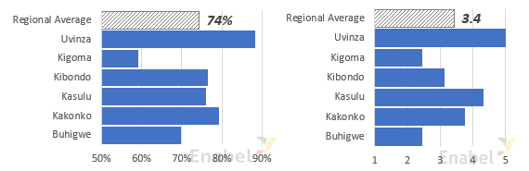
Source: SAKIRP beneficiary survey Dec 2018

556 farmers were trained on group constitution and management.
A Kiswahili training manual of farming as a business was developed. The training “farming as a business” was rolled out in 2018-Q2. 4000 farmers were trained by 3 local consultancy firms.

The support to agricultural production remains important as yields are often inadequate to cover production costs. Increasing access to improved cassava varieties and increasing bean yields (varieties, crop protection) are essential to the generation of tradable surpluses and improvement of household incomes. The reported average yield of cassava chips improved from in 2.9 T/ha 2017 to 3.7 T/ha in 2018. Bean production is improved from 456 kg/ha to 570 kg/ha in 2018.

The participatory variety assessment of cassava outlined Mkombozi as still the most preferred variety because of the starch content and early yields. Mkombozi is CBSV susceptible. Of the double tolerant varieties Chereko was the preferred variety by the farmers.

Preferred cassava varieties Origin cassava planting material
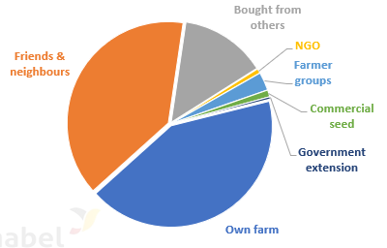
Source: SAKIRP on farm demos 2017-18.

Virus diseases are a serious threat for the profitability of the cassava value chain. Cassava brown streak virus has led to the collapse of yields in the Lake Zone and Rwanda. The cassava pest & disease scan was carried out by ARI Maruku / Tumbi and Ukiriguru. The cassava brown streak virus (CBSV) spread further because of inadequate quality monitoring of QDS cutting production fields by the relevant stakeholders. The available quantities of double tolerant varieties (for instance Chereko) are small and transport cost high. As a consequence, local susceptible varieties and Mkombozi are still widely planted. Micro propagation and collaboration with prisons for cutting multiplication will provide relief in the future. Cassava multiplication plots established in 2017 did not yet produce sufficient cuttings in 2018 because of insufficient maturing stages.

Severity of cassava brown streak virus (CBSD) Severity of cassava mosaic disease (CMD)
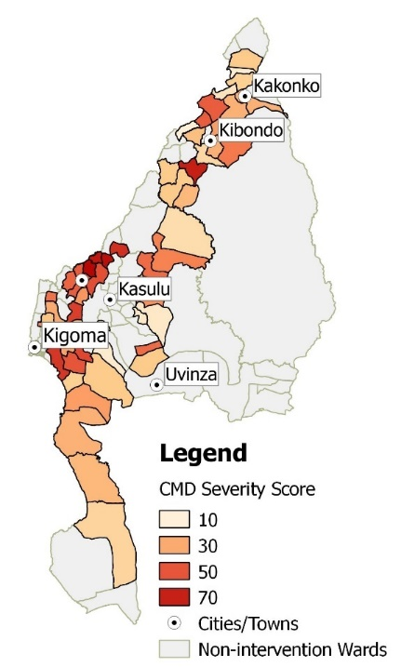
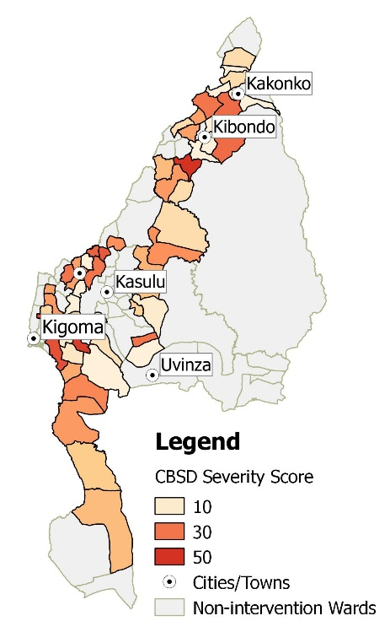

Source: SAKIRP household survey 2018 & quarterly beneficiary monitoring

The bean crop was important this year to stabilise the household income while other crop prices were declining. The availability of improved bean varieties has improved to 32% but actual adoption is lower (12%). Average yields have improved from 456 kg/ha (2017) to 570 kg/ha (2018). This is still low but reflect the soil fertility, moisture and management constraints. Yields of 1.800 kg/ ha have been obtained in the best plots. The average adoption of improved bean varieties improved from 12% in Feb 2018 to 17% in Oct 2018. 67 bean field days were organised at district and ward level. -

Availability & adoption of improved bean varieties Origin bean seed sources

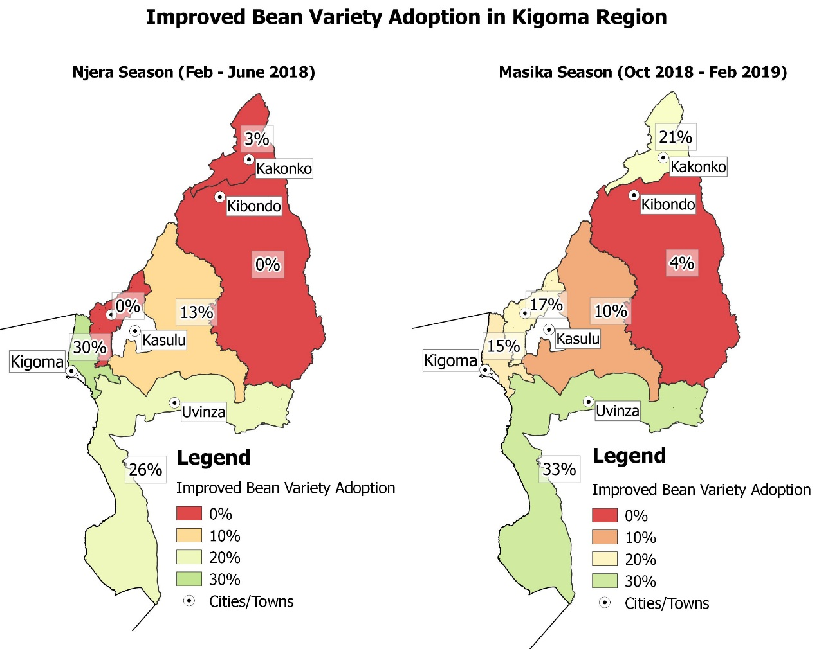

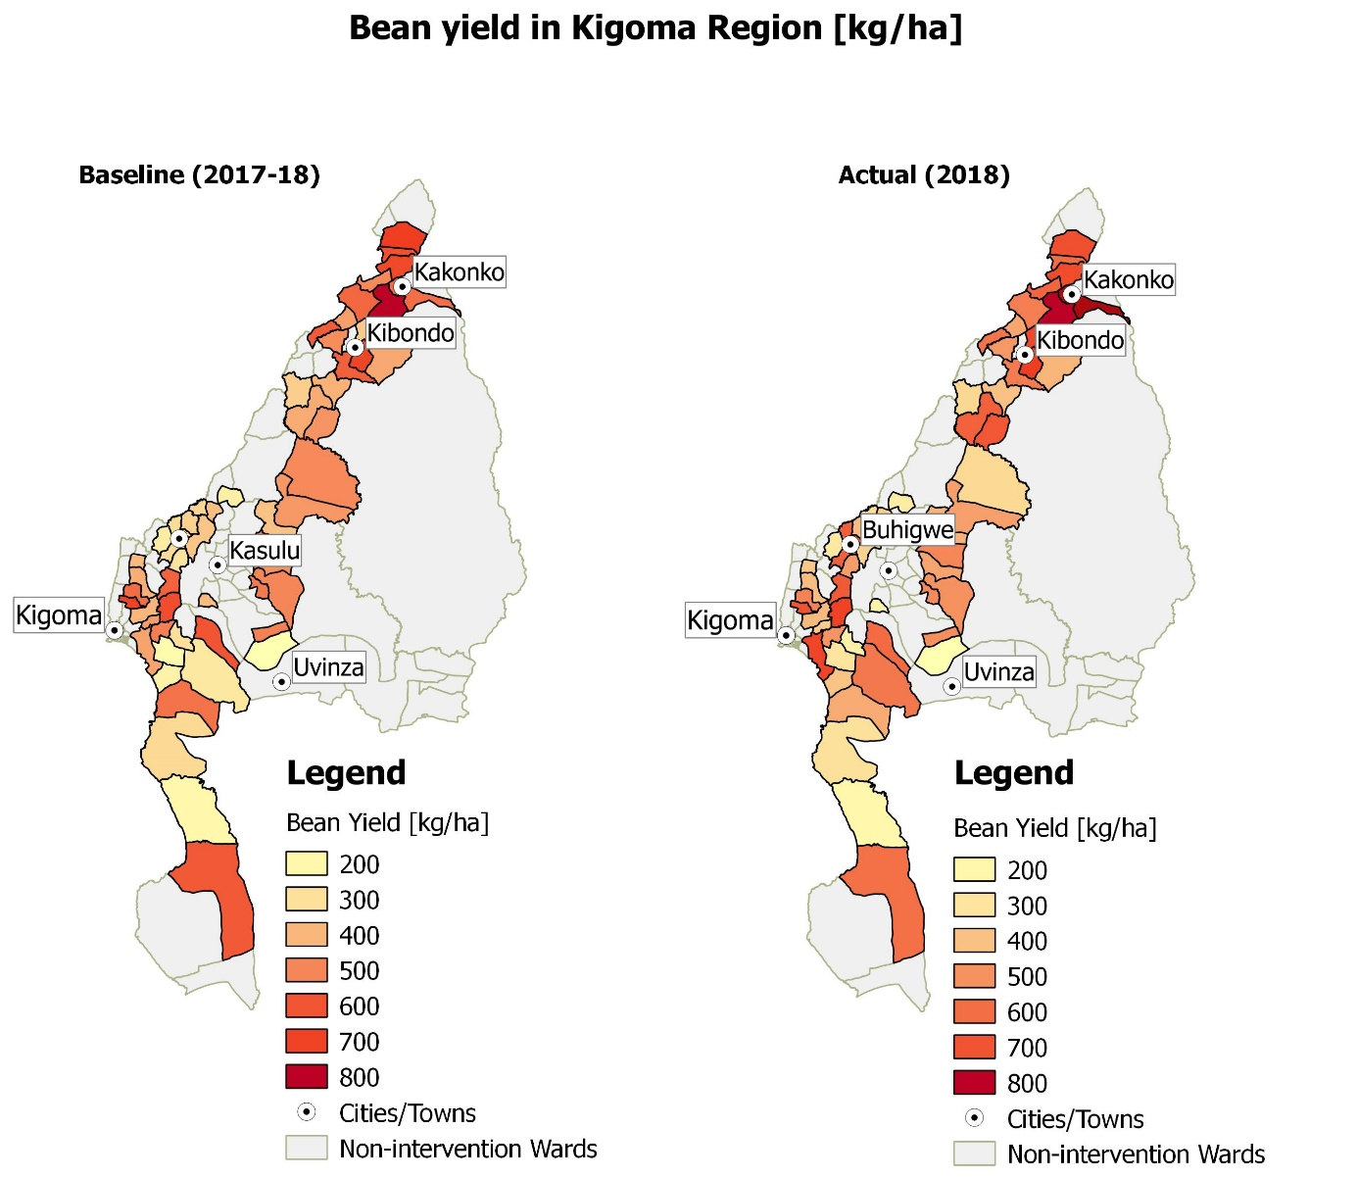

On farm demonstration plots are a tangible activity for agricultural technology assessment.
Farmer field school principles of action research and in the field, observations are used to assess the new varieties of cassava & beans and good agronomic practices. Nevertheless, some groups are more interested in production and subsidized inputs.

Good agricultural practices tested on farm versus local practice
Beans | - Varieties (Lyamungo 90, Jesca, Calima Uyole, Montcalm, Uyole Njano, Kigoma Yellow)  - Modest fertilizer rate & foliar spray  - Liming
Cassava | - Disease resistant varieties CMD – CBSV  (Kipusa, Chereko, Mkumba, Mukuranga, Mkombozi & local)  - Spacing  - Modest fertilizer use

Bean and Cassava Demonstration and Multiplication Plots in Kigoma Region
 | Demonstration plots |  | Multiplication plots
Year | Beans | Cassava | Beans | Cassava
2017 | 96 | 93 | 24 | 24
2018 | 208 | 113 | 164 | 203

In order to strengthen local seed systems, SAKIRP applied the pragmatic concept of community multiplication plots based on the following observations:
- Only 5.3% of the seed used in Tanzania is certified which is exceedingly inadequate to meet the needs of farmers. 95% of the seed planted by farmers is from the informal seed systems.
- The need of rapid and cost-effective multiplication at ward level in order to serve many farmers.
- Community multiplication plots offer a good entry-point for new varieties from the formal system. They are complementary to the certified seed supply.
- Seed business in remote villages is not profitable for agro-dealers. The fragmented demand and high transport cost do not make business sense.

The 164 community bean multiplication plots produced 40.000 kg of bean seeds in 2018.
The 203 community cassava multiplication plots are expected to yield 10 million cuttings for the 2019-Q4 season.

SAKIRP is conscious about the need for clean planting materials and strict disease monitoring. The seeds and planting materials for demos and multiplication plots were acquired from ARI Maruku / Uyole and TOSCI registered commercial seed farmers (CSE) in order to ascertain the quality. Unfortunately, SAKIRP had to recall and destroy cassava cutting material from a certified cutting producer whose field was found infected with CBSV in Kakonko. The quality & quantity of CSE cassava planting material remain a challenge. 55 farmers were trained on quality declared seed production by Tanzania Official Seed Certification Institute (TOSCI). The focus was on procedures, phyto- sanitation and legal ways of producing and marketing of QDS seeds.

The intended large-scale cutting multiplication by the prisons for cassava multiplication did not take off because of insufficient basic planting material of Chereko and institutional constraints.

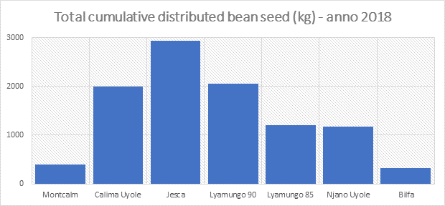

Estimated available planting material produced
in Kigoma Region (at group level)
 | Bean seed (kg) | Cassava cuttings
2017 | - | -
2018 | 50.000 | 1.000.000
2019 | 500.000 | 10.000.000
Projected 2020 | 1.000.000 | 200.000.000
Projected 2021 | 10.000.000 | 4.000.000.000
Equivalent planted fields 2021 | 115.000 ha | 400.000 ha

Technology adoption in individual households varied amongst the crops. In cassava, it increased only slowly from 10% to 13% because of the low prices and long production cycle. One positive development is the increased uprooting of diseased cassava plants. In beans, average technology adoption increased considerably from 18% baseline value to 29% in Dec 2018. Fertilizer use (DAP & foliar spray) and correct spacing are more and more adopted. Lack of affordable credit and input supply in far off villages are important constraints to better technology adoption.

Technology adoption in individual households

Cassava

Beans

Source: SAKIRP household survey 2018 & quarterly beneficiary monitoring
Soil samples were analysed to provide better guidance for fertilisation. In some areas, where the soil has been cultivated for several decennia, liming is required to restore soil fertility.

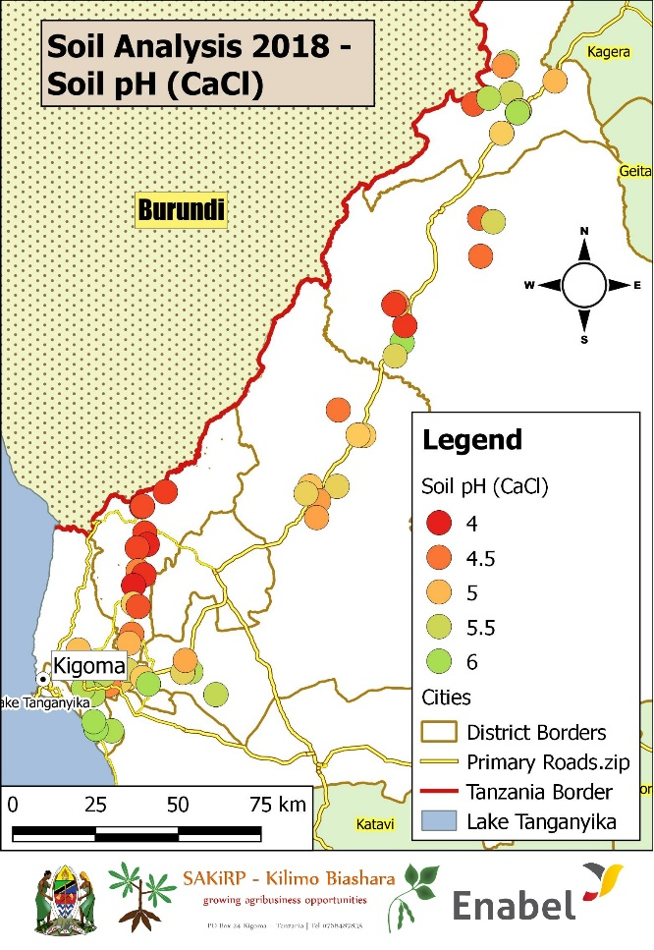

A field training of integrated pest management in beans was organised for 324 farmers.

Contract farming and value chain development through lead firms.
The champion firm - GAFCO - decided to pull-out of the bean value chain in Tanzania because of the unfavourable market conditions. The collaboration with smallholder farmers proved not profitable because of high transaction cost, side-selling, poor quality, fragmented production and adverse weather conditions. GAFCO realised that albeit its efforts and investments, the input loans, crop insurance and poor production levels were indebting smallholder farmers and not contributing to improved incomes. The GAFCO withdrawal led to a drop to farmers engaged in contract farming. SAKIRP lost an important partner for structured bean markets in Kakonko district and the demonstration of the value chain development model. A new partnership for structured bean markets was started with the Belgian firm Casibeans and the local firm Third Man.

All farmer groups were trained on post-harvest management of beans and demo materials were distributed. 3 bean threshers and 3 bean cleaners were purchased and they will be field tested in 2019-Q1. 80% of the cassava graters donated by different agencies were evaluated. No machine is integrated in the informal village economy. Constraints are related to the group approach, limitation of the press technology and missing market linkages. Local contribution, the association with existing village milling machines and better pressing technology would alleviate the problems. However, the main constraint remains the market for pressed flour as the small consumer basis wants fermented cassava.

Performance output 5: marketing & trade.

Progress of indicators
The aim of this result is to increase farmers’ access to organised markets for both beans and cassava through the installation of commercially viable and sustainable market linkage arrangements. Sustainable trade and market access are highly dependent on the performance of other project results such as result two access to value chain financing and result four which seeks to improve farmer organisation and productivity. To date, progress on result five indicators has lagged behind due to the value chain financing impasse for local traders together with the unpreparedness of large-scale commodity firms to enter into sourcing arrangements with local smallholder producers. The predominance of informal trading arrangements perpetuates unstructured marketing thereby slowing down efforts towards collective and structured marketing.

Result 5: Improved market access and sustainable trade
INDICATORS | Project  Baseline |  | Overall Target | 2018 |  | 2019 | 2020
INDICATORS | Date | Value | Overall Target | Actual | Target | Target | Target
I5.1a - % of smallholder producer groups participating in structured cassava market relationships | 2017 | 5% | 50% | 1% | 10% | 25% | 50%
I5.1b - % of smallholder producer groups participating in structured bean market relationships | 2017 | 4% | 50% | 1% | 10% | 25% | 50%
I5.2a - Value of cassava sold through structured marketing by smallholder producer groups (Million TZS) | 2017 | 28 | 8.000 | 4 | 600 | 3.800 | 8.000
I5.2b - Value of beans sold through structured marketing by smallholder producer groups (Million TZS) | 2017 | 21 | 4.000 | 112 | 400 | 1.900 | 4.000
I5.3a - % increase in sales by local cassava traders | 2017 | 0% | 50% | -5% | 50% | 50% | 50%
MALE |  | 0% |  | -9%
FEMALE |  | 0% |  | 7100%
I5.3b - % increase in sales by local bean traders | 2017 | 0% | 50% | 53% | 10% | 25% | 50%
MALE |  | 0% |  | 53%
FEMALE |  | 0% |  | n/a
I5.4a - % of farmers accessing objective sources of cassava market information | 2017-2018 | 41% | 75% | 33% | 50% | 65% | 75%
MALE |  | 44% |  | 35%
FEMALE |  | 39% |  | 32%
I5.4b - % of farmers accessing objective sources of bean market information | 2017-2018 | 29% | 75% | 32% | 50% | 65% | 75%
MALE |  | 28% |  | 35%
FEMALE |  | 31% |  | 28%

Indicator | Comments
I5.1a - % of smallholder producer groups participating in structured cassava market relationships | Less than 1% of all the groups have transitioned to structured marketing. These are groups that are involved in joint cassava processing. Dried cassava trade has remained largely informal and unstructured.
I5.1b - % of smallholder producer groups participating in structured bean market relationships | 1% of groups are engaging in structured production and marketing of beans. These are groups that are linked to Casibeans. This indicator significantly regressed because of the withdrawal of GAFCO
I5.2a - Value of cassava sold through structured marketing by smallholder producer groups (Million TZS) | Only 4 million worth of cassava flour was sold under structured marketing arrangements. The low volume reflects the low demand and inability of groups to consistently produce to the needs of the market
I5.2b - Value of beans sold through structured marketing by smallholder producer groups (Million TZS) | Beans sold to GAFCO under contract farming grossed TZS112 million
I5.3a - % increase in sales by local cassava traders | The volume of cassava sold by smallholder farmers declined 5% as export demand dropped and margins shrunk.
I5.3b - % increase in sales by local bean traders | Beans recorded a 53% increase in volumes traded as some traders redirected their efforts to this crop away from cassava
I5 - % of farmers accessing objective sources of cassava and bean market information | This indicator rose to 32% as the project leveraged extension officers and digital methods to expand the dissemination of information on market trends

Progress of main activities
Progress has been made under all the five major activity groups for this result area.

Planned activities | Progress status
Planned activities | A | B | C | D
Conducting market surveys
International market research and intelligence gathering |  | X
National market research and intelligence gathering |  | X
Supporting collectors, processors and traders in VCD initiatives and facilitate market linkages
Market linkage and promotional support to SMEs |  |  | X
Business development support to SME aggregators |  | X
Business development support to SME processors |  |  | X
Strengthening the existing market information system(s) for the major crops
Collect, collate and disseminate market information |  | X
Supporting public infrastructures and sale points
Equipment and material support to village aggregation centres |  | X
Technical support to aggregation management committees |  | X
Strengthening advocacy capacities regarding trade issues and other issues with the value chain
Support the development of an effective Business Membership Organisation of SME aggregators and processors |  | X
Training and capacity development on cross-border trading |  | X

Analysis of progress made
The year 2018 experienced excess production and supply of staple food crops including maize and beans. In Kigoma, as in the rest of Tanzania, this led to a sustained decline in the price of dried cassava which traded below 150 Tanzanian shillings per kilogram for most of the year. Depressed prices triggered reductions in the volume of trade as farmers held to the stocks anticipating an improvement in price. Bean prices remained largely stable with periodic movements reflecting seasonal changes in supply and demand. Building on the successful trials of new bean varieties in the 2017/2018 season, the project has stepped up the commercialisation of the bean value chain through introduction of structured marketing arrangements targeting global bean markets. A pilot run for structured bean marketing is underway linking smallholder with Casibeans, a Belgian commodity trading firm, with the intermediation of a local agricultural exporting firm, Third Man Private Ltd.
Overall assessment of the progress made on main activities

Progress under this result has been slow on the back of a slump of cassava prices and a general oversupply of staple foods across the East African region. Efforts were directed towards the laying of strong foundations for fostering competitiveness in each of the value chains.

Value chain profiling and promotion
Promotional value chain profiling leaflets were prepared for both cassava and beans. Profiles were shared with potential buyers as part of value chain promotion to attract private agribusiness firms to Kigoma.

Farming as a Business Training
To foster a commercial orientation to farming, the project trained over 4.000 farmers on farming as a business. On-the-job coaching is in progress to ensure the business knowledge is translated into practical actions at farmer group level.

Farming as a Business Training Summary | Total/Av.
Registered farmers | 5381
Farmers trained | 4239
% farmers trained | 79%
Groups registered | 195
Groups trained | 191
Total cost in TZS - million | 137 m
Average group attendance | 26
Average cost/farmer in TZS | 32,001
Average cost/farmer in € | 12

Structured marketing arrangements
The project has linked 200 farmers to a local agribusiness firm, Third Man Ltd, for exporting Lyamungo beans to Europe. A total volume of 50 metric tons is expected to be delivered to the market in 2019-Q1.

Figure: Participation in Collective Marketing on the Increase

Cassava value addition and processing
- In response to the sustained cassava price slump, the project promoted primary processing of cassava at farmer group level. This was accompanied with linkages with secondary processors who use the raw cassava flour supplied by farmers to produce refined cassava flour for distribution to retail markets.
- Optional markets were explored including the market for dried cassava in China but this market proved to be unviable due to high transportation costs from Kigoma to Dar es Salaam

Farmer groups involved in processing | 3
Quantity processed between June 2018 and January 2019 | 6.7 MT
Farmer groups linked to secondary processors | 3

The main challenges constraining cassava flour processing are limited domestic demand, difficulties of getting TBS certification which is a requirement to export and stiff competition from maize flour prices. The higher prevalence of informal cassava processing and trading also constitutes a major barrier to the emergence of formal processors within Kigoma region. Moreover, the ability of most entrepreneurs to invest in product development is limited.

Market access and sustainable trade challenges
Progress on this result has been hindered by a combination operational factors and a general deterioration in the market environment.

Business viability and sustainability challenges
- Over the past three seasons, bean prices in Tanzania have been consistently higher than in other East African countries like Rwanda and Uganda. The domestic market offers good prices to smallholder farmers. As a result, Tanzania has turned into a high-cost sourcing country with adverse effects on profit margins of private sector actors.

- Difficulties associated with smallholder production saw GAFCO withdraw from its contract farming activities in Kakonko and the rest of the country. Reasons cited for the withdrawal include the following:
  - Recurrent cases of crop failure occasioned by successive climate perils across all GAFCO's areas of operation.
  - Despite efforts to mitigate the risk to farmers with crop insurance, there have been multiple instances where farmers have lost money and remain in debt.
  - Inadequate yields and the resultant low production, made it difficult for farmers and GAFCO to reach sustainability.
  - Continuation of financing in this high-risk environment, smallholder farmers would have resulted in unsustainable increase in insurance premiums and interest rates.
  - Growing market pressure on all the crops leading to reduced margins and overall losses
  - Smallholder side selling behaviours and sub-export quality smallholder production contributed to operational challenges.

- Unfavourable market conditions for cassava
- A generally depressed market for staple food crops in East Africa led to reduced demand and price pressure on both cassava and beans
- Local demand for improved cassava flour remains insignificant. Expansion into regional cassava flour markets is hindered by lengthy and costly quality certification processes

High costs of production and market participation for beans
- Yields for beans in Kigoma are still much lower compared to other parts of the country. As a result, beans produced by farmers in Kigoma are not competitive on a price basis. Coupled with high costs of transportation, this high production cost base discourages large agricultural firms from establishing sourcing linkages with Kigoma farmers

Undercapitalisation at trader and processor level
- SMEs engaged in trading and processing are still constrained by lack of investment and working capital. As a result, SMEs’ buying scope is limited resulting in low prices and high business fragmentation. The result is that trading in both beans and cassava remains highly inefficient
- Undercapitalisation has limited meaningful investments into processing activities
- The blockage of the value chain financing grant left the project with limited options for addressing financing constraints faced by local SME traders.
- On the whole, the project’s efforts to support the private sector are constrained by the lack of appropriate private sector supporting tools

Lack of a home market for cassava
- Cassava production in Kigoma remains highly dependent on demand conditions in the primary export markets of Burundi and Rwanda. Local demand is too insignificant to support transformation.
- Unlike in other markets like Nigeria and Uganda, Tanzania lacks a government industrial policy to support cassava sector industrialisation. Lack of government guidance has seen limited interest from the private sector

Lessons learnt
- Increasing productivity is central to value chain transformation
- Increasing yields of both cassava and beans is key to increasing profitability for both farmers and private sector firms. Low yields generate price tension and scare away buyers
- Investment in improved inputs should translate into increased yields or else the farmer is left worse off due to the increased cost of production
  - Export pricing structure is not as high as anticipated by farmers and the price premium is not large enough if yields do not significantly rise in line with additional input investments
- Gaps in input supply undermines structured marketing arrangements
  - Dysfunctional input supply markets hinder well-resourced farmers from venturing into commercial production, especially for beans. This situation puts the project in a dilemma as it cannot directly support farmers outside the smallholder threshold.
- Medium and large-scale farmers can be an essential partner for smallholder market inclusion
  - Smallholder farmers, on their own, lack the clout to meet the volumes demand by the market. It is, therefore, essential to have a large-scale farmer inclusive model in order to boost production volumes and generate some economies of scale
- Local markets are a competitive option for smallholder farmers
  - In the case of beans, national markets present a better option in terms of net returns. This is true in view of the additional effort and costs required to meet export quality requirements and move the beans through a much longer value chain.
Recommendations
- Make adjustments in the targeting strategy to allow for a hybrid targeting strategy
  - A focus on smallholder farmers that totally excludes medium to large-scale farmers undermines the sustainability of structured market linkages and misses an opportunity to build and strengthen local value chain dynamics.
  - The project should be flexible enough to allow participation of smallholder farmers in a manner that increases the overall attractiveness and competitiveness of the value chain. Large-scale producers lower the costs of sourcing from Kigoma by counterbalancing the low productivity of their smallholder counterparts.
- Expand the scope of value chain engagement training to cover informal middlemen (dalals) to encourage system-wide behaviour change. The cooperation of middlemen is indispensable to the development of structured and efficient markets.

Transversal Themes

Gender
Efforts have been made to mainstream gender considerations at different stages of the project. Currently SAKIRP reaches out to about 14. 800 farmers and 68% are women.
The high female participation was achieved through:
- Selection of value chains in which women have the biggest participation i.e. beans and cassava.
- Selection of groups with the highest membership of women i.e. village loan and savings associations – VICOBAs. The strong participation of women hinges on the selection of VICOBAs during the initial diagnostic survey of producer groups. The graph below shows percentages of women participation by type of producer group.

Graph: Participation of women in groups, by group type
District | Male (adult) | Female (adult) | Male (youth) | Female (youth)
Buhigwe | 21% | 56% | 7% | 16%
Kasulu | 21% | 58% | 6% | 15%
Kakonko | 24% | 54% | 10% | 12%
Kibondo | 25% | 54% | 9% | 12%
Kigoma | 25% | 57% | 5% | 12%
Uvinza | 30% | 51% | 7% | 13%
Total (%) | 24% | 55% | 7% | 13%

Source: SAKIRP diagnostic survey 2017

The SAKIRP interventions allow for strengthening qualitative participation of women in the value chain and in decision-making in the farmer producer groups. Gender considerations were mainstreamed in the “farming as a business” manual. SAKIRP data collection tools are gender-segregated. The gender mainstreaming manual was prepared and all lead farmers received special training on gender mainstreaming. The following action points were agreed during the training:
- Data recording by gender for every intervention done by the lead farmer at the group level.
- Sensitize and encourage participation of women in training activities
- Facilitate review of the group by-laws to introduce the clause for the 50-50% in leadership positions.
- Identify beans and cassava women traders within and outside the groups
- Sensitize groups to adopt weeding herbicides or animal draught technology to relieve women from the burden of manual farm labour.

At the level of output, some results are already obtained. See the table below:
Output Indicator | Female | Male
General engagement with project | 68% | 32%
Lead Farmers (extension service by farmers) | 40% | 60%
Group chairperson | 44% | 56%
Group secretary | 47% | 53%
Training participation | 72% | 28%
Farmers participating in contract farming | 42% | 58%
Ward extension officers | 11% | 89%

Gender equity and participation concerns have been considered in the choice of end markets. In combination with external, domestic market segments were included for both value chains as they are more accessible to women.

Grating technologies are being piloted with the objective of lessening the drudgery on women. Three groups have been supported with processing facilities to upgrade the value of their farm produce (cassava graters) and market linkage was facilitated. Out of 3 three groups, one is women’s group and the other two are mixed groups which demonstrated gender equality. Some challenges have been encountered in efforts to upgrade processing activities by women in urban centres. The major challenge has been the unwillingness to migrate to improved cassava flour. Women traders general deal in traditionally prepared dried and fermented cassava flour and there is fear of losing customers. Meanwhile, business development assistance support to Maendeleo Women of Informal Sector Cross-Border Trader Association (MWISCBTA) is continuing, including linkages to farmer producer groups for the supply of grated cassava paste.

In the bean value chain, thresher and cleaning technology is being tested to reduce the time that women spend threshing and winnowing beans. Successful deployment and scale-up of this technology will increase the viability of bean production for both men and women. 40% of contract farming participants are women and future expansion will seek to increase the number of women included.

A dedicated technical advisor was in charge of gender and capacity building since the beginning of the project but unfortunately, he left the project at the end of 2018.The anchoring of gender expertise will be reconsidered in the mid-term review.

There is still a gender discrepancy for the progress of the technical indicators:

Indicator – Dec 2018 | average | male | female
Value of incremental sales of cassava by smallholder beneficiaries | 462. 627 | 630,840 | 326,840
Value of incremental sales of beans by smallholder beneficiaries | 199,457 | 208,327 | 187,297
% adoption of cassava improved technologies by smallholder beneficiaries | 13% | 15% | 11%
% adoption of beans improved technologies by smallholder beneficiaries | 29% | 33% | 21%
Yield of cassava [MT/Ha] | 3,7 | 4 | 3.4
Yield of beans [Kg/ha] | 570 | 568 | 588
% of beneficiaries engaging in collective cassava marketing | 10% | 12% | 8%
% of beneficiaries engaging in collective bean marketing | 10% | 13% | 8%
Farmers participating in contract farming | 194 | 58% | 42%
Source: SAKIRP household survey 2018

Gender difference in land cultivation – ha.

Source: SAKIRP household survey 2018

Challenges
- Limitation to access formal loans by smallholder farmers, including women, to finance value chain activities for increased yield to allow them to participate effectively in the market
- To facilitate women, access and control over the production resources such as land is out of SAKIRP’s mandate and cannot easily be achieved within the project life time. It has a cultural constraint rather than legal issues.
- Resistance to adopt labour reducing technologies such as recommended herbicides and mechanization. Promotion is going on to enhance adoption.

Gender differences in key socio-economic parameters
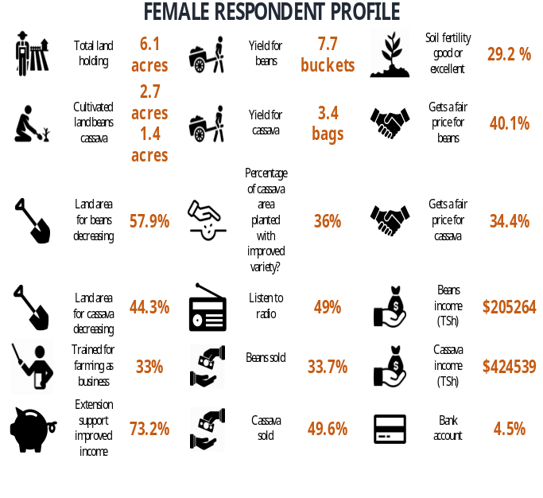
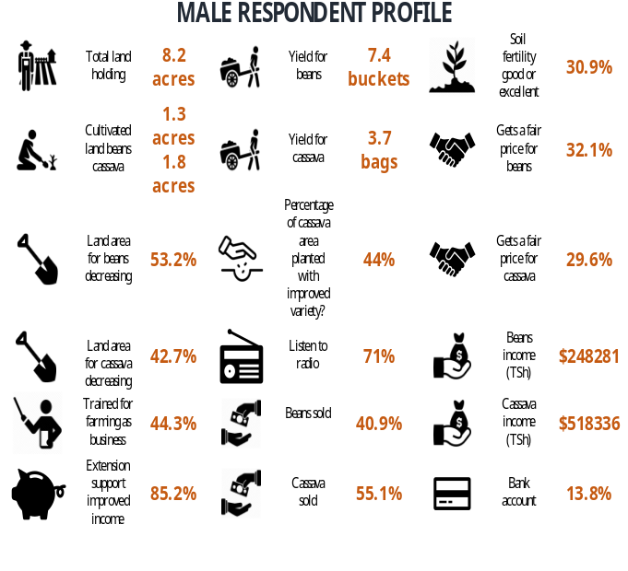

On the whole, the gender and women empowerment will need to be stepped up to enable both men and women to equitably control value chain activities and benefits.

Environment and climate change
SAKIRP is mainstreaming the environmental issues in its activities. There are strong linkages between environment and LED and agriculture. With the demographic growth, expansion of agricultural production relies heavily on further cultivation of miombo woodlands in Kigoma region.

 | Buhigwe | Kakonko |  | Kasulu | Kibondo | Kigoma | Uvinza | Total Region
Conservation zone in vicinity? | 26% | 43% |  | 56% | 63% | 25% | 83% | 50%
Average Distance [km] | 4 | 3 |  | 9 | 4 | 5 | 5 | 5
Encroachment problems encountered * | 16% | 24% |  | 46% | 16% | 36% | 33% | 40%
* Note that the percentage of encountered problems are calculated for the groups in the vicinity of conservation zones only.

A lot of cassava cultivation is taking place in miombo forests. Cultivation has often reached the borders of Moyowosi game reserve and forest reserves. Smallholder farmers will encroach wetlands and forest & game reserves in search for free and fertile land. There is strong political pressure to de-gazette conservation zones and allow agricultural production. In the highlands, there is increased risk of soil erosion. The southern wards of Uvinza in Uvinza are in a last frontier zone where pastoralists and farmers are cultivating the last patches of miombo forests in the open areas.

Demos and multiplication plots in conservation zones are not supported. Emphasis will be put on soil & water conservation and proper land use. Ridging along the contours of cassava plots and the association with leguminous crops at the end of the rotation can have an important conservation impact if applied on a regional scale. Cassava is relatively tolerant of poor soil fertility management by smallholder farmers and drought. It is therefore seen as a crop that contributes to the resilience of smallholdings in the context of climate change.

Pesticides are an important factor to increase farm and labour productivity. SAKIRP advises on the proper use of agricultural inputs to mitigate their environmental damage. The use of fertilizer is not an environmental threat given the small amounts that are used. The use of fertilizer will allow for a better and faster closed canopy of the crops thereby limiting water runoff and erosion. Fields with well managed soil fertility reduce the need for further cultivation of miombo forests and wetlands. Beans are the only leguminous crop in the crop rotation of smallholder farmers in Kigoma and their further promotion will add to nitrogen fixing and maintenance of soil fertility albeit on a limited scale.

With regards to the management of the project, the biggest environmental foot print is the carbon emissions of the flights between Kigoma and Dar es Salaam and Europe for staff, consultants and backstopping. Backstopping by Skype and WhatsApp reduces the need for travel. An additional pollution factor is the use of heavy 4*4 vehicles even on tarmac roads. During procurement, 3 hiluxes were purchased that are more fuel efficient than land cruisers. The use of motorcycles is encouraged where appropriate. Establishing a regional transport pool rather than operating individual project cars will further contribute to efficiency. Printing is very much reduced – most data storage and communication is done by ICT. Efficient use of electricity, water and transport will reduce waste and pollution. It is expected that the Enabel green procurement guidelines will provide best practices in the future.

Issue | Mitigation effort
- Encroachment conservation zones (national parks, watershed areas, forest reserves, game reserves) by farmers | - Pre-condition for support – no fields in conservation zone  - Sensitisation producer groups  - Monitoring by village government & SAKIRP
- Soil erosion - especially in cassava production as canopy closes only after 3 months. | - Promote cultivation on closed ridges along contour lines  - Promote use fertilizer & manure for better crop growth.
- Pesticide contamination – biggest threat is insecticide impact on bees. Excessive use of agro pesticides can also contaminate groundwater but this level has not been achieved. | - Train farmers on integrated pest management, correct use pesticides and destruction containers  - Promote tobacco that is easily broken down and has less residues  - Do not promote atrazine and simazine as pre-emergence herbicide  - Collaborate bee user associations & district bee officer to identify susceptible areas where tobacco should not be used.  - Collaborate district water engineer to identify sensitive zones.

Other
Local economic development, markets for the poor, promotion of small and medium enterprises and public-private partnerships are important concept which complement the value chain approach to make economic growth inclusive and provide trade and employment opportunities for the poorer sections of the population.

Risk management

Identification of risk or issue |  |  | Analysis of risk or issue |  |  | Deal with risk or issue |  |  | Follow-up of risk or issue
Risk description | Period of identification | Category | Likelihood | Potential impact | Total | Action(s) | Resp. | Deadline | Progress | Status
JLPC not really effective due to being too much concerned on operational issues and too little on strategic issues | TFF | OPS | Medium | Medium | Medium Risk | Streamline JLPC with only strategic institutions and delegate operational monitoring to Technical committees  and to Regional and District Stakeholder Meetings | Project coordination unit | ongoing | split steering committee and regional stakeholders meeting helps to off sett operational issues | Terminated
 |  |  |  |  |  | From the start creating clear comprehension of the members of the JLPC what their mandate and role is. | Project coordination unit, RR | Oct-16 | first meeting steering committee dealt with responsibilities and the mandate. | Terminated
Tendency of Districts to spread the project activities over too many value chains and areas, which dilutes the quality of outputs in each. | TFF | OPS | Medium | Medium | Medium Risk | Continuous dialogue with districts on strategy of project and reasoning behind strategic choices | Project coordination unit | Jun-17 | only 2 value chains selected will keep multiplication of activities in check | Terminated
 |  |  |  |  |  | Early communication guidelines | Project technical team | Nov-16 | clear communication that SAKIRP not local government programme and not all admin units need to be covered | Terminated
Tensions among the population on both sides of the border disturb seriously the cross-border trade | TFF | OPS | Medium | Medium | Medium Risk | Develop market strategies which are not only focused on the cross-border trade but also on the market of  other regions in Tanzania | ITA marketing | Jul-17 | civil unrest in Burundi has consequences for the trade there but creates markets around the refugee camps. Refugee and seasonal labour from Burundi are essential for crop expansion in Kigoma | Terminated
Insufficient attention for the gender dimension in VC activities | TFF | DEV | Medium | Medium | Medium Risk | Top down accountability for integrating gender at all phases of the programme and at all levels of the PIU | NTA Gender | ongoing | Selection of value chains and producer groups in function of gender. Experienced gender NTA left project – need for new approach to support gender, TOR value chain assessment gender specific, gender trainings conducted 2018- Q2, producer groups membership 68% female | In progress
Delays of implementation at District level linked to administrative and technical bottlenecks | TFF | OPS | Medium | Medium | Medium Risk | Provide technical and administrative assistance to Districts to influence bottlenecks, calling on their accountability and on the support through JLPC | DEDs districts project coordination | ongoing | many activities are implemented in regie, personnel shortage at agricultural department impacts on implementation. DFPs and WAEOs double for other functions | In progress
 |  |  |  |  |  | Variety of partners including private sector and civic society | PIU | Jul-17 |  | In progress
Delays in contracting service providers due to bureaucratic procedures at region and district for procurement and tendering | TFF | OPS | Medium | Medium | Medium Risk | Centralize as much procurement as possible for service contracts, but keep a close eye on performance-based payments | Procurement officer | ongoing | Enabel tendering procedures are followed as the project is managed in regie. Belgian tender procedures require also time and resources. | In progress
 |  |  |  |  |  | Procurement is according to Belgian legislation | IFO | ongoing | grant procedures are very elaborate and will affect time for implementation of the micro finance fund | In progress
Mistrust among value chain actors (e.g. private - public sector) and not having  the willingness to collaborate | TFF | OPS | Medium | Medium | Medium Risk | Have an approach from the beginning of the dialogue between actors to create trust and engagement and ensuring the capacity of facilitators for this | Project team | ongoing | SAKIRP has been reaching out private sector. mistrust is there given taxation regime and difficulties to obtain licenses. Mistrust expands equally to development projects that are seen as fat cats. | In progress
Resistance in LGA to contract nonstate service providers with the necessary know-how and expertise | TFF | OPS | High | Low | Medium Risk | Involve LGA fully in the assessment of the need for services and support by the chain actors and the assessment of performance of service providers  (including the public sector) | PIU | Jul-17 | Directive of presidency that government agencies in the first place do business with other state actors is a setback to better engage the private sector | terminated
 |  |  |  |  |  | Advocate during the project implementation consequent  the principles of Value for Money. | PIU | Jul-17 | ongoing + competitive procurement and call for proposals | terminated
Implementation modalities of other donor funded projects are only facilitating micro-projects and therefore possibly disrupting a VCD approach | TFF | OPS | Medium | Medium | Medium Risk | Establish good communication and coordination platforms with other projects/agencies who have interventions linked to the selected value chains | PIU | ongoing | SAKIRP has reached out to other programmes in pro-active way to avoid duplication and use as much as possible existing modalities - need for stronger coordination mechanisms between agricultural projects - many have same crops | In progress
Service providers do not continue after the end of the project due to lack of core funding | TFF | DEV | High | Medium | High Risk | service component was scaled down given the risk, lack of demand and available funding | Project technical team | ongoing | Autochthone demand for BSD services is limited. Mixed consultants with about 40% from Kigoma.Sido and MoCoU having branches locally. | In progress
 |  |  |  |  |  | reliance on district extension service and strong capacity building instead of outsourcing to NGOs | Project technical team | in place |  | In progress
 |  |  |  |  |  | make sure service provision takes local purchase power into consideration | BDSP | recurrent |  | In progress
The inability to open "special accounts" for the project as per Execution Agreement, leads to a cumbersome fund flow system | TFF | FIN | Medium | Medium | Medium Risk | Use of the District development or miscellaneous account needs careful monitoring to ensure funds are earmarked for project and not allocated to other sectors | Financial team | 2016-Q2 | specific agreement provides for project implementation in "regie" that allows for efficiency but reduces ownership by LGA | Terminated
 |  |  |  |  |  | Use of alternative accounts by transferring money through M-pesa | Financial team | 2016-Q2 | specific agreement provides for project implementation in "regie" | Terminated
Ineffective control of financial information at District and Regional level and questionable reliability and inconsistency in report data | TFF | FIN | Medium | Medium | Medium Risk | Prepare PIM in an early stage and provide orientation and training and guidance in its use | Financial team | recurrent | PIM approved by JLPC  Kobotoolbox helps to improve data reliability | terminated
 |  |  |  |  |  | Provide administrative backup from PIU to districts to help improve quality of reporting |  | recurrent | pending implementation | terminated
 |  |  |  |  |  | Activities are implemented in regie and large fin admin section is employed | Financial team | recurrent | done | terminated
 |  |  |  |  |  | Organize regular financial audits (internal and external) and deal with issues through management reports | Financial team | recurrent | audit 2017 was done in Jan 2018 and did not reveal major issues. Next audit 2019-03 | terminated
Delays of implementation at project level due to difficulties to find and retain the right HR | Q3 2016 | OPS | Low | High | Medium Risk | Paying attention to retention potential | PIU & RR | recurrent | In 2018 – high turn-over staff – 4 NTAs / 1 procurement officer | In progress
 |  |  |  |  |  | Expedite the recruitment of partners | PIU & RR | recurrent | WAEO double as ward executive officers | In progress
Food export bans of the government while main cassava markets of Kigoma region are in neighbouring countries | inception phase | DEV | High | Medium | High Risk | organise/ link with farmer lobby groups - communicate evidence-based research on food security | RAA | recurrent | pending - discussed with AGRA who have lobbying section DSM & Dodoma | In progress
 |  |  |  |  |  | l | RAA | recurrent | Ban was lifted after good harvests | In progress
 |  |  |  |  |  | sensitize RC and district leadership | PIU | recurrent | issue brought up in RRC of Nov 2016 | In progress
Few dependable local partners for the implementation of SAKIRP activities in Kigoma region and reliable organisations already fully engaged with their own plans | inception phase | DEV | Medium | High | High Risk | mobilize partners from outside the region - allow for national call for proposals + rely on existing district extension system | PIU | recurrent | collaboration & capacity building of 31 extension workers | In progress
 |  |  |  |  |  | screen for best local partners during inception phase and value chain assessment | PIU | 2017-Q3 | diagnostic survey ongoing but ENABEL procedures grant agreements very tedious and slow | In progress
Many more agricultural programmes that target the same local partners will create an absorption capacity problem of donor funding | inception phase | DEV | High | Medium | High Risk | strengthen coordination mechanisms region for agricultural sector | PIU | recurrent | issues raised during induction meeting new leaders at region & 1 coordination meeting organised - coordination with senior AGRA staff is excellent but implementing partner is still considering adjustments | In progress
 |  |  |  |  |  | coordination agreements with other agricultural programmes | PIU | recurrent | agreement signed with LIC/DANIDA for cassava processing | In progress
Bean output is limited and might not justify an exclusive market approach | inception phase | DEV | Medium | Medium | Medium Risk | assess production output beans during value chain assessment | consultants | 2017-Q1 | important consideration during the VCA | In progress
 |  |  |  |  |  | include improved but locally adapted bean varieties and crop husbandry in value chain development | DFP-NTA FFS | recurrent | introduction new improved varieties with better yield potential or on farm testing Jesca, Uyole Njano, Lyamungu 90, Production for Casibeans pilot was expected 50 tons but only half of this was produced | In progress
Trade in Kigoma is dominated by the informal sector with limited growth potential and interest to develop smallholder agriculture | inception phase | DEV | High | Medium | High Risk | assess capacity of informal sector for value chain development | DFP-NTA markets | 2017-Q3 | important consideration during the VCA | In progress
 |  |  |  |  |  | promote Kigoma as investment destination for formal exporters of agricultural commodities | DFP-NTA markets | 2017-Q3 | collaboration with GAFCO as only larger and formal bean commodity exporter | In progress
Cassava brown streak virus disease is not contained and reduces cassava production considerably | inception phase | DEV | High | High | Very High Risk | training farmers & extension workers on CBSV identification and quarantine | DAICOS - DFP-NTA FFS - partners | 2017-Q4 | implemented & on-line tools and extension materials produced | In progress
 |  |  |  |  |  | introduction of cassava varieties that have double tolerance: CMD & CBSV | DAICOS - DFP-NTA FFS - partners | 2017-Q4 | introduction double tolerant varieties for on farm testing and multiplication | In progress
 |  |  |  |  |  | cassava disease scan | WAEO, ARI Maruku & M&E unit | recurrent | implemented: survey identified 10% regional prevalence with some hot spots of >30% (Uvinza, Kakonko, Kasulu wards) | In progress
The credit crunch risk that financial institutions will not have adequate funds to avail for agricultural lending. This is in light of the general reduction in liquidity in the market | inception phase | DEV | High | Medium | High Risk | convert collateral fund into revolving loan fund for more leverage | SC | 2017-Q3 | approved approach | In progress
Ward extension officers will not be able to improve their performance in supporting farmer groups. This risk is heightened by the likelihood of having more projects drawing on the same staff | JLPC | DEV | Medium | High | High Risk | cluster offices | PIU | 2017-Q3 | cluster offices established | In progress
 |  |  |  |  |  | open discussion with DEDs / RAS | PIU | 2018-Q1 | ongoing via RAA | In progress
 |  |  |  |  |  | performance reviews | DED/ PIU | 2018-Q1 | performance assessments Waeos via Kobo toolbox and DFP reporting | In progress

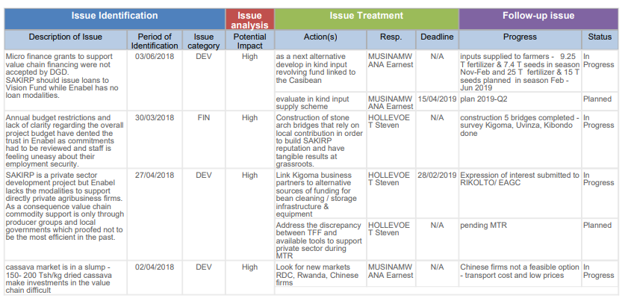

Steering and Learning

Strategic re-orientations

Strategic re-orientations | justification | Approval steering committee
- More emphasis on production alongside trade and aggregation | The value chain assessment revealed crucial bottlenecks at the level of production. The quantities of beans produced are small in Kigoma region and availability of improved varieties is limited. Viral diseases threaten cassava production and trade as what happened in Lake Zone and Rwanda. | Yes, meeting 13th July 2017
- Pluralistic approach of collaborating with producer groups rather than the single focus on farmer field schools | In Kigoma region, FFS are few and they have been dormant waiting for the next round of ASDP funding. The diagnostic survey of village groups identified the VICOBAS and smallholder producer groups as high potential grassroots structures. | Yes, meeting 13th July 2017
- Stronger collaboration with the local government extension system | Only the local government has extension staff on the ground in the districts. ENABEL grant agreement procedures are very strict and few local organisations can comply with them. Collaboration with government services does not require these elaborated procedures. | Yes, meeting 13th July 2017– but monitoring performance is required
- Investment fund refocused on public infrastructure | The TTF proposal of an investment innovation fund for the private sector met a procurement challenge as Enabel cannot provide grants to private companies. Private companies can only be assisted through credits and not by a grant fund. As a consequence, the investment fund focuses now on public infrastructure, based priorities by district councils, | Yes, meeting 13th July 2017
- Be realistic about targets & improvement service delivery component | Limited available budget. Limited demand for business development services. Few organisations that can effectively provide BDS services | Yes, meeting 13th July 2017
- Adoption of input credit  scheme. | The value chain financing grant was vetoed. As an alternative an in-kind credit supply scheme for inputs was developed to kick-start structured market linkages. It is understood that this is a sub-optimal mitigation strategy that deviates from best practice in micro-finance. | Yes, meeting 28th October 2018
- The construction of bridges to improve the access from farm to markets/ | The market infrastructure survey showed critical bottlenecks at the majority of sites: no market master plans, no land for expansion, demolishing existing structures would involve compensation and long negotiations, markets are seen as tax enforcement instruments rather than tools to promote trade and employment. In addition, UNCDF made a commitment to construct the same markets. Supporting bridges will improve access to agricultural markets and general service delivery. It is high on the government agenda. | Yes, meeting 28th October 2018

Recommendations

Recommendations | Actor | Deadline
- Expand the scope of value chain engagement training to cover informal intermediaries to encourage system-wide behaviour change. The cooperation of local intermediaries is indispensable to the development of structured and efficient markets. | PIU | 2019-Q3
- Allow flexibility in the project targeting strategy to allow for a hybrid targeting strategy that is inclusive of large-scale farmers that do not fall into the poor category. | JLPC | JLPC Meeting 2019 Q1
- Promote the adoption of a value chain financing approach through convening a coordination working group to share lessons and experiences | PIU | 2019 – Q3
- Expand the use of anchor farmers to the multiplication of improved cassava cuttings | PIU | 2019-Q4
- Improve the logistics related to the processing of cassava cuttings from sub-contracted suppliers of ARI Maruku so that the quality and vigour adheres to the required standards and that no additional financial burden is caused to clients. | ARI Maruku | ongoing
- Step up the certification of cassava commercial seed entrepreneurs and the verification of the quality of the produced cuttings. Increase the TOSCI resources or delegate more to districts, so that regular and in-dept are too thinly spread over the vast area of Western Tanzania. | TOSCI - MEDA | ongoing
- Adhere to minimum standards to contain the spread of cassava brown streak virus i.e. QDS production fields that are CBSV infected and its distributed should be immediately destroyed. | TOSC  ARI Maruku | ongoing
- Belgian development aid will focus more on private sector development. The approval of the tools (grants to innovative private sector proposals, support to micro-finance) need to be expediated so that Enabel can fulfil this new | Enabel HQ  DGD | ongoing

Lessons Learned

Lessons learned | Target audience
- Low productivity is currently the main constraint to value chain transformation for beans. Increasing productivity is a pre-condition for attaining price competitiveness on the market. | VCD projects
- Regional and national level buyers are already embedded within the local market through the agency of informal market intermediaries who pass on information about local supply opportunities. Therefore, a value chain transformation model that leaves out local market intermediaries is bound to face resistance and disruption. | VCD projects
- Underdeveloped agricultural input supply systems constitute a weak link in structured marketing arrangements. Input supply system strengthening should be prioritised earlier along the value chain development cycle | VCD projects
- Exclusive focus on smallholder farmers undermines the business viability and sustainability of structured market linkages. Supporting smallholder farmers is a high cost approach because of the low input-output ratio. A hybrid model that combines medium and large-scale farmers with smallholder farmers is better proposition for agribusiness firms. | VCD projects
- Linkages of informal farmer producer groups to formal financing should be preceded by adequate financial literacy training and group strengthening efforts. Premature linkages are likely to lead to non-performing loans and eventual demise of producer groups | Financial service providers
- In Kigoma region, farmer field schools are few and they have been dormant waiting for the next round of ASDP funding. The TFF assumption that FFS are the essential building blocks for strong farmers’ organisations does not hold ground. A systematic assessment of the existing producer groups and SACCOs (market orientation, management, social coherence, leadership, risk mitigation) will identify the most reliable partners and the capacity gaps. Farmers’ organisations are weak in Kigoma region and will not provide for the driving force of the value chain development. | Steering committee
- 95% of the cassava produced in Kigoma is exported to Burundi and Rwanda. These markets are temporary because of political unrest (Burundi) or a collapse of the production (Rwanda). A big volume is exported informally to Burundi. Exports of cassava to neighbouring countries do not affect food security in the region as local residents prefer generally maize. Awareness on cassava diseases is low while the risk of a cassava brow streak virus outbreak is high. | Agricult projects  Min Agriculture
- There is a good market for yellow beans and beans in general. Kigoma production remains low due to poor husbandry conditions. The Kigoma yellow variety does not attract a premium payment – on the contrary beans from Kigoma are seen as of inferior quality by Kahama traders. Kigoma yellow has a limited yield potential. As a cash crop it is better replaced by improved yellow varieties released by research institutions that should be tested on farm first. | General
- Important risks are: government bans on food exports as 90% of Kigoma cassava is exported to East African neighbours; cassava production collapse due to cassava brown streak virus while no tolerant varieties have been released; the informal actors that have limited growth capacity and no commitment to development of smallholder agriculture | Steering committee
- From local governments, there is still a strong demand that the programme gets involved in agricultural production. The findings of the value chain assessment, the low yields and the non-availability of disease resistant cassava varieties underpin that need. | Steering committee
- Cassava producers in Kigoma are largely disengaged from the value addition process. Albeit the media hype of Chinese companies and value addition, cassava processing did not take off. Even with the current low prices the Burundi market remains the best rewarding. | General
- Despite the industrialisation drive in the country, the opportunity for cassava use in industrial processes has not matured yet. The immediate opportunity is in regional food markets where demand is already proven | General
- Most agricultural market information systems have failed to outlive their sponsoring projects due to lack of viable business model to sustain them | General
- Social media, especially WhatsApp, represent a new opportunity for agricultural communities and value chain actors to generate and share valuable market information | General
- Digital tools enhance the efficiency and timeliness of data collection whilst making it much is to remotely supervise field staff and assure quality of their work inputs | LGA agriculture departments
- Many storage structures built under DASIP remain unused because of a poor commercial location, ownership by village government and lack of market linkages. It is not the farmers that seek large storage capacity but private traders. | LG, MA
- Lack of a financial services breeds adverse coping mechanisms and marketplace practices by farmers, i.e. selling of crops before they mature and selling of crops without value addition. | General
- The value chain development model remains a difficult undertaking in a context of smallholder farmers, fragmented production/ markets and remote regions such as Kigoma. Companies refer to high costs of working with smallholders, poor quality, risk of side-selling and high expectations. The recent pull-out of GAFCO and the reluctance of other firms to fill the gap are indicators for the very narrow margins. | Steering committee
- Bean cleaning technology has not made a headway amongst bean trading companies. Hand picking remains the standard practice due to high cost of imported equipment, poor local manufacturing and workers management. | Steering committee
- Stone arch bridges are a tested and strong technology that offer considerable cost advantages as compared to reinforced concrete bridges, | TARURA

Annexes

Quality criteria

1. RELEVANCE: The degree to which the intervention is in line with local and national policies and priorities as well as with the expectations of the beneficiaries
In order to calculate the total score for this quality criterion, proceed as follows: ‘At least one ‘A’, no ‘C’ or ‘D’ = A; Two times ‘B’ = B; At least one ‘C’, no ‘D’= C; at least one ‘D’ = D
Assessment RELEVANCE: total score |  |  | A | B | C | D
 |  |  | √
1.1 What is the present level of relevance of the intervention?
√ | A | Clearly still embedded in national policies and Belgian strategy, responds to aid effectiveness commitments, highly relevant to needs of target group.
 | B | Still fits well in national policies and Belgian strategy (without always being explicit), reasonably compatible with aid effectiveness commitments, relevant to target group’s needs.
 | C | Some issues regarding consistency with national policies and Belgian strategy, aid effectiveness or relevance.
 | D | Contradictions with national policies and Belgian strategy, aid efficiency commitments; relevance to needs is questionable. Major adaptations needed.
1.2 As presently designed, is the intervention logic still holding true?
 | A | Clear and well-structured intervention logic; feasible and consistent vertical logic of objectives; adequate indicators; Risks and Assumptions clearly identified and managed; exit strategy in place (if applicable).
√ | B | Adequate intervention logic although it might need some improvements regarding hierarchy of objectives, indicators, Risk and Assumptions.
 | C | Problems with intervention logic may affect performance of intervention and capacity to monitor and evaluate progress; improvements necessary.
 | D | Intervention logic is faulty and requires major revision for the intervention to have a chance of success.

2. EFFICIENCY OF IMPLEMENTATION TO DATE: Degree to which the resources of the intervention (funds, expertise, time, etc.) have been converted into results in an economical way
In order to calculate the total score for this quality criterion, proceed as follows: ‘At least two ‘A’, no ‘C’ or ‘D’ = A; Two times ‘B’, no ‘C’ or ‘D’ = B; at least one ‘C’, no ‘D’= C; at least one ‘D’ = D
Assessment EFFICIENCY: total score |  |  | A | B | C | D
 |  |  |  | √
2.1 How well are inputs (financial, HR, goods & equipment) managed?
 | A | All inputs are available on time and within budget.
√ | B | Most inputs are available in reasonable time and do not require substantial budget adjustments. However, there is room for improvement.
 | C | Availability and usage of inputs face problems, which need to be addressed; otherwise results may be at risk.
 | D | Availability and management of inputs have serious deficiencies, which threaten the achievement of results. Substantial change is needed.

2.2 How well is the implementation of activities managed?
 | A | Activities implemented on schedule
√ | B | Most activities are on schedule. Delays exist, but do not harm the delivery of outputs
 | C | Activities are delayed. Corrections are necessary to deliver without too much delay.
 | D | Serious delay. Outputs will not be delivered unless major changes in planning.
2.3 How well are outputs achieved?
 | A | All outputs have been and most likely will be delivered as scheduled with good quality contributing to outcomes as planned.
√ | B | Output delivery is and will most likely be according to plan, but there is room for improvement in terms of quality, coverage and timing.
 | C | Some output are/will be not delivered on time or with good quality. Adjustments are necessary.
 | D | Quality and delivery of outputs has and most likely will have serious deficiencies. Major adjustments are needed to ensure that at least the key outputs are delivered on time.

3. EFFECTIVENESS TO DATE: Degree to which the outcome (Specific Objective) is achieved as planned at the end of year N
In order to calculate the total score for this quality criterion, proceed as follows: ‘At least one ‘A’, no ‘C’ or ‘D’ = A; Two times ‘B’ = B; At least one ‘C’, no ‘D’= C; at least one ‘D’ = D
Assessment EFFECTIVENESS: total score |  |  | A | B | C | D
 |  |  | √
3.1 As presently implemented what is the likelihood of the outcome to be achieved?
√ | A | Full achievement of the outcome is likely in terms of quality and coverage. Negative effects (if any) have been mitigated.
 | B | Outcome will be achieved with minor limitations; negative effects (if any) have not caused much harm.
 | C | Outcome will be achieved only partially among others because of negative effects to which management was not able to fully adapt. Corrective measures have to be taken to improve ability to achieve outcome.
 | D | The intervention will not achieve its outcome unless major, fundamental measures are taken.
3.2 Are activities and outputs adapted (when needed), in order to achieve the outcome?
√ | A | The intervention is successful in adapting its strategies / activities and outputs to changing external conditions in order to achieve the outcome. Risks and assumptions are managed in a proactive manner.
 | B | The intervention is relatively successful in adapting its strategies to changing external conditions in order to achieve its outcome. Risks management is rather passive.
 | C | The intervention has not entirely succeeded in adapting its strategies to changing external conditions in a timely or adequate manner. Risk management has been rather static. An important change in strategies is necessary in order to ensure the intervention can achieve its outcome.
 | D | The intervention has failed to respond to changing external conditions, risks were insufficiently managed. Major changes are needed to attain the outcome.

4. POTENTIAL SUSTAINABILITY: The degree of likelihood to maintain and reproduce the benefits of an intervention in the long run (beyond the implementation period of the intervention).
In order to calculate the total score for this quality criterion, proceed as follows: At least 3 ‘A’s, no ‘C’ or ‘D’ = A; Maximum two ‘C’s, no ‘D’ = B; At least three ‘C’s, no ‘D’ = C ; At least one ‘D’ = D
Assessment POTENTIAL SUSTAINABILITY : total score |  |  | A | B | C | D
 |  |  |  | √
4.1 Financial/economic viability?
 | A | Financial/economic sustainability is potentially very good: costs for services and maintenance are covered or affordable; external factors will not change that.
√ | B | Financial/economic sustainability is likely to be good, but problems might arise namely from changing external economic factors.
 | C | Problems need to be addressed regarding financial sustainability either in terms of institutional or target groups costs or changing economic context.
 | D | Financial/economic sustainability is very questionable unless major changes are made.
4.2 What is the level of ownership of the intervention by target groups and will it continue after the end of external support?
 | A | The steering committee and other relevant local structures are strongly involved in all stages of implementation and are committed to continue producing and using results.
√ | B | Implementation is based in a good part on the steering committee and other relevant local structures, which are also somewhat involved in decision-making. Likeliness of sustainability is good, but there is room for improvement.
 | C | The intervention uses mainly ad-hoc arrangements and the steering committee and other relevant local structures to ensure sustainability. Continued results are not guaranteed. Corrective measures are needed.
 | D | The intervention depends completely on ad-hoc structures with no prospect of sustainability. Fundamental changes are needed to enable sustainability.
4.3 What is the level of policy support provided and the degree of interaction between intervention and policy level?
 | A | Policy and institutions have been highly supportive of intervention and will continue to be so.
√ | B | Policy and policy enforcing institutions have been generally supportive, or at least have not hindered the intervention, and are likely to continue to be so.
 | C | Intervention sustainability is limited due to lack of policy support. Corrective measures are needed.
 | D | Policies have been and likely will be in contradiction with the intervention. Fundamental changes needed to make intervention sustainable.
4.4 How well is the intervention contributing to institutional and management capacity?
 | A | Intervention is embedded in institutional structures and has contributed to improve the institutional and management capacity (even if this is not an explicit goal).
√ | B | Intervention management is well embedded in institutional structures and has somewhat contributed to capacity building. Additional expertise might be required. Improvements in order to guarantee sustainability are possible.
 | C | Intervention relies too much on ad-hoc structures instead of institutions; capacity building has not been sufficient to fully ensure sustainability. Corrective measures are needed.
 | D | Intervention is relying on ad hoc and capacity transfer to existing institutions, which could guarantee sustainability, is unlikely unless fundamental changes are undertaken.

Decisions taken by the steering committee and follow-up
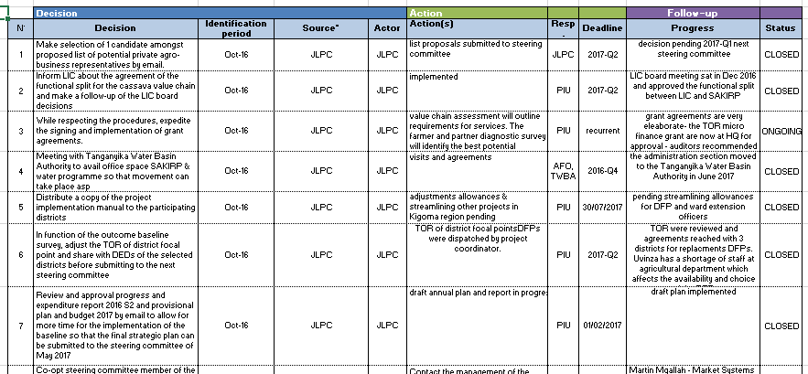

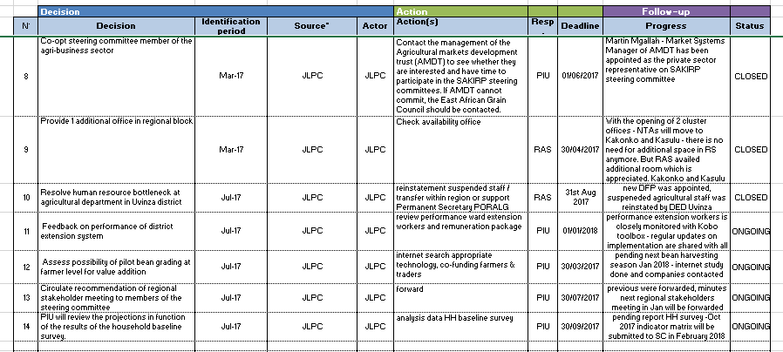

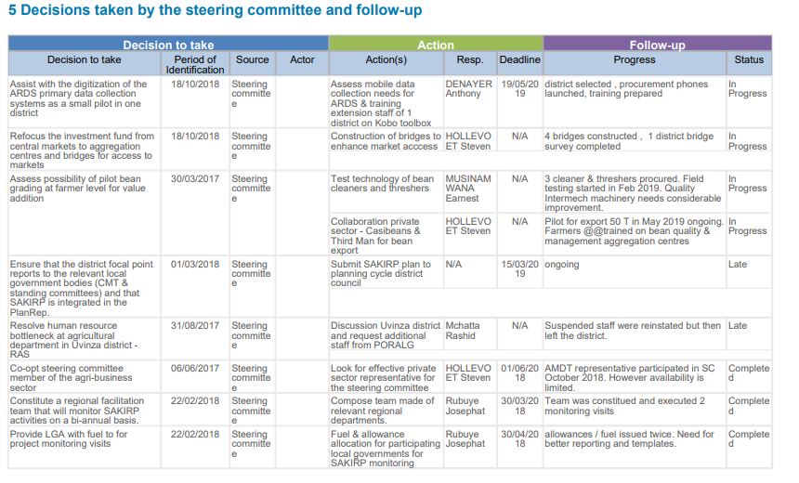

Updated Logical framework
The logical framework has not been updated as the opportune moment is the midterm review in 2019-Q2. There is definitely a need to appraise the log-frame in view of:
- The non-approval of the value financing grant that was proposed in the TFF
- The lack of Enabel modalities to support the private sector.
- The limited absorption capacity of smallholder producer groups
- The shift from private investments to public infrastructure.

Some indicators will need polishing and other be added to capture better the quality and value addition.

MoRe Results at a glance

Logical framework’s results or indicators modified in last 12 months? | No but it is anticipated during the MTR 2019 especially for result 2.
Baseline Report registered on PIT? | Baseline report is still being improved. A draft version was posted on PIT and Go-fast.
Planning MTR (registration of report) | 2019-Q2
Planning ETR (registration of report) | 2021-Q1
Backstopping missions since | last backstopping mission was in 2017-Q2  next backstopping mission is planned in 2018-Q2 to review recommendations of the MTR and incorporate in new planning.

“Budget versus current (y – m)” Report

euro | Budget | TOT previous Years | TOT 2018 | Balance | Disbursement Rate end 2018
Total | 8,000,000 | 1,269,625 | 870,558 | 5,859,817 | 27%
A - Activities | 4,260,000 | 346,980 | 367,787 | 3,545,233 | 17%
Result 1 | 312,000 | 113,705 | 15,865 | 182,429 | 42%
Result 2 | 2,030,000 | 26,850 | 26,538 | 1,976,612 | 3%
Result 3 | 585,000 | 86,330 | 147,968 | 350,702 | 40%
Result 4 | 852,000 | 41,380 | 162,536 | 648,084 | 24%
Result 5 | 481,000 | 78,715 | 14,880 | 387,406 | 19%
B - NTAs/ITAs | 2,054,400 | 489,147 | 350,218 | 1,215,035 | 41%
X - Reserve | 93,050 | 0 | 0 | 93,050 | 0%
Z - General Means | 1,592,550 | 433,498 | 152,553 | 1,006,499 | 37%

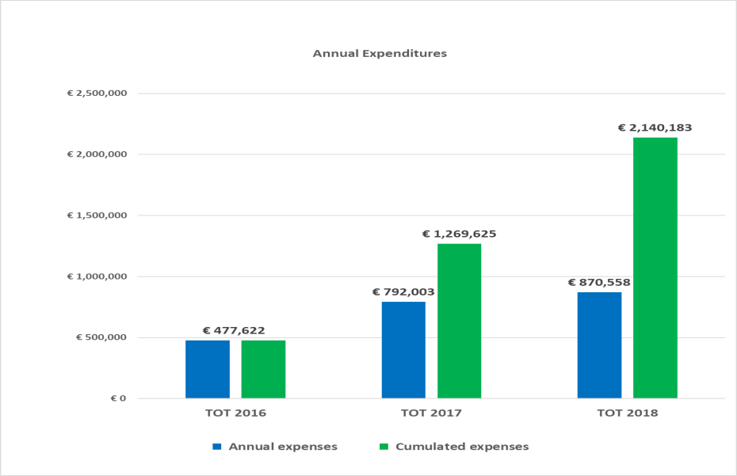

The distribution of the expenses per quarter in 2018 is as follows:

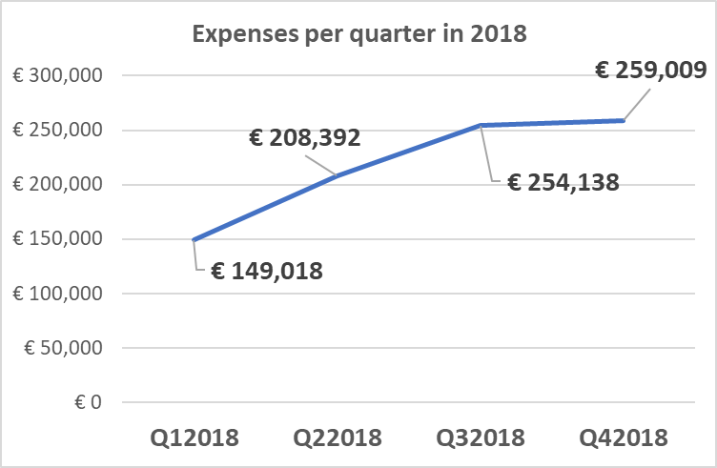

The activities expenditures of € 367,787 are split per type of per result in 2018 as follows:

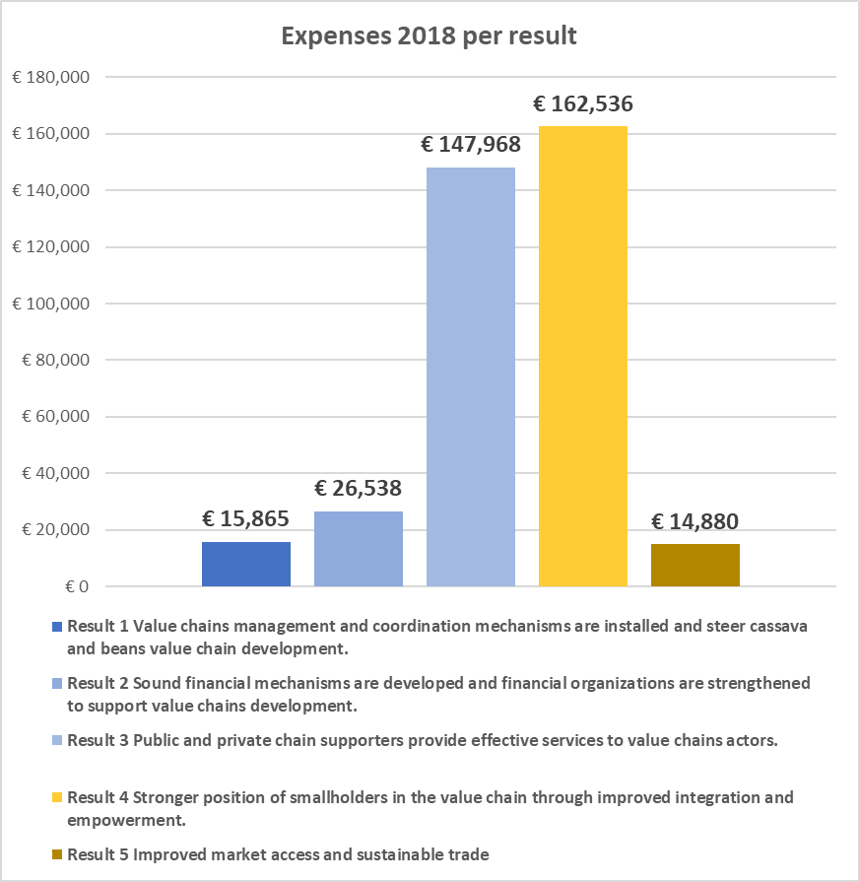

The Project Financial plan for the following year targets € 1,356,012 in 2019. This represents a 55% increase compared to 2018. The targeted overall budget consumption by the end of 2019 amounts: € 3,496,196 with a 42% budget execution ratio.

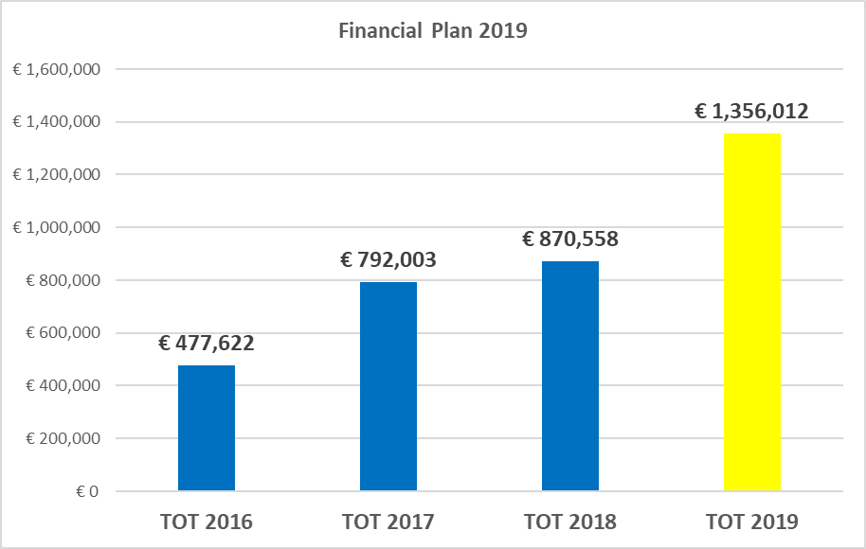

Communication resources
Extension materials (Kiswahili)
- Posters cassava mosaic virus & brown streak virus (reprinted with permission CRS)
- Leaflets cassava mosaic virus & brown streak virus (reprinted with permission CRS)
- Cassava cultivation (adapted from the original Meda brochure)
- Manual on cassava cultivation
- Manual on bean cultivation
- Manual farming as a business
- Gender training manual for lead farmers and extension workers.

Tools
- Diagnostic tools for the assessment of farmer and partner organisations
- Questionnaires for market surveys of beans and cassava
- Written tests and interview questions for the selection of technical advisers
- Kobo toolbox for data collection and performance monitoring of field workers
- Training manual Kiswahili – farming as a business
- Quick survey priority ranking rural markets
- Map Kigoma region
- Template assessment sites proposed for bridge construction
- MoU with village for bridge construction

Reports
- Value chain assessment beans in Kigoma region
- Value chain assessment cassava in Kigoma region
- Market study: cassava Burundi & Uganda
- Market study: cassava Rwanda
- Market study: beans in Tanzania
- Household baseline survey Kigoma region 2017
- Household survey Kigoma region 2018
- Quick scan of cassava pest and diseases 2017 & 2018
- Value chain financing assessment for cassava and beans in Kigoma region
- Credit preparedness in Kigoma region
- Evaluation of cassava graters in Kigoma region

Technical specifications
- TORs of high quality were developed for the value chain assessment and the market surveys of beans and cassava.
- Criteria for selection of lead farmers.
- Construction stone arch bridges

Impact refers to global objective, Outcome refers to specific objective, output refers to expected result
A = The activities are ahead of schedule B = The activities are on schedule C = The activities are delayed, corrective measures are required D = The activities are seriously delayed (more than 6 months). Substantial corrective measures are required
A: The activities are ahead of schedule B The activities are on schedule C The activities are delayed, corrective measures are required. D The activities are seriously delayed (more than 6 months). Substantial corrective measures are required.
This is the value of cassava sold by groups engaged in cassava processing
This is the volume of beans sold through GAFCO during 2018
There is only one female-owned business which increased trading volume from 1500kgs to 108000 kgs
There is no female trader trading in beans
A = The activities are ahead of schedule B = The activities are on schedule C = The activities are delayed, corrective measures are required D = The activities are seriously delayed (more than 6 months). Substantial corrective measures are required

