
Formulation report

study and expertise fund

Mozambique

DGD Code : NN 3014385
navision Code : moz 13 026 11



Table of contents
Table of contents 2
Abbreviations 3
1 Adopted operating procedure 4
1.1 Context 4
1.2 Mission Management and Approach 4
1.3 Validation of the identification 5
1.4 Initial record 6
1.5 Final record 8
2 Policy Context 9
2.1 Reference to national policies of the partner country 9
2.2 Institutional framework 9
2.3 Belgian strategy 10
2.4 Interventions by other donors, main lessons learned and possible synergies 11
3 Additional Studies 13
4 Technical and financial file 14
5 Risk Analysis 15
5.1 priorities are not defined 15
5.2 Resolving coherence matters in the Belgian bilateral programme 15
6 Cross cutting themes 16
7 References 17
8 Annexes 18
8.1 BTC Memo on the status of the formulation of the ‘capacity building fund’ dated 22/08/2013 18
8.2 Programme of the mission 21

Abbreviations
BFFS | Belgian Fund for Food Security
BI | Beneficiary Institution
BTC | Belgian Technical Cooperation
CB | Capacity Building
DGD | Directorate General for Development Cooperation and Humanitarian Aid
DIC | National Directorate of Investments and Cooperation
DNEAP | National Directorate of Studies and Policy Analysis
DNP | National Directorate of Planning
ENDE | National Development Strategy
FSNP | Food Security and Nutrition Programme
FUNAE | National Energy Fund
GoM | Government of Mozambique
ICP | Indicative Cooperation Programme
ME | Ministry of Energy
MFP | Ministry of Public Service
MICOA | Ministry of Environmental Coordination and Action
MMAS | Ministry of Women and Social Affairs
MINAG | Ministry of Agriculture
MINEC | Ministry of Foreign Affairs and Cooperation
MISAU | Ministry of Health
MPD | Ministry of Planning and Development
MTR | Mid Term Review
NSA | Non State Actors
NEPAD | New Partnership for Africa’s Development (led by the African Union)
PAP | Programme Aid Partnership
PARP | Action Plan for the Reduction of Poverty
PEDSA | Strategic Plan for Agricultural Development
PESS | Health Sector Strategic Plan
PNDRHS | National Plan for the Development of Human Resources for Health
PNISA | National Investment Plan for the Agrarian Sector in Mozambique
RSP | Public Sector Reform
SC | Steering Committee
SCF | Study and Consultancy Fund
SETSAN | Technical Secretariat for Food and Nutrition Security
TFF | Technical and Financial File
ToR | Terms of Reference
VAIS | Flanders International Cooperation Agency (Vlaams Agentschap voor Internationale Samenwerking)
- Adopted operating procedure
  - Context
Mozambique and Belgium signed a new Indicative Cooperation Programme in December 2012 for the period 2013 – 2017. An overview of the priority sectors, budgets and different instruments of the ICP is presented in the table below.
Indicative Cooperation programme | Budget
Sector programmes
Rural development - livestock component (MINAG) | € 25 million
Energy for rural development (ME, FUNAE) | € 19 million
Other instruments
Delegated cooperation to the United Nations for Gender and Environment | € 4.5 million
Institutional Capacity Building Fund  (renamed “Study and Expertise Fund” in the present TFF) and the Scholarships programme | € 6.5 million
TOTAL | € 55 million
Both sector programmes comprise a component of institutional strengthening through technical assistance and capacity building.
  - Mission Management and Approach
    - Objectives of the scoping mission
The purpose of the scoping mission was rather large and multiple and can be summarised as follows: “collect additional information on the current Study Fund and validate, complement and/or redirect the data from the identification file, as well to provide recommendations for the subsequent formulation process, taking into account the opportunities and risks identified”. (cf. ToR of scoping mission, 1.1.)
As part of the recommendations, issues related to the (new) strategic anchorage of the Fund, the future modality design and preliminary conditions, assumptions and risks were to be given specific attention.
An important element that was also included in the ToR of the mission was for the formulation team to “carry out a reflection on the links and coherence between the identification file of the CB programme and the future scholarships programme (also foreseen in the new ICP) and on the capacity building component in sector interventions”. Given the present intervention was the first one of the new ICP to be formulated, this additional task was seen as critical by all parties to clarify several grey areas and ensure a common understanding of the ICP text by all of those concerned.
    - Readjustment of formulation schedule
At the end of the scoping mission, the formulation team was able to conclude (in agreement with the BTC representation, Attaché and MPD) that a second mission would not be necessary as sufficient information was able to be gathered to allow the team to conduct the necessary analysis and propose the framework of intervention.
  - Validation of the identification
    - General and specific objectives
BTC was not involved in the identification phase of the intervention, and some time was therefore dedicated to discussing and clarifying the initial ambitions and scope of the CB Fund with the Head Attaché at the beginning of the scoping mission.
During the restitution of the scoping mission with MPD, the formulation team presented a revised specific objective. The initial specific objective proposed in the identification note – i.e. “Organisational capacities of selected institutions that receive support from the Belgian Cooperation have been improved (…) ” – was reformulated as follows: “ Organisational capacities of institutions of the priority sectors of the Belgian-Mozambican Cooperation have been improved” through short and medium-term consultancies and technical assistance, specific studies in priority sectors and areas of geographic concentration, as well as seminars.
Following the mission, this objective was further fine-tuned after having further discussed the need to narrow down the ambition of the scope of the intervention at HQ level (within BTC and with DGD) given the nature of such an instrument and modality. The intervention results were formulated as well at HQ level focusing on processes related to the effective implementation of the fund. The rationale behind these choices lies with the fact that ongoing and future sector programmes supported by the Belgian Cooperation will remain the driving force of sector strengthening (including capacity building) and hence the Study and Expertise Fund should be seen as an additional instrument that can come to support further efforts through its flexibility.
Specific Objective | Institutional and organisational capacity building efforts have been supported through short- and medium-term consultancies and technical assistance, specific studies and seminars in the priority sectors and geographical areas of concentration of the Belgian-Mozambican Cooperation.
Results | R1. The Study and Expertise Fund is set up and procedures are known among the institutions of the priority sectors at different levels  R2. Needs from the sectors are identified in line with their strategic and policy priorities  R3. Activities supported through the Study and Expertise Fund are implemented in a qualitative way
    - Budget of the intervention
The budget foreseen for the intervention is currently € 4 million out of a total envelope of € 55 million as provided in the ICP covering 2013 – 2017.
However several discussions held at HQ between August and November 2013 leaned towards a revision of the budget to € 3 million. (see point 1.4. here below for further details). The budget was finally set at 2.6 million euro after receiving the list of planned studies, consultancies and long-term expertise on 22/09/2014.
  - Initial record
N° of intervention DGD | NN
Navision Code BTC | MOZ 13 026 11
Name of intervention | Fund for Capacity Building
Partner institution | Ministry of Planning and Development
Duration of intervention | 60 months of implementation
Date of intervention | Start in 2014
Contribution of partner country | N/A
Belgian contribution | € 4 million
Sector (DAC code)
Brief description of the intervention | The identification file presented the intervention as follows: “ (…) the Fund for Capacity Building will play an important role in strengthening institutional capacities which will enable the realization of the PARP-goals.  The capacity building programme shall be based on the concept of organizational capacity building, meaning that the project aims at improving overall performance of institutions and organisations and their staff members.”
General objective | Contributing to capacity development of Mozambican institutions in the sector Agriculture/Food security, Energy for rural development and Health.
Specific Objective | The organisational capacities of selected institutions which are benefiting from the Belgian Cooperation have been improved by:  - Short term support in the format of consultancies;  - Specific studies, geographically and thematically concentrated in the above mentioned sectors, with a special attention to harmonization with the studies done by other donors and taking into consideration the priority transversal themes  - Short term support through the organization of specific seminars in Mozambique (training facilities).
Results | N/A
The identification file has been modified at different levels (see Final Record on next page). An explanation for each modification is given here below.
- The name of the intervention
Internal discussions within BTC and with DGD following the scoping mission led to a proposal to change the name of the intervention in order to reflect more adequately the ambition of the fund and highlight its real purpose in its name. So moving on from a former intervention running under the name of “study and consultancy fund” (from 2002 to date) to the suggestion of DGD of creating a “capacity building fund” in the ICP and identification file, BTC now suggests to rename the intervention “study and expertise fund” as is the case in a number of countries. This will allow for a better understanding of the purpose and nature of intervention as well as more harmonisation and better consistency with similar instruments operating in other countries.
- The specific objective
The first part of the specific objective presented in the identification file, which states that “organisational capacities of selected institutions which are benefiting from the Belgian Cooperation have been improved”, must be revised as it is not feasible measure the effect of punctual support generated through the study and expertise fund within the more global picture of capacity building overall. Moreover, capacity building is a very ambitious concept that requires efforts at different levels and on the long-term, therefore measurement of “improved capacity building” would be best embedded in large sector programmes rather than within an instrument such as the study and expertise fund, which should be considered as complementary to all other efforts and strategies covered through wider institutional support.
The scope of the specific objective is therefore reduced to supporting capacity building efforts in the priority sectors.
- The budget
During the writing of the TFF a general recommendations from within BTC was formulated to reduce the overall budget of the intervention from € 4 to 3 million.
The main concern came from the fact that future sector programmes supported by BTC in Mozambique already hold major capacity building components within their budgets, and that absorption capacity of the “CB Fund” may be affected due to low spending on soft activities such as consultancies, studies and seminars (even if the hiring of international expertise may be able to counter-balance these estimations). Equally as preoccupying, a thin envelope of € 2.5 million was provided for scholarships in the new ICP and it is estimated that more funds will have to be allocated to this instrument (which still requires a formulation following the guidelines of the new scholarships strategy).
As mentioned under 1.3.2 the budget was finally set at 2.6 million euro after receiving the list of actual planned studies, consultancies and long-term expertise. If necessary a replenishment remains possible as long as the total budget of the ICP has not been exhausted.

  - Final record
Intervention number | NN 3014385
Navision Code BTC | MOZ 13 026 11
Name of Intervention | Study and Expertise Fund
Partner Institution | Ministry of Planning and Development
Length of the intervention | 60 months of implementation (72 months for the Specific Agreement)
Date of the intervention | 2014
Contribution of the Partner Country | In kind :  - National coordinator (part-time basis)  - Furnished office space.
Belgian Contribution | € 2,600,000
Sector (DAC codes) | 43010 Multisector Aid
Brief description of the intervention | An instrument supporting priority sectors of the Belgian-Mozambican Cooperation through studies, consultancies, technical expertise and seminars is foreseen in the IDCP 2013-2017.  The Fund will support institutions involved in the agriculture/livestock, energy for rural development and health sectors as well as those dealing with Good Financial Management, Gender and Climate Change.
Global Objective | The Overall General Objective is “Contributing to Capacity Development of Mozambican institutions in the sectors of Agriculture/Food Security, Energy for Rural Development and Health”.
Specific Objective | Institutional and organizational capacity building efforts have been supported through short- and medium-term consultancies and technical assistance, specific studies and seminars in the priority sectors and geographical areas of concentration of the Belgian-Mozambican Cooperation.
Results | R1. The Study and Expertise Fund is set up and procedures are known among the institutions of the priority sectors at different levels  R2. Needs from the sectors are identified in line with their strategic and policy priorities  R3. Activities supported through the Study and Expertise Fund are implemented in a qualitative way
- Policy Context
  - Reference to national policies of the partner country
See chapter 1 of TFF hereby.
  - Institutional framework
    - Ministry of Planning and Development
The proposal of anchoring the management of the Fund within the Ministry of Planning and Development (MPD) was confirmed to be relevant by the formulation team. More specifically, the analysis carried out during the mission allowed the formulation team to come to the following conclusions:
- MPD is interested in taking on a coordinating and technical role in the implementation of the CB fund
- MPD was confirmed by the sectors as being the appropriate institution to coordinate the capacity building fund, because of:
  - Its link with the sectors (e.g. through the mainstreaming of methodological guidelines on planning, M&E, studies and policy analysis)
  - Its good level of knowledge on cross-cutting issues / transversal themes and its capacity to make the connection among the sectors
- MPD has had a fair amount of experience in coordinating international projects and funds in relation with the sectors and cross-cutting reforms (e.g. Decentralisation)
Interviews with the Director of International Cooperation and the Deputy Director of Planning allowed the team to confirm MPD’s interest. Unfortunately, the (new) Director of Studies and Policy Analysis was abroad during the time of the scoping mission and it would have been interesting to collect her views on the existence and ambitions of the fund. The specific anchorage of the Fund within MPD was not discussed – it is expected that this topic be raised during the technical restitution of the TFF. Some thoughts and recommendations on this specific issue that may guide the discussion are listed here below:
- MPD has several technical directorates (Planning - DNP, Studies & Policy Analysis - DNEAP, and the newly established M&E directorate - DNMA), the strongest being the Planning directorate which holds key and central functions within the Ministry and beyond and has highly qualified technical staff. DNP also hosts the aid coordination unit and is therefore strongly connected with all budget support donors through the Programme Aid Partnership framework. There is a risk however that DNP may be too ambitious and driven by its own capacity building needs, having just completed the elaboration of MPD’s first institutional development plan in 2013 (with the financial support of the Embassy of Ireland).
- DNEAP has ongoing, long-term collaboration with several universities across the globe and its staff holds strong technical potential from an academic perspective (especially within its macroeconomics, rural development and population studies units). The DNEAP director was recently changed (June 2013) and it is hard to estimate the effective capacity and leverage DNEAP would hold within MPD for co-managing an instrument such as the Study and Expertise Fund. Nevertheless, their technical contributions and inputs should be sought and secured through strong working relationships to be established with the future Fund management team.
- Anchoring the Fund at the level of DIC (Dir. of International Cooperation) would provide an opportunity for reaching out more easily and horizontally to each technical directorate according to the needs that arise. Although the technical and managerial capacity of DIC staff is relatively unknown to us at this stage, this may still be the fairest option.
    - Link with sector institutions
During the scoping mission, the formulation team held interviews with representatives (national director level) of several line ministries and government institutions (i.e. Ministry of Health, Ministry of Agriculture, Ministry of Energy, National Secretariat for Food Security and Nutrition). All of the partners that were consulted showed significant interest in the Fund and gave a series of ideas on what type of support they may request in the future. This enables the formulation team to confirm the added value of the intervention and identify preliminary needs, such as:
- Support to the Ministry of Health for the development of its first Health Financing Strategic Plan (process to start in late 2013)
- Support to the Ministry of Health in further strengthening managerial tasks and related training within the national health system
- Support to the Ministry of Agriculture in strengthening the conceptualisation and implementation of multi-sector “development corridors” within key strategic locations in the country
- Support to the Ministry of Energy in enhancing linkages between sector policies and cross-cutting issues such as Gender and Climate Change.
- Support to SETSAN in compiling and disseminating key data on food security and nutrition drawn from surveys or evaluations.
  - Belgian strategy
    - Purpose of the Study and Expertise Fund
The strategy for the study and expertise Fund in its new form is to have a cross-cutting, flexible instrument that can respond to needs emerging from sectors or institutions related to cross-cutting issues in a way that is complementary to other interventions supported by the Belgian Cooperation in Mozambique.
The proposal of elaborating a TFF for this new intervention is certainly an asset. It has required that lessons learned from the low implementation of the Study and Consultancy Fund (2002 – 2013) be drawn and has enabled the formulation team to assess in detail the different options aiming at setting up an efficient and effective system through a more suitable modality than the one that has existed until now.
    - Links with sector support and scholarships
Since the start of the formulation process a number of questions were raised regarding the notion of “capacity building fund” and its relation with the new scholarships approached, which is now presented as capacity buildings approach following the adoption of a new strategy by BTC and DGD in 2011.
In the new ICP signed with Mozambique the text referring to scholarships does not mention the new approach and mostly suggests that individual scholarships will be pursued as in the past. A mission from BTC HQ scholarships unit led in August 2013 enabled for actors of the Belgian Cooperation in Maputo to become better acquainted with the new approach and agree on a common ground to start working on the identification of the future scholarships / capacity building programme in Mozambique. Meanwhile an internal validation committee held on 22 August under the leadership of the Operations Manager decided to suspend the formulation of the “capacity building fund” until further clarification was obtained, within BTC and with DGD, on the complementarity of all these different instruments. A meeting with DGD in October eventually led to an agreement on the scope to be covered by the “fund” by renaming the intervention and reducing its ambitions as a capacity building catalyser in order to leave this critical task to ongoing or future sector support interventions.
    - Inclusion of Non-State Actors (NSA)
Non-state actors have been included as potential beneficiaries of the Fund in the TFF. The option to consider NSA in the intervention framework of the study and expertise fund will allow for a more inclusive approach of different stakeholders involved in every priority sector. For example, the agriculture sector holds a great variety of private sector actors which are considered in MINAG’s strategic investment plan and constitute key players for the development of the sector.
Non-state actors will have to submit propositions to the Fund Coordination team (which consists of the Ministry of Planning and BTC) in accordance with the criteria that will be developed in the procedures manual and approved by the Steering Committee.
  - Interventions by other donors, main lessons learned and possible synergies
See chapter 1.4. of TFF hereby for an overview of interventions by other donors.
The formulation team held bilateral interviews with donor agencies either providing direct support to one of the directorates of MPD or active in the area of capacity building or the public sector reform. This involved meetings with staff from the EC, Embassy of Ireland, Italian Cooperation, Swiss Cooperation and UNICEF.
About the public sector reform broadly speaking, a common fund existed until 2011 and received technical and financial support from a number of development partners such as DANIDA, DFID, the World Bank, the Italian Cooperation, etc. The implementation of the reform and the running of the common fund through a specific technical unit overseeing the reform (UTRESP) proved to be a great challenge to the point where all donors turned away from the Ministry of Public Service (MFP) when the programme was eventually closed in 2011. The MFP is currently developing new plans with regards to public sector management but it remains to be seen to what extent they will be supported by the donor community in this endeavour.
Lessons learned from recent support provided by the Embassy of Ireland for the development of MPD’s institutional plan show that putting MPD fully in charge of project implementation and finances has had its share of inconvenience especially in regards to delays in financial reporting.
Given the new form and cross-cutting nature of the Belgian study and expertise fund in a Ministry with which BTC has had limited collaboration to date, the option of going for “régie” seems best suited in this phase. This will also allow for the focus to be set on the strategic and technical involvement of key MPD staff.
Synergies with other donors supporting MPD in capacity building, policy drafting and overall strengthening of the links between planning, budgeting and sector policies as well as financial and technical monitoring would certainly lead to a win-win situation for all stakeholders involved. Donors such as the nordic countries, UNICEF and the Embassy of Ireland have had a strong collaboration with MPD for many years and share similar areas of interest to those of the Belgian Cooperation. Therefore regular consultations with these development agencies for the purpose of harmonising agendas would certainly be beneficial.
Information sharing within technical working groups on consultancies or studies to be launched (as well as their outputs) should be ensured as they would also enable greater aid effectiveness and coherence of the Fund’s actions with the wider development agenda in Mozambique, as mentioned in the TFF.
- Additional Studies
N/A.

- Technical and financial file
See file hereby.
- Risk Analysis
See TFF hereby for the complete list of risks and mitigating measures drawn to the attention of all stakeholders involved in the present formulation.
Two major risks are highlighted here below, one of them being included in the TFF in lesser detail and the other pertaining to the sphere of the Belgian Cooperation itself.
  - priorities are not defined
The single most important risk identified by the formulation team is mentioned under 3.5.2. of the TFF and is related to one particular “effectiveness risk” as stated in the table below.
Risks | Risk Level | Alleviation measure
Priorities are not defined by the sectors themselves | High | Role of coordination team to facilitate the inclusion of sectors and ensure that key institutions are actively involved in the identification of needs and formulation of requests
What is not specified in the TFF is that the concern of the formulation team mainly lies in the Study and Expertise Fund becoming an instrument predominantly sought by MPD for its own capacity building and related needs. MPD has just adopted its first Institutional Development Plan (2013) and expects to roll out an action plan from 2014 – partly with financial support from the Embassy of Ireland. However the areas to be covered are numerous, especially with regards to the newly established National Directorate of Monitoring & Evaluation (2012).
In addition, MPD has its own agenda on planning issues as well as on policy analysis and studies and may not share the same views as sector ministries when it comes to fixing priorities on the capacity building, research or policy-making agenda.
As a tangible safeguarding measure, the TFF proposes that studies, consultancies or technical expertise requested from MPD itself have to be approved by the Steering Committee (hence involving representatives of the sectors as well). The formulation team stresses the importance for the BTC project manager and BTC ResRep to remain vigilant as to the proportion of support granted to MPD activities and calls for BTC to ensure that the Fund coordination team develops close ties and constructive working relationships with the priority sectors of the Belgian Cooperation and institutions related to the main cross-cutting issues, as well as with different MPD directorates.
  - Resolving coherence matters in the Belgian bilateral programme
The other major risk is related to issues of complementary and coherence between the Study and Expertise Fund and ongoing as well as future interventions of the Belgian bilateral cooperation (ICP 2013-2017), as already mentioned under point 2.3.2 of the present formulation report.
It will remain crucial for the team in charge of the ‘scholarships programme’ formulation to carefully take the care of avoiding overlaps with the study and expertise fund and remain focused on the ‘training’ component of its support while leaving studies, consultancies and expertise under the care of the study and expertise fund.
- Cross cutting themes
See Chapter 6 of TFF hereby.
- References
BTC – Belgian Development Agency, Appreciation report of the Bilateral Cooperation between Belgium and Mozambique. Preparatory document for Joint Commission 2012. 2012.
BTC – Belgian Development Agency, Scholarships programme. New strategy. June 2011.
BTC – DGD, Programme d’Appui en Expertise. Note de Synthèse des propositions faites par le groupe de travail commun DGCD/CTB. Juillet 2008.
BTC – DGD, Programme d’Appui à la Réalisation d’Etudes et de Consultations. Note de Synthèse des propositions faites par le groupe de travail commun DGCD/CTB. Juillet 2008.
European Commission, ToolKit for Capacity Development, Tools and Methods Series, 2010.
Ministry of Planning and Development, Plano de Desenvolvimento Institucional, 2013.
Ministry of Planning and Development, Estratégia Nacional de Desenvolvimento, August 2013 (draft).

- Annexes
  - BTC Memo on the status of the formulation of the ‘capacity building fund’ dated 22/08/2013
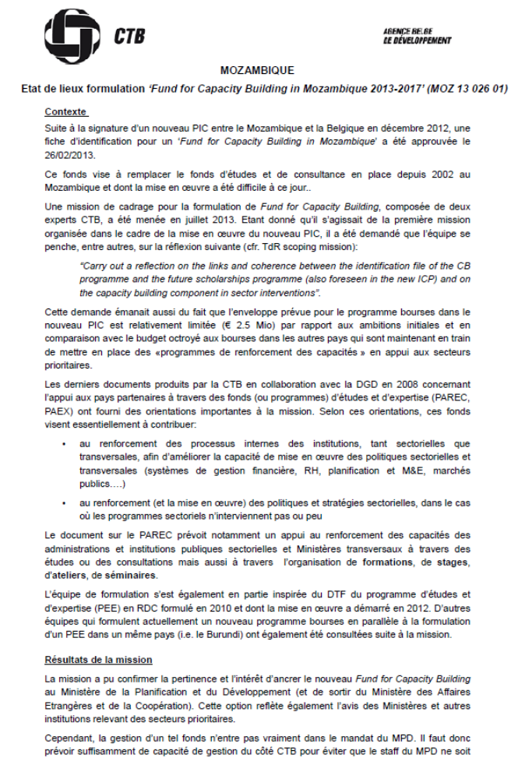
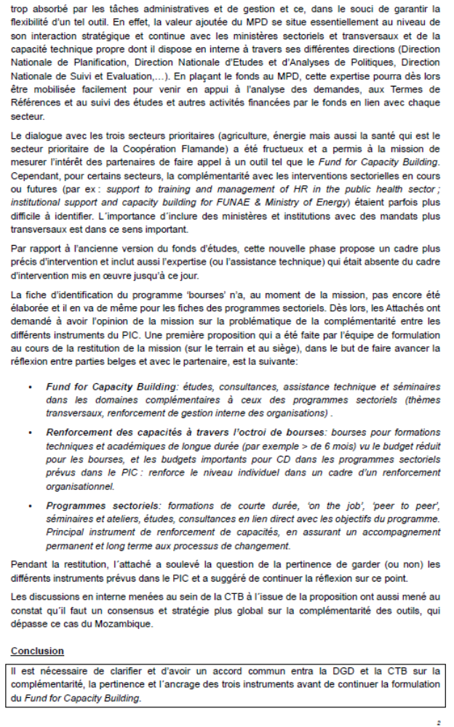
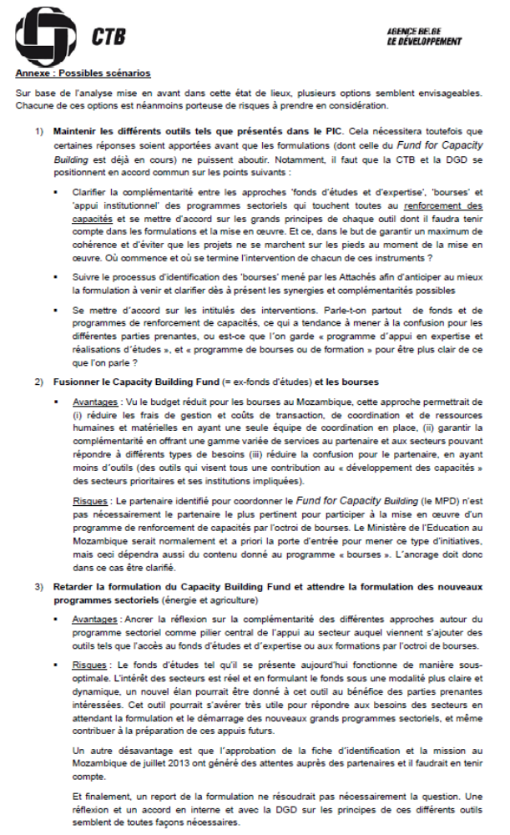
  - Programme of the mission
MOZ capacity building fund – Scoping mission July 2013
- From 03/07-2013 to 10/07/2013: bilateral meetings
Name | Institution | Position
Belgian Cooperation
Tom Smis | BTC | Resident Representative
Mamunune Agy | BTC | Programme Officer
Marc Deneer | Belgian Embassy | Attaché
Jan Cloin | BTC – Energy Fund (FUNAE) | Technical Assistant, Renewable energy project
Eric Korsten | BTC – Ministry of Health (MISAU) | Technical Assistant, HRH project
Government of Mozambique
Francisco Neto Novela | Ministry of Foreign Affairs (MINEC) | Director of Administration, Finance and Human Resources / Director of the Belgian-Mozambican Study Fund
Ester dos Santos José | Ministry of Planning and Development (MPD) | Deputy National Director of Investment and Cooperation
Cristina Matusse | Ministry of Planning and Development (MPD) | Deputy National Director of Planning
Raimundo Matule | Ministry of Agriculture (MINAG) | Director of Economy
Célia Gonçalves | Ministry of Health (MISAU) | Director of Planning and Cooperation
Marcela Libombo | Technical Secretariat on Food Security and Nutrition (SETSAN)
Edgar Cossa | Technical Secretariat on Food Security and Nutrition (SETSAN)
Miquelina Menezes | Energy Fund (FUNAE) | Chair person, economist
Development partners
Matthew Brooke | EU delegation | Head of Rural Development, Agriculture and Food security
Francesca Bruschi | Italian Cooperation | Policy Analyst
Inocencio Macuacua | Irish Embassy | Governance Advisor
Caroline Ennis | Irish Embassy | Economist
Lisa Kurbiel | UNICEF | Senior Social Policy Specialist
Telma Loforte | Swiss Cooperation | Economist
- 11/07/2013 – restitution at MPD: List of participants
Belgian Embassy | Marc Deneer-Attaché  Maria João Costa -Attaché
BTC Moz | Tom Smis-RR  Agy Mamunune –PO
MPD | Beatriz Tovela (DIC)  Noemia Utxavo (DNP)  Ester dos Santos (DIC)  Cândido Jecque (DIC)
BTC HQ | Charlotte Taylor - Formulation manager  Sofie Van Waeyenberge- support to the formulation

