Provision of Integrated Humanitarian Response for Vulnerable Populations in Somalia

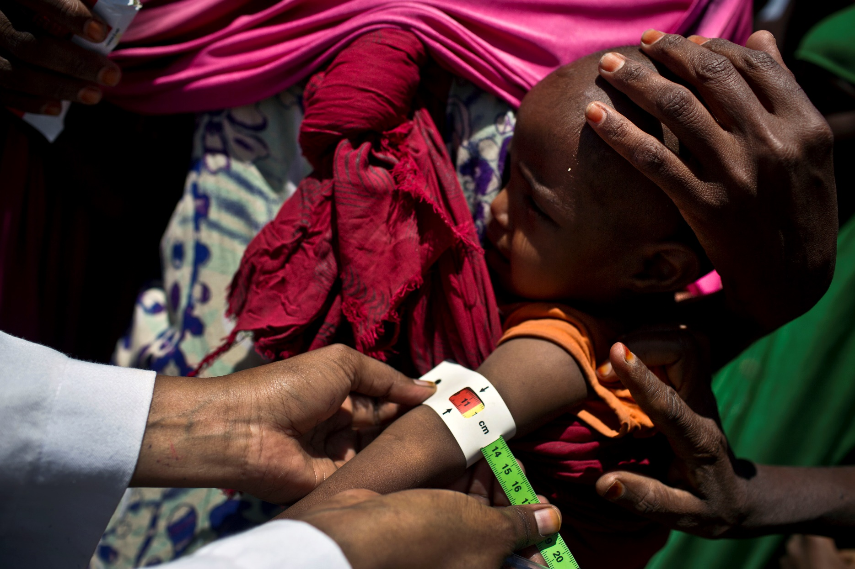

Proposal to the Government of Belgium
UNICEF Somalia
April 2019

Project Summary

Title of Proposal: | Provision of Integrated Humanitarian Response for Vulnerable Populations in Somalia
Country and Region(s) | Somalia: Lower Shabelle and Galmudug in South Central Somalia; Saanag, Togdheer, Awdal and Wogooyi Galbeed regions in Somaliland; Bari and Nugaal regions in Puntland; IDP settlements where gaps exist.
Donor | Government of Belgium
Total Proposed Budget | 2 million EURO
Project Duration | 12 months (August 2019 – August 2020)
Project Outcomes | This project will provide a package of life-saving integrated interventions for women and children affected by conflict and acute malnutrition through provision of free health, nutrition and WASH services through fixed and mobile outreach to enable communities to access quality primary health care, nutrition and WASH services and build resilience against repeated shocks.
Project Outputs | Output 1.1: Pregnant women have access to Basic Emergency Obstetric and Neonatal care (ANC, skilled birth deliveries, PNC, newborn care) and referral of complicated cases.  Output 1.2: Children under-5 years and women have access to promotive and preventive services (including immunization) at both community and health facility levels.  Output 2.1: Improved, integrated, quality basic nutrition services for children and pregnant and lactating women, including IDPs, are available.  Output 2.2: Individuals, households and communities have improved knowledge of essential nutrition behaviours and increased capacity to plan manage and monitor recurrent shocks and stresses.  Output 3: 56,400 people affected by drought, conflict and other emergencies are provided with access to safe water supply and improved sanitation services.
Focus  Population | Children under-five years of age, pregnant and lactating women and IDP populations.
Target areas | Lower Shabelle (Baraawe, Afgooye, Merka), Galmudug Dhusamareb and Abudwak, Bari (Bossaso), Nugaal (Garowe), Saanag (Ceerigavo) Wogooyi Galbeed (Hargeisa), Awdal, Togdheer, Sool and IDP populations where gaps exist in services.
Relevance to Somalia 2019 HAC | The project is aligned with the HAC 2019 interventions for Health, WASH and Nutrition.
Implementing Partners | CARE International, Ministry of Health (MoH), Somali Young Doctors Association (SOYDA) Tadamun Social Society (TASS), Somalia Awareness Raising and Education Development Organization (SAREDO), Center for Peace and Democracy (CPD), Shilhale Rehabilitation and Ecological Concern (SHILCON), Somalia Rebuild Organization (SRO), African Network for the Prevention and Protection against Child Abuse and Neglect (ANNPCAN), World Vision International (WVI), Health Poverty Action (HPA), Somali Red Crescent Society (SRCS), American Refugee Committee (ARC).
Date Submitted | April 30, 2019
UNICEF Contacts | Jesper Moller  Representative a.i.  Jmoller@unicef.org | Jeremy Shusterman  Chief, PM&E/Emergency Manager OiC  Jshusterman@unicef.org | Einas Mansour  Donor Relations Specialist  emansour@unicef.org

Contents
1
Project Summary 2
List of Acronyms 4
Humanitarian Action for Children in Somalia 5
Situational Analysis 5
Background 6
Justification 9
Project Objective and Expected Results 10
UNICEF Strategy and Response 14
Monitoring and reporting 17
Budget 18
Visibility and recognition 20

List of Acronyms

AWD Acute watery diarrheoa
FAO Food and Agriculture Organization
FEWSNET Famine Early Warning Systems Network
GAM Global acute malnutrition
GBV Gender-based Violence
HAC Humanitarian Action for Children
HRP Humanitarian Response Plan
HNO Humanitarian Needs Overview
IDP Internally displaced persons
OTP Outpatient Therapeutic Programme
RRF Resilience and Recovery Framework
SAM Severe acute malnutrition
SARI Severe acute respiratory infections
UNICEF United Nations Children’s Fund
WASH Water, sanitation and hygiene
WFP World Food Programme

Humanitarian Action for Children in Somalia

The Humanitarian Response Plan (HRP) was launched in January 2019 and seeks US$ 1.08 billion to provide life-saving assistance and livelihood support to 3.4 million Somalis affected by conflict, climatic shocks and displacement across the country.
In line with the 2019 HRP, UNICEF’s Humanitarian Action for Children (HAC) will provide an integrated response to climatic shocks, displacement and conflict in Somalia, including life-saving support to address malnutrition and excess mortality. UNICEF will sustain critical services in crisis-affected areas and target internally displaced persons (IDPs) in priority locations, while continuing to expand services in hard-to-access areas and targeting marginalized populations. The response will prioritize integrated programming that includes nutrition, water, sanitation and hygiene (WASH) and health services and responsiveness to social inequalities impacting on levels of vulnerability within populations. UNICEF will maintain its cluster leadership roles and continue to work closely with line ministries to coordinate activities and support capacity building. Where possible, UNICEF will respond jointly with the World Food Programme (WFP) to address critical malnutrition rates. In line with the Grand Bargain commitments, cash-based assistance will be prioritized, with a gradual transition from humanitarian cash transfers to safety net approaches. UNICEF will also work to strengthen linkages with the Joint Resilience Action, in coordination with WFP and the Food and Agriculture Organization (FAO), to contribute to longer-term, shared outcomes and build resilience, in line with the United Nations New Way of Working principles.
UNICEF’s HAC appeal for 2019 is requesting US$145.3 million to meet the needs of crisis-affected people and children in Somalia. This funding will allow UNICEF and partners to sustain the provision of life-saving services, including essential nutrition, health and WASH interventions, as well as critical child protection and education-in-emergencies activities. These efforts will focus on sustaining service delivery in settlements of IDPs given the current scale of displacement. Continued and timely donor support will be critical to scaling up the response and averting famine.

Situational Analysis

Children in Somalia continue to live in one of the harshest places in the world to be a child, faced with repeated climate shocks, continued conflict, displacement and violence. By January 2019, over 4.2 million people, including 2.5 million children, needed humanitarian assistance and protection. Over 1.5 million people are expected to require emergency nutrition support and treatment, with 903,100 children aged under-five projected to be acutely malnourished from August 2018 to September 2019, including 138,000 severely malnourished.
By December 2018, over three million children, out of 4.9 million in the country, were estimated to be out of school, including 1.85 million school aged children who require urgent assistance. There are also an estimated 2.6 million people displaced in Somalia, including over one million in the last year alone, with women and children representing the majority of the displaced. Exclusion and discrimination of women and girls, socially marginalized groups, continue to exacerbate elevated levels of acute humanitarian needs.
The 2018 Deyr (seasonal rainfall) was below average to poor in many parts of Somalia. As a result, the northeast and central regions of Somalia are expected to be affected by drought, with the overall humanitarian situation expected to worsen until the next Gu rainy season in April 2019.

Background

According to the 2019 Humanitarian Needs Overview (HNO), an estimated 4.2 million people are in need of humanitarian assistance, including 2.5 million children in Somalia. As per the post Deyr 2018 Food Secuirty and Nutrition Analusys Unit (FSNAU) assessment, despite overall improvement in the food security and nutrition situation, humanitarian needs in Somalia remain above the levels seen prior to the 2017 drought crisis, where the prevalence levels of severe acute malnutrition (SAM) remain above the emergency threshold of two per cent.

Additionally, an estimated 2.6 million people are internally displaced, including more than 500,000 IDPs in Banadir region alone. The scale of displacement is contributing to high-levels of acute humanitarian needs. Major humanitarian needs persist, particularly among IDP populations, due to residual impacts of drought, ongoing displacement, forced evictions, conflict and marginalisation.

The worsening dry conditions have resulted in deteriorating pasture and water availability particularly in northern and central regions of Somalia, compounding an already fragile humanitarian situation. More than 885 cases of measles have been reported since January 1, 2019, with a third of the cases recorded in February alone, indicating an alarming situation requiring immediate response. More than 81 per cent (655) of all the cases are under five years of age. The elevated concern about possible outbreaks of communicable diseases due to the worsening water shortages is increasing.

According to the Famine Early Warning Systems Network (FEWSNET) update of February 2019, the number of Acutely Food Insecure People in IPC 3 increased by 10 per cent in northern regions in the last six months from 712,000 to 786,000 exposing more communities to the possibility of contracting disease due to weakened immunities.

The Government of Somaliland appealed for urgent need of humanitarian interventions in some of the regions, particularly the eastern region, which was affected by increased shortage of water, food insecurity and a critical malnutrition situation. The Somaliland Ministry of Health reported an increase in disease outbreaks such as Severe Acute Respiratory Infections (SARI) in parts of Sool and Sanaag regions in the north of Somalia. The early warning and disease outbreak reports of Epidemiological Week 7 reported 213 cases and 1,360 cumulative cases since the start of the year. There is need for lifesaving interventions in IDP locations in affected regions where increased movement was reported. For example, in January and February, more than 41,632 IDPs moved within the six most food insecure regions in Somalia. Coupled with poor health indicators and a fragile health system unable to address the important health needs of the population, the situation is expected to deteriorate further if aid is not sustained or scaled up in the worst-affected areas and if the next Gu rainy season performs poorly.

Figure 1. Trends in Prevalence and Burden of Wasting: Somalia 2015 – 2018
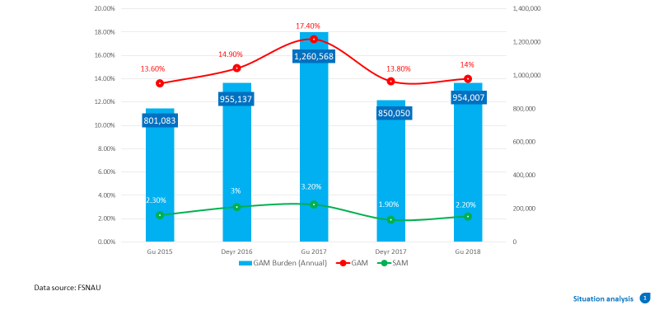

The FSNAU post-Deyr findings for Somalia showed a decrease in global acute malnutrition (GAM) from 17.4 per cent down to 14 per cent in the post-Gu 2018 season (please see Fig 1). However, malnutrition rates across Somalia still remain among the worst in the world, with 954,000 children under-five years of age projected to be malnourished in 2019, including 173,000 expected to be suffering from life threatening SAM. Nearly 30 per cent of these children live in IDP camps, with IDPs disproportionately affected with emergency prevalence of acute malnutrition (GAM >15 per cent) in 7 of 15 the locations surveyed by the FSNAU. The situation is a serious humanitarian emergency among Mogadishu IDPs where GAM rates are more than 15 per cent, associated with a crude death rate of over 1 per 10,000 population per day.

With three million people in need of access to emergency health services and 2.9 million people in need of WASH support, recurrent disease outbreaks—including acute watery diarrhea (AWD)/cholera and measles—continue to represent a major threat to children.

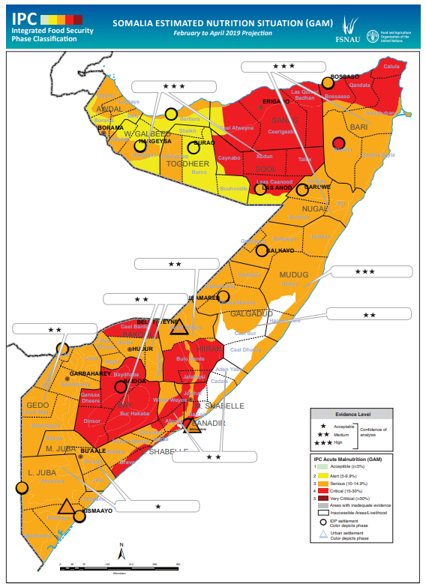
Figure 2. Somalia Estimated Nutrition Situation (GAM) February – April 2019

Justification
This project will provide a package of life-saving integrated interventions for vulnerable populations, including women and children, affected by conflict and acute malnutrition in targeted areas in Somalia, including Lower Shabelle and Galmudug in South Central Somalia; Saanag, Toghdeer, Awdal and Wogooyi Galbeed regions in Somaliland; Bari and Nugaal regions in Puntland and IDP settlements where gaps exist.
The above targeted regions are among the priority regions for UNICEF emergency health interventions due to higher burden of disease and low levels of predictable access. While most areas in these three regions are currently Stressed; IPC Phase 3 or IPC Phase 4, the health situation in the three regions is very critical with Lower Shabelle having poor accessibility, insecurity and high influx of IDPs. There have been high displacement over recent years in Lower Shabelle; and women of reproductive age living as IDPs at target districts are especially at risk of postpartum haemorrhage, eclampsia, pre-eclampsia toxaemia, abnormalities of presentation, underweight babies, previous bad obstetric history, severe anaemia and unsafe abortion as they have limited access to the health services. This is primarliy due to poor access to health services/hospitals, which are far from the IDP settlements, and security and transportation concerns, especially during outreach services. Competition for limited resources between IDPs and host communities also excerbates the situation.
Furthermore, according to the FSNAU post Deyr 2018 report, food security is expected to deteriorate in parts of northern and central Somalia from February to June 2019. Many northern and central agropastoral and pastoral livelihoods are expected to deteriorate to Crisis (IPC Phase 3) until May/June, when the onset of Gu rainfall leads to improved livestock productivity, livestock births increasing saleable animals, and increased agricultural labor opportunities. In the absence of assistance, food security outcomes are expected to deteriorate to Emergency (IPC Phase 4) in Guban Pastoral livelihood zone and to Crisis (IPC Phase 3) in central Addun Pastoral, Northern Inland Pastoral, East Golis Pastoral of Sanaag, northwestern Hawd Pastoral, Southern Agropastoral of Hiiran and Bay-Bakool Low Potential Agropastoral livelihood zones. More than 1.5 million people will face Crisis or worse (IPC Phase 3 or higher) through June 2019. An additional 3.4 million people are classified as Stressed (IPC Phase 2), which brings the total number of people in Somalia facing acute food insecurity through mid-2019 to 4.9 millionThe median prevalence of GAM has remained Serious (10–14.9 per cent) over the past three seasons (12.6 per cent in 2018 Deyr, 14.0 per cent in 2018 Gu and 13.8 per cent in 2017 Deyr). Those facing acute food security Crisis (IPC Phase 3), or worse, urgently need humanitarian assistance through June 2019 to prevent further deterioration.
The high level of acute malnutrition persists across Somalia due to a combination of factors, including food insecurity, high morbidity, low immunization and vitamin-A supplementation, and poor care practices. A Critical (≥4-5.6 per cent) prevalence of SAM was observed in Bakool Southern Inland Pastoral livelihood zone in the post_Dyer (November 2018) FSNAU assessment. The Crude Death Rate (CDR) was Critical (1 to <2/10 000/day) in West Golis Pastoral and northwestern Hawd Pastoral, while morbidity rates remain high (>20 per cent) in half of the populations surveyed. Overall, an estimated 903,100 children under the age of five years (total acute malnutrition burden) are likely, or already face, acute malnutrition through December 2019 including 138,200 with life threatening SAM. Therefore, urgent and sustained nutrition assistance is required to support recovery and prevent deterioration in the nutrition situation.
Finally, according to the April 2019 Somalia Water and Land Information Management (SWALIM) report, the poor performance of Deyr 2018, coupled with harsh weather conditions from January to March, left many parts of Somalia facing mild to moderate drought conditions. This led to serious water scarcity and necessity for earlier than normal water trucking across the country, particularly in Somaliland and Puntland; the Shabelle and Juba river levels are very low, with dried up riverbeds seen in some areas. This resulted in serious deterioration in water access, heightened water scarcity and water stress, with soaring water prices across many regions of Somaliland, Puntland and South-Central Somalia. The situation is affecting both households at point of sale and emergency humanitarian partners running water trucking services in IDP camps, as well as vulnerable communities. The poor rain performance will likely exacerbate the already poor water supply and sanitation coverage, contributing significantly to overall public health risks in Somalia and a likely increase the number of people in need of humanitarian WASH support.

Lack of clean water and poor sanitation and hygiene practices not only cause diseases but also create a huge burden on women and children as women and girls perform most of the unpaid labor associated with WASH in households and communities, which reduces the time they have available for education, economic activities and leisure. Women and girls are also often vulnerable to harassment or violence when they travel long distances to fetch water, use shared toilets, or practice open defecation. In addition, lack of proper hygiene supplies like soap and sanitary pads affects dignity of women and girls.

Project Objective and Expected Results

This project will provide a package of life-saving integrated interventions for women and children affected by conflict and acute malnutrition in South Central Somalia, Somaliland and Puntland regions, as well as IDP settlements. Through this project, UNICEF will provide integrated interventions through fixed and mobile outreach to enable communities to access quality primary health care, nutrition and WASH services and build resilience against repeated shocks. The specific objectives of the project are as stipulated below:
Objective 1: Reduced morbidity and mortality from maternal and child health-related conditions amongst targeted IDP and host community populations.
Objective 2: Treatment of 5,000 children affected by life threatening SAM in northern regions of Somalia.
Objective 3: Provision of a comprehensive package of nutrition promotional and preventative services for 9,200 children under 5 years and 2,300 pregnant and lactating women (PLW).
Objective 4: Provision of gender responsive and protection sensitive access to WASH services for 56,400 people in areas affected by drought and other emergencies.

Project results framework- Health

Output | Activities | Assumptions/Risks
Output 1.1: Pregnant and lactating women have access to Basic Emergency Obstetric and neonatal care (antenatal care, skilled birth deliveries, postnatal care, newborn care) and referral of complicated cases. | Indicator(s):  1.1 Number of pregnant women receiving ANC4. Target: 1,265  1.2 Number of skilled birth deliveries at a health facility. Target: 1,380  1.3 Number of pregnant and lactating mothers receiving postnatal consultations. Target: 2,300
 | - Activity: Provide quality emergency primary health care services for 13,340 mothers, newborn and children. | Assumptions/Risks: Stable security situation, community acceptance and support and continuous availability of medical supplies and equipment and human resource for health by the Ministry of Health (MoH).
 | 1.2 Activity: Enhance referral mechanisms and provide skilled birth deliveries and enhanced referral support for 1,380 women.
 | 1.3 Activity: Support the provision of routine and emergency immunization for 2,300 PLW.
Output 1.2: Children under-5 and women have access to promotive and preventive services (including immunization) at both community and health facility levels. | Indicator(s)  - # of under 1-year children vaccinated with pentavalent 3 doses. Target: 1,840  - Number of children under 5 immunized for Measles. Target: 7,360  - Number of Children under 5 with ARI treated at facility and outreach level. Target: 4,600  - Number of children under 5 treated for acute diarrhoea in health facilities. Target: 400
 | 1.2.1 Activity: Provide routine and emergency immunization for all antigens for 8,096 children under 5, both at facility and outreach level. | Assumptions/Risks: Stable security situation, community acceptability and support and continuous availability of medical supplies and equipment and human resource for health by the MoH.
 | 1.2.3 Activity: Support periodic intensification immunization activities, including provision of vitamin A and deworming for 6,900 IDP and hard to reach communities in target regions.
 | 1.2.3 Activity: Treat 4,600 children under-five against childhood illnesses using integrated management of childhood illness (IMCI) and integrated community case management (ICCM) at facility and community level.
 | 1.2.4 Activity: Promote social mobilization and provide health education interventions to increase the health awareness of communities and disease prevention.

Project results framework – Nutrition

Output | Activities | Assumptions/Risks
Output 2.1: Improved, integrated, quality basic nutrition services for children and PLW, including IDPs, are available. | Indicator(s):  - # of children under-5 with SAM admitted in Therapeutic Feeding programmes. Target: 5,000  - Proportion of children under 5 with SAM admitted in Therapeutic Feeding programme discharged cured. Target: >75%
 | - Activity: Procure lifesaving nutrition supplies including 5,000 cartons of ready to use therapeutic food (RUTF), therapeutic milk and essential medicines. | Assumptions/Risks:  The number of humanitarian crises will not overwhelm capacity to respond.  Under performance of Gu 2019 rains leading to deteriorating drought conditions, food insecurity and malnutrition.
 | 2.2 Activity: Deliver lifesaving care and treatment to 5,000 children affected by SAM.
 | 2.3 Activity: Train 50 service providers on the revised Integrated Management of Acute Malnutrition (IMAM) treatment protocol.
Output 2.2: Individuals, households and communities have improved knowledge of essential nutrition behaviours and increased capacity to plan manage and monitor recurrent shocks and stresses. | Indicator(s)  - Number of primary caregivers of children aged 0-23 months who received counselling on infant and young child feeding (IYCF). Target: 10,000  - Number of boys and girls aged 6-59 months screened for acute malnutrition. Target: 40,000
 | 2.2.1 Activity: Mass screening of 40,000 children under 5 for acute malnutrition and referral for appropriate care and treatment. | Assumptions/Risks: Communities are open to receiving information, behavior change messages and other efforts to change sociocultural beliefs and practices.  Deterioration of security situation limiting access to vulnerable communities.
 | 2.2.2 Activity: Delivery of basic nutrition services package, which includes IYCF counselling of pregnant, lactating women and caregivers of children under five, micronutrient supplementation, deworming and immunization of under five boys and girls.

Project results framework – WASH

Output | Activities | Assumptions
Output 3: 56,400 people affected by drought, conflict and other emergencies provided with access to safe water supply and improved sanitation services. | Indicator(s):  1. Number of people in targeted settlements and communities with access to safe water services. Target: 30,000  2. Number of people in targeted settlements and communities having access to a gender separated sanitation facility. Target: 26,400  3. Number of people in targeted settlements and communities reached with hygiene promotion activities, including menstrual hygiene management (MHM). Target: 30,000  4. Number of institutions (schools, health and nutrition) provided with a minimum water and sanitation package. Target: 10
 | Activity 3.1: rehabilitation and upgrading of 30 water points. | Assumptions/Risks:  No new escalation of conflict in the target locations.  No major political instability due to power struggle affecting access to project sites.  UNICEF continued operational presence in the country.  No major currency fluctuations affecting the US$ value of the grant.  Continued government cooperation on facilitation of project implementation.
 | Activity 3.2: construction of 700 emergency shared family latrines.
 | Activity 3.3: rehabilitation and maintenance of 400 emergency shared family latrines.
 | Activity 3.4: training of 100 hygiene promoters.
 | Activity 3.5: Hygiene promotion in schools, health facilities and communities, including MHM, targeting 30,000 people.
 | Activity 3.6: Construction/ rehabilitation of upgrading of WASH facilities in 10 institutions (health and nutrition facilities and schools)
 | Activity 3.7: WASH technical support and monitoring.

The 2019 HAC is annexed to this proposal and also available here: Somalia Humanitarian Action for Children 2019

UNICEF Strategy and Response

Delivery of a core package of integrated services: UNICEF is prioritizing an integrated delivery of nutrition, WASH and health programme in areas at risk and affected by conflict. Priority will be given to the delivery of life-saving services concurrently addressing underlying causes of exposure to the risk of malnutrition, disease outbreaks and poor sanitation and hygiene.

This will be achieved through timely procurement of life-saving core pipeline supplies, increased partnership coverage and the expansion of critical services in the most affected areas, with a focus on integration of programmes. The wide network of outpatient therapeutic programme (OTP) sites will continue to be used as the preferred platform for the delivery of multi-sectoral services including health, WASH and demand creation for services. UNICEF recognizes that Somalia has the weakest nutrition work force in the region, which partially stems from the weak institutional capacity to standardize and regulate the health work force training in general. Thus, while nutrition training is not formally integrated in medical training curricular, in-service training is the main strategy for UNICEF and the MoH to build capacity for improved service delivery. To do this, the nutrition program provides a critical platform for training service providers and the delivery of Infant and Young Child Feeding (IYCF) counselling, using the adapted package of IYCF materials.

In areas targeted by nutrition, UNICEF and partners will also provide a package of hygiene kits, household water purification products, water containers and MHM kits for families of malnourished children and PLW, together with key hygiene messages. To increase routine immunization rates, UNICEF and partners will promote demand creation for immunization and early health care seeking practices. Scaling up WASH and health programme components, as part of an integrated and coordinated response, will include prevention and response to disease outbreaks, including cholera and measles, with an emphasis on child protection.

UNICEF will continue to focus on increasing response in the areas of highest needs and lowest levels of predictable access. In addition, all WASH interventions will be implemented as per the agreed Cluster gender and gender-based violence (GBV) checklist for privacy and safety of women and girls, including gender segregation of sanitation facilities, establishing of water and sanitation facilities in accessible and safe locations near settlements and use of appropriate technologies to ensure privacy and ease of use by women.

Strengthened linkages for multi-sectoral actions: Consistent with the Resilience and Recovery Framework (RRF) agenda of bridging the humanitarian-development nexus and the humanitarian country team’s efforts to contextualize the centrality of protection throughout all interventions in Somalia, the nutrition program will serve as entry point for multi-sector and multi-agency integration of humanitarian and development interventions. Children screened, for both moderate acute malnutrition (MAM) by community health workers through the various community service delivery platforms, will receive appropriate referral for treatment. An estimated 50,000 children will be reached at least once during the project cycle with a holistic package of curative, preventive and promotional services, including screening, immunization, vitamin supplementation, deworming and IYCF counselling. In the process, mothers and caregivers of children aged under-5, as well as PLW, will benefit from individual counselling on IYCF practices to improve optimal maternal and child nutrition. The aim is to prevent children from relapsing into acute malnutrition by addressing the multifaceted causes of malnutrition, including lack of access to basic services, disease outbreaks and poor hygiene, while enhancing the impact of nutrition therapeutic interventions.

Timely response: To ensure a timely response, UNICEF will continue to pre-position essential supplies in affected areas both at the facility-level and with partners’ warehouses. Additional resources are required to support the core pipelines of nutrition, WASH, health and to ensure the continuity of life-saving services. Considering the impacts of the recent floods, it is key to ensure a rapid replenishment of hygiene kits and essential medicines to mitigate the risk of disease outbreaks.

Partnership (coverage and capacity): UNICEF is coordinating its interventions with line ministries, disaster management agencies and relevant clusters to ensure there is no duplication in the response and critical gaps are covered. Where possible, UNICEF is responding jointly with WFP and the World Health Organization (WHO) through an augmented response package which includes unconditional food assistance, preventive and curative nutrition programmes, livelihood activities, health services and support to communities to access safe water and improve sanitation and hygiene conditions. UNICEF is mainstreaming contingency mechanisms in partnership agreements to provide for quick and rapid scale-up or redeployment of activities in case of changing needs and sudden deteriorations in the humanitarian situation for children, allowing for a flexible and nimble needs-driven response.

Priorities for Belgium funding 2019

Funds from the Government of Belgium will enable UNICEF to sustain its humanitarian response, with a focus on an integrated WASH, nutrition and health response. Considering the scale of internal displacement, priority will be given to addressing needs in targeted IDP sites. The proposed interventions outlined below will directly contribute to this process:

Procurement and distribution of supplies for the treatment of MAM and SAM - Out of the total annual Cluster caseload of 173,000 SAM cases, UNICEF will target an estimated 164,000 children under-5 years of age, which includes 34,000 children with MAM living in hard-to-reach areas where targeted supplementary feeding programme (TSFP) services are absent. To achieve this, UNICEF will procure 2,287 metric tons (MT) of life-saving supplies, including an estimated 164,000 cartons of RUTF. To date, UNICEF has a funding gap to procure 17,000 cartons of RUTF and essential medicines to cover the targets of the HRP for the fourth quarter and part of the third quarter of 2019.

UNICEF target for SAM in Somalia is 134,000 children under-5 years of age. UNICEF anticipates a pipeline break of essential medicines and RUTF during the third and fourth quarters of the year. This funding support will enable UNICEF to fill the gap by procuring an additional 124 cartons of therapeutic milk and essential medicines but also to cover urgent gaps in operational costs of delivering services in targeted hotspot areas.

Delivery of the basic nutrition services package (BNSP), including care and treatment of SAM - Building on the successes and lessons learned from rolling out the pre-famine response, UNICEF will sustain coverage of emergency life-saving services, and the BNSP through fixed and outreach clinics as a key strategy in delivering an integrated package of services through a single service delivery point, in collaboration with key partners and clusters. UNICEF will provide technical support and operational costs to implementing NGOs to deliver the BNSP in static and outreach clinics. In the process of treating SAM, nutrition service delivery points will avail a platform for convergence and the integration of multi-sector and multi-partner services, including WASH (hygiene, containing water disinfectants, water storage containers and soap for hand washing and health (immunization, malaria control) to children and mothers attending nutrition services in static and mobile outreach clinics. UNICEF estimates that 50,000 children aged under-5 will be reached at least once with the BNSP package, which includes screening and referral for appropriate treatment of acute malnutrition, deworming for intestinal infestations, vitamin A supplementation, which is critical in boosting the immune system, as well as the delivery of routine immunization against common childhood killer diseases. In parallel, PLW, as well as adolescent girls, will receive both group and individual IYCF counselling essential in promoting and preserving appropriate child care practices.

Primary Health Care including Basic Emergency Obstetric and Neonatal Care for pregnant and lactating women
- Provision of comprehensive Essential Package of Health Services (EPHS) at supported health facilities.
- Provision of skilled birth delivery and referral of complicated cases to secondary care facilities.
- Deployment of outreach and emergency response teams to areas of highest needs and lowest levels of predictable access. Mobile services increase the capacities of static facilities enabling health providers to serve marginalized, nomadic and hard to-reach communities.

Prevention of diseases outbreaks and emergency Immunization
- Provision of measles, Pentavalent, oral polio vaccine (OPV), BCG and Tetanus Toxoid (TT) vaccines through the routine immunization programme and through localized immunization campaigns in targeted IDP sites of Lower Shabelle, Nugaal and Sool regions.
- Measles control and catch up campaigns for unvaccinated children under-five.
- Provision of social mobilization and health education interventions to increase health awareness of communities and the demand for health services.
- Preposition of health supplies in locations prone to AWD/cholera.

Integrated Community Case Management (ICCM) to jointly address malaria, diarrhea and pneumonia treatment and prevention for children aged under-5
- Building on the Ministry of Health programming to train female and community health care workers, under the GAVI/Health Systems Strengthening (HSS) managed by the Global Fund Program in 11 regions in Somalia, including target regions, such as Lower Shabelle, available teams will offer treatment for the most prevalent conditions, such as pneumonia, malaria and diarrhoea. Medical staff will also be trained as required, especially within IDP communities and surrounding rural areas. A total of 100 female health workers are deployed in this region to provide ICCM support to communities.
- Cross-sectional training of health, nutrition and WASH teams to support disease prevention and awareness campaigns, such as diarrhoea prevention and handwashing initiatives and promotion of mother-led mid upper arm circumference (MUAC) measurement. These interventions will be conducted by each team, leading to enhanced awareness and ultimately a behavioural change within the population.

Rehabilitation and upgrading of existing strategic water points - The rehabilitation/upgrading of water points will include changing and maintenance of water pumps and generators, rehabilitation of water tanks and changing of handpumps into solar-powered water supply systems.

Sanitation and hygiene promotion - Facilitating behavior change in acutely vulnerable communities for sanitation and hygiene practice through improved access to and use of sanitation facilities and targeted hygiene promotion focusing on women and children. This includes construction, rehabilitation and maintenance of emergency shared household latrines, community awareness on hygiene and solid waste management for schools and health facilities.

WASH in institutions – This will target mainly health and nutrition facilities in areas where high cases of malnutrition in coordination with health and nutrition programmes. The planned activities included construction/rehabilitation of sanitation facilities, improving water storage and water pipelines, training of facilities staff on WASH and hygiene promotion activities.

Monitoring and reporting

Under UNICEF’s monitoring framework, regular monitoring and reporting will be carried out throughout the implementation period. Where access is possible, UNICEF staff and partners will undertake direct joint monitoring and evaluation which includes field visits, surveys and assessments. Information collected by UNICEF, partners and communities during joint monitoring visits will be triangulated to validate achievements and identify gaps. Partners will provide weekly activity reports to the relative Cluster. UNICEF field staff will conduct follow up and provide their observations on the project implementation. UNICEF will conduct analysis of the data provided by each facility to ensure that project implementation is going according to plan and that the best quality of services is provided and will conduct monthly monitoring missions/meetings during the project. If areas become inaccessible due to security reasons during implementation, independent third-party verification will be carried out to monitor and evaluate projects using standard tools with pre-set indicators.

Supply delivery to partners will be tracked through a UNICEF call center which comprises of tracking and monitoring release orders, transportation by transporters, delivery to partners, receipt by partner and confirmation receipt of supplies. UNICEF field-based health project assistants will continuously monitor the consumption and stock level of supplies every month in coordination with the program manager. A bi-weekly stock and consumption report will be prepared for general monitoring and for the provision of technical guidance. In case of stock shortage, UNICEF staff will report for immediate support. UNICEF, MoH and NGOs field staff will conduct direct monitoring of the sites through monthly visits to the projects centres where they will do verification checks, stock checks, and beneficiary interviews, plus inspection of records. Additional monitoring visits by the country office team will be conducted once in every quarter, which will be combined with field meetings and other capacity-building efforts

UNICEF plays a key role in humanitarian coordination in-country. UNICEF is part of the Humanitarian Country Team (HCT), participates in the Humanitarian Heads of Agencies meetings and the Inter-Cluster Working Group, which lead strategic and cross-sectoral coordination of humanitarian programmes. UNICEF continues to lead the WASH and Nutrition Clusters. This will allow UNICEF to provide technical support to partners, ensuring that partners have sufficient capacity to reach people most in need with an integrated package of high impact services, achieving value for money while avoiding gaps and duplication in service delivery. This Belgium fund will enable UNICEF to strengthen cross sectoral collaboration, enabling complementarity and integration to ensure continuity of service delivery along a continuum across health, nutrition and WASH. This funding will complement other UNICEF funding sources to ensure a smooth transition of targeted children and women within the different components of the IMAM programme.

The operational capacity of the UNICEF-led Clusters is significant, with a network of over 140 partners, including sub-regional coordinators in over 15 regions. The network facilitates access to information, coordination and interventions in hard to-reach and inaccessible areas. UNICEF established multiple formal and tacit coordination mechanisms for engagement with national and local authorities. Through regular interactions, UNICEF programme sections and management coordinate needs assessments and planned interventions with relevant line ministries. For example, UNICEF continues to actively support the national health cluster and technical group to bring in all stakeholders for effective planning, implementation and monitoring of the program. UNICEF, as a standing practice, looks to involve relevant authorities in programme design as well and programme review.

UNICEF programme staff will continue to conduct monitoring and support supervision to implementing sites in accessible areas to ensure that service delivery is consistent with global emergency standards. In areas which are not accessible to UNICEF programme staff, third party monitors will be contracted to provide information on programme implementation which is triangulated with programmatic reports submitted by implementing partners. Furthermore, from 2019, UNICEF will support the transition from the current nutrition cluster web-based ONA reporting system to the MoH owned DHIS2 platform.

Budget

UNICEF requests Euros 2 million from the Government of Belgium to provide an integrated package of lifesaving WASH, health and nutrition services to vulnerable women and children in Somalia. This is a one-year (12 month) budget that covers activities as shown below:

Description | Amount ($) | Amount €)
Output 1.1: Pregnant women have access to Basic Emergency Obstetric and Neonatal care (ANC, skilled birth deliveries, PNC, newborn care) and referral of complicated cases | 303,450 | 269,160
1.1 Activity: Provide emergency primary health care services for 13,340 mothers, newborns and children | 88,816 | 78,780
1.2 Activity: Enhance referral mechanisms and provide skilled birth deliveries for 1,380 women | 74,949 | 66,480
1.3 Activity: Support the provision of routine and emergency immunization for 2,300 PLW | 59,696 | 52,950
Operational costs to 8 facility running costs and technical management | 79,989 | 70,950
Output 1.2: Children under-5 and women have access to promotive and preventive services (including immunization) at both community and health facility levels | 291,346 | 258,424
1.2.1 Activity: Provide routine and emergency immunization for all antigens for 8,096 children under 5, both at facility and outreach level | 108,895 | 96,590
1.2.2 Activity: Support periodic intensification immunization activities including provision of vitamin A and deworming for 6,900 IDP and hard to reach communities in target regions | 101,894 | 90,380
1.2.3 Activity: Treat childhood illnesses using the IMCI and ICCM at facility and community level for 4,600 children under-five | 43,968 | 39,000
1.2.4 Activity: Promote social mobilization and provide health education interventions to increase the health awareness of communities and disease prevention | 36,589 | 32,454
Output 2.1: Improved, integrated, quality basic nutrition services for 5,000 children under five years, pregnant and lactating women including IDPs are available | 269,766 | 239,284
2.1.1 Activity: Procure lifesaving nutrition supplies including 5,000 cartons of RUTF, therapeutic milk and essential medicines | 118,967 | 105,524
2.1.2 Activity: Deliver lifesaving care and treatment to at least 5,000 children affected by severe acute malnutrition | 150,799 | 133,759
Output 2.2: Individuals, households and communities have improved knowledge of essential nutrition behaviors and increased capacity to plan manage and monitor recurrent shocks and stresses | 325,029 | 288,302
2.1 Activity: Mass screening of 40,000 children under 5 for acute malnutrition and referral for appropriate care and treatment | 90,304 | 80,100
2.2 Activity: Deliver the basic nutrition services package which includes IYCF counselling, micronutrient supplementation, deworming and immunization to 10,000 children and caretakers of children under five years | 133,326 | 118,261
2.3 Activity: Train 50 service providers on the revised IMAM treatment protocol | 51,001 | 45,238
Technical support, monitoring and supervision (UNICEF staff costs) | 50,399 | 44,702
Output 3: 56,400 people affected by drought, conflict and other emergencies provided with access to safe water supply and improved sanitation services | 594,796 | 527,584
Activity 3.1: Rehabilitation and upgrading of 30 water points | 241,094 | 213,850
Activity 3.2: construction of 700 emergency shared family latrines | 154,735 | 137,250
Activity 3.3: rehabilitation and maintenance of 400 emergency shared family latrines | 32,142 | 28,510
Activity 3.4: training of 100 hygiene promoters | 15,073 | 13,370
Activity 3.5: Hygiene promotion in schools, health facilities and communities targeting 30,000 people | 15,073 | 13,370
Activity 3.6: Construction/rehabilitation of upgrading of WASH facilities in 10 institutions (health and nutrition facilities and schools) | 76,381 | 67,750
Activity 3.7: WASH technical support and monitoring cost | 60,298 | 53,484
Other Programmable Support costs | 303,382 | 269,100
Field operations and emergency coordination | 240,924 | 213,700
Programme Assurance (planning, monitoring, reporting, risk management) | 44,645 | 39,600
Communication and visibility | 17,813 | 15,800
Total Programmable costs | 2,087,770 | 1,851,852
Indirect cost recovery (8%) | 167,022 | 148,148
Total | 2,254,792 | 2,000,000

* Note: The funding amounts per activity are indicative and for information purposes. UNICEF will provide financial reporting through its standard system-generated Donor Financial Statements.

Visibility and recognition
UNICEF communication and visibility activities will highlight the impact of the Government of Belgium’s contribution on the lives of children in Somalia using a mix of traditional, new and social media channels as per the agreed proposal. UNICEF Somalia will issue a press release, develop human interest stories, and promote the contribution of the Government of Belgium on social media (Twitter, Facebook and Instagram) to a wide range of audiences including the Somali population and the international community. Advocacy and Communications materials will follow the UNICEF and Government of Belgium branding guidelines.

The visibility package will include:

- Two press releases - at project onset, to announce receipt of funding and another after project end to show preliminary results;
- Two human interest stories to illustrate how lives have been changed;
- Where appropriate, signage bearing the Kingdom of Belgium logo will be displayed at project sites
- A package of high quality photographs produced and shared through UNICEF Somalia, UNICEF Africa, and UNICEF Brussels social media channels and websites.

Weekly EPI/POL Update, Week 13.
Displacement Tracking Matrix (DTM) Somalia: Flow Monitoring Dashboard - February 2019
FSNAU/FEWSNET 2018 Post-Deyr Technical Release, February 2019.
The amounts in USD are indicative only. The actual USD equivalent will be calculated per UN Exchange Rate in effect on the date of receipt of disbursement.

