Country Programme
RWANDA 2019-2024
Part III - Agriculture

Table of contents
1. Agriculture Sector 3
1.1 General orientations 3
1.1.1 General objectives of the Belgian Federal Government for the Rwandan Agriculture program 2019-2024 3
1.1.2 Rwandan strategy and policy for agriculture 3
1.2 Context analysis 5
1.3 Analysis of Key Actors 5
1.3.1 From the public sector 5
1.3.2 From the private sector 6
1.3.3 Key Development Partners 6
1.3.4 Civil Society, International and National Non-Government Organizations. 6
1.4 Strategic Choices for the sector 12
1.4.1 Alignment to the Rwandan policies and strategies 12
1.4.2 MDTF support complemented by support to agriculture value chains not covered by the MDTF 12
1.4.3 Two track approach: smallholder farmers & commercial agriculture 13
1.4.4 Private Sector development as a driver in developing the value chains 13
1.4.5 Accountability 13
1.4.6 Cross-cutting issues: Youth, Women, Environment, and ICT 14
1.5 Priority target groups 16
1.5.1 Final beneficiaries (population) 16
1.5.2 Intermediary beneficiaries (public and private actors whose capacities are strengthened) 16
1.6 Strategic alliances – Complementarity and synergies 17
1.6.1 Engaging the private sector 17
1.6.2 Strategic partnership with Belgian expertise (including the private sector) 17
1.6.3 Articulation with other development partners 17
1.7 General and specific objectives 17
1.8 MDTF modality: Support the implementation of PSTA4 to promote the commercialization of agricultural value chains. 19
1.8.1 Result framework for the intervention: 19
1.8.2 Hypotheses, risks and mitigation measures 21
1.8.3 Organizational set-up 22
1.8.4 Belgian contribution 23
1.8.5 ProfR2 - MDTF Monitoring Framework 23
1.8.6 Program-For-Results Results Framework Matrix 26
1.8.7 Program-For-Results Phase 2 Disbursement Linked Indicators Matrix 30
1.9 Project modality: Development of the value chains of poultry and pork and the related animal feed value chains 38
1.9.1 Specific context elements related to the targeted value chains 38
1.9.2 Specific strategic considerations for the interventions 42
1.9.3 Result framework of the intervention 44
1.9.4 The Result framework 66
1.9.5 Risk identification and mitigation measures 76
1.9.6 Organizational structure of the interventions 79
1.9.7 M&E, learning and knowledge management 81
2. ANNEX 83
Annex 1 Duration of the execution of interventions 2 & 3 84
Annex 2 Abbreviations 86

Agriculture Sector

General orientations

General objectives of the Belgian Federal Government for the Rwandan Agriculture program 2019-2024
The Belgian return to the agriculture sector is inspired by its potential to work through this sector to support job creation, private sector development and gender. Seventy percent of the active population in Rwanda works in Agriculture, with more women than men working in the sector, while one quarter of rural families are led by women. Belgium aspires to build on the expertise of its universities and private sector organisations in implementing this programme which could support applied research components, while the positive experiences of the past bilateral cooperation with the Farmer Field Schools on improving extension services has the potential to strengthen farmers and cooperatives on both in technical aspects and in entrepreneurship. Belgium recognises the potential for job creation and economic growth in supporting agro-processing and agribusiness. Based on these aspirations, Belgium proposes to work around 2 general objectives:
- The revenue of farmers increases through quality proximity extension services, improved access to inputs and through the introduction of new technologies;
- The private sector creates more added value through more efficient markets, improved storage transformation and agro-processing.

Rwandan strategy and policy for agriculture
National Strategy for Transformation (NST 2018-2024)
The NST has been designed to serve as the implementation plan and strategy for the remainder of Vision 2020 (2018 to 2020) and the first four years (2021 to 2024) of the Vision 2050. In addition, the NST will serve to integrate the global commitments Rwanda has signed – SDGs, AU agenda 2063, EAC vision 2050. The NST sets the direction for the government and is the overarching planning document that guides the delivery of the country’s ambitions outlined in vision 2020 and 2050. The NST has three pillars which form the basis of the continuing drive towards Rwanda's transformation;
- Economic Transformation - Accelerate inclusive economic growth and development founded on the Private Sector, knowledge and Rwanda’s Natural Resources.
  - Priority Area 6: Modernize and increase productivity of Agriculture and livestock - Strengthen the commercialization of crop and animal resource value chains by increasing private sector engagement, promoting market-oriented agri-businesses, and capturing greater in-country surplus and value added. Establish a program to improve professionalization of livestock farmers and increase their output in terms of quality, volume and productivity.

- Social Transformation - Develop Rwandans into a capable and skilled people with quality standards of living and a stable and secure society.
- Transformational Governance, which underpins economic and social transformation.

The NST is the high-level strategy that integrates the Sector Strategic Plans (SSPs) like the PSTA4 and District Development Strategies (DDSs). For this programme, the focus will be on the two-key sector strategic plans – Agriculture (PSTA4); and the private sector development (PSDYE).

Strategic Plan for the Transformation of Agriculture phase 4 (PSTA-4)
The Ministry of Agriculture and Animal Resources has developed the Strategic Plan for the Transformation of Agriculture phase 4 (PSTA-4), 2018-2024, which is fully aligned with the national priorities and the National Strategy for Transformation (NST-1) and the National Agriculture Policy (NAP). PSTA4 envisages a transformation of agriculture from a subsistence sector to a knowledge-based value creating sector that contributes to the national economy and ensures food and nutrition security.
This transformation will be delivered through:
- shifting towards market orientation and farm profitability,
- strengthening private sector service delivery and investment – in areas such as extension services and inputs
- pushing for domestic market recapturing and high-value exports in value chains where Rwanda is naturally competitive,
- enhancing focus on diversified animal resources (e.g. fisheries, poultry, pork), and
- increased emphasis and investment in research and skills development
The strategic document PSTA-4 will guide public investments in agriculture during the period 2018-24 and sets out the estimated required resources for the agricultural sector in those 6 years, contributing to the three NST domains of economic, social, and governance transformation towards the aspirations of Vision 2050. Under this vision, Rwanda aspires to attain upper middle-income country status by 2035 and high-income status by 2050 with the intention of providing high quality livelihoods and living standards to its citizens by mid-century. Vision 2050 stresses the importance of agro-processing and technology-intensive agriculture with a commercial focus under its Domain III: Transformation for Prosperity. While in same time increasing resilience to climate changes of communities, production schemes and ecosystems.

Furthermore, the PSTA4 is an implementation plan under the National Agricultural Policy 2017-2030 (NAP), which sets the policy framework for a productive, green climate resilient and market-led agriculture sector towards 2030. The PSTA-4 considers a range of agriculture subsector policies and strategies. For example, the more recent National Agribusiness Investment Promotion Strategy (2017); National ICT for Agriculture Strategy (2016-2020). Table 1 below outlines the PSTA4 priority areas which will guide the implementation of this Agriculture portfolio programme.

Table 1: PSTA-4 Priority Areas:
 | Priority Area | Outcome
1 | Innovation and Extension | Technological upgrading and capacitated farmers and rural value chain actors able to make informed decisions and profitably engage in off farm activities
2 | Productivity and resilience | Increased productivity, nutritional value and resilience through sustainable, diversified and integrated crop, livestock and fish production system
3 | Inclusive markets and value addition | Improved productivity and inclusiveness of agricultural market systems and increased value addition and competitiveness of diversified commodities for domestic, regional and international markets
4 | Enabling environment and responsive institutions | Effective and efficient public and private sector services in the agricultural sector, including for increasing gender equity and introduction of skilled youth to commercial farming and jobs along the agricultural value chains.
Source: PSTA4 2018-2023

Private sector development youth and employment strategy
PSDYE (Private Sector Development and Youth Employment) 2018 – 2024 – builds of the success achieved in the 1st PSDS. Will focus on Value Chain (VC) Approach - represents a novel policy innovation in the history of Rwandan development policy, aiming at addressing specific constraints for each targeted VC in a concerted and inclusive manner. Focusing on value chains rather than individual firms or sectors also allows for a deeper appreciation of the interlinkages and interdependencies that exist between private sector players, which ultimately has significant influence on the overall competitiveness of final goods and services – and the economy as a whole
The Rwanda Livestock Master Plan (LMP)
The LMP approved in December 2017 sets out the strategies, activities and investment budgets for better genetics, feed, and health services, as well as complementary policy support, marketing and processing of products, which could help meet the national development plan targets and development objectives of Rwanda by improving animal productivity and total product output in the key livestock value chains, while increasing resilience of production system to climate change.
It therefore implements the PSTA-4’s intervention area 2.3, “Animal Resources and Production Systems” (under Priority area 2: Productivity and Resilience), which has as objective “To increase productivity of animal resources, aquaculture, and fisheries in Rwanda in a sustainable way, and improve availability and accessibility of animal products.” The LMP also contributes to the PSTA-4’s Priority Area 3: “Inclusive Markets and Value Addition”, particularly with regards to
Market Linkages and Quality Assurance & Regulation.

Four key livestock value chains—live animals and red meat and milk (from indigenous cattle, sheep, and goats), dairy with crossbred cows, chicken and eggs, and pig/pork —are identified which contribute most to national economic development objectives and the long-run development of the sector. The LMP incorporates a set of proposed investments of which 48% are expected to be mobilized through the public sector and 52% through private sector investors. It proposes encouraging PPP’s in areas were initial investor risks are too high.
The PSTA-4 and LMP prioritize increasing productivity per animal to close the country’s large protein dietary gap. This will be done by addressing the feed deficit (both in quality and quantity), animal health, genetics, and markets. While interventions in the milk/cow value-chain will be continued, there will be increased focus on poultry and pork- identified as major opportunities in the Livestock Master Plan (2017) partly thanks to their lower feed requirements - as well as fisheries and aquaculture where there is increasing private sector interest.
The success of the LMP is considered critical to the achievement of food security at the sector and national levels in Rwanda. Beyond very positive impacts on rural people, the transformation of the livestock sector has the potential to impact positively on urban consumers through more and better-quality animal source foods and lower prices of animal food products.

Context analysis
The Government of Rwanda has put in place strategies to diversify the country’s economy for the past 15 years, and particularly increased the share of services in the GDP, nevertheless agriculture remains the backbone for sustained economic growth, contributing around 31% to GDP (NISR, 2017) and employing about 70% of the workforce (EICV IV). With an average annual growth of 5.3%, the agriculture sector has more than doubled in value from 2000 to 2016. Food crops represent the dominant sub-sector accounting for 58% of the sector in terms of GDP contribution, followed by Forestry (21% of total), Livestock (12%), Traditional Export Crops (7%), and Fishery (1%). However, recent years have seen a slight decline in the food crop growth rate, whereas livestock has seen accelerating growth with an average of 5.2% p.a. and is currently the fastest growing sub-sector, growing 8.3% p.a. between 2012 and 2016 . For 2017, the Ministry of Finance and Economic Planning projected the agricultural sector to grow at 4.8%, again with livestock standing out with 11% growth.
Meat per capita consumption is currently 7.9 kg in Rwanda while the FAO’s recommendation is 37kg. Although the local, indigenous chicken now constitutes 75% of the chicken population, only 32% of the chicken meat and 34% of the eggs are produced in the village chicken systems. Sixty-eight percent (68%) of the chicken meat comes from specialized broilers and layers and 66% of the eggs from specialized layers. To increase the future per capita meat availability, it will be essential that both semi intensive family pig and specialized piglet fattening systems and the number of specialized broiler units be vastly increased. Rwanda’s ambition is that 95% of the additional meat in 2031/32 would come from chicken (37%) and pigs (58%). To reach these targets, successful investments in broiler and pig improvement will be needed. (LMP, 2017)
Despite substantial growth in agricultural production over the past 10 years, staple food production remains below the targeted consumption and is compensated by importation. Imperfect agricultural commodity markets and value chains affect both farm profitability and food security. Lack of capacity for adoption of profitable innovations for market-oriented production limits the productivity and profitability. Farmers require a range of agronomic and “farming as business” skills to optimize land, crop and livestock husbandry practices and to make well-informed investment choices for greater production and/or profitability. Another important challenge is to increase the resilience to climate change while improving productivity of production systems to ensure their sustainability. This issue is especially very important in the Eastern Province which is facing higher occurrence of drought/un-predictable rain periods, jeopardizing production of current no resilient systems.

Analysis of Key Actors

From the public sector
A number of GoR departments will be vital in the successful implementation of the agricultural programme. The programme will be primarily delivered through the close collaboration with MINAGRI and specifically the Rwanda Agriculture Board. The Ministry of Trade & Industry (MINICOM) plays an important role in private sector promotion and enhancing competition. The National Industrial Research and Development Agency (NIRDA), that enables industrial innovation will be an important partner in attracting investment in the agribusiness.
Table 6, below provides an overview of the government departments and agencies and their roles.

From the private sector
Table 7 below presents a selection of private sector actors / organizations that are important for the agricultural programme and the development of the targeted value chains. A key focus of the programme will be to strengthen private sector voice in order to ensure their active participation in the development of reforms, policies, standards, and critically in taking up the investments opportunities in each of the value chains.

Key Development Partners
Table 8 provides a mapping of the various donors supporting the agricultural sector. The mapping is important in order to reduce the scope for duplication, to harmonise approaches, and most importantly to leverage these programmes in order to maximize the impact of the Enabel portfolio.

Coordination during the implementation with the USAID programmes – Hinga weza/Agricultural growth project, and Nguriza nshore/access to finance programme, and IFADs new programme, in support of the small livestock sector (under formulation), will be particularly important.
Coordination with programmes focusing on access to finance and insurance products (for smallholders and agribusiness) will also be sought to maximize impact (IFC, USAID, WFP, …).

Several organisations set-up interesting approaches in linking farmers to markets, as the Farm to Market Alliance, coordinated by WFP, and the Wood Foundation in creating a private service company to link famers in the tea sector with the market.

Coordination with the DFID IMSAT civil society programme, can strengthen the grassroots approach taken by the DFID programme, to ensure that all stakeholders are involved and consulted in the transformation of the selected value chains and understand the potential benefits and impacts of the interventions.

Civil Society, International and National Non-Government Organizations.
A number of civil society, INGOs and NGOs are involved in the selected value chains. The most relevant for this agricultural programme are:
- VSF Belgium: provision of proximity veterinary services
- Business Professionals Network (BPN) Rwanda: a Swiss non-profit organization, providing support to Small and Medium sized Enterprises (SMEs) which demonstrate real potential of growth.
- Heifer International: Capacity building of livestock farmers, provision of veterinary services, extension services, and provision of heifers (pure breeds);
- ICCO Cooperation: Promotes access to finance by small farmers, supports microfinance institutions and partners in developing new and innovative financial products;
- Oxfam Great Britain: Training of farmers on nutrition;
- One Acre Fund: Promotes the Twigire Muhinzi Extension Program and promotes the use of inputs by smallholder farmers;
- Send a Cow: Trains model farmers on dairy best practices, supports farmers on animal feeding (forage) and genetic improvement;
- Global Alliance for Improved Nutrition (GAIN): Development of agri-business plans and funding them, and assisting SMEs with technical assistance;
- World Vision: Inputs distribution, training on farm management through ToT, equipping processing units and post-harvest facilities, livestock distribution and artificial insemination; etc.

Table 6: A mapping of public sector agencies pertinent to this portfolio
Actors | Functions | Function description
Ministry of Agriculture and Animal Resources (MINAGRI) | Policy and Strategies development | Leading institution in matters related to agriculture and animal resources in Rwanda. It ensures an improved coordination in agriculture along with other ministries and institutions involved in the agricultural sector
Rwanda Agriculture Board (RAB) | Agriculture production and extension. | Developing agriculture and animal husbandry through reform and using modern methods in crop and animal production, research, agricultural extension, education and training of farmers in new technologies. Examine, verify and issue certificates authorizing imports of domestic animals, semen, and other agricultural and animal husbandry products; support agricultural and animal husbandry cooperatives towards a better service delivery.
Rwanda Cooperative Agency (RCA) | Promotes and regulates cooperatives | Supervises the grouping of a large number of smallholders into more effective market-oriented cooperative organizations.
National Agricultural Export Development Board (NAEB) | Improve the balance of payment | In relation to meat sector NAEB participates in elaboration of policies and strategies for developing exports of agricultural and livestock products, to issue certificates of origin for agricultural and livestock products for export as provided for by relevant laws among others.
Rwanda Agricultural and livestock Inspection and Certification Services (RALIS) | Inspection Certification | Deliver animal products certification services including enforcement of sanitary laws, monitoring and surveillance of animal diseases, and animal inspection and certification.
Rwanda Standards Board (RSB) | Standards,  Quality Assurance | Control and certifies the production site,  Equipment and processed products.
District | The District as local government implementing institution | In supporting the decentralisation, a Joint Action Development Forum (JADF) is in place and plays a pivotal role in the implementation of the decentralization strategy set by the GoR
Ministry of Trade & Industry (MINICOM) | Private sector promotion, enhancing competition and protection of consumers | Institution that develops laws & regulations that govern and boost private enterprise and ensure fair competition between companies (particularly in the service and industry sectors); promote trade integration into regional and global markets.
National Industrial Research and Development Agency (NIRDA) | Enables industrial innovation through technology monitoring, acquisition, development and transfer & applied research. | NIRDA provides support services to improve the competitiveness of existing industries in order to increase their export potential or their potential to undertake import substitution and to identify new sub-sectors or value chains where investment by the private sector would likely lead to export growth or import substitution.
Rwanda Development Board (RDB) | Spearheads investment promotion | RDB brings together all the government agencies responsible for the entire investor experience: business registration, investment promotion, environmental clearances, privatization and specialist agencies.
Local Administrative Entities Development Agency (LODA) | Implements the local economic and community development polices and strategies, social protection and poverty reduction programs. | LODA focuses on Local Economic & Community Development, Social Protection, and capacity building of local administrative entities. It monitors and evaluates the implementation of development programs by Local Governments with the view of contributing to the capacity building of population and decentralized entities as well as reducing extreme poverty.
Source: Compiled for this portfolio

Table 7: mapping of private sector actors pertinent to this programme
Actors | Functions | Function description
Private Sector Federation (PSF) | Promotion and representation of the interests of the Rwandan business community | PSF acts as an umbrella federation which reunites professional chambers, among which the Chamber of Agriculture.
Rwanda Council of Veterinary Doctors (RCVD) | Regulatory body for veterinarians | Ensuring that its members provide quality and reliable services. Also provides training.
Rwanda Poultry Industry Association | Promotion and representation of the interests of the Rwandan Poultry Industry Community, under Private Sector Federation. | This is an umbrella that cover all the stakeholders in the Poultry Industry in Rwanda: (farmers, veterinarians, feed processors, the equipment and input suppliers, transporters, poultry product processors,)  The objective of the platform is to advocate for all actors involved in the poultry value chain. It among others facilitates its members in access to finance, to participate in Exhibitions and study tours within the country and/ or abroad, benefits from several trainings in the Poultry Sector, information sharing, etc
Rwanda Pig Farmer’s Association (RPFA) | Promotion and representation of the interests of the Rwandan Pig farmers, under Private Sector Federation | This is an Umbrella that put together all stakeholders in in Rwanda Pig Industry (pig farmers, pig veterinarians, pig feed processors, pig input suppliers, entrepreneurs in pig industry, pig product processors, etc.)  The main roles of the association are as follows:  - Advocacy services for the members  - Capacity building and services to pig farmers and others actors in value chain.  - Networking and market linkage.  - Working closely with the Ministry of Agriculture and Animal Resources, Rwanda Agriculture Board and other government institutions to develop Pig Industry in Rwanda.  - Advocacy for standardization and certification of pork produced in Rwanda
Rwanda National Meat Value chain Platform | Platform of all actors in the Meat Value Chain (meat processors, meat sellers, abattoirs, etc.  The platform is under Private Sector Federation | This is a common ground for public-private dialogue on all matter pertaining to the common interests of interests of the value chain actors,  Main functions are:  - Advocacy  - Better management of coordination of the meat value chain  - Professionalization of the meat industry  - Capacity building of members, etc.
Source: Compiled for this portfolio

Table 8: Mapping of development partners
Organization | Projects
World Bank | - Program-for-Results Phase2  - Rwanda Feeder Roads Development Project  - Transformation of Agriculture Sector Program through the PforR  - Land Husbandry, Water Harvesting and Hillside Irrigation AF  - Third Rural Sector Support Project
IFC | - Smallholder farmer financing programs with WFP to improve food security  - IFC through the Global Index Insurance Facility (GIIF), has provided grants and technical support to implementing partners to develop weather index insurance products to protect smallholder farmers and pastoralists’ assets  - IFC announced a $10 million subordinated loan to I&M Bank (Rwanda) to strengthen the bank’s capital base, and help it increase lending to small and medium enterprises (including agri-business) (28 May 2018)
WFP | - Smallholder farmer financing programs with IFC to improve food security  - Farm to Market Alliance is a joint initiative by WFP, AGRA, Bayer Crop Science AG, International Finance Corporation, Syngenta Crop Protection AG, Rabobank, Grow Africa, and Yara International ASA  - WFP continues to support smallholder farmers in Rwanda by providing training in post-harvest loss reduction and linking them with formal buyers and agriculture service providers including banks and financial institutions
The Netherlands | - The Netherlands supports Minagri in support to feeder roads, support to the Potato Project and Nutrition through the United Nations Children's Fund (UNICEF).  - SNV, in partnership with Agriterra, Holland Greentech, IDH Sustainable Trade Initiative and CDI Wageningen, will implement the HortInvest Rwanda project from 2017 to 2021.  - SEAD: “Strengthening Education for Agricultural Development” (SAED) with focus on the sectors of poultry, dairy, Irish potato and horticulture
USAID | - USAID/Rwanda Private Sector Driven Agricultural Growth (PSDAG) project aims to increase smallholder incomes by promoting private sector investments and connecting smallholders to markets in order to transform the Rwandan agricultural sector  - USAID Launches Hinga Weze, a New 28 Billion RWF Agricultural Growth Project (26 April 2018)  - Nguriza Nshore (“Lend so that I may invest”) is a new five-year USAID funded project managed by DAI. The project aims to drive rural economic growth by facilitating access to finance to off-farm small and medium sized agribusinesses
European Union | - Agriculture budget support, to enhance the agriculture sector's sustainable use of land and water resources, value creation and contribution to nutrition security, EUR 200 million from 2016-2021.  - Grants to CSOs  - Ijwi ry’Abahinzi n’Aborozi (Farmers Voice Project) with Imbagara and International Alert;  - Strengthen CSO Capacity in Promoting Sustainable Agriculture Policies and Citizen Participatory Budgeting in Rwanda with ActionAid, CALDHO and CCOAIB.  - Enhancing the capacity and participation of small scale farmers and civil society organisations in decision-making and governance processes related to sustainable agriculture and food security in Rwanda
DFID | - Programme of Support to Agriculture in Rwanda (2014-2019)  - Improving Market Systems for Agriculture in Rwanda (IMSAR) (2015-2021)  - Sustainable Inclusive Livelihoods through Tea Production in Rwanda (2016-2023)  - UK Support to Access to Finance Rwanda (AFR) Phase II Operations (2016-2020): includes Supporting the flow of financial services to the agriculture sector
IFAD | - PASP HUB capacity development programme and business coaching; (ii) Post-harvest climate resilient agri-business investment support;  - Rwanda Dairy Development Project (RDDP)  - Small Livestock intervention in preparation
FAO | - the project “Agricultural Services and Digital Inclusion in Africa”, designed four mobile applications for farmers in rural areas in Rwanda with an aim of increasing the use of data in their agriculture activities.
The Wood Foundation | - Philanthropist organisation focussing on smallholder tea farming and has developed a range of partnership projects in the Tanzania and Rwanda tea sectors, working with and supporting over 45,000 smallholder tea farmers. The longer-term vision is to develop the first smallholder-owned tea factories in Rwanda.
Source: Compiled for this portfolio

Strategic Choices for the sector

Alignment to the Rwandan policies and strategies
The Agriculture portfolio is fully aligned with national priorities and the Agriculture sector policies and strategies.
In order to transform the sector as outlined in NST PSTA4 and PSDYE, there are a number of interventions required. These interventions are at the macro-level and specifically in reforming the way the ministry of agriculture does business and the type of enabling environment it creates to encourage investment. PSTA4 recognises that significant reforms are required to shift government away from being a very active actor in the sector to one that enables and facilitates a private sector to drive growth, investments, innovation, productivity and profitability in the sector. It is in this vein that the WBG P4R programme was designed to support the critical reform agenda. This portfolio will be investing in the Multi Donor Trust Fund (MDTF) which is the vehicle for donor support for the vital macro level reforms required to boost the transformation process. With 50% of the budget to be implemented through this MDTF, oriented through the Program for Results modality, there is an optimal alignment with the Rwandan national indicators as well as financial and operating systems.
In addition, interventions will be required at value chain level and for this portfolio, the government has asked Belgium to support the reforms and transformation of the Pork, Poultry and related animal feeds value chains. Hence, the remaining 50% of the budget implemented through the project modality will stay within the framework of the national strategies and work plans, addressing priority bottlenecks in selected value chains, and exploit opportunities to professionalise the value chain.

MDTF support complemented by support to agriculture value chains not covered by the MDTF
The World Bank’s PforR (Program for Results) Program, which is funded through a Multi-Donor Trust Fund (MDTF), supports the first three years of PSTA4, is focused on a series of mutually reinforcing interventions that will deliver intermediate outcomes but, more importantly, will incentivize organizational reform, create new policy instruments, build increased capacity, and establish new systems that will build a sound institutional platform to enable MINAGRI to deliver PSTA4.
The MDTF covers the different priority areas of the PSTA4 and covers the different attention points that motivated the return of Belgium to the agriculture sector. In order to avoid that the projects would fund the same results as those which are identified as disbursements indicators for the PforR, the project component will focus on a limited number of value chains, complementary to, but not covered by the PforR support. The projects will focus on building capacities to develop inclusive and sustainable value chains, with the market as an entry point for defining the strategies. The specific experiences of the project modality will support the broader dialogue within the MDTF framework.
Considering that via the MDTF at least 3 value chain platforms will be developed, with however the exclusion of value chains related to animal resources, a strategic choice was made to focus on Pork and Poultry, with integration of the related sub value chain of animal feed.
The poultry and pork value chains have been identified as priorities in the Rwanda Livestock Master Plan. The choice of these 2 value chains is related to their potential for inclusive growth, market growth and competitiveness as well as resilience to climate change. The smaller livestock also benefits more women and potentially youth, not only as producers, but also as service providers, entrepreneurs, labourers and consumers.
The market potential is determined by the potential to substitute the significant number of imports of poultry and pork products if both value chains are properly structured. The market potential is also determined by the geographic location of Rwanda, and particularly the Eastern DRC is an important export market (20Mn people). By increasing the production and consumption of chickens and pigs and substituting partially red meat, the climate resilience of the livestock sector will be improved substantially.
The identified bottlenecks for animal feed motivates the strategic choice to not focus only on the pig and poultry value chain but to include support to the interconnected sub value chains of animal feed, which include the link to the value chains of maize and soybeans.

Two track approach: smallholder farmers & commercial agriculture
The development of the agricultural sector requires a differentiated approach which is adapted to i) various categories of farmers and ii) diverse geographical and agro-climatic zones. Rwanda has in its different agro-climatic zones numerous small holder farmers which have to be supported to move beyond subsistence farming, but also commercial farmers who play an increasing role in the agriculture sector and open new windows for job creation and agro-processing and agribusiness.
Both in the dialogue related to the PforR as in the project modality, attention will be given to the different production systems and their optimal interdependence. The LMP foresees that two major production systems have to be transformed:
- The traditional family production system in an improved family production system: traditional family chicken into improved family chicken and the traditional family pig farming into a modern semi-intensive mixed family pig production system
- Private investors create commercialized specialized chick production (layers and broilers) and commercialized piglet fattening systems respectively.
As these different production systems require partially different support, two complementary, but mutual reinforcing and interlinked interventions are proposed for the project support. The first intervention will focus on professionalizing the family production systems and linking small holder farmers to new market opportunities and anchor firms, while the second intervention will focus on attracting private investments for commercial specialised production and processing systems, to serve the high end market.

Private Sector development as a driver in developing the value chains
PSTA-4 puts forward the ambition to transform the public sector from an implementer to an enabler of private sector investment. This ambition guides the set-up of the MDTF and will be a continuous point of attention in the further development of the project approach.
Result area 1 of the PforR component of the MDTF ambitions to introduce relevant financing mechanisms/business models for attracting private sector investment.
The geographical focus for the project modality will be determined based on opportunities. Preference will be given to regions where committed private investor(s) or a network of various private actors/investors is/are willing and able to play the role of ‘driver’ in the upgrading of the (sub-) value chain. This assumes that these ‘driver firms’ have the willingness to invest time and resources in strengthening the value chain, have a commitment of a ‘fair’ distribution of benefits along the value chain and have the willingness to work with other stakeholders/actors of the value chain to solve sector-wide problems. Assessment of the location of these firms indicates that this portfolio will be mainly focussed in the Kigali, Rwamagana, Musanze, and Lake Kivu region (Rubavu and Rusizi).
The interventions will not only focus on areas where potential private investors are present, but also support Rwanda in identifying investment opportunities and support the launch of requests for proposals to attract private sector investments, whereby the interventions will support agreed upon de-risking activities, such as support the delivery of technical assistance, business development and extension services, and the provision of patient finance to farmers.
In assessing potentials for private sector investments and identifying potentials for de-risking, close cooperation will be kept with other actors, like IFC, whom ambition to support attracting international investors in the agro-processing sector. In developing the modalities to improve service delivery to small holder farmers (extension services, veterinary services, improved feed), attention will be given to support the delivery of these services by private sector actors. Skills development support to small holder farmers will not only focus on technical skills, but include entrepreneurial skills.

Accountability
The PforR setup includes a specific component, managed by the World Bank, intended to support informed debate by building evidence to inform positions on the government’s programs and policies. Research components will be discussed in the PforR steering committee. The PforR has a specific result area 4 focusing on improved efficiency in public expenditure of the core delivery agency RAB. The approach of working on value chains – both in PforR and in the project modality – will support the creation and operationalization of value chains platforms, bringing together public and private sector actors to develop in an inclusive way the different value chains.

Cross-cutting issues: Youth, Women, Environment, and ICT
- Youth & Women
A strong focus on inclusion will be imperative to ensure that women and men benefit equally from the intervention, and that opportunities are also made available to the burgeoning youth population. Whilst the first intervention has a clear focus on inclusivity and gender, the challenge will come in translating aspiration to implementation and ensuring that partners have the knowledge and capacity to ensure inclusion at every stage of the programme interventions. Attention will need to be given to the structural and often invisible social barriers that may prevent women from participating and benefiting from the new opportunities.

It will also be critical to ensure that women and youth within the community are given the opportunity to participate. In some cases this may mean having to make additional efforts and interventions to ensure equal participation, whether in terms of targeted capacity-building and training for ‘left behind’ groups, including women and youth, or facilitation of childcare arrangements to enable women to benefit from income earning opportunities. Other recommendations based on previous research on the role of gender and youth in the all three value chains include the importance of ensuring wider participation by (i) providing SHF de-risking facilities for the pork and poultry value chains that will address the access to finance challenge that the youth and women face; (ii) encouraging registration of women and (iii) ensuring women’s leadership roles in the groups that are formed in this programme.

- Youth
As unemployment and underemployment of youth, particularly in rural areas, is one of the biggest threats to sustained economic growth in Rwanda, this programme will in its different interventions pay particular attention to ensuring that youth will be among the beneficiaries. Specifically, the programme will ensure that youth can benefit from its capacity building opportunities in the selected value chains (as they have per definition less experience), that they will be given special attention for its interventions in promoting access to finance (a particular hindrance for youth development in all economic sectors) and that they benefit from employment and other opportunities created by the programme’s interventions to boost the development of the selected value chains (sometimes by applying quota with regards to youth beneficiaries).

- Women/gender
Throughout all its interventions, the project will ensure that gender parity is respected, and actively encourage participation of women so as to make them beneficiaries on an equal footing with men. To achieve this, the programme includes measures to ensure equal participation of women in its training and employment opportunities; in access to finance, markets, inputs and production facilities, and in any schemes or opportunities that arise from its interventions to boost the selected value chains. The programme will also ensure that any training materials or other communication tools developed in the context of its interventions are gender-sensitive.

- Environment & Climate Change
According to FAO, livestock supply chains account for 7.1 GT CO2, equivalent to 14.5% of global anthropogenic greenhouse gas emissions. Emissions are caused by feed production, enteric fermentation, animal waste and land-use change. Cattle (beef, milk) are responsible for about two-thirds of that total, largely due to methane emissions resulting from rumen fermentation, the contribution of pork and chicken egg production being much smaller, as indicated in the figure below.

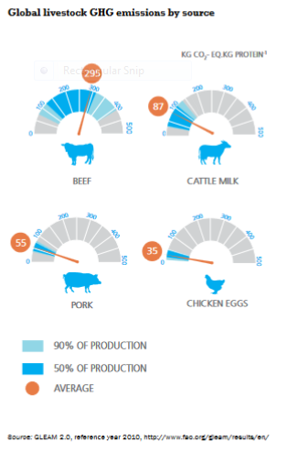

There is considerable scope for reducing emissions and creating off-sets. But action must be much more decisive, as the livestock sector is growing rapidly. Effective policies, strong institutions and the application of advanced practices are needed.
The different interventions will put a strong emphasis on actively promoting different ways to substantially reduce emissions from livestock production, to apply climate-friendly agricultural and processing techniques and to ensure that the activities undertaken are climate-change-resilient.

This will mainly be done by
(1)„productivity improvements that reduce emission intensities;
Emission intensities (emissions expressed per kg of milk, meat or egg) vary a lot among producers, indicating considerable scope for improvement. FAO estimates that available improved husbandry practices can reduce emissions by 20 to 30%, across all production systems, while it also supports better resilience to climate change.
Good Animal Health and Husbandry practices will actively be promoted and supported: Improving reproductive efficiency and extending the reproductive life of the animal will improve lifetime performance per animal and reduce GHG emission intensities. Reducing the incidence and impact of diseases, parasites and insect burdens will result in higher productivity and efficiency “with lower losses and less unproductive animals that emit GHG.
Animal Genetic Resources and Breeding: Breeding is an important factor for increasing productivity by improving traits such as live-weight gain or fertility. It can also improve adaption of livestock to changing environments, resistance to stress or shocks and diseases. When investing in breeding programmes, conservation of animal genetic diversity that can ensure farmers to have access to the best animals in each environment will be taken into account.

(2) Good environmental practices
Both in the poultry and pig value chains, the main source of pollution at the farm level is manure (mainly water pollution and odour, emission of greenhouse gasses is low). This can be mitigated by building the right infrastructure and using appropriate techniques for handling, storage and disposal of the manure, and proper dosage when using it as fertiliser.
At on-farm processing facilities and slaughterhouses, there should be infrastructure and procedures for the efficient use of water and proper disposal of waste. Whenever relevant, the use of for example solar energy and rainwater harvesting will be encouraged.

(3) carbon sequestration through improved soil management;
Good environmental practices will be promoted at field level such as agro-forestry practices where appropriate tree planting and management will be promoted to support soil erosion control and fertility of targeted lands, while at the same time ensuring diversification of products (fruit, fodder, fuel wood, etc) and income for households. In particular attention should be given to embed the production of soya and maize (for animals feeding) into smart agriculture/agro-forestry systems ensuring better resilience to climate change.

(4) better livestock integration in the circular bio-economy.
While a linear economy uses external inputs to produce outputs and waste, a circular economy minimizes the leaks of energy and materials from the system by re-circulating them in production. Better integrating livestock into the circular bio-economy can be achieved by increasing the share of by-products or waste that humans cannot eat (for example crop residues and agro-industrial by-products) in the livestock feed ration or by recycling and recovering nutrients and energy from animal waste.
Pig manure has the advantage that if produced in sufficient quantities it can be converted into biogas, which not only provides an environment-friendly way of disposing of the manure, but also produces cooking gas thus substituting wood fuel. The programme therefore has a special component to help smallholders obtain a biogas digester.
The circularity needs to be considered at all scales: in mixed crop-livestock systems at farm level and; in specialized crop and livestock farms linked via manure banks and feed supply chains; in trade of by-products at value chain level,..

(5) strengthening of regulatory framework and policy dialogue

Regulatory frameworks will be strengthened, and environmental considerations will be integrated. The regulations need to consider for example the sanitary and technical requirements for including, for example, insects or waste from households or the food service industry into livestock feed rations. For example in Japan, 52% of waste from the food industry is now used as livestock feed, thanks to adequate policies and a certification system.

Other limiting factors such as disregard of externalities (no carbon tax), and existing subsidies on inputs (e.g. fossil fuel or fertilizers) can also be part of the policy dialogue.

3. Focus on innovation by leveraging ICT
More use of technology and data in the agriculture sector is expected to positively impact on food security and economic development. ICTs help maximizing the impact of existing rural advisory services, financial services, and can facilitate access to markets, information and entrepreneurship opportunities. The “Rwanda’s Smart Rwanda Master Plan and ICT for Agriculture strategy (ICT4RAG)”, aims to accelerate Agricultural transformation from subsistence-based to market oriented agriculture whereby ICT has been considered as enabler. The programme will pilot and/or expand the scaling up of already existing ICT solutions. FAO, under the project “Agricultural Services and Digital Inclusion in Africa”, designed and tested four mobile applications for farmers in rural areas in Rwanda with an aim of increasing the use of data in their agriculture activities. The applications, namely; Weather and Crop Calendar, Cure and Feed your Livestock, AgriMarketplace and e-Nutrifood offer information and advisory services. Rwanda has a growing and vibrant ICT sector which is expected to participate in the design of relevant technological solutions that will be required in the implementation of the various interventions.

Priority target groups

Final beneficiaries (population)
The final beneficiaries will be the general population of Rwanda, benefitting from better access to qualitative food products, improved food security, increased opportunities in agriculture and agro-processing and agro-business.

For the project approach the final beneficiaries include also the different actors in the different value chains.

Intermediary beneficiaries (public and private actors whose capacities are strengthened)
The main intermediary beneficiaries will be both private and public actors active in the agriculture sector: (i) the MINAGRI, RAB, NAEB, NIRDA, districts, which will be partners in the implementation of the PforR and of the support to the 2 value chains and the related sub value chain; (ii) the different actors of the value chains, the small holder, medium and commercial farmers, processors, traders and distributors and their sector organisations and federations(iii) the broad spectrum of private service providers who will be implicated in the different value chains, in the extension services, in the infrastructure works, in the delivery of veterinary services, in agro-processing and agro-business, as well as (iv) research institutions implicated in the applied research components.

Strategic alliances – Complementarity and synergies

Engaging the private sector
The private sector will be key in the implementation, both for the delivery of services to beneficiaries and for its crucial role in the transformation of the agricultural sector to a knowledge-based sector: value chains are composed mainly of private sector actors. The Chamber of Agriculture in PSF and the concerned ‘sector platforms’ such as the Rwandan Poultry Industry Association and the Rwanda Pig Farmers’ Association, as well as the Rwanda Council of Veterinary Doctors (RCVD), Rwanda Animal Feeds Association (RAFA) are expected to be engaged in the project implementation.

Strategic partnership with Belgian expertise (including the private sector)
Belgian expertise is expected to be mobilized in the research components or technical assistance of the project modality. Belgian pork, poultry and animal feed actors – both private and academic - are recognized for their expertise. For example the Flanders Poultry Cluster brings the best of Flanders technical poultry expertise to global partners looking for top production results. This is accomplished by bringing together technical experts and prime companies by organizing meetings and company visits. The Belgian Federal Agency for the Safety of the Food Chain has a proven track record in preserving the safety and quality of food. Partnerships with Bio can potentially be developed to support investment for the private sector development in the agriculture sector.

Articulation with other development partners
Through the contribution to the MDTF, articulation with DFID, the Netherlands and the World Bank are inherently integrated in the program. During implementation further articulation will be developed with USAID programs, IFC, and other programs in the agriculture sector. (see also 1.8.1). In particular, it will be important to closely coordinate the development of the IFAD programme in order to ensure its implementation is supportive of this portfolio’s interventions. This program will be embedded as well within the existing structures for policy dialogue in Rwanda: the Joint Sector Reviews as well as the Agriculture Sector Working group and Technical Working Groups.

General and specific objectives
The General objective for the Agriculture sector is “Revenues for farmers’ households and other private actors in the agricultural value chains increases in a sustainable manner”. Based on the general objectives and the related Rwandan strategic plans, three specific objectives, each with its own modality, are formulated:

For the MDTF modality:

Specific objective 1: support through the MDTF the implementation of PSTA4 to promote the commercialization of agricultural value chains

For the project modality, 2 interventions, each which its specific objective have been defined:

Specific objective 2: Develop inclusive and sustainable feed, pig & poultry value chains in which all actors run a profitable business

Specific Objective 3: Attract private investment to develop a modern industrialized value chain to produce high quality meat products and eggs to substitute import as well as to export.

Specific Objective 1 will focus on strengthening the implementation of the PSTA4 through the Multi Donor Trust Fund (MDTF) managed by the World Bank, focusing on supporting the transformation of agriculture from a subsistence sector to a knowledge-based value creating sector that contributes to the national economy and ensures food security. 14.5 Mill Euros of the agriculture sector will be reserved for this modality and will be transferred to the World Bank. The Belgian contribution will contribute both to co-financing the PforR program as well as provide complementary funding windows that seek to maximize the impact of the PSTA4.

Specific Objective 2 and 3 are complementary to specific objective 1 by focusing on two specific value chains and the related sub-value chain for animal feed. These objectives align to the PSTA-4 as well as the Live Stock Master plan and aim at demonstrating best practices in operationalizing commercial value chains.

The total budget of the Agriculture sector is 30 million €, of which 14.5 million € will be reserved for the Result Based Financing Modality through the MDTF and 15.5 million € for the Project Modality. The Agriculture portfolio is underpinned by two different general aid modalities: a contribution to a Multi Donor Trust Fund modality and a Project Based Funding modality.

MDTF modality: Support the implementation of PSTA4 to promote the commercialization of agricultural value chains.

The MDTF is a programmatic trust fund, which allows donors to (i) co-finance the Results-based Financing approach in support of the PforR program and (ii) to support a complementary component that seeks to maximize the impact of the PSTA4.

Result framework for the intervention:

SO 1 (MDTF modality):
Support through the MDTF the implementation of PSTA4 to promote the commercialization of agricultural value chains.

Result 1 Result-based financing in support of PforR result areas (Component 3 of the MDTF)
The aim of the PforR program is “To promote the commercialization of agriculture value chains in Rwanda”. The program will strengthen the implementation of the PSTA4. The support to PforR allows donors to jointly support and stimulate the GoR in the process of agricultural transformation and address the challenges of leveraging private sector investment in the agriculture Sector.
With the contribution to the PforR the following 4 result areas under the component Results-Based Financing will be supported:
Results Area 1: Policy and Organizational Reform – aligned with priority area 1 and 4 of PSTA4 – for improving the structure and strengthening MINAGRI’s capability to undertake sector analysis, associated policy reforms and design/introduce relevant financing mechanisms/business models for attracting private sector investment.
Results Area 2: Enabling Agriculture Commercialization – aligned with priority area 4 of PSTA4 – for improving the quality of public investments in essential value chain services to leverage commercial agriculture, which include introducing business models that will link public investments to commercial markets and leverage increased levels of private sector investments. Promotion of Productive Alliances will be supported to strengthen the linkages between producers, buyers and the public sector within agricultural value chains.
Results Area 3: Delivery of Improved Agricultural Value Chain Services – aligned with priority area 3 & 4 of PSTA4- fostering competitive agricultural value chains with measures to improve productivity and inclusiveness of agricultural market systems and increase value addition and competitiveness of diversified agricultural commodities for domestic, regional and international markets. The PforR Program ambitions to introduce and accelerate the expansion of services that reduce the risk of agricultural investments by improving dialogue between private and public actors, increasing the use of private sector service delivery (e.g. out-grower schemes and productive partnerships), and expanding access to information and financial services.
Results Area 4: Efficiency of Public Expenditures – aligned with priority area 4 of the PSTA – supporting improved efficiency in public expenditure of the agencies that account for the largest share of the sector expenditure.
For the total program of the PforR the following Disbursement Linked Indicators (DLI) are formulated:
DLI 1: Organizational Development Plan successfully prepared and implementation on track;
DLI 2: Improved analytical and policy reform competencies demonstrated;
DL1 3: Digital information platforms designed and operational
DLI 4: Mechanism to Strengthen Agriculture Public-Private Dialogues and Agriculture Value Chain Platforms designed and implemented
DLI 5: New irrigation area identified, developed and/or managed where commercial viability has been a determining appraisal criterion
DLI 6: New terracing area identified, developed and/or managed where commercial viability has been a determining appraisal criterion
DLI 7: Volume of private sector investment (in US$) matching public financing in PPP infrastructure project
DLI 8: Private sector extension service models designed, launched and achieving positive response
DLI 9: Reform of RAB
In addition to the component 3 for Result Based Financing of the PforR there is another component in the PforR:
Result 2: Providing Evidence Based Analysis on Donor Partners (Component 1 of the MDTF):
This component is intended to support extra capacity development activities and to support informed debate between Government and Development Partners by building evidence to inform positions on the government’s programs and policies. As Rwanda’s agriculture transformation moves forward, it will be important to inform the progress – and potentially adjust the expected outcomes of key programs – and develop the evidence base. The analytical work and advisory support will concentrate on key public policy questions related to commercialization, rural employment, digital solutions, and access to finance that is related to PSTA delivery.
Some emerging areas of analytical work have been identified as follows: (a) analytics on how to create a sufficient number of jobs for a rapidly growing labour force, improving labour productivity, earnings, and quality of jobs, and ensuring access to jobs for more vulnerable population groups, including youth, women, those in the bottom 40 percent, and refugees; and (b) pro-poor market links focused on supply chains with high potential for inclusive employment/livelihoods. It is expected that any proposed areas of support will be detailed and reviewed by the MDTF Steering Committee.

This component acknowledges that government institutions in Rwanda are not yet fully equipped—in terms of both human and technical resources—to manage the transition towards being an Enabler of Private Sector Investment. Institutions like MINAGRI and RAB will be expected to undertake greater responsibilities, in new areas. A range of needs, from staff training and development through to monitoring and evaluation (M&E) system development and data analysis will be required both at the national level and in districts.
The types of support required will include:
- Assistance to MINAGRI Senior Management, including Private Sector advisory staff. Activities include specific investments, policy support and training.
- Third-party analytical capacity: Funds may be used to establish partnership with national/international agencies with relevant technical knowledge in private sector engagement.

Hypotheses, risks and mitigation measures
The following risks were identified for the MDTF component of the programme:
Table 10: MDTF risks and mitigation measures
Risks | Probability | Impact | Action | Mitigating Measures
MINAGRI and donors have divergent views on policy priorities | Medium | High | mitigation | Steering committee will act as forum for building consensus on the current and future work plans
Changes in leadership in MINAGRI/RAB and/ or donors may impact the direction of the MDTF | High | medium | mitigation | Financing/ administrative agreements will institutionalize approaches agreed
MINAGRI is unable to achieve the objectives and targets of PforR operation | Medium | High | mitigation | The PforR operation will undergo a mid-term review in 2019. This will provide an opportunity for restructuring. The MDTF can be restructured to ensure alignment with the PforR Operation.

MINAGRI is seeking to mitigate risks to the PforR Program specifically by: (i) supporting a parallel program of technical assistance funded by a MDTF – this will assist in the reorientation of MINAGRI, NAEB and RAB (and potentially other institutions); (ii) providing detailed analytical inputs on potential agricultural value chains most attractive for private sector investment as part of the agribusiness ‘deep dive’ under the ongoing Country Private Sector Diagnostic.

Organizational set-up

The MDTF is funded by the World Bank, DFID and the Dutch cooperation. The MDTF is open to additional contributors. The MDTF became effective on June 26th 2018, whereby the PforR component is planned for 3 fiscal years and the broader MDTF program for 4 years. A Mid Term review of the PforR component is planned for end 2019.
A steering committee is established, comprising representatives of the World Bank, contributing Donors, and MINAGRI. The steering committee meets twice a year. It provides advice on the future strategic direction and priorities for the MDTF, on the basis of a periodic report prepared by the World Bank. Approval criteria and conditions may be reflected in the administrative agreement or set out in a program management document. The World Bank and donors may agree in the steering committee meetings to adjust the amount of contributions based on the financial needs of the MDTF.

Table 11: Breakdown of Existing Donor Contributions by Component
PforR Rwanda Agriculture MDTF
Trust Fund Specific Indicative Budget in Holding Currency
Bank Executed (BE)
Providing Evidence Based Analysis on Donor Partners | $3.323.700
Supervision | $475.695
Program Management and Administration | $203,479
Subtotal (BE) | $3.998.840
Recipient Executed (RE)
Results-based Financing in Support of the PforR Results Areas | $89.920.000
Subtotal (RE) | $89.920.000
Trust Fund Fee (4.5% of the RE) | $4.096.800
Total Budget in Holding Currency | $98.015.640
Source: WBG P4R2

The MDTF set-up does not foresee the possibility for earmarking funds to one of the impact areas related to one of the DLIs or to one of the components. By contributing to the MDTF, Enabel will become member of the MDTF Steering Committee and will as such participate in the decisions on the future strategic directions and priorities for the MDTF. In the follow-up, Enabel will focus on the progress in the mobilization of private sector actors for the agricultural sector, while feeding in the experience it develops on the 3 specific value chains managed under the project modality. For the PforR special attention will be given to the DLI 4, 7 and 8.

The follow-up of these DLI and the broader experiences through the MDTF to mobilize private sector actors will support the private sector support aspired to in the 3 specific value chains supported under specific objective 2. An early formalization of the Belgian support to the MDTF will allow Enabel to participate in the 6 monthly implementation support missions and steering committees of 2019 and in the MTR for the PforR component end 2019. The MTR will assess progress compared to the identified DLI’s and creates the possibility to revisit the disbursement indicators.

The MDTF concept note describes the broad set-up of the MDTF program. The Steering Committee will meet twice a year and will advise on the future strategic direction and priorities of the MDTF, while specific approval criteria or conditions can be developed in the administrative agreement.
Program Management and Administration will be assured by the World Bank and will include assuring respect of program governance arrangements, assure organization of trust fund-related meetings; planning and executing work plans and budgets; developing communications programs and conducting outreach; disseminating lessons learned; reporting on progress to donors; and monitoring and evaluating the program. The WBG will use its systems and procedures to contract the necessary expertise required to implement the programme.
Specific one-to-two-weeks implementation support missions are organized by the World Bank every 6 months. Enabel experts will be mobilized to participate in the support missions. Enabel will participate in the biannual mission to assess progress toward the achievement of the DLIs. Through its contribution to the MDTF, Enabel will participate in agriculture policy dialogue with a specific focus on private sector investment, dialogue and provision extension services. Enabel will actively participate in the Agriculture Sector Working Group through two clusters – livestock and agribusiness.

Belgian contribution

The MDTF support will be managed by the World Bank, Enabel will sign a direct grant agreement with the World Bank and funds will be transferred by Enabel to the World Bank in line with the disbursement modalities agreed upon in the grant agreement. The disbursements will take into account commitments made by other donors, funding needs and the need to balance the annual expenditures in the portfolio.
The following disbursement schedule has been proposed to the World Bank
Table 12: MDTF / P4R Schedule of Disbursements
Year | FY 2019 - 2020 | FY 2020 - 2021 | FY 2020 - 2021
Belgium contribution (Euro) | 5,000,000 | 5,000,000 | 4,500,000

ProfR2 - MDTF Monitoring Framework

The Monitoring framework presented below, is the monitoring framework proposed by the World Bank. It will be further completed after discussions in the MDTF steering committee.
Result | Indicator | Target | Data Source/ Methodology | Responsibility/Comments
Component 1: Providing the evidence-base for an informed dialogue between Donor Partners and government (Bank Executed)
1. Relevant analytical work commissioned and made available to Agricultural Sector Working Group | 1.1 # of analytical reports delivered | => to be specified  e.g., Public Expenditure Review, Impact Evaluations, cross-cutting sectorial issues) | Final Reports | World Bank
2. Agricultural Sector Working Group effectively facilitated | 2.1 Annual portfolio review conducted, and final report circulated | YES | Final Report | World Bank
 | 2.2 # of donor partner dialogues convened during the past 12 months | at least x# of dialogues convened | Final summary meeting proceeding | World Bank
3. Third Party analytical support delivered | 2.1 % of contractually agreed products delivered on time | 100%  =>products still to be specified | copy of final accepted document | World Bank  Consultants and Technical Agencies contracted based on thematic and technical knowledge (e.g. organization development, institutional capacity development, private sector development, analytical analysis)
Component 2: Results-based Financing in Support of the PforR2 Results (Recipient Executed)
DLIs achievement and the timely completion of Program Action Plan effectively monitored | # of implementation support missions conducted | Two ISM per year | Aide Memoires, Back-to-Office Reports, ISRs, | World Bank
Improved harmonization in donor support to PSTA4 | Financial disbursement decisions are aligned with Disbursement Linked Indicators, Disbursement Arrangements and Verification Protocols established in annex 2 of PforR2 PAD | YES | Financial management reports to MDTF | World Bank

Program-For-Results Results Framework Matrix

The table below presents the result framework of the actual PforR.

RESULT_FRAME_TBL_PDO
PDO Indicators by Objectives / Outcomes | DLI | CRI | Unit of Measure | Baseline | Intermediate Targets (IT) |  | End Target
 |  |  |  |  | Y1 | Y2
To promote the commercialization of agriculture value chains in Rwanda
Performance of MINAGRI and RAB in achieving the milestones established in their respective Organizational Development or Restructuring implementation plan |  |  | Percentage | 0.00 | 0.00 | 0.00 | 70.00
MINAGRI |  |  | Percentage | 0.00 | 0.00 | 0.00 | 70.00
RAB |  |  | Percentage | 0.00 | 0.00 | 0.00 | 70.00
Improvements in the Enabling Business of Agriculture (EBA) Scores |  |  | Number | 0.00 |  |  | 0.00
Seed |  |  | Number | 20.20 | 24.20 | 28.40 | 32.00
Fertilizer |  |  | Number | 52.60 | 53.00 | 54.00 | 56.00
Markets |  |  | Number | 49.30 | 50.00 | 51.00 | 53.00
Private investment in agriculture value chain services (US$) |  |  | Amount(USD) | 101.50 | 150.00 | 175.00 | 200.00
.

.
RESULT_FRAME_TBL_IO
Intermediate Results Indicators by Results Areas | DLI | CRI | Unit of Measure | Baseline | Intermediate Targets (IT) |  | End Target
 |  |  |  |  | Y1 | Y2
Policy and Organizational Reform
Organizational Development plan successfully prepared and implementation on track. | DLI 1 |  | Text | None | Organizational review, including capacity needs assessment of MINAGRI completed and new functional structures in place | OD Plan for MINAGRI prepared and approved | Upgrade of HR management function completed
Improved analytical and policy reform competencies demonstrated. | DLI 2 |  | Text | NA | Private Sector Leveraging Strategy with implementation plan published | Annual Report by MINAGRI on Public-Private Investment in Agriculture published | Agricultural input subsidy schemes reviewed, alternative models for increasing efficiency assessed, reforms agreed and implemented
Digital information platforms designed and operational. | DLI 3 |  | Text | NA | A common data warehouse platform is designed and ready for use, whereby existing data in MIS and ALIS I are fully interfaced (at least down to the level of all districts) | The Farmer registration application and ALIS II are fully interfaced with MIS and ALIS I in the common data warehouse platform. Both, Farmer registration and ALIS II, will hold data covering all districts | The Livestock registration application (holding cow data with national coverage) will be interfaced with MIS, ALIS I and II, Farmer registration application in the common data warehouse platform  Sector Performance Dash Board is in place and publicly accessible online, whereby it provides reports on national agricultural macro indicators, national Indicator of Food Security and PSTA4 results indicators
Mechanism to strengthen Agriculture Public-Private Dialogues and Agriculture Value Chain Platforms designed and implemented. | DLI 4 |  | Text | NA | Two mechanisms designed, piloted, and budgeted: (1) National Agriculture Public-Private Dialogues (Ag. PPD) on themes with strategic relevance (2) Commodity value chain platforms | Two national Agriculture PPDs held and at least 3 Agriculture VC platforms established with operating plans | Additional 2 Agriculture PPDs held  Agriculture VC platforms are fully functional and yielded evidence of satisfactory results (as per M&E of operating plan
Improvement in functional performance of interagency coordination mechanisms. |  |  | Text | 0.00 |  |  | >20%
Enabling Agric Commercialization
Share of small scale farmers using improved seeds. |  |  | Percentage | 18.00 | 20.00 | 25.00 | 30.00
New irrigation area identified, developed and/or managed where commercial viability has been a determining appraisal criterion. | DLI 5 |  | Hectare(Ha) | 0.00 | 0.00 | 1,260.00 | 1,680.00
New terracing area identified, developed and/or managed where commercial viability has been a determining appraisal criterion. | DLI 6 |  | Hectare(Ha) | 0.00 | 0.00 | 745.00 | 2,310.00
Volume of private sector investment (in US$) matching public financing in PPP infrastructure projects. | DLI 7 |  | Text | 0.00 |  | 4.00 | 7.15
Delivery of Improved Agric Value Chain Services.
Number of different models of service delivery contracts signed and pilot under implementation. |  |  | Number | 0.00 | 1.00 | 3.00 | 5.00
Number of farm households reached by private advisory services (non-outgrower schemes) has increased. | DLI 8 |  | Number | 0.00 |  | 6,000.00 | 8,000.00
Number of new farm households participating in outgrower schemes has increased. |  |  | Number | 0.00 |  |  | 10,000.00
Number of Productive Alliances under implementation. |  |  | Number | 0.00 |  | 25.00 | 50.00
Number of Productive Alliances under implementation in Livestock Value Chain. |  |  | Number | 0.00 |  | 10.00 | 20.00
Number of Productive Alliances under implementation high value crops Value Chain. |  |  | Number | 0.00 |  | 15.00 | 30.00
Business leader’s perceptions about agricultural investment climate in Rwanda. |  |  | Text | NA |  |  | >15%
Efficiency in Public Expenditures
Reform of RAB. | DLI 9 |  | Text | NA | Implementation Plan for RAB restructuring order prepared and approved by its Board | +/-3% Deviation between budget and outturn expenditure 2019/20 | Unqualified audit opinion on financial statement of RAB
Annual increase of earmarked transfers from MINAGRI to local government. |  |  | Percentage | 0.00 | 2.00 | 4.00 | 5.00

Program-For-Results Phase 2 Disbursement Linked Indicators Matrix

The table below presents the DLI matrix of the Approved PforR2 Operation. The Matrix for the Additional Financing is currently under development and will only be completed by the World Bank after the signing of the formal commitments of DFID, the Dutch Cooperation and Enabel. The proposed matrix will be validated by the MDTF steering committee.

Disbursement Linked Indicators Matrix

DLI 1 | Organizational Development Plan successfully prepared and implementation on track.
Type of DLI |  |  | Total Allocated Amount (USD)
Output |  |  | 10,000,000.00
Period | Value |  | Allocated Amount (USD)
Baseline | NA

Prior Results |  | 0.00

2018/2019 | Organizational review, including capacity needs assessment of MINAGRI completed and new functional structures in place | 4,000,000.00 | Total disbursement upon receipt of unqualified OAG report

2019/2020 | Organizational Development (OD) Plan for MINAGRI prepared and approved | 4,000,000.00 | Total disbursement upon receipt of unqualified OAG report

2020/2021 | Upgrade of HR management function completed | 2,000,000.00 | Total disbursement upon receipt of unqualified OAG report

DLI 2 | Improved analytical and policy reform competencies demonstrated.
Type of DLI |  |  | Total Allocated Amount (USD)
Output |  |  | 10,000,000.00
Period | Value |  | Allocated Amount (USD)
Baseline | NA

Prior Results |  | 0.00

2018/2019 | Private Sector Leveraging Strategy with Implementation Plan published | 4,000,000.00 | Total disbursement upon receipt of unqualified OAG report

2019/2020 | Annual Report by MINAGRI on Public-Private Investment in agriculture published | 2,000,000.00 | Total disbursement upon receipt of unqualified OAG report

2020/2021 | Agricultural input subsidy schemes reviewed, alternative models for increasing efficiency assessed, reforms agreed and implemented | 4,000,000.00 | Total disbursement upon receipt of unqualified OAG report

DLI 3 | Digital information platforms designed and operational.
Type of DLI |  |  | Total Allocated Amount (USD)
Output |  |  | 8,000,000.00
Period | Value |  | Allocated Amount (USD)
Baseline | None

Prior Results |  | 0.00

2018/2019 | A common data warehouse platform is designed and ready for use, whereby existing data in MIS and ALIS I are fully interfaced (at least down to the level of all districts) | 2,000,000.00 | Total disbursement upon receipt of unqualified OAG report

2019/2020 | The Farmer registration application and ALIS II are fully interfaced with MIS and ALIS I in the common data warehouse platform. Both, Farmer registration and ALIS II, will hold data covering all districts | 2,000,000.00 | Total disbursement upon receipt of unqualified OAG report

2020/2021 | The Livestock registration application (holding cow data with national coverage) will be interfaced with MIS, ALIS I and II, Farmer registration application in the common data warehouse platform  Sector Performance Dash Board is in place and publicly accessible online, whereby it provides reports on national agricultural macro indicators, national Indicator of Food Security and PSTA4 results indicators | 4,000,000.00 | Total disbursement upon receipt of unqualified OAG report

DLI 4 | Mechanism to strengthen Agriculture Public-Private Dialogues and Agriculture Value Chain Platforms designed and implemented.
Type of DLI |  |  | Total Allocated Amount (USD)
Output |  |  | 8,000,000.00
Period | Value |  | Allocated Amount (USD)
Baseline | NA

Prior Results |  | 0.00

2018/2019 | Two mechanisms designed, piloted, and budgeted: (1) National Agriculture Public-Private Dialogues (Ag. PPD) on themes with strategic relevance and (2) Commodity value chain platforms | 2,000,000.00 | Total disbursement upon receipt of unqualified OAG report

2019/2020 | Two national Agriculture PPDs held and at least 3 Agriculture VC platforms established with operating plans | 2,000,000.00 | Total disbursement upon receipt of unqualified OAG report

2020/2021 | Additional 2 Agriculture PPDs held  Agriculture VC platforms are fully functional and yielded evidence of satisfactory results (as per M&E of operating plan) | 4,000,000.00 | Total disbursement upon receipt of unqualified OAG report

DLI 5 | New irrigation area identified, developed and/or managed where commercial viability has been a determining appraisal criterion.
Type of DLI |  |  | Total Allocated Amount (USD)
Output |  |  | 10,000,000.00
Period | Value |  | Allocated Amount (USD)
Baseline | 0.00

Prior Results |  | 0.00

2018/2019 |  | 0.00

2019/2020 | 1,260.00 | 5,000,000.00 | Proportionally to verified area under recognized PPP

2020/2021 | 1,680.00 | 5,000,000.00 | Proportionally to verified area under recognized PPP

DLI 6 | New terracing area identified, developed and/or managed where commercial viability has been a determining appraisal criterion.
Type of DLI |  |  | Total Allocated Amount (USD)
Output |  |  | 10,000,000.00
Period | Value |  | Allocated Amount (USD)
Baseline | 0.00

Prior Results |  | 0.00

2018/2019 |  | 0.00

2019/2020 | 745.00 | 5,000,000.00 | Proportionally to verified area under recognized PPP

2020/2021 | 2,310.00 | 5,000,000.00 | Proportionally to verified area under recognized PPP

DLI 7 | Volume of private sector investment (in US$) matching public financing in PPP infrastructure project.
Type of DLI |  |  | Total Allocated Amount (USD)
Output |  |  | 20,000,000.00
Period | Value |  | Allocated Amount (USD)
Baseline | NA

Prior Results |  | 0.00

2018/2019 |  | 0.00

2019/2020 | 4.00 | 10,000,000.00 | Proportionally to verified volume private sector investment

2020/2021 | 7.15 | 10,000,000.00 | Proportionally to verified volume private sector investment

DLI 8 | Private sector extension service models designed, launched and achieving positive response.
Type of DLI |  |  | Total Allocated Amount (USD)
Intermediate Outcome |  |  | 15,000,000.00
Period | Value |  | Allocated Amount (USD)
Baseline | NA

Prior Results |  | 0.00

2018/2019 |  | 0.00

2019/2020 | Number of farm households reached by private advisory services (non-outgrower scheme) has increased: 6000 | 5,000,000.00 | Proportionally to verified number of farm households reached

2020/2021 | Number of farm households reached by private advisory services (non-outgrower schemes) has increased: 8000 Number of new farm households participating in outgrower schemes has increased: 10,000 | 10,000,000.00 | Proportionally to verified number of farm households reached

DLI 9 | Reform of RAB.
Type of DLI |  |  | Total Allocated Amount (USD)
Output |  |  | 9,000,000.00
Period | Value |  | Allocated Amount (USD)
Baseline | None

Prior Results |  | 0.00

2018/2019 | Implementation Plan for RAB Restructuring Order prepared and approved by its Board | 3,000,000.00 | Total disbursement upon receipt of unqualified OAG report

2019/2020 | +/-3% Deviation between budget and outturn expenditure 2019/20 | 3,000,000.00 | Total disbursement upon receipt of unqualified OAG report

2020/2021 | Unqualified audit opinion on financial statement of RAB | 3,000,000.00 | Total disbursement upon receipt of unqualified OAG report

.

The graph below illustrates the verification process with an important role for the Office of the Auditor General:
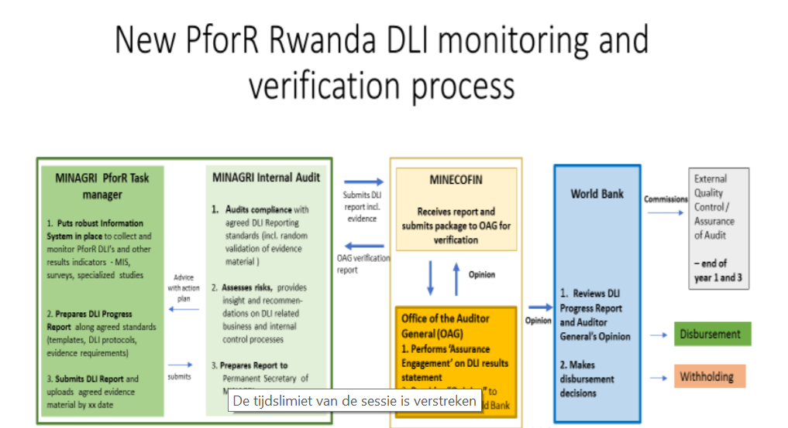

Project modality: Development of the value chains of poultry and pork and the related animal feed value chains

Specific context elements related to the targeted value chains
The Livestock Master Plan (LMP) aims to increase the production of small livestock and to do so through private sector investors and through small holder farmers in Rwanda. A critical component of the plan is to ensure that the small holders are supported in a way that ensures that they have access to technical assistance and are linked to those adding value and to final markets where their animals (live) or processed products can be sold. PSTA4 speaks of enhancing the role of the private sector in the development of the sector and in this case how small livestock farming will be driven by private sector investment. It is within this context that the Belgian-funded project has been designed to support the Rwanda commercial poultry, pig, and animal feeds value chains in a sustainable way.

Poultry and pork value chains
The poultry and pork value chains face in general the same challenges: restricted commercialization and ability to attract both domestic and foreign investment, a lack of quantity and quality animal feed, lack of proximity of extension, veterinarian and animal health services, a need for improvement of the breeds (especially the traditional family animals), lack of slaughter facilities and processors that can produce and distribute a variety of high-quality meat products.
- Poultry sub-sector context
The poultry value chain is the fastest growing subsector in Rwanda, and has significant potential for growth and with it the opportunity to (i) improve the livelihoods of thousands of poor farmers in the rural areas by connecting them to those adding value and to final markets; (ii) contribute to addressing the malnutrition and stunting challenge; (iii) raise income for those involved; (iv) reduce imports while expanding exports of poultry products.
Actors
The sector is characterised by traditional and industrial poultry farmers.
The traditional poultry farmers are the largest component of actors in the sector who produce mainly in villages in the backyards. Most farmers have livestock as an income supplement, but not as their main occupation. They face important challenges related to diseases, access to markets and the ability to invest to improve their husbandry operations. Industrial poultry farming in Rwanda started quite recently and the sector has seen a number of significant investments that are transforming the industry as a whole. These investments have gone in to the Day Old Chick production, broiler production and processing and high-tech egg production.
There main private sector investments that started in the poultry sector are the following:
- Abusol Ltd entered the Rwandan market in 2016 with a state for the art $1m facility in Bugesera aimed at increasing egg production in Rwanda both for domestic and the export market. The firm produces high quality eggs, using modern technologies, with a capacity to accommodate around 65,000 chickens, and produces quality animal feeds.
- Uzima LTD is a poultry company that started its operations in Rwanda in 2017, taking over the former national hatchery. It has thus far planned investments of $4m in upgrading the hatchery and developing an extensive small holder network. It intends to transform the poultry industry in Rwanda by reaching out to smallholder farmers across Rwanda and the East African market with a more robust improved bird called ‘Sasso’ that resists the local conditions and is four times more productive compared to the local chickens. Uzima LTD has a business relation established with 200 ‘contact farmers’/agents all over the country (private farmers including women or youth groups) who grow-up 300 – 500 chicks per cycle for selling the chicks to interested farmers in the surroundings.
- Poultry East Africa Ltd (PEAL) is a $2.5m poultry farming social enterprise based in Bugesera, Rwanda. It’s the only fully integrated poultry farm with its own feed mill, broiler farm and slaughtering-processing-distribution facilities. The firm is striving to be the first commercial poultry farm in Rwanda that meets global standards of output.
In addition to the three large investments, there a number of SME investments in the poultry sector all over Rwanda. These large scale and small scale act as important drivers for increasing the production capacity in the value chains. Most farmers (46%) have between 100 to 500 birds, 22% of the farmers have less than 100 birds, and only the remaining 32% have more than 500 birds.
There are two industry bodies that represent actors in this value chain - The Rwanda Poultry Industry Association (RWPA) and the Rwanda Poultry Association.

Production
Since 2010, the number of chickens (layers, broilers and indigenous chicken) in Rwanda has grown exponentially. In 2010 the country had 3.5 million chickens which produced about 80 million eggs. By 2016, the country had more than 5 million chicken and egg production had increased to 157.7 million eggs amounting to 7,974 tonnes. Statistics from Rwanda Agriculture Board show that poultry contributed a lot in Rwanda’s overall meat production increase from about 86,000 tonnes in 2015 to about 116,000 tonnes in 2016. Poultry accounted for 30%, representing over 30,000 tonnes.
The local breed “Inyarwanda” is a mixed breed. The exotic layer breeds used are Rhode Island red, Derco and Norman, while the exotic broiler breeds are Cobb 500, and to a lesser extent Hubbard.
When it comes to supply of day-old chicks (DOC), there is a positive evolution in which local production is gradually substituting imports from the region (Kenya and Uganda) or international (France and Belgium) at a significant cost.
The PSDAG Poultry Competitiveness Study (USAID 2016) shows that in 2010, only 398,552 DOC were produced locally and 1,087,390 were imported, yet by 2015 local production had more than doubled to 912,000 DOC while imports had reduced to 870,000 chicks.
While broilers are easier to raise, the costs for small holder participation are still relatively high given the cost of DoCs, feed, and vet services. The level of productivity is still very low with many of the birds produced by SHF taking longer to achieve the desired weight before sale. This is mainly due to the lack of access to the appropriate feed formulations. There is one major slaughter house linked to PEAL, the largest industrial broiler producer in Rwanda. Other than PEAL which is based in Bugesera, other areas of the country especially those near the main export markets are underserved and will require slaughter house facilities.
Markets
Rwanda has a production deficit in eggs and chicken relative to consumption and resorts to imports to fill the gaps.
In addition to increasing local demand (mainly in urban areas), there is still a huge export potential for poultry products and chicken meat. While formal exports of live chickens are minimal, at around 500 birds in 2016/17 (NISR Statistical Yearbook), there is thriving informal cross-border business in live chickens, with 644,216 birds exported in the same financial year. The nearby export markets with the biggest potential (both for meat and eggs) are the east of the DR Congo (Goma and Bukavu together constitute a market of 2 million people) as well as Burundi – those markets are currently served mostly by Uganda, as well as Tanzania.
As for egg production, the PSDAG Study shows a marked increase in national production from about 80 million eggs (5,203 tons) in 2010 to 115.5 million eggs (7,505 tons) in 2015. However, this represents only half of the national demand, which was estimated by the same study at 203 million eggs (13,200 tons) in 2015. As a result, about 7,900 tons of eggs are imported annually, while 2,200 tons are exported from Rwanda.
The collection and efficient distribution of eggs from the rural areas is not well established. This in turn hinders the potential of egg producers because they are not sure that their production will get to the market in a timely manner.
For the potential to be realised, a number of challenges the sector faces will have to be addressed. These include; (i) the lack of parent stock for both the layers and broilers which limits the production of day old chicks; (ii) low levels of productivity; (iii) the limited segregation of the roles of key components of the value chain; (iv) the high cost of inputs especially feeds; (v) limited facilities available for value addition; (vi) the susceptibility to diseases due to poor bio-security (vii) and most importantly the high cost of entry for poor famers into the value chain.

- Pig sub-sector context
The Pig sub-sector is one of the least developed components of Rwanda’s livestock sector. The pig sub-sector / value chain is the least professionalized and has not attracted significant investments. It is mainly dominated by small breeders or fatteners as well as cooperatives, as there are no big specialised pig breeding companies.
Production
Production is concentrated in southern and western Rwanda. The majority of producers are small holder farmers who rear pigs in their backyards. The sector has significant potential for growth. Pigs like poultry have high turnover rate, quick return on investment, high growth rate and a short generation interval. Pig farming in Rwanda has been growing progressively with the number of pigs increasing by 76% in the last five years to over 1.7 million.
The Integrated Household Living Conditions Survey 2013-14 (EICV4) also showed a marked increase in the percentage of households raising pigs, from 24% (EICV3, 2010-11) to 32% (EICV4) nationally.
Pig meat production in Rwanda has nearly tripled from 7,228 tons in 2010 to 21,072 ton in 2016/17 (according to the LMP). Only a fraction (76 tons) of this comes from commercial specialized farm, as shown in table 4 below.
Currently there is no separation between the piglet production and the fattening. This lack of specialisation affects the ability to scale up operations given the cost of undertaking investments in the two components of the value chain. These high investments costs limit the ability of poor SHF to participate and when they do the lack of affordable feeds and lack of access to vet services result in low level of productivity.
The African Swine Disease is a permanent risk that could cause heavy mortality losses. FMS is also a serious health problem. Access to quality veterinary health care services and medicines is crucial for livestock productivity, and for both animal and human health. Veterinary services are provided both by public as by private actors..
There are currently five slaughterhouses in the country at varying levels of sophistication in terms of processing. The lack of appropriate slaughtering facilities in communities has compromised standards, a situation that has affected efforts to enter new pork markets outside the country. Feedback from Rwanda pig farmer’s association indicates that “Our products are being turned down by buyers because of standards, which arises from the way they are processed and handled along the value chain.
Rwanda imports large amounts of pork products that could be produced locally. There are no capacity building efforts to train and educate butchers and chefs on how to prepare various pork cuts and processed products. Equally there is no certification system for professionals in the sector and most of important of all there are no standards developed for products in the sector.
Market
Live pigs are mostly sold in Western Province (11,400 pigs sold per month on livestock markets) and Southern Province (14,400 pigs sold per month). There is minimum specialization in pig production farms, and most farmers would sell any age group including pre-weaned pigs. However, weaners are the most marketed category. Farm gates the most common mode of selling, whereas others sold in the nearest public markets, and a small share on contract.
While Pork fetches much higher prices than traditional red meat, many pig farmers are still struggling to benefit due to a number of constraints affecting the value chain. There is limited coordination between supply and market activities.
Consumption of pork products has grown significantly and following the implementation of the MICE strategy Rwanda is attracting significant numbers of business tourists. This increased inflow of tourists has created the demand for quality cuts of pork products however given the under-developed pork industry it has not been able to meet the demand hence the significant import of pork products which puts further the pressure on Rwanda’s burgeoning trade deficit. The LMP sets a target of an increase of 239% of pig meat in the next 5 years moving from 19,000 to 67,000 metric tons of pork
Of all dressed meat in Rwanda, 21% comes from pigs. However, local production, while increasing, is still not able to satisfy the local demand, and also grows at a slower rate than the demand as the table 5 shows:
Table 5: Pork meat market, 2012-2014 (tons)
2012 |  | 2013 |  | 2014
Sold | Demand | Sold | Demand | Sold | Demand
7,938 | 15,215 | 8,905 | 22,723 | 10,210 | 34,033
Source: LMP 2017
In addition, like for chicken meat there is a huge potential market for pork in Goma and Bukavu in the Eastern DRC, as it is estimated that the major butcheries in those cities require at least 17 tonnes of pork per week. Furthermore, big Congolese cities such as Beni, Kisangani and Lubumbashi are also supplied in meat by air from Goma. Currently however, just like with live chickens, exports of pigs are mostly informal. According to the NISR Statistical Yearbook, in 2016/17 only 22 pigs were formally exported, against 69,404 live pigs sold in informal cross-border trade.
The Rwanda Pig Farmers Association (RPFA) is the main body representing the farmers and other actors in the sector. There other body is the Rwanda Meat Producers Association. Implementation of the proposed interventions in the value chain will require close collaboration with both associations.

Gender
In Rwanda, men are the main actors in most farm activities related to pigs. Men sell the pigs and control the way the money is used. The traders approach the men rather than the women who have no say in pig sales. In most cases, the men buy replacement pregnant gilts, weaner or a young boar in the expectation that the women continue to raise whatever livestock is around. This situation is different from for example Central kenya, where women play a major role in the semi intensive system. The intervention will have to create awareness around these issues, and promote intensively the participation of women in the value chain.

For the potential outlined above to be achieved, a number of constraints affecting the sector will have to be addressed. The constraints include; (i) in-breeding of animals that affects their health and productivity; (ii) high cost and limited availability of feeds; (iii) timely access to vet services; (iv) the separation and professionalization of roles within the value chain (breeding, piglet production, and fattening); (v) high cost of Small Holder Farmers (SHF) entry and participation; (vi) lack of a strategy on how to grow domestic demand or maximise the export potential. Evidence from other EAC countries is that the pork value chain if well developed, it has the potential to lift thousands of smallholder livestock farmers out of poverty and also provide an additional source of nutrition (protein) in the diet.

- Animal feeds context
The animal feed is a critical component of the livestock sector. Rwanda has over the years faced a significant challenge in producing sufficient animal feed to support the development of its livestock sector. The bulk of rural livestock farmers utilise grasses and maize and legumes in feeding their animals. The feed is of low quality, lack the proper nutritional content, which affects the productivity.
Nevertheless, over the last 5 years, a number of animals feed producers have set up in the country in an effort to tap into the significant domestic and regional market demand. There are now six main factories specialized in feed manufacturing in Rwanda located in each of Rwanda’s five provinces. Together they account for more than 60% of local production, and account for 90 percent of feed sold on the local market.
A further ten, non-specialized units account for the remaining 10% of feed sold on the local market. In addition, significant number of farmers produces feed concentrates on their farms. Farm-produced feed reached 25,600 tons in 2015, or two-thirds of total demand, estimated at 38,400 tons. Factories and other feed millers supplied the remaining 12,810 tons.
Imports of ready-mixed poultry feed are negligible. Rather, traders and manufacturers import feed ingredients, which they mix according to daily demand.
The investments have led to an increase in the domestic production however the cost of feeds has remained high mainly due to the high cost of feed production inputs – Soya, maize, and calcium.
The average price of commercially produced feed in Rwanda is FRw 308 per kg—significantly higher than in Kenya (FRw 250 per kg), Uganda (FRw 240 per kg) or Tanzania (FRw 125 per kg). A key reason for the prices being higher in Rwanda is that neighbouring countries enjoy easier access to key ingredients such as maize, fish and soybean meal, which make up 87 percent of poultry feed. Tanzania has the lowest price of feed in the region exhibiting a strong regional competitive advantage of the country. The price of poultry feed in Rwanda also reflects the lack of economies of scale in production and the high cost of ingredients, mainly imported from Uganda and Tanzania. Competition for maize is driven by demand for human consumption, while other key inputs (fish, cottonseed meal) are subject to high and fluctuating prices over the year.
In recognition of the critical role animal feeds play, the government has removed VAT from processed animal feeds and also offered reduced electricity tariffs for the feed producers. These efforts are expected to attract investments and critically help increase productivity and lower the costs of feed sold to farmers.
A new industry body has been newly registered to represent the animal feeds companies – Rwanda Animal Feeds Association (RAFA).
Main bottlenecks identified in the animal feed industry include the following;
- Availability and quality of feed ingredients: (i) the poor quality (high aflatoxin levels) and limited availability of maize (energy source); (ii) lack of reliable supply of Soya (plant protein) or alternatives; (iii) the limited availability of alternative sources of calcium
- Price
- Quality and Safety information and Assurance
- Efficiency and Effectiveness of the processed feeds

For the potential of the livestock value chain to be achieved, the main constraints affecting the animal feeds sector have to be addressed
The project has been designed to work with the private sector to address the domestic inputs production problem.

Specific strategic considerations for the interventions
As already indicated in chapter 1.4. “Strategic choices”, two complementary, but mutual reinforcing and interlinked interventions are proposed for the project support, based on the two track approach, considering smallholder production systems and industrial production systems.
The first intervention aims to support and develop inclusive and sustainable value chains in line with the market demands and will focus on professionalizing the smallholder production systems, still providing the majority of meat products in the country. Even though the intervention will support smallholders, the intervention will target those who want to run livestock activities as a professional business, and who are ready to innovate in order to improve efficiency. Farmers who keep a couple of chickens or one pig in the backyard, mainly for food security purposes, are not the target of this intervention. The intervention aims in the first place to increase incomes of smallholders and to create additional jobs, especially for youth and women, but will also through integration of transversal issues look for a positive impact on nutrition, gender and environment.
Responding to the most important challenges related to improving sustainable production and productivity, being good feeding and husbandry practices and quality animal health services, the intervention will strengthen in the first place quality services related to production and health, respectively through the FFS approach, and through expanding the VSF model of quality proximity private veterinary services. Good environmental practices and gender considerations will be important topic in the trainings. To create the capacity to run farms as a business, and to gain better access to markets, inputs and finance, facilitators and farmers will be trained in farmer business schools. Linkages will be actively sought with anchor firms or larger actors operating in the sector, as there are the feeding industry, the DOC producers, traders etc. Small processors, traders, collectors and other actors operating in the value chain can also benefit from business development service to run their activities in a more professional and efficient way. To improve the production of quality and affordable feed in the country, the intervention will contribute to increased production of feed ingredients, mainly maize and soybean, and facilitate a system of sustainable supply of these ingredients by the smallholders to the feeding industry through an out growers service company.
The second intervention aims to attract private investments to develop a modern industrialized value chain to produce high quality meat products and eggs to substitute import as well as to export, and reduce the trade deficit of Rwanda. The intervention will make use of the Rwandan specialized institutions to strengthen the existing businesses operating in the chains with business and technical coaching, and to attract new private investors to facilitate the industrialization, including at farm level, in line with the Rwandan strategies. A focus will be put on the promotion of those investments that will have a service or market link with smallholders, or that have a strong innovation or environment component.
The two interventions are linked with each other. For example, the DOC produced by breeding centers which receive support through the second intervention will supply DOC to small farms which are supported through the first intervention. On the other hand, the animal feed factories which are supported in the first intervention will supply feed to the industrialized farms supported through the second intervention. Both interventions will be private sector led except in areas where public funds will be required to de-risk private sector investments or to open up participation in the value chain for poor SHFs.
Finally, the improvement of the conducive environment, through better standard, regulations, and policies, and the strengthening of the coordination between the value chain actors to develop joint strategies, win-win partnerships and innovations will benefit the actors of both the two production systems.
In both interventions, there will be an emphasis on actively promoting different ways to reduce emissions from livestock production, to apply climate-friendly agricultural and processing techniques and to ensure that the activities undertaken are climate-change-resilient. Social impact (including gender issues) of the supported actions and investments will also be thoroughly analysed and monitored, to ensure the interventions contribute to an inclusive growth and development.
The proposed actions aim to address the challenges and opportunities in a comprehensive way, and are presented in the figure below.

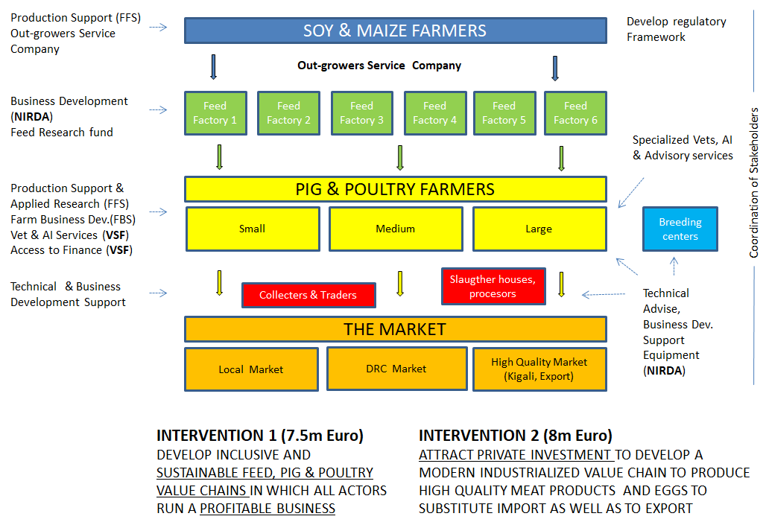

Result framework of the intervention

INTERVENTION 1. DEVELOP SUSTAINABLE VALUE CHAINS

SPECIFIC OBJECTIVE: DEVELOP INCLUSIVE AND SUSTAINABLE FEED, PIG & POULTRY VALUE CHAINS IN WHICH ALL ACTORS RUN A PROFITABLE BUSINESS

Result 1.1: The feed industry supplies affordable and quality feed, which includes locally sourced ingredients

Improving access to animal feed is a critical component of the livestock value chain. The viability of poultry and pig value chains is heavily dependent on a solution being found in addressing the animal feeds challenge – cost of inputs – hence market price and volatility, quality, availability of supply. There are a number of private sector led investments in the sector that have provided options for domestic supply of animal feed. Nevertheless, the lack of domestically sourced inputs forces the companies to import most of the feed ingredients. This leaves the industry susceptible to commodity shocks (maize and soya) which affects the efficiency of the animal feeds producers. Government has attempted to support the value chain by removing VAT and reducing electricity tariffs. These measures may have helped however, they do not address the underlying constraints.
Soya bean and maize are two important ingredients of animal feed. Although soya bean is produced in Rwanda, the feed companies are currently importing almost all soya bean. By building on the successes of increasing productivity through the Farmer Field School (FFS) approach and by investing in a new model that aims to link the soya and maize farmers to animal feed companies in a fair and sustainable way, the interventions aim to address this important challenge. The intervention is perfectly placed to facilitate fair, transparent links between the suppliers of ingredients and the feed companies on one hand and on the link between the feed companies and animal producers on the other hand.

Soya bean production in Rwanda

Currently, much of the Soya is being purchased from suppliers in neighbouring countries as a result of local farmers not being able to meet the high demand in Rwanda. There are about 9,000 farmers involved in soya production across the country, especially in Southern and Eastern provinces producing more than 60,000 tons annually. The annual demand for soya for human consumption and animal feeds is estimated by RAB to be at least 100,000 metric tons and growing rapidly. Production is erratic and unreliable. Given that soya is not part of the Rwandan diet, it is not grown as widely because SHF are wary of the inability to sell the soya beans. The main market constraint is the failure to link demand to supply. On the other hand the off takers (animal feed companies), consider the smallholder as an unreliable component of their supply chain and hence are reluctant to commit to buying local. The net result is significant imports of soya that increase the cost of animal feeds.

Activity 1.1.1. Develop profitable, resilient and sustainable soya and maize farms which run their farms and farmer groups/cooperatives as business with sustainable links to input suppliers and buyers

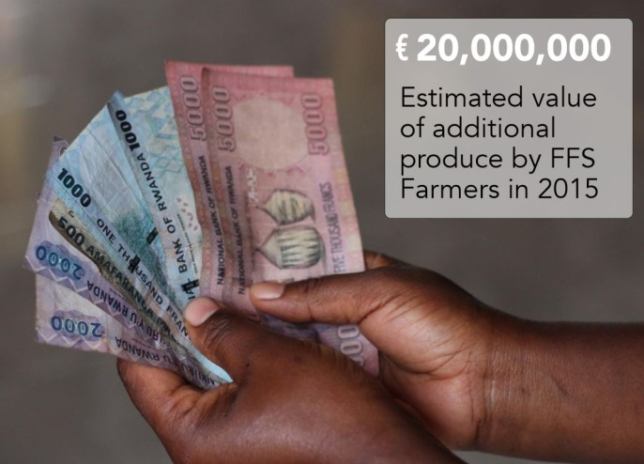
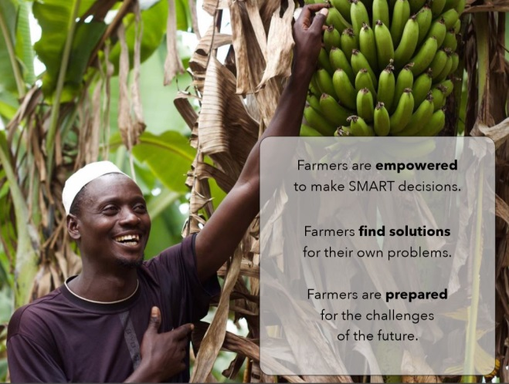
The previous Belgian funded intervention in agriculture focused on seed production and extension services. Through the expansion of the Farmer Field School approach, the SSPATII program trained more than 2500 FFS facilitators who worked directly with more than 200,000 thousand farmers. Productivity compared to non-trained farmers increased with 46% (average for all crops) and thanks to the organization of the farmers into groups, the FFS farmers benefited from a range of social aspects, such as savings, training on transversal themes such as Gender and HIV, family planning etc. About 20% of the FFS groups invested as a group in a new business. Harvest studies showed that the productivity of Soya bean increased by 56%.

The FFS approach is a group-based experimental learning approach in which FFS farmers get the opportunity to discover which farming practices give the best results. In FFS, the plant is the teacher. The FFS approach builds the skills and capacity of farmers to identify and analyse problems, to conduct experiments aiming at developing local solutions appropriate to local specific challenges. Each FFS group needs a competent facilitator (with strong technical, facilitation skills and group building skills) to lead FFS group members through the hands-on learning process. Each FFS group has its own experimental learning plot in which the groups comes together on a weekly basis.
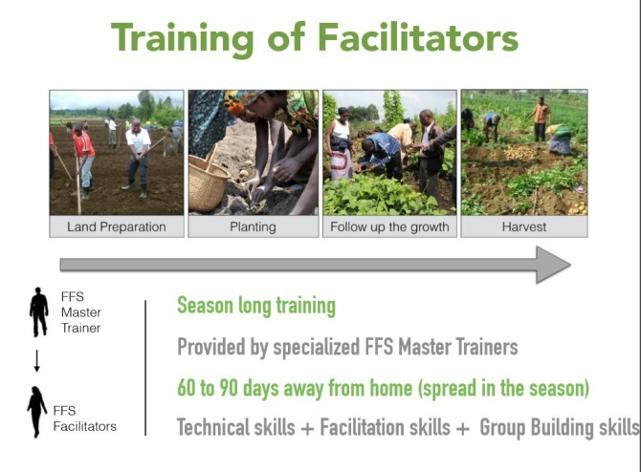
The FFS Facilitators are elected among the farmers. They are intensively trained by FFS Master trainers. After training a first FFS group, the FFS Facilitators continue to train additional groups. By the end of the SSPATII program, all FFS Facilitators were organised in private service cooperatives, who were hired by the Government to train farmers.

The FFS approach has proven that it can build the capacity of farmers to apply good agricultural and environmental-friendly practices and that the approach can be used to address a range of transversal themes. However, the SSPAT II intervention insufficiently focused on linking the farmers with specific markets. The current intervention wants to build on the success of the FFS but further improve it by linking the FFS facilitators to the Out-growers Service company (See Activity 1.1.2).

Although the SSPATII program has already trained more than 200 FFS Facilitators on Soya bean production, it is essential to train new FFS facilitators in specific regions where soya beans could be produced to supply the various feed companies. The Gabiro irrigation project is aimed at attracting commercial agriculture in large scale farming of maize, beans, soya and horticulture. The intervention will leverage the activities and opportunities to address the issue of soya availability. Therefore, the Rwandan FFS Master trainers based in RAB (graduated in the SSPATII Program) will be mobilized to organize a season long training course based on the training methods developed under the SSPAT II program. It is estimated that an additional 150 soya/maize FFS Facilitators are needed. Each of the FFS Facilitators will work with at least 3 new FFS groups for 3 seasons with each group. The training will also include the Farmer Business School training modules.

This intervention will continue to use the FFS network to address a number of transversal themes such as family planning, gender, HIV prevention, etc. An important new transversal theme will be added: Family nutrition. Studies have shown that in many Rwandese households, the meals do not provide the essential elements. Often this is due to the lack of knowledge of how to prepare a healthy, balanced meal. If the introduction of nutrition in the FFS curriculum proofs to be successful, it can relatively easily be scaled through by training all FFS facilitators in the country.
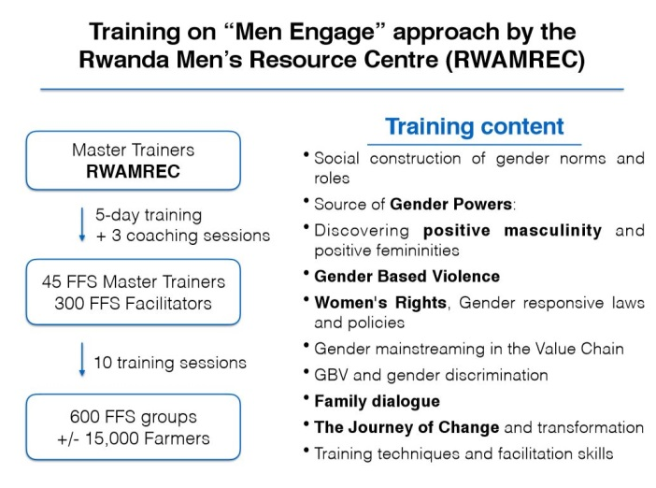
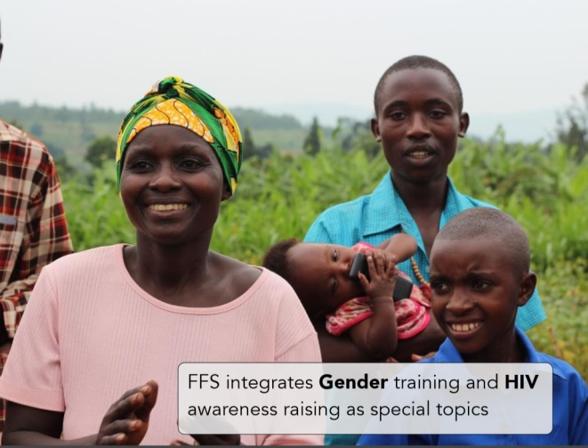

Note: Activity 1.1.1. is complementary to activity 1.1.2., during the process of negotiating an out-grower company model, the possibility to integrate the FFS approach in the activities of the out-grower company model will be discussed. Activity 1.1.1. can be potentially integrated fully in activity 1.1.2.

Activity 1.1.2. Develop a reliable and sustainable supply system of locally produced soya bean and maize for feed companies through the out-grower company model

One of the most important challenges of the sustainable agricultural production is to link the supply of agricultural produce to a sustainable market. Another important challenge for farmers is to have access to the right inputs (available at the right time!) as well as to get access to finance to purchase these inputs.

The logic is that if farmers can be linked to off-takers of their produce then they are guaranteed a market and as a result they are able to maximize the potential productivity of their limited land holding and in turn generate higher income that shifts them out of the cycle of poverty. In order to address the demand and supply constraints, some form of de-risking is required. In this case, for farmers to effectively participate and become reliable suppliers, patient capital investments and capacity building will be required. It is the lack of these that have limited the production of soya and the active participation of small holder farmers.
In the case of animal feed industry, it would be in the interest of both the farmers and the animal feed companies to create a sustainable and fair supply of locally produced soya bean and maize to be used to produce animal feed. It is obvious that such kind of link is only sustainable if it is based on a WIN – WIN model for both the soya and maize producers as well as for the animal feed company.
Based on a success in the tea sector, the intervention intends to pilot a model of creating an Out-growers Service Company which will on the one hand provide a range of services to the soya and maize producers and on the other hand provide a sustainable supply of maize and soya to the animal feed companies.

- Improving the production of soya/maize The Out-growers Service Company will provide a range of services that would build the capacity and capability of the SHFs to produce in a sustainable way high quality soya and become reliable suppliers of soya/maize for those off takers that require it as an input in their production process.

- Improve aggregation and distribution of soya/maize – The Out-growers Service Company will aggregate the produce of the farmers. Post-harvest handling practices and proper drying and storage facilities are needed. Through the capacity building of farmers and the necessary investments, the Out-growers Service company will assure that high quality products can be delivered to the off takers.

The service company itself will operate on a cost- recovery basis and can therefore be considered as a non-for-profit service provider and aggregator. The long term goal is to hand over the ownership of service company to the farmers themselves.

This approach was pioneered by the Wood Foundation Africa (TWFA) in Tanzania and Rwanda tea sectors with strong results. To date, the early results indicate that the model has been successful in attracting significant FDI in the tea sector (over $78m - $50m from Unilever and $28m from Luxmi). A unique selling point of the TWFA Africa is that they have a real long term perspective (15 to 20 years) to set up the service company, operate it in an effective and efficient way and hand it over to the tea farmers once they are ready for it. As a non-for-profit organization, the TWFA will continue to provide support until the end goal has been reached.

The Wood Foundation Africa (TWFA) has expressed its interest to create an out-growers service company to serve the soya and maize farmers and to create a reliable domestic supply of soya and maize for the animal feed companies. In comparison to the tea sector, there are a few important differences, but the principle of an out-growers service company remains the same.

How will the Out-growers Service Company work?

- Soya and maize producers will receive the right inputs (seed, fertilizer,…) from the Out-growers service company. The farmers do not have to pay for the inputs at this moment.
- Soya and maize producers will receive training and advice through the FFS model. The FFS facilitators will be hired by the Out-growers Service Company.
- The Out –growers service company will aggregate the produced soya and maize and sell it to the animal feed companies (based on contracts signed before the production season).
- The Out-growers Service Company will pay the soya and maize farmers based on the price received from the buyers minus the cost of the inputs and the services provided.
- The Out-growers Service Company runs on a cost-recovery basis

Main costs related to create and operate the service company:

- Registration of the company
- Recruitment and salary of staff
- Hiring and office and warehouse
- Capital to purchase inputs (revolving fund)
- Operational costs related to logistics (transport and others)

The commitment of The Wood Foundation Africa
The most important commitment of TWFA is that they have a long term perspective. Especially in the tea sector, return on investment can only be realized after 10 to 15 years. The opportunity of piloting the model in a seasonal crop is particularly interesting because the company could be handed over to the farmers after a shorter period of time. However, it will still take many years until the farmers will be ready for it. Therefore, the long term commitment of TWFA is essential.
On a financial point, the TWFA is ready to match the financial support of the intervention with their own investment.

Linkage to the WFP Farm to Market Alliance (FTMA).

The WFP Farm to Market Alliance (FTMA) supports African farming families to transition to commercial agriculture by addressing the major challenges that smallholder farmer’s face. FTMA empowers smallholders to become reliable market players through access to four integrated pathways: predictable markets, affordable finance, technologies and quality inputs, and handling and storage solutions. The programme in Rwanda focuses on the maize value chain. As the soya and maize value chain is new for the Wood Foundation, it could be interesting to link up with the FTMA especially to learn from their experiences with post-harvest practices, drying and storage, and logistics such as transport.

The intervention will sign a grant with the Wood Foundation to create and operate the Out-growers service company. Preferably, a possible collaboration with WFP will be managed by the Wood Foundation but if further negotiations would demonstrate that a direct grant to the WFP would be better, it can be considered. The intervention will provide extra funding that would facilitate the extension of the programme to the soya value chain, which could potentially be taken fully over by the TWFA depending on the grant negotiations.

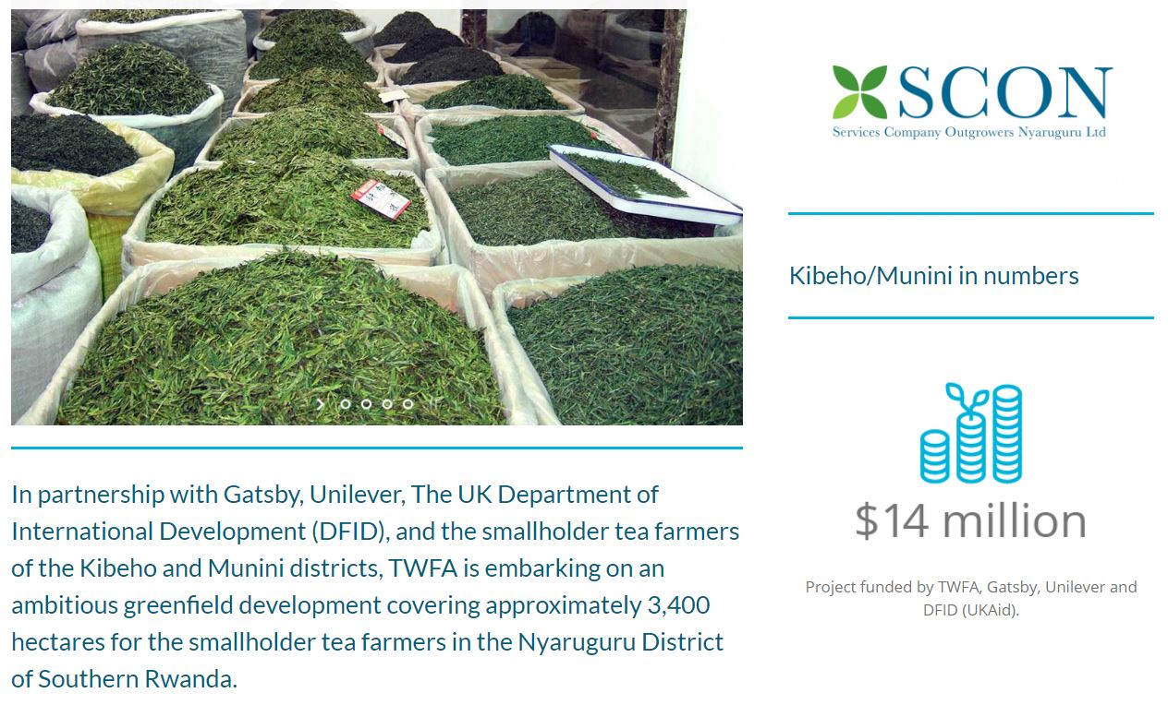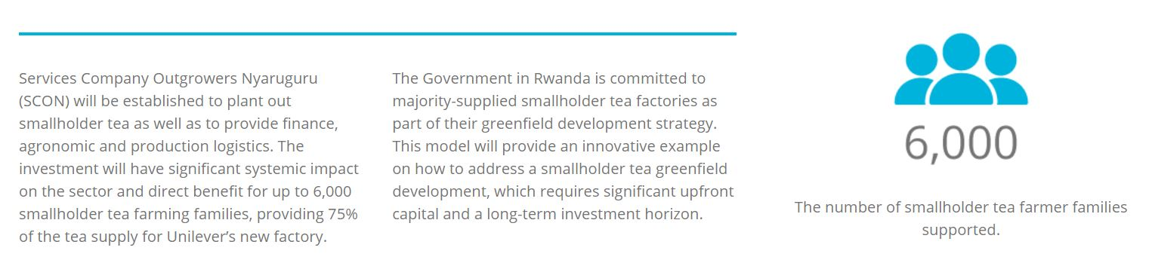
Activity 1.1.3. Tailor-made technical advice and business development support for feed companies

There are currently six private animal feed companies operating in Rwanda. They currently work under their capacity (estimated at 30%). In order to establish a professional pig and poultry value chain, it is essential that these feed companies are successful. The profitability of an animal feed company depends on:
- The efficiency of purchasing feed ingredients, both locally and imported
- The efficiency of the production process
- The sales of animal feed to livestock farmers

The intervention will facilitate the linkages between the feed company both on the supply side (see the out-grower service company model – activity 1.1.2) and the demand side (see activity 1.2.1). In addition, in order to address the specific challenges that each of these companies might have in running their businesses, the interventions will facilitate tailor-made technical advice and business development support, on the demand of each company. The intervention will use a comprehensive approach to fully understand the context in order to provide the exact support needed to allow the companies to develop and grow. The ambition is that these private animal feed companies will pull and push the livestock industry to the next level by running their businesses in the professional and sustainable way, including strong and sustainable linkages to the farmers on the input (maize and soya bean farmers) and on the output (livestock farmers) side. By creating WIN – WIN relations and ensuring profitability at all levels, the interventions will facilitate true private sector led development of the value chain.
The intervention will work with NIRDA to hire experts to assess the situation (tech audit) of the animal feed industry in Rwanda in general both from a technical as well as business point of view as well as to understand challenges and opportunities of each company, taking also into account social and environmental issues. The tech audit will provide a broader holistic comprehension of the challenges and opportunities of the sector and will allow to launch the open call (call for proposals) for the animal feed companies. The interested feed companies can apply for specific technical advice, business development, cash flow management advice, marketing advice etc. The companies cannot apply for direct financial support or equipment. NIRDA applies a participatory approach in which companies that submit interesting proposals are individually coached to improve their request in order to assure that the expert advice is focused on the most relevant issues.
The intervention will also link up with BIO to assess if any of the existing companies could apply for support from BIO.
How to run a profitable animal feed company?
In order for a feed company to be profitable, it is essential that it purchases different kind of feed sources in a flexible and efficient way, both domestically as well as import. The aim is to produce the same quality feed in the cheapest way possible, depending on the fluctuating prices of the various ingredients. If the company will produce the feed always with the same ingredients and the price of these ingredients is volatile, the price of the animal feed the company is selling would have to fluctuate as well in order to stay profitable. However, farmers want the price to be fixed, at least for a decent period of time. Therefore running a profitable animal feed company requires a wide range of expertise including technical, operational, logistical and financial management.

More details on how NIRDA operates is provided in the second intervention (Result 2.1 & 2.2)

Activity 1.1.4. Set up a feed industry research fund to support innovative research

The intervention will support RAFA with a research fund to support the Rwandan animal feed producers in accessing new technologies and best practices. This research fund can be used to develop and test innovations at the level of research institutes or universities or other relevant organisations, as well as to support directly the animal feed producers in piloting and testing the use of new sources of feed ingredients. Environmental aspects will receive special attention, such as opportunities of using more by-products or waste that humans cannot eat in the livestock feed ration, and hence contributing to a more circular bio-economy. The exact research to be financed and the institution responsible will be agreed upon by RAFA and RAB at the time of the intervention. Based on the discussion with RAFA members the following proposal have already been expressed and could be confirmed during the implementation of the intervention:

- The use of insects as alternative sources of protein– research on alternative sources of protein that can be used in the animal feeds manufacturing process. The concept of using insects as a source of protein is not new. Globally, there are approximately somewhere in the region of 2000 species of edible insects in the world; of these species, those considered the most suitable for the purposes of animal feed production have been identified in FAO research (FAO 2010). Most research has focussed on either the black soldier fly (BSF) or housefly as these species have high and rapid reproduction rates. There are several key ways through which farming insects could be a beneficial alternative for agricultural production of protein. The mass farming of insects requires between 50-90% less land than conventional agriculture per kilogram of protein. Research is needed in Rwanda to assess the viability of farming insects as an alternative source of protein for animal feed.
- Alternative sources of energy - Experience in Asia has shown that using silage from sweet potato roots, sometimes mixed with other ingredients, constitutes an excellent and nutritious food supplement for pigs. Research in Rwanda is needed to assess the viability of using sweet potatoes roots as pig feed complement. (As this technology would be used at farm level (not at feed processing level) RAFA or RAFA members could implement this research through the L-FFS (Activity 1.2.1)
- Increasing the supply of calcium – calcium is a key ingredient in the manufacture of animal feed in particular poultry feed. Currently the source of calcium used in the feed produced in Rwanda is from snail shells collected from the East African lake shores of Mombasa and Dar es salam. This process is not only harmful to the environment it is also not sustainable. Research could support the RAFA in:
- Finding local sources of feed grade limestone - Limestone provides the essential element of calcium that is needed for proper bone development in animals. Calcium is also essential to the formation of egg shells in chickens. Animal feeds containing limestone are primarily for chickens (meat birds & laying hens), turkeys, and pigs. Research with the Rwanda Mining Board to review Rwanda’s mineralisation maps in order to locate potential areas where feed grade limestone could be sourced, as well as complementary research to assess the feasibility of using the limestone available in Rwanda for animal feeds.
- Bulk purchase of feed grade limestone – a supplier of feed grade limestone has been identified in Tanzania, however the cost of transporting it to Rwanda is high. One of the options to be tested is to engage Trademark East Africa (TMEA) who have extensive experience tackling Non-tariff barriers (NTBs) in the EAC to assess potential transport constraints that could be the reason for the high transport costs. The other option is for the RAFA-members to come together and enter into an agreement to buy in bulk so as to arrive at economies of scale on purchase and transport.

The contribution of the intervention in the research fund is limited. However, it is expected that the RAFA members can contribute to the fund directly or RAFA could apply for other sources of funding to finance research that they found to be relevant to them.

Result 1.2: Increasing productivity and profitability in the poultry and pig value chain actors

Activity 1.2.1. Develop profitable, resilient and sustainable livestock farms which run their farms and farmer groups/cooperatives as business with sustainable links to input suppliers and buyers through the farmer field schools and farmer business schools approach

The farmers field school (FFS) model has proven to be an effective model to increase in a sustainable way productivity of various crops in Rwanda. This intervention will introduce livestock FFS to the pig and poultry farming in Rwanda. The key principle is that farmers are not just told what to do but they get an opportunity to discover for themselves what works best for them by conducting trials in their farms. This group based participatory learning method empowers farmers to take decisions based on their own observations. Through the FFS, producers will be mainly strengthened in proper management and husbandry practices. Environmentally and climate-friendly and resilient practices (as avoiding water pollution by proper handling, storage and disposal of manure), will be part of the curriculum (see also 1.4.6).

Implementing the Livestock FFS will include various steps:
- Selection of FFS groups (600 in total, with at least 50% female members)
- Selection of FFS facilitators among the group members (1 per group) (200 in total)
- Training of FFS facilitators by qualified Pig and Poultry L-FFS Master trainers (4 session for 50 facilitators)
- Facilitation of the FFS groups by the FFS facilitators

The groups can be existing groups and cooperatives, already active in pig and poultry production, or new groups. Especially for the pork sector, where the participation of women is limited in Rwanda, special efforts will be made during the selection of the groups to ensure women participate in the training.

Example of how the L-FFS approach will improve feeding methods and how it will create a market for commercial animal feed.
The assumption is that pigs will grow faster and in a more cost – efficient way when it is fed with commercial feed in combination with locally produced or purchased cheap feed stuff. However, most farmers find commercial feed too expensive. The L-FFS facilitator will discuss with the farmers on how to set up a trial to confirm or reject the assumption. Farmers are actively involved in setting up the trials (the trial is set up with the group members in their farms) and farmers join the weekly training session in order to monitor the results. Each week farmers will also learn about a special topic.

 | Commercial feed | Home-made feed
Group 1 (6 pigs) | 100%
Group 2 (6 pigs) | 70% | 30%
Groups 3 (6 pigs) | 50% | 50%
Group 4 (6 pigs) | 30% | 70%
Group 5 (6 pigs) |  | 100%

The feeding cost of the different groups as well as the weight of the pigs will be monitored in order to do a cost-benefit analysis of each feeding regime group.
The animal feed companies will be linked to the FFS facilitators by inviting them to the training session of the facilitators. The results of the feeding trials will not only inform the farmers, but the feed factories will also learn from the results of the field trials.
The FFS group members meet on a weekly basis. All aspects of farming will be addressed. Apart from technical issues, the FFS methodology allows to address other issues such as gender, HIV and nutrition. The principle is always the same. Qualified trainers intensively train the facilitators and the facilitators train the group members.

Farmer Business Schools
Why is FFS a relevant and valuable approach for sustainable livestock and rural development according to FAO (Global FFS Platform)
- Livestock producers often face particularly complex, dynamic and location-specific challenges that cannot be tackled with blanket recommendations and conventional extension methods.
- Given that livestock is often central to small-scale producers’ livelihoods, they can be resistant to changing their livestock practices just because someone tells them what and how to change.
- Many livestock FFS result in the formation or strengthening of associations and marketing groups.
- The FFS approach can be applied to the wide range of different livestock production systems and species, from cattle to poultry, pigs and from small ruminants to insects.
- Livestock FFS can develop new/strengthened networks among livestock producers, local institutions, service providers and researchers.
- Livestock FFS have shown themselves to be an effective vehicle for women’s empowerment and gender equality because they can lead to changes in household gender dynamics and decision-making.
- Livestock FFS can be used to introduce livestock production as a new income generating activity within non-livestock communities.

Dramatic changes are taking place in farming worldwide as a result of globalisation, liberalisation, and rapid urbanisation. Farmers are intensifying existing patterns of production and diversifying their farm enterprises in an attempt to improve their livelihoods. Technical know-how is not enough. In order to be competitive and take advantage of the new opportunities that are arising, farmers increasingly have to adapt their farm business to market changes and improve efficiency, profitability and income. Farmers’ skills and capacity can only be built through a process of learning and practice. The Farm Business School (FBS) has been developed by the Food and Agriculture Organization of the United Nations to help farmers learn how to make their farming enterprises and overall farm operations profitable and able to respond to market demands. The learning takes place at the village level and farmers' capacity in entrepreneurial and management skills is built via a "learning by doing" approach. All groups trained on FFS will also receive a training on FBS.

The L-FFS/FBS facilitators will play an important role in facilitating access to inputs, finance (including insurance) and markets. Fair contract arrangements with buyers and suppliers will be actively searched for.

Strengthening existing private extension services

In Rwanda private sector actors have already developed, some with support some without benefitting from support, their own marketing strategies with inclusion of extension services to their clients.

- Poultry East Africa LtD “Commercial poultry farming has been practised worldwide for decades. Modern farming techniques and world-class technology has improved productivity over the years. At PEAL, we want to be the first farm in East Africa that meets global standards of output, applying best practices to achieve maximum capacity. While we are productivity and efficiency driven, we also guarantee quality and biosecurity in our operations. Through our operations, we are able to create an integrated network of farmers. We work with other farmers for raw material such as maize and soya bean, these are essential for our feed, which is in turn sold to other poultry farmers. We also employ and train local Rwandese on the farm, equipping them with best practices and skills of the trade.”

- Zamura Feeds LtD is Rwanda’s leading manufacturer of animal feeds. “As a full-service livestock feed production company, our objective is to provide farmers access to high quality, affordable feeds in order to increase their egg, dairy, and meat production yields. This is not only important for helping farmers grow their business but to provide adequate nutrition to the population served.” Zamura Feeds accompanies its sales with extension services - technical support to its off-taker farmers.

- Uzima Chicken Limited is “ a new poultry company starting operations in Rwanda and has taken over the Rubilizi National Hatchery and plans to transform the poultry industry in Rwanda, by reaching out to small holder farmers across Rwanda and the East African Market with a robust bird that resist the local conditions and is more productive”.

The existing initiatives are however far from covering the potentials and needs. The intervention will assure not to develop stand-alone approaches from the broader value chain, but support strengthening of the existing initiatives of private sector actors, work with other private sector actors who have not yet included extension services in their offer to analyse the potential commercial benefits of integrating these services.
During the implementation, it will be crucial that the extension services development is done in partnership with the different actors and that public funding does not substitutes funding activities which should be borne by private sector operators. The breeding centres will play an important role in providing the right genetic material (be it in the form of providing Day old Chicks (DOC’s) or Artificial insemination (AI). Assuring that their genetic material is known and used is first and foremost essentially their marketing strategy. The same is true for animal feed producers and other private sector operators whose clients are the SHF’s. Extension strategies services promoting the use of goods produced by economic operators should in the end be funded by these economic operators. The intervention ambitions to support these private sector actors to take up their role.
The intervention will introduce the L-FFS approach to all private stakeholders and evaluate how their extension agents can join the training and/or how the newly trained facilitators can link with their effort.

Activity 1.2.2. Develop affordable, reliable and effective veterinary services by expanding the VSF model

A critical area is increasing the availability of private sector vets. The project will further build on the model implemented in southern province by Veterinaires Sans Frontières-Belgique (VSF-B), which has the potential to be replicated or scaled up. The program will assure a direct grant to VSF-B to train 45 private sector vets to cover the districts where the bulk of the poultry and pig SHF intervention will be located.

Through the support of the VSF the intervention will also support the Rwanda Council for Veterinary Doctors (RCVD) to implement a system for qualifying and certifying animal health workers, in order to assure that only actors benefiting of the minimal technical requirements can deliver the vet services.



Vets without Borders Belgium (VSF-B) is a Belgian NGO with considerable experience in establishing networks of private veterinary practitioners in Rwanda's Southern Province since 2008. This has been done through four projects (PROXIVET phases I and II; EVE phases I and II), all financed by the Belgian Cooperation.
VSF-B provides support intended to help the private vets to fulfil their roles properly. This takes the form of material support (which is financed in part by VSF-B and in part through a loan from a SACCO) as well as training both in technical aspects and in business development and basic accountancy.
VSF-B experience for private Vets capacity building
- VSF-B has been working in this field in Rwanda since 2008 and has perfected its approach in the installation of animal health networks, successfully supporting a total of 33 private vets and veterinary technicians in Southern Province.
- VSF-B has carried-out similar activities in other African countries (Mali, Niger, Burkina Faso, DRC) and has acquired a considerable knowledge which can be applied and built upon in the Rwandan context.
- VSF-B works with the private sector at two levels: (1) Private veterinarians and veterinary technicians; and (2) sector MFIs (SACCOs);
- Sustainability: VSF-B seeks to promote sustainability through (1) capacity-building of private vets and veterinary technicians; and (2) collaborating with the SACCOs by providing a guaranteed line of credit to help finance loans for the vets and increase their access to capital, with the creation of a self-generating revolving fund from the reimbursements of credit by the vets which will help finance other activities for this group of clients.

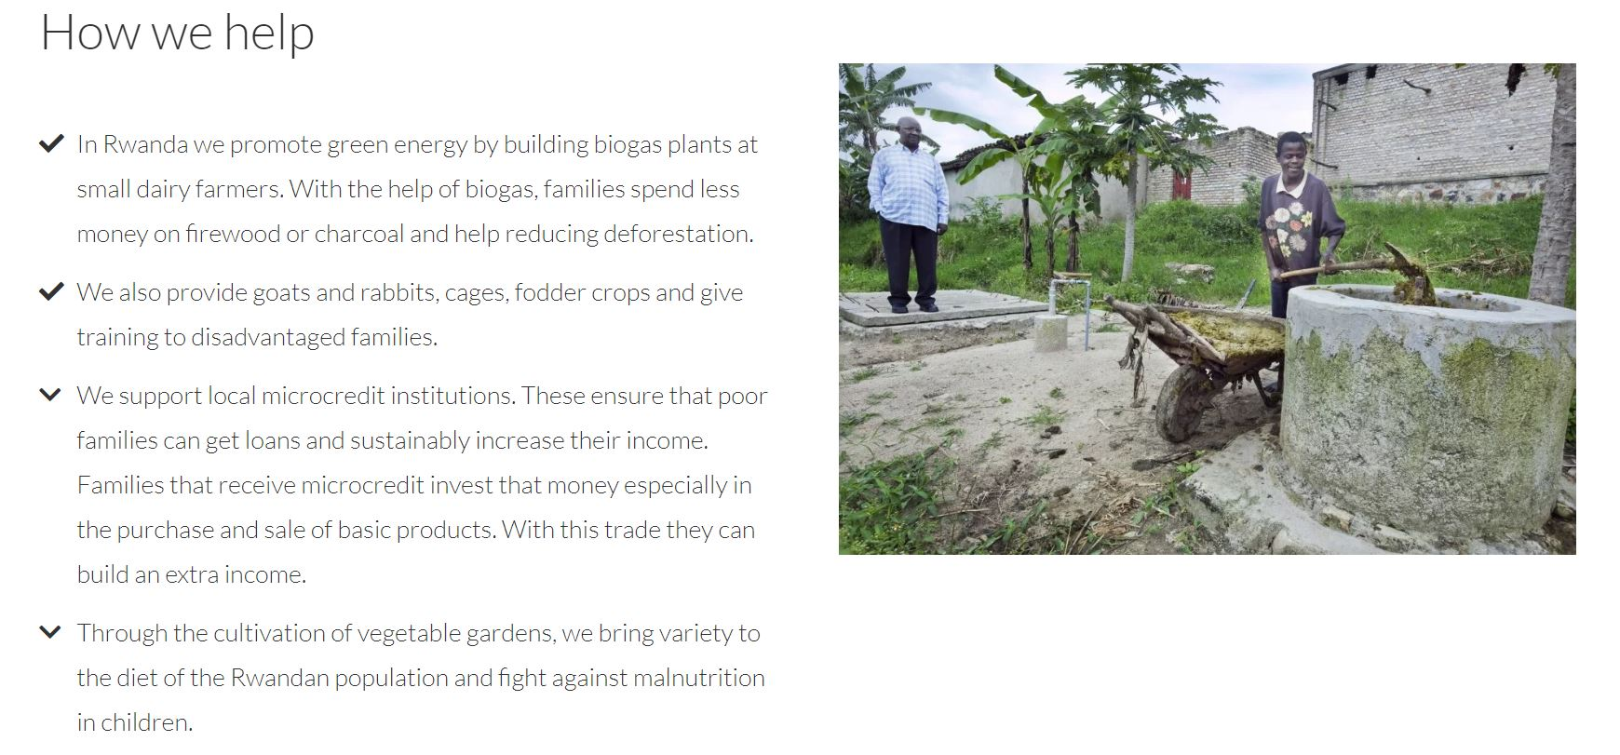
OTHER VSF ACTIVITIES IN RWANDA

Activity 1.2.3 Co-financing of specific green investments

Rearing pigs generates large quantities of excrement that can be collected and utilised for biogas production and as organic manure. The intervention ambitions to support the introduction of the use of biogas in the pork sector. Poultry and pork manure are today already traded between farmers, constitute a contribution to the challenges of soil fertility and are part of the business plan at farm level. However the biogas developed is only rarely optimised, while it entails a potential supplementary economic and ecological benefit. By introducing biogas, the intervention aims to support the SHF participating in the scheme to diversify their energy sources by using biogas digesters to generate methane used for cooking. Since VSF is already offering such services to livestock farmers and since their approach is linked to existing government initiatives and locally available credit institutions, the intervention will include this activity in the grant to VSF.

Activity 1.2.4 Access to finance

Starting a livestock farm is a serious investment, even for a small farm. The price of one pregnant sow is around 450 euro. This high cost forms a real bottleneck to convince farmers to enter into to business of livestock farming. The intervention ambitions to support the access to finance. The economic reality of a large number of SHF’s is that they lack sufficient capital to make the basic investments to step into the poultry or pork value chains.
The intervention wants to support sustainable access to credit rather than providing livestock for free. Therefore the intervention will work with one or more service providers to work with banks and/or microfinance institutions and RAB to lower the cost of credit. In order to ensure that farmers who take out a loan for livestock farming, RAB will ensure that only farmers who graduated from the L-FFS and who have access to one of the proxy-vets can get access to these preferential credit systems. Linkages with other interventions focussing on access to rural finance will also be made, while the intervention will analyse how it can align with the agricultural input subsidies schemes, which are under revision with the support of the PforR program (DLI2).

Activity 1.2.5 Provide business development support to egg collectors, traders, meat processors

The collection and efficient distribution of eggs from the rural areas is not well established. This in turn hinders the potential of egg producers because they are not sure that their production will get to the market in a timely manner. Pig producers sell their animals to traders who buy live animals from the farms. Very few businesses add value to the meat by properly processing it. The assumption is that there is a good potential to develop business between the farmers and the egg/meat consumers, both on the domestic and regional market. This activity intends to support the existing egg collectors and traders to professionalize the way they run their business. On the other hand, this part of the value chain offers opportunities for youth and women. The intervention will launch a tender to attract a specific organisation or company to provide both standard and tailor-made training and support.

INTERVENTION 2. ATTRACT PRIVATE INVESTMENT

SPECIFIC OBJECTIVE: ATTRACT PRIVATE INVESTMENT TO DEVELOP A MODERN INDUSTRIALIZED VALUE CHAIN TO PRODUCE HIGH QUALITY MEAT PRODUCTS AND EGGS TO SUBSTITUTE IMPORT AS WELL AS TO EXPORT

The modernisation and industrialisation of the pig and poultry is an ambitious goal. It is clear that this can only be realized by committed private investors. Based on the Rwanda Livestock Masterplan and consultations with the stakeholders the envisioned modernisation is described below. However, these models will need to be confirmed in detailed studies which will be undertaken during the implementation. Ultimately, it will be the private sector investors themselves to decide in which part of the value chain they want to invest.

The envisioned modern egg production value chain

Layer sub-value chain - There are a number of challenges identified in this value chain. These include the lack of local parent stock for day old chicks which then means they are imported into the country from the region (Kenya and Uganda) or international (France and Belgium) at a significant cost. Additionally, the value chain is not stratified – no separation between the starters (raising DOC until 60 days) and egg producers. It is assumed that productivity and profitability will increase if the egg producers can purchase 2 month old chickens that have been professionally raised and which have been properly vaccinated rather than buying a DOC. The key is stratifying the value chain to help generate efficiencies from specialisation at various stages of the chain.
There are a number of private firms involved in large-scale / industrial eggs production such as ABUSOL that have taken a whole of value chain approach – import the DoC and raise the pullets to egg production stage.
To modernize and industrialize this sub value chain, following investments are envisioned:
- Breeding Centre/ Centre of excellence for Layers – One centre in Rwanda which would be responsible for the introduction of parent stock, day old chick (DoC) production, provide a training centre for starters and producers. To facilitate private sector engagement, public funding might be required for the acquisition of parent stock of layers for breeding and the hatchery equipment. This centre could possibly also undertake applied research on a range of issues – feed formulation and vaccination protocols.
- Starters / pullet producers – they receive the DoCs and raise them to pullets (60 days). It is estimated that five national starters / pullet producers are needed. Critically, the location of these starters should be determined by their proximity to key export demand markets (Rubavu and Rusizi) and areas in the domestic markets with high demand for chicken products (Kigali, Musanze, Rwamagana).
- Egg producers – they receive the pullets and raise them to layers (20 weeks). Ideally these will be located near high demand markets. They will be responsible for raising pullets to egg production and then producing eggs for sale. Apart from small farmers who produce eggs in a more traditional production facility, the intervention aims to attract investment in medium and large scale modern industrialized production facilities.

Broilers sub-value chain - There are a number of challenges identified. These include the lack of local parent stock for day old chicks which then means they are imported into the country from the region (Kenya and Uganda) or international (France and Belgium) at a significant cost. While broilers are easier to raise, the costs for small holder participation are still relatively high given the cost of DoCs, feed, and vet services. The level of productivity is still very low with many of the birds produced by SHF taking longer to achieve the desired weight before sale. This is mainly due to the lack of access to the appropriate feed formulations. There is one major slaughter house linked to PEAL the largest industrial broiler producer in Rwanda. Other than PEAL which is based in Bugesera, other areas of the country especially those near the main export markets are underserved and will require slaughter house facilities.

To modernize and industrialize this sub value chain, following investments are envisioned:

- Breeding Centre/ Centre of excellence for broilers - one centre in Rwanda would be responsible for the introduction of parent stock, day old chick production, provide a training centre for producers. The centre could also undertake applied research on a range of issues – feed formulation and vaccination protocols. To facilitate private sector engagement, public funding might be required for the acquisition of parent stock of layers for breeding and cost of the hatchery equipment.
- Broiler producers – they receive the DoCs and raise them to the stage when they can be sold for meat. The intervention aims to attract investor to set up industrialized broiler farms of various sizes. To facilitate private sector engagement, public funding might be required for the acquisition of equipment required to get started as broiler producers.
- Slaughter house and processing facilities – it is estimated that two additional slaughter houses are needed to be located near the areas of greatest demand. At the moment the large-scale facility at PEAL in Bugesera services Kigali market. There is a need to develop facilities in Rusizi and Rubavu to service the DRC export market. However, the market for this kind of product in DRC need to be confirmed. In order to de-risk the private sector investment public funding might be required to purchase equipment.

Pork value chain - Currently the value chain is underdeveloped and there is limited coordination between supply and market activities. In particular, the value chain is fraught with challenges at all levels from breeding (genetics) to access to appropriate feed, extension services (vet services), quality and standards, access to finance and most importantly access to markets. For Rwanda to maximise the potential of this sector and to be able to reduce the volume and value of imported pork products, the constraints highlighted above have to be addressed. In order to create a modern pig industry, the following investments are considered essential:
- Breeding centre- the lack of good genetics is a constraint for the development of the pork value chain. Consultations with industry stakeholder and review of the literature have indicated that the in breeding is a problem and has to be addressed if Rwanda is to improve the productivity and beneficiation of the value chain. Consequently, the breeding centres will focus on introducing a new breeding stock in to Rwanda. They will link up with the private proxy vets to offer artificial insemination services to a network of piglet producers. In order to address the inbreeding problem, the centre will develop a generic record keeping system and will be responsible for updating the national database. The centres are expected to be located close to the areas where demand is greatest but could also be located in the traditional pig rearing areas of Rwanda. To facilitate the de-risking of the private investments investment, public funding might be needed.
- Piglet producers – receive the insemination from the breeding centre and then produce the piglets at scale which they rear until the age of 4 months. Currently there is no separation between the piglet production and the fattening. This lack of specialisation affects the ability to scale up operations given the cost of undertaking investments in the two components of the value chain. Therefore the intervention aims to separate the piglet production function from the fattening function in the areas.
- Pig fatteners – receive the piglets from the piglet producers and then fatten them over a period of 6 to 8 months.
- Slaughter houses and cold storage - There are currently five slaughterhouses in the country at varying levels of sophistication in terms of processing. The lack of modern slaughterhouses in communities has compromised standards, a situation that has affected efforts to enter new pork markets outside the country. Feedback from Rwanda pig farmer’s association indicates that “Our products are being turned down by buyers because of standards, which arises from the way they are processed and handled along the value chain. We are confident the hotels and restaurants will start buying our pork in large quantities if we get more modern slaughterhouses and ensure standards along the process.” This component of the intervention will aim to de-risk private sector investment into modern slaughter houses, introduce a modern carcass transportation and cold chain system, and introduce an environmentally friendly waste collection and disposal system and the development of slaughter house protocols that meet international standards. In order to attract private investments, public funds might be needed to support purchase of equipment, implementation of climate and environment initiatives like solar water heater, rainfall water harvesting and a waste disposal system. In addition, public funding might be required to finance the development of cold storage infrastructure.

Linking sector expertise with business expertise to attract the rights investments and modernize the value chains in a sustainable way.

Supporting private investment in order to develop and modernize the value chains will be done through bringing together the livestock expertise from the Rwanda Agriculture Board (RAB) and the investment and business development expertise from National Industrial Research and Development Agency (NIRDA).

The General Director or NIRDA, Ms Kampeta, about the role of NIRDA:
“NIRDA plays the role of facilitator. We as government staff are not well placed to advise business, yet we will find the right experts to advice in any specific sector.” Furthermore our role is to ensure that we only support businesses that have a valid business case. Therefore we will always perform a sector wide Tech Audit and work closely with every single company that might receive support through us. We often see that companies request for financial support for equipment but sometimes they just need to expertise to help them to purchase the right equipment, or in other case they can become more competitive by improving their packaging and their look rather than investing in more equipment. “

The NIRDA Open calls are designed to introduce firm-level interventions and innovations, aimed at improving Rwandan Enterprises productive capabilities and capacity to produce competitive products, both for domestic and international markets.
NIRDA offers a holistic approach to selected firms that includes:
- Acquisition and adaptation of specific technologies needed to improve industrial competitiveness (in the form of equipment, software, or related investments).
- Acquisition and or provision of technical support and expertise necessary to maximize the use of equipment, processes or systems for use of new technologies to improve their competitiveness.
- Training of staff to maximize productivity through the use of new or the adaptation of existing technologies to improve their competitiveness.
NIRDA is in the process of developing a partnership with BPN, a Suisse NGO specialized in assuring longer term business development services to entrepreneurs.

Even though the main target of NIRDA are existing companies, they can also launch call to attract new investors. However, each open call should either be for existing or new companies. They should not be mixed up as it would give an advantage to the existing companies. If needed two open calls can be launched in parallel: one for existing and one for new companies.
The intervention intends to partner up with NIRDA at various points in the value chain:
- Open call to provide specific tailor-made support to the existing animal feed companies (financed under intervention 1)
- Open call to attract new investors in the industrialized pig and poultry farms
- Open call to the existing pig and poultry farms specifically to modernize by using industrial technologies
- Open call (either for existing or for new) companies in the animal breeding (both poultry and pig)
- Open call (either for existing or for new) companies in value addition of animal products (slaughter houses, meat processors)
Foreseen impact of investments on inclusive and sustainable growth will be assessed for each investment. Social and environmental criteria will be part of all calls. Special efforts may be needed to attract women and youth to respond to the calls (sensitization, quota, ..) or to sensitize enterprises on opportunities in more environmental and animal friendly or inclusive investments.
Whenever possible, the intervention will link up with BIO to assess if any of the business could apply for support from BIO. The link between NIRDA and BIO, and especially a good understand of how BIO operates, could ultimately result in other investment from Bio in different sectors supported by NIRDA.
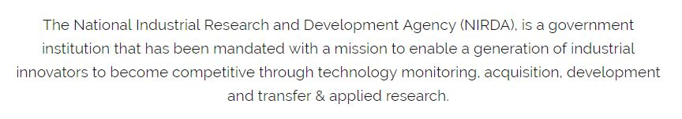
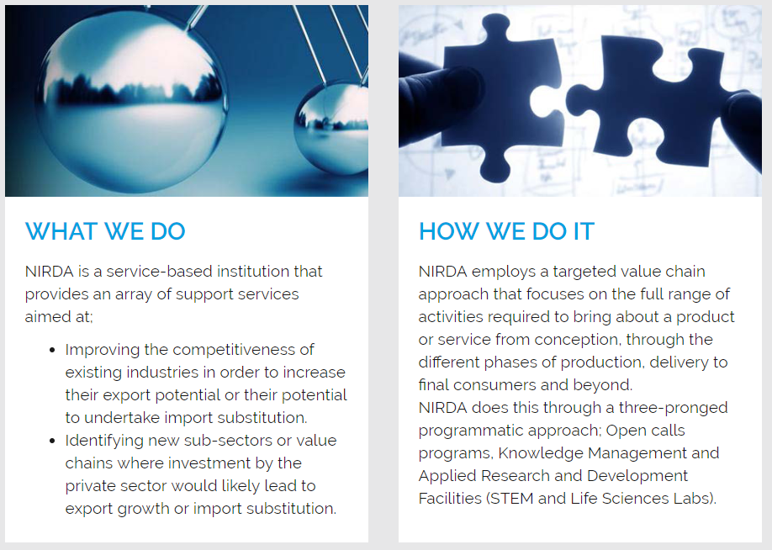

Result 2.1: The necessary information and data is gathered to define and validate priority investment areas in the pig and poultry value chain
A first set of activities is focused on collecting sufficient information to prepare the open calls:
Activity 2.1.1 Studies on modernisation of the pig and poultry value chain in order to produce and market high quality meat products for local consumption and export.

While during the development of the program, different consultations and analysis have taken place, more in depth analysis is needed to confirm or invalidate the various investments elements of the envisioned value chains. The feasibility studies will include a more in-depth analysis of:
- the markets both national and regional, with a specific focus on the DRC market;
- the potential for the ‘centres of excellence’ or breeding centres, leading to clear orientations for the requests for proposals to potential investors (see activity 2.3.);
- the potential/relevance of specialised slaughter houses, the potential best relevant locations based on the market potentials, and orientations for potential requests for proposals to attract investors;
- the investments needed at the level of farmers to step into the different specialisations (both at the level of physical investments, and of needs for support in the form of extension services and BDS), assuring the basis for the further development of activities of the intervention.
- Identify the potential supplementary activities needed to tackle the challenges in the value chains, including aspects of inclusion and gender.
- Identify opportunities and potential actions needed to contribute to a more environmental- and climate- friendly and resilient livestock sector.

The terms of reference for the different studies will be developed in close collaboration with RAB and NIRDA. The outputs will not only feed in to the further development of the intervention , but will also support the different stakeholders in better understanding the potential of their markets and improving their respective business models.

Activity 2.1.2 Feasibility studies and development of investment profiles and business plans of each type of enterprise identified in the study

While the studies under activity 2.1.2 look at the complete value chain, these consecutive studies will focus more in detail on specific businesses such as breeding centres, industrial farms, slaughter houses, meat processors, etc. At this level it will also become clear if there are sufficient businesses that can be upgraded with additional investments or if new businesses need to be created. This phase will confirm if the business case is valid or not, also from an environmental and social point of view. The studies will result in investment profiles which will be used to attract domestic and international investors.

Activity 2.1.3 Development of Terms of References and criteria to launch various open calls for requesting technical advice, business development and financial support

Based on the outcomes of the various studies and assessments in the activities described above specific open call will be launched by NIRDA. All necessary documents will be developed by specialized experts, in close collaboration with RAB, NIRDA and the intervention. In all calls, special attention will be paid to environmental and social criteria to promote innovative initiatives in those fields (see also chapter 1.4.6).
To ensure equal participation of women and youth, the application of quota might be necessary.

Result 2.2: Priority investments are realized by the private sector with support of the intervention

A second set of activities are focused on the actual call and finally the support to the businesses.

This activity will be implemented through a grant to the National Industrial Research and Development Agency (NIRDA). NIRDA is a government institution mandated with a mission to enable a generation of industrial innovators. NIRDA functions through calls for proposals, develops research and knowledge management. Its support to entrepreneurs’ ambitions is to be holistic: acquisition and adaptation of specific technologies needed to improve industrial competitiveness (in the form of equipment, software, or related investments); acquisition and or provision of technical support and expertise necessary to maximize the use of equipment, processes or systems for technologies to improve their competitiveness; training of staff to maximize productivity through the use of new or the adaptation of existing technologies to improve their competitiveness; focused BDS to entrepreneurs. For the later, NIRDA is in the process of developing a partnership with BPN, a Suisse NGO specialized in assuring longer term business development services to entrepreneurs.

Activity 2.2.1 Support the creation of industrial pig and poultry farms (All-in All-Out systems) who use modern technologies and who can ensure high quality output

This activity focuses on the modernization/industrialisation of pig and poultry farming systems. It will require more investment in modern technology, but it is considered essential in order to ensure a quality approach throughout the value chain. The technologies include automatic drinking and feeding systems, specialized barn construction, ventilation systems, etc. Industrial farming systems are often ‘All in – All out systems’. This means that all animals arrive in the farm at the same time and all of them leave the farm at the same time. In traditional farming systems, the animals are added and removed any time, which facilitates the introduction of diseases. The all in –all out systems allows a thorough cleaning and complete sanitation between production cycles.

At this moment it is difficult to estimate the number of farm and the farm size, since the cost of investments (capital investment and operating costs of the first cycle(s)) is currently unknown. Rather than focusing on specific numbers of investments or the size of the farm, the intervention will focus on the introduction of modern production systems, including sound environmental practices, as well as on the real profitability of industrial pig and poultry farming. Special attention will be given to the participation of youth and women.

This activity will be implemented through a grant to RAB. With technical support of NIRDA in the calls for proposal.

Activity 2.2.2 Technical advice, business development and financial support to businesses in the pig and poultry value chain such as breeding centres, centre of excellence, pullet producers slaughter houses and meat processors

The kind and numbers of call to be launched by NIRDA will be based on the outcome of the various studies described above. Based on the information currently available, it is expected that it will include:
- Breeding centers: companies to assure the right genetic material for poultry (layers & breeders) and for pork; environmental considerations such as conservation of animal genetic diversity to ensure producers have access to the best animal in each environment, will be taken into account
- Starter/Pullet production (raising layers chicks from DOC until 60 days)
- Slaughter houses, cold storage facilities , food processing (value addition) including support for applying sound environmental practices

The studies might identify other potential private sector opportunities, which can be supported through NIRDA.

The calls will not be limited to attracting new investors, but also include operationalizing support to existing industrial actors to improve their access to technology, social and/or environmental performance, access to equipment and support to strengthening their business model. This support can potentially cover present actors in the poultry sector, but also the existing private sector veterinary hospital, as well as different actors in the animal feed sector (see activity 1.1.4)

Note: One of the outcomes of the consultations with the different private sector actors led to an expression of interest of one of the already operating firms to invest with technical support of the intervention in a breeding center in the poultry sector. The local actor is already advancing with potential European partners, whom are considering mobilizing capital for the needed investments. The intervention can adapt the details of the call to opportunities which might concretize during implementation. However, any support should be the result of an open call procedures with a 100% transparency and with attention that the intervention does not create unfair competition.

The financial contribution of the intervention should never exceed 30% of the capital investment cost. Furthermore, the focus should be on the total package of services, including expertise rather than on ‘just’ subsidizing the investment in equipment.

Activity 2.2.3 Capacity building of specialized veterinarians for medium and large scale livestock farmers

The activity 2.2.3 and 2.2.4 focus on the development of specialized services for intensive modern livestock farmers. During implementation economy of scales will be ambitioned between the two activities.

Under intervention 1, new private proximity vets will be trained and supported. They will serve the small-holders. The medium and large-scale farms will be served by university graduates (Veterinary doctors). Since industrialized farming systems are new in Rwanda, the veterinary doctors will need additional training on health-related issues that come with these production systems. Furthermore, the veterinary medicine continues to evolve. It is important that the specialized veterinarians stay well informed about new developments. The impact of diseases in large scale production systems can have a huge impact on the productivity and profitability. The intervention will launch a tender to attract a service provider to provide this kind of training to a selected number of specialized vets. The exact number will depend on how the sector evolves.

Activity 2.2.4 Capacity building of specialized farm advisors (general management, feeding management, hygiene, etc.) for medium and large scale farms

Similarly to the training for specialized vets, the large poultry and pig farms will need expert advice on modern production systems. The industrialized farming systems are new so there are not many experts who know how to manage such production systems. Initial advice can be included in the support through NIRDA, but it is important that this kind of advice is offered on a continuous basis and by Rwandan advisors. The intervention will launch a tender to attract a service provider to provide this kind of training to a selected number of specialized farm advisors. Environmental and climate-friendly practices will be part of the training. The exact number will depend on how the sector evolves.

Activity 2.2.5 Set-up a system to train butchers, meat processors and chefs

Building the capacity of processors – Rwanda imports large amounts of pork products that could be produced locally. There are no capacity building efforts to train and educate butchers and chefs on how to prepare various pork cuts and processed products. Equally there is no certification system for professionals in the sector and even more important there are no standards developed for products in the sector. This intervention is expected to support the development of product and market development strategies, implement a training programme for professionals in the sector, and develop new standards and protocols in addition to implementing a certification programme.

Result 2.3. Improve the regulatory and conducive environment to facilitate private sector investment and growth of the poultry, pork and animal feed value chains

Activity 2.3.1 Develop laws, strategies, policies, guidelines related to the pig, poultry feed value chain for animal breeding, animal feed, animal identification, animal health insurance and bio security, slaughtering through stakeholder consultation and based on international best practice

In all three value chains, there is a need to develop a range of standards and to ensure they meet both regional and international norms. The intervention will support the harmonisation of export standards, develop standards for slaughter houses (both poultry and pig), develop protocols on health and safety and humane animal treatment standard, and how the cold chain should be maintained from the slaughter house to the supermarket shelf / export market.
The intervention will support RAB to review, amend, update policies, strategies and guidelines. These reviews will include also the development of a series of norms and standards to regulate the market, to allow certification for the pork, poultry and animal feeds. The support will include support to RAB for the development of new legislation aimed at formalising the regulation of the livestock sector, jointly with the Rwandan law reform commission.
Elements expected to be included in the legislative reforms concern an update of the Animal Disease Act of 2008, and development of legislation relating to bio-security, breeding, animal registration as well as an animal insurance law. Additionally, an animal epidemic contingency policy and plan will be developed.

The regulatory framework should contribute to a positive impact on the environment and the well-being of animals.

Overview of regulatory work
Update the 2008 Animal Disease Act
Develop and animal epidemic contingency policy and plan
Develop a Bio-security law, policy, strategy and guidelines
Develop a new breeding law, policy, strategy and guidelines
Develop an animal feeds law, policy, strategy and guidelines
Develop a national animal identification and registration law, system and guidelines
Develop animal health insurance law and guidelines
Develop and harmonise international export standards / certification for Pork, poultry and animal feeds
Review and update agricultural incentives as it relates to pork, poultry and animal feeds
Set up a repository/database of market data, information, standards, stakeholders, investment opportunities
Develop standards and guidelines for slaughter and processing in both value chains
Support the implementation and enforcement of the new animal health code of ethics

For all the above activities, the intervention will hire consultants to develop the ToR as well as for the actual drafting of all the documents. It is very important that all stakeholders are consulted and are effectively part of the process.

Activity 2.3.2 Develop an animal epidemic contingency policy and plan and update the 2008 animal disease act

See Activity 2.3.1

Activity 2.3.3 Develop and harmonise international export standards/certification for pork and poultry

See Activity 2.3.1

Activity 2.3.4 Review and update available agricultural incentives related to the pork, poultry and animal feeds and describe them in an attractive brochure

A number of initiatives and incentive that could be applicable for livestock farmers already exists in Rwanda. A consultant will be hired to make an overview and to develop an attractive brochure to be distributed.

Activity 2.3.5. Design and implement an animal identification/tagging system for tracing and pilot the system in the pig/pork value chain

In the same line as already being implemented for the cattle, there is need for a national small stock identification and registration system, which must allow traceability and consumer protection. The program will support RAB to propose legislation and policy to guide the implementation.

Activity 2.3.6 Strengthen the capacities of the meat certification/inspection services

Meat inspection services fall under the responsibility of RALIS. In order that all meat inspectors are fully trained about new regulations applicable to export of meat and meat products and to ensure that sufficient meat inspectors are available to inspect all professional and especially export oriented slaughterhouses, the intervention foresees a grant to RALIS.

Activity 2.3.7 Improve the existing system for qualifying and certifying animal health professionals in the pig/poultry chain

The intervention will help the RCVD to improve the existing system for qualifying and certifying animal health professionals in the pig and poultry chain. Since VSF-B is already supporting them and as they are well placed to follow up these activities, this activity will be included in the grant to VSF.

Activity 2.3.8 Support the implementation and enforcement of the new animal health code of ethics

The intervention will help the RCVD to implement and enforce the newly minted animal health code of ethics. Since VSF-B is already supporting them and as they are much better placed to follow up these activities than the program itself, this activity will be included in the grant to VSF.

Activity 2.3.9 Develop an awareness campaign that facilitates the compliance and enforcement of standards and regulations

The intervention will support the development and implementation of an awareness campaign that facilitates the compliance and enforcement of standards and regulations. This will be done by RAB.

Activity 2.3.10 Upgrade RAB national laboratory

The RAB national laboratory needs to be upgraded with proper equipment in order to perform test related to food safety of animal products.

Activity 2.3.11 Set-up a livestock research fund in RAB

More research is needed on a wide range of topics related to the pig and poultry value chains. In order to select the best and most relevant research, the intervention will assist RAB to set up competitive research fund to which livestock researchers and scientists can apply. The financing provided by the intervention is limited, but it is expected that if the research fund is considered a success, more funding can be attracted either from the national government budget or from other donors. Priority will be given to research topics contributing to the development of a more environmental and climate-friendly and resilient livestock sector.

Activity 2.3.12 Behaviour change for a better balanced diet with attention for animal protein sources

The objective is to raise awareness on the importance of the source of animal proteins by conducting various activities of sensitization (Media campaigns, awareness modules for SHF and at the level of households, …)

Result 2.4: Increased coordination between value chain actors to foster innovation & market access

Activity 2.4.1. Strengthen the capability of existing industry and sector representative bodies to advocate for improvements within the value chains

The programme will strengthen the advocacy of the industry and farmer representative bodies. This can be through training, exchange visits, or studies and assessments to gain more insight and understanding of important subjects for the dialogue with the government on policies, regulation and standards.

Activity 2.4.2. Set up an effective multi-actor stakeholder VC platform with representatives of various industry and sector associations, to define VCD strategies and priorities for developing the value chain

Market driven productivity will be boosted through public private dialogue along the value chains. Multi-stakeholder processes will be facilitated, bringing together producers, collectors, processors, traders, policy-makers, service providers and other relevant actors to identify constraints and opportunities in value chains and to define priorities for further development and innovation in the value chains. Encouraging dialogue and trust between stakeholders creates linkages, which lead to mutual wins, joint ownership and possible partnerships.
Different value chain platforms will be set-up, or where they already exist further strengthened in their functioning and be partners for developing and validating strategies, and for demand driven research for innovation. The quality of these multi-stakeholder processes is of paramount importance, and the intervention can provide technical assistance where needed.

Activity 2.4.3. Set up an Innovation fund to implement innovative ideas during a pilot stage (IT solutions, insurance, financing, …)

Innovations that have been identified as a priority by the value chain platform to make the value chains more efficient, sustainable and effective can be piloted through the innovation fund. Innovations can be for example in the area of ICT, environment, or related to finance or insurance products. Depending on the type of innovation proposed, the responsible organisations will be identified to lead the pilot. The VC platforms will discuss and follow up the results.

Activity 2.4.4 Set up a repository database of market data, information standard, investment opportunities

One of the main causes of inefficient markets systems is the information asymmetry challenge. Without adequate knowledge and data, producers are not aware of what is being demanded and vice versa. In order to address this vital gap, the intervention will support the development of a one-stop database for each of the value chains - providing market data and information, standards, stakeholders and investments opportunities. This will allow investors interested in any of the value chains to access all the relevant data and information needed to make investments decisions.

The Result framework
For the MDTF Intervention

Indicators | Baseline PSTA (2016/17) | Target PSTA 23/24
% of agricultural production growth measured by production volumes and fixed 2014 prices | TBD | 10%
Export value (USD million) | 378 | 537
Rural households living below poverty line (gender disaggregated) | 43.3% (EICV) | 21.6% (CGE model)
Number of jobs related to agriculture compared to baseline, gender disaggregated (labour force survey) | TBD | 300.000
Annual income growth for smallholder farmers (CGE model) | 3.7% | Yearly growth of 3.7% during 5 years
Percentage of food insecure households | 20% | 12%
Kcal production per capita | 1934 | 2919
Share of agriculture land under sustainable land management practices | 56% | 78%

For the Project modality

Objectives & results | Indicators | Baseline | Target 2022/23
Global Objective: Revenues for farmers’ households and other private actors in the targeted agricultural value chains increases in a sustainable manner”. | GDP contribution (million RWF)  1/pig meat, by prod. system  2/chicken meat, by prod system  3/eggs, by prod system | 1/SHF 21.026  industrial system: 46  2/SHF 13.269  Indus Syst: 7160  3/SHF : 7048  Indus Syst: 4284  (2016/17, LMP) | 1/SHF: 35.000  Ind. system: 15.000  2/SHF 20.812  Indus syst:17274  3/SHF: 16.316  Indus Syst:8617  (LMP)
 | Average income of farmers involved in the programme , disaggregated by sex and age | Survey with a representative sample to be followed throughout the programme | Yearly growth of 8%
 | Number of jobs created in the programme focus areas (geographical) | Survey with a representative sample of 400 farmers to be followed throughout the programme | 10.000 sustainable jobs created or reinforced
 | Percentage of malnourished children under 5 (stunting) of households directly involved in the intervention | Xx (EICV IV) | Reduction of at least 50%
 | Rural households directly involved in the programme living below poverty line (gender disaggregated). | 43.3% (EICV) | 15%
SO 1: Develop inclusive and sustainable pig & poultry, and the related animal feed value chains in which all actors run a profitable business | Number of actors (SHF, SME´s, ..) participating in the targeted value chains (gender and age disaggregated) | For pork sector, very poor links between actors in the VC | At least 5000 smallholder farmers for poultry and pork VC, and 9000 for feed VC, with 50% women
 | % of businesses which make a profit, disaggregated by type of business and by gender | / | At least 80%
R1.1 The feed industry supplies affordable and quality feed, with an increasing part of locally sourced ingredients, and in line with the demand | tons of soybeans and maize locally sourced by feeding industry | Will be determined based on tech audit of Feed industry | 20 % increase
 | Yield (ton/ha) soybean | 0.472 (2016- FAOstat) | 1.5
 | Percent of SHF purchasing commercial feed |  | 40% for pig SHF  70% for poultry
R1.2 Increasing productivity and profitability in the poultry and pig value chain actors | production of meat products (metric tonnes)/ eggs (thousands) by SHF | Pork: 19.900  Chicken: 5081  Eggs: 83.370  (2016/2017) | Pork: 25.000  Chicken:9000  Eggs: 120.000
 | Increase of number of pigs sold through negotiated contracts between producers and buyers | 12% | 25%
 | Number of producers that receive quality extension (production + business development) and veterinary services, and satisfaction rate |  | At least 12000 producers chicken and pork  At least 9000 soybean and maize producers, satisfaction rate of 80%
OS2. Attract private investment to develop a modern value chain to produce high quality products to substitute import as well as to export | Reduction in trade deficit (Poultry, pork & animal feeds products)  Imports  1/Poultry meat  2/ DoC imports  3/Pork products  4/Soybeans  Exports  1/Poultry meat:  2/DoC exports:  3/Pork products:  4/soybeans  Net (x-m) - | Imports (2017)  1/ $66,000  2/ $1,242,875  3/ RWF158,926,678  4/ $2.3M (2017)  Exports (2017)  1/RWF 2,700,842  2/ 0  3/  4/$ 19,722 (2017) | Imports  Reduce by 30%  Exports  Increase by 20%
 | Metric Tonnes of meat /eggs (thousands) produced by industrial or specialized commercial systems | Pork meat: 76  Chicken: 10.634  Eggs: 160.300 | Pork meat: 2000  Chicken: 14.000  Eggs: 220.000
 | Value of investment (domestic & foreign) attracted in the poultry and pig and animal feeds value chains |  | Additional 10M USD attracted
R2.1. The necessary information and data is gathered to define and validate priority investment areas in the pig and poultry value chain | Quality and timing of information gathered | NA | All feasibility studies and data gathered have been finished in year 1 and are of sufficient quality to identify the different types of investment calls. Environmental and social dimensions have been properly taken into account.
R2.2. Priority investments are realized by the private sector with support of the intervention | Number of medium and large scale producers that invested with a co-investment of the intervention and disaggregated by type of farm, sex and age | medium and large scale producers in the pig sector quasi inexistent  xx in the poultry sector | At least 25 medium scale producers and 2 large scale producers in the pig sector  At least 200 medium scale producers in the poultry sector and 2 large scale producers  At least 30% women and 30% youth
 | Number and type of enterprises that invested responding to the open calls, with support from the intervention + amount invested | No existing enterprises in the pig sector  6 feeding companies  X enterprises in the poultry sector | At least 25 enterprises operating in the targeted value chains
R2.3. Improve the regulatory and conducive environment to facilitate private sector investment and growth of the poultry, pork and animal feed value chains | Stakeholders satisfaction about the conducive environment | Scoring based on survey with VC stakeholder actors (through platform) looking at different dimensions (access to information, regulatory framework, access to finance/insurance) | Increased scoring on all dimensions
R2.4. Increased coordination between value chain actors to foster innovation & market access | Functionality of platforms for the different value chains (number of actors participating, themes discussed and decisions taken, ..) | Scoring based on survey with VC stakeholder actors | Increased scorings as compared to initial scoring
 | Number and type of innovations identified and piloted | NA | At least 5 innovations have emerged, and at least 3 have been piloted. At least half of the proposed innovations have an environmental dimension.

SPECIFIC OBJECTIVE: DEVELOP INCLUSIVE AND SUSTAINABLE FEED, PIG & POULTRY VALUE CHAINS IN WHICH ALL ACTORS RUN A PROFITABLE BUSINESS (7,85m Euro)
Activity | Description | Budget | Budget Allocation/Explication | Contractualisation instrument/partners
Result 1.1: The feed industry supplies affordable and quality feed, which includes locally sourced ingredients (1,930,000)
Activity 1.1.1 | Develop profitable, resilient and sustainable soya and maize farms which run their farms and farmer groups/cooperatives as business with sustainable links to input suppliers and buyers | 250.000 | Training of Facilitators:  100 Soya and Maize Facilitators are trained in the Farmer Field School approach(including transversal themes and FBS) (2500 euro per facilitator a season long training =250,000 euros | Grant to RAB with technical support of Enabel
Activity 1.1.1 |  | 180.000 | Training of farmers:  The trained FFS facilitators organise weekly training sessions with 3 groups each for 3 consecutive seasons (100*3*3*200 euro =180,000 euro) | Grant to RAB with technical support of Enabel
Activity 1.1.2 | Develop a reliable and sustainable supply system of locally produced soya bean for feed companies through the out-grower company model | 1.000.000 | • Adapt the Out-growers Service Company model implemented by the Wood Foundation in the tea to the soya bean and maize supply chain  (supply to the feed factories) | Grant to The Wood Foundation Africa  (Possibly a grant to the World Food Programme)
Activity 1.1.3 | Tailor-made technical support and business development support for feed companies | 200.000 | Conduct a Tech Audit and launch an open call for providing tailor-made support (expert advice) to the feed companies | Grant to NIRDA
Activity 1.1.4 | Set up a feed industry research fund to support innovative research (co-managed by RAB and feed manufacturers) | 300.000 | ToRs for studies will be developed by RAFA and RAB | Public tenders by Enabel  (joint development of ToR’s and joint evaluation committee)

Result 1.2 : Increasing productivity and profitability in the poultry and pig value chain actors (4,925,000)
Activity 1.2.1 | Develop profitable, resilient and sustainable livestock farms which run their farms and farmer groups/cooperatives as business with sustainable links to input suppliers and buyers through the farmer field schools and farmer business schools approach | 600.000 | Training of Facilitators  200 livestock farmers, follow a season long training to become qualified L-FFS & FBS Facilitator, including transversal themes such as gender, nutrition, (3000 euro per facilitator= 600,000 euro) | Grant to RAB with technical support of Enabel
Activity 1.2.1 |  | 960.000 | Training of farmers  The trained L-FFS facilitators organise weekly training sessions with 3 groups each for 3 consecutive cylces (200*3*3*200 euro 360,000 euro)  Operational cost of trails in the FFS groups (600,000) | Grant to RAB with technical support of Enabel
Activity 1.2.2 | Develop affordable, reliable and effective veterinary services by expanding the VSF model | 900.000 | Train 45 new proxi vets | Grant to Vets Without Borders (VSF) Belgium  (jointly negotiated with RAB)
Activity 1.2.3 | Co-financing of specific green investments | 250.000 | Support the installation of Biogas: 400 * 500 euro = 200,000 + 50,000 for the service. Based on the model currently implemented by VSF | Grant to Vets Without Borders (VSF) Belgium  (jointly negotiated with RAB)
Activity 1.2.4 | Access to finance for livestock farmers | 2.015.000 | Contract a service provider to work with banks and/or micro-finance institutions to provide sustainable access to credit for farmers. The budget will be used to provide loans and/or to lower the cost of credit as well as to finance the operational costs (max 7%) | Call for proposal by Enabel (TOR and Award to be approved by RAB)
Activity 1.2.5 | Provide business development support to egg collectors, traders, meat processors | 200.000 | Support existing and/or new egg collectors, animal traders and meat processors to develop their business | Public tenders by Enabel  (joint development of ToR’s and joint evaluation committee)

General means (995,000)
 | Administrative Staff | 85.000
 | National Technical assistants | 448.000
 | Investment | 51.000
 | Operating costs | 187.000
 | Monitoring & Evaluation | 224.000

SPECIFIC OBJECTIVE: ATTRACT PRIVATE INVESTMENT TO DEVELOP A MODERN VALUE CHAIN TO PRODUCE HIGH QUALITY MEAT PRODUCTS AND EGGS TO SUBSTITUTE IMPORT AS WELL AS TO EXPORT (7,65 m Euro)
Activity |  | Description |  | Budget (Euro) | Budget Allocation/Explication |  | Contractualisation mode/partners
Result 2.1: The necessary information and data is gathered to define and validate priority investment areas in the pig and poultry value chain (450,000)

Activity 2.1.1 |  | Studies on modernisation of the pig and poultry value chain in order to produce and market high quality meat products for local consumption and export (incl. breeding, feeding, animal health services, marketing, cold chain,…) |  | 200.000 | Contract national and international consultants to conduct a Tech Audit  (NIRDA approach) |  | Public tenders by Enabel  (joint development of ToR’s and joint evaluation committee)
Activity 2.1.2 |  | Feasibility studies and development of investment profiles and business plans of each type of enterprises identified in the study (breeding centres, industrial farms, slaughter houses, meat processors, …) |  | 150.000 | Contract national and international consultants (NIRDA approach) |  | Public tenders by Enabel  (joint development of ToR’s and joint evaluation committee)
Activity 2.1.3 |  | Development of Terms of References and criteria to launch various open call for requesting technical advise, business development and financial support |  | 100.000 | Contract national and international consultants (NIRDA approach) |  | Public tenders by Enabel  (joint development of ToR’s and joint evaluation committee)
Result 2.2: Priority investments are realized by the private sector with support of the intervention (4,020,000)
Activity 2.2.1 |  | Support the creation of industrial pig and poultry farms (All-in All-Out systems) who use modern technologies and who can ensure high quality output |  | 2.000.000 | Launch request for proposals (Open calls) for farming enterprises to request technical advise, business development support and financial support to create modern industrialized farms. |  | Grant to RAB  (Grant Steering committee composed of RAB, Enabel and NIRDA).
Activity 2.2.2 |  | Technical advise, business development and financial support to businesses in the pig and poultry value chain such as breeding centres, centre of excellence, pullet producers slaughter houses and meat processors |  | 1.600.000 | Launch request for proposals (Open calls) for businesses in the pig and poultry value chain to request technical advise, business development support and financial support to create modern industrial business. |  | Grant to NIRDA
Activity 2.2.3 |  | Capacity building of specialized veterinarians for medium and large scale livestock farmers |  | 150.000 | Training of specialized vets on emerging technologies related to industrial farming systems. |  | Tender by Enabel  (joint development of ToR’s and joint evaluation committee).
Activity 2.2.4 |  | Capacity building of specialized farm advisors (general management, feeding management, hygiene, etc) for medium and large scale farms |  | 150.000 | Training of specialized farm advisors on emerging technologies related to industrial farming systems. |  | Tender by Enabel  (joint development of ToR’s and joint evaluation committee).
Activity 2.2.5 |  | Set up a system to train butchers, meat processors and chefs |  | 120.000 | Develop training module and organize at least 10 training sessions over 2 year period. |  | Tender by Enabel  (joint development of ToR’s and joint evaluation committee).
Result 2.3. Improve the regulatory and conducive environment to facilitate private sector investment and growth of the poultry, pork and animal feed value chains (1,720,000)
Activity 2.3.1 | Develop laws, strategies, policies, guidelines for animal breeding, animal feed, animal identification, animal health insurance and bio security, slaughtering through stakeholder consultation and based international best practice. |  | 320.000 |  |  | Contract national and international consultants to develop the ToRs in close collaboration with RAB and MINAGRI. Contract national and international consultants to develop the laws, strategies, policies and guidelines. |  | Tenders by Enabel  (joint development of ToR’s and joint evaluation committee).
Activity 2.3.2 | Develop an animal epidemic contingency policy and plan and update the 2008 animal disease act. |  | 30.000
Activity 2.3.3 | Develop and harmonise international export standards/certification for pork and poultry. |  | 50.000
Activity 2.3.4 | Review and update available agricultural incentives related to the pork, poultry and animal feeds and describe them in a attractive brochure |  | 30.000 |  |  | Contract national consultants |  | Tender by Enabel (TOR and Award to be approved by RAB)
Activity 2.3.5 | Design and implement an animal identification/tagging system for tracing and pilot the system in pig/pork value chain |  | 250.000 |  |  | Hire a specialized company to design (based on the experience with the catte identification system) |  | Grant to RAB
Activity 2.3.6 | Support the implement the meat certification/inspection services - |  | 100.000 |  |  | Focus on documents training not in implementation |  | Grant to RALIS (MINAGRI)
Activity 2.3.7 | Improve the existing system for qualifying and certifying animal health professional in the pig and poultry chain |  | 25.000 |  |  | The organisation Vets with Borders will be supported to expand the support to the Rwanda Council of Veterinary Doctors |  | Grant to Vets Without borders
Activity 2.3.8 | Support the implementation and enforcement of the new animal health code of ethics |  | 25.000 |  |  | The organisation Vets with Borders will be supported to expand the support to the Rwanda Council of Veterinary Doctors |  | Grant to Vets Without borders
Activity 2.3.9 | Develop an awareness campaign that facilitates the compliance and enforcement of standards and regulations |  | 120.000 |  |  | Ensure that all stakeholders are well aware of new standards and regulations. |  | Grant to RAB
Activity 2.3.10 | Upgrade RAB national laboratory |  | 300.000 |  |  | Purchase of essential equipment in order to improve the check to quality and safety of meat |  | Grant to RAB
Activity 2.3.11 | Set up a livestock research fund in RAB |  | 350.000 |  |  | RAB will set up and manage competitive research fund to finance livestock research |  | Grant to RAB
Activity 2.3.12 | Behaviour change for a better balanced diet with sufficient attention for animal protein sources (campaign to raise awareness,...) |  | 120.000 |  |  | ie. : regular Media campaigns and other sensitization activities on nutrition, on knowledge to process pork-meat to adopt new nutrition habits,… |  | Grant to RAB
Result 2.4 : Increased coordination between value chain actors to foster innovation & market access (550,000)
Activity 2.4.1 | Strengthen the capability of existing industry and sector representative bodies to advocate for improvements within the value chains |  | 50.000 |  |  | Training on advocacy, on technical issues to prepare dialogues with the government, ... |  | Small grant to representative bodies, or tender launched by Enabel
Activity 2.4.2 | Set up effective multi-actor stakeholder VC platform with representatives of variuous industry associations, to define VCD strategies and priorities for developing the value chain |  | 50.000 |  |  | Technical support to facilitation of platforms |  | Technical assistance of Enabel or service provider contracted by Enabel
Activity 2.4.3 | Set up a Innovation fund to implement innovative ideas during a pilot stage (IT solutions, insurance, financing.…) |  | 400.000 |  |  | Lumpsum for piloting innovations, defined by the platforms |  | Enabel tender or grant to an organisation in function of defined innovations
Activity 2.4.4 | Set up a repository database of market data , information standard, investment opportunities, … |  | 50.000 |  |  | Consultancy to set up system for the database |  | Grant to CICA/MINAGRI
General means (910,000)
 | Administrative staff |  | 88000
 | National Technical assistants |  | 448000
 | Investment |  | 51000
 | Operating costs |  | 187000
 | Monitoring & Evaluation |  | 136000

Risk identification and mitigation measures

Common Risks for both interventions
Risks | Likelihood | Impact | Level | Action | Mitigating Measures
The effect of climate change would have significant impact on natural resources, in particular crop production, affecting seasonal available maize and soybean grains thereby reducing availability of main ingredients for animal feed mills and consequently cost of production increases in poultry and pig value chains. | Possible | Major | High | mitigate | The project will work with RAB to introduce resistant varieties, strengthen integrated farming systems, capacity building on climate and environmental risks and risks management.  Use of biogas, solar energy usage promotion, support rain water harvesting infrastructures, etc.
Due to higher temperatures as a result of climate change, more frequent disease outbreaks, causing heavy mortality losses | Possible | major | High | Mitigate | Surveillance and early detection/diagnosis will be strengthened through strengthening quality veterinary services  Strengthening of capacities in Pig husbandry and health management, through quality extension and advisory services
Regional political relations affect trade environment hence impacting market access | Possible | Major | Very high | Mitigate | Coordinate with existing trade facilitation programmes in the region to address implementation of new NTBs  The market studies will identify other markets opportunities that would allow market diversification.  Development of the local market to create increased domestic consumption that will cushion against any global trade shocks
Ineffective coordination of government departments and agencies affects project performance | Possible | Major | High | Mitigate | Strong coordination by Minagri/RAB in bringing other stakeholders to participate in the project governance structures as designed  Linking the project activities into the MINAGRI annual work plan  Active participation in the agricultural sector working group
New programmes undermine the private sector approach undertaken under this programme | Possible | Major | Very high | Mitigate | Work closely with RAB and through the sector working groups to ensure that the programme designed does not undermine the private sector driven approach  Donor coordination to ensure funding partners are aware of the private sector led approach taken in this programme  Partners designing new programmes invited to join the technical committee as designed in the governance structure of the programme
Fiduciary
Financial Resources managed through other implementing partners outside Enabel are not used for intended purposes | Possible | Major | High | Mitigate | Fiduciary oversight through actions such as audit, quarterly financial reports as well as other actions to be considered. This will mitigate the likelihood of the event occurring as well as the amount under risk.  Active role in financial oversight by steering committee

Risks | Likelihood | Impact | Level | Action | Mitigating Measures
Intervention 1
Effectiveness
Little interest from the private feeding companies to enter in contractual arrangements with SHF for supply of feed ingredients, due to uncompetitive prices | possible | moderate | moderate | mitigate | Possible contract arrangements will be well discussed between actors beforehand
Business management capacity of the new SMEs/Private sector investment does not develop fast enough to cope with their expansion and manage their activities to support the value chain development  effectively | Possible | Moderate | High | mitigate | The project provides inputs appropriate to the needs of the hub supported by an extensive training and business coaching programme. Where appropriate, the project finances a turnaround programme proven effective under other similar projects in the region.
Intervention 2: Attracting private investment
Risks | Likelihood | Impact | Level | Action | Mitigating Measures
Effectiveness
Weak Foreign and domestic private sector response to the investment opportunities identified in the programme | Possible | major | Very High | Mitigate | Create a conducive environment through the through result area 1  Detailed, focused and tailored RFPs that response to market needs – informed by the feasibility and market studies
Profitability too low to develop the sector and attract investors | Possible | Major | Very high | Mitigate | Create a conducive environment through the through result area 1  Improve efficiency of value chains
Business management capacity of the new SMEs/Private sector investment does not develop fast enough to cope with their expansion and manage their activities to support the value chain development  effectively | Possible | Moderate | High | mitigate | The project provides inputs appropriate to the needs of the hub supported by an extensive training and business coaching programme. Where appropriate, the project finances a turnaround programme proven effective under other similar projects in the region.
Standards and regulations elaborated are not benefitting the different key stakeholders equally, given weak capacities of private representative bodies to represent different key actors | Possible | Moderate | Moderate | mitigate | Standards and regulations will be elaborated through consultation processes  Capacities of representative bodies will be reinforced

Organizational structure of the interventions

The principles that guide the implementation of the project are:
- Alignment to the PSTA4 strategy,
- Ownership of the program by RAB
- Private sector-led program which require quick delivery process within the project
- The management of the project will be aligned to ENABEL procedures with strong involvement of RAB management. The DDG RAB in charge of livestock will be the co-manager of the program.

The implementation modalities will be more detailed in the project implementation manual (PIM). The PIM will we elaborated at the beginning of the project by the project team together with ENABEL and RAB. The PIM has to be approved by the SC. After one and a half year the implementation modalities will be evaluated to see whether the different processes run well. Following consultations with GoR, we proposed the following organisational structure to guide the implementation of the portfolio.
The project will be part of the Agricultural Sector Working Group (ASWG), which is an essential forum for dialogue and coordination around key agricultural development issues. Members of the ASWG include development partners, NGOs, the private sector, civil society, farmer organizations, financial institutions, and government agencies.
There are also Sub-Sector Working Groups (SSWGs) for four permanent specialized clusters: crop development; livestock development; agribusiness, markets and export development; and planning & budgeting. SSWGs seek to enhance stakeholders’ roles in the processes of planning, monitoring, advisory, coordination and financing for the sector.
At the district level, the Joint Action Development Forum (JADF), made up of district authorities, local and international NGOs, farmer and community organizations, and traditional and religious leaders, meets regularly to discuss sectoral issues. The implementation of the District Development Plan is overseen by the JADF. These forums are also essential in the implantation of the project.

Figure 6: Proposed Project Governance Structure
MINAGRI – Co chair Enabel co-Chair

Project Steering Committee
Key decision and coordinating body for the project
Meet on a quarterly basis

Project Technical Committee
Chaired by DDG RAB
Brings together all the implementing partners to coordinate interventions
Meets on a monthly basis
Project Management
Chaired by the Project Lead
Coordinate and support the implementing partners
Provide day to day management of the project

The project Steering committee has been suggested as the best way to manage the implementation of the various interventions. The committee will have the following mandate / roles
- Providing guidance and assess progress on the Program implementation and ensure that implementation is consistent with Program objectives
- Providing technical backstopping for those activities that relate to their mandates.
- Ensure that the Programme activities are consistent with national policies and strategies and funds are sued for the purpose intended;
- Approve the Program Annual Work Plan and Budget (AWPB)
- Approve and amendments of the project Implementation manuals and implementation plans;
- Approve quarterly and annual Financial Reports and audit reports
- Undertake annual evaluation of the performance and effectiveness of Programme activities
- Resolve or do advocacy for any issues that arise during implementation;

The following organisations are proposed as steering committee members
Table 15: Steering committee membership
Members | Role
PS MINAGRI | Chairperson
ENABEL Rep | Co-Chair
DDG RAB | Secretary
NIRDA | Member
RSB | Member
RALIS / RICA | Member
Trade & Industry MINICOM | Member
LODA | Member
RAFA | Representing the Animal feeds industry
RPA | Representing the poultry industry
IFAD | Representing the donor Group
RPFA | Representing the pig industry
To be determined during inception | Civil society representative

The project technical committee will bring together the implementing partners to help coordinate the various interventions to ensure a cohesive set of programmes. The technical committee will be responsible for the following;
- Development of the annual work plan and budget to be approved by the steering committee
- The update of the portfolio risk matrix which will be an amalgamation of the individual project risk matrices
- Resolve operational barriers affecting project implementation.
- Review and provide feedback on consultancy reports

The project management is designed to ensure the following:
- GoR through RAB have ownership over the implementation of the portfolio and the various programme interventions
- Secondment of RAB officials will ensure long-term sustainability and the transfer of knowledge and skills to GoR
- An international technical advisor will be provided to the DDG RAB to help provide advice and technical inputs to guide the implementation of the programmes
- A number of local technical experts will be recruited to drive the programme implementation.
- It is proposed that the monthly project meetings are held with the DDG-Livestock RAB and head of Enabel to assess progress and provide key inputs into the decision making process.

Figure 7: Project management structure
 |  |  |  | ENABEL representation |  |  |  |  |  |  | DDG RAB (Livestock)
 |  |  |  | Project Intervention Manager |  |  |  |  |  |  | Economist – Private sector expert
 |  |  |  |  |  |  |  |  |  |  |  |  |  |  |  |  |  |  | Seconded by RAB
Local admin
Finance, procurement.
 |  |  |  |  |  |  | Accountant
Livestock Specialist |  |  |  | Extension Specialist |  |  | Private Sector Specialist |  |  |  |  |  |  |  |  | Livestock Specialist |  |  |  |  | Extension Specialist

M&E, learning and knowledge management

Project management will be guided by a results-based management approach which aims at ensuring that all processes, services and activities of the project and its implementing partners will contribute to the achievement of project targets within the framework of the project design. As part of this approach, planning, monitoring and evaluation will be results-oriented to enable an analysis of the soundness of the project’s theory of change and the tracking of progress towards outputs, outcomes, impact and sustainability.
- Approach to planning - will be guided by the project’s strategy, log-frame and broader results framework which will inform the development of annual work plans oriented towards, and explicitly stating, planned results with clear identification of how planned activities are expected to lead to those results. A draft Annual work plan and budget will be drawn up in consultation with implementing partners, including beneficiaries (private sector bodies, farmer’s representation bodies) where relevant. AWPBs will be cleared by the Project Steering Committee.
- Approach to monitoring and evaluation - the objectives of the project’s M&E system are three-fold: (i) it will provide information on progress towards results useful for results-based management at all levels, (ii) it will enable the tracking of physical progress against the targets set in the AWPB, and (iii) it will collect and disseminate lessons for learning purposes vis-à-vis options for scaling up, replication and risk management. There is an opportunity to leverage an existing M&E framework currently being implemented by the WGB in the agricultural sector. The Development Impact Evaluation (DIME), a unit in the research group of the World Bank, generates high-quality and operationally relevant impact evaluation research to transform development policy. DIME has been working with MINAGRI to design rigorous evaluations and innovative implementation modalities, rolling out Randomized Controlled Trials within government programs, and collecting agricultural data on an annual basis. In addition to household surveys, in recent and on-going work, DIME is working closely with a number of government agencies to collect high frequency data and digitize existing data, building the capacity and scale of the data infrastructure in the country.
- Approach to learning and knowledge management - The core relevance of the M&E system is in the use of the information it elicits for planning and decision-making as well as accountability. A knowledge management strategy for the three value chains will be developed built on three core pillars of knowledge management: people, processes and technology. Quarterly review meetings with implementing partners will be organised by project management to discuss progress towards results in relation to each quarterly progress report, the format of which will explicitly include a focus on lessons learnt in terms of challenges, good practices, etc. Study tours, exchange visits and learning routes will be organised for lateral knowledge transfer. Concurrently, downward flowing information about project progress to beneficiaries and implementing partners in the field is of utmost relevance in fostering ownership and participation. Systems for these information flows will be developed and used on a regular basis, including stakeholder review meetings, planning workshops, a newsletter to be shared with all stakeholders The project will collaborate with the Agricultural Information and Communication Centre (CICA) within MINAGRI to produce relevant knowledge products and communication materials, such as press releases, extension materials, and radio spots. The project management information system will capture information related to planning, monitoring, evaluation and learning and act as a database and information system for project management and relevant stakeholders.

Mid-term review
An external mid-term review (MTR) will be executed after programme’s second and half year. The main objective of the mid-term review is to assess the progress of the programme’s activities against planning (efficiency) and the extent the results and specific objective are going to be achieved during the course of the intervention (effectiveness). The review will also examine the financial, institutional and managerial setting of the intervention. Its findings and recommendations will be presented to the SC. The mission’s report will be used for a reorientation during the course of the programme if necessary.

ANNEX

Annex 1 Duration of the execution of interventions 2 & 3
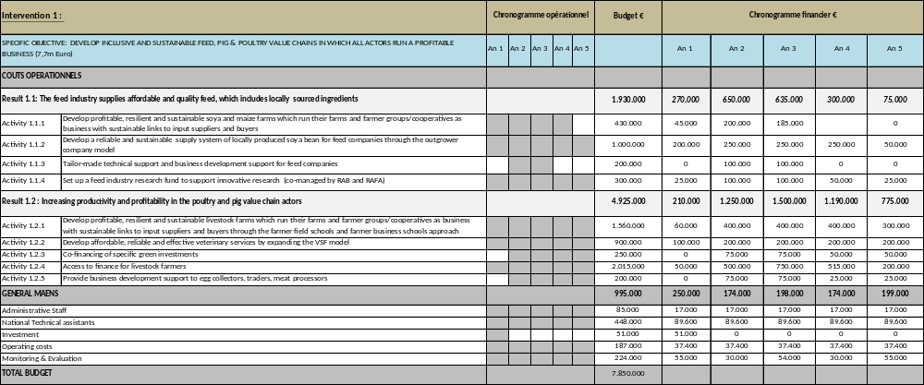
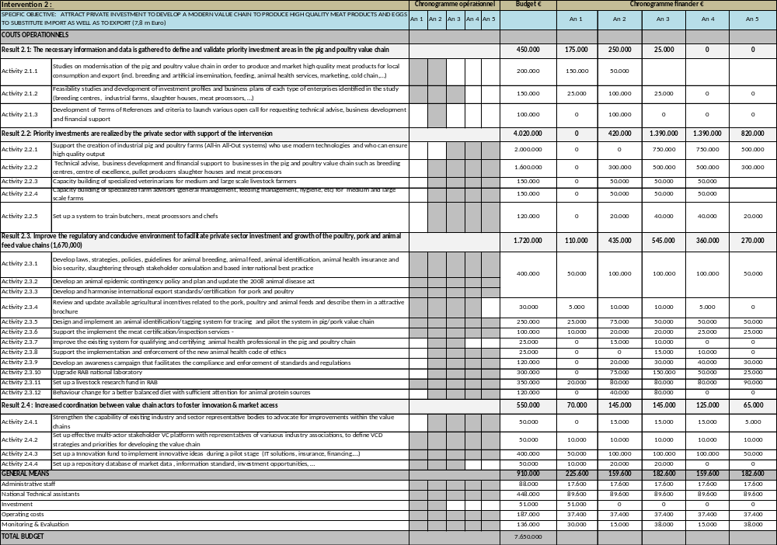

Annex 2 Abbreviations
ABUSOL | Agri Business Solutions
AFR | Access to Finance Rwanda
AGRA | Alliance for a Green Revolution in Africa
AI | Artificial Insemination
AMIR | Association Micro Finance Institutions in Rwanda
ASF | African Swine Fever
ASWG | Agricultural Sector Working Group
BDS | Business Development Service
BSF | Black Soldier Fly
CCOAIB | Conseil de Concertation des Organisations d’Appui aux Initiatives de Base
CDI | Centre for Development Innovation
CICA | Agricultural Information and Communication Centre
CSP | Commercial Specialized Piglet Fattening System
DDG | Dried Distillers Grains
DFID | Department for International Development
DIME | Development Impact Evaluation
DLI | Disbursement Linked Indicators
DOC | Day Old Chick
EAC | East Africa Community
EICV 3 | Rwanda Integrated Households Living Conditions Survey
EICV 4 | Integrated Household Living Conditions Survey
Engraisseurs | Pig fatteners
EU | European Union
FAO | Food & Agriculture Organization
FBS | Farmers Field School
FDI | Foreign Direct Investment
FFS | Farmers Field Schools
FTMA | Farm to Market Alliance
GA | Grow Africa
GAIN | Global Alliance for Improved Nutrition
GDP | Gross of Domestic Production
GIIF | Global Index Insurance Facility
GOR | Government of Rwanda
ICT | Information and Communication Technology
IFAD | International Fund for Agricultural Development
IFC | International Finance Corporation
IMBARAGA | Rwanda Farmers Federation
IMSAR | Improving Market System for Agriculture in Rwanda
JADF | Joint Action Development Forum
LMP | Livestock Master Plan
LODA | Local Administrative Entities Development Agency
LSA | Livestock Sector Analysis
M&E | Monitoring and Evaluation
MDTF | Multi Donor Trust Fund
MICE | Meetings, Incentives, conferences, Events and Exhibitions
MINAGRI | Ministry of Agriculture and Animal Resources
MINICOM | Ministry of Trade and Industry
NAEB | National Agricultural Export Development Board
NAIPS | National Agriculture Investment Promotion Strategy 2017
Naisseurs | Piglet Producers
NAP | National Agriculture Plan
NAP | National Agriculture Project
NICTAS | National ICT for Agriculture Strategy (2016 to 2020)
NIRDA | National Industrial Research and Development Agency
NISR | National Institute of Statistics of Rwanda
NST 1 | National Strategy for Transformation
NTBs | Non-tariff barriers
OSC | Out-growers Service Company
PASP HUB | Post-Harvest and Agriculture Business Support Project
PBFM | Project Based Funding Modality
PEAL | Poultry East Africa Ltd
PforR | Program for Result
PforR | Program for Results Financing Instrument
PPP | Private Public Partnership
PSDAG | Private Sector Driven Agricultural Growth Project
PSDYE | Private Sector Development and Youth Employment
PSF | Private Sector Federation
PSTA | Strategic Plan For the Transformation of Agriculture
PSTA 4 | The Fourth Strategic Plan for the Transformation of Agriculture
RAB | Rwanda Agriculture Board
RAFA | Rwanda Animal Feeds Association
RAILS | Rwanda Agriculture Livestock Inspection and Certification Service
RAS | Rwanda Agricultural Sector
RCA | Rwanda Cooperatives Agency
RCVD | Rwanda Council of Veterinary Doctor
RDB | Rwanda Development Board
RDDP | Rwanda Diary Development Project
RFP | Request for Proposal
RFRDP | Rwanda Feeder Roads Development Project
RHA | Rwanda Hospitality Association
RICA | Rwanda institute for Conservation Agriculture
RMP | Rwanda Meat Production
RPA | Rwanda Poultry Association
RPFA | Rwanda Pig Farmers Association
RPIA | Rwandan Poultry Industrial Association
RSB | Rwanda Standard Board
RWPA | Rwanda Poultry Industry Association
RWPA | Rwanda Poultry Association
SACCOS | Umurenge Savings and Credit Cooperatives
SDG | Sustainable Development Goals
SEAD | Strengthening Education for Agriculture Development
SHF | Small Holder Farmers
SME | Small and Medium Enterprises
SP | Specialized Chicken Production
SPIU | Single Project Implementation Unit
SSWGs | Sub-Sector Working Groups
TFC | Traditional Family Chicken
TMEA | Trade Mark East Africa
TP | Transformation for Prosperity
TWFA | The Wood Foundation Africa
UNICEF | United Nations Children Fund
USAID | United States Agency for International Development
VC | Value Chain
VSF | Vétérinaires Sans Frontières / Veterinary without borders
WB | World Bank
WFP | World Food Program
YARA | Yara International ASA

Minagri, PSTA-4, 2017
National Bank of Rwanda, Monetary Policy And Financial Stability Statement, March 2018
Avoid, Mitigate, Accept
Minagri Annual Report 2016-2017
Rwanda agriculture and animal resource report 2017
Zamura feeds, Gorilla feed ltd, PEAL ltd, PAFI Ltd, Abusol Ltd, Huye Feed Processing Plant and Tunga Feeds
Reference: Somers R, Salama SG, Rucibigango M,Ngerero G, Kiyikiza D, Higiro J, & Gahakwe D (2017) Achievements of the program “Support to SPAT II - Market Oriented Advisory Services and Quality Seed”
Scaling up these activities is out of the scope of this intervention and will have to be funded from other sources.
www.peal.rw, website of the company, confirmed by field visits;
www.zamurafeeds.rw
www.uzimachicken.com
To date VSF has trained 15 vets under the current programme.
This operation has professionalised large-scale egg production but is not the norm in a country where the majority of eggs are produced by small holder farmers.

