Country Programme
RWANDA
2019-2024
PART I General part

Table of contents

1.1 Introduction 3
1.2 Context of the new country program 3
1.3 Overview of the country program 4
1.3.1 Health sector 4
1.3.2 Agriculture sector 5
1.3.3 Urbanisation sector 6
1.3.4 Public Finance Management 6
1.3.5 Studies and consultancies 6
1.3.6 Overview of the proposed country portfolio 2019–2024 and budget 8
1.3.7 Duration and chronogramme 10
1.4 Piloting and monitoring of the country programme 11
1.4.1 Piloting of the country programme 11
1.4.2 Modalities for changing the country programme 11
1.4.3 Management & expertise 12
1.4.4 Explanatory note on the financial instruments of the portfolios 13

Introduction
The new country programme for the Belgo-Rwandan cooperation 2019 – 2024 is here presented in five parts, which together form the full country programme, integrating both the strategy and the portfolio.
Part I contains a short overview of the overall programme and also the modalities for piloting and monitoring the country programme;
Part II contains the detailed description of the health programme: the strategic orientations and the different interventions;
Part III contains the detailed description of the Agriculture programme: the strategic orientations and the different interventions;
Part IV contains the detailed description of the Urbanisation programme: the strategic orientations and the different interventions;
Part V contains the detailed description of the Public Finance programme: the strategic orientations and the intervention.

Context of the new country program
The approved outline of the new programme
By exchange of letters between the Belgian Embassy and the Rwandan Ministry of Finance and Economic Planning, the outline for a new country programme of the Belgian-Rwandan development cooperation covering the period 2019-2024 was approved on June 18^{th,} 2018. Enabel was allowed to start the elaboration of this outline with the related technical ministries.
The approved outline foresees that the new development programme will intervene in three sectors: health, agriculture and urbanisation, and in each of these sectors particular attention will be given to a limited number of cross-cutting themes: gender, private sector development and accountability.
Given the experience of Enabel with national execution, e-procurement, IFMIS, and its experience in the ongoing programmes with public finance management (PFM) budget dialogue, Belgium will also contribute to the PFM multi-donor fund, with specific focus on decentralised entities. The expertise budget will foresee the budget allocation for the required international expertise. A classical study fund open for both public and non-governmental actors will complete the overall country programme.
A total budget of 120 million Euros has been allocated for the Belgian contribution to the programme.
After the validation of the strategy, Belgium and Rwanda agreed to commit the 8 million Euros initially foreseen as reserve budget to the Urbanisation sector and for 1 million Euros to the Agriculture sector.
In the Health sector, Enabel was requested to develop a Result-Based Financing (RBF) intervention (based on the Global Fund approach) which is to cover 60 % of the health programme budget, while for Agriculture, Belgium will join the Multi Donor Trust Fund (MDTF) managed by the World Bank with a contribution amounting to 50 % of the agriculture portfolio.
A new programme cycle in two steps, leading to a result-oriented country programme to be fully implemented within the given timeframe
In the new programme cycle, Belgium has introduced a two-step approach:
- A country strategy determines the broad orientations of the new programme: the results framework at the level of the general objectives, the specific objectives and, the indicators at the impact level;
- A country portfolio determines the specific interventions and their respective results frameworks including the outcome and output indicators and targets, budgets, modalities and risks and hypotheses.
This country programme document entails both the strategy and the portfolio. For each sector, the specific interventions are included and developed after the description of the broader strategic orientations. The country programme is the result of an intensive dialogue with the related technical ministries, as well as consultations with other Belgian, European and international development partners in the related sectors.
The importance given to the achievement of results leads to a strong focus on the outcome indicators. Changes to the outcome indicators will only be possible through an exchange of letters.
Important changes with the previous approach of the Belgian cooperation are:
- The entire country programme will be formally committed through one single specific agreement: the implementation period for the programme is limited to the duration of the specific agreement, which implies that all activities will have to be finished during the validity of the specific agreement. However, payments related to public tenders awarded during implementation can still be made after the final date of the specific agreement.
- The role of the Joint Committee in following up on implementation of the overall programme and in assuring that the programme is implemented fully within the limited timeframe becomes more important: a yearly progress report will pay specific attention to the progress in achieving the objectives and results of the different interventions, but also identify possible risks and difficulties encountered as well as opportunities for improved implementation. Reorientations of budget allocations can be proposed between interventions and between sectors, validated within certain limits in the Joint Committee and requesting an exchange of letters for more important changes.
- International experts in charge of supporting the implementation of the programme are no longer budgeted in the sector interventions, but in a separate global expertise envelope.
A summary description of each sector is included in this general part, while for each sector a separate part is developed which entails the more detailed strategy and interventions description.

Overview of the country program
HEALTH
GO | Delivery of Sexual & Reproductive Health services including FP services as well as access of Households to Health Care increase
 | SO 1 | To ensure that all women, new-born, children, adolescents and men have universal access to quality integrated RMNCAH (Reproductive, Maternal, New-born, Child and Adolescent Health) and/or FP/ASRH (Family Planning & Adolescent Sexual Reproductive Health) services
 | SO 2 | To ensure accessible, evidence-based, improved and innovative health services (with a special attention to sexual and reproductive health services) with increased citizens participation and engagement in development
AGRICULTURE
GO | Revenues for farmers’ households and other private actors in the targeted agricultural value chains increases in a sustainable manner
 | SO 1 | Support through the MDTF the implementation of PSTA4 to promote the commercialization of agricultural value chains.
 | SO 2 | Develop inclusive and sustainable pig & poultry, and the related animal feed value chains in which all actors run a profitable business
 | SO 3 | Attract private investment to develop a modern value chain to produce high quality products to substitute import as well as to export
URBANISATION
GO | The urban infrastructure for inclusive and sustainable economic development is functional and expands further
 | SO 1 | Sustainable and resilient urban development is enhanced in the districts of Rubavu, Musanze and Rwamagana
 | SO 2 | Inclusive economic development is enhanced, especially in the MIR construction sector
PFM
GO | Support Rwanda’s socio-economic transformation through effective and accountable transformation
 | SO | Increase the effectiveness and sustainability of Public Finance Management systems at central and local government level
Study Fund
SO |  | Strengthen - through studies, consultancies and the mobilisation of expertise - the institutional and organisational capacity of public and non-governmental organisations in Rwanda linked to the priority sectors of the bilateral cooperation: health, agriculture, urbanisation and the transversal themes: gender, private sector development and accountability.

Health
Two separate objectives & two interventions have been developed:
Specific objective 1: To ensure that all women, new-borns, children, adolescents and men have universal access to quality integrated RMNCAH (Reproductive, Maternal, New-born, Child and Adolescent Health) and/or FP/ASRH (Family Planning & Adolescent Sexual Reproductive Health) services.
Specific objective 1, using the Result Based Financing approach (RBF), will focus on the roll-out of the national work plans of the health programmes related to Family Planning, Adolescent Sexual & Reproductive Health and Maternal, Neonatal and Child Health to increase the national coverage of these services. The Belgian contribution will fund a part of the annual work plans agreed upon.
Specific objective 2: To ensure accessible, evidence-based, improved and innovative sexual and reproductive health services for empowered citizens.
Specific objective 2 intervention will specifically zoom on: (i) quality of services at operational level when implementing the national strategies with documentation of good practices, (ii) innovation by working on concepts/models/methods that support the national strategies, learning from it and provide evidence-based feedback to the strategic level, included on opportunities for public-private partnership, (iii) accountability mechanisms, both downward and upward.
Under result 2 special attention will be given to Gender Based Violence (GBV), by supporting the improvement of the existing One Stop Centres at the level of the District Hospitals but also in extending the skills and support services to the level of the Health Centres. On the level of prevention, the program will support the respective districts in increasing awareness on GBV.
The project intervention will focus on 7 districts: Rulindo, Gakenke, Gisagara, Nyarugenge, Rusizi, Nyamasheke and Karongi. In the last 3 districts, the Enabel intervention will complement the ongoing support of UNFPA & UNICEF.

Agriculture
Where initially two different specific objectives were determined in the strategy development phase, during development of the portfolio the option was taken to opt for two complementary interventions resulting in the development of 3 interventions, each with its own specific objective:
Specific objective 1: support through the MDTF the implementation of PSTA4 to promote the commercialisation of agricultural value chains.
Specific Objective 1 will focus on strengthening the implementation of the PSTA4 through the Multi Donor Trust Fund (MDTF) managed by the World Bank. The MDTF allows donors to jointly support and stimulate the Government of Rwanda in the process of agricultural transformation and address the challenges of leveraging private sector investment in the agriculture Sector.
Specific objective 2: Develop inclusive and sustainable feed, pig & poultry value chains in which all actors run a profitable business.
This intervention aims to support and develop the current actors in the value chains. It starts from what already exists and aims to improve it, all along the value chain. Even though the intervention will support small production systems, it considers that all actors should operate as a business. Farmers who keep one pig in the backyard that is fed with leftovers are not the target of this intervention. This intervention aims to quickly address two major challenges: poor feeding practices and general farm management on the one hand and limited animal health services on the other hand.
Specific objective 3: Attract private investment to develop a modern industrialised value chain to produce high quality meat products and eggs to substitute imports as well as to export.
This second intervention aims to attract private investments to develop a modern industrialised value chain to produce high quality meat products and eggs to substitute imports as well as to export. In this intervention RAB and Enabel will work with NIRDA, the specialised Rwandan institution to facilitate the industrialisation. The selection criteria used during the calls for proposals will be fine-tuned during implementation, but will include criteria on inclusiveness, job creation and poverty alleviation, environmental impact as well as animal wellbeing.
The last two interventions are linked to each other. The regulatory framework and the organisation of the value chain platform will concern all actors, both small holder farmers and large private investors. But also between the actors, interaction exists and will be further developed. For example, the Day Old Chicks (DOC) produced by breeding centres which receive support through the second intervention will supply DOC to small farms which are supported through the first intervention. The animal feed factories which are supported in the first intervention will supply feed to the industrialised farms supported through the second intervention. The interventions will be private sector led except in areas where public funds will be required to de-risk private sector investments or to open-up participation in the value chain for poor small holder farmers (SHFs).
Applied research, extension services, business development services, support to agro-processing and agro-business will be activities that will be supported to develop the selected value chains, while the specific experiences of the project will support the broader dialogue within the MDTF framework.

Urbanisation
For the Urbanisation sector, consensus is developed around the proposed geographical focus and the key orientations. Where initially one specific objective for the Urbanisation sector was withheld, the extra budget led to revisit the set-up and develop 2 interventions:
Specific objective 1: Sustainable and resilient urban development is enhanced in the districts of Rubavu, Musanze and Rwamagana.
This intervention aims to support the investments in infrastructure in the 3 districts. It will start with a number of quick wins in each district, supporting the development of pre-identified infrastructure works, but also support the overall capacities of the districts in managing urban economic planning and the establishment of medium-term investment pipelines in a participatory way, assuring involvement of the private sector and population in the process and assuring optimal synergies between spatial (infrastructure) and economic planning. The second part of infrastructure investments will be identified through the investment pipeline.
The infrastructure investments supported by the programme will be economic infrastructure, directly benefitting the citizens within the urban area, with a positive cost efficiency assessment on the cost ratio between the investment cost and the number of off-farm jobs generated particularly for women and youth, with limited social and environmental impact, favouring the use of locally-made construction materials.
Specific objective 2: Inclusive economic development is enhanced, especially in the MIR construction sector with a geographic priority focus on the districts of Rubavu, Musanze and Rwamagana.
This intervention aims to support the promotion and improvement of construction materials made in Rwanda, to support the production of high quality construction materials to substitute imports as well as to export. It has a specific focus on supporting technical and vocational centres to operationalise work placed learning and to include the use of Made in Rwanda (MIR) construction materials in their curricula.
The two interventions are interlinked: the technical specifications for the infrastructure works will integrate the use of MIR construction materials based on the better understanding of the potential and the workplace learning support will be operationalised on the construction sites supported by the first intervention.

Public Finance Management
The support to the PFM multi-donor fund aspires to “increase the effectiveness and sustainability of Public Financial Management systems at central and local government level”.
The focus for the Belgian policy dialogue will be on three objectives of the PFM Sector Strategic Plan:
- Expand the coverage and functionalities of the Integrated Financial Management and Information System (IFMIS) and other PFM ICT systems;
- Increase compliance with PFM systems and international accounting and auditing standards;
- Strengthen PFM systems supporting subnational investments and services.
These three objectives are chosen due to their direct link with the other sectors of the country programme. They are strongly connected with the health and agriculture support, which will apply full use of country systems through RBF and PforR approaches, as well as with the urbanisation sector given the emphasis that will be put on investments through districts.

Studies and consultancies
The specific objective of the studies and consultancies fund is to strengthen - through studies, consultancies and the mobilisation of expertise - the institutional and organisational capacity of public and non-governmental organisations in Rwanda linked to the priority sectors of the bilateral cooperation: health, agriculture, urbanisation and the transversal themes: gender, private sector development and accountability.
The studies and consultancies fund will be open to Rwandan public institutions, Rwandan non-governmental actors and federations of private sector actors (PSF, Chambers of commerce, e.o.).
Requests for mobilisation of funds for studies and consultancies can be introduced both through Enabel as well as through the Ministry of Finance and Economic Planning. Requests will need to be approved by the Permanent Secretary of the Ministry of Finance and Economic Planning and the Resident Representative of Enabel.
The implementation of the studies and consultancies will be conducted by Enabel through grants with the requesting institutions, public tenders or mobilisation of Belgian expertise under the framework contracts Enabel has with different Belgian public institutions. A final report of each study including a final financial report will be shared with the Ministry of Finance and Economic Planning and the beneficiary of the study.
A budget of 1.151.000 Euro is available for studies and consultancies.

Overview of the proposed country portfolio 2019–2024 and budget
Sector | Intervention / Specific objectif | Lead Ministry/Rwandan partner | Modality - partners involved | Budget
Health | Intervention 1: To ensure that all women, new-borns, children, adolescents and men have universal access to quality integrated RMNCAH (Reproductive, Maternal, New-born, Child and Adolescent Health) and/or FP/ASRH (Family Planning & Adolescent Sexual Reproductive Health) services | MoH & MINECOFIN main recipients | Result based direct grant agreement with MINECOFIN/MoH as main recipients; Sub-recipients (districts, CSO's, Hospitals) through national system; Enabel management for evaluations & verification missions | 27.000.000 €
Health | Intervention 2: To ensure accessible, evidence-based, improved and innovated sexual and reproductive health services for empowered citizens in 7 districts | Steering committee chair: MoH / Main implementing partner RBC | Grants to MoH, districts, RBC, CSO's; Enabel tenders for action research and evaluations | 18.000.000 €
Health | Total Health |  |  | 45.000.000 €
Agriculture | Intervention 1: Support through the MDTF the implementation of PSTA4 to promote the commercialization of agricultural value chains. | MINAGRI | Grant to World Bank, contracting with Governement of Rwanda and evidence based dialogue tenders assured by World Bank | 14.500.000 €
Agriculture | Intervention 2: Develop inclusive and sustainable feed, pig & poultry value chains in which all actors run a profitable business | Steering committee chair: MINAGRI / Main implementing partner RAB | Grants to RAB, NIRDA, grants to CSO's (VSF-B) & Wood foundation; Enabel tenders for a number of studies & evaluations | 7.850.000 €
Agriculture | Intervention 3: Attract private investment to develop a modern industrialized value chain to produce high quality meat products and eggs to substitute import as well as to export. | Steering committee chair: MINAGRI / Main implementing partner RAB | Grants to RAB, NIRDA, MINAGRI, Private sector federations, VSF-B; Enabel tenders for a number of studies & evaluations; | 7.650.000 €
Agriculture | Total Agriculture |  |  | 30.000.000 €
Urbanisation | Intervention 1: Sustainable and resilient urban development is enhanced in the districts of Rubavu, Musanze and Rwamagana. | Steering committee chair: MINALOC / Main implementing partner LODA | Grants to LODA, RHA, MINIFRA, MINALOC, CSO's (through calls for proposals with LODA); | 19.840.200 €
Urbanisation | Intervention 2: Inclusive economic development is enhanced, especially in the MIR construction sector with a geographic priority focus on the districts of Rubavu, Musanze and Rwamagana. | Steering committee chair: MINALOC / Main implementing partner LODA | Grants to LODA, NIRDA, RSB; Enabel tenders for surveys, evaluations, mappings. | 8.159.800 €
Urbanisation | Total Urbanisation |  |  | 28.000.000 €
PFM | Intervention 1: Increase the effectiveness and sustainability of Public Financial Management systems at central and local government level. | Chair steering committee MINECOFIN, Main implementing partner MINECOFIN | Grant with MINECOFIN, funds pooled with KfW, EU and 20 % GoR contribution; Enabel management for evaluations; | 5.000.000 €
PFM | Total PFM |  |  | 5.000.000 €
Study & consultancy | Study and Consultancy fund | Chair steering committee MINECOFIN, Main implementing partner MINECOFIN | Open to both public and non-governmental actors. Modalities will be defined per study or consultancy request. Possible modalities include grants, Enabel managed tenders, mobilisation of framework contracts; | 1.151.000 €
Study & consultancy | Total Studies and consultancies |  |  | 1.151.000 €
Management & expertise |  | Expertise | Enabel managed | 9.649.000 €
 |  | Provision | Depending on MTR | 1.200.000 €
 |  | Total |  | 10.849.000 €
Total Belgian contribution |  |  |  | 120.000.000 €

Grants are the major implementation modality of the portfolio, of which the majority will be signed with Rwandan public institutions. These grants with public institutions will not foresee any contribution to structure costs or management fees, while only a limited % will be used for general means: the Rwandan Ministry of Public Service and Labour does not allow public entities to recruit staff not foreseen in their approved organisational chart, a policy supervised also by the Ministry of Finance and Economic Planning, which requests Ministries to implement programs through their existing Single Project Implementation Unit and technical departments. However recruitments of a limited number of staff to assure the extra work related to administrative and financial reporting and M&E is generally accepted, to allow compliance with the donor reporting requirements.
The grant to the World Bank for the Multi Donor Trust Fund will foresee a 4,5 % trust fund fee, as well as a contribution to the supervision, program management and administration costs. (See part III Agriculture, page 20).
For the grants with CSO’s the call for proposals will define the structure costs and management costs, however Enabel will during implementation assure that these remain within acceptable margins (maximum 7% structure costs and maximum 5% management costs).
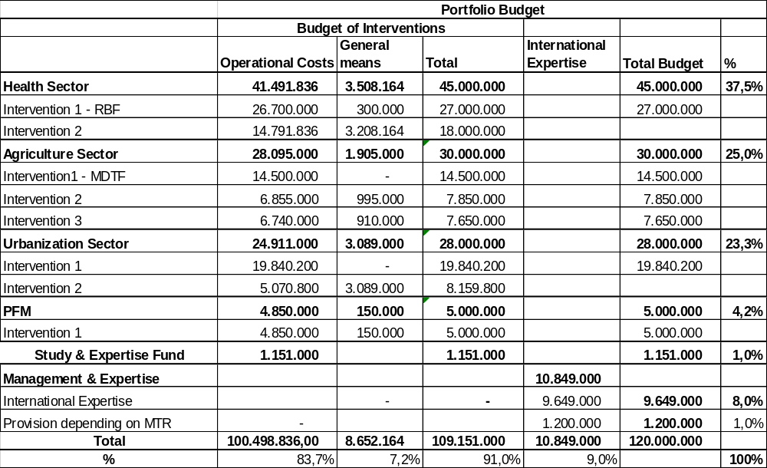

Duration and chronogramme
The total implementation period will be 60 months including an inception phase of 3 months and a closing phase of 3 months.
Considering that the majority of the activities will be implemented by public institutions through grants that they will manage according to the Rwandan PFM framework, the programme will start formally with the FY 2019 – 2020 and will cover 5 Rwandan fiscal years, with the first and last year covering half of a fiscal year for the Belgian system.
In order to allow these programmes to start effectively with the fiscal year 2019 – 2020, the preparations of the first disbursements for the RBF and the PFM support will be covered by the technical ministries and the Enabel experts already in the country for the ongoing programmes. No expenditures will be done on the country programme before July 1th 2019, the start of the FY 2019-2020.
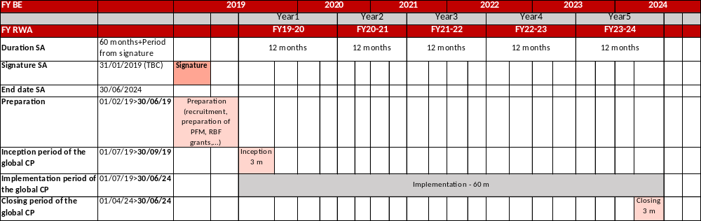

Piloting and monitoring of the country programme

Piloting of the country programme
The implementation of the country programme will follow the principles of the general agreement on cooperation signed between the Kingdom of Belgium and the Republic of Rwanda in September 2018. A specific agreement will stipulate, among others, the duration, the objectives, a budget overview and the type of actors who will implement the interventions.
The Belgian Party shall entrust the coordination and the implementation of the objectives specified in the Specific Agreement to the Belgian Development Agency, Enabel. The contractual relations with the actors involved in the implementation of the interventions or parts of the interventions will be stipulated through contracts signed between Enabel and the actors concerned, after the Specific Agreement has been formally signed.
Piloting will be assured both at the level of the different interventions, as at the level of the country programme:
- Each intervention will report to its respective Steering Committee

The mandate of the Steering Committee is to follow-up the implementation of the intervention, to assure strategic guidance, to validate work plans, financial plans, operational and financial reports. The SC will analyse potential constraints hampering the implementation and to support solutions to assure optimal implementation.
The composition of the different Steering Committees is described in the portfolio, each SC is chaired by a Rwandan public institution and co-chaired by Enabel and meets normally two times a year.

- At the level of the country programme, the Joint Committee as established by the general agreement on cooperation will meet once a year.

A yearly progress report capitalising on the different intervention reports will be presented to the Joint Committee. It will cover the overall country programme and give an overview of the progress of each intervention in achieving its results and objectives, report on the budget execution, the main challenges, risks and opportunities.
The Joint Committee is mandated to follow up on the overall implementation of the country programme, to analyse possible constraints and to support solutions to assure optimal implementation. The Joint Committee will validate possible proposals for changing the overall portfolio.
For each intervention budget allocations are made to assure evaluations and capitalisation. The findings of the evaluations and capitalisation exercises will be shared at the level of the different Steering Committees, while the main findings will be integrated in the yearly report to the Joint Committee.

Modalities for changing the country programme
Changes are possible at the level of an intervention or at the level of the country programme.
For each intervention, the Steering Committee is mandated to assure overall strategic follow-up of the intervention and to validate changes which do not affect the general or specific objective, the impact of outcome indicators and the total budget of the intervention.
Other changes to the country program will be discussed within the joint committee, which can propose on reorientations of budget allocations between interventions and between sectors, requesting an exchange of letters between the governments of Belgium and Rwanda. The modalities for changing the country program will be determined in the specific agreement.

Management & expertise
On the Belgian side, the coordination and implementation of the country programme is entrusted to Enabel. The overall coordination of the portfolio will be assured by the Resident Representative.
Enabel will assure the implementation through a combination of grants, public tenders and cooperation agreements with public actors. For investment support to private actors, Enabel will make a grant to public institutions (direct grant) that have the mandate to support companies: facilitating the access to credit, provision of expertise, support for innovative projects, and contribution to investments.
Each intervention will have an Enabel intervention manager, while support staff at the level of the management and expertise budget will support the intervention teams in complying with Enabel requirements and assuring the financial and administrative follow-up and compliance.
For a more comprehensive understanding of the set-up of the different interventions, we refer to the different sector specific parts of the portfolio.
Overall the expertise is needed to assure:
- The role of intervention manager on behalf of Enabel in the different interventions, to support the development of grant agreements and work plans, to support the implementation and suggest solutions to identified problems, to assure reporting and quality assurance in line with the overall obligations Enabel has towards the Belgian government;
- To assure coordination of the interventions within each sector, while assuring the required capacity for an active participation in the technical sector dialogue;
- To assure the management of fiduciary risks and financial control and reporting (the role of the Administrative and Finance experts and the contracting experts);
- To cover specific technical expertise needed for the implementation of the interventions;
- To support the work related with co-chairing a sector working group.
HR portfolio | Months
Intervention managers and sector experts | 444
Expert in administration and finance | 60
Expert in contract management | 60
Total

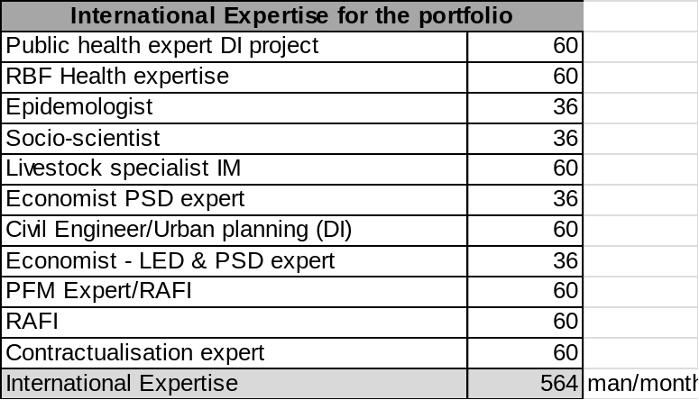

The needs for the management & expertise will be reassessed during the mid-term review of the programme. An amount of 1.200.000 € is kept uncommitted, after the MTR the allocation of this budget will be determined.

Explanatory note on the financial instruments of the portfolios
The financial instruments included in the Rwanda portfolio are based on the existing legal framework.
In other words, the portfolio includes no loans or instruments falling under the framework of the Royal Decree regarding innovative financing instruments.
The instruments that do fall under the portfolio are:
· Grants
· Public procurement contracts
· Cooperation Agreements with public actors
Enabel may award grants to:
· a public-law legal person
· a regional public-law organisation
· a non-profit association or a foundation
· a private legal body for which profit maximisation is not the primary objective
Enabel will not itself finance refinancing or credit lines, but it will facilitate the process of searching for partners.
Furthermore, the intended types of instruments are:
1. Guarantee funds
Enabel will award a grant to a Guarantee fund of a public institution.
Through public procurement, furthermore, expertise can be sourced in view of strengthening the institution and provide it with support in managing the Fund.
2. Investment support
Enabel will award a grant to public institutions (direct award) or to not for profit organisations (following a Call for Proposals) which support businesses: facilitation of obtaining a credit, provision of expertise, support to innovative projects, and contribution to investments.

