
Results report 2012

Insert partner logo here
LOCAL GOVERNMENT REFORM AND DEVELOPMENT PROGRAM (LGRDP) IN PALESTINE DGD CODE: NN 3007129
NAVISION CODE : PZA 09 024 11

Acronyms 4
1 Intervention at a glance (max. 2 pages) 5
1.1 Project form 5
1.2 Project performance 5
1.3 Budget execution 6
1.4 Summary 6
2 Analysis of the intervention 7
2.1 Context 7
2.1.1 General context 7
2.1.2 Institutional context 7
2.1.3 Management context: execution modalities 7
2.1.4 Harmo-context 7
2.2 Outcome 8
2.2.1 Analysis of progress made 8
2.2.2 Risk management 10
2.2.3 Potential Impact 11
2.2.4 Quality criteria 11
2.3 Output 1 14
2.3.1 Analysis of progress made 14
2.3.2 Budget execution 15
2.3.3 Quality criteria 15
2.4 Output 2 16
2.4.1 Analysis of progress made 16
2.4.2 Budget execution 17
2.4.3 Quality criteria 17
2.5 Output 3 18
2.5.1 Analysis of progress made 18
2.5.2 Budget execution 19
2.5.3 Quality criteria 19
3 Transversal Themes 20
3.1 Gender 20
3.2 Environment 20
3.3 Other 20
4 Steering and Learning 21
4.1 Action Plan 21
4.2 Lessons Learned 21
5 Annexes 22
5.1 Original Logical framework 22
5.2 Updated Logical framework 22
5.3 MoRe Results at a glance 22
5.4 “Budget versus current (y – m)” Report 22
5.5 Resources 22
5.6 Decisions taken by the JLCB and follow-up 23

Acronyms
AFD Agence Francaise de Developpement
BD Budget Directorate (MoLG)
BTC Belgian Technical Cooperation
CD Complaints Directorate (MoLG) / Capacity Development
CSO Civil Society Organisations
EOI Expression of Interest
F&AD Finance and Administrative Directorate (MoLG)
F&MD Formulation and Merging Department
HZC High Zoning Council
IC International Community
ICA Israeli Civil Administration
ICA(R) Institutional Capacity Assessment (Report)
ICD Internal Control Directorate
ICP Indicative Cooperation Program
ITA International Technical Assistant
JSC Join Service Council
LGRDP Local Government Reform and Development Project
LG Local Government
LGU Local Government Unit
M&E Monitoring and Evaluation
MDLF Municipal Development and Lending Fund
MDP Municipal Development Program
MoLG Ministry of Local Government
NSA Non State Actors
oPt Occupied Palestinian Territories
PNA Palestinian National Authority
PSC Project Steering Committee
PSU Project Support Unit
SDIP Strategic Development and Investment Planning
SMCL Structure mixte de concertation locale
TC Technical Committee
TOR Terms of Reference
VC Village Council
WG Working Group

Intervention at a glance (max. 2 pages)

Project form
Project name | Local Government Reform and Development Project  (LGRDP)
Project Code | PZA 09 024 11
Location | Palestine (West Bank)
Budget | 15.000.000 Euros
Partner Institution | Ministry of Local Government
Date of implementation Agreement | 25 November 2010
Duration (months) | 72 months
Target groups | Amalgamating Municipalities, LGUs, MoLG
Impact | To strengthen the institutional and management capacities of the local government system
Outcome | To support institutional reform through improved capacities and services of selected clusters of smaller LGUs and improve the institutional capacity of MoLG
Outputs | 1. MoLG capacitated to implement the MoLG strategic plan
Outputs | 2. LGUs in 4 to 6 clusters are facilitated for provision of joint services and amalgamation
Outputs | 2’ Capacities of LGUs are enhanced for improved planning, financial management, HRM and accountability
Outputs | 2’’ Services of LGUs are improved through provision of sustainable infrastructure development
Outputs | 3 Amalgamated municipalities are continuously progressing their performance

Project performance

 | Efficiency | Effectiveness | Sustainability
Outcome | A | C | B
Output 1 | A | C | B
Output 2 | B | C | D
Output 3 | B | A | B

Budget execution

Total Budget 2012 | Expenditure year N | Balance | Total Disbursement rate
3.784.000 | 3.498,000 | 286.000 | 92,5%

Summary
Formulate 5 key points (briefly, in one or two sentences) that a reader of this report should remember.

- Component 1: after physical support, LGRDP will focus on policies, strategies and modalities regarding decentralisation and the management of the territory
- Component 2 : Awareness and institutional development of JSCs should be strongly deepened
- Component 3 : can gradually be more aligned to MDP mechanism
- Coordination and collaboration between all stakeholders must be improved
- Participation of communities in the local development process should be increased

National execution official | BTC execution official

Analysis of the intervention
INTRODUCTION

The intervention is articulating three components at three levels with different beneficiaries and different modalities of implementation. These components must be connected together, and their good articulation will improve the impact of the whole intervention.

Beyond general analyses, the report of the intervention must then be also done regarding each of these components.

- Component 1: output 1 - MoLG level – in Regie – implemented by the PSU (in close collaboration with the MoLG)

- Component 2: outputs 2,3 and 4 - Four LGUs’ clusters – in co-management – implemented by MDLF (with a specific MDLF support staff)

- Component 3: output 5 - Amalgamated Municipalities – in co-management, as much as possible aligned to MDP – implemented by MDLF (in close coordination with other donors supporting the MDP – trust fund approach)

Context

General context : a stronger legitimacy of LGUs
In 2012, the major contextual element that had an important influence on the intervention was the organisation in November 2012 of elections of LGUs’ Councils. These local elections that had been postponed for years with, consequently, a lack of legitimacy of most of Local Councils, allowed to have new legitimate elected Councils in all LGUs (Villages and Municipalities).

This process has a strong impact on the intervention:

- Positive impacts :

  - All LGUs are now led by elected bodies (which was not the case before elections when about 30% of LGUs were managed by appointed officials);

  - LGUs’ councils are now really representing local citizens with a greater legitimacy;

  - This new situation put the MoLG in front of a new dynamic and a new need for training and for supporting LGUs.

- Negative impacts that will be taken into account within the intervention in 2013:

  - Most of Village Councils have changed in the four pilot clusters where LGRDP is intervening. This will require to aware them again on the amalgamation process and to validate all what has been previously done with previous Councils;

  - The will of new Village Councils for amalgamation is not fully sure;

  - New elected councelors have a lack of knowledge, skill and experience for playing their roles.

Institutional context : a very appropriate and strong anchorage in the MoLG whith new strategic orientations
The overall program is anchored in the MoLG who is the key institution in charge of decentralisation and territorial development. As the LGRDP is supporting the Local Government Reform and Development, this anchorage is fully relevant and very appropriate.

In 2012, local government’s issues and the key role of LGUs in the State building process and in the Palestinian development have been gradually considered as to be among most important challenges of the PA for the next years. The issue of managing better their territory is becoming a strategic governance issue in Palestine.

To answer to this new “vision” of its role, the MoLG has updated in 2012 a Strategic plan around which all donors’ interventions will be articulated. This strategic plan has been shared with all partners in beginning of 2013 in a national workshop.

In that context, the MoLG is designing some new important policies and is reviewing all existing one:

- Some new policies appeared to be crucial for strengthening the management of the palestinian territory and for promoting the LGUs’ role in the palestinian development :

  - The MoLG has designed with the Cabinet (Prime Minister) a policy regarding Area C (65% of the West-Bank territory under the control of the ICA). This policy and its implementation strategy is fully supported by the International Community, and should be fully included within the Local Government reform policy. The LGRDP has included a new activity in his Component 1 to support the implementation of that policy (see here under);

  - The Ministry is working on the design of an approach and a policy on Local Economic Development which appears to be as crucial as necessary to promote local development. This strategy will complete the development planning approach at the local level.

- In 2012 and following LGRDP first capacity development activities, the MoLG got more conscious on the necessity of adapting, improving, completing and connecting together existing policies. When LGRDP started in 2011, the notion of the “Local Government Reform” was as vague as undefined. Different policies and strategies were implemented such as “amalgamation”, LGUs capacity development, JSCs, etc…. with a lack of coherence together, without any evaluation of their impact and following disconnected processes. Despite all activities implemented by the MoLG, the administration and the management of the territory remained very weak with a lack of local development. Our institutional capacity assessment pointed the crucial need of reviewing all these policies and underlined the necessity of connecting them all together to design what will become the Local Government reform. This more strategic approach is now possible after local elections. It will also give a more strategic orientation to LGRDP intervention.

  - The amalgamation policy (which was failing) is fully under revision and will be connected with the JSC policy;

  - The JSC policy which appears to be uncomplete is also under revision;

  - The planning policy (SDIP) will be completed and improved with the inclusion of a LED approach;

  - The Capacity Development approach is completed, following the evolution of Municipalities;

  - The MDLF is preparing a MDP phase 2 to be more adapt ed to the evolution of MoLG policies and to LGUs evolultive needs.

- In 2012, under our initiative, all development partners supporting the MoLG have made strong efforts to better coordinate their intervention (mainly BTC, GIZ, CHF-USAID, JICA, DANIDA) and to present themselves in front of the MoLG as a unique “pool” supporting together the MoLG strategic plan. As such, interventions are becoming more coherent and implemented with synergy.

Regarding components 2 and 3 implemented by the MDLF, this sub-anchorage appears very appropriate too. The MDLF has been created to implement the MoLG policies. As such, it is relevant that they are in charge of LGRDP component 2 which is implementing the “amalgamation” policy. For component 3 which consist in contributing to the MDP (supported by WB, Sweedish and Danish Cooperation, AFD, KFW) and implemented by the MDLF, our anchorage is even more than appropriate.

Management context: execution modalities moderately appropriate
- Component 1 : appropriate

MoLG capacity development activities are implemented by the PSU through BTC regie modalities. Despite this approach, the TFF was stipulating that the PSU will use WB procedures for all procurement. In 2012, the Steering Committee approved the proposal to use from 2013 the Belgium procurement regulation which appears to be more relevant. The fact that this component is implemented in Regie allowed the project to implement in 2012 nearly 100% of the working and financial plan.

Nevertheless, it will make sense to gradually transfer part of responsibilities to the Ministry. The capacity of the Ministry to implement their CD plan should become itself an indicator of the impact of the project. This point will be assessed in 2013 and should be considered in the formulation of the LGRDP extension tht will take place at the end of 2013.

The new activity added in 2012 in the Component 1 (area C masterplans) is implemented under co-management. It is leading to a stronger ownership of the concerned Department.

The Regie approach is nuanced by the fact that all activities must be approved by a Technical Committee composed of representative of the Ministry. This TC worked well in 2012, with about 6 meetings. Also, the National cooridnator of the program is sharing all decisions, as if we were in a co-management approach.

In 2012, the CD expert who was placed within the Ministry resigned. Her replacement have been punctally done by a short term consultant who have completed the institutional capacity and who has designed a second phase of the capacity development plan.

- Component 2: moderately apropriate

This component is implemented by the MDLF through co-management, but with a very close and continuous control on procurement and payments. This control at each stage of the procurement process is heavy and should be gradually lightened to apply the normal non objection process before awarding and paying, as other donors are doing with MDLF.

For imlementing the component 2 activities, the MDLF has assigned a four staff support team with some difficulties. The social expert and the planner have only been recruited on mid-2012. The coordinator appeared to be weak and he went away at the end of 2012. This situation generated problems in the quality of the intervention in the four clusters, leaving sub-contracting companies implementing activities with a lack of MDLF leadership. This situation should be better managed in 2013. The Coodinator should be replaced. The social expert must also be replaced after she resigned.

- Component 3: not appropriate

Despite the fact that the MDP is working as a trust fund supported by different donors, BTC is still following a co-management approach requiring a close control of the process. These modalities doesn’t appear to be fully relevant and appropriate. BTC should assess here the possibility of a full alignment on MDP modalities (with regular evaluation of the WB), if not applying for this component a national execution approach.

Harmo-context : increasing harmonisation with other actors despite the difficult situation of occupation

2012 has been an important year regarding dynamics and alignement between all stakeholders in the local governance sector:

- Thanks to the development of MoG strategies (around their strategic plan), all donors are more and more supporting the palestinian agenda rather than implementing their own agenda;

- Main donors supporting the MoLG have organised number of coordination meetings with the target of following a common working plan. A monthly meeting with the Minister of LG will be organised with all projects and programs to make a point on the implementation of the strategic plan;

- The MoLG has designed with the support of the LGRDP two CD plans: a HR development plan and a communication strategy which will be endorsed and supported by all donors;

- The area C strategy is implemented together by the MoLG with the technical support of BTC, French Cooperation, GIZ, EC and UN-Habitat and a political support of the International community in Jerusalem (interest group leaded by the EC);

- All assessments related to the MDP phase 2 are followed up, shared and will be endorsed with by all donors supporting the MDLF (WB, Danish and Sweedish cooperation, AFD, BTC, GIZ and KFW, EC, and Holland cooperation).

Despite these positive aspects, there are still some coordination problems between the MoLG and other Ministries, coming from a difference of vision on the decentralisation issue.

Outcome

Analysis of progress made

Outcome:
To support institutional reform through improved capacities and services of selected clusters of smaller LGUs and to improve the institutional capacity of MoLG
Indicators |  | Baseline value | Progress year N-1 | Progress year N | Target year N | End Target | Comments
Capacities of departments of MoLG are improving |  |  |  | 20% | 50% | 100% | Urgent and crucial physical needs provided
Capacities of the selected clusters are improving |  |  |  | 15% | 25% | 100% | JSCs are formally in place, but they still don’t perform well
Analysis of progress made towards outcome: Analyse the dynamics between the outputs achieved and the likely achievement of the Outcome (see Results Report Guide):
Relation between outputs and the Outcome. (How) Are outputs (still) contributing to the achievement of the outcome: | Yes if policies for Developping LGUs are adapted, completed, improved and/or developped
Progress made towards the achievement of the outcome (on the basis of indicators): | LGRDP provided in 2012 basic physical supports which allow to base on it a more strategic CD approach
Issues that arose, influencing factors (positive or negative): | . Lack of coordination and collaboration between stakeholders  . Weak and uncompleted policies
Unexpected results: | . The interest for amalgamation is not yet fully understood by local stakeholders

Risk management

Risk Identification |  |  | Risk analysis |  |  | Risk Treatment |  |  | Follow-up of risks
Description of Risk | Period of identification | Risk category | Probability | Potential Impact | Total | Action(s) | Resp. | Deadline | Progress | Status
Lack of regulation regarding decentralisation (and repartition of roles and responsibilities between the central and the local level)  The non endorsement of MoLG proposed policies by the Cabinet – lack of will for decentralisation | ICA |  | Medium | High | C | Completion / Improvement / Development of LG policies  Include the management of that risk within the communication strategy | MoLG | 2014 | On-going
 |  |  |  |  |  | Involve other Ministries in MoLG policies design process | MoLG | 2014
Difficulties of MDLF to implement project activities (which are news for them in term of approach) | 2012 |  | Medium | High | C | To increase institutional support of the LGRDP PSU to MDLF | PSU | 2013
Lack of coordination of donors working in the same sector with the same stakeholders | 2012 |  | Medium | Medium | B | Organising continuous contacts with other donors | PSU / MoLG | 2013 | On-going
Lack of understanding of national policies at the local level | 2012 |  | High | High | D | MoLG Communication strategy | MoLG | 2013
Lack of participation and of NSA involvement in local governance | 2012 |  | High | High | D | JSCs Communication strategy | JSCs | 2013 | On-going
Blocking of Area C development by the ICA | - |  | High | High | D | Promote a deep negociaton between communities and ICA on master plans | MoLG | 2015
 |  |  |  |  |  | Coordinated advocacy of the International Community | IC | 2015
Weak capacities of LGUs to complete and to implement their plan | ICA |  | High | High | D | A deep ICA at the local level | MDLF | 2013 | On-going
 |  |  |  |  |  | A strong CD plan at the local level | MDLF | 2015 | On-going

Potential Impact

2012: following a quick need assessment, the LGRDP has provided urgent “classical CD activities (basic training, working equipment, rehabilitations...) to the MoLG and has implemented amalgamation acitivities as described in the TFF following the existing approach.

But, CD activities should serve relevant and effective policies. It should support institutions to play their role and to successfully implement adequate policies.

However, it appeared that the MoLG policies implemented by the MDLF regarding the LG reform were not completed, fully effective and really operational. The process implemented as provided in the TFF presented a lack of sustainability. Also, CD activities to the MoLG should support operational role within the policy context which was not clear nor relevant.

So, as if the “amalgamation” objective is fully relevant to contribute to the goal of the LGRDP, it is necessary to review policies, strategies and ways of implementation. And the MoLG CD should be designed in that new framework.

What is the situation?

The baseline situation of the administration of the territory is as followed :

- A “fragmented” decentralized administration (more than 380 local Government Units in West Bank and 25 LGUs in Gaza) at “one” territorial level administrated by elected councils with strong disparities (in terms of: territorial levels that LGUs are actually covering, status, size, capacity, resources, …) which are nevertheless supposed to have the same responsibilities and to implement similar tasks:

  - 134 Municipalities (with the legal recognition and status – 109 in West Bank and 25 in Gaza) with 2.950.000 inhabitants (about 60% of the population of Gaza and West Bank) which are classified on a scale from A to D following the date of their creation. These municipalities are managed by a Municipal Council supported by the MDP (MDLF).
  - 272 Village Councils of very different size, number of inhabitants (from about 300 inhabitants to 15.000 inhabitants) and different level of administrative organization (including more than 140 abandoned communities in area C). These villages are managed by a Village Council with (normally) the support of the MoLG branches (Governorate branches). Most of Villages are currently unable to fulfill a “municipal” role. This weak capacity is largely due to their weak structure and weak available human and financial resources.
  - More than 85 Joint Service Councils (between LGUs) for specific technical tasks (including JSC for planning and amalgamation). JSCs are composed of Villages’ Mayors.

- Beyond a too great number of LGUs very different of each other on a small territory, the territorial administration and the institutional framework of local development in Palestine is characterized by fragmentation at all levels:

  - At “geographic” and political levels: Because of the Israeli occupation and policy, the Palestinian territory is fragmented in three types of areas (A,B and C), what is totally breaking the territorial unity and cutting up the territory into different zones with constraints to the free circulation of goods and people. The occupation leads also to strong constraints to free local administration in areas C where the Palestinian State has no sovereignty.

  - At regulatory level: the regulatory framework is a combination (juxtaposition) of (partly outdated) legislation originating from different countries (Ottoman, Jordan, Egypt, Israel, Palestinian) and more recent pieces of amendments to fit to actual conditions.

  - At “administration” level: the notion of LGU is covering many different status and classes of local authorities (Village Councils, Joint Service Councils, Municipalities A, B, C and D) of very different size and population with big differences in their capacity and their level of organization.

  - At “development” level: the fragmentation is generated by different factors. Some areas are benefiting of strong supports from donors to the detriment of areas with weak supports. Some LGUs have the status of Municipality and have as such access to the MDP. Other LGUs have elaborated their SDIP and are weakly supported by the State budget for investments. In other areas, some services are implemented through JSCs with the support of the MoLG. Master plans are not covering the whole territory… The picture is fragmented and unbalanced. Areas C have been left behind. Development plans are not following national strategies, and the missing national development plan doesn’t allow to frame and to consolidate regional and local plans. The fragmentation is as much “horizontal” (between territories) than “vertical” (between territorial levels). In such a situation, the territory is actually composed by isolated LGUs trying to attract resources for themselves (from all possible sources) without considering any more that they are a space of administration and development.

  - At history level: LGUs have been established at different moments of the Palestinian History following different criteria and legal framework.

  - At level of policies: all policies regarding the LG development (amalgamation, JSCs, Planning, Capacity development, control, etc.) are disconnected from each other. Behind the notion of Local Government reform, there is not a clear idea of its content. In fact, all these specific policies should be fully connected together. This disconnection is weakening the LG development itself with a lack of visibility for all stakeholders. This fragmentation is also partly due to donors and development partners who had until today a tendency to intervene following their vision, their approach and their agenda.

In fact, there is not clear criteria to define what a Municipality is (in terms of average size, population, capacity, etc.), and what their competencies and responsibilities are at which specific territorial level.

- Beyond fragmentation, LGUs are also facing a number of issues that have an impact on their capacities and their performance, including:

  - A paradoxical and strong tendency of local authorities to centralize powers;

  - Very limited budgets and resources;

  - Lack of a decentralization policy and of legal basis that defines roles, responsibilities, organizations. modalities, … of LGUs;

  - No clear mechanism for fiscal decentralization;

  - Weak institutional and HR capacities;

  - Lack of a comprehensive organizational framework of the public administration system with regards to the different territorial levels;

  - Lack of institutional communication and coordination between stakeholders and weak participative governance.

  - A great number of LGUs are too small and does not have the resources and the capacity to perform their core functions and deliver basic set of services for the community.

  - The activities of LGUs have never been systematically monitored.

This “fragmented” context and LGUs weaknesses lead to a vital need to better structure, to harmonise and to organize an effective and relevant decentralized administration system of the territory. This will oblige first of all to reorganise LGUs by integrating them into larger entities which are supposed to be more “viable” and capable to perform administrative and development functions by providing a clear set of basic services to their citizens as provided in the Local Government Law of 1997. This necessary “structuration” is also a key condition to design, to promote and to implement local development dynamics which will participate to the Palestinian territorial development and, consequently, to the strengthening of the Palestinian territory.

Considering that there are too many small LGUs on the small “Palestinian” territory with very weak capacities for managing their local affairs, the Palestinian authority implemented policies whose purpose is that LGUs work together (Joint Service Council policy) or even merge together to form a larger entity (amalgamation policy). Such processes require to be based on clear and feasible visions, policies and strategies on how to achieve that complex process.

Amalgamation is nowhere a simple administrative process as a “mechanical construction” designed at the “central” level and implemented at the local level following technical criteria of planners. It is first of all a social and a political process with very sensitive dimensions related to culture, identity, history and power and local interest issues which can’t be administratively managed from the top. The first cement of a municipality is the desire and the agreement, if not the will, of local citizens to live and to work together. This requires a deep change of mentality which can’t just be ordered by the central authority.

Consequently, the LGRDP should support the review of policies, the design of strategies and the identification of modalities of implementing these policies.

The LGRDP aimed impact is still valid, but it appeared clearly in 2012 that the policies supported by the program and the way through which they are implemented by the MDLF are not effective and are even failing with a lack of sustainability.

In such a situation, the LGRDP will contribute to sectoral objectives if it will focus first of all on strategic issues and on a review of MoLG policies, strategies and modalities of implementation such as:

- Design of MoLG policies and LG reform (amalgamation, decentralisation, JSCs)
- Strategies and implementation modalities of these policies
- Design of development tools (planning, LED, local fiscality, ...)
- Implementation of these policies on the whole territory.

The LGRDP CD plan will include this strategic and political dimension within its approach, and CD plans will be redesigned in that sense.

Quality criteria

1. RELEVANCE: The degree to which the intervention is in line with local and national policies and priorities as well as with the expectations of the beneficiaries
In order to calculate the total score for this Q-criterion, proceed as follows: ‘At least one ‘A’, no ‘C’ or ‘D’ = A; Two times ‘B’ = B; At least one ‘C’, no ‘D’= C; at least one ‘D’ = D
1.1 What is the present level of relevance of the project?
 | A | Clearly still embedded in national policies and Belgian strategy, responds to aid effectiveness commitments, highly relevant to needs of target group.
 | B | Still fits well in national policies and Belgian strategy (without always being explicit), reasonably compatible with aid effectiveness commitments, relevant to target group’s needs.
 | C | Some issues regarding consistency with national policies and Belgian strategy, aid effectiveness or relevance.
 | D | Contradictions with national policies and Belgian strategy, aid efficiency commitments; relevance to needs is questionable. Major adaptations needed.
1.2 As presently designed, is the intervention logic still holding true?
 | A | Clear and well-structured intervention logic; feasible and consistent vertical logic of objectives; adequate indicators; Risks and Assumptions clearly identified and managed; exit strategy in place (if applicable).
 | B | Adequate intervention logic although it might need some improvements regarding hierarchy of objectives, indicators, Risk and Assumptions.
 | C | Problems with intervention logic may affect performance of project and capacity to monitor and evaluate progress; improvements necessary.
 | D | Intervention logic is faulty and requires major revision for the project to have a chance of success.

2. EFFICIENCY OF IMPLEMENTATION TO DATE: Degree to which the resources of the intervention (funds, expertise, time, etc.) have been converted into results in an economical way (assessment for the whole of the intervention)
In order to calculate the total score for this Q-criterion, proceed as follows: ‘At least one ‘A’, no ‘C’ or ‘D’ = A; Two times ‘B’ = B; At least one ‘C’, no ‘D’= C; at least one ‘D’ = D
2.1 How well are inputs (financial, HR, goods & equipment) managed?
 | A | All inputs are available on time and within budget.
 | B | Most inputs are available in reasonable time and do not require substantial budget adjustments. However there is room for improvement.
 | C | Availability and usage of inputs face problems, which need to be addressed; otherwise results may be at risk.
 | D | Availability and management of inputs have serious deficiencies, which threaten the achievement of results. Substantial change is needed.
2.2 How well are outputs managed?
 | A | All outputs have been and most likely will be delivered as scheduled with good quality contributing to outcomes as planned.
 | B | Output delivery is and will most likely be according to plan, but there is room for improvement in terms of quality, coverage and timing.
 | C | Some output are/will be not delivered on time or with good quality. Adjustments are necessary.
 | D | Quality and delivery of outputs has and most likely will have serious deficiencies. Major adjustments are needed to ensure that at least the key outputs are delivered on time.

3. EFFECTIVENESS TO DATE: Degree to which the outcome (Specific Objective) is achieved as planned at the end of year N
In order to calculate the total score for this Q-criterion, proceed as follows: ‘At least one ‘A’, no ‘C’ or ‘D’ = A; Two times ‘B’ = B; At least one ‘C’, no ‘D’= C; at least one ‘D’ = D
3.1 As presently implemented what is the likelihood of the outcome to be achieved?
 | A | Full achievement of the outcome is likely in terms of quality and coverage. Negative effects (if any) have been mitigated.
 | B | Outcome will be achieved with minor limitations; negative effects (if any) have not caused much harm.
 | C | Outcome will be achieved only partially among others because of negative effects to which management was not able to fully adapt. Corrective measures have to be taken to improve ability to achieve outcome.
 | D | Project will not achieve its outcome unless major, fundamental measures are taken.
3.2 Are activities and outputs adapted based on the achieved results in order to the outcome (Specific Objective)?
 | A | The project is successful in adapting its strategies / activities and outputs to changing external conditions in order to achieve the outcome. Risks and assumptions are managed in a proactive manner.
 | B | The project is relatively successful in adapting its strategies to changing external conditions in order to achieve its outcome. Risks management is rather passive.
 | C | The project has not entirely succeeded in adapting its strategies to changing external conditions in a timely or adequate manner. Risk management has been rather static. An important change in strategies is necessary in order to ensure the project can achieve its outcome.
 | D | The project has failed to respond to changing external conditions, risks were insufficiently managed. Major changes are needed to attain the outcome.

3. POTENTIAL SUSTAINABILITY: The degree of likelihood to maintain and reproduce the benefits of an intervention in the long run (beyond the implementation period of the intervention).
In order to calculate the total score for this Q-criterion, proceed as follows: At least 3 ‘A’s, no ‘C’ or ‘D’ = A ; Maximum two ‘C’s, no ‘D’ = B; At least three ‘C’s, no ‘D’ = C ; At least one ‘D’ = D
3.1 Financial/economic viability?
 | A | Financial/economic sustainability is potentially very good: costs for services and maintenance are covered or affordable; external factors will not change that.
 | B | Financial/economic sustainability is likely to be good, but problems might arise namely from changing external economic factors.
 | C | Problems need to be addressed regarding financial sustainability either in terms of institutional or target groups costs or changing economic context.
 | D | Financial/economic sustainability is very questionable unless major changes are made.
4.2 What is the level of ownership of the project by target groups and will it continue after the end of external support?
 | A | The JLCB and other relevant local structures are strongly involved in all stages of implementation and are committed to continue producing and using results.
 | B | Implementation is based in a good part on the JLCB and other relevant local structures, which are also somewhat involved in decision-making. Likeliness of sustainability is good, but there is room for improvement.
 | C | Project uses mainly ad-hoc arrangements and the JLCB and other relevant local structures to ensure sustainability. Continued results are not guaranteed. Corrective measures are needed.
 | D | Project depends completely on ad-hoc structures with no prospect of sustainability. Fundamental changes are needed to enable sustainability.
4.3 What is the level of policy support provided and the degree of interaction between project and policy level?
 | A | Policy and institutions have been highly supportive of project and will continue to be so.
 | B | Policy and policy enforcing institutions have been generally supportive, or at least have not hindered the project, and are likely to continue to be so.
 | C | Project sustainability is limited due to lack of policy support. Corrective measures are needed.
 | D | Policies have been and likely will be in contradiction with the project. Fundamental changes needed to make project sustainable.
4.4 How well is the project contributing to institutional and management capacity?
 | A | Project is embedded in institutional structures and contributed to improve the institutional and management capacity (even if this is not a explicit goal).
 | B | Project management is well embedded in institutional structures and has somewhat contributed to capacity building. Additional expertise might be required. Improvements in order to guarantee sustainability are possible.
 | C | Project relies too much on ad-hoc structures instead of institutions; capacity building has not been sufficient to fully ensure sustainability. Corrective measures are needed.
 | D | Project is relying on ad hoc and capacity transfer to existing institutions, which could guarantee sustainability, is unlikely unless fundamental changes are undertaken.

Criteria | Score
Relevance | A
Effectiveness | C
Sustainability | B
Efficiency | A

Output 1: Component 1

Analysis of progress made

Output 1: MoLG capacitated to implement the MoLG strategic plan
Indicators |  | Baseline value | Progress year N-1 | Progress year N |  |  | Target year N |  | End Target |  |  | Comments
Selected departments have clearly defined strategic and operational goals |  |  |  | yes
Selected departments can show a successful implementation of their respective departmental work plans |  |  |  |  |  |  |  |  |  |  |  | In 2012, LGRDP provided physical support to allow Department to work
Enhanced exchange between central and district level takes place (quantitatively & qualitatively) |  |  |  | yes |  |  |  |  |  |  |  | Through common workshops. District offices have been supported with physical support
Progress of main activities |  |  |  |  | Progress: |  |  |  |  |  | Comments (only if the value is C or D)
 |  |  |  |  | A | B |  | C |  | D
1 MoLG Institutional assessment |  |  |  |  |  |  |  |  |  | X | Following the resignation of the CD expert, this activity has been delayed (2013)
2 MoLG District offices need assessment |  |  |  |  | X
3 Physical support |  |  |  |  |  | X
4 MfDR training |  |  |  |  | X
5. Area C masterplans |  |  |  |  |  |  |  | X |  |  | Delayed (long procurement procedures and political sensitivity – implemented in co-management
Analysis of progress made towards output: Analyse the dynamics between the activities and the probable achievement of the Output (see Results Report Guide).
Relation between activities and the Output. (how) Are activities contributing (still) to the achievement of the output (do not discuss activities as such?): | The physical support must be completed by activities on internal factors of institutional capacity (strategies, HR, leadership, working processes...). Physical support allowed to create a contact, to generate trust between the LGRDP and the MoLG and to answer to urgent needs
Progress made towards the achievement of the output (on the basis of indicators): | Conditions are met to move forward
Issues that arose, influencing factors (positive or negative): | Lack and/or weaknesses of policies
Unexpected results (positive or negative):

Budget execution
- 2012 Financial plan: 541.000 Euros
- 2012 expenses: 261.000 Euros
- Balance: 280.000 Euros
- Budget execution: 52%

Quality criteria

Criteria | Score
Efficiency | A
Effectiveness | C
Sustainability | B

Output 2 : Component 2

Analysis of progress made
Output 2: LGUs in 4 to 6 clusters are facilitated for provision of joint services and amalgamation
Output 2’: Capacities of LGUs are enhanced for improved planning, financial management, HRM and accountability
Output 2’’: Services of LGUs are improved through provision of sustainable infrastructure development
Indicators |  | Baseline value | Progress year N-1 | Progress year N |  |  | Target year N |  | End Target |  |  | Comments
% of LGU clusters that after year 2 have formally approved new institutional structures in place |  | 0 | 0 | 100% |  |  | 100% |  |  |  |  | The 4 Clusters have approved the JSC for planning and amalgamation. The next step is the “Municipalisation”
% of LGU clusters with improved/quality systems for:  • Development planning,  • HRM (including actual staffing)  • Financial management  • Service delivery and  • Local accountability |  | 0 | 0 | 80%  10%  0%  5%  5% |  |  | 100%  50%  50%  20%  50% |  | 100%  100%  100%  100%  100% |  |  | The institutional capacity assessment to develop the JSC has not yet been completed – will be completed in 2013
% Completion of planned infrastructures at acceptable quality, |  | 0 | 0 | 80% |  |  | 100% |  | - |  |  | Internal and connexion roads – identified from their SDIP
Realistic operation and maintenance plans for all investments, |  |  |  | 0 |  |  | 0 |  |  |  |  | Investments have just been completed
Sustained operations after end of project support
Progress of main activities |  |  |  |  | Progress: |  |  |  |  |  | Comments (only if the value is C or D)
 |  |  |  |  | A | B |  | C |  | D
1 Awareness campaign |  |  |  |  | X |  |  | X |  |  | The awareness appeared weak and must be completed (by a local communication plan)
2 Assets registration |  |  |  |  | X
3 SDIP (planning) |  |  |  |  |  |  |  | X |  |  | Plans must be completed (in terms of local development)
4 Equipment and furniture of JSCs |  |  |  |  | X
5 Internal and connexion roads |  |  |  |  |  | X
6. Institutional assessment for the JSC development |  |  |  |  |  |  |  | X |  |  | The ICA should be completed to improve its relevance, feasibility and quality
7. CD plan |  |  |  |  |  |  |  |  |  | X | Delayed, until the completion of the ICA
Analysis of progress made towards output: Analyse the dynamics between the activities and the probable achievement of the Output (see Results Report Guide).
Relation between activities and the Output. (how) Are activities contributing (still) to the achievement of the output (do not discuss activities as such?): | Activities must be furthermore developed and improved through a more participative process  The amalgamation policy must be reviewed and connected to the JSC policy (see here above)
Progress made towards the achievement of the output (on the basis of indicators): | Still weak – must be strongly improved – will be taken into account in the new amalgamation and JSC policy under review.
Issues that arose, influencing factors (positive or negative): | A lack of local actors and communities participation that can lead to a lack of sustainability  A lack of clear policy which generates confusions  An administrative approach for a political and social sensitive process  Actually, a donor driven process
Unexpected results (positive or negative):

Budget execution
- 2012 financial plan: 1.243.000 Euros
- 2012 expenses: 1.236.000 Euros
- Balance: 7.000 Euros
- Budget execution: 99%

Quality criteria

Criteria | Score
Efficiency | B
Effectiveness | C
Sustainability | D

Output 3: Component 3

Analysis of progress made

Output 3: Amalgamated municipalities are continuously progressing their performance

Indicators |  | Baseline value | Progress year N-1 | Progress year N |  |  | Target year N |  | End Target |  |  | Comments
Performance score of the newly created municipalities is increasing on annual basis |  |  |  |  |  |  |  |  |  |  |  | Not yet applicable – will be assessed next year for Municipalities supported in 2012 (investments completed in 2013)
Progress of main activities |  |  |  |  | Progress: |  |  |  |  |  | Comments (only if the value is C or D)
 |  |  |  |  | A | B |  | C |  | D
1 Funding investments in 9 amalgamated municipalities (through MDP) |  |  |  |  | X
Analysis of progress made towards output: Analyse the dynamics between the activities and the probable achievement of the Output (see Results Report Guide).
Relation between activities and the Output. (how) Are activities (still) contributing to the achievement of the output (do not discuss activities as such)?: | The activity is supporting the implementation of the amalgamated municipality development plan. As such, it is directly contributing to improve their performance as a new Municipality by developing their infrastructures.
Progress made towards the achievement of the output (on the basis of indicators): | Not yet applicable – see in 2013
Issues that arose, influencing factors (positive or negative): | Limited resources compared to the needs
Unexpected results (positive or negative): | -

Budget execution
- 2012 financial plan : 2.000.000 Euros
- 2012 expenses: 2.000.000 Euros
- Balance: 0 Euros
- Budget execution: 100%

Quality criteria

Criteria | Score
Efficiency | B
Effectiveness | A
Sustainability | B

Transversal Themes

Gender
The MoLG has a department in charge of gender who has been involved in the ICA implemented by the MoLG.

The HR development plan of the MoLG will focus on this theme.

Regarding LGUs, existing social dynamics are identified, including dynamics with a gender dimension that will be supported to strengthen local development at the level of the cluster.

Environment
All investments supported at the local level is including an environmental assessment (MDLF).

Steering and Learning

Action Plan

Action plan | Source | Actor | Deadline
Supporting the MoLG in reviewing policies and strategies (political dialogue) in order to strengthen the management and the administration of the territory (define what is the local government reform) – Decentralisation vision | All report | MoLG | Q4 2013
Focus CD plan on HR development and on Communication | 2.3.1. | CD expert | Q2 2013
Awareness and communication at the local level will be deepened | 2.4.1. | MDLF | Q4 2013

Lessons Learned

Lessons learned | Target audience
A key strength of LGRDP is its capacity to work in parallel at all territorial level with a very wide scope of intervention | EST – Governance Unit
Institutional change requires time | EST – Governance unit
The most difficult challenge is that all stakeholders work together – Institutional development is a multi actor process | EST
Communication is a key issue in institutional development processes | EST

Annexes

Original Logical framework

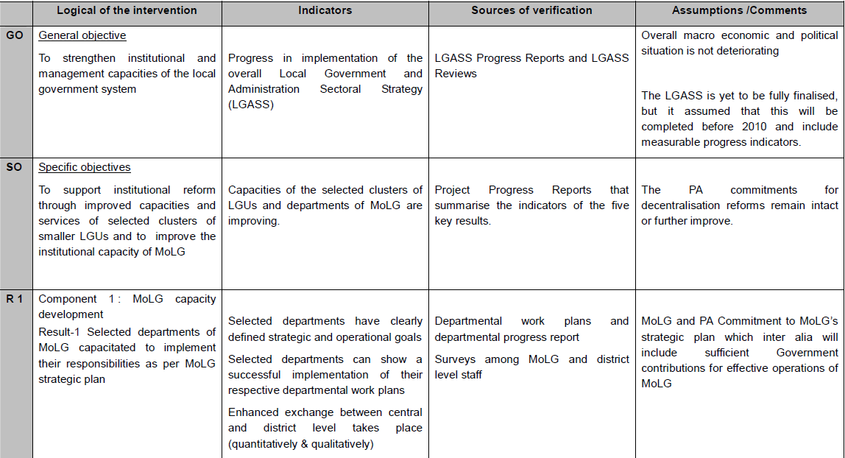
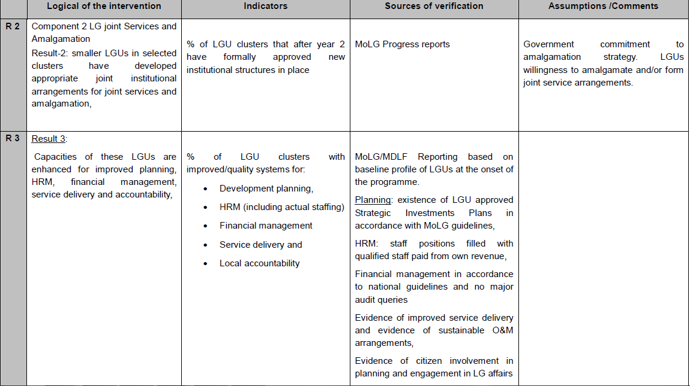

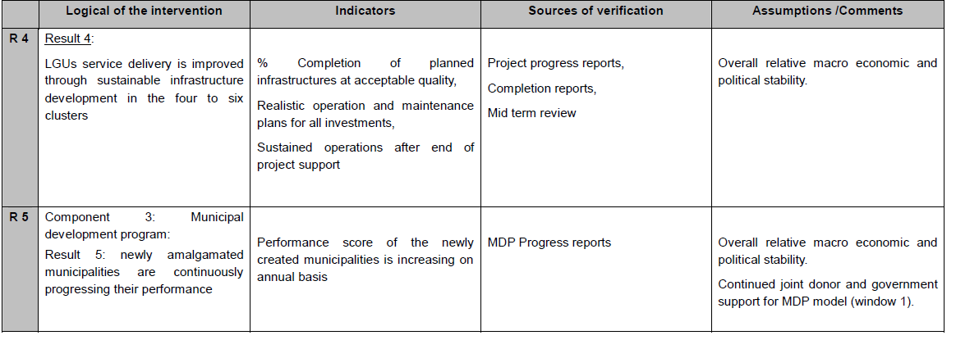

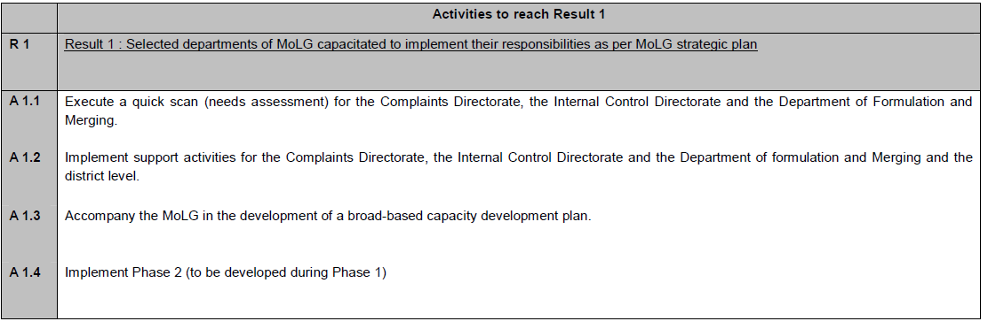
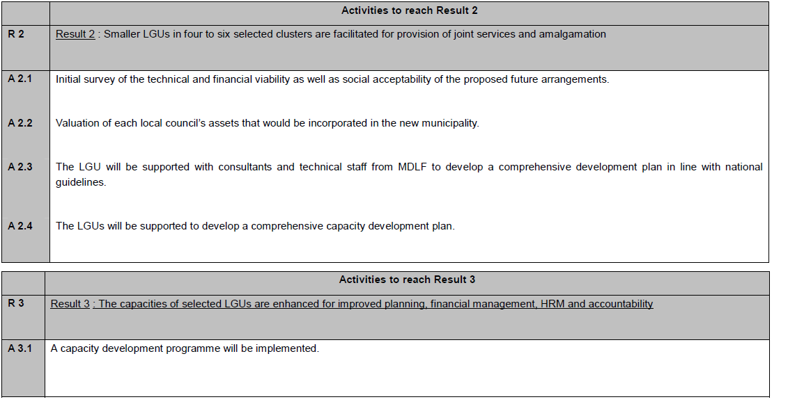
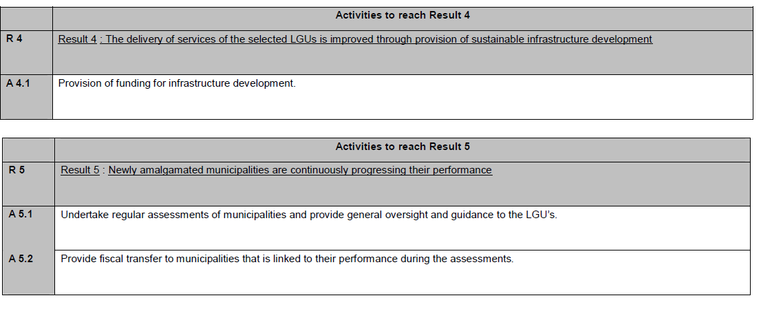

5.2 “Budget versus current (y – m)” Report
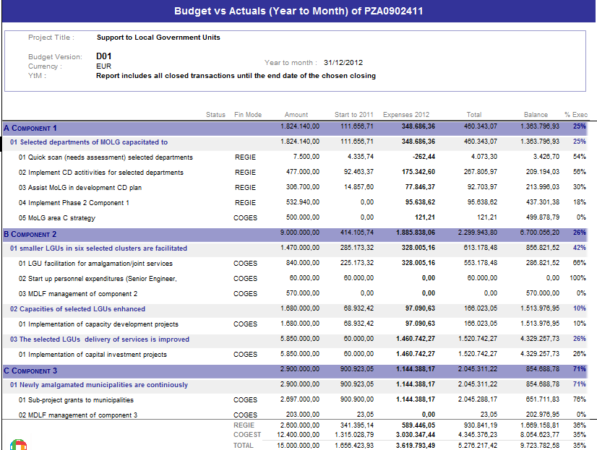
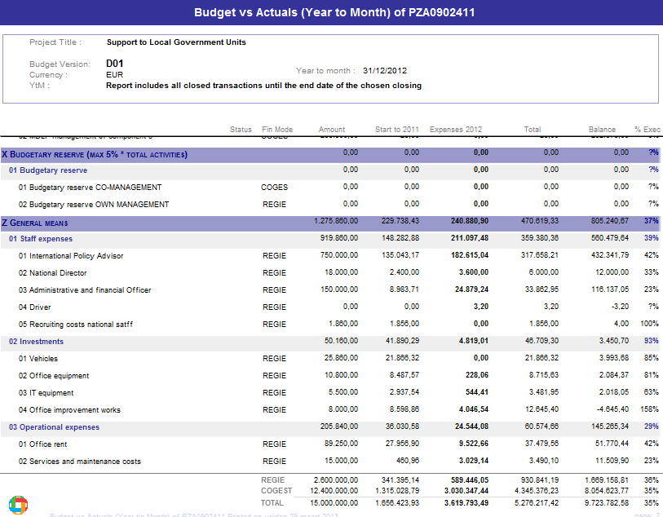

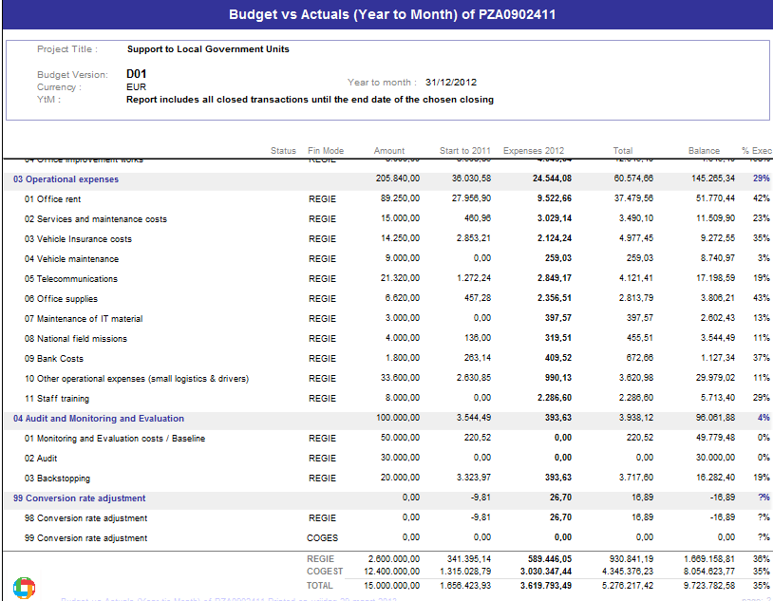

5.3 Decisions taken by the JLCB and follow-up

Decision to take |  |  |  |  | Action |  |  | Follow-up
Decision to take | Period of identification | Timing | Source | Actor | Action(s) | Resp. | Deadline | Progress | Status
Promotion of a strong coordination between Donors | March 2012 |  |  |  | LGRDP organized regular meetings with all donors supporting the MoLG |  |  | done
 |  |  |  |  | Some assesments are endorsed by all donors |  |  | Done – on-going
To complete the institutional framework of LGRDP (technical committees, MDLF support staff, role of the national coodinator | March 2012 |  |  |  | All TCs have been put in place and are operational |  |  | done
 |  |  |  |  | The role of the National coordinator has been clarified |  |  | done
 |  |  |  |  | MDLF must complete and improve the LGRDP support staff |  |  | On-going
 |  |  |  |  | An assessment will be done |  | Q3 2013
To better align LGRDP (component 3) to MDP system | Sept 2012

Impact is a synonym for global objective, Outcome is a synonym for specific objective, output is a synonym for result
Name and Signature
Name and Signature
In this document: Impact is a synonym for global objective, Outcome is a synonym for specific objective, output is a synonym for result
A: The activities are ahead of schedule B The activities are on schedule C The activities are delayed, corrective measures are required. D The activities are seriously delayed (more than 6 months). Substantial corrective measures are required.

