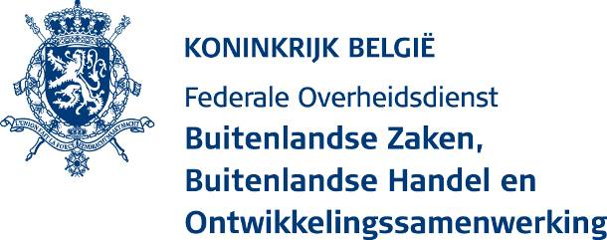
Humanitaire Hulp
Uw contactpersoon:
Alessia Veri
Tel: 02 501 41 12
E-mail: alessia.veri@diplobel.fed.be

Mevr. Tiene Lievens
Head of International Cooperation
Rode Kruis Vlaanderen

Motstraat 40
2800 MECHELEN
België

 |  | uw bericht van | uw kenmerk | ons kenmerk | datum
 |  | 07/04/2020 | 2019-02-REG-DGD | D5.1/AV/HUM.04.03.01.2019.06/4991/1
 |  |  |  | te vermelden in elke briefwisseling

Onderwerp: Request related to the current COVID-19 outbreak – Programme “Enhancing community resilience to epidemics and hydro-meteorological hazards in the African Great Lakes region” (Rwanda, Tanzanie, Uganda) – PG/2019/06

Dear Mrs Lievens,

I am pleased to let you know that I agree to your requests regarding the programme “Enhancing community resilience to epidemics and hydro-meteorological hazards in the African Great Lakes region”, as reported in your two letters 2019-02-REG-DGD dated 7 April 2020.

The first letter concerns the modification of the intervention zone as well as a modification of some activities and indicators of the logical framework, in Rwanda and Tanzania (not Uganda). This type of request is provided for in de ‘Bepalingen en Voorwaarden’ of the agreement that regulates the modalities of the intervention (point 2.7).

More precisely, you would like to adapt your response in Rwanda and Tanzania to the acute needs of preparedness and response due to the current Covid-19 Virus Outbreak. Your request is well documented, explaining the activities you intend to do and why some activities have to be left out because of the outbreak. We commend the RKV and its partners on the efforts to responding to this crisis.

You also requested to extend the window of the crisis modifier to address the needs related to the COVID-19 response, if necessary, in Tanzania. This is already possible for Rwanda thanks to the extension the DGD approved early this year, in response to the Ebola outbreak.

These changes in your programming incurs budgetary modifications as stated in your second letter. The adapted budget you have provided shows the clear changes in the budgetary lines.

Your letters sufficiently justify both of your requests for the points aforementioned.

This letter forms an addendum to the agreement, regulating the execution modalities of the above-mentioned programme, and constitutes an integral part of this agreement.

Best regards,
Bruno van der Pluijm
Directeur-generaal
Directie-generaal Ontwikkelingssamenwerking en Humanitaire hulp

