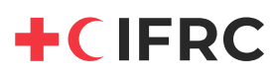
Funding proposal
IFRC Emergency Appeal MDR00005: COVID-19 outbreak
14 April 2020

Organization:
International Federation of Red Cross and Red Crescent Societies
Chemin des Crêts 17
1209 Geneva
Switzerland

Contact person:
Nienke Boskma
Senior Officer, Partnerships and Resource Development
Mob. +41 79 431 2442
Email: nienke.boskma@ifrc.org

Zone of operation:
Global

Name of the project:
IFRC Revised Emergency Appeal MDR00005: COVID-19 outbreak

Start date:
Date of signature of Ministerial Order.
Duration:
Until 31st March 2021 (current end date of the revised emergency appeal)
Extension possible to 18 months.

Amount requested:
EUR 5 million

Indirect costs and reporting costs:
Standard PSSR 6.5% + timeframe earmarking 1% = 7.5% = EUR 375 000
Final pledge based financial report: CHF 200 (~EUR 190)

Budget:
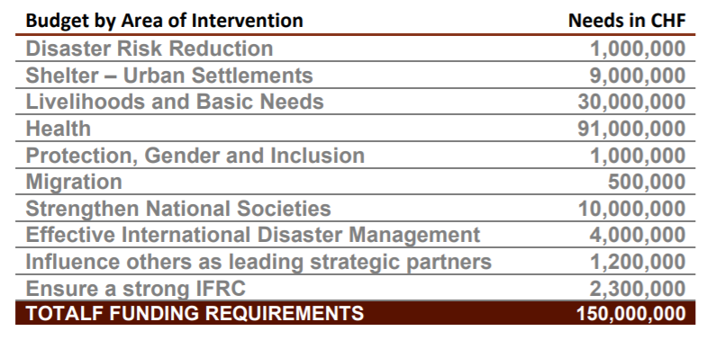

Bank details:
Bank name: UBS Switzerland AG
Bank address: Rue des Noirettes 35, 1227 Acacias, Geneva, Switzerland
Account name: International Federation of Red Cross and Red Crescent Societies
Beneficiary address: Chemin des Crêts 17, Petit-Saconnex, CH-1209 Geneva, Switzerland

EUR ACCOUNT: 240-C0573530.0
SWIFT: UBSWCHZH80A
IBAN: CH6200240240C05735300

