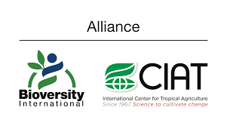

Safeguarding vegetatively propagated crop diversity to nourish people now and in the future: With Cost Extension
JAN 2021 – DEC 2021
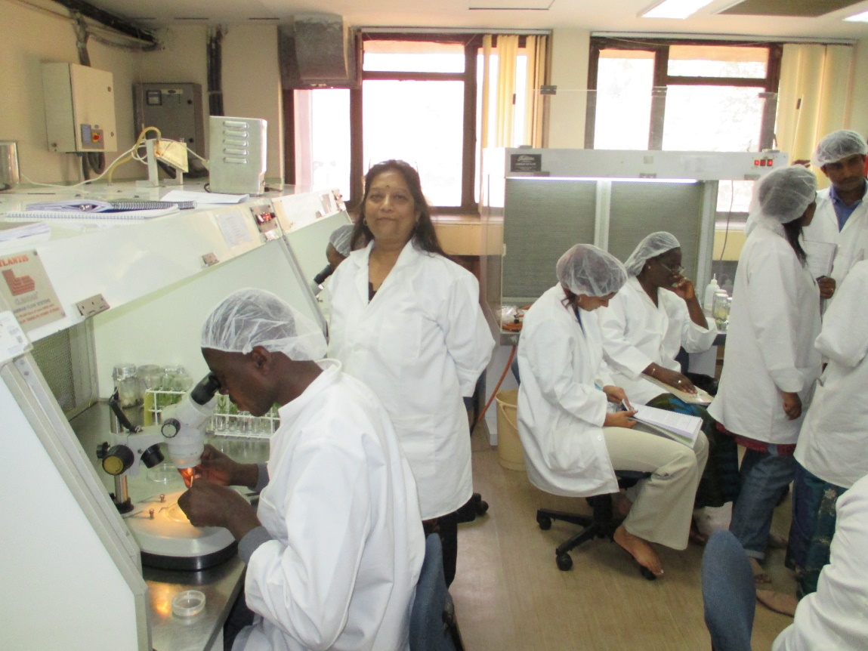
Training on Cryopreservation techniques at NBPGR (National Bureau for Plant Genetic Resources), Delhi, India :photo by Bart Panis, Bioversity International
Submitted by Bart Panis, Bioversity International
July 2020
- Background and problem statement
Crop genetic diversity is vital to ensure our current and future food security. Without it, farmers cannot adapt to climatic changes and make agriculture more productive, resilient and sustainable, and breeders cannot develop new and improved varieties that cope with new pests and diseases. Yet this diversity is increasingly under threat, especially now with climate change and fast-growing global population claiming more land for non-agricultural activities. Once a crop variety is lost, whether through man-made or natural disasters or through genetic erosion, it is lost forever. Indeed it is reported that one in five plant species is at risk of extinction.
This is why we need plant collections across the world. These collections are also threatened by lack of financial support and political unrest. We need therefore a global backup system for all our food crops in locations that are stable and supported by international law. The Global Seed Vault, in Svalbard, Norway, has the largest backup collection of crop seeds originating from the majority of countries around the world. However, vegetatively propagated crops such as Roots, Tubers, and Bananas (RTB), and other such crops cannot be conserved through seeds. These are currently conserved as collections of field plants or plantlets in test tubes – a relatively expensive, risky, and labour-intensive conservation method in the long term. The recent COVID-19 outbreak has proven how potentially vulnerable such in vitro collection is. When the technical staff that maintain such materials have no access to the laboratory for subculturing activities due to quarantine or lockdown measures, the biological material will degenerate and finally perish. For these crops, whose annual global production is estimated to be more than 1 billion tonnes and worth at least USD 100 billion, there is currently no global long-term backup collection. Hundreds of millions of people depend on these crops for their food, nutrition security and livelihoods. Root, tuber, banana and plantain crops alone provide such security to more than half a billion people in poverty.

- Preserving the genetic diversity of vegetatively propagated crops for eternity though cryopreservation
Storing plant material in liquid nitrogen at -196°C, known as cryopreservation, allows safe, long-term conservation of vegetatively propagated crops. The very low temperature stops all biological and physical processes, so the plant can remain unaltered for millennia and be regenerated when needed. Cryopreservation has been commonly used in medicine and the life sciences since the 1950s for long-term conservation of biological materials. The main hurdle associated with this storage method is the occurrence of lethal ice crystals at such low temperatures. All cryopreservation protocols are thus focussed on the crystal-free “freezing”.
Research on plant cryopreservation at KU Leuven (Universiteit Leuven) started in the late 1980s, and its pace accelerated when Bioversity International (“Bioversity” hereafter) joined forces. Today cryopreservation is applied extensively to back up the collection of banana varieties at the International Transit Centre hosted at KU Leuven. With around 1,600 banana samples called accessions, the International Transit Centre is the world's largest collection of banana germplasm diversity available for breeding, preservation, and other research uses. More than 1,100 of these accessions are currently stored in liquid nitrogen and additionally safely backed up in Montpellier, France, one thousand kilometres from Leuven.
KU Leuven and Bioversity are global leaders in cryopreservation, with more than 30 years of experience. Bioversity has developed procedures for the cryopreservation of 38 plant species including apple, banana, potato, and tomato (See Annex B). Some of these procedures are optimised while the others need to be reviewed and validated further. Moreover, no protocol has yet been developed for important species like cacao and most tropical fruits.
The Directie-Generaal Ontwikkelingssamenwerking en Humanitaire Hulp (DGD) funded project “Safeguarding vegetatively propagated crop diversity to nourish people now and in the future” ran from 2017 to 2020, where efficient cryopreservation protocols were established for sweet potato, coconuts, and yacon - an Andean vegetatively propagated root crop. These studies resulted in peer reviewed publications (Wilms et al, in press; Wilms et al. 2019, Hammond et al, submitted). What is more important still, is the foreseeable application of such methods in the longer-term conservation of these important crops.
The International Potato Center (CIP) maintains one of the world’s largest cultivated sweet potato gene banks with over 5,500 accessions kept in vitro. Our method will be shared with them in order to safely preserve this germplasm for future generations.
Over the past 30 years more than 150 researchers from 46 countries (See Figure 1) have been trained on plant cryopreservation techniques in Leuven. The duration of their training ranged from three days and one year, financed by different sources including the Fonds Wetenschappelijk Onderzoek (FWO), the World Bank, the European Union (EU), and the DGD. Many of these trainings have given rise to new technologies for specific crops and common publications and/or research projects (see Annex C). Some previous trainees are now also actively applying their skills and the techniques acquired in Leuven to their crop collections; examples are in the USA, Peru, Germany, New Zealand, India, China, and Norway. In the first phase of this project between Jan 2017 and June 2020 alone, 13 researchers from Nicaragua, Czech Republic, Slovak Republic, South Korea, Australia, Mexico, Thailand, Italy, Kazachstan, India, and Indonesia have received training in Leuven.
Public awareness on the possibilities of cryopreservation, however, needs to be raised.
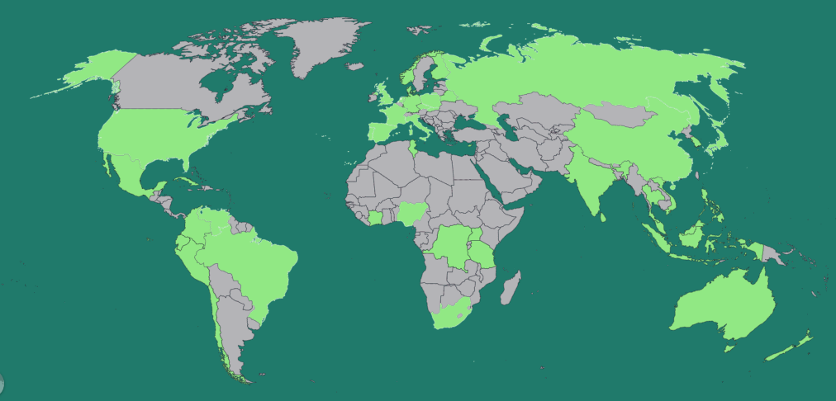
Figure 1: Overview of countries from which researchers already received training on cryopreservation in Leuven, Belgium.

- Developing a secure safety backup for cryopreserved genetic resources
The Global Seed Vault is a backup collection of almost every seed-bearing crop variety conserved in gene banks across the world. Genetic material of unique crops in the world is safeguarded here so that in the event of catastrophes, the material can be restored to compromised collections. Only recently, the Vault had to be opened earlier than expected; the civil war in Syria damaged the operations of an international gene bank in Aleppo, where precious varieties of wheat, barley, and grasses adapted to dry areas were conserved. Other events have compromised collections in Afghanistan, Iraq, the Philippines, and Samoa. This demonstrates the crucial mission to safely store and back up plant genetic resources. Without them, progress towards greater food and nutrition security would be seriously undermined.
The Global Seed Vault cannot conserve many of the crops that we consume every day, such as banana, potato, or apple, because these crops do not produce seeds. As a result, their seeds lack the right genetic makeup or cannot be stored easily. These are vegetatively propagated plants, reproduced through cuttings or suckers. To date, no global backup repository for vegetatively propagated crops has been established. Nor exists a validated set of protocols or the required capacity to prepare such material for long-term storage. Further, crops that do not reproduce through seeds have a narrower genetic base due to the fact that the new plants are genetically identical to their parents. This makes them more vulnerable to pests, diseases, and other risks, calling for an even more urgent effort to safeguard their diversity.
As a vital complement to the Global Seed Vault, Bioversity proposed establishing a backup cryopreservation facility for vegetatively propagated crops (see Annex A), for which a feasibility study was conducted (see https://www.bioversityinternational.org/e-library/publications/detail/feasibility-study-for-a-safety-back-up-cryopreservation-facility-independent-expert-report-july-20/). This study was organised by Bioversity, the Crop Trust, and the CIP, carried out by independent experts, and funded through the support of Australia, Germany, and Switzerland.
The study highlights precisely the advantages of cryopreservation for conservation of clonal/recalcitrant seed crop collections and recommends a substantive global effort to facilitate its universal implementation and to overcome major practical constraints. In addition, a safety backup is required to accommodate 5,000-10,000 accessions arising from on-going cryopreservation activities.

- Work plan for 2021
Building on Bioversity’s successes and expertise in using cryopreservation at the world’s largest banana collection housed in Leuven, the development of improved cryopreservation protocols and capacity will help safely store crops that cannot be conserved through seeds.
The proposed work is a one-year extension of the project executed in 2017-2020. The former project dealt with the development of storage protocols and more specifically cryopreservation protocols for plant genetic resources of vegetatively propagated crops. The emphasis therein was on the crops which provide food security in the Global South, such as sweet potato, cassava coconut, and taro. This next phase will focus on building associated cryopreservation capacity among partners in Africa, Asia, and South America, and progress our cryopreservation facilities in Leuven as a leading site for learning and a centre of excellence for cryopreservation.
During the first phase, activities were already undertaken to promote the cryopreservation facility at KU Leuven/Bioversity International as a backup facility for other institutes working in the field of cryopreservation. On 22 March 2019, the idea of the Cryovault attracted interest from the Belgian Government and was presented to the Bureau of International Treaty on Plant Genetic Resources for Food and Agriculture (ITPGRFA). As a next step, Belgium was to propose this concept at the “Eighth Session of the Governing Body of the International Treaty on Plant Genetic Resources for Food and Agriculture” held in Rome, 11-16 November 2019. Upon presentation of the proposal (see http://www.fao.org/3/ca6931en/ca6931en.pdf, and Annex 5 ), Belgium received favourable reception: “The GB welcomes Belgium’s proposal to host a global safety backup cryopreservation facility at the Catholic University of Leuven-Bioversity International Genebank to safeguard cryopreserved plant material for future generations; and requests the Secretariat to explore, with the government of Norway, other practical means to enhance the linkages between the ITPGRFA and the Svalbard Seed Vault.” (See http://enb.iisd.org/vol09/enb09740e.html?&utm_source=enb.iisd.org&utm_medium=feed&utm_content=2019-11-19&utm_campaign=RSS2.0.) In 2021 this initiative will continue to develop in collaboration with different partners.
In short, we will:
- provide cryo-storage facilities for selected vegetatively propagated crops of other institutes to be cryopreserved at the laboratory,
- improve protocols for cryopreserving selected crops where the protocols still need “tweaking”, with an emphasis on those providing food security in the Global South. The focus in 2021 will be on cassava, taro, and coconut.
- build capacity among partners in Africa, Asia, and South America in cryopreservation techniques through a Belgian Fellowship Program that brings visiting researchers for one to two months’ fellowships to Leuven. A minimum of six trainees will be trained in Leuven. Some were already planned for 2020 with their travels delayed due to the COVID-19 pandemic.
Trainees that have been contacted and have agreed to be trained in Leuven
- Dr. Olivia Damasco, Plant Cell and Tissue Laboratory, Institute of Plant Breeding, UP Los Banos, College, Laguna, The Philippines
- Ms. Ulamila Lutu, Research Technician, Centre for Pacific Crops and Trees (CePaCT), Pacific Community, Suva, Fiji
- Dr. Marcos Montero, Bioplant Centre, University of Ciego de Avila, Plant Breeding Laboratory, Cuba
- Dr. Janay Almeida dos Santos Serejo, Embrapa Mandioca e Fruticultura, Empresa Brasileira de Pesquisa Agropecuária (Embrapa), Cruz das Almas-BA, Brasil
- Dr. Aliou Ndiaye, Laboratoire de Biotechnologies Végétales, Faculté des Sciences & Techniques, Université Cheikh Anta DIOP de Dakar, Dakar-Fann – Senegal
- Dr. Vu Dang Toan (PhD), Plant Breeder, Plant Resources Center, VAAS, MARD, Southern An Khanh, An Khanh, Hoai Duc, Ha Noi, Vietnam
These scientists are all linked to or are working with crop collections, and they are all planning to apply cryopreservation for the safe preservation of their genetic resources.
In January 2021, the COVID-19 situation will be evaluated. If travelling of trainees to Belgium is still questionable; an online training course will be developed and proposed to a selected group of candidates. The list of trainees mentioned can eventually be enlarged to a group of 10 researchers. This training will include:
- Online presentations on the theoretical background of cryopreservation and on the state-of-the-art techniques; where are we, for which crops efficient cryopreservation protocols are already developed; cost associated with cryopreservation.. In the case where time zones do not allow timings suitable for everyone, two presentation moments will be organised.
- Practical courses on cryopreservation; these will be executed with 2 selected crop species, i.e. banana and sweet potato. In vitro plant materials to execute cryopreservation experiments will be established locally or send by the Leuven laboratory. On request a third species can be included. Experiments will be followed remotely (live) and results of the different researchers compared. Importantly, prior to the course, facilities need to be evaluated whether experimental work can take place in the best conditions; the presence of a laminar air flow bench, culture room, binocular microscopes, and a liquid nitrogen source are essential.
The aim of the proposed work is to progress our cryopreservation facilities in Leuven as a leading site for learning and a centre of excellence for cryopreservation, as a cryopreservation knowledge and training centre.
This technical and capacity-building work, along with harnessing the collective expertise of the CGIAR and partners, will effectively support the separately proposed cryo-storage facility for vegetatively propagated crops (See Annex A).

- Resources needed
Specific funding (100,000 Euro) will be required for the following:

Staffing
A part-time senior scientist and coordinator of the project (0.15 FTE) will oversee the experiments to develop cryopreservation protocols, to work through and reach agreements with collaborating institutes, to purchase equipment, to train external cryopreservation technicians and researchers, and to report on the activities.
A part-time project assistant (0.075 FTE) will help the senior scientist in reaching agreements with collaborating institutes, purchase equipment, organise trainings, and report on the activities.
A technician (0.5 FTE) will help the senior scientist in the further development of cryopreservation protocols. Additionally, the technician will be involved in commissioning the empty dry shippers vessels, processing the dry shippers’ consignments of cryopreserved materials, training, administration, and maintaining the storage rooms.
A PhD student (0.5 FTE, 0.5 FTE covered by other funds) will help the senior scientist in further development of cryopreservation protocols. Additionally, the PhD student will be involved in training.

Consumables
Consumables such as plasticware, plant tissue-culture media, plant growth regulators, cryo-tubes, liquid nitrogen, and safety materials are needed to perform cryopreservation.

Training/Cryopreservation Fellowships
Part of the capacity building will be implemented through a series of one- to two-month-long cryopreservation fellowships. At least 6 trainings are foreseen. These trainings will i) increase awareness of the possibilities of cryopreservation, and ii) train scientists and/or technical staff on already established cryopreservation protocols and the latest cryopreservation developments. The focus will be on training researchers from developing countries that are associated with existing collections of vegetatively propagated crops. Funds for this activity will be partially recovered from the previous project.

- Project outputs
- At least 6 researchers trained on the development of cryopreservation protocols for a crop species of their interest with focus on: (i) candidates from developing countries, and (ii) those crop species from which in vitro collections already exist.
- New cryopreservation protocols developed, optimised and published for at least 2 important crop species including cassava and taro.
- Cryopreserved materials accepted and stored in liquid nitrogen tanks at the ITC from those institutes that already execute cryopreservation.
- Increased worldwide awareness on the need of long-term preservation of crop genetic resources by means of scientific publications (CryoLetters, CryoBiology, Plant Cell tissue and Organ Culture), social media, popular media as well Twitter and Glo.be.

- Project Impact
Increased diversity of vegetatively propagated crops is conserved safely, in the long term for future generations, even in the face of unexpected circumstances such as the current COVID times. Moreover, each sample that is stored elsewhere will be backed up in addition at the cryo facility in Leuven.

- Achieving Sustainable Development Goals (SDGs) and System-Level Outcomes (SLOs) with the cryopreserved gene bank
CGIAR is a worldwide partnership addressing agricultural research for development of which Bioversity International is one of the fifteen Centres globally. Following the 2016 CGIAR governance reforms, the CGIAR System approved a plan to align the efforts of all stakeholders to proactively manage a necessary evolution and tackle the rising issues in the increasingly hostile environmental conditions. The key message is collaboration and partnership, between funders and CGIAR centres, among CGIAR centres intra-organisationally as well on regional, national, and international levels. As a result of the Strategy & Results Framework (SRF) 2016-2030, three System-Level Outcomes (SLOs) have been defined, namely 1) reduced poverty, 2) improved food and nutrition security, and 3) improved natural resources and ecosystem services. It is no coincidence that the key date of 2030 reconciliates with that of the global Sustainable Development Goals (SDGs) announced by the United Nations (UN) in 2015. CGIAR’s SLOs respond precisely to a number of the SDGs, and they share the common aim to end poverty and improve the world we live in by 2030. Most notably, CGIAR will focus on research priorities where it has demonstrated a proven track record of expertise. The work described in this proposal can in particular make major contribution with respect to SDG 1: no poverty, and SDG 2: zero hunger, and SLO 1) reduced poverty, and SLO 2) improved food and nutrition security, in addition to SDG 13: climate action and SDG 17: partnerships for the goals.
Currently billions of people – approximately one in ten of the world’s population – live in poverty, while almost 690 million people in the world – 8.9% of the world population – are acutely or chronically undernourished. Women and children remain especially disadvantaged and vulnerable. In addition, overexploitation has led an estimated 3.5 billion hectares (HA) land degraded and unproductive. On the other hand, it has been observed that CGIAR’s disbursements translate to benefits twice the costs, and even as high as 17 times when harvested over the lifetime of projects.
To prepare for the food and nutrition requirements of the growing world population under limited total supply and in harmony with the finite available resources, instead of unilaterally seeking to increase food output or to alter diet, for example, we must look at “sustainable intensification” and employ multiple strategies in all fronts. Agri-food system research, specifically climate-smart agriculture, is an effective investment to end poverty and hunger.
The Crop Trust together with CGIAR coordinates a Genebank Platform and brings together 11 gene banks containing 773, 112 accessions of crop collections. Unequivocally gene banks are the fundamental of biodiversity conservation. Maintaining and making crop and tree diversity available is crucial in achieving food and nutrition security and correlates immediately to SDG2: zero hunger and SLO 2) improved food and nutrition security. As the global climate changes, the crop diversity held in these gene banks is vital, more than ever, for developing varieties able to withstand unprecedented weather extremes and increased incidence of natural disasters. Materials in the gene banks have been used to develop improved varieties of crops that can grow faster, produce higher yields, use less water, and withstand pests, diseases, and climate extremes. When breeders and smallholders have access to this information, hunger and, subsequently, poverty can be reduced and eventually eradicated, thereby securing SDG1: no poverty and SLO 1) reduced poverty. The cryopreservation techniques and protocols developed by Bioversity partnered with KU Leuven can enhance the capacity to innovate and transform research outputs into practical outcomes. In comparison to field gene banks, the long-term secure method of cryopreservation for vegetatively propagated crops such as Roots, Tubers and Bananas (RTB), and other crops which cannot be conserved through seeds, is ever more pivotal.
In its Strategy and Results Framework (SRF), CGIAR’s call to unite and build coherent and integrated partnerships echoes the increasing international political convergence encouraged by the UN, in order to effectively meet the competing demands of global development. We live in an organic system on Planet Earth, where the impact of a single player’s action is felt by the rest of the world. Wildfires in the Amazon, Australia, or California emit significant quantities of CO2 with direct consequences to the global climate. Extreme weather conditions brought about by global warming have been observed in the form of heatwaves, drought, tropical cyclones, and flooding across different regions of the world. Leaders at the UN and WWF International have warned that pandemics such as the COVID-19 outbreak resulting in major social, financial and health destructions, are more likely under the current rampant destruction of the natural world. No one single person would be spared the effect of our joint activity. In other words, we must respond to UN’s plea as outlined by the SGOs and devise solutions collectively and globally. The partnership of Bioversity International Transit Centre and the Laboratory of Tropical Crop Improvements, Department of Biosystems at KU Leuven is an example of such collaboration, in essence echoing SDG 15: partnerships for the goals. Its prominent role can be further strengthened by consolidating and expanding the existing high-quality cryopreservation facility, not only as a secure, worldwide backup of vegetatively propagated crops, but also as an international knowledge centre of excellence in this field, to combat the climate crisis hence coupling with SDG 13: climate action. To ensure Belgium’s active position on the world stage, the continuing involvement of the Belgian government and support of Foreign Affairs of Belgium for this research are therefore as imperative as ever.

- Bioversity International and Belgium
Belgium’s interest in bananas goes back to the 19th and 20th centuries, when the many banana varieties present in the African colonies of Congo, Rwanda, and Burundi were observed and appreciated. Since then, the Belgian government has invested in collecting and researching in banana diversity. The port of Antwerp is the world’s biggest harbour for banana import and export. With an annual influx of 1.4 million tonnes, Belgium is the world’s second biggest importer of bananas after the US, and it is the second largest exporter after Ecuador. Moreover, banana handling in Belgium creates 1,500 high-value jobs.
Bioversity has been operating in Belgium for more than 35 years. In 1985, it established the International Transit Centre (ITC), hosted by the Katholieke Universiteit Leuven, which has grown into the largest collection of banana germplasm in the world thanks to the support of the Gatsby Foundation, the World Bank, the Global Crop Diversity Trust, and Belgian Development Cooperation.
In the decades since its establishment, the ITC has become the hub for the safe movement of banana germplasm anywhere in the world due to the implementation of a system for indexing its samples for the presence of viruses at Gembloux Agro-Bio Tech, University of Liege. Only samples that have been indexed as free of viruses are distributed.
More recently, arrangements have been made with the Botanical Garden of Meise in Belgium to be able to store wild banana seeds. Currently this project is still at the research level, nonetheless this strategically important seed gene bank will be established in due course.
Between 1985 and 2014 the ITC distributed over 17,000 samples to users in 109 countries worldwide. On average, 75% of the samples go to users in the main banana growing regions – Africa (27%), the Americas (25%), and Asia and Pacific (23%) with the remainder going to universities and research centres in Europe.
The Laboratory of Tropical Crop Improvement, Department of Biosystems at KU Leuven, Belgium, where the Bioversity International Transit Centre (ITC) is housed, has more than 30 years of experience with the development of plant cryopreservation protocols.

- ANNEXES
ANNEX A: The rationale for a cryopreservation facility for vegetatively-propagated crops
The Cryopreservation facility will offer a joint service as a global public good for providing:

A safe backup service for gene banks worldwide.
Thanks to the backup cryopreservation facility, a copy of crop samples conserved around the world will be safe. It will act as a complementary facility to the Svalbard Global Seed Vault for vegetatively propagated crops. With these two facilities, the majority of existing crop diversity – tens of thousands of species and varieties of all food crops and their wild relatives – will be preserved for present and future generations. Any material stored in the cryopreservation facility will remain the property of the institute from which it comes, and the deposit will follow relevant national and international law.

An international knowledge centre for plant cryopreservation research and a technical assistance facility for high-quality cryopreservation.
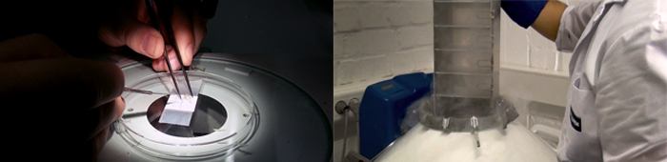
In view of Bioversity International’s and KU Leuven’s extensive experience in the field of cryopreservation, the backup cryopreservation facility will also act as a hub for training and capacity building. In strengthening the global crop cryopreservation capacity, the cryopreservation facility will help institutes around the world to cryopreserve their collections, establish cryopreservation protocols for their priority species, or receive training on different storage techniques.
Left: Preparation of banana samples for cryopreservation. Right: Banana samples are plunged in liquid nitrogen at the International Transit Centre in Leuven. Credit: Bioversity International/N. Capozio
A detailed training catalogue for the cryopreservation facility offering a variety of options for individuals and groups will be developed based on our established track record of providing such services. Furthermore, the Knowledge Centre will serve as a hub through which we work with researchers on complementary projects to develop cryopreservation protocols for a range of crops.
An ongoing independent feasibility study is currently examining the possibility of establishing such a cryopreservation facility and determining the best option for its location.

ANNEX B: List of plant species that have been successfully cryopreserved by KU Leuven/Bioversity International (and collaborating institution)

- Abies normannia (CRA, Gembloux, Belgium)
- Apple (Fruit Tree Research Institute, Italy)*
- Ash (CNR, Firenze, Italy)*
- Avocado (IFAPA, Malaga, Spain)*
- Azalea (ILVO, Belgium)
- Banana*
- Bituminaria (University of Valencia, Spain)
- Byrsonima intermedia (UFLA, Brazil)*
- Callerya speciosa (Institute of Tropical Crop Genetic Resources, Hainan, China)*
- Cassava (IITA, Nigeria; CIAT, Colombia)
- Chicory (CRA, Gembloux, Belgium)
- Coconut*
- Date Palm (Université de Sfax, Tunesia)*
- Dragon fruit
- Garcinia (NBPGR, India)
- Hop (University of Oviedo, Spain)*
- Lily (PRI, The Netherlands)
- Mitriostigma (Botanical Garden Meise)
- Narcissus (Daffodil) (University of Krakow, Poland)*
- Magnolia (Huntington Library, USA)*
- Olive (IFAPA, Malaga, Spain)*
- Passion fruit (UFLA, Brazil)*
- Pelargonium (INH, Angers, France)*
- Photinia (CNR, Firenze, Italy; Gebze, Turkey)
- Pinus nigra (Slovak Academy of Sciences)*
- Potato (CIP, Peru; Luxemburg; VIR, Russia)*
- Raspberry (Fruit Tree Research Institute, Italy)*
- Rose (University of Krakow, Poland)
- Snowdrop (University of Krakow, Poland)*
- Stevia*
- Strawberry (CRA, Gembloux, Belgium)
- Sweet potato (CIP, Peru)*
- Taro (SPC, Fiji)*
- Thyme (Univ Alicante, Spain)*
- Tomato (University of Valencia, Spain)
- Ulluco (CIP, Peru)
- Vitis (CNR, Palermo, Italy, PFR, Palmerston, NZ)*
- Yacon (CRI, Prague, Czech Replublic) *
+
* Collaboration that resulted in a publication in an international peer reviewed journal

ANNEX C: Articles related to cryopreservation and published by KU Leuven /Bioversity

- Hammond S., Viehmannova I., Zamecnik J., Panis B. and Faltus M. (submitted to Plant Cell Tissue and Organ Culture) Droplet-vitrification method for shoot tip cryopreservation of yacon [Smallanthus sonchifolius (Poepp. and Endl.) H. Rob.]: effects of PVS2 and PVS3 on survival and regrowth.
- Wilms H., Fanega Sleziak N., Van der Auweraer M., Brands M., Verleije M., Hardeman D., Andre E. and Panis B. (in press) Development of a fast and user-friendly cryopreservation protocol for sweet potato genetic resources. Scientific Reports
- Min-Rui Wang, Maurizio Lambardi, Florent Engelmann, Ranjith Pathirana, Bart Panis, Gayle M. Volk, Qiao-Chun Wang.(2020) Advances in cryopreservation of in vitro-derived propagules: technologies and explant sources. Plant Cell Tiss Organ Cult. https://doi.org/10.1007/s11240-020-01770-0
- Prudente, D. D. O., Paiva, R., Domiciano, D., de Souza, L. B., Carpentier, S., Swennen, R.,. Panis, B. (2019). The cryoprotectant PVS2 plays a crucial role in germinating Passiflora ligularis embryos after cryopreservation by influencing the mobilization of lipids and the antioxidant metabolism. JOURNAL OF PLANT PHYSIOLOGY, 239, 71-82. doi:10.1016/j.jplph.2019.05.014
- Panis, B. (2019). Sixty years of plant cryopreservation: From freezing Hardy mulberry twigs to establishing reference crop collections for future generations. In Acta Horticulturae Vol.1234 (pp. 1-8). doi:10.17660/ActaHortic.2019.1234.1
- Wilms, H., Rhee, J. H., Rivera, R. L., Longin, K., & Panis, B. (2019). Developing coconut cryopreservation protocols and establishing cryo-genebank at RDA; a collaborative project between RDA and Bioversity International. In Acta Horticulturae Vol.1234 (pp. 343-348). doi:10.17660/ActaHortic.2019.1234.45
- Folgado, R., & Panis, B. (2019). Cryopreservation of Ashe magnolia shoot-tips by droplet vitrification. In Acta Horticulturae Vol.1234 (pp. 233-240). doi: 10.17660/ActaHortic.2019.1234.31
- B Panis, R Swennen, J Rhee, N Roux (2016) Securing plant genetic resources for perpetuity through cryopreservation. Indian Journal of Plant Genetic Resources 29 (3), 300-302
- Carimi F., Carra A., Panis B., Pathirana R. (2016). Strategies for conservation of endangered wild grapevine (Vitis vinifera L. subsp. sylvestris (C.C. Gmel.) Hegi). Acta Horticulturae: Vol. 1115. XXIX IHC – Proc. IV Int. Symp. on Tropical Wines and Int. Symp. on Grape and Wine Production in Diverse Regions (pp. 81-86) International Society for Horticultural Science.
- Terezia Salaj, Radoslava Matusova, Rony Swennen, Bart Panis, Jan Salaj (2016) Tissue regeneration of Abies embryogenic cell lines after 1 year storage in liquid nitrogen. Biologia 71 (1), 93-99
- Malgorzata Maslanka, Bart Panis, Malgorzata Malik (2016) Cryopreservation of Narcissus L.'Carlton' somatic embryos by droplet vitrification. Propagation of Ornamental Plants 16 (1), 28-35
- Ranjith Pathirana, Andrew McLachlan, Duncan Hedderley, Bart Panis, Francesco Carimi (2016) Pre-treatment with salicylic acid improves plant regeneration after cryopreservation of grapevine (Vitis spp.) by droplet vitrification. Acta Physiologiae Plantarum 38 (1), 1-11
- Folgado, R., Panis, B., Sergeant, K., Renaut, J., Swennen, R., and Hausman, J.F. (2015). Unravelling the effect of sucrose and cold pretreatment on cryopreservation of potato through sugar analysis and proteomics. Cryobiology 71 (3), 432-441
- Gisbert C., Dabauza M., Correal E., Swennen R. and Panis B. (2015) Cryopreservation of Bituminaria bituminosa varieties and hybrids. Cryobiology 71 (2), 279-285
- Panta A. Panis B., Ynouye C., Swennen R., Roca W., Tay D. and Ellis, D. (2015) Improved cryopreservation method for the long-term conservation of the world potato germplasm collection. Plant Cell Tissue and Organ Culture 120: 117-125.
- Pathirana, R., McLachlan, A., Hedderley, D., Carra, A., Carimi, F., and Panis, B. (2015) Removal of leafroll viruses from infected grapevine plants by droplet vitrification. Acta Horticulturae, 1083, 491-498.
- Coutinho Silva L., Paiva R., Swennen R., André E. and Panis B. (2014) Cryopreservation of Byrsonima intermedia embryos followed by room temperature thawing. Acta Scientiarum, Agronomy 36:309-315.
- Panta A., Panis B., Ynouye C., Swennen R. and Roca W. (2014) Development of a PVS2 droplet vitrification method for potato cryopreservation. CryoLetters 35:255-266.
- Folgado R., Sergeant K., Renaut J., Swennen R., Hausman J.-F. and Panis B. (2014) Changes in sugar content and proteome of potato in response to cold and dehydration stress and their implications for cryopreservation. Journal of Proteomics 99-111.
- Coutinho Silva, L., Paiva, R., Swennen, R., Andre, E., Panis, B. (2013). Shoot-tips cryopreservation by droplet vitrification of Byrsonima intermedia A. juss.: a wooden tropical and medicinal plant species from Brazilian Cerrado. Cryo Letters, 34, 338-348.
- Folgado, R., Panis, B., Sergeant, K., Renaut, J., Swennen, R., Hausman, J. (2013). Differential protein expression in response to abiotic stress in two potato species: Solanum commersonii Dun and Solanum tuberosum L. International Journal of Molecular Sciences, 14, 4912-4933.
- Zhiying, L., Tengmin, L., Li, X., Panis, B. (2013). Crypreservation of Callerya speciosa (Champ.) Schot through droplet-vitrification. Propagation of Ornamental Plants, 13, 189-195.
- Tengmin, L., Li, X., Zhiying, L., Panis, B. (2013). Cryopreservation of Neottopteris nidus prothallus and green globular bodies by droplet vitrification. Cryo Letters, 34, 481-489.
- Maslanka, M., Panis, B., Bach, A. (2013). Cryopreservation of Galanthus elwesii Hook. apical meristems by droplet vitrification. Cryo Letters, 34(1), 1-9.
- Fki, L., Bouaziz, N., Chkir, O., Benjemaa-Masmoudi, R., Rival, A., Swennen, R., Drira, N., Panis, B. (2013). Cold hardening and sucrose treatment improve cryopreservation of date palm meristems. Biologia Plantarum, 57(2), 375-379.
- Salaj, T., Matusikova, I., Swennen, R., Panis, B., Salaj, J. (2012). Long-term maintenance of Pinus nigra embryogenic cultures through cryopreservation. Acta Physiologiae Plantarum, 34, 227-233.
- Fki, L., Bouaziz, N., Sahnoun, N., Swennen, R., Drira, N., Panis, B. (2011). Palm cryobanking. Cryo Letters, 32(6), 451-462.
- Condello, E., Caboni, E., Andre, E., Piette, B., Druart, P., Swennen, R., Panis, B. (2011). Cryopreservation of apple in vitro axillary buds using droplet-vitrification. Cryo Letters, 32(2), 175-185.
- Carpentier, S., Vertommen, A., Swennen, R., Witters, E., Fortes, C., Souza Junior, M., Panis, B. (2010). Sugar-mediated acclimation: the importance of sucrose metabolism in meristems. Journal of Proteome Research, 9(10), 5038-5046.
- Salaj, T., Matusikova, I., Panis, B., Swennen, R., Salaj, J. (2010). Recovery and characterisation of hybrid firs (Abies alba x A. cephalonica and Abies alba x A. numidica) embryogenic tissues after cryopreservation. Cryo Letters, 31, 206-217.
- Marco-Medina, A., Casas, J., Swennen, R., Panis, B. (2010). Cryopreservation of Thymus moroderi by droplet vitrification. Cryo Letters, 31(1), 14-23.
- Ozudogru, E., Capuana, M., Kaya, E., Panis, B., Lambardi, M. (2010). CRYOPRESERVATION OF Fraxinus excelsior L. EMBRYOGENIC CALLUS BY ONE-STEP FREEZING AND SLOW COOLING TECHNIQUES. Cryo Letters, 31(1), 63-75.
- Wang, Q., Panis, B., Engelmann, F., Lambardi, M., Valkonen, J. (2009). Cryotherapy of shoot tips: a technique for pathogen eradication to produce healthy planting materials and prepare healthy plant genetic resources for cryopreservation. Annals of applied biology, 154(3), 351-363.
- Sanchez-Romero, C., Swennen, R., Panis, B. (2009). Cryopreservation of olive embryogenic cultures. Cryo letters, 30(5), 359-372.
- Lambert, E., Goossens, A., Panis, B., Van Labeke, M., Geelen, D. (2009). Cryopreservation of hairy root cultures of Maesa lanceolata and Medicago truncatula. Plant cell tissue and organ culture, 96(3), 289-296.
- Sant, R., Panis, B., Taylor, M., Tyagi, A. (2008). Cryopreservation of shoot-tips by droplet vitrification applicable to all taro (Colocasia exculenta var. esculenta) accessions. Plant Cell Tissue and Organ Culture, 92, 107-111.
- Gallard, A., Panis, B., Dorion, N., Swennen, R., Grapin, A. (2008). Cryopreservation of Pelargonium apices by droplet-vitrification. Cryoletters, 29(3), 243-251.
- Elsen, A., Vallterra, S., Van Wauwe, T., Thuy, T., Swennen, R., De Waele, D., Panis, B. (2007). Cryopreservation of Radopholus similis, a tropical plant-parasitic nematode. Cryobiology, 55(2), 148-157.
- Salaj, T., Panis, B., Swennen, R., Salaj, J. (2007). Cryopreservation of embryogenic tissues of Pinus nigra Arn. by a slow freezing method. Cryoletters, 28(2), 69-76.
- Misson, J., Druart, P., Panis, B., Watillon, B. (2006). Contribution to the study of the maintenance of somatic embryos of Abies nordmanniana Lk: Culture media and cryopreservation method. Propagation of ornamental plants, 6(1), 17-23.
- Zhu, G., Geuns, J., Dussert, S., Swennen, R., Panis, B. (2006). Change in sugar, sterol and fatty acid composition in banana meristems caused by sucrose-induced acclimation and its effects on cryopreservation. Physiologia plantarum, 128(1), 80-94.
- Panis, B., Piette, B., Swennen, R. (2005). Droplet vitrification of apical meristems: a cryopreservation protocol applicable to all Musaceae. Plant science, 168(1), 45-55.
- Agrawal, A., Swennen, R., Panis, B. (2004). A comparision of four methods for cryopreservation of meristems in banana (Musa spp.). Cryoletters, 25(2), 101-110.
- Helliot, B., Swennen, R., Poumay, Y., Frison, E., Lepoivre, P., Panis, B. (2003). Ultrastructural changes associated with cryopreservation of banana (Musa spp.) highly proliferating meristems. Plant cell reports, 21(7), 690-698.
- Panis, B., Strosse, H., Van den Hende, S., Swennen, R. (2002). Sucrose preculture to simplify cryopreservation of banana meristem cultures. Cryoletters, 23(6), 375-384.
- Ramon, M., Geuns, J., Swennen, R., Panis, B. (2002). Polyamines and fatty acids in sucrose precultured banana meristems and correlation with survival rate after cryopreservation. Cryoletters, 23(6), 345-352.
- Helliot, B., Panis, B., Poumay, Y., Swennen, R., Lepoivre, P., Frison, E. (2002). Cryopreservation for the elimination of cucumber mosaic and banana streak viruses from banana (Musa spp.). Plant cell reports, 20(12), 1117-1122.
- Cote, F., Goue, O., Domergue, R., Panis, B., Jenny, C. (2000). In-field behavior of banana plants (Musa AA sp.) obtained after regeneration of cryopreserved embryogenic cell suspensions. Cryo-letters, 21(1), 19-24.
- Panis, B., Peeters, M., Swennen, R. (1997). Cryopreservation of banana and cotton: a tool for safe germplasm preservation. African Crop Science Journal, 3, 87-97.
- Panis, B., Totte, N., VanNimmen, K., Withers, L., Swennen, R. (1996). Cryopreservation of banana (Musa spp) meristem cultures after preculture on sucrose. Plant science, 121(1), 95-106.
- De Meulemeester, M., Panis, B., De Proft, M. (1992). Cryopreservation of in-vitro shoot tips of chicory (Cichorium-intybus L.). CryoLetters, 13, 165-174.
- Dhed'a, D., Dumortier, F., Panis, B., Vuylsteke, D., De Langhe, E. (1991). Plant regeneration in cell suspension cultures of the coocking banana cv. 'Bluggoe' (Musa spec. AAB group). Fruits, 46 (2), 125-135.
- Panis, B., Withers, L., De Langhe, E. (1990). Cryopreservation of Musa suspension cultures and subsequent regeneration of plants. CryoLetters, 11, 337-350.

See The State of the World’s Plants (2016) Kew Gardens, UK at www.stateoftheworldsplants.com
Estimate based on FAOSTAT 2012
See for example http://www.rtb.cgiar.org/background/
The state of food security abd nutrition in the world. (2020). Food and Agriculture of the United Nations: http://www.fao.org/3/ca9692en/online/ca9692en.html
M. Renkow, D. B. (2010). An aggregated ex-post benefit cost ratio of all CGIAR research investment, 17.26, 'Plausible, extrapolated to 2011' (figure 1). The impacts of CGIAR research: A review of recent evidence. Food Policy, DOI: 10. 1016/j.foodpol.2010.03.006.
H.C.J. Godfray, T. G. (2014). Food security and sustainable intensification. Philosophical Transactions of the Royal Society of London, 369(1639). https://pubmed.ncbi.nlm.nih.gov/?term=Godfray%20HC%5BAuthor%5D&cauthor=true&cauthor_uid=24535385
Popova, E. (2018). Special Issue on Agricultural Genebanks. Biopreservation and Biobanking, 325-326. http://doi.org/10.1089/bio.2018.29044.ejp
Andersen, I. (05/04/2020). COVID-19 is not a silver lining for the climate, says UN Environment chief. https://news.un.org/en/story/2020/04/1061082
M. Lambertini, E. M. (2020, 6 17). The Guardian Opinion. https://www.theguardian.com/commentisfree/2020/jun/17/coronavirus-warning-broken-relationship-nature

