POOLED FUNDING FOR DEVELOPMENT COOPERATION PROGRAMMES

Building Social Protection Floors for All
Support to the 2nd phase of the ILO Global Flagship Programme (2022 - 2025)
Social Protection Department / ILO Global Technical Team on Social Protection

 | Programme details
Country: | Global, regional and country-level support
Duration: | 48 months (16/12/2021 – 31/12/2025)
Funding partners: | Government of Belgium, Government of Luxembourg
Total programme budget: | 75 million USD
Resources available:
Belgium | 5.6 million EUR (5.98 million USD)
Luxembourg | 2.4 million EUR (2.73 million USD)
Budget needed: | 53 million USD

- Background and justification
As of 2020, only 46.9 per cent of the global population were effectively covered by at least one social protection benefit (Sustainable Development Goal (SDG) indicator 1.3.1), while the remaining 53.1 per cent – as many as 4.1 billion people – were left wholly unprotected. Behind this global average, there are significant inequalities across and within regions, with coverage rates in Europe and Central Asia (83.9 per cent) and the Americas (64.3 per cent) above the global average, while Asia and the Pacific (44.1 per cent), the Arab States (40.0 per cent) and Africa (17.4 per cent) have far more marked coverage gaps.

Access to healthcare, sickness and unemployment benefits has taken on particular relevance during the pandemic. While almost two thirds of the global population are protected by a health scheme of some kind, significant coverage and adequacy gaps remain. When it comes to income protection during sickness and unemployment, the coverage and adequacy gaps are even more pronounced. Approximately a third of working-age people have their income security protected by law in case of sickness, and less than a fifth of unemployed workers worldwide actually receive unemployment benefits.

Gaps in the coverage, comprehensiveness and adequacy of social protection systems are associated with significant underinvestment in social protection, particularly in Africa, the Arab States and Asia. Countries spend on average 12.9 per cent of their GDP on social protection (excluding health), but this figure masks staggering variations. High-income countries spend on average 16.4 per cent, or twice as much as upper-middle-income countries (which spend 8 per cent), six times as much as lower-middleincome countries (2.5 per cent), and 15 times as much as low-income countries (1.1 per cent).

This financing gap for building social protection floors has widened by approximately 30 per cent since the onset of the COVID-19 crisis, owing to the increased need for healthcare services, income security measures, and reductions in GDP caused by the crisis. To guarantee at least a basic level of social security through a nationally defined social protection floor, lower-middle-income countries would need to invest an additional US$362.9 billion and upper-middle-income countries a further US$750.8 billion per year, equivalent to 5.1 and 3.1 per cent of GDP respectively for the two groups. Low-income countries would need to invest an additional US$77.9 billion, equivalent to 15.9 per cent of their GDP.

COVID-19 threatens to imperil years of progress towards achieving the Sustainable Development Goals (SDGs), reversing gains in poverty reduction. It has also revealed the pre-existing stark protection gaps across all countries and made it impossible for policymakers to ignore the persistent social protection deficits experienced in particular by certain groups, such as informal workers, migrants and unpaid carers.

At the 109th Session of the International Labour Conference in June 2021, the tripartite constituents of the International Labour Organization (ILO) adopted a framework for action towards universal social protection that reaffirmed the primary responsibility of states in this regard, while also acknowledging the crucial importance of international solidarity with technical cooperation to support countries with more limited economic means. The ILO constituents also adopted a Global call to action for a human-centred recovery from the COVID-19 crisis that is inclusive, sustainable and resilient, with universal social protection at its centre.

Following extensive consultations with implementing and development partners, the 2nd phase of the Flagship Programme on Building Social Protection Floors for All has been developed to contribute to the implementation of the conclusions of the International Labour Conference., The Programme will support Member States in achieving universal social protection by supporting the development of universal, comprehensive, adequate social protection systems that are sustainable and adapted to today’s world of work and the challenges ahead. It will help Member States to emerge from the crisis and build a more just, inclusive and sustainable world, in which social protection is a reality for all.

This multi-donor programme supports the implementation of the 2nd phase of the Flagship Programme. It supports specific country and thematic outcomes and outputs as identified in table 6 and as specified in the country and thematic annexes. The multi-donor programme is aligned with the vision, value proposition and theory of change of the Flagship Programme. Its monitoring and evaluation will be an integral part of the monitoring and evaluation of the Flagship Programme.

ILO mandate: Universal social protection for All

The backbone of ILO’s work
In line with the Declaration of Philadelphia (1944), the Flagship Programme on Building Social Protection Floors for All supports Member States in extending national social security measures in order to ensure a basic income for all those who need such protection, as well as comprehensive medical care for all. The Universal Declaration of Human Rights (1948), the International Covenant on Economic, Social and Cultural Rights (1966), the Convention on the Elimination of All Forms of Discrimination against Women (1979), the Convention on the Rights of the Child (1989) and the Convention on the Rights of Persons with Disabilities (2006) define the human right to social security and social protection, which is complemented and concretized by the international social security standards.

To support the implementation of the human right to social security, the Flagship Programme promotes the ratification and application of the ILO’s up-to-date social security standards – Conventions and Recommendations – that have been adopted by ILO Member States and cover all areas of social protection.
In particular, these include the Social Security (Minimum Standards) Convention, 1952 (No. 102), which established the minimum standard for social security and first defined social security in a systemic manner, with reference to the risks that should be protected, and established the core principles of governance and financing and the minimum benchmarks to be met by benefits in terms of eligibility conditions, level and duration. More advanced thematic standards were subsequently adopted, building on the principles of Convention No.102 but setting higher benchmarks and requirements as compared to the minimum standard.

The Social Protection Floors Recommendation, 2002 (No. 202) also represents a key reference. This standard articulates the ILO’s vision on how to implement the human right to social security; lists the principles based on which universal social protection systems should be built; and calls on countries to develop concrete policies and national strategies to this effect, prioritizing the establishment of social protection floors to ensure at a minimum that all those in need have access to essential health care and basic income security over the life cycle and that higher levels of protection are provided to as many people as possible, as soon as possible.

National social protection floors should cover at least all residents and children and should comprise at least four basic social security guarantees:
- access to a nationally defined set of goods and services, constituting essential health care, including maternity care, that meets the criteria of availability, accessibility, acceptability and quality;
- basic income security for children, at least at a nationally defined minimum level, that provides access to nutrition, education, care and any other necessary goods and services;
- basic income security, at least at a nationally defined minimum level, for persons in active age who are unable to earn sufficient income, in particular in cases of sickness, unemployment, maternity and disability; and
- basic income security, at least at a nationally defined minimum level, for older persons.

Countries should guarantee a social protection floor to all as a fundamental element of their national social protection systems. Importantly, these are “floors” or first building blocks and not a “ceiling”. Countries should not stop at the “floor level” but should instead progressively develop national social protection systems that provide higher levels of protection for a comprehensive range of life-cycle risks to all. By pursuing this two- dimensional extension strategy, countries will progressively achieve universal social protection, which is not only about covering the entire population of a country but also about the scope, level and sustainability of protection, in line with Convention No. 102 and Recommendation No. 202.

The principles and minimum benchmarks for social protection systems established in ILO social security standards provide a unique framework to ensure that social protection schemes follow a rights-based approach; express solidarity across population groups; aim to leave no one behind; are based on social dialogue; and adhere to universal coverage and non-discrimination. Recommendation No. 202 (Para. 3 (a)–®) establishes 18 guiding principles for which states should assume the overall and primary responsibility in the policy design, financing and implementation of their national social protection systems.

Based on the principle of coherence across social, economic and employment policies, support provided through the Flagship Programme will also be guided by ILO Conventions and Recommendations related to those other policy areas, especially the Transition from the Informal to the Formal Economy Recommendation, 2015 (No. 204) and the Employment and Decent Work for Peace and Resilience Recommendation, 2017 (No. 205).

A framework for action
At its 109th session in 2021, the International Labour Conference held a recurrent discussion that highlighted in its conclusions the urgency to establish universal social protection systems that are adapted to the developments in the world of work and are resilient, effective, inclusive, adequate and sustainable.
To live up to the commitment of the 2030 Agenda for Sustainable Development to leave no one behind, social protection systems must provide social protection for all and take into consideration the specific needs of women, as well as people living with disabilities and other vulnerable groups, including migrants and refugees. The discussions and conclusions also highlighted in particular the need to expand social protection to workers in the informal economy in order to facilitate their transition to formal employment. Social protection further plays a key role in mitigating the effects of climate change and facilitating a just transition. Finally, the conclusions reaffirmed the primary role of the state and the need for solidarity in the financing of sustainable systems.
The conclusions identify three areas for action by the ILO and its Member States. The first area focuses on measures to promote universal social protection and calls on the Member States, supported by the ILO:
- to realize, through strong social dialogue, universal social protection, which provides comprehensive, adequate and sustainable protection for all, over the life cycle;
- to strengthen social protection systems under the primary responsibility of the state; and
- to provide sustainable and adequate financing for social protection systems with due regard to equity and social justice.
The second area focuses on mobilizing ILO means of action and specifically requests the ILO:
- to support Member States in the formulation and implementation of national social protection policies and strategies, with a specific focus on crisis-resilient social protection, coherence and coordination with other socio-economic policies, as well as on support for a just transition;
- to support research and capacity-building to expand the evidence base on universal social protection, its adequacy, sustainability and impact. This will further contribute to the monitoring of SDG targets related to social protection;
- to support effective planning and resource mobilization and allocation; and
- to implement effective standard-related action, including the launch of a campaign to ratify Convention No. 102 and the assessment of the impact of international social security standards in national policymaking and multilateral partners’ activities.
The third area reaffirms the ILO’s mandate and leadership in social protection in the multilateral system and promotes policy coherence. This includes the ILO taking an active steering role in global partnerships such as the Social Protection Inter-Agency Cooperation Board (SPIAC-B) and the Global Partnership for Universal Social Protection to Achieve the Sustainable Development Goals (USP2030). The ILO should also strengthen its engagement with international financial institutions (IFIs) with a view to promoting the inclusion of ILO standards and international principles in their social protection-related policies and in-country programmes. The ILO should also support domestic resources mobilization efforts by countries with limited fiscal space or facing economic crisis, through technical assistance as well as through the mobilization of complementary international financing for social protection. Finally, the ILO should explore the possibility of introducing an International Social Protection Day.
Complementary to the Conclusions concerning the second recurrent discussion on social protection (social security) adopted by the International Labour Conference at its 109th Session in 2021, the Conference also adopted a Global call to action for a human-centred recovery from the COVID-19 crisis that is inclusive, sustainable and resilient, in which Member States committed to achieving universal access to comprehensive, adequate and sustainable social protection.
The Flagship Programme in its second phase will support the implementation of the conclusions of the discussion on social protection (social security) and the Global call to action for a human-centred recovery (see subsequent section on the Strategy). More specifically:
- Universal social protection. The Flagship Programme will contribute to the progressive achievement of universal social protection in 50 pre-identified countries and strengthen national social protection systems, including through inclusive social dialogue and more sustainable and adequate financing.
- ILO means of action. The Flagship Programme will contribute to mobilizing development cooperation resources in order to provide technical assistance to ILO Member States and will promote and explore the linkages between social protection and other policies (for example climate, macroeconomic, active labour market, formalization policies). Through the support it provides to countries, the Flagship Programme will build Member States’ statistical capacities for social protection and support the organization of a ratification campaign for the ILO standards related to social security.
- Leadership and policy coherence in the multilateral system. The Flagship Programme will also reinforce collaboration with the UN system through country, regional and global partnerships, as well as by further promoting international social security standards in UN strategies, partnerships and programmes. The Flagship Programme will ensure that the technical assistance it provides can support more and better investments in social protection. It will also engage with IFIs, the European Union (EU) and other financial assistance partners to increase or secure fiscal space for social protection and promote the use of ILO standards and international principles on social protection in the design and implementation of their budget supports and programmes. It will further contribute to the exploration of feasible international financial assistance mechanisms (e.g. a Global Social Protection Fund) in order to complement and support, at least temporarily, countries’ efforts in mobilizing domestic resources for social protection.

- The programme

Vision
Realizing the human right to social security for all. Our vision is of a world in which all countries have national social protection systems that provide comprehensive and adequate social protection to all their populations throughout their lives, prevent poverty, reduce inequality and combat social exclusion. This includes providing access to health care, family allowances, unemployment benefits, old age and disability pensions and maternity benefits, among others, working in tandem with services, including child, health and long-term care services. Universal social protection should be inclusive of all ages and categories of the population – rural and urban, women and men, persons with disabilities, migrants and refugees – and should prioritize protection mechanisms that enable the transition of workers to the formal economy. This may require specific and adapted approaches to reach those still excluded from national social protection systems.

Robust social protection systems: A cornerstone of economies and societies that are fit for the future. Our vision is of a world in which national social protection systems are not temporary arrangements – created in response to periodic shocks or crises – but robust, reliable and sustainable mechanisms. They should be built prior to crises, should be based on a national consensus achieved through inclusive social dialogue and should aim to secure protection throughout the life cycle. They should be the main responsibility of the state and be embedded in law in order to provide rights and obligations for current and future generations. They should be adequately and sustainably financed, with policymakers, workers and employers organizations committing to closing financing gaps for social protection through domestic resources mobilization, with the backing of key financial institutions and complemented by additional international financing for social protection, when needed. They should be administered in a sound manner, based on the principles of transparent and accountable management and tripartite governance. They should include in their design, financing and administration their capacity to face systemic changes, such as demographic change, as well as covariate shocks and crises. Through coherence with employment, climate and macroeconomic policies, they should facilitate transformations in the economy and society and just transitions to a socially and environmentally respectful economy.

Value proposition
Universal social protection is part of the ILO mandate and was reconfirmed as a key priority of its work at the 109th Session of the International Labour Conference.
The Flagship Programme on Building Social Protection Floors for All responds to the demand of 100 Member States that have requested ILO support in the area of social protection. Policy and technical support are based on the international social security standards, which provide common guidance to countries in shaping their national social protection systems, following a rights-based approach and using inclusive social dialogue throughout the process.
Inclusive social dialogue and consultation with other relevant and representative organizations of persons concerned are essential for social protection systems to be responsive to specific needs; to respect the rights and dignity of beneficiaries; and to increase the social acceptance of policy decisions and ownership and the trust in these decisions and public institutions, as well as compliance in their implementation. Through a reactivated Global Business Network for Social Protection Floors and the Social Protection, Freedom and Justice for Workers Network, the Flagship Programme aims to increase the voice of workers’ and employers’ organizations in social protection policy debates.
The ILO provides support in building social protection systems from A to Z, using its diverse expertise and experience in policy design; the application of international social security standards; the development of laws; the costing and financing policies and programmes; financial and administrative governance; monitoring and evaluation; and building a culture of social protection.
The scope of the ILO’s expertise includes all branches of social security (from health care to pensions, unemployment and maternity) to ensure that national social protection systems can respond to the needs of people across the life cycle. The ILO helps Member States to establish – through social dialogue – concrete policy as well as legal, administrative, operational and financial solutions that leave no one behind; are adapted to national contexts; and include all workers, including workers in the informal economy and all forms of work, migrants and refugees, persons with disabilities and others. It also ensures that social protection policies and programmes are gender-sensitive and disability-inclusive.
The ILO’s technical and policy support relies on decades of experience, technical expertise and good practices documented through guides and quantitative models as well as the sharing of country experiences. Through recurrent discussions with its constituents and daily work in countries, the ILO adapts its approaches to the changing world of work and ensures that social protection systems are responsive to new and emerging challenges. It also makes use of new technologies in order to standardize and disseminate widely its approaches, such as the actuarial models that are today available online for a broad range of users.
The ILO’s Decent Work Agenda links social protection to other areas of the world of work (for example employment, including active labour market policies, the formalization of micro and small enterprises, social dialogue, labour migrations, minimum wages, just transition and so on), which is key to make social protection more relevant (as an enabler of other policy changes) and sustainable (as it can benefit from these changes as well). At country level, the Decent Work Agenda is translated into Member State-owned decent work country programmes that propose such integrated strategies to respond to national priorities and are designed and implemented through social dialogue.
The ILO’s field presence in the area of social protection has increased in the past five years, through the rapidly developed GTT. This allows the provision of a more timely response to ILO constituents’ needs, coupled with additional specialized expertise provided by regional specialists and experts at headquarters. It also increases the ILO’s presence in UN country teams and its contribution to One UN work on social protection.
The Flagship Programme supports primarily ILO constituents – governments and employers’ and workers’ representatives – and brings together a large number of other key actors, such as development partners, academia, businesses and civil society. It offers a platform for South–South learning and collaboration that can inspire countries and development partners and share solutions on specific aspects of policy design and implementation.
The ILO’s leadership in global networks on social protection (such as the SPIAC-B and USP2030) and strategic partnerships with specific agencies (for example partnerships with the EU, the World Bank, the International Monetary Fund (IMF) and the UN system) increases the political support for social protection and creates a better understanding of the ILO’s vision that is reflected in inter-agency tools and joint country support.
The ILO Flagship Programme provides space for the ILO to engage and work with development partners to support the shared ambition of universal social protection, while focusing their support on specific countries or thematic areas in line with their own priorities. Through their contribution to the Flagship Programme and synergies across projects, development partners help achieve much wider and sustainable changes than through stand-alone projects.

Figure 1: ILO’s value proposition
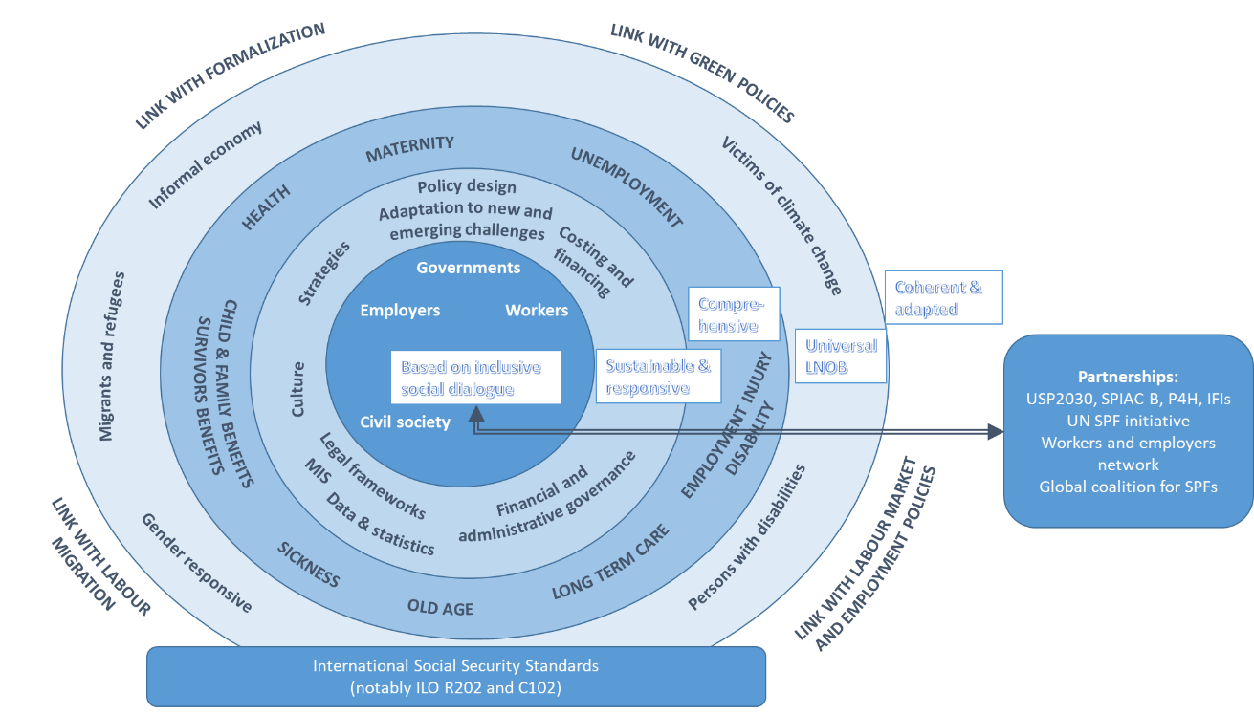

Based on inclusive social dialogue and the application of international social security standards, the Flagship Programme supports Member States in building national social protection systems that are sustainable and adapted to new and emerging challenges, are universal and leave no one behind, are comprehensive across the life cycle and are coherent with other policies. Through partnerships, the Flagship Programme increases ownership for universal social protection and the application of international social security standards.

Ambition: from results to impact

Institutional changes
The ambition of the Flagship Programme in its second phase is to achieve institutional changes in all 50 focus countries by 2025 and more specifically to achieve:
- step 1 in 10 countries;
- step 2 in 30 countries; and
- step 3 in 40 countries.

Table 1: Institutional changes achieved during the first phase of the Flagship Programme and ambitioned in the second phase
 | First phase (2016–2020):  21 focus countries |  | Second phase (2021–2025):  50 focus countries
 | Ambition | Achievement | Ambition based on country plans
Step 1. Strategy adopted | 21 | 10 | 10
Step 2. Scheme design/law | 14 | 13 | 30
Step 3. Improving operations | 7 | 16 | 40
Source: ILO, “Results Monitoring Tool” and country strategies.

Figure 1: Institutional changes achieved during the first phase of the Flagship Programme and ambitioned in the second phase
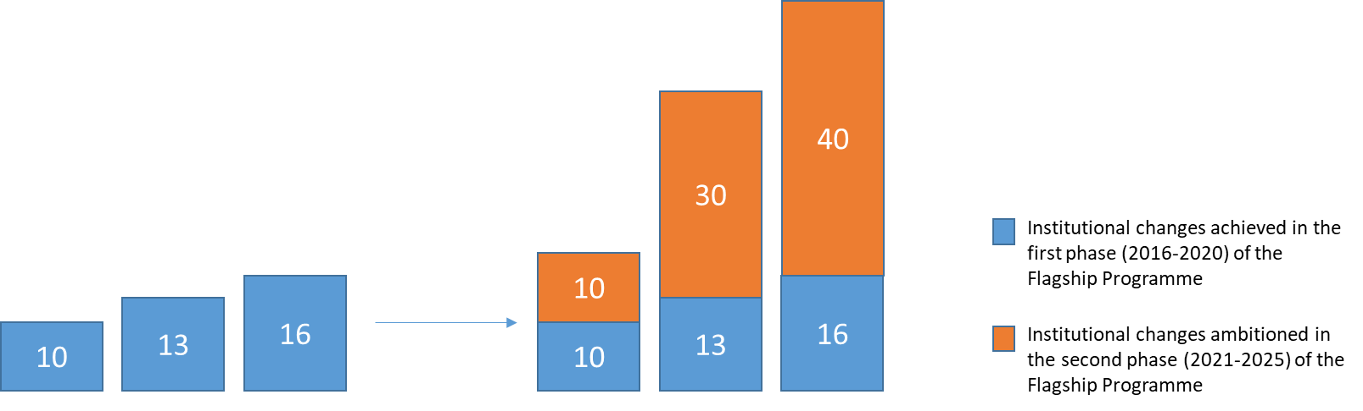
Source: ILO, “Results Monitoring Tool” and country strategies.

Impact on people
The ambition of the Flagship Programme in its second phase is to contribute to :
- increase legal coverage for an additional 20 million people;
- increase effective coverage for an additional 30 million people; and
- improve protection for an additional 10 million people (people will be covered for a wider range of risks and/or have higher levels of benefits).

Table 2: Impact on people (legal and effective coverage) achieved during the first phase of the Flagship Programme (based on a sample of 10 reporting countries/territories) and ambitioned in the second phase
 | First phase (2016–2020):  21 focus countries | Second phase (2021–2025):  50 focus countries
 | Achievements in 10 reporting countries | Ambition based on country plans
Legal coverage | 11.6 million people | 20 million people
Effective coverage | 10.9 million people | 30 million people
More comprehensive and adequate social protection | 2.6 million people | 10 million people
Source: ILO, “Results Monitoring Tool” and country strategies.

Figure 2: Impact on people (legal and effective coverage) achieved during the first phase of the Flagship Programme (based on a sample of 10 reporting countries/territories) and ambitioned in the second phase
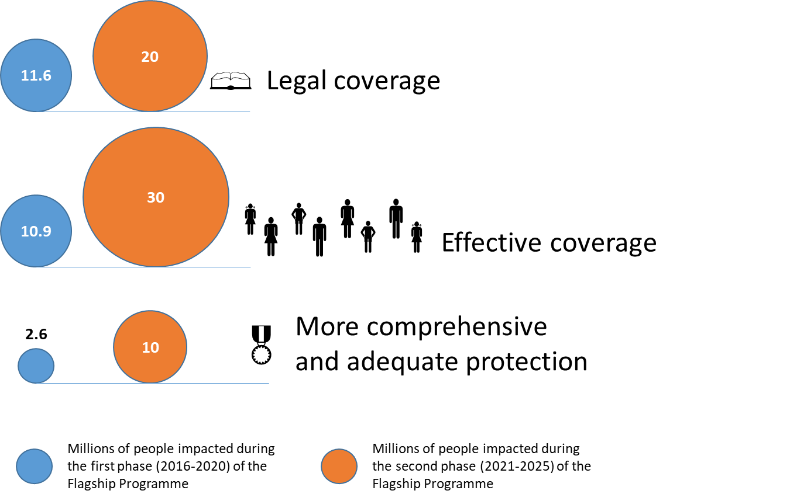

This will contribute to achieving the SDGs on social protection, notably SDG targets 1.3 and 3.8, and the goal set by the UN Secretary-General, in launching the Global Accelerator for Jobs and Social Protection on 28 September 2021, to lift 146 million people out of poverty by 2030 as a result of investments in governance, social protection, the green economy and digitalization.

Theory of change
The first phase of the Flagship Programme on Building Social Protection Floors for All laid the foundations for the development of robust social protection systems in 21 priority countries through concrete institutional changes leading to impacts on people. The second phase builds on these achievements.
The theory of change of the Programme is illustrated in figure 2.
Figure 2: Theory of change of ILO Flagship Programme
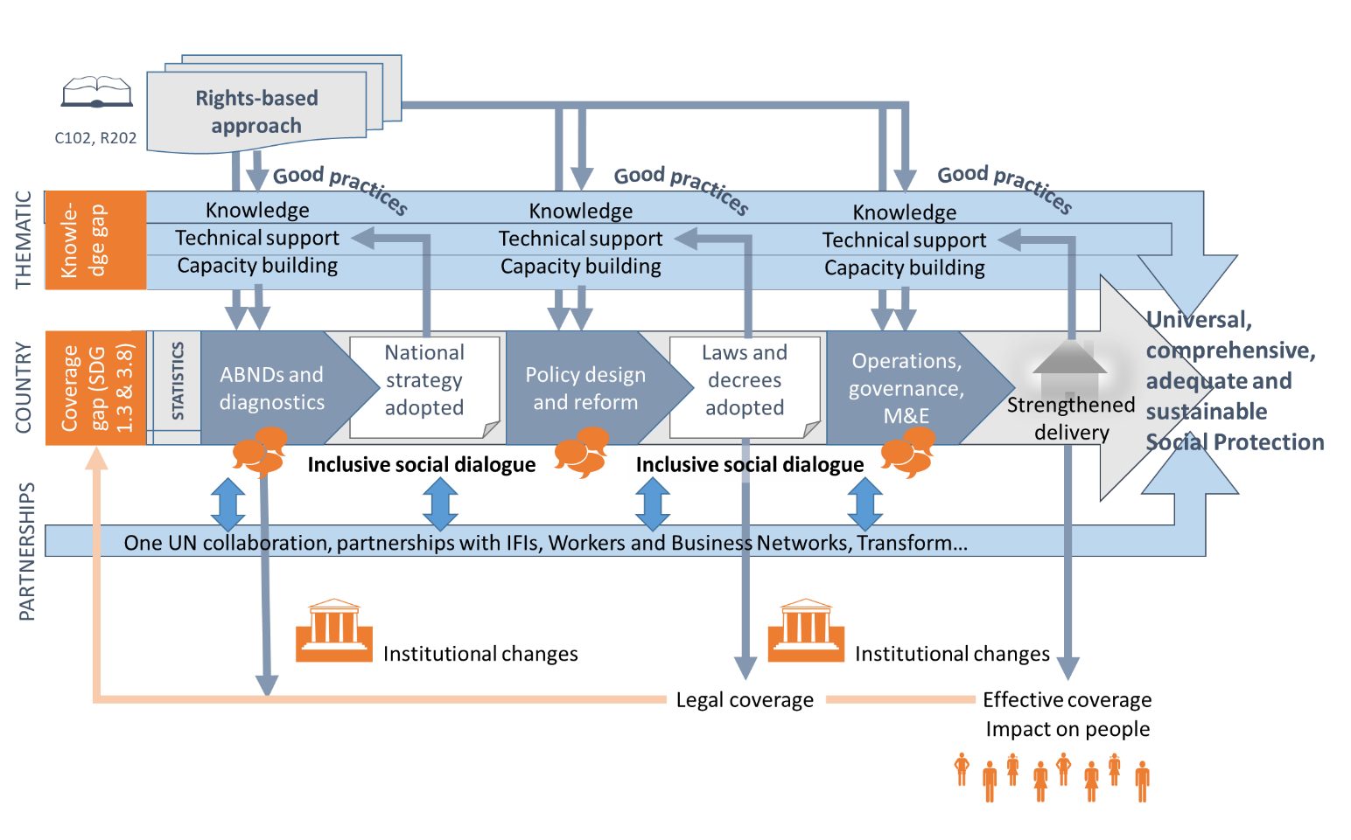

PILLAR 1: A THREE-STEP APPROACH AT COUNTRY LEVEL
Expected outcome: Universal access to comprehensive, adequate and sustainable social protection systems that are gender-responsive, disability-inclusive and adapted to developments in the world of work in 50 countries
The Flagship Programme supports the implementation and strengthening of rights-based, country-specific, robust, resilient and universal social protection systems in 50 countries (see table 1) through a step-by-step approach which is flexible enough to respond to country situations and needs for support; this step-by-step approach is not necessarily chronological and linear, as several steps may be carried out in parallel. Country teams respond to constituents’ needs and adjust and engage in partnerships for social protection at country level.
International social security standards. The ILO support will follow a rights-based approach anchored in human rights and promote the ratification and application of relevant ILO Conventions and Recommendations, in particular Convention No. 102 and the more advanced standards, as well as Recommendation No. 202 across the three steps.
Data and statistics. The social protection situation (baseline) is assessed based on national statistics of coverage and expenditure. Assessing this baseline is crucial to inform national social dialogues on policy priorities. Progress made in the implementation of social protection systems will also be measured against this baseline. Data collection and compilation uses the ILO’s Social Security Inquiry and the World Social Protection Database. National statistical capacities are increased to ensure up-to-date and accurate measurements of the national social protection situation and allow each country to monitor progress towards universal social protection and inform its policy reforms.
Step 1. Adopting a national social protection strategy. Through relevant monitoring, diagnostic studies and a participatory assessment-based national dialogue (ABND), the ILO supports the development of a long-term vision for social protection. This process involves a whole-of-government approach, including social security institutions, and a broad national dialogue with workers and employers’ representatives and other stakeholders, supported by relevant United Nations agencies, civil society organizations, IFIs and other development partners. It uses ILO social security standards, in particular Recommendation No. 202, which provides a framework against which countries can assess their national systems and prioritize action. National counterparts identify policy options to close social protection gaps and their cost is estimated and projected over time. A fiscal space analysis helps identify financing options for newly proposed programmes or adjustments to existing schemes and provides recommendations on the mobilization of domestic resources. It also serves to identify funding gaps that require international solidarity in resource mobilization (for example budget support, funds jointly resourced by national budgets and development partners). The ABND contributes to forging a consensus on priorities for the implementation or extension of a nationally defined social protection floor and more comprehensive social protection systems. This step leads to the adoption by the government of a national social protection strategy (NSPS), which is an institutional change that can be reported as part of the results measurement framework of the Flagship Programme. While adopting the NSPS, it is also important to build the case for social protection, convince decision-makers (for example ministries of finance and tripartite boards of national social security institutions) to invest in the further development of social protection and secure sufficient and sustainable financing for the implementation of the NSPS.
Step 2. Designing and reforming schemes. Based on the priorities established in the NSPS or specific demand from ILO constituents, the ILO supports the design and reform of social protection schemes or programmes. This covers various areas (branches) of social protection (medical care, unemployment protection, old-age pensions, maternity and so forth), with the objective of extending social protection to groups that are so far excluded from comprehensive and adequate social protection (such as workers in the informal economy, migrant workers, refugees and so on). The ILO’s support includes the provision of technical advisory services, capacity-building and the strengthening of social dialogue mechanisms at all levels, as well as the enhancement of social partners’ capacities to contribute to policy discussions on social protection. The ILO’s advice is based on international social security standards and good practices and includes formulating policy options; conducting costing and actuarial studies; assessments of sources of financing; mobilization and use of additional international financial sources, design of the institutional set-up; and drafting or amendment of social security laws and regulations. These studies and technical advice support informed decision-making on scheme design and implementation modalities and facilitate sound planning for the incorporation of social protection reforms into national and social security budgets. It is important to secure the necessary budgetary allocations for new or expanded social protection benefits. The ILO supports Member States in improving linkages between social protection and public finance management, identifying financing options for social protection and conducting actuarial assessment for setting the parameters of new or expanded schemes. Additional efforts are often required to ensure the buy-in of key decision-makers (for example parliamentarians). This step leads to the creation or reform of a social protection scheme, programme or branch, which is an institutional change that can be reported as part of the results measurement framework of the Flagship Programme. The adoption of a law or decree of implementation has an impact on the legal coverage of the population, which should be reported in the results measurement framework of the Flagship Programme and ultimately in the World Social Protection Database.
Step 3. Improving operations. Once the law is passed, the ILO supports the implementation of social protection schemes and programmes or improves their operations, administrative and financial governance. This step aims to strengthen administrative and delivery capacities, including management information systems (MISs) and one-stop-shops for beneficiary registration and payment of benefits, as well as complaints and appeals mechanisms. It also improves coordination across the schemes and institutions involved in policy design, financing and delivery of social protection. It strengthens the tripartite governance of the scheme and ensures the participation of those concerned at the national, regional and local levels. Through this step, the ILO carries out actuarial studies to improve the financial governance of the scheme. The communication and education of the wider public may also be necessary to create a national consensus around proposed policy reforms, build ownership and trust in the system and increase future compliance. This step also includes the development of agreements with service providers in the health, child and long-term care sectors. Integrated approaches that link social protection with other policies (such as employment or tax policy), services and programmes (employment services, skills and return to work programmes) are also developed and operationalized. The effective implementation or reform of a social protection scheme is an institutional change that can be reported as part of the results measurement framework of the Flagship Programme; it also has an impact on the effective coverage of the population; the comprehensiveness and adequacy of the protection; and social protection expenditure, which should be reported in the results measurement framework of the Programme and ultimately in the World Social Protection Database.
Inclusive social dialogue, a cross-cutting enabler. The three steps are implemented through tripartite participation of representative organizations of employers and workers, as well as consultations with civil society organizations, in order to ensure that policy options receive wide support from those who benefit and contribute to social protection and that the governance of the social protection system is truly tripartite.
Role of the Flagship Programme in the 50 countries and territories
In each of the 50 countries and territories, the Flagship Programme supports:
- the identification through inclusive social dialogue of governments’, workers’ and employers’ priorities in the area of social protection in order to set the Flagship Programme’s country objectives and strategy, which should be coherent with the overall strategy of the Flagship Programme, the national decent work programme, ILO programme and budget country programme outcomes and the UN Sustainable Development Cooperation Framework (UNSDCF).
- resource mobilization for the implementation of the country programme, whether domestically (for example resources from government or social security institutions), through local partners (for example UN resident coordinator, UN country team, UN agencies, local embassies and non-governmental organizations ) or through regional/global partners (for example development banks, development partners and trust funds);
- ensuring the necessary human resources on the ground to support the programme, including through staff recruitment and capacity-building;
- the implementation of the country programme through policy and technical advice, tripartite social dialogue and capacity-building for national counterparts and collaboration with UN and development partners (including, through the social protection sector group, to work towards joint advocacy and projects);
- the design, implementation and monitoring of national social protection financing modalities (for example contingency fund, basket fund, budget support) in order to complement and support, at least temporarily, countries’ efforts in mobilizing domestic resources for social protection (with a focus on low-income countries);
- the provision of additional political and technical support from regional or global specialists and experts (see pillar 2);
- the identification of indicators of monitoring and evaluation and collection of data, both prior to the implementation of the programme and on a regular basis, in order to assess its impact in terms of institutional changes (adoption of strategies and laws, implementation of social protection schemes and increase in social protection expenditure) and its impact on people (legal coverage and effective coverage), as well as the inputting of this information to the Results Monitoring Tool; and
- drawing useful lessons learned by closely assessing the success, enabling factors, entry points, difficulties and bottlenecks in providing policy and technical support, including the “turning points” that have led to policy decisions, sharing this experience through country briefs and informational stories as well as global and regional events to foster South–South learning.
The Flagship Programme will also complement and support the regional strategies of the Office, notably the “Strategy Note for the Extension of Social Protection in Africa”.
List of prioritized countries
The ILO Flagship Programme will support 50 countries and territories, which have been identified through consultations with the GTT, regional and country directors and the members of the Global Tripartite Advisory Committee (GTAC). The consideration of the following five criteria (slightly adjusted from those used during the first phase) helped in selecting the 50 countries and territories.
- Vision. There is already a shared understanding among governments, workers and employers representatives of the importance of progressively achieving universal social protection, through rights-based, gender-sensitive and inclusive social protection systems that leave no one behind.
- Strong political will and national ownership. The government shows commitment to implementing national social protection frameworks through the priority given to social protection extension in national strategies, SDG implementation plans, the COVID-19 pandemic response and post-crisis recovery plans, the budget or human resources assigned to social protection and the efforts made to increase fiscal space. There is also a strong momentum from social partners (workers and employers organization) to introduce or extend social protection.
- Potential. These countries have the potential to achieve results within five years and serve as role models for others.
- Priority for the UN. Social protection is a pillar of the One UN sustainable development plans and ILO decent work country programmes.
- Partnerships. Pre-existing collaboration with other international and national bodies, including development partners and IFIs, is a strong basis for the multiplication of ILO’s investment through its Flagship Programme.
Other criteria were also used for selection, such as regional balance, development status, ILO presence and past experience, among others.

Country strategies
For each of the 50 countries and territories pre-identified for in-country support during the second phase of the ILO Flagship Programme, dedicated web pages provide an overview of the social protection situation; country priorities; previous and current support provided by the ILO; and the main priorities for the second phase.
Table 3: List of countries and territories pre-identified for in-country support during the second phase of ILO Flagship Programme
Africa (26) | Americas (5) | Arab States (4) | Asia (10) | Europe and Central Asia (5)
Angola | Barbados | Iraq | Cambodia | Albania
Burkina Faso | Ecuador | Jordan | India | Kyrgyzstan
Burundi | El Salvador | Lebanon | Indonesia | Ukraine
Cabo Verde | Paraguay | Occupied Palestinian Territory | Lao People’s Democratic Republic | Tajikistan
Cameroon | Suriname |  | Nepal | Uzbekistan
Côte d’Ivoire |  |  | Pakistan
Democratic Rep. of the Congo |  |  | Philippines
Egypt |  |  | Samoa
Eswatini |  |  | Timor-Leste
Ethiopia |  |  | Viet Nam
Ghana
Kenya
Madagascar
Malawi
Morocco
Mozambique
Nigeria
Rwanda
Senegal
Sierra Leone
South Africa
Sudan
United Republic of Tanzania
Togo
Uganda
Zambia

PILLAR 2: TECHNICAL SUPPORT BASED ON APPLIED KNOWLEDGE
Expected outcome: Increased evidence of successful approaches to building universal, comprehensive, adequate and sustainable social protection systems that are gender-responsive, disability-inclusive and adapted to developments in the world of work and aligned with international social security standards
The Flagship Programme supports the three-step approach at country level by providing specialized knowledge on thematic areas in order to support Member States in building national social protection systems that are comprehensive and adequate, universal and robust. This thematic support is provided in the 50 countries identified under pillar 1 but it may also be provided to other countries, based on their demand for specialized technical assistance.
The development of national social protection systems requires knowledge and expertise across several thematic areas in order to strengthen countries’ capacities to innovate, develop and improve the design and implementation of their social protection systems so that they can adequately respond to new and emerging challenges in the world of work, including climate-related events or other covariate shocks.
The Flagship Programme has identified a number of thematic areas that warrant specific attention to further advance technical knowledge, build capacities and develop relevant tools, in line with international social security standards and good practices, in order to inform the technical assistance provided to countries, capacity-building and knowledge development and sharing, including through South–South exchanges.
Within each thematic area, the Flagship Programme will provide technical advisory services based on constituents request. Additional outputs include the development of knowledge products, online tools, and guiding documents related to the specific thematic area.
The list of key thematic areas for the Flagship Programme was identified based on:
- the needs expressed by ILO Member States during the first phase of the Flagship Programme, as well as new and emerging needs highlighted during the COVID-19 crisis;
- the recommendations provided by constituents during the 109th Session of the International Labour Conference;
- the priorities under outcome 8 of the ILO’s Programme and Budget 2020–2021 and 2022–2023, and
- the recommendations of the independent evaluation of the first phase of the Flagship Programme.
Additional themes may be added to respond to and reflect the priorities and needs of ILO constituents.
Each thematic work stream further develops an approach based on ILO principles, which will be implemented at country level, as and where appropriate, and further developed based on lessons learned. These thematic work streams will be at the heart of the applied research focus of pillar 2 of the Flagship Programme. Thematic pages on the ILO’s social protection platform will provide more in-depth information on each thematic stream of work, including the support provided to countries in this thematic area. A brief description of the thematic areas is also contained in the Annex.
Table 4. Thematic areas prioritized in the second phase of ILO Flagship Programme
Realizing the human right to social security for all | Robust and sustainable social protection systems
Expanding social health protection towards universal health coverage (including health, maternity, sickness and long-term care)  Unemployment protection  Old-age pensions | Inclusive and effective social dialogue  Building national systems of social protection statistics and monitoring and evaluation frameworks  Financing social protection  Building rights-based social protection systems (including a ratification campaign)  Financial governance and sustainability – actuarial valuations  Digital transformation  Adaptation of social protection systems to new and emerging challenges  Culture of social protection
Extending social security to workers in the informal economy and protecting workers in all types of employment
Disability-inclusive social protection systems
Social protection for migrants, refugees and host communities
Just transition to a more environmentally sustainable economy and society
Leveraging social protection to promote gender equality

The thematic areas complement each other and may also overlap to a certain extent. For instance, to extend social protection to workers in the informal economy requires not only policy design but also additional fiscal space, administrative reforms and awareness-raising. Unemployment protection will be at the core of supporting the adaptation to the new world of work and a just transition. Similarly, pension reforms usually entail policy work as well as actuarial valuations and legal reforms.
These thematic areas are used to support the development of national social protection systems across the three-step approach. Some thematic areas, such as inclusive and effective social dialogue and culture, are used across all three steps. As part of the thematic area on legal frameworks, a global ratification campaign for Convention No.102, as called for by the Conclusions concerning the second recurrent discussion on social protection (social security) adopted by the International Labour Conference at its 109th Session in 2021, will be designed and rolled out, including in all countries of the Flagship Programme. Other thematic areas are used more specifically in one or two of the three steps.

Role of the Flagship Programme in the 16 thematic areas
The Flagship Programme supports, for each thematic area the following outputs:
- The development of policy and technical methodologies and tools aligned with ILO principles and good practices collected from around the world; this can be in the form of policy briefs, a good practices guide, a resource package, an online quantitative tool and so on. This can be done in close collaboration with United Nations agencies (for instance with the Food and Agriculture Organization of the United Nations on the extension of social protection to rural workers) and other partners, such as the International Social Security Association on actuarial tools and administrative governance.
- In response to country requests for specialized technical support and capacity-building on these thematic areas, the implementation of the methodologies and tools in the 50 countries supported under pillar 1 as well as other countries that request support. This assistance can be provided by the country teams, regional specialists or global experts through country, regional and global projects (focusing on several countries).
- The development or consolidation of the TSF to provide on-demand and timely specialized services. In its second phase, the Flagship Programme will consolidate the services developed at headquarters (for example on public finance, health, the extension of social protection to workers in the informal economy, legal drafting, actuarial studies, MISs, cash payment mechanisms, culture and communication, or statistics) and create two new positions on highly relevant thematic areas: “social protection, climate change and just transition” and “unemployment protection”. In Asia and the Pacific, the Flagship Programme will consolidate the existing regional service offer (on health and actuarial studies) and create a new regional service offer on unemployment protection. In other regions, regional service offers will be created on relevant thematic areas, such as unemployment protection in Latin America; the extension of social protection to the informal economy in Africa and Europe and Central Asia; and public finance in Africa. In the Middle East and North Africa, a regional South–South exchanges and capacity-building initiative will be developed to support Arabic-speaking countries on several thematic areas. More information on the TSF is provided below in the section entitled “Implementation structure: collaboration and synergies”.
- Monitoring of the work under these thematic streams and measuring the results and impact of the thematic streams of work on the development of national social protection systems, which implies collecting baseline data and inputting information in the Results Measurement Tool.
- The documentation of relevant country experience, including drawing useful lessons learned by closely assessing the success, enabling factors, entry points, difficulties and bottlenecks, which can contribute to enriching the knowledge base (for example country briefs, information stories, illustrations to enrich and further develop existing guides, feedback on the use of online quantitative tools and so on). The thematic approaches, tools and knowledge products will be adjusted and further developed through a dynamic feedback loop, leading to the development or improvement of good practices guides and tools.
- The organization of regional and global seminars on the topic to share experience, country cases and promote South–South learning.
- The further dissemination of ILO approaches through global networks (SPIAC-B and USP2030) and the development of ISPA tools and capacity-building programmes in partnership with the International Training Centre of the ILO (ITC-ILO) in Turin, the UN Staff College and so on.

PILLAR 3: PARTNERSHIPS FOR SUCCESS
Expected outcome: Increased impact of ILO social security standards in the multilateral system and increased capacities of social partners in supporting the development of universal social protection
To support pillars 1 and 2, the ILO will further develop partnerships with development partners, UN agencies, IFIs, workers’ and employers’ organizations, civil society organizations and academia. Through initiatives such as USP2030, the UN Social Protection Floors Initiative and the discussions on a global financing mechanism for social protection, the ILO will be able to multiply its impact; work towards providing harmonized and joint messaging on social protection and coordinated support to countries; and increase the dissemination channels for the learning outcomes of the Flagship Programme.
Delivering as One UN on social protection
Social protection is a priority for the United Nations, both as a human right and as an integral part of the 2030 Agenda and the UN strategy for the socio-economic response to and recovery from the COVID-19 pandemic.
The UN Social Protection Floors Initiative, which was launched in 2009, was successful in defining a common framework for One UN work on social protection and was reinforced by USP2030, which launched in 2019 a global call to action on universal social protection. During the first phase of the Flagship Programme, One UN work on social protection was reinforced through strong collaboration with the Joint SDG Fund, which the ILO supported through its participation in the operational committee, as well as the design and implementation of the first portfolio of 35 One UN projects on social protection. One UN work on social protection was also reinforced thematically (in particular on social protection financing and governance) through several global projects that were co-implemented with other UN agencies (United Nations Children’s Fund (UNICEF), United Nations Department for Economic and Social Affairs (UNDESA) and so on) and the TRANSFORM training of trainers’ initiative. Partnerships and projects implemented with other agencies provide opportunities for sharing the ILO’s vision, learning from others and disseminating the good practices guides and other tools developed in the framework of the Flagship Programme.
The second phase of the Flagship Programme will further support policy coherence among UN agencies and IFIs, promoting international social security standards at the global, regional and country levels of engagement, contributing to the following outputs:
- The Flagship Programme will support the development of a renewed One UN framework for engagement at country level through the UN resident coordinator system, including through the development of a manual for joint UN support for universal social protection and the further development of longer-term and more sustainable One UN projects.
- It will expand and adapt the TRANSFORM initiative to the countries of the Middle East and North Africa, francophone Africa and Asia.
- The Flagship Programme will play a key role in the ILO’s engagement in global partnerships, such as the SPIAC-B, USP2030, the Global Network for Health Financing and Social Health Protection (P4H), The Global Action Plan for Healthy Lives and Well-being for All/Sustainable Financing for Health Accelerator (GAP/SFHA), UHC 2030 and the UN Social Protection Floors Initiative, by fostering policy coherence in (joint) development cooperation projects, statements and publications. It will also contribute to the development and testing of ISPA tools in areas such as effective social dialogue, financing, administrative governance and MISs, among others. It will support the implementation of a partnership with the United Nations Development Programme in selected countries on social protection financing, extension and linkages with climate change, including through systematic participation in integrated national financing frameworks (INFFs) processes.
- The Flagship Programme will also promote and contribute to implementing the “Pathfinder countries” initiative as part of USP2030 and will facilitate the coordination of the P4H network, develop and sustain its network of country focal points and support the implementation of country pilots as part of the GAP/SFHA initiative in the health sector.
- Through its collaboration in these global partnerships and inter-agency work at the regional and country levels, the Flagship Programme will raise awareness and promote the application of international social security standards in UN strategies, programming frameworks and development cooperation programmes on social protection.
- The Flagship Programme will also support the design and implementation of the UN Secretary-General’s initiative of a Global Accelerator for Jobs and Social Protection, which will support countries in building universal social protection systems through technical assistance, policy coherence, enhanced governance and a comprehensive financial architecture.
Partnership with IFIs. Partnerships with IFIs are particularly important to promote the adequate and sustainable financing of social protection. The ILO and the African Development Bank are currently shaping a regional collaboration, including on social protection. The ILO and IMF are developing a framework of collaboration to which the Flagship Programme will contribute through concrete country projects and its thematic approach on financing social protection.
Partnership with the EU and European Member States. The ILO and the EU, together with UNICEF and the Global Coalition for Social Protection Floors, launched a partnership on strengthening social protection systems and the linkages with public finance management through 2023. The partnership provides technical expertise and advisory services to more than 20 countries and complements financial support provided by long-standing EU Member States partners, for example Belgium, France, Ireland, Luxembourg and Portugal. It also creates bridges between ILO Flagship Programme and EU delegations in selected countries on linking technical and financial assistance to build universal, comprehensive and sustainable social protection systems.
The Global Business Network for Social Protection Floors. In line with the Conclusions concerning the second recurrent discussion on social protection (social security) adopted by the International Labour Conference at its 109th Session in June 2021, the Flagship Programme will seek to reactivate the Global Business Network for Social Protection Floors. Some possible avenues of intervention, over time, could be to develop specific national initiatives to strengthen the enabling role that the business community and employers’ organizations can play in contributing to stronger and more sustainable national social protection systems. Core elements of the Flagship Programme, in line with the ILO Programme and Budget 2022–2023, will include capacity-building of employers’ organizations; specific support for national dialogues on social protection; and the development of a service offer on social protection that employers’ organizations can provide to their members in three to five developing countries.
Social Protection, Freedom and Justice for Workers Network. In line with the Conclusions concerning the second recurrent discussion on social protection (social security), the Flagship Programme will develop specific projects, through the Social Protection, Freedom and Justice for Workers Network, to meaningfully involve workers organizations in the formulation, monitoring and evaluation of social protection policies and strategies, as well as in the governance of national social security systems and social security funds. It will strengthen trade unions’ capacities to campaign/negotiate for social protection reforms and the establishment of universal social protection systems that are comprehensive and sustainable. This will include capacity-building and technical assistance in three to five countries. Country experiences will be documented systematically and the contribution of workers’ organizations to policy changes will be assessed through the Results Monitoring Tool of the Flagship Programme. They will also be shared through a web portal and a newsletter and South–South learning events and will enrich the social protection modules of the Global Labour University as well as ITC-ILO courses for workers’ organizations. In addition, trade unions will be key partners in the ratification campaign for Convention No. 102.
Global Coalition for Social Protection Floors. The Flagship Programme will collaborate with the Global Coalition for Social Protection Floors in advocating at the global level for universal social protection and international solidarity, and by working at country level with its members through specific projects and capacity-building activities. The Global Coalition will be associated to the design and roll out of the global ratification campaign for Convention No.102.

- Strategy to implement the programme

COLLABORATION AND SYNERGIES
The Flagship Programme on Building Social Protection Floors for All will continue its strong focus on country-level support, provided by regional specialists and technical experts based in countries and complemented by experts from the TSF and additional guidance provided by regular budget staff based at headquarters.
This country support will enable the generation of practical knowledge on how to build social protection systems that leave no one behind. The first phase of the Flagship Programme has shown the importance of having dedicated country teams on social protection to support constituents. During the first phase the GTT increased to 180 staff across the world. Over two thirds of the staff are financed through development cooperation projects. The GTT (including country teams, regional and global experts) will support synthesizing these lessons learned and make sure that experiences are shared across countries and regions. The result will be a virtuous cycle of knowledge – generation, sharing, application, evaluation and adjustment – that will benefit ILO constituents at all levels to support progress towards universal social protection and the SDGs.
Figure 3: The ILO’s Global Technical Team on social protection
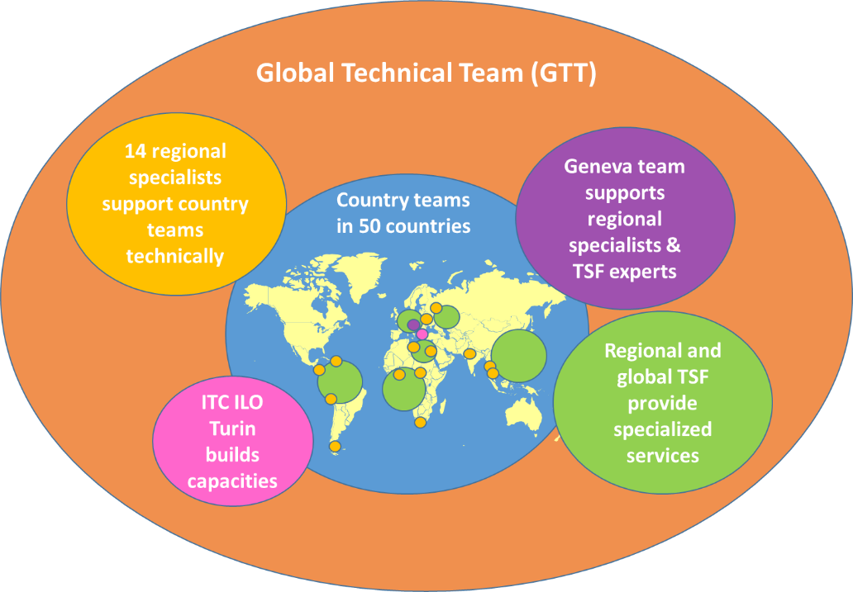

Figure 4: Governance and management of the Flagship Programme
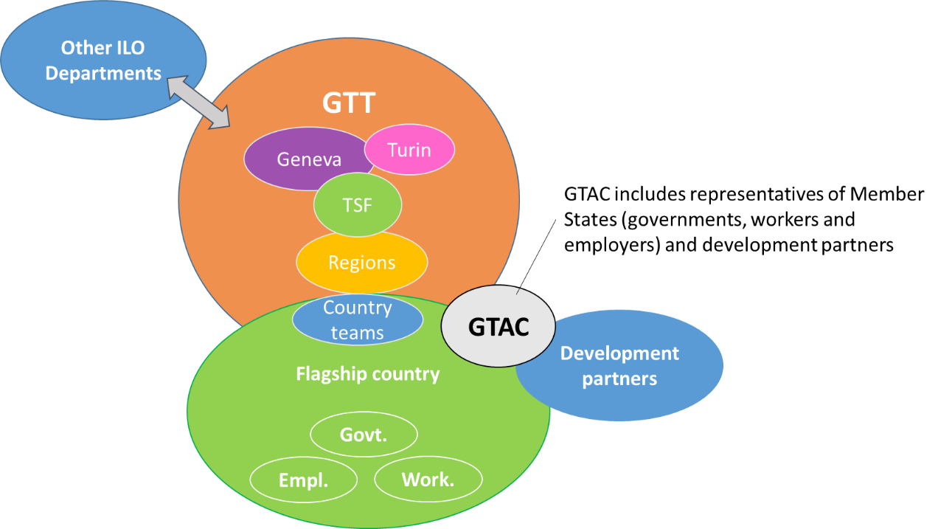
Overall strategic guidance for the orientation of the Flagship Programme will be provided by the Global Tripartite Advisory Committee (GTAC). The role played by the GTAC is an integral element of the governance of the Flagship Programme, as outlined at its 325th Session by the ILO Governing Body, which requested the ILO to “… establish a tripartite advisory committee for each Flagship Programme at both the global and national levels”. The GTAC is composed of 12 nominated members: 4 government representatives from countries where the Flagship Programme is being implemented, 4 government representatives from development partner countries, 2 representatives from the Employers’ Group and 2 representatives from the Workers’ Group. It will convene annually.
The Flagship Programme will be managed by a dedicated management team, headed by the Deputy Director of the ILO’s Social Protection Department and composed of dedicated regular budget and development cooperation staff members at headquarters and regional offices and in decent work teams. The Flagship Programme is implemented by the GTT, which comprises social protection specialists and experts working at country, regional and headquarters levels. The ILO contributes to the Flagship Programme through support provided by regular budget staff in the areas of resource mobilization, the development of partnerships, internal and external communication, and management of the Flagship Programme, oversight of projects, monitoring and evaluation using the Results Monitoring Tool and so on. The ILO also contributes through regular budget staff at the Social Protection Department and regional Decent Work Teams, who provide “technical backstopping” to projects by providing their knowledge and checking policy coherence on specific areas of specialization. The Flagship Programme will rely on the GTT to facilitate the provision of support to constituents, document experience, collect and consolidate results and share good practices across the team. The Flagship Programme in its second phase will strengthen the GTT by creating ownership of the Flagship Programme, building its capacities and fostering more exchanges.
The TSF is part of the GTT and complements country teams by providing timely and high- quality support on strengthening different areas of social protection reflecting the ILO’s comparative advantage based on its internationally agreed standards and principles. It is composed of experts that are entirely dedicated to supporting ILO constituents at country level; based on this support, TSF experts also document good practices and further develop the knowledge base related to their area of technical expertise (for example policy and technical briefs, good practices guides, capacity-building packages, online quantitative tools and so on).
The positions of experts in the TSF are in most cases financed by development cooperation projects. They work closely with specialists financed by the ILO’s regular budget, who play a key role in the technical backstopping of the work undertaken under the Flagship Programme in order to ensure a coherent approach and a high quality of services. For instance, the TSF includes one expert on public finance and social protection financing that is backstopped technically by the Public Finance Economist of the Social Protection Department, as well as one legal expert who works in tandem with the Legal Officer of the Social Protection Department. This ensures strong complementarity of expertise across regular budget specialists and TSF experts, policy coherence aligned with ILO standards, and delivery of timely and quality services to member States.
In the second phase of the Flagship Programme and as indicated above, the TSF will be continued and strengthened at global and regional levels through the mobilization of resources for existing TSF positions and the creation of new TSF expert posts. A joint planning and reporting mechanism will be introduced to ensure that support is available when requested by constituents at country level and lessons learned at country level will be disseminated.
Table 5. TSF expert positions prioritized in the second phase of the Flagship Programme
Current TSF expert positions (to be maintained) | New TSF expert positions (to respond to the needs of constituents)
Headquarters:  - public finance  - health  - extension of social protection to workers in the informal economy  - legal drafting  - actuarial studies  - MISs  - cash payment mechanisms  - culture and communication  - statistics  Asia:  - health  - actuarial studies | Headquarters:  - social protection and climate change  - unemployment protection  Asia:  - unemployment protection  Africa:  - extension of social protection to workers in the informal economy  - public finance  Latin America:  - unemployment protection  Europe and Central Asia:  - extension of social protection to workers in the informal economy  Arab States:  - TSF expert position to support a regional hub of South–South exchanges and capacity-building using TRANSFORM methodology

Social protection is an integral part of the ILO’s Decent Work Agenda and the development of social protection systems is strongly interrelated with employment policies, occupational safety and health policies, the transition to a greener economy and many other policies or initiatives. A number of joint projects have already been launched under the first phase of the Flagship Programme on Building Social Protection Floors for All through the Labour Migration Department; the Better Work Flagship Programme; the Gender, Equality, Diversity and Inclusion Branch; and the Safety + Health for All Flagship Programme. The Social Protection, Freedom and Justice for Workers Network and the Global Business Network for Social Protection Floors have been developed in close collaboration with the Bureau for Workers’ Activities and the Bureau for Employers’ Activities. Several other ILO departments are contributing to the successful implementation of the ILO Flagship Programme on Building Social Protection Floors for All, notably the Office of the Deputy Director-General for Policy; the Strategic Programming and Management Department; the Communication and Public Information Department; the Partnering for Development Department; and the Evaluation Office. The second phase of the Flagship Programme on Building Social Protection Floors for All will further identify relevant opportunities for strategic partnerships and joint projects with other programmes and units at the ILO.
A large number of development partners have supported the Flagship Programme during its first phase through specific (multi-)country and thematic projects. It was able to increase the effectiveness and efficiency of individual projects and development partners’ contributions by creating a common framework and modus operandi that leverages synergies across countries and project teams. Development partners will be key partners, not only through their financial contributions but also through their technical involvement in key thematic areas of the Flagship Programme and through their guidance role in the GTAC.
This multi-donor programme is one vehicle to support the implementation of the 2nd phase of the Flagship Programme. The specific country and thematic outcomes and outputs supported by the multi-donor programme are identified in table 6 and detailed in the geographic and thematic annexes. The orientation of the multi-donor programme will be guided by a specific Donor Steering Committee.
The Donor Steering Committee composed of all financial contributors to this multi-donor programme under the Flagship Programme will convene annually, ideally before the GTAC and development partners meeting. The Donor Steering Committee will:
- Take stock of progress and results achieved with financial support of the mutlidonor programme and provide strategic guidance for the future implementation and development of workplans of the multi-donor programme.
- Approve the contribution to specific country and thematic areas of the multi-donor programme through approving the annual financial report of the multi-donor programme and the narrative report of the Flagship Porgramme.
- Identify issues and challenges to be raised in the GTAC.
- Validate the Flagship programme annual report
- Provide guidance on evidence-based communication materials to promote the multi-donor programme, highlight the synergies and impacts.

- The contribution of the Multidonor Programme to the 2nd Phase of the Flagship Programme
This multi-donor programme has been developed to allow development partners pool their financial support to the ILO’s Flagship Programme on Social Protection and to allow for
- Increased opportunities for creating policy coherence in multilateral platforms and multistakeholder partnerships.
- Greater ability to leverage resources from within and beyond the ILO for the achievement of the SDGs and a human-centred COVID-19 recovery.
- Increased impact and sustainability of individual contributions through joint efforts and long-term engagement.
- A platform for engagement with multiple partners, programme countries and ILO constituents.
- Flexibility for the ILO in allocating resources to national priorities and emerging needs.
- Shift from a constellation of projects to a cohesive programme with one governance setup.
- Increased efficiency in management, technical assistance and ILO service delivery at the country level.
- Better opportunities for learning and knowledge sharing due to the large amount of countries and scope of thematic areas covered.
- Joint reporting and evaluation.
- More visibility through coordinated communication efforts.
The Multidonor Programme is only one vehicle to finance the Flagship Programme. The Management Team identifies with the funding partners the geographic and thematic priorities of the Flagship Programme that are supported through the multi-donor programme.

Table 6: Based on the currently available funding, the Multidonor Programme will support:
 | Regional support | TSF support included | Outputs based on currently available funding | Outcome 2025
Country support
Burundi |  | X | - Feasibility studies defining the parameters, institutional arrangements and incentives for the participation of workers in the informal economy are validated by ILO constituents and other organizations representing the target population  - Increased awareness of key stakeholders of the importance of social protection to support the implementation of the National Development Plan 2018 – 2027  - Social protection stakeholders and agencies have the capacities and tools to effectively drive the horizontal and vertical extension of coverage towards building social protection floors | The design of a social protection scheme responding to the needs and priorities of workers in the informal economy and other vulnerable groups is developed and endorsed by government and social partners
Democratic Republic of the Congo |  | X | - The consensus of the architecture of the Universal Health Coverage system is achieved and the coordination level is implemented  - The basis for the Solidarity Health Fund are established  - The relevant national social protection stakeholders have the necessary capacities and relevant information to effectively implement social protection schemes and to advocate for their sustainable financing | Guaranteeing the extension of coverage of social protection, particularly through social health protection
Rwanda |  | X | - Social security products and services, including unemployment protection, respond to the needs and priorities of workers in the informal economy and in the formal sector  - Mechanisms and tools are available to strengthen administration and facilitate access to social security services for the informal sector.  - The Rwanda Social Security Board, labour inspectors and tripartite constituents have the necessary capacities and relevant information to effectively implement social protection schemes and to advocate for their sustainable financing. | Formal and informal economy workers and their families have access to better social protection schemes in line with the Social Protection Floors Recommendation 202.
Burkina Faso |  | X (regional) | - Les paramètres techniques et financiers du Régime d’Assurance Maladie Universelle sont approuvés  - La CNAMU a les capacités pour gérer la gratuité des soins pour les femmes enceintes et les enfants de moins de 5 ans  - Le cadre de contractualisation entre les organes de gestion du RAMU et les prestataires de soins est finalisé et mis en œuvre  - Les mutuelles sociales et autres institutions en charge de la couverture de l’économie informelle disposent d’outils et leurs capacités sont renforcées pour participer à la gestion efficace du RAMU  - La stratégie d’extension du RAMU aux acteurs de l’économie informelle et les membres de leurs familles est mise en œuvre | L’architecture institutionnelle et technique du Régime d’Assurance Maladie Universelle est opérationnelle et facilite l’extension de la couverture de santé aux travailleurs de l’économie informelle et leurs familles.
Senegal |  | X (regional) | - Les structures décentralisées de la mutuelle sociale nationale des artisans sont opérationnelles  - Les capacités des organisations socio professionnelles de l’économie informelle sont renforcées pour une meilleure participation à la mise en œuvre du RSPC  - Une mutuelle sociale est mise en place pour l’extension du RSPC secteur du commerce  - Les acteurs opérationnels et institutionnels ont les capacités nécessaires pour la mise en œuvre d’une mutuelle sociale dans le secteur du commerce | Les acteurs institutionnels et techniques disposent des capacités et outils nécessaires pour la mise en œuvre du RSPC et pour progressivement étendre les champs physique et matériel du Régime Simplifié des Petits Contribuables
Lao PDR |  | X (global and regional)l | - The management and administration of the National health insurance is strengthened and translate into enhanced institutional capacity and operational effectiveness and efficiency at all levels  - Relevant policy reforms on medical care, sickness and maternity benefits are prepared, with a focus on extending coverage and financing, informed by evidence produced within the Project  - Foundations for building a culture of social health protection, including medical care, sickness and maternity, are established | Effective, efficient, accountable and sustainable gender sensitive social health protection is delivered with an increased coverage in Lao PDR
Thematic support
Data and statistics | African region | X | Constituents in Burundi, DRC and Rwanda have the capacities and the tools available to collect, analyse and disseminate information on social protection coverage | Improved availability of social protection data in the African region
Financing | African region | X | Constituents in Burundi, DRC and Rwanda have the capacities and the tools available to engage in policy discussions on strong public finance management and financial sustainability of social protection systems | Improved social dialogue on financing social protection in Africa, and more specifically in Burundi, DRC and Rwanda through capacity building and knowledge sharing.
Integrated policy for the extension of social protection to workers in the informal economy | West Africa | X (regional) | - Une expertise sur demande sur des politiques intégrées pour la protection sociale, y compris les politiques de financement, est disponible au niveau de la sous-région  - L’Union Economique et Monétaire Ouest Africaine (UEMOA) et la Conférence Interafricaine de la Prévoyance sociale (CIPRES) ont des capacités renforcées pour appuyer leurs Membres dans la mise en œuvre de politiques de protection sociale alignées avec les principes et standards de l’OIT | Les partenaires tripartites ont les capacités et les outils nécessaires pour promouvoir des politiques intégrées, financées de manière adéquate, en appui à l’extension de la protection sociale aux travailleurs dans l’économie informelle.
Regional support to the extension of Social Health Protection in Asia | Southeast Asia | X (regional) | - Coordination capacities of Connect’s Secretariat are strengthened, and membership is extended to new members  - Regional capacities on Social Health Protection are developed  - Relevant knowledge, with a focus on gender, is produced and shared within CONNECT’s network  - Technical support is provided to other countries from the region, based on demand, and South-South knowledge exchanges on social health protection is promoted across regions | CONNECT is a recognized network of public and non-for-profit institutions working on social health protection in the Asia Pacific region, and contribute to the extension of Social health protection through joint research, collaborative and gender responsive capacity building opportunities and advocacy efforts
Partnerships
Integrated into other components notably at regional level
Management of the Flagship Programme
Coordination of the Flagship Programme |  |  | - Monitoring and evaluation mechanisms are in place, using the Results Monitoring Tool  - Annual Flagship Programme Reports are produced  - Progress and achievements of the Programme are showcased on its website and through country and thematic pages  - Evidence-based communication materials to promote the multi-donor programme, highlight the synergies and impacts | - Regular communication on the achievement of the FP.  - Knowledge sharing strategy is developed and implemented  - Visibility of the FP internally and externally is increased

Additional information on the planned outcomes and outputs are included in the country and thematic annexes.

- Strategy to communicate, promote and raise visibility of the programme
A communication and visibility strategy will be developed and implemented to improve internal and external communication within the Flagship Programme on Building Social Protection Floors for All and to increase ownership of the Flagship Programme among ILO staff and constituents as well as development partners. The following actions have already been identified as important:
- Develop and mainstream a common branding to be used by all country, regional and global projects of the Flagship Programme in order to reinforce the link of individual projects to the Flagship Programme.
- Prepare generic presentations of the Flagship Programme and deliver them in a more systematic manner in order to increase the awareness of development partners, ILO Directors, GTT staff and ILO constituents at the global, regional and country levels.
- Publish regular communication products (information stories) showing how the programme is advancing and the results that have been achieved (using the Results Monitoring Tool), combined with broader policy messages.
- Produce short, clear and digestible communication/advocacy materials on key policy messages and country cases (country briefs series) that can be shared with constituents to inspire them and drive policy changes.
- Create and update a dedicated website, including country pages and thematic pages, that will be updated by designated focal points.
- Use social networks in a more systematic manner to highlight new partnerships and events or disseminate information stories.
- Organize annual meetings of development partners to take stock of progress, showcase lessons learned under the Flagship Programme and foster South-South exchange. The meeting will be joint effort by all members of the GTT.
- Support the ILO’s efforts to increase the visibility of its Flagship Programme, such as by clearly identifying projects belonging to the Flagship Programme in the Development Cooperation Dashboard.
In addition, communication within the GTT will be reinforced through the following actions:
- Promote a more systematic use of the Results Monitoring Tool to share information, knowledge, results and impact and foster South-South learning across the GTT.
- Update the GTT map on a regular basis to provide and share – both internally and with partners – the names and photos of all national and international staff working in the Flagship Programme countries.
- Create a thematic mapping of skills and expertise across the GTT and identify future skills that will help our GTT achieve its objectives (in collaboration with the Business Innovation Unit of the ILO).
- Develop and implement a capacity-building plan for country teams and other experts, including regular courses and knowledge-sharing activities, in order to increase knowledge on substantive issues (technical and policy skills on universal social protection) and develop “soft skills” (resource mobilization, partnership development, results monitoring and reporting, communication and so on).
- Organize regular knowledge and information-sharing session cafés and problem-solving workshops and create a community of practices to strengthen the expertise available across thematic areas.
- Extend the management team at the regional level by nominating regional focal points for the Flagship Programme.
- Organize regular GTT Flagship Programme meetings, including interactive capacity-building sessions that focus on technical areas and programme management issues.
Across all actions of the Flagship Programme, the support provided by its partners will be acknowledged. Specifically, all logos of partners will be displayed on the Flagship Programme’s website, in the Flagship Programme’s annual report and at the development partners meeting. All materials developed under the Flagship Programme will make reference to the support provided through the Flagship Programme and its partners.

- Monitoring and evaluation of results and impact achieved
The Flagship Programme on Building Social Protection Floors for All will contribute to achieving a number of targets and indicators of outcome 8 of the Programme and Budget for 2020–2021 and for 2022–2023 and of SDG targets 1.3 and 3.8. The ILO’s contribution to other goals and SDG targets will also be measured, although not across all projects.
Table 7: Correspondence of the indicators used as part of the ILO Flagship Programme, the Programme and Budget for 2022–2023 and the SDGs
 | Indicators of the ILO Flagship Programme on Building Social Protection Floors for All | Output indicators for the Programme and Budget for 2022–2023 | SDG targets and indicators
Impact on people | Disaggregated by sex and risk:  - Number of persons  legally covered  - Number of persons effectively covered (registered, contributing)  - Number of persons with higher benefits (adequacy)  - Number of persons with more comprehensive social protection (additional risks covered) | No indicators on impact on people, although this impact is captured in the narrative of the programme and budget reporting | Disaggregated by sex and risk:  - The number of people that have effective coverage thanks to the implementation of the new/revised measure (reported through SDG indicators 1.3.1, 3.8.1 and 3.8.2)
Institutional results related to country support | Number of countries that have adopted new or revised policies and strategies; legal frameworks; or institutional changes  to extend coverage, enhance comprehensiveness and/or increase adequacy of benefits | Indicator 8.1.1. Number of member States with new or revised national social protection policies to extend coverage, enhance comprehensiveness and/or increase adequacy of benefits | No indicators on systems building, although SDG target 1.3 refers to implementing nationally appropriate social protection systems and measures for all  However, indicators related to an increase in the proportion of total government spending dedicated to social protection (reported through SDG indicators 1.b.1 and 1.a.2) allow the monitoring of domestic efforts in building systems
 | Number of countries that have adopted or operationalized policy measures to improve the financial and administrative governance of the social protection system, including compliance, information management and  statistical system | Indicator 8.2.1. Number of Member States with new or revised policy measures to enable social protection systems to be sustainable and provide adequate benefits
 | See results indicators of relevant thematic approaches (Annex) | Indicator 8.3.1. Number of Member States with new or revised integrated policy responses, including social protection, to support and protect workers and employers during their life and work transitions
Institutional results related to thematic support | See results indicators of thematic approaches (Annex)
Institutional results related to partnerships | Percentage of country results that have been achieved through joint support by ILO and partners
Outputs: ILO contributions | Technical support  Number of knowledge and policy products that have been prepared by the Flagship Programme and endorsed by tripartite constituents (for example ABND report, feasibility study, actuarial study)  Capacity-building Number of persons from social security agencies/ governments, employers’ or workers’  organizations trained with the support of the ILO Flagship Programme  Knowledge development and sharing  Government, employers’ or workers’ organizations design, manage or deliver social protection systems using a knowledge product developed by ILO/ through its Flagship Programme  Ratification campaign Number of countries that have ratified ILO Convention No. 102 and other up-to-date standards, with ILO support  Partnerships  Percentage of Flagship Programme countries with a tripartite national coordination mechanism and a UN/development partners’ coordination mechanism on social protection  Percentage of position papers, technical and policy documents, frameworks of collaboration, global actions and joint country projects, adopted through partnerships, that refer to universal social protection and are guided by international social security standards

The logical framework below shows how technical support will contribute to the Flagship Programme’s outputs at country level and on knowledge generation. These outputs will contribute to increased coverage or strengthening of social protection systems globally, impacting people and contributing to the realization of several SDGs.
Key indicators have been developed to harmonize monitoring across country interventions and projects and to allow reporting on the thematic approaches under pillar 2 and partnerships under pillar 3. These indicators are listed under each thematic area in the Annex or will be finalized during the first two months of the second phase.
Results Monitoring Tool – Each country support (pillar 1) will be systematically documented in the Results Monitoring Tool in order to keep track of actions, outputs, institutional changes achieved and impact on people. For each thematic support (pillar 2), the Results Monitoring Tool will keep track of the country, regional and global actions implemented through the approach and the results in terms of policy changes (if any) and will assess the impact at country level on relevant indicators such as the coverage of excluded groups, the increase in social protection investments or the use of effective social dialogue. Similarly, it will be important to keep track of the strategic partnerships (pillar 3) and assess their contribution to strengthening national social protection systems and the application of international social security standards in partners’ strategies and programmes. The indicators tracked will indicate not only the number of institutional changes and people impacted but to what extent the results and impact have been achieved through the application of the principles embedded in international social security standards.
Table 8: Frequency of collection of information to feed the Results Measurement Tool
 | Frequency | Tools
Impact on people | Annually (2022, 2023, 2024, 2025) | - Programme and budget reporting  - Results Monitoring Tool  - National statistical systems  - Annual Flagship Programme reports  - Country and thematic pages  - GTT experts  - Social security enquiries  - World Social Protection Database
Institutional results | Annually (2022, 2023, 2024, 2025) | - Programme and budget reporting  - Results Monitoring Tool  - Annual Flagship Programme reports  - Country and thematic pages  - Social security enquiries  - Technical reports  - GTT experts
ILO’s contributions to institutional changes and impact | Annually (2022, 2023, 2024, 2025) | - www.social-protection.org platform  - Thematic pages  - Country pages  - Project reports  - GTT experts

A clustered independent evaluation of the Flagship Programme’s second phase and of outcome 8 of the programme and budget is expected to be conducted in 2026.
The Results Monitoring Tool was developed and rolled out during the first phase of the Flagship Programme. It includes information on more than 600 social protection interventions implemented by the ILO since 2008. The tool will be used not only to report on project implementation and results achieved but also to indicate if implementation has been aligned with international social security standards (notably the guiding principles of Recommendation No. 202). It also creates an institutional memory and fosters South–South learning and collaboration across countries and regions.
Country pages will consolidate information from the Results Monitoring Tool and the World Social Protection Database to provide an overview of the social protection situation and the ILO’s previous and ongoing support for all priority countries. Thematic pages will be developed using a similar structure in order to showcase for every thematic area the current state of knowledge, the ILO approach, related ILO interventions, the results achieved and key resources. Web pages for the workers and business networks as well as One UN collaboration on social protection will be improved and updated regularly.
The www.social-protection.org platform continues to be the key hub for communicating on the Flagship Programme and to disseminate tools and knowledge products developed. A dedicated website of the Flagship Programme will be developed.

- Sustainability
Several areas of the Flagship Programme contribute to the sustainability of the changes achieved under the Programme. The support provided aims at anchoring social protection in national legal framework to ensure the sustainability of institutional changes. The thematic focus on building a culture of social protection will increase the general public’s and policy makers’ understanding of social protection and encourage them to prioritize the development of robust systems. The support provided by the Flagship Programme on financing of social protection will contribute to the sustainability of schemes but also highlight the return on investment of social protection funding. Tripartite social dialogue creates a national consensus on social protection, which also contributes to its sustainability.

Partnerships at national, regional and global level further contribute to multiply impact of the Flagship Programme but also to the sustainability of social protection policies and advisory aligned with ILO principles that go beyond the direct support of the Programme.

Finally, the ILO Flagship Programme has been designed as a long-term intervention supporting countries over 15 years. Such a long-term engagement is crucial to accompany constituents along the road to universal social protection reaching from the development of strategies, to the design of schemes and finally their operationalization. The flexibility provided through this multi-donor programme allows to strengthen the continuity of ILO support and increases the agility of the ILO Global Technical Team on social protection to respond to the needs of ILO constituents at country level.

- Budget
The budget for implementing the second phase of Flagship Programme on Building Social Protection Floors for All from 2021 to 2025 is estimated at US$160 million, of which 81 per cent will be allocated to in-country support, 15 per cent to cross-country policy advice and 4 per cent to the management of the Flagship Programme (overall management; resource mobilization and partnerships; programming and results monitoring;, communication, visibility and capacity development; and information and knowledge dissemination).
Figure 6: Estimated budget for the second phase of the Flagship Programme, distribution by pillar
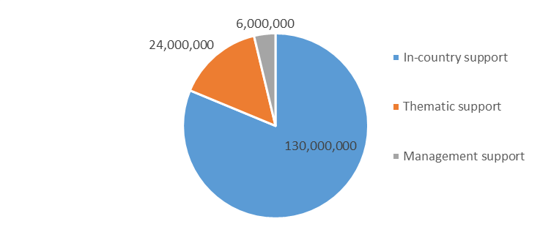
As a result of resource mobilizing efforts during the first phase, about US$75 million have already been mobilized for the second phase. The ILO will contribute to the programme through its regular budget, including support by social protection specialists in Geneva and in the field, which is estimated at about US$10 million, leaving a resource gap of US$75 million. The additional funding is expected to be covered by voluntary allocations (extra budgetary resources).
Table 9: Funding gaps for the second phase of the Flagship Programme
 | US$
In-country support (1) | 130 000 000
Thematic support (2) | 24 000 000
Management support (3) | 6 000 000
Mobilized (during first phase for second phase) (4) | 75 000 000
Funding gap (5) | 85 000 000
Contribution of regular budget to the Flagship Programme (6) | 10 000 000
Resource gap (1+2+3) – (4+6) | 75 000 000

Structured funding dialogues will be organized annually to identify how resources can be mobilized, pooled, coordinated and managed in the most efficient way. The mobilization of funding will be key to respond to the needs of constituents at country level and to support knowledge generation in key thematic areas.

See ILO, Resolution and Conclusions concerning the second recurrent discussion on social protection (social security), International Labour Conference, 109th Session, 2021; and ILO, Global call to action for a human-centered recovery from the COVID-19 crisis that is inclusive, sustainable and resilient, International Labour Conference, 109th Session, 2021.
“Universal social protection entails actions and measures to realize the human right to social security by progressively building and maintaining nationally appropriate social protection systems, so that everyone has access to comprehensive, adequate and sustainable protection over the life cycle, in line with ILO standards.” (ILO, Resolution and Conclusions concerning the second recurrent discussion on social protection (social security), International Labour Conference, 109th Session, 2021, para. 3).
See ILO, Resolution and Conclusions concerning the second recurrent discussion on social protection (social security), International Labour Conference , 109th Session, 2021; and ILO, Global call to action for a human-centered recovery from the COVID-19 crisis that is inclusive, sustainable and resilient, International Labour Conference, 109th Session, 2021.
Among the ILO’s 187 Member States, 100 have prioritized social protection as part of their 2020–2021 programme of work with the ILO.
Medical care, child and family benefits, survivors’ benefits, maternity, unemployment, sickness, employment injury, invalidity, old age and long-term care.
UN, "Investing in Jobs and Social Protection for Poverty Eradication and a Sustainable Recovery", Secretary-General's Policy Brief, 28 September 2021.
The “UN Development Assistance Frameworks (UNDAFs)” have been renamed the “UN Sustainable Development Cooperation Frameworks (UNSDCFs)” in order to more accurately reflect the relationship between governments and the UN development system in collaborating to achieve the SDGs.
Other branches of social security (child and family benefits, maternity, invalidity and so on) are still covered by the Flagship Programme and supported through country projects, although this second phase will not develop a specific approach on them.
See USP2030 website, www.usp2030.org
See P4H website, https://p4h.world
See UHC 2030 website, www.uhc2030.org
See United Nations Social Protection Floors Initiative website, http://un.social-protection.org
See UN, "Investing in Jobs and Social Protection for Poverty Eradication and a Sustainable Recovery", Secretary-General's Policy Brief, 28 September 2021.
ILO, Resolution and Conclusions concerning the second recurrent discussion on social protection (social security), International Labour Conference, 109th Session, 2021.
ILO, Resolution and Conclusions concerning the second recurrent discussion on social protection (social security), International Labour Conference, 109th Session, 2021.
Meet our Global Technical Team https://www.social-protection.org/gimi/ShowWiki.action?id=10
SDG targets 1.a, 1.b, 5.4, 8.5, 10.4, 13.2, 16.3, 16.6, 16.7, 17.1, 17.2, 17.3 and 17.6.
The following thematic areas are especially relevant: social protection for workers in all forms of employment, including workers in the informal economy, domestic and rural workers; social protection for migrants, refugees and host communities; just transition to a more environmentally sustainable economy and society; financing social protection; and gender-sensitive social protection.

