Strategic Workplan 2023-24
Background
SheDecides is a global movement taking political action for a world where every woman, girl and young person in all their diversity, can decide what to do with their body, life and future. The Government of Belgium has been central to the SheDecides movement as a co-founder, driving political voice and leading SheDecides Champion. Since 2017, the movement members and allies have boldly been standing up for bodily autonomy and sexual and reproductive health and rights for all. The SheDecides movement is a unique network of diverse change-makers from Africa, Asia, the Arab Region, Latin America and the Caribbean, Europe and North America. SheDecides Champions include governments, ministers, parliamentarians, civil society organizations, service providers, youth-leaders, grassroots activists, media, private sector, artists, researchers, and donors. The Movement is a catalyst for collective action, greater than the sum of its parts. SheDecides galvanizes global support for her right to decide through coordinated political action, connecting national to global-level advocacy, communications and thoughtfully crafted opportunities for Champions, movement members and allies to speak out on bodily autonomy. SheDecides’ vision for 2022-2027 is to advance sexual and reproductive health and rights (SRHR), and bodily autonomy by countering the rising tide of opposition, strengthening coordinated political action and amplifying the collective voices of our movement members and allies.

What impact will SheDecides have?
As a convening partner of progressive leaders across the world, SheDecides helps to shape coordinated efforts to challenge regressive narratives, policies and laws through revitalized political leadership and smart partnerships. SheDecides will leverage our well positioned and powerful network of progressive and supportive governments and civil society organizations, feminist networks and youth-led organizations, to ensure joint efforts to counter global opposition and advance bodily autonomy and SRHR in advocacy spaces where decisions are made. SheDecides will amplify the voices, provide public facing events space and put the spotlight on experts often excluded from decision-making spaces, such as young people and representatives from other regions than the global north to showcase best practices on progress to counter the negative narrative and voices of the SRHR opposition, push back or regression.
What SheDecides will do | Expected achievements
Build collective strength of movement members | A stronger, more interconnected and tightly coordinated intergenerational movement that can nimbly respond to opportunities to advance bodily autonomy and SRHR, and collectively respond to threats.
Convene movement members and allies | A strategically interconnected web of members and allies that are well-positioned to act together to advance bodily autonomy and SRHR, and challenge opposition.
Coordinate political action amongst movement members and allies | A tightly coordinated movement that is able to quickly and effectively plan and respond to global advocacy opportunities to advance bodily autonomy and SRHR and to challenge opposition as it arises.
Support global coordination amongst movement members around accountability for political and financial commitments | A coordinated SheDecides movement that can collectively encourage support and demand accountability for the commitments made by governments to advance bodily autonomy and SRHR
Amplify the voice and political actions of movement members and allies | A movement that builds progressive stories and narratives and amplifies youth voices to advance bodily autonomy and SRHR to push back against opposition.
Create opportunities for movement members and allies to reach new audiences | A movement that can shift the needle on public opinion on bodily autonomy and SRHR issues by reaching a broad global audience through innovative partnerships and public-facing campaigns.

Overview SheDecides workplan 2023/24
Taking political action
SheDecides will support and participate in strategical multilateral and international policy and decision-making spaces in 2023/2024 including; CSW/GEF, CPD/ICPD+30, UNGA/HLM UHC SDG review, Summit of the Future, as well as other strategic meetings and opportunities where our Champions and allies meet, such as Women Deliver and other regional or global conferences, the Global Forum for Adolescents, feminist development cooperation forum meetings, as well as relevant EU fora to advance global SRHR commitments, including in relation to Team Europe Initiative. The EU presidency held by Belgium in 2024, offers an important strategic opportunity for SheDecides to support joint political action together with the government of Belgium through high-level events and international gatherings in Brussels, as well as making strong political leadership on SRHR visible in our global communication work.

The SheDecides Support Unit (SDSU) maximizes synergies within the SheDecides Movement as well as external partners and allies, to share positive narratives that build support for progressive stances on bodily autonomy, comprehensive sexuality education, safe and legal abortion and young people’s SRHR. Our coordinated political actions will be steered towards public-facing high-level events, with a particular focus on providing space for diverse and cross-regional dialogue on best practices and political leadership in Africa, Asia, Europe, Latin America and the Caribbean.
Speaking up and amplifying
Communication plays an important role in building understanding of bodily autonomy, shifting narratives and norms and challenging gender and power dynamics that stand in the way of the freedom, rights and dignity of women, girls and young people in all their diversity. SheDecides will strategically use communications and tailored key messages to reach targeted political audiences at selected global policy moments in 2023 and 2024. We also aim to reach and include new and broader audiences, to tell powerful and interesting human stories and connect with people’s hearts and minds in a fresh, understandable way by eschewing technical jargon.

SheDecides Champions are thought and action leaders on bodily autonomy and SRHR, formally appointed to serve as ambassadors of the SheDecides movement. They come from countries all over the world, honing their efforts at global, regional and sometimes national level. The vocal support of well-known and respected public figures in priority countries will build the political and public support, ultimately serving as a catalyst for acceleration and propagation of progressive stances on sexual and reproductive health and rights.

The SheDecides Support Unit places a strong focus on amplifying and making visible best practices, progress and positive results in relation to global development cooperation commitments that are delivered by governmental champions and partners. In this regard SheDecides Support Unit will provide communication support for our Champions and allies for instance through coordinated Op-Eds, press releases, toolkits, social media assets, as well as coordinated and tailored campaigns and public-facing events.
Connecting key stakeholders
Partnerships are central to the work of the SheDecides movement. We work to enable and increase coordination and support strategic synergies within a broad SRHR, bodily autonomy and the gender equality ecosystem, and as a feminist movement taking joint action, our intended impact builds upon the change work that our members and allies are driving. We partner with our Champions across regions and sectors to advance common goals by convening our movement members; by coordinating political action; supporting global coordination amongst members and by amplifying our Champions’ leadership so as to reach a wider audience and push back against the opposition.

We also partner beyond our Champions with diverse organizations, UN-agencies, political leaders, youth leaders, leading experts and different types of movements and activists working in relation to and beyond the broader bodily autonomy movement.
Some of our key partnerships include:
- Nexus Initiative With aligned priorities and cross-over with SheDecides governmental champions, SheDecides Support Unit and Nexus Initiative Secretariat have been working closely to advance bodily autonomy at the global level. Having formally signed a collaboration agreement in 2019, SheDecides supports the mandate of Nexus, convening partners to strategize, coordinate advocacy and align messaging to maximize impact. As Nexus operates behind closed-doors, SheDecides supports Nexus members with broader, public-facing platforms, connection with the diverse Champion network consisting of governmental representatives, young experts, civil society leaders, service providers, advocates, researchers, funders. We work together ahead of key advocacy moments to build and broaden the base of support for SRHR, with SheDecides amplifying efforts through strategic communications and proactive media outreach to counter opposition. In 2023 and 2024 we will focus on the strategic political coordination around key messages to support bodily autonomy, CSE and young people’s SRHR, with a particular focus on providing a public platform for supportive voices, including governmental representatives amongst selected outreach countries beyond global north.
- The Global Partnership on CSE: SheDecides Support Unit coordinates with UNESCO, UNFPA, WHO, Norway and Sweden as part of the advocacy group, providing technical and political coordination and mapping out and selecting how, when, who and where to communicate and amplify messages, unpacking content strategically tailored to different audiences and target groups and amplifying good practices on CSE so as to reach a broader audience and support on CSE
- Global Safe Abortion Dialogue committee: SheDecides Support Unit coordinates closely with CSOs (notably Ipas, MSI, IPPF, Amplify Change) and governments including WHO, Sida, Norad, Global Affairs Canada and others as part of this initiative. As this group is mainly focused on abortion care provision and technical capacity building amongst partners, SheDecides connects the dots between national and global level, and brings in a strengthened political perspective by careful elaboration and consultation with partners on strategic opportunities to amplify political voice and action at a global level. We are currently elaborating ideas with the committee on joint efforts showcasing progress and leadership on abortion care within the context of UHC, at the upcoming Women Deliver Conference and the HLM on UHC in 2023, and SDG advancements in 2024.
- We also coordinate closely with UN partners, including UNFPA, OSGEY, UN Women around important global advocacy processes including ICPD+30, Generation Equality Forum, Agenda 2030/SDG review/Summit of the Future and other key opportunities.
- Young people’s SRHR: A focus area for SheDecides in 2024 will be young people’s SRHR. Beyond the SheDecides youth Champions, youth-led or youth focused SheDecides champions (Plan International, Youth Coalition, International Federation of Medical Students Association (IFMSA), Giris not Brides) - SDSU will scale up collaborations with existing youth platforms, networks and new champions and allies, including (AGIP) Adolescents Girls Investment Plan, Transform Education, UNGEI, UNICEF, Choice for Youth and Sexuality, Right Here Right Now (Rutgers).
SheDecides Activities 2023/2024

SheDecides new strategy builds on the following theory of change:

If we convene and strengthen our movement and build linkages to important allies, so that we (as a movement) are better able to take joint political action that can effectively demand global-level accountability for advancements towards bodily autonomy and SRHR, then we will be better positioned to use our collective power and amplified voice to counter opposition and advance support for bodily autonomy and SRHR.

Below are the 3 pillars and 6 goals, that set out the structure for our workplan 2022-2027, with selected examples of key activities for 2023:

Pillar 1: Convene and Strengthen
Building collective power amongst movement members is at the core of SheDecides’ vision and theory of change. The first pillar of our strategic plan focuses on reinforcing and expanding the SheDecides movement, and forging alliances between movement members and new potential allies.

Goal 1: Solidarity and collective strength is built amongst movement members so that they are able to advance bodily autonomy and SRHR and strategically counter opposition.

Goal 2: Connections between movement members and allies are built and strengthened so that bodily autonomy and SRHR gain broader support.

To ensure that SheDecides continues to be a broad and representative movement, and works in tight coordination for impactful engagement, in 2023 we will:

- Increase the legitimacy and reach of the SheDecides movement through increasing the number of Champions representing lower- and lower- and middle-income countries, youth movements, and governments currently outside of the movement.
- Deepen and increase collaborations and partnership with allies beyond the SRHR sector (e.g. Education, Gender Equality, Human Rights, Democracy).
- Generate support for SRHR through enabling and coordinating Champions’ public engagement at key moments and providing the guidance needed to ensure timely and powerful communications.
- Strengthen the ability of the SheDecides movement to push back against opposition through sharing information, learning and tactics on how to counter these forces, including through Master Classes between Champions and allies.
- Host the Youth Accountability Panel, created by the young people who drive the SheDecides movement, which ensures independent youth-led accountability for the commitments made through the Youth Engagement Strategy.
Pillar 2: Take Political Action
SheDecides will encourage political action by supporting decision makers to take action to advance bodily autonomy and SRHR. We will support those often excluded, such as young people, to gain access to global advocacy spaces where they can take action to advance their rights.

Goal 3: Political coordination among movement members and allies has increased so that global advocacy around bodily autonomy and SRHR is more impactful.

Goal 4: Global coordination around accountability is supported so that political and financial commitments around bodily autonomy and SRHR are advanced.

To harness coordination and drive change, in 2023/2024 we will:
- Support political leadership at ministerial high-level events at the UN, celebrating global advances on SRHR including on CSE, abortion care young peple’s SRHR in relation to strategic global policy processes and opportunities (ICPD/Beijing/Agenda2030/WHA)
- Spotlight middle ground government leadership on transformative education for gender equality and CSE, and provide an opportunity to profile young CSE leaders at high-level events, in collaboration with UNESCO, UNFPA and the Global Partnership Forum on CSE.
- Support youth leaders to participate in dialogues with relevant decision-makers in the margins of key moments at the UN in partnership with youth-led organizations, and Champion organizations.
- Leverage our SheDecides network to coordinate political action on Abortion with the Global Safe Abortion Dialogue, strengthening the advocacy work, including utilising the technical expertise of service providers and midwives and developing clearer external framing and advocacy opportunities to keep abortion in the policy spotlight.
- Support promotion of the inclusion of SRHR within UHC/SDG framework. (Starting with Women Deliver event on abortion as health care – bringing in both governments and civil society from the Africa francophone region as well as WHO)
- Provide space and spotlighting political leadership from Africa, Asia, Europe and Latin America and the Caribbean who are leading efforts to advance bodily autonomy, SRHR and abortion rights ahead of the SDG review/UHC High Level meeting.
- Support SheDecides Governments investing in feminist foreign policy dialogues.
- Leverage our SheDecides network to strategize and coordinate political action to counter opposition to SRHR.
- Map out strategic action and partnerships in relation to ICPD+30/Generation Equality/SDG activities, convene and strengthen collaborations in this regard as well as supporting tailored events in 2024 with a particular focus on advancing global SRHR commitments for young people.
Pillar 3: Amplify and Speak Out
If we want to change attitudes, we must use all of our communications channels to change hearts and minds, directly challenging the gender-biased attitudes that limit perspectives and close doors on women and girls. While SheDecides’ voice is one of many, we believe we can have an impact by working through our networks and access points to reach new audiences and challenge old ways of thinking.

By amplifying the voices of movement members, developing communications tools and publicizing progress and commitments, SheDecides will keep the pressure on decision-makers and inspire others to act. We will work to reach new, global audiences and contribute to shifting public narratives that counter opposition to bodily autonomy and SRHR.

Goal 5: SheDecides movement members’ collective voice and action is strengthened and amplified through public facing advocacy, so that bodily autonomy and SRHR gain broader support.

Goal 6: Creative media, content and partnership opportunities are created so that movement members and allies can speak out to new, broad global audiences and counter opposition.

Through developing positive narratives that challenge regressive laws, spotlighting where progress is being made, strengthening media partnerships, and diversifying our audiences, SheDecides will take on the backlash and fight back. To do this, we will:

- Spotlight political leadership on SRHR and bodily autonomy through creating positive peer-pressure and highlighting the commitments and actions taken by supportive governments through our media and communication work.
- Open hearts and change minds, creating a stronger basis of public support through sharing the experiences of young people and challenging regressive attitudes, including through new media partnerships.
- Increase understanding and support of SRHR issues through a series of op eds, media stories, including bold voices and perspectives that take a stance on abortion care and abortion rights, CSE and young people’s right to bodily autonomy through sharing of positive best practices.
- Support and maintain the SheDecides Comprehensive Sexuality Education Campaign in coordination with Champions and the Global Partnership on CSE.
- Support and maintain communication efforts to amplify the work and political support for CSE amongst SheDecides Champions and partners, spotlighting good practice of countries implementing CSE programmes from around the world, amplifying the demands of young people, and developing positive frames and good outcomes of CSE, to counter the backlash on sexuality education.
- Create a digital storytelling campaign for International Safe Abortion Day focussing on the perspectives and experiences of service providers, midwives and medical experts.
- Map out opportunities for youth champions to engage, speak out and connect to Global Forum for Adolescents hosted by PMNCH.
- Map out strategic and creative media and communication partners and methods for a broader reach of messages.
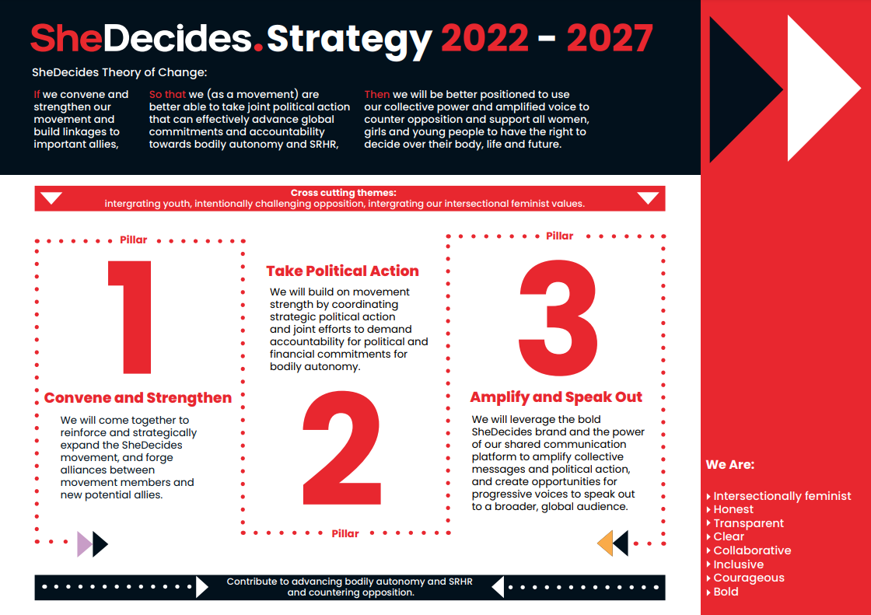

SheDecides Financial support 2023

Existing donors:
Packard: 250.000 (2022/2023)
Canada: 180.000 USD (2023-2024)
France: 60.000 EUR (2023)
UNESCO: 45.700 USD (February-April 2023)
Luxembourg: 226.000 EUR (2023-2024)

Incoming/previously announced/possible new support:
Belgium: 500.000 EUR (tbc 2023-2024)
Netherlands 300.000 USD (tbc) Part of multiannual support, 900.000 USD
2023-2025)
Post code Lottery/Rutgers 400.000 USD (2023-2025)
Sweden: 100.000 USD (tbc 2023)
Germany: 100.000 EUR (tbc 2024)
Packard core: 250.000 USD (2024)
Packard communication/organizational grant: 62.500 USD (2024)

Estimated costs workplan 2023
Total costs SheDecides: $ 1 011 340
IPPF hosting fee (10%): $ 91 940

Detailed multi-annual budget including staff costs, organizational costs provided in annex entailing; coordination SDSU, partnership building travels, team meetings, results reporting, fundraising, MEL, consultancy, capacity building, YAP support, governance and office costs etc
Activity overview:
Pillar 1: $ 44 000
Pillar 2: $ 102 000
Pillar 3: $ 51 000

Fundraising efforts overview 2023:
- We will actively be fundraising throughout the year for our activities and core costs in 2023 and 2024, including to diversify our financial support beyond governmental donors with a focus on initial outreach to selected foundations (such as Ford Foundation, Hewlett, Wellspring, UN Foundation etc).
- We will map out other means of income, such as resource sharing for joint activities with our Champion partners and allies where possible, to reach a fully costed workplan for 2023 and 2024.
- The number of activities and communication support will be reduced in case of not achieving financial targets.
- We will approach Norway and United Kingdom for possible investment in upcoming joint activities particularly in relation to Nexus outreach work ahead of CSW, CPD/ICPD+30, Women Deliver and UHC/SDG review and the Global Safe Abortion Dialogue work in 2023.
- We also wish to increase our collaboration with and support from CIFF with regards to SRHR opposition work and coordination.
- She Decides has had meetings with BMGF and OSF for possible areas of joint interest and investments and we will follow up on this in 2023/2024.
- SheDecides Support Unit is in the process of reviewing the MOU with IPPF to look into possibilities of reducing certain office costs where possible to include financial administrative support within the 10% of the hosting fee, in the full house support agreement with IPPF, as we are now paying extra for instance for our SheDecides financial officer and other administrative costs for SheDecides, on top of the IPPF hosting fee.

