**UNHCR PROJECT PROPOSALS 2023**

**Government of Belgium**

*Total funding EUR 8,000,000*

|  |  |  |  |
| --- | --- | --- | --- |
| 1. **Country** | **Project title** | **Belgium’s funding** | **Page** |
| Ethiopia | Protection assistance to meet the needs of vulnerable Somali refugees in Doolo Zone, Ethiopia | EUR 1,500,000 | 2 |
| 1. Lebanon | Multi-purpose cash assistance (MPCA) to meet the needs of severely vulnerable Syrian refugees in Lebanon | EUR 2,500,000 | 7 |
| 1. Niger | Strengthening access to protection and solutions to refugees, asylum seekers, internally displaced and host communities in Niger | EUR 2,000,000 | 12 |
| 1. Syria | Provision of integrated community-based protection services through UNHCR-supported community centres in the Syrian Arab Republic | EUR 2,000,000 | 19 |
| **Belgium’s Total funding** | | **EUR 8,000,000** |  |

*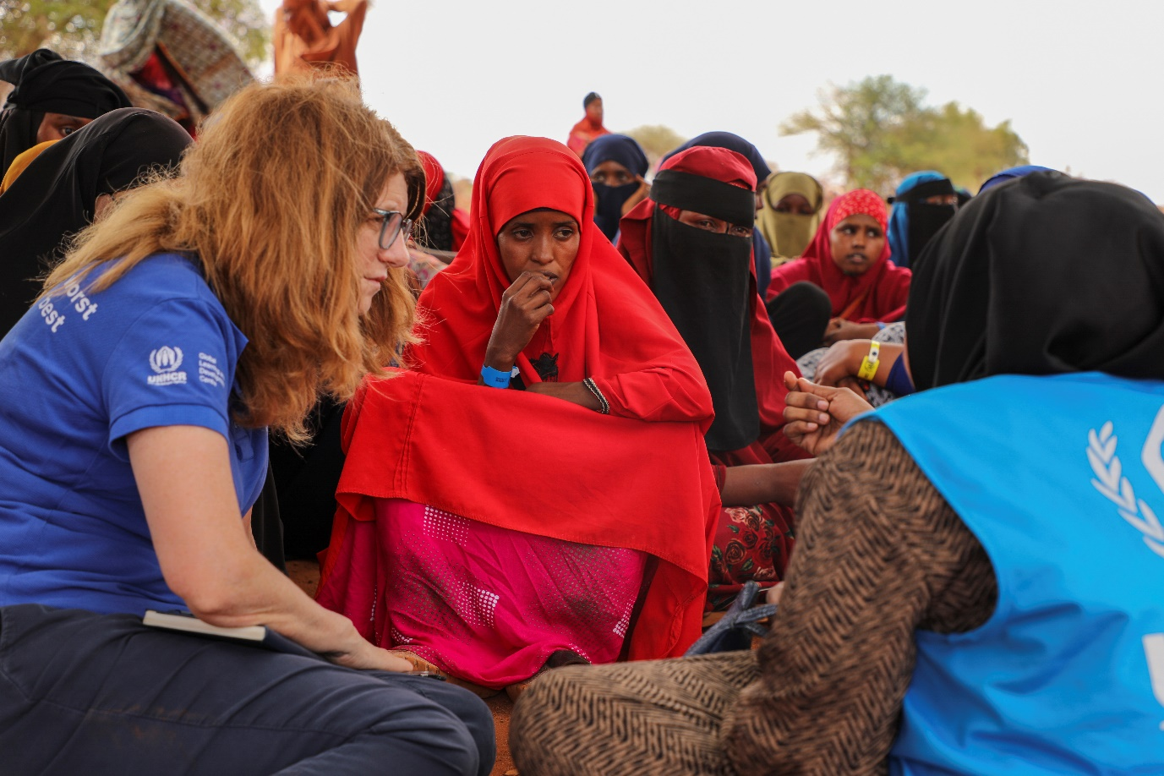UNHCR Emergency Team meets with Somali refugees during Level 1 Registration in Goob, Doolo Zone,*

to assess their most urgent protection needs. ©UNHCR/Lucrezia Vittori

*Protection assistance to meet the needs of vulnerable Somali refugees in Doolo Zone, Ethiopia*

**UNHCR Ethiopia**

August 2023

Project overview

|  |  |
| --- | --- |
| 1. **Project Title** | Protection assistance to meet the needs of vulnerable Somali refugees in Doolo Zone, Ethiopia |
| 1. **Total Budget** | 1. EUR 1,500,000 (USD 1,651,983)* |
| 1. **Implementation Period** | 1. The projects will start after its approval by the Donor for a duration of up to 12 months. |
| 1. **Number of Beneficiaries** | 1. 100,000 vulnerable Somali refugees in Ethiopia |
| 1. **Summary of Project and Expected Outcomes** | 1. The project will contribute to provide protection assistance to severely and highly vulnerable refugee families, by providing registration and documentation to the new arrivals as well as GBV and Child Protection response and assistance to Persons with Specific Needs (PSN). |

*\* The exchange rate used is 0.908 (UN rate August 2023)*

Country background and operational context

Despite UN Security Council calls for an end to the fighting, the conflict that started six months ago continues to intensify in Laascaanood, Somaliland area of Somalia, as Somaliland forces shelled a neighbourhood in Laascaanood on Saturday 24 June. The conflict led to the death of 299 people, injured more than 1,913, and displaced over 150,000 individuals. Those ongoing tensions still push families to flee in Ethiopia where humanitarian actors are struggling to provide emergency lifesaving protection and assistance to over 100,000 refugees who have arrived to the Doolo zone, a remote and drought affected area with limited humanitarian presence.

The humanitarian situation in Ethiopia’s Doolo zone is extremely dire, local communities already suffering from the effect of the drought. According to protection monitoring reports, the response on the ground is severely hindered with four to five households arriving every day in dire needs. Women (43%), children (33%) and people with specific needs, including those with disability (16%) make up for the majority of arrivals. Women reported selling their valuables and belongings to afford transportation to flee violence and reach Ethiopia in search of safety. Most refugees presented with signs of psychological distress caused by the loss of family members in the fighting and separation during fighting and flight.

Since the beginning of the response, only 30,000 refugees have received humanitarian assistance and over 70,000 are dependent on host community families for support with shelter and food. This high presence of refugees in host communities has depleted many of their resources, including water catchment points that amidst prolonged dry periods have been lifesaving. Many refugees sleep in makeshift shelters or in the open to wait for support.

In March 2023, humanitarian actors in Ethiopia launched the Inter- Agency Refugee Response Plan Emergency Appeal[1] in which UNHCR is appealing for $41.7 million to cover UNHCR’s response to the unexpected arrival of Somali refugees in Ethiopia in 2023.

Project objective

The objective of the project is to provide protection assistance to extremely vulnerable refugee families, by providing registration and documentation to the new arrivals. Throughout this process, UNHCR and protection partners will conduct vulnerability screening for groups at risk amongst new arrivals including unaccompanied and separated children, pregnant and lactating women, the elderly, and persons with a disability or serious medical conditions.

In addition, this generous fund from the Government of Belgium will allow to provide adequate GBV and Child Protection response to reduce resorting to negative coping strategies.

Time frame

1. This Project will start after its approval by the Donor for a duration of up to 12 months.

Beneficiaries

The contribution of the Government of Belgium will contribute to provide support to 100,000 vulnerable Somali refugees who escaped clashes and insecurity in the Somali region of Laascaanood and fled to the Doolo zone, in the Somali region of Ethiopia.

Among those new arrivals, the project will specifically target women (43%), children (33%) and people with specific needs, including those with disability (16%).

Activities

**Access to Asylum, Documentation & Registration**

Throughout the project duration, UNHCR together with RRS, humanitarian partners and the Ethiopian Immigration Department will undertake protection monitoring missions at all border-crossing points (official and unofficial) assessing arrivals and immediate needs and ensuring access to territory and asylum. To this end, trainings on international protection principles will be provided to all persons involved in the emergency response.

UNHCR will support the Government of Ethiopia in ensuring that appropriate screening procedures are in place to promote respect for the civilian and humanitarian character of asylum. All new arrivals will be screened during pre-registration at the household level and thereafter undergo individual registration with biometrics undertaken by RRS. Through registration, the refugees will receive documentation, including family attestations and individual identification cards for those above 14 years of age.

Vulnerability screening will be conducted for groups most at risk, including Unaccompanied and Separated Children (UASC), pregnant and lactating mothers, older persons, persons with disabilities and those with severe medical conditions. Protection desks will also be set up to identify and respond to protection cases, and protection monitoring within the settlement conducted.

**Prevention and Response to Gender- Based Violence (GBV)**

To address immediate needs, UNHCR and partners will focus their response on providing case management and referrals to the identified GBV cases. Psychosocial support (PSS) will be provided through access to the Women and Girls Friendly Space and sessions with the social workers. Sexual Reproductive Health (SRH) will be included with the distribution of dignity kits to women and girls. Finally, capacity building will be provided to frontline responders, GBV referral pathways will be established, and community structures supported (including women's networks and organizations). Information will be shared in the Somali language with the community members to inform them of available services for GBV survivors, as well as dissemination on key messages on Protection from Sexual Exploitation and Abuse (PSEA).

**Child Protection Assistance (CP)**

During pre-registration, 3,400 children were identified as unaccompanied and separated (UASC) from their family members across the Doolo Zone. UNHCR and partners will initiate Best Interest Procedures (BIP) upon identification and registration of children at risk. Mental health and psychosocial support (MHPSS) services will also be provided to children and caregivers, including through access to Child-Friendly Spaces (CFS) to allow children to engage in safe play and recreational activities to build their resilience and promote psychosocial wellbeing.

Tracing and family reunification services will take place in collaboration with the ICRC and alternative care placement for UASC will be implemented through the Bureau of Women and Children Affairs (BOWCA) in collaboration with protection partners. Case management training for partners, BOWCA social workers and outreach workers will also be undertaken. Child Protection committees will be established and strengthened to enhance community participation in sensitization, monitoring and reporting child abuse and exploitation in the settlement.

**Assistance to Persons with Specific Needs (PSN)**

Among the new arrivals, 16% have been reported as with specific needs. Throughout this project, PSN will be identified and referred to the adequate services. Distributions of materials will also be undertaken as assistive devices, wheelchairs, crutches and white canes.

UNHCR and partners will work with community leadership structures to support and facilitate community-based protection activities, initiatives and promote peaceful co-existence among new arrivals and host communities. The consultation with the host communities shall be in place parallelly and the specific needs of the host communities with most vulnerabilities shall be considered to promote the social cohesion between refugees and host communities in the aspects of resources sharing.

|  |  |
| --- | --- |
| **Indicator** | **Target** |
| # of refugees registered on an individual basis | 40,000 |
| # of GBV cases supported with survivor-centred services | 240 |
| # of UASC provided with alternative care and/or reunited | 200 |
| # of PSN who received specific support | 1,500 |

Coordination

This emergency response is coordinated by UNHCR with UN partners and NGOs. It aims to support the Government of Ethiopia to meet its international obligations to protect refugees, in line with the Refugee Coordination Model, and to include refugees in national services, fulfilling the Government’s commitment under the GCR. Linking the refugee emergency to ongoing national efforts and policies will ensure a comprehensive response that encompasses protection and solutions.

Local authorities including the Somali regional state and regional government bureaux of health, water, education and planning play a key role in the response. A coordination platform for the refugee emergency in Jijiga has already been set up, co-chaired by the RRS and UNHCR and including sector working groups on protection, child protection and gender-based violence.

The response through this allocation will support the UNHCR Ethiopia Supplementary Appeal which requires $41.7 million to help 100,000 Somali refugees until the end of the year.

Financial Requirements

The table below recapitulates the contribution requested by the UNHCR Ethiopia in relation to the response to the Somali situation.

|  |  |  |  |  |
| --- | --- | --- | --- | --- |
|  |  | **UNHCR’s overall Requirements** | **Proposed Belgian contribution** | |
|  |  | USD | USD* | EUR |
| **Attaining Favorable Protection Environments** | Access to Territory, Registration and Documentation | 2,500,000 | 551,000 | 500,308 |
| Gender- Based Violence | 2,150,000 | 277,180 | 251,679 |
| Child Protection | 2,120,000 | 368,200 | 334,326 |
| Community Engagement and Support to PSN | 600,000 | 166,303 | 151,003 |
| **Staffing Costs** | |  | 188,475 | 171,135 |
| **Sub-total** | |  | **1,551,158** | **1,408,451** |
| Support costs 6.5% | |  | 100,825 | 91,549 |
| **TOTAL** | |  | **1,651,983** | **1,500,000** |

*\* The exchange rate used is 0.908 (UN rate August 2023)*

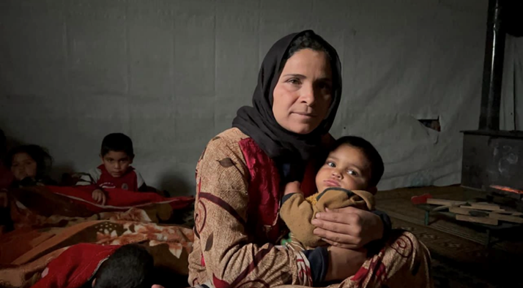

Mariam, a Syrian refugee holds her son inside a tented shelter in the Bekaa Valley. ©UNHCR

*Multi-purpose cash assistance to meet the needs of severely vulnerable Syrian refugees in Lebanon.*

**UNHCR Lebanon**

August 2023

Project Overview

|  |  |
| --- | --- |
| 1. **Project Title** | 1. Multi-purpose cash assistance (MPCA) to meet the needs of severely vulnerable Syrian refugees in Lebanon |
| 1. **Total Budget** | 1. EUR 2,500,000 (USD 2,753,304*) |
| 1. **Implementation Period** | 1. The project will start after its approval by the Donor for a duration of up to 12 months. |
| 1. **Number of Beneficiaries targeted by the contribution** | 1. 8,617 families of severely vulnerable Syrian refugees in Lebanon |
| 1. **Summary of Project and Expected Outcomes** | 1. The project will contribute to providing monthly MPCA to 128,700 of the most severely vulnerable Syrian refugee families to help them meet their basic needs such as shelter, food and medicine. |

*\* The exchange rate used is 0.908 (UN rate Aug 2023)*

Country background and operational context

Lebanon remains the country hosting the largest number of refugees per capita in the world. According to the Government of Lebanon, around 1.5 million refugees are currently residing in the country. The protracted nature of the Syrian refugee situation, coupled with the impact of the economic and financial crisis have cumulatively led to an exponential rise in extreme poverty among refugees, and further eroded the resilience of people to withstand protection risks. At the end of June 2023, 795,322 Syrian refugees and asylum-seekers were registered with UNHCR in Lebanon, in addition to 11,645 refugees and asylum-seekers from other nationalities. The government and people of Lebanon have demonstrated outstanding generosity for many years, despite the heavy economic and social situation the country is currently going through.

The deepening socio-economic crisis continues to undermine the subsistence capacity of already vulnerable refugees and Lebanese. Individuals and families are falling deeper into poverty due to high inflation, rising food prices and loss of income. The 2022 Vulnerability Assessment of Syrian Refugees (VASyR)[2] found that 90 per cent of households are living in extreme poverty and need support to meet their basic needs in 2022. As the situation prolongs, refugees are increasingly struggling to pay for the basic life essentials including rent, food, health care and successive small amounts are accumulating to become burdens that increase their vulnerabilities. Most households also reported borrowing from friends or local supermarkets. As such, most refugee families have incurred high debt, with 93% borrowing money to buy food and 49% borrowing money to pay rent.

Most refugees continue to resort to harmful coping strategies to survive. The 2022 VASyR indicates that some of the most implemented strategies among refugees were reducing expenditure on food (89 per cent), buying food on credit (81 per cent), and reducing expenditure on health (60 per cent) and education (30 per cent). Additionally, one out of ten refugee households reported withdrawing their children from school to reduce expenditures. These coping strategies negatively affect resilience and the capacity to generate income in the future, making refugee families more vulnerable to food insecurity and more dependent on humanitarian assistance.

Project objective

1. The MPCA is an integral part of UNHCR’s comprehensive protection response to refugees in Lebanon. The overall goal of MPCA is to improve the living conditions of vulnerable refugee families and reduce their susceptibility to exploitation and other protection risks such as child labour and survival sex.
2. The objective of the project is to support severely and highly vulnerable refugee families who are already struggling to meet their basic needs, cover additional expenses incurred, and reduce resorting to negative coping strategies.

Time frame

1. This Project will start after its approval by the Donor for a duration of up to 12 months.

Activities

UNHCR’s MPCA programme aims to provide 128,700 of the most severely vulnerable Syrian refugee families in Lebanon with cash assistance to help them meet their essential needs such as shelter, food and medicine. With the support of the Belgium contribution, a total of 8,617 families will be reached with MPCA.

Families are able to withdraw cash from any ATM in Lebanon and afford the goods and services they need most according to their prioritisation without repeatedly travelling to and queueing at distribution points to collect in-kind items.

Functioning markets, technical capacity, adequate banking services, and infrastructure throughout Lebanon allows cash-based assistance to be an effective and efficient modality to meet refugees’ basic needs; shelter, food, medicine, clothing, and household items are readily available through the local market and ATMs are easily accessible. Both refugees and UNHCR value the dignity that cash assistance allows. Injecting cash into the local economy may also contribute to attenuating increasing tensions between refugees and local populations by increasing cash flow in local markets. In this context, cash-based assistance serves as a viable and preferred alternative to in-kind assistance.

MPCA is provided through LOUISE[3], the single electronic card platform established in 2016 that brings together UNHCR, UNICEF, WFP, and NGO partners involved in cash transfer activities in Lebanon. LOUISE, as an inter-organizational platform, oversees the majority of cash-based assistance in Lebanon and provides coordinated and coherent cash-based assistance to Syrian refugees. UNHCR, alongside partners and relevant sectors, uses an econometric formula to predict the expenditure of refugee households as a proxy of socio-economic vulnerability. The model was first introduced in 2016 and is reviewed and updated every year to ensure that the targeting approach stays relevant and is adapted to trends in the refugee community. The formula is derived from the VASyR data.

To ensure that assistance reaches the intended beneficiaries and serves its purpose, UNHCR has put in place a robust system of financial control, verification and monitoring. This includes:

* Identity verification during card collection for beneficiaries who are not yet in possession of an ATM card;
* Validation of beneficiary identity prior to uploading for those who received an ATM card before;
* Card embossment only after identity checks;
* Bank upload instruction through Secured File Transfer;
* Secure File Transfer Protocol (SFTP) protected by digital signature;
* Post-distribution monitoring including withdrawal tracking;
* Outcome monitoring reports;
* Focus group discussions, surveys and distribution record tracking.

UNHCR uses iris scans systematically for the validation process for MPCA and is working towards validating all refugees benefiting from MPCA every three months. Validation by iris scan is also used systematically during the regular registration and protection-related activities when refugees approach UNHCR's reception centres. UNHCR also conducts mobile validation using iris scans for refugees who are not able to approach the centres e.g., due to immobility.

Since 2018, UNHCR has also implemented a grievance redress mechanism (GRM) for the cash assistance programme to enhance responsiveness to refugees who were discontinued from assistance or who were never assisted. The GRM was co-designed by refugees who, themselves, initiated a review process by placing claims through dedicated channels such as UNCHR’s call centre, a web link, and reception centres. In 2022/2023, after a thorough review of the grievance redress mechanism’s (GRM) claims, UNHCR included approximately 13,500 claimants to receive MCAP through the GRM During the targeting and GRM periods, several consultations are held with refugees, such as workshops with Refugee Outreach Volunteers (OVs) and Focus Group Discussions with both assisted and non-assisted refugees. The Call Centre also serves as the main complaint mechanism for refugee families receiving assistance.

|  |  |
| --- | --- |
| **Indicator** | **Target** |
| # of households receiving cash grants | 8,617 |

Beneficiaries

The contribution of the Government of Belgium will contribute to providing a monthly MPCA of USD 25[4] per family to up to 8,617 of the most vulnerable Syrian refugee families (43,085 individuals) to assist them in meeting their most urgent needs. MPCA recipients will include female-headed households, persons with serious medical conditions, the disabled, women at risk, persons with specific legal or physical protection needs, children at risk, single parents, older persons at risk, unaccompanied/separated children and minor-headed households.

The outcome monitoring for MPCA conducted in late 2022[5] indicated that most of the refugees who received cash assistance mainly spent the cash on food (94%), rent (56%), hygiene costs (31%), health care (24%), and bills and utilities (17%). The majority of respondents (97%) mentioned that the assistance improved their living conditions and reduced their feelings of stress. Also, 98% indicated that the assistance contributed to reducing their financial burden.

Financial Requirements

The table below recapitulates the contribution requested by the UNHCR Lebanon in relation to the response to the Syria situation.

|  |  |  |  |  |
| --- | --- | --- | --- | --- |
|  |  | **UNHCR’s Overall Requirements** | **Proposed Belgian contribution** | |
|  |  | USD | USD* | EUR |
| **Realizing Basic Rights in Safe Environments** | Well-being and basic needs (Cash Assistance) | 319,953,963 | **2,753,304** | **2,500,000** |
| Multi-purpose cash assistance for 8,617 families for 12 months | |  | 2,585,262 | 2,347,418 |
| **Sub-total** | |  | **2,585,262** | **2,347,418** |
| Indirect Support Costs 6.5% | |  | 168,042 | 152,582 |
| **TOTAL** | |  | **2,753,304** | **2,500,000** |

*\* The exchange rate used is 0.908 (UN rate August 2023)*



*Photo ©UNHCR/* *Romain Pichon-Sintes*

*Strengthening access to protection and solutions to refugees, asylum seekers, internally displaced and host communities in Niger*

**UNHCR Niger**

August 2023

*Project overview*

|  |  |
| --- | --- |
| 1. **Project Title** | Strengthening access to protection and solutions to refugees, asylum seekers, internally displaced and host communities in Niger |
| 1. **Total Budget** | 1. EUR 2,000,000 (USD 2,202,643*) |
| 1. **Implementation Period** | 1. 12 months from Donor’s Ministerial decree date |
| 1. **Number of Beneficiaries** | An estimated 133,635 refugees, IDPs, asylum seekers and host community members in the regions of Maradi and Diffa |
| 1. **Summary of Project and Expected Outcomes** | 1. The project will contribute to the strengthening of the protection response for refugees, asylum seekers, internally displaced and host communities in the Maradi and Diffa regions of Niger through a comprehensive multisectoral protection response and the provision of support in terms of Core Relief Items (CRIs) and housing to new arrivals, as well as ensuring adequate hygiene conditions. |

*\* The exchange rate used is 0.908 (UN rate August 2023)*

*Project objective*

1. The project's goal is to enhance the protection environment for vulnerable populations, offering support in terms of CRIs and housing, while also ensuring proper hygiene and sufficient access to clean drinking water.

*Country background and operational context*

The context in Niger is heavily influenced by its location in the heart of a turbulent region where violent extremism has been on the rise since 2012 due to the increasing presence of non-state regional-based armed groups (NSAGs) and cross-border incursions and subsequent military push-back operations conducted by government forces.

Niger is facing unprecedented humanitarian challenges that result from years of volatility and growing non-identified armed groups activity in its border regions. Border regions with Nigeria, Burkina Faso and Mali are hosting more than 700,000 persons under UNHCR mandate, and the numbers continue to grow. In addition, persistent terrorist threats – including the activity of Boko Haram – has led to a frequent and preventive internal displacement within the country.

This large-scale displacement to and within the country, is exacerbated by the disproportionate effects of the climate crisis, which is impacting an already fragile economic situation and the living condition of local communities, 80% of whom depend on agriculture. Climate shocks such as floods and droughts only worsen rural poverty and impact public service delivery.

The regions of Maradi and Diffa are witnessing a rapid increase in protection and humanitarian incidents, which require additional support and capacity from the humanitarian community and international stakeholders.

The Lake Chad Basin region continues to see affluxes of Nigerians refugees. Due to repetitive incursions in the Nigerien territory since 2015 the moves in the region become became increasingly mixed, more specifically in the south-east of the region, which hosts over 310,000[6] displaced people (refugees, returnees, IDPs), the majority of whom settled in more than 150 spontaneous sites, villages, and towns along the main route in the region (RN1).

Since 2021, thanks to the increased presence and patrolling of the FDS (*Forces de Défence et Sécurité)* and the engagement of the Government of Niger in providing security, the *Comité Technique Tripartite sur le Nexus Urgence-Développement* (CTTNUD) to develop a national strategy for durable solutions, which includes a regional action plan for the Diffa region and is part of a constructive dialogue between partners and the Government. Although there is still some caution due to prevailing insecurity in Nigeria, progress has been made towards security and populations have found favourable conditions to return to certain areas, albeit with little local support for basic services and individual assistance.

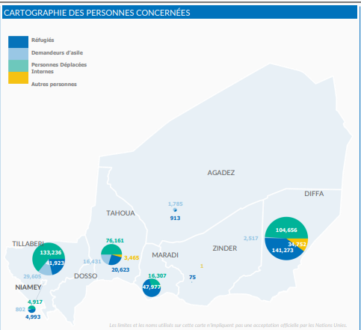The security situation in the Maradi region remains relatively calm. However, there is persistent criminality in the form of kidnapping and cattle rustling, targeting the local community along the border with Nigeria. Incursions by armed individuals are recurrent, especially at night, mainly in the departments of Mandarounfa and Guidan Roumji (see below map).

A total of 81% (76,702) of the displaced persons in the Maradi region are settled in refugee hosting villages along with the host communities. The rest, 31% (17,719), stay in so-called “villages of opportunity”. There are three villages of opportunity, Chadakori hosts 7,915 people, Dan Dadji Makaou hosts 5,445 people, and Garin Kaka hosts 4,359 people. They are models adopted by UNHCR and the Government of Niger to support the most vulnerable individuals and families in the regions, displaced persons and host communities in the framework of an out-of-camp policy. UNHCR and its partners have provided protection services and humanitarian assistance to the population in the villages of opportunity existing since 2019.

In the regions targeted by this project, UNHCR will continue to work closely with all relevant partners to lead the refugee response in all sectors and to provide protection and solutions to displaced populations. On top of this, UNHCR’s work in Niger ensures a comprehensive protection response in the framework of mixed situations, with a particular attention to the most vulnerable persons, such as women, children, and persons with specific needs. [7]

*Time frame*

1. The Project will start after its approval by the donor for a duration of up to 12 months.

*Activities*

The project, funded by the generous support of the Government of Belgium, will aim to contribute to strengthen the protection response for refugees, asylum seekers, internally displaced and host communities in the Maradi and Diffa regions of Niger through a comprehensive multisectoral protection response and the provision of support in terms of CRIs and housing to new arrivals, as well as ensuring adequate hygiene conditions.

**1.Strengthening child protection, reducing Gender Based Violence (GBV) risks, and improving response services**

Although Niger has ratified and adopted several international instruments, the legal and institutional framework for protection remains weak. The national protection services do not have enough resources to respond to the needs of child protection and GBV prevention and response, which makes the support of agencies like UNHCR essential. Over the years, the identification of GBV cases has improved thanks to the efforts of humanitarians but reporting of incidents by survivors remains limited. This is mainly due to customary barriers, harmful traditional practices, fear of reprisals, stigmatization in the community, and insecurity in the region, which does not always allow humanitarian organizations to access the affected population.

The national social welfare services on the ground lack the human resources and capacity to address the major challenges related to the displacement of children, especially unaccompanied or separated children. Specific protection problems affecting refugee children include exploitation and abuse, gender-based violence (child marriage, survival sex, sexual exploitation), child labour, psychosocial distress, family separation, association with armed groups and forced recruitment, and exposure to the risks of mines and other explosive devices, among others.

In addition, the lack of understanding of children's rights and the absence of community-based child rights protection mechanisms makes it difficult to identify, protect and assist refugee children at risk of protection. In this context, girls and boys, especially unaccompanied and/or separated children, and children living with disabilities are exposed to all types of abuse and exploitation.

Funding from Belgium will allow UNHCR to continue this response in 2023 and 2024 while also conducting activities to mitigate the risk of GBV and child protection, improving the response services to address identified needs, and strengthening the protection system in order to promote a protective environment.

The following activities are planned:

* Providing multisectoral response services, such as individual case management, psychosocial support, medical services, legal assistance, and material assistance. The services will be coordinated and managed through a referral system agreed on by partners and the affected communities.
* Conducting awareness-raising sessions and sensitization campaigns on GBV and child protection issues and the availability of response services.
* Advocacy towards various stakeholders (institutions, authorities, partners) on the prevention, risks and response of GBV, including the strict application of laws.
* Promoting the resilience of young girls and women, including survivors of GBV, through support and mentoring in income-generating activities where possible. The interventions will be monitored and reported for accountability towards the affected population.
* Training and refresher sessions will be organized for UNHCR and partners staff on case management and coordination strategy.
* Community-based groups on child protection and GBV will be identified and assisted through training to improve active participation of the community in prevention and response, including identification of risks and reporting.

**2. Ensuring refugees have sufficient basic and domestic items**

While the Government of Niger, UNHCR, and partners continue efforts to ensure refugee families have access to basic goods and services, there is still a significant need. 86% of refugee households are more exposed to high protection and health risks, including respiratory infections, and skin diseases. Support is urgently needed for vulnerable households in the Sayam Forage camp in the Diffa region[8] through the distribution of basic necessities to enable them to live in dignified and acceptable conditions. As local communities hosting refugees often experience increased pressure on scarce resources, support for basic needs and services is also important to support integration and peaceful co-existence.

With the funding, UNHCR will be able to provide non-food assistance to refugees and other vulnerable displaced persons in the camp and sites in the Diffa region as well as the new arrivals from North-West Nigeria in the Maradi region, in alignment with the Non-Food Item (NFI) Working Group strategy. Dignity kits will be distributed to women in reproductive age. The target population will mainly be refugees in Sayam camp and its surrounding in the Diffa region, as well as in urbanized sites as well as in the various villages alongside the border in the Maradi region. In view of the immense needs, priority will be given to the most vulnerable people.

**3. Ensuring refugees and asylum seekers live in satisfactory conditions of sanitation and hygiene**

The current needs in the hygiene and sanitation sub-sector of the target populations relate to the lack of family latrines and disinfection kits both in the Nigerian refugee camp and outside the camp in Chetimari, Gueskerou, and Diffa Departments as well as in the villages of opportunity in the Maradi region. In health centres and schools, existing institutional latrines need to be strengthened to meet standard norms as well as community-based household solid waste management services. In the event of an emergency, the construction of community emergency latrines, household awareness activities on essential good family practices and support in sanitation kits, and prevention of waterborne disease will be carried out. In case of non-assistance in the sub-sector, the degradation of the current living environment could lead to the resurgence of water-related diseases due to a lack of compliance with preventive measures.

The intervention targets the Nigerian refugee population, asylum seekers as well as host community members living in the Sayam Forage camp and in humanitarian housing sites as well as those living the villages of opportunities, which includes families with special needs (female heads of households with dependent minor children, the elderly, the chronically ill, and people with disabilities) and also large families. Schools, health centres and community spaces will be equipped with the community and/or institutional hygiene and sanitation facilities.

With the funding, UNHCR and partners will be able to provide the following support:

* Five hundred separate community or institutional sanitary facilities/latrines (M/F) with handwashing facilities will be constructed in durable materials for existing health centres, schools, and community spaces.
* 1,000 family latrines will be constructed for most vulnerable refugee families with special needs, such as the elderly, persons with disabilities, persons with serious chronic illness, single female households, children-headed households, etc. Beneficiaries will participate in the construction of the latrines where possible. The prioritization will be based on vulnerability and family size, starting with larger families.
* Four waste management and collection sites will be maintained in the camp and in the refugee hosting areas outside the camp and in the return villages, and regular waste collection will be organized.
* Community-based groups and the WASH committees will be trained on good hygiene practices and provided with personal protection kits (PPE), disinfection (chlorine and soaps) and sanitation kits (broom, wire brush and buckets). The groups will carry out maintenance of sanitary facilities and conduct awareness-raising and sensitization campaigns on good hygiene practices in the camp and targeted areas.

The current potable water supply to refugees in the Sayam Forage camp and outside the camp is at 11.12 litres of water/person/day. In addition, the population has to cover long distance to get to water distribution points and there is a lack of water collection, which disproportionately affects women and girls and increases their protection risks. The situation of access to drinking water is even more critical in the return villages, where the existing hydraulic installations are not operational and require rehabilitation work. These conditions also prevent the realization of other important interventions for communities.

With the funding, UNHCR and partners will be able to provide adequate water to the refugees and asylum seekers living in the Sayam Forage camp and humanitarian settlement sites. Schools, health centres and community spaces will be equipped with water points. Two new boreholes with a water distribution network will be constructed. Three existing boreholes will be reinforced and powered with solar energy. The water treatments will be conducted on a regular basis. The activities will be conducted in collaboration with local authorities and refugee communities, including in identifying construction sites and water distribution points.

**4. Providing shelters to refugees**

There is an urgent need to support vulnerable families in Diffa and Maradi with durable shelter kits. Note that 60% of forcibly displaced households do not have access to decent shelter and are exposed to high protection risks, including diseases, such as malaria, fire risks in shelters made of highly flammable materials, and the effects of violent winds and harsh sunshine, with temperatures reaching 45°C in the dry season.

While in line with UNHCR's strategic vision for the Villages of Opportunity in Maradi, the shelter response will be based on a participative and integrated approach. It will be implemented in complementarity with other multisectoral assistance to foster refugees’ reintegration and resilience in terms of shelter, essential household items, and other basic needs. This aims to maximize the impact of UNHCR's protection interventions and improve the living conditions of people of concern. UNHCR will work to find more sustainable shelter solutions aiming to enhance local construction practices, avoid creating division by imposing standards that are too far removed from the existing local construction models, and capitalize on the knowledge and strength of the local markets.

With the ongoing insecurity situation in Nigeria, UNHCR and the Government of Niger forecast to continue receiving asylum seekers in the Maradi region. For that, UNHCR and partners will continue to assist them with emergency shelters for their social and physical protection.

*Beneficiaries*

An estimated total of 133,635 refugees, IDPs, asylum seekers, and host communities in the Diffa and Maradi region will directly benefit from the implementation of these activities.

1. In Diffa region, the activities will be mostly implemented in Sayam Forage camp, while the CRIs will be also distributed within the returnee’s areas, such as the villages of Kablewa, Diffa, Gueskerou, Bosso et Toumour. In Maradi the activities will be implemented in the three villages of opportunity of Dan Dadji Makaou, Chadakori, and Garin Kaka.
2. The selection process of beneficiaries will take into consideration the assessment results of the Age, Diversity, and Gender (ADG) evaluation to define beneficiaries and to define the ones mostly in need for the respective activities. UNHCR will continue to engage and discuss with refugees and persons of concern to better understand their needs and the risks they face.

*Budget*

|  |  |  |
| --- | --- | --- |
|  | **USD\*** | **EUR** |
| 1.Strengthening child Protection, reducing GBV risks, and improving response services | 538,030 | 488,531 |
| 2.Ensuring refugees have sufficient basic and domestic items | 495,595 | 450,000 |
| 3.Ensuring refugees lives in satisfactory conditions of sanitation and hygiene | 440,528 | 400,000 |
| 4. Providing shelters to refugees | 445,653 | 404,653 |
| Activities Total | 1,919,806 | 1,743,184 |
| **Staffing** | **134,750** | **148,403** |
| **Activities + Staffing** | **2,068,209** | **1,877,934** |
| Indirect Support costs 6.5% | 134,434 | 122,066 |
| **TOTAL** | **2,202,643** | **2,000,000** |

*\* The exchange rate used is 0.908 (UN rate August 2023)*

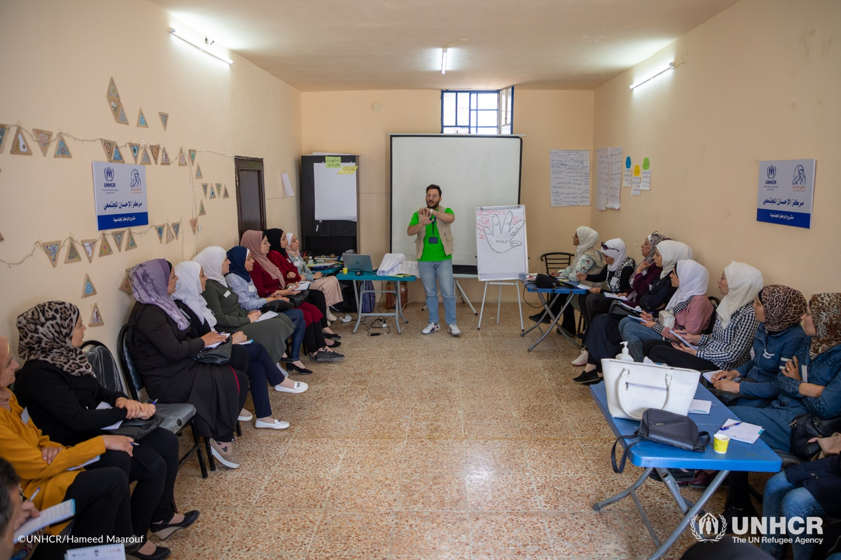

*A workshop for schoolteachers on interactive education at UNHCR-supported community centre in Kafar Dael, Aleppo city*. *© UNHCR/H. Maarouf*

*Provision of integrated community-based protection services through UNHCR-supported community centres in the Syrian Arab Republic*

**UNHCR Syria**

August 2023

Project overview

|  |  |
| --- | --- |
| 1. **Project Title** | 1. Provision of integrated community-based protection services through UNHCR-supported community centres in the Syrian Arab Republic |
| 1. **Total Budget** | 1. EUR 2,000,000 (USD 2,202,643 )* |
| 1. **Implementation Period** | 1. The projects will start after its approval by the donor for a duration of up to 12 months. (Jan-Dec 2024) |
| 1. **Number of Beneficiaries** | 1. Approximately 14,500 individuals *(to be updated upon completion of the 2024 detailed planning exercise in October 2023)* |
| 1. **Summary of Project and Expected Outcomes** | 1. The project will support community-based protection services for communities affected by the crises in Syria (refugees, asylum-seekers, internally displaced people, returnees, and host communities) |

*\* The exchange rate used is 0.908 (UN rate August 2023)*

Country background and operational context

The Syria crisis entered its thirteenth year in March 2023. The security situation in parts of the country remains unpredictable, with the economic and humanitarian situation growing increasingly dire. The continued devaluation of the Syrian Pound, significant hikes in the price of basic commodities, major shortages in essential goods such as fuel, gas and electricity, the wide-ranging effects of the Ukraine crisis, particularly on supply chains, and the debilitating impact of the February earthquakes have all brought additional constraints on the daily lives of the Syrian people in general and in particular those displaced.

The [2023 Syria Humanitarian Needs Overview (HNO)](https://reliefweb.int/report/syrian-arab-republic/syrian-arab-republic-2023-humanitarian-needs-overview-december-2022) estimates that over 15.3 million people need humanitarian assistance in Syria. This is the highest number of people in need since the beginning of the crisis. Syria also has the largest number of internally displaced people (IDPs) in the world with 6.8 million people internally displaced. The 2023 HNO states that humanitarian and economic indicators in the country continue to deteriorate, and many basic services have collapsed. The UN estimates that 90 per cent of Syrians are currently living below the poverty line, with 85 per cent of households unable to meet basic needs and 55 per cent Syrians estimated to be food insecure. The February earthquakes have further compounded existing needs in a country exacerbated by over 12 years of crisis, and an estimated 8.8 million people in Syria have been negatively affected by the earthquakes.

Despite these challenges, and although conditions are not yet fully conducive for a safe, dignified and sustainable return, a limited number of displaced people have spontaneously returned (IDP returnees) to their areas of origin due to a range of reasons, including the inability to afford the cost of living in the urban areas to which they had fled, and the general stabilization of the security situation in their place of origin. According to OCHA, 115,500 IDPs returned to their places of origin in 2022, which brings the total number of IDP returnees since 2017 to 3,405,600. As for refugees who have returned from abroad (refugee returnees), in 2022, UNHCR verified/monitored the return of 50,769 refugees from Türkiye, Lebanon, Jordan, Iraq and Egypt back to Syria. In the first seven months of 2023, UNHCR verified/monitored the return of some 20,000 refugees. In total, between 2016 and July 2023, UNHCR verified/monitored the return to Syria of almost 374,000 refugees.[9] For many, however, the decision to return has meant carving out a precarious existence in areas that are severely damaged and continue to suffer from a lack of basic services and livelihood opportunities.

Syria also hosts refugees and asylum-seekers. As of end-July, some 18,900 refugees and asylum-seekers were registered with UNHCR. The majority of the registered refugees are from Iraq and reside primarily in urban areas in Damascus, Al-Hasakeh, Aleppo, Homs, Tartous and Latakia Governorates. Since refugees and asylum-seekers do not have the right to work, their socioeconomic conditions are even more severe than Syrians, and their vulnerabilities further increased after the February earthquakes.

As part of the UN Country Team and the Humanitarian Country Team in Syria, UNHCR has been providing assistance to vulnerable populations in Syria, including IDPs, refugees, asylum-seekers, returnees and the communities hosting them based on identified needs and vulnerabilities. Interventions include assistance for shelter, provision of [core relief items](https://reliefweb.int/attachments/2c9a55c2-3778-4172-aa88-b4babc903b04/Syria%20-%20Core%20relief%20items%20factsheet%20-%20Oct%202022.pdf), water, sanitation and health (WASH), [education](https://reliefweb.int/attachments/7f229720-8240-4ebb-9d8d-08e36aefbd0f/UNHCR%20Syria%20Education%20Factsheet%20-%20Q4%202022.pdf), [livelihoods](https://reporting.unhcr.org/syria-livelihoods-and-economic-inclusion-factsheet), access to basic services (including minor repairs to schools, hospitals, civil registries, cadastral services), and [protection services](https://reliefweb.int/attachments/d2ddee5d-4697-442b-bd32-7335b186cd4a/UNHCR%20Syria%20Community%20Centre%20Factsheet%20-%20Q4%202022.pdf) (including legal assistance, civil documentation, child protection, prevention and response to gender-based violence).

UNHCR employs a community-based and area-based approach and delivers assistance mainly through community-based protection networks, including UNHCR-supported community centres and outreach volunteers. The community-based protection networks in Syria is fundamental for UNHCR Syria’s Protection and Solutions Strategy, bringing to the fore community participation, reaching out to affected populations, assessing protection risks and vulnerabilities using a participatory age, gender and diversity approach, identifying community resources, responding to the priority needs expressed by communities, strengthening community self-help networks, and offering a wide range of protection services and support to benefit refugees, asylum-seekers, IDPs, returnees and host communities.

Project objective

The project, funded by the generous support of the Government of Belgium, will ensure the delivery of protection interventions through UNHCR’s community-based protection networks to address the needs of refugees, asylum-seekers, returnees, IDPs and host communities. It also aims to enhance the engagement of communities and beneficiaries in the overall assistance delivery.

Time frame

The project will start after its approval by the donor for a duration of up to 12 months.

Activities

This project aims to ensure access of vulnerable people (refugees, asylum-seekers, IDPs, returnees and host communities) to services provided through UNHCR’s community-based protection networks, composed of **UNHCR-supported community centres, satellite centres, mobile units,** and **outreach volunteers**, and enhance the engagement of people and communities in need in assistance delivery.

**UNHCR-supported community centres** are designed as a “one-stop shop,” providing various protection interventions (listed below). Each UNHCR-supported community centre serves 10,000 to 12,000 beneficiaries per year. Besides the community centres, **satellite centres** (smaller versions of community centres providing only some services) and **mobile units** also offer protection services based on identified needs in underserved or remote locations. The latter respond flexibly to population movements and increase outreach to the most vulnerable populations who do not have easy access to the community or satellite centres.

The community and satellite centres are supported by **outreach volunteers**. The outreach volunteers, selected from the affected communities and trained by UNHCR and its partners, play a fundamental and active role in building trust between UNHCR and the communities. The outreach volunteers’ responsibilities are:

* acting as advocates for the most vulnerable members within their communities,
* informing communities of the services available in the community centres,
* identifying needs,
* providing first response, and
* referring cases to the community centres or other services providers for further intervention.

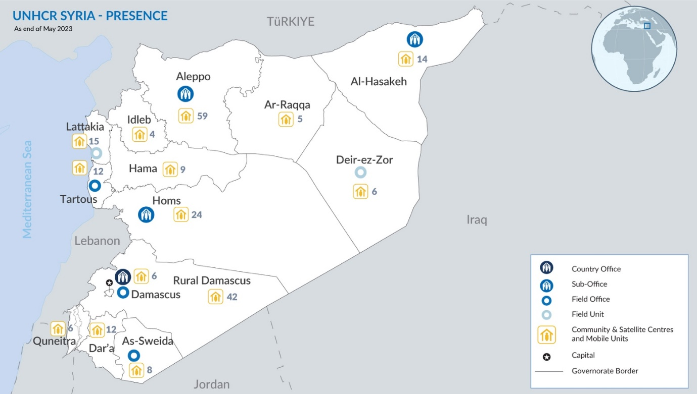As of June 2023, UNHCR was supporting 114 community and satellite centres and 108 mobile units in all 14 governorates of the country and engaging around 2,400 outreach volunteers to strengthen its protection activities.

**Delivering protection services through the community-based protection network**

Indicators:

* # of people receiving protection services through community centers/satellite centers/mobile units
* # of people in leadership and decision-making positions (# of outreach volunteers)

The assistance provided at the UNHCR-supported community centres, satellite centres and mobile teams with the support of outreach volunteers includes:

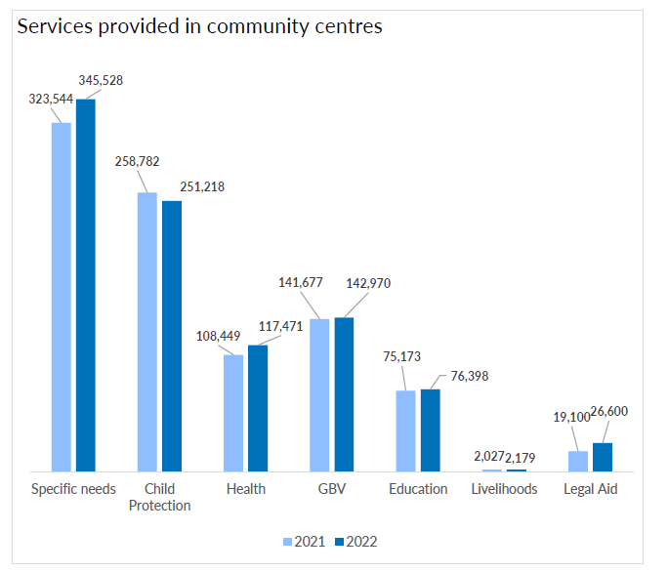

* child protection case management,
* legal awareness and legal aid,
* psychosocial support,
* response and prevention of gender-based violence,
* non-formal education programmes,
* services for persons with disabilities and older persons,
* social and recreational activities,
* life and vocational skills development,
* income-generating support,
* health counselling,
* awareness-raising on a range of protection issues, and
* consultations with communities to ensure their meaningful participation.

People receive the assistance based on their assessed needs and vulnerabilities.

**Supporting community-led initiatives**

Indicator:

* # of community-led initiatives supported

To enhance engagement of beneficiaries in UNHCR’s assistance delivery, UNHCR supports communities to identify their needs and priorities, design projects to address the issues, and implement the projects themselves (“*community-led initiatives*”). The community-led initiatives allow the communities to build up resilience and respond to needs prioritized by themselves.

The community-led initiatives have various objectives such as: social cohesion, life skills development, peace building, conflict resolution, poverty reduction, social protection and social inclusion. Some examples of community-led initiatives are establishing a safe place for students to study, producing winter clothes for older people, sewing school uniforms for children of families in need, repelling insects in residential areas to protect people from insect-borne diseases, and providing equipment to schools.

In 2022, around 900 community-led initiatives were successfully carried out in 14 governorates.

Beneficiaries

The generous funding from Belgium will contribute to supporting approximately 14,500 vulnerable people across Syria (the number of beneficiaries will be confirmed after the detailed planning around October 2023).

Financial requirements

|  |  |  |  |  |  |
| --- | --- | --- | --- | --- | --- |
|  |  | | **UNHCR’s overall Requirements** | **Proposed Belgian contribution** | |
|  |  | | USD | USD* | EUR |
| **Empowering communities** | | Community engagement | 13,484,232 | 2,068,209 | **1,877,934** |
| **Sub-total (project direct cost)** | | | | **2,068,209** | **1,877,934** |
| Support costs 6.5% | | | | 134,433 | 122,066 |
| **TOTAL** | | | | **2,202,643** | **2,000,000** |

*\* * The exchange rate used is 0.908 (UN rate August 2023)*

1. <https://data.unhcr.org/en/documents/details/99687>
2. <https://ialebanon.unhcr.org/vasyr/#/>
3. Lebanon’s One Unified Inter-Organizational System for E-Cards.
4. The amount of cash assistance provided is calculated based on a Minimum Expenditure Basket (MEB). The transfer value might change throughout the implementation depending on fluctuations in the LBP/USD exchange rate and other factors.
5. <https://reliefweb.int/report/lebanon/mid-term-outcome-monitoring-multipurpose-cash-assistance-syrian-refugees-lebanon-september-2022>
6. As of 31 July 2023, https://data.unhcr.org/en/documents/details/99463
7. Please note that despite the Coup d’état in Niger, which took place on 26 July 2023, UNHCR and partners have continued to implement all humanitarian activities and plan to continue and boost humanitarian assistance, continuing to stay and deliver to the most vulnerable populations in need. UNHCR regularly updates its business continuity plan and risk strategy and will inform the Government of Belgium in case any of the proposed activities cannot be implemented as planned.
8. Sayam Forage is the only existing refugee camp in Niger, most of the refugees residing in the country are integrated in existing villages in the framework of an out-of-camp policy, which fosters integration and peaceful co-existence.
9. Note that this is a conservative estimate based on returns that UNHCR has been able to verify and monitor. The actual figures are likely to be higher.