|  |
| --- |
| -  **Sustainable Agriculture Kigoma Regional Project SAKIRP**  **Annual Results Report 2020**  Tanzania |

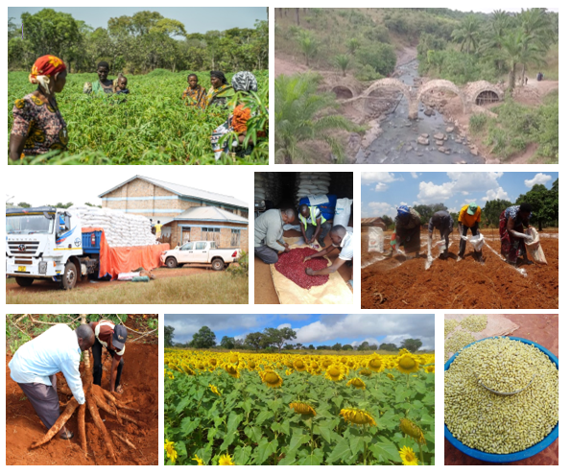

DGD code : 3016473

Navision code : TAN 14 031 11

Contents

1 Acronyms 4

2 Intervention at a glance 6

2.1 Intervention form 6

2.2 Self-assessment performance 8

2.2.1 Relevance 8

1.1.1 Efficiency 9

1.1.3 Effectiveness 10

2.2.2 Potential sustainability 12

2.3 Conclusions. 14

3 Results Monitoring 16

3.1 Evolution of the context 16

3.1.1 General and institutional context 16

3.1.2 Management context 17

3.2 Performance outcome 18

3.2.1 Progress of indicators 18

3.2.2 Analysis of progress made 19

3.2.3 Potential Impact 22

3.3 Performance output 1: value chain coordination. 23

3.3.1 Progress of indicators 23

3.3.2 Progress of main activities 24

3.3.3 Analysis of progress made 24

3.4 Performance output 2: value chain financial services - infrastructure. 27

3.4.1 Progress of indicators 27

3.4.2 Progress of main activities 28

3.4.3 Analysis of progress made 28

3.5 Performance output 3: chain supporters render effective services. 32

3.5.1 Progress of indicators 32

3.5.2 Progress of main activities 32

3.5.3 Analysis of progress made 33

3.6 Performance output 4: farmers & production strengthened. 36

3.6.1 Progress of indicators 36

3.6.2 Progress of main activities 38

3.6.3 Analysis of progress made 38

3.7 Performance output 5: marketing & trade. 49

3.7.1 Progress of indicators 49

1.1.1 Progress of main activities 52

3.7.2 Analysis of progress made 52

4 Budget monitoring 55

5 Risk management 56

6. Synergies and complementarities 58

7. Transversal Themes 59

7.1 Gender 59

7.2 Environment and climate change 61

7.3 Digitalisation 62

7.4 Decent work 62

8 Lessons Learned 63

9. Steering 64

9.1 Changes made to the intervention. 64

9.2 Decisions taken by the steering committee 64

9.3 Strategic re-orientations 66

9.4 Recommendations 67

10. Annexes 68

10.1 Quality criteria 68

10.2 Updated Logical framework 70

10.3 Summary of More Results 72

10.4 “Budget versus current December 2019 report 72

10.5 Communication resources 73

# Acronyms

|  |  |
| --- | --- |
| AAS | Assistant Administrative Secretary |
| AFM | Administration and Financial Manual |
| AFO | Administration and Financial Officer |
| AGRA | Association for Green Revolution in Africa |
| AIDS | Acquired Immunes Deficiency Development Syndrome |
| AMCOS | Agricultural Marketing Cooperative Society |
| ANO | Announcement of No Objection |
| ARDS | Agricultural Routine Data System Tz |
| ARI | Agricultural Research Institute |
| ASARECA | Association for Strengthening Agricultural Research in Eastern and Central Africa |
| ASDP | Agricultural Sector Development Programme |
| ASDS | Agricultural Sector Development Strategy |
| BIO | Belgian Investment Organisation |
| BDSP | Business Development Service providers |
| BFFS | Belgium Fund for Food Security |
| CB | Capacity Building |
| CBO | Community Based Organisation |
| CBODP | Capacity Building & Organizational Development Plan |
| CBSV | Cassava Brown Streak Virus |
| CBTNA | Capacity Building Training Need Assessment |
| CMO | Implementation Agreement |
| CMV | Cassava Mosaic Virus |
| CPI | Capacity Performance Index of farmer groups |
| CRS | Catholic Relief Services |
| CRDB | Cooperative Rural Development Bank |
| CSE | Commercial seed entrepreneur |
| CSO | Civil Society Organisation |
| DADP | District Agricultural Development Plan |
| DAICO | District Agriculture, Irrigation and Cooperative Officer |
| DAP | Diammonium Phosphate – fertilizer |
| DASIP | District Agricultural Sector Project |
| DED | District Executive Director |
| DFP | District Focal Person |
| DRC | Democratic Republic of Congo |
| EA | East Africa |
| ETR | End Term Review |
| FAAB | Farming as a business |
| FHHH | Female headed household |
| FEWSNET | Famine Early Warning Systems Network |
| FO | Farmers Organisation |
| FSP | Financial Service Provider |
| HH | Household |
| GAFCO | Good African Food Company |
| GAP | Good Agricultural Practices |
| GEWE | Gender Equality and Women Empowerment |
| GIS | Geographic Information System |
| GoTz | Government of Tanzania |
| IFAD | International Funds for Agriculture Development |
| IITA | International Institute for Tropical Agriculture |
| JGI | Jane Goodall Institute |
| JLPC | Joint Local Partner Committee |
| LF | Lead Farmer |
| LGA | Local Government Authority |
| LIC | Local investment climate |
| MATI | Ministry of Agriculture - Training Institute |
| MEDA | Mennonite Development Association |
| MFI | Micro finance institution |
| MIS | Market Information System |
| MIVARF | Market Infrastructure Value Addition and rural Finance Support Programme |
| MoCoU | Moshi Cooperative University |
| MoF | Ministry of Finance |
| MoU | Memorandum of Understanding |
| MTR | Mid Term Review |
| MVIWATA | Mtandao wa Vikundi vya Wakulima Tanzania |
| NMB | National Microfinance Bank |
| NRM | Natural Resources Management |
| NRM-LED | Natural Resources Management for Local Economic Development |
| NTA | National Technical Adviser |
| O&OD | Opportunities & Obstacles to Development |
| PASS | Private Agriculture Sector Support Trust |
| PIU | Project Implementation Unit |
| PO-RALG | President’s Office – Regional Administration and Local Government |
| PPP | Public Private Partnership |
| PSC | Project Steering Committee |
| PSO | Private Sector Organisation |
| Pyxus | Sunflower processing firm located in Dodoma |
| QDS | Quality Declared Seed |
| QFP | Quality Food Products Ltd |
| RAS | Regional Administrative Secretary |
| RFT | Regional Facilitation Team |
| RR | Resident Representative |
| RS | Regional Secretariat |
| RSM | Regional Stakeholder Meeting |
| SA | Specific Agreement |
| SACCOS | Saving and Credit Cooperative Organisation |
| SAKIRP | Sustainable Agriculture Kigoma Regional Project |
| SIDO | Small Industries Development Organization |
| SPM | Structured production and marketing |
| SME | Small and medium enterprises |
| TADP | Tanzania Agricultural Development Bank |
| TARURA | Tanzanian Rural & Urban Road Agency |
| TBS | Tanzania Bureau of Standards |
| TCCIA | Tanzania Chamber of Commerce Industry and Agriculture |
| TFF | Technical and Financial File |
| TOC | Theory of Change |
| TOR | Terms of Reference |
| TOSCI | Tanzania Official Seed Certification Institute |
| VC | Value Chain |
| VCA | Value Chain Assessment |
| VCF | Value Chain Finance |
| VICOBA | Village Community Bank |
| WAEO | Ward Agricultural Extension Officer |
| WEO | Ward Executive Officer |

# Intervention at a glance

## Intervention form

|  |  |
| --- | --- |
| Intervention title | Sustainable Agriculture Kigoma Regional Project SAKIRP |
|
| Intervention code | TAN 14 031 01 |
| Location | Kigoma Region Tanzania |
| Sector (CAD codes) | 31120: Agricultural development |
| Total budget | € 8.000.000 Belgium + 800.000 Tanzania |
| Partner Institution | MAFC, PO-RALG / Regional Secretariat Kigoma |
| Start date Specific Agreement | 25th November 2015 |
| Date intervention start | 1st June 2016 |
| Planned end date of execution period | 24/05/2021 + extension till 31/12/2022 approved |
| End date Specific Agreement | 24/11/2021 + extension till 30/06/2023 approved |
| Target groups | Direct beneficiaries: smallholder farmers, especially women and other chain actors of cassava, sunflower & beans value chains. Secondary beneficiaries: local chain supporters private & public. |
| Impact | Local economic development and wellbeing of smallholders is improved in Kigoma Region through sustainable agriculture development |
| Outcome | Smallholders’ income is increased and diversified in Kigoma region, especially for women, through pro-poor value chains development. |
| Outputs | R1: Value chains management and coordination mechanisms are installed and steer cassava and beans value chain development. |
| R2: Sound financial mechanisms are developed and financial organisations are strengthened to support value chains development. |
| R3: Public and private chain supporters provide effective services to value chains actors. |
| R4: Stronger position of small holders, especially women, in the value chain through improved integration and empowerment. |
| R5: Improved market access and sustainable trade |
| Period covered by the report | January - December 2020 |

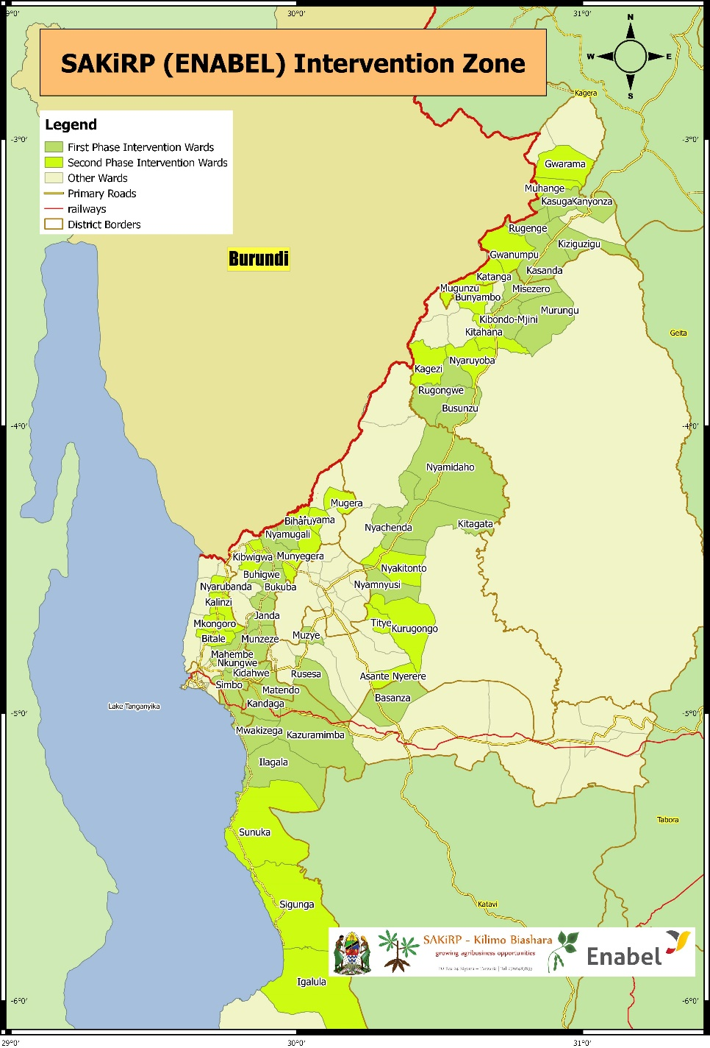-

## Self-assessment performance

### Relevance

|  |  |  |
| --- | --- | --- |
|  | Performance[1]  Self-assessment | Performance  Midterm review |
| **Relevance** | B | B |

The relevance of the project remains robust given:

* Cassava and beans are important crops cultivated and traded in large volumes in Kigoma region. 86% of households in Kigoma rely on crop production as their main source of income (see graph below) while cassava and beans are the biggest income generators across the region.

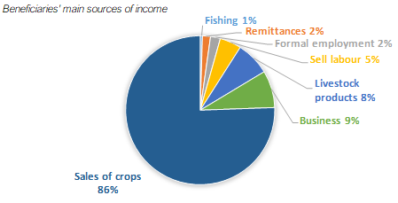

*Source HH survey 2020*

* Value chain development to alleviate poverty and boost economic growth remains high on the national and regional agenda. The Tanzanian government emphasises value addition in the agricultural sector through local processing to spur industrialisation.
* With the absence of an agricultural national programme, local governments in Kigoma Region perceive SAKIRP as central to smallholder agriculture development and increasing crop cess revenue.
* Improving crop yields and generating sufficient commodity volumes for marketing a core factor for the profitability of smallholder farming.
* The construction of bridges to increase the access to markets and social services remains high priority for rural communities and the Tanzanian government.

There were new developments in 2020 that further increased the relevance of SAKIRP:

* Sunflower was successfully added as a third value chain. Local processing of sunflower creates opportunities for value addition and diversifying income in Kigoma region. Growing sunflower is in support of the government policy of import substitution and developing a domestic edible oil sector
* In support of the Tanzanian government policy, SAKIRP provided substantial support to selected mixed crop Agricultural Marketing Cooperative Societies (AMCOS) with the aim of strengthening marketing and generate economies of scale in food crops distribution chains.
* The new Enabel modality of leveraging existing credit guarantee funds opens up new prospects for financial linkage of farmers’ groups and SMEs. The collaboration with PASS and banks is expanding credit access for food crop value chain actors in Kigoma. Improving agricultural credits for smallholder farmers is one of the most critical factors for agrarian development in East-Africa.

Feedback from project partners and the midterm review indicate that the overall intervention logic remains valid. However, some fundamental assumptions made during the formulation have fully not materialized:

* In Kigoma region, value chains are dominated by the informal sector with limited scope for growth and capacity to transform smallholder agriculture. In cassava trade, there are no lead firms. In beans, the few formal firms withdrew because of narrow margins and a difficult business environment. Both crops have only limited opportunities for value addition in Kigoma region.
* Contrary to the optimistic market dynamics during the formulation, conditions for the cassava value chain have deteriorated and stabilised at a low equilibrium.
* The assumption of free trade in East Africa is challenged by the developments on the ground. Border closures and non-tariff barriers between EAC members states are frequent.
* For equity reasons, development projects emphasise the empowerment of farmer groups to engage in collective marketing. However, the socio-economic dynamics on the ground favour the model of individual producer marketing through agents funded by individual traders. The latter system seems to cope better with the existing financial constraints, trading risks and governance-related risks in farmers’ organisations. The long-term viability of the smallholder collective marketing system remains in doubt and would require more time to build and sustain.

### Efficiency

|  |  |  |
| --- | --- | --- |
|  | **Performance**  **Self-assessment** | **Performance**  **Midterm review** |
| **Efficiency** | B | C |

Factors that impacted on efficiency:

1. After the deadlock in the value chain financing component, Enabel obtained the legal mandate to engage in microfinance through the co-funding of existing guarantee facilities in 2020. SAKIRP seized that opportunity to establish a co-guarantee fund with PASS in 2020-Q3. The co-guarantee fund attracted the interest of TADP to work more in Kigoma. It is expected that the co-guarantee fund will leverage bank loans for SME and AMCOS in 2021.
2. The absence of producer organisations that can mobilise a large membership and the fragmented trade of cassava and beans means that there are hardly few economies of scale for value chain development. The VC development work is therefore slow, iterative and transaction costs are high. During the extension phase, SAKIRP is working on developing the capacity of a limited number of AMCOS to mitigate that situation and set positive examples.
3. The focus on smallholder farmers is socially just but requires also a lot of capacity building and patience. SAKIRP has not been in the position to directly support the private sector. Medium-scale commercial farmers with the capacity to co-fund investments and create economies of scale fall outside the project target group and cannot be directly supported. SAKIRP can only support smallholder producer groups which need a lot of support to meet market requirements.
4. While the principle of local contribution builds beneficiary ownership and sustainability, it has also affected the pace of implementation leading to slow budget turn-over.
5. For equity reasons, some districts insisted on the expansion to remote wards or wards without competent agricultural extension workers. While additional assistance is required in such wards, the efficiency is low without effective supervision due to long distances and inadequate staffing.

Factors that contributed to efficiency:

1. The Enabel direct management has proven efficient. The cost efficiency of project activities is good and aligned with market prices. Its focus is on grassroots investments and capacity building.
2. The SAKIRP team has proven flexible and undertaken many judicious adjustments such as reorienting the project towards production, collaboration with the LG extension system, reorienting the investment innovation fund towards public infrastructure and subsequently arch stone bridges, promoting district cluster offices, developing stronger collaboration with local governments, introducing a junior M& E assistant within the team, or deciding to base part of its team outside Kigoma in Kibondo and Kakonko to strengthen ties with the field and facilitate monitoring of district-level activities.
3. The TFF expected expensive grant agreements with NGOs for the implementation of agricultural extension activities and capacity building of producer groups. The project opted for better value for money collaboration with FAAB coaches and the LG extension officers in the field allowing for considerable savings.
4. Collaboration with local authorities, particularly the use of WAEOs to provide extension support to farmer groups, has been commended by MTR as it minimises project implementation costs. In this sense, equipping WAEOs with extension gear, motorcycles, smartphones for mobile monitoring and data collection should be credited for improving SAKIRP’s outreach.
5. The 2 cluster offices allow for a closer follow-up at grassroots level and improved communication with local VC stakeholders. The fact that offices are provided by the Kigoma Regional Secretariat; as well as by the respective district councils in Kakonko and Kasulu; is a mechanism for limiting project costs. It offers opportunities for close coordination with local government authorities[2] and collaboration with other agricultural projects.
6. The stone arch bridge technology has been extremely cost efficient. With a limited construction budget of <1 million euro, SAKIRP will build more than 70 bridges and make a substantial contribution to the road network in Kigoma region.
7. The mobile data management allows for more efficient data collection, two-way communication & learning resulting in better performance monitoring of extension staff.

The budget execution of 55% is a reflection of the cost-efficient approach and a number of project modalities that needed mitigation and could not been implemented immediately.

### Effectiveness

|  |  |  |
| --- | --- | --- |
|  | **Performance**  **Self-assessment** | **Performance assessment**  **Midterm review** |
| **Effectiveness** | B | B |

|  |  |
| --- | --- |
| Result | Achievements |
| * Value chain coordination | * SAKIRP has developed an efficient mobile data collection and analysis system integrated within the LG extension service. It provides, market information and WhatsApp platforms for WAEOs, FAAB coaches and small and medium traders. * High quality studies of the value chains and the domestic and export markets help stakeholders to make correct decisions. * SAKIRP has facilitated dialogue and negotiation platforms between AMCOS members, local government and buyers such as WFP and Pyxus for markets, price setting and targeting serious producers. |
| * Value chain financing | * Progress in value chain financing have only recently gained track and the results will only been seen in the 2 coming years. * An in-kind input revolving fund of 290.000 euro was established to unlock the stalemate in VC financing, boost production and build the credit management capacity of AMCOS. It is anticipated that this experience will increase the eligibility of AMCOS to access bank loans in 2021. The in-kind agricultural input credit recovering rate improved from 51 % in 2019 to 89% in 2020. 1500 farmers were able to access inputs on concessional credit terms. The regrouping of in-kind loans under the AMCOS umbrella and the twinning of AMCOS with FAAB coaches contributed to the better repayment rate. * PASS and SAKIRP set up a 300.000-euro co-guarantee fund so that commercial banks are more willing to fund risky agricultural crop trading. This facility has enabled the collaboration with TADB and 750.000 euro of loans will be issued to 7 AMCOS and 10 SMEs in 2021-Q1. * The business innovation fund was transformed into a “access to markets” infrastructure fund. 21 bridges have been built and 17 are in an advanced construction stage. With the project extension, 70 bridges will be constructed as the fund is very popular with local governments. The strong stone arch bridge technology allows for the mobilisation of local resources and provides a cost saving of 80% compared to reinforced concrete bridges. TARURA is in the process of mainstreaming this technology because of the strength and cost efficiency. |
| * Value chain support services | * SAKIRP has rendered LG extension more operational in Kigoma Region through facilitation, training and performance assessments. Farmers report 96% satisfaction rate of the local government extension services supported by SAKIRP. 11.171 farmers are covered in 54 wards % of the region. 65% of project beneficiaries are women. * SAKIRP trained and facilitated a pool of 9 ward “farming as a business” coaches. They have upgraded producer groups and AMCOS in the field of aggregation, quality and bean marketing. Farmers rate the satisfaction with FAAB coaches as 83%. |
| * Strengthening production & producer groups | * Based on the Capacity Performance Index (CPI), the capacity of the groups has improved from 11% in 2019 to 23% in 2020 being in the highest cat III category. These cat III groups have moved beyond the stage of being merely an association expecting government and donor subsidies. * Through hands-on aggregation and production, 9 AMCOS have grown in their management ability and coordination of collective actions. * Adoption of good agricultural production techniques make a direct impact on poverty reduction and provided the minimum bulk for structured trading. Nevertheless, there is still a lot of scope to improve the production of smallholder farmers. * Community multiplication plots and micro propagation SAKIRP introduced double tolerant cassava varieties in Kigoma region to deal with the brown streak virus outbreak. However, to make an impact the scale of multiplication needs to be stepped up drastically. * Beneficiary farmers report a satisfaction rate of 87% with the peer extension support provided by the lead farmers supported by SAKIRP. * Demonstration that farmers can meet stringent quality standards if provided strict post-harvest management and price incentives. |
| * Markets and trade | * For first time in Kigoma region, smallholder farmers were able to deal with WFP procurement requirements and deliver beans to the refugee camps. Out of order of 500 tons, Kigoma farmers supplied 370 tons. The price was 30% above market price. * WFP appraised the quality of the beans as very high due to strict post-harvest management supported provided to meet standards. * The consolidation of smallholder producer groups into cooperative marketing societies has helped to increase efficiency, mitigate risks and pave way for farmer integration to more structured and formal markets. * To make a regional economic impact, the quantities need to be scaled up significantly. Improvement of production and AMCOS management are key factors to achieving this goal. * 14 aggregation and buying centres were set up and supplied with post-harvest management equipment to improve bean quality management. They have been managed by AMCOS supported by FAAB coaches. * 17 SME entrepreneurs (crop traders and processors, mostly in both beans and cassava) have formed a business membership network to foster collaboration and coordination within the value chains. Plans to formalise this network are underway with support from the Tanzania Chamber of Commerce, Industry and Agriculture (TCCIA). * Based on case study analysis, stone arch bridges reduced transport cost by 50% and increased traffic density of motorcycles and cars by 170%. |
| * Improvement on farmers’ income | * In 2020, the income of the overall beneficiaries increased modestly by 3%. However, the income of AMCOS members that participated in structured bean production & marketing increased by 10% per annum and is 69% above non-beneficiaries. * A pilot of sunflower production/ marketing was added to diversify income and offer better resilience to climate change and poverty threats. The sunflower rollout in 2021 is expected to make an important contribution to HH income. * The income increase for women farmers lags behind their male counterparts. The average income generated by women from structured bean marketing arrangements was 28% below the income of male farmers. |

### Potential sustainability

|  |  |  |
| --- | --- | --- |
|  | **Performance**  **Self-assessment** | **Performance assessment**  **Midterm review** |
| **Potential sustainability** | B | B |

SAKIRP will enter its consolidation and exit phase in 2021-22. Sustainability is the major concern.

Economic sustainability

The adoption of some improved agricultural practices is well-received by producers and increases in agricultural production and productivity will be increased in the short, medium and long run. Limited access to capital and growing challenge of climate variability will most likely hamper the realization of such change.

AMCOS Agricultural Marketing Societies

The sustainability of AMCOS hinges on the integrity of the management, functional checks and balances and on the willingness of the members to invest their own resources and to grow the AMCOS agribusiness. The historic track record of primary societies and cooperatives provides important pointers. Without external support, the informal trade has persevered in coping with the many challenges of agricultural commodity trade in rural areas. During the exit phase SAKIRP will work in the following ways to strengthen AMCOS and contribute to their sustainability:

* Engage the district cooperative officer as an additional level of oversight
* Emphasise member resource mobilisation of AMCOS to foster internal controls.
* Engage formal private sector firms, such as Pyxus, to create a context in which AMCOS can be competitive with informal crop buying agents.
* Leverage the credit guarantees for scaling up the operations of AMCOS. Making sure that the initial loans are properly managed by AMCOS to build a track record amongst banks for future lending in the post SAKIRP phase.

Cassava

The boom in cassava export opportunities to Burundi and Rwanda in the 2015-17 period was a transitory phenomenon which rode on the back of production challenges in the importing countries. Nevertheless, cassava will remain an important component of the farming system in Kigoma because of its low production costs, the resilience to climate change and poor soil fertility. SAKIRP activities help to build the sustainability of the cassava value chain while addressing the main bottlenecks: disease tolerant varieties and phytosanitary measures to reduce the CMD/ CBSV disease threat and increased yield for better smallholder profitability.

Beans

Profit margins for beans sold under structured marketing arrangements are narrow and highly sensitive to farmers’ yields. Increasing yields is central to economic viability of structured marketing arrangements. Meanwhile, climate change is taking a heavy toll on the profitability of bean production. For bean production and trading to be sustainable, reasonable margins must be ensured for all actors to sustain and scale up structured marketing arrangements. The sustainability of directly selling beans to WFP will depend on strategic partnerships with the private sector to meet the requirements of highly formalised procurement processes and minimum commodity volumes. SAKIRP has been connecting AMCOS to diverse buyers that have less stringent procurement requirements to increase sustainability of the bean market linkages.

Sunflower

The outlook of the economic sustainability of sunflower is good because the crop diversifies smallholder income; its production costs are low and it is more resilient to climatic changes that undermine traditional cropping patterns. There is a readily available market for locally processed oil and all non-processed seed that meets minimum quality requirements will be purchased by Pyxus. SAKIRP will scale-up sunflower production to > 1200 Tons in 2021-22. SAKIRP will facilitate loans for installing more SME sunflower expellers. With 2 successful sunflower seasons, additional sunflower presses at strategic wards and anchoring Pyxus in Kigoma, the perspectives for sustainability are good. It is anticipated that sunflower will be fully integrated in the Kigoma farming system.

Bridges for access to markets

The construction of stone arch bridges offers strong perspectives of sustainability. The simple technology has proven to be sustainable over the ages. In addition, the strong involvement of local communities and the Tanzania Rural and Urban Road Authority (TARURA) means that bridge maintenance is likely to be integrated in the local development agenda over the long run. Finally, the creation of a pool of local masons with expertise in stone arch bridge construction, along with the low cost of the technology and the strong level of contribution of beneficiaries towards building material implies that bridge building is likely to continue beyond the SAKiRP project timeframe. Several districts have visited Kigoma region to understudy the technology and have already started the bridge construction. TARURA is mainstreaming the stone arch bridge technology in its annual plan. On the other hand, only 2 TARURA managers in Kigoma have constructed stone arch bridges through their own funding.

Seed & cutting supply

The sustainability of the sunflower hybrid seed supply is guaranteed by the strong involvement of the private sector. Without donor support, commercial cassava cuttings units have been struggling with profitability everywhere in Tanzania. The sustainability of the bean seed sector should not focus on commercialisation but on on-farm seed selection, increased phytosanitary measures and seed dressing.

Value chain financing

The co- guarantee facility identified viable and linked high-potential AMCOS to banks for the provision of working capital loans. Prospects for sustainability are good given the intermediation of PASS Trust which will be available on an ongoing basis. The commercial scalability depends on successful buy-in and roll-over of roles to financial service providers and agribusiness firms. The sustainability of the in-kind input revolving funds is a moderate risk. Without effective oversight, the default rate will increase drastically. Sustainability will be increased by mandating that membership capital contributions be increased to a minimum of 20% to grow the fund and create local checks and balances. Through FAAB coaches and DCOs, SAKIRP will make sure that the initial loans under the co-guarantee fund are properly managed and inspire more trust from the banks.

Ownership

SAKIRP has closely involved regional and local government authorities as well as technical services and other VC stakeholders within its activities, actively working towards building their capacity. As a result, regional and district authorities, extension services, TARURA, TCCIA and SIDO should be in a better position to continue supporting cassava, sunflower and bean value chain development beyond the project timeframe.

To avoid donor dependency, the starting point was to work with existing producer groups that have a minimum track record on the ground and not to create specific project related groups. A lot of efforts are invested in the capacity building of AMCOS, extension workers and lead farmers. These efforts foster local ownership and post-project sustainability.

Ownership by the private sector (farmers, aggregators, processors and international firms) in structured bean market linkages is a sustainability factor which is still being developed. The ownership by Pyxus is excellent with both partners co-funding the activities in the sunflower value chain. The formalisation of the business membership organisation of crop traders and processors will contribute to the sustainability of trading activities across all value chains. The continued involvement of traders depends a lot on the profitability of the value chain.

The SAKIRP principles of alignment with market dynamics and local contribution are important tools to enhance ownership, improve communication and identify core priorities. Examples are the on-farm demo & seed multiplication plots, aggregation of bean produce, grater technology, storage facilities and bridges that require the mobilisation of locally available resources. Community contribution has, however, slowed down the implementation and increased the need for closer monitoring.

Contribution to institutional and management capacity

SAKIRP has been a key player in improving the performance of local government extension services. The experience shows that capacity improvement of extension workers is possible if a dedicated human resource management system is put in place. The government recommends that 20% of the crop cess is used to fund the operational cost (that are now supported by SAKIRP). The mobile phone information system (and Kobo toolbox) appears quite manageable by local authorities. In order to sustain the mobile data collection a stronger alignment with LG data requirements is required.

SAKIRP supports the policies of the Ministry of Agriculture directly through hands-on implementation, investments and experimenting with modalities to adjust to the context on the ground. The examples and lessons learnt (dealing with constraints AMCOS, commercialisation smallholder farms, edible oil sector,) in Kigoma will contribute to robust guidelines in the future.

TARURA is in the process of mainstreaming the appropriate technology of stone arch bridges. The agency has been keen to promote the technology at international workshops and in the Road Boards. This will have a considerable impact on the service provision and outreach of TARURA.

## Conclusions.

1. The project SAKIRP is on track to achieve result 1 (value chain coordination – monitoring & evaluation), result 3 (provision of effective value chain services). It is moderately on track to achieve result 4 (empowerment smallholder farmers) and 5 (marketing and trade) for the larger target population of all 11.000 beneficiaries. SAKIRP has made recent significant gains with structured production and marketing for a selected group of AMCOS (1.000 farmers).
2. In line with the MTR recommendation to prioritize quality over quantity, SAKIRP has focused in 2020 on a limited number of AMCOS as vehicles for increased smallholder capacity building and market / financial linkages. For AMCOS members, the benefits have been significant: annual income increased by 10% and absolute household income was 69% above that of non-beneficiaries. Availability of input loans increased to 77%. The absence of producer organisations that can mobilise a large membership and the fragmented trade of cassava and beans are the main challenges to scaling up these income gains made with AMCOS and make a regional wide impact on poverty alleviation. Whether SAKIRP can turn this situation around will depend on the good governance structures and long-term business orientation of AMCOS and the willingness of banks to take more risks under the PASS / SAKIRP agricultural commodity loan guarantee facility.
3. Value chain financing (result 2) has only recently gained some traction. Transitioning smallholder producer groups to legally recognised institutional forms, such as AMCOS, has been critical for unlocking access to finance and fostering accountability and sustainability. The establishment of a 300.000-euro co-guarantee facility by PASS and SAKIRP has started leveraging the participation of TADB. How AMCOS and SMEs manage the first batch of TADB loans in 2021 will be decisive for the credit roll-out in the remaining SAKIRP period. The in-kind input credits for beans and sunflower made a big difference locally but are difficult to scale-up. Nevertheless, the in-kind loans are improving the management capacity of AMCOS, making them more eligible for bank loans in the future.
4. Cassava prices are only slowly recovering but the production is resilient. The crop is threatened by cassava brown streak virus and only offers limited income and processing opportunities. In 2020, the income of smallholder farmers has improved because of the bean production and marketing. Unfortunately, bean production is highly vulnerable to adverse weather patterns which are characteristic of changing climatic conditions. The adoption of sunflower as a third value chain has offered new perspectives for better crop rotation, improved & diversified income, local value addition, collaboration with the private sector and climate risk mitigation. For the rollout of sunflower VC support the following factors are important: 1- the AMCOS credit discipline & contract management, 2- a balanced approach between local processing/grain sales and 3- reasonable weather conditions will be crucial. A successful sunflower season in 2021 will galvanise the collaboration with Pyxus and growth opportunities for committed AMCOS.
5. The biggest bottleneck to value chain development and market integration for smallholder farmers is low productivity. While production is widespread, it is not adequately concentrated to make the resultant volumes commercially viable for large-scale buyers. Thus, the project’s structured production and marketing linkages must aim at generating economic volume and not geographical outreach. De-risking the production node of all value chains is an imperative for attracting private sector investment in smallholder production. A properly functioning production system reduces funding risks for downstream activities like aggregation, trading and processing.
6. The beneficiaries appreciate the improved services of the local government agricultural extension through the collaboration with SAKIRP. The very high appreciation scores of 96% reflect the difference with the status prior to SAKIRP involvement. More can be done to make WAEO services better result and farmer oriented. The FAAB coaches have an appreciation score of 83%. FAAB coaches play an important role as AMCOS shadow managers.
7. The region-wide construction of stone arch bridges demonstrated the technology and budgetary advantages. The national agency TARURA has understudied the technology and is in the process of mainstreaming it. The community contribution for bridges built local ownership but also reduced the speed of construction. The community contribution principle might need to be reviewed to allow for full budget absorption in remaining limited time frame.
8. The no-cost project extension allows for the consolidation of value chain development initiatives for cassava and beans, fully exploit the value addition and income generating opportunities of sunflower and expand the access to markets / bridge component. There will still be 2 sunflower seasons and one bean season to build the capacity of the most dynamic AMCOS to aggregate produce, manage membership and access bank loans.
9. The budget turn-over is 55% at the end of 2020. In order to achieve full budget absorption during the 2 remaining years, the local contribution for bridges will be reviewed to speed up construction, AMCOS warehouses will be built by full contracts. The investment in phytosanitary pilot zones for cassava and additional sunflower processing at strategic wards will contribute to the budget turn-over in the consolidation phase.

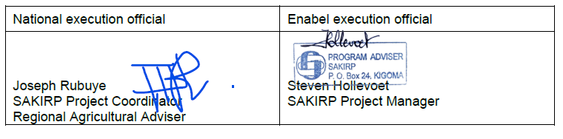

# Results Monitoring[3]

## Evolution of the context

### General and institutional context

The Tanzanian government agricultural policy aims at job creation, intensification of agriculture, commercialisation of smallholder farms, value addition, the creation of mixed crops AMCOS to obtain economies of scale and the promotion of agricultural commodities as raw materials for the industrialisation drive. Nevertheless, sudden changes in policy with more emphasis on price controls of fertilizer & produce, food export regulation, compulsory marketing through cooperative unions and general protectionist tendencies have made an impact on the private investment that is needed to achieve the set agricultural development objectives. Given its distant geographical position from the main markets in Tanzania, economic growth opportunities of Kigoma rely strongly on the export business with East African countries. The planned construction of tarmac roads and the connection to the national electricity grid will improve the competitiveness of Kigoma region.

The governments of Tanzania and Burundi agreed to enhanced voluntary repatriation and a general backing for the refugee camp closure. With the closure of the markets in the camps, neighbouring farmers lost an important outlet especially for cassava and maize. The ongoing border closure between Rwanda and Uganda, led to more Rwandese traders coming to Kigoma for the purchase of maize and cassava.

The 2020 agricultural production season set on with precipitation levels as high as 691.8 mm of rain in the month of December 2019 alone, which by far exceeded the long-term (1998-2018) average precipitation levels of about 175 mm in December months (according to the Tanzania Meteorological Agency, TMA). This heavy rainfall in 2020 caused havoc for bean yields but a bumper harvest of rice. Lake Tanganyika water levels reached a historical record height as with other lakes in East Africa.

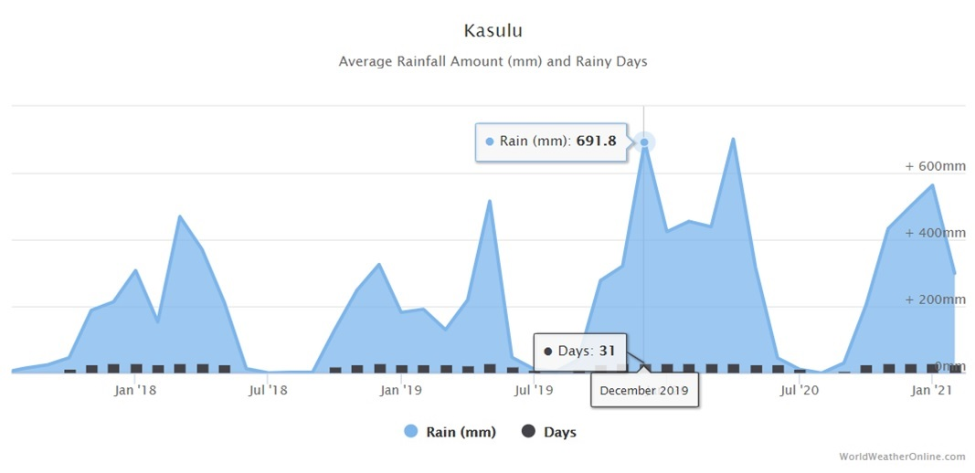

*Source: WorldWeatherOnline.com*

The recovery of cassava production in Rwanda and Burundi triggered a decline in prices of both fresh and dried cassava in Kigoma. This has led to a marked drop in cassava export volumes from Kigoma to Burundi. The danger of cassava brown streak virus lingers on as the virus is established in some wards of Uvinza, Kasulu and Kakonko.

For Kigoma Region, the central government has a strong drive to promote the palm oil value chain with the aim of import subsititution and supply raw materials for the industrialisation policy. The Ministry of Agriculture emphasised the creation of AMCOS for mixed crops. With the help of these AMCOS, farmers should be able to move from subsitence farming to economic production. The government bulk procurement of fertilizer continued and helped to offer DAP and urea at reasonable prices.

The covid-19 pandemic had limited impact on the execution of the project. After a partial lockdown of 2 months, the government removed barriers and activities continued by and large,

The year 2020 was an election period. The executive was fully occupied by the organisation of the elections. In some wards, the local contribution for the bridges became a contentious issue because of electioneering by councillors. As a consequence, the community contribution stopped and bridges were not finalised.

### Management context

#### Partnership modalities

There have been no major changes in the partnership modalities. The Ministry of Agriculture is the line ministry for the coordination at national level. The project is supervised by the steering committee composed of the regional secretariat, the Ministry of Finance and Planning, the President’s office for Regional Administration and Local Governments, the Ministry of Agriculture and Enabel. The Kigoma RAS is the chairperson.

The project implementation unit is anchored in the Kigoma Regional Secretariat. This is relevant for a bilateral project and offers opportunities for networking with local government authorities and the collaboration with new agricultural projects. The Project Coordinator is the regional agricultural adviser with a clear mandate for coordination of agriculture-related activities. In the districts, the DFP is responsible for coordinating activities of extension staff and has direct oversight from the DED. The major partner of a value chain project is the private sector. The private sector is, unfortunately, very informal and hardly organised in Kigoma region. SAKIRP participates as a member in the regional business council facilitated by LIC. For the access to markets / bridge construction component, the collaboration with the Tanzania Rural and Urban Roads Agency is essential.

The project added the PASS Trust as a grantee partner responsible for the implementation of the value chain finance credit co-guaranteeing facility capitalised to the value of €150.000. Alongside the provision of credit risk mitigation cover, PASS Trust also comes in as a business development services provider targeting smallholder farmer cooperatives as well as crop traders and processors. In the sunflower value chain, Pyxus Ltd has been enlisted as a market off-taker for unprocessed sunflower seed. Under this off-taking arrangement, the company guarantees a market for sunflower that meets defined quality standards. Further, the company provides technical backstopping services which help to strengthen the local agricultural extension systems.

#### Operational modalities

SAKIRP follows the financial management and procurement regulations of the Belgian partner (*regie* management). Project staff has been familiarised with those procedures. The project is using a cashless financial system based on Mpesa, in addition to the internet Banking system. The advantages of the good use of the new financial management tool UBW are now visible in through the supports to the project activities. The 2020 financial audit which took place from 15th to 19th February outlined minor problems (related to the management of housing and transport allowance for national staff implemented since June 2020). The project financial turnover stands at 54,7% for 60% of the implementation period. The reorganisation of the administrative and finance team is on-going to allow the project to comply with the new structure of Enabel. Link to that the project implementation manual revision is ongoing and will be submit for amendment soon. The new Enabel resident representative in now on board.

## Performance outcome

This section describes progress made at performance outcome level by linking the outputs with the outcome as visualized below:



### Progress of indicators

|  |  |  |  |  |  |  |  |  |  |
| --- | --- | --- | --- | --- | --- | --- | --- | --- | --- |
| Specific Objective: Smallholders’ income is increased and diversified in Kigoma region, especially for women, through pro-poor value chains development | | | | | | | | | |
| INDICATORS | Project   Baseline | | Overall Target | 2018 | | 2019 | | 2020 | |
| Date | Value | Actual | Target | Actual | Target | Actual | Target |
| I0.1a - % Increase in smallholders’ total income derived from cassava | 2017 | 0% | 2% | -3% | 2% | -18% | 10% | -11% | -5% |
| *MALE* |  | 0% |  | -1% |  | -18 |  | -9 |  |
| *FEMALE* |  | 0% |  | -4% |  | -19 |  | -13 |  |
| I0.1b - % Increase in smallholders’ total income derived from beans | 2017 | 0% | 12% | 4% | 2% | 4% | 4% | 20% | 8% |
| *MALE* |  | 0% |  | 6% |  | 8% |  | 23% |  |
| *FEMALE* |  | 0% |  | 2% |  | 1% |  | 18% |  |
| *SPM-BENEFICIARIES* |  | 0% |  | - |  | 0% |  | 27% |  |
| *SPM-MALE* |  |  |  | - |  | 0% |  | 30% |  |
| *SPM-FEMALE* |  |  |  | - |  | 0% |  | 29% |  |
| I0.1c - % Increase in smallholders’ total income derived from sunflower | 2017 | - | 10% | - | - | 0% | - | 1% | 2% |
| *MALE* |  |  |  | - |  |  |  | 2% |  |
| *FEMALE* |  |  |  | - |  |  |  | 1% |  |
| I0.2a: Total value of **Cassava** traded by smallholder beneficiaries [Billion TZS] **cumulative** | 2017-2018 | 3 | 40 | 10 | 12 | 14 | 18 | 18 | 25 |
| *MALE* |  | 1 |  | 4 |  | 6 |  | 7 |  |
| *FEMALE* |  | 2 |  | 6 |  | 8 |  | 11 |  |
| I0.2b: Total value of **Beans** traded by smallholder beneficiaries [Billion TZS] **cumulative** | 2017-2018 | 1 | 25 | 6 | 8 | 10 | 12 | 15 | 17 |
| *MALE* |  | 1 |  | 3 |  | 4 |  | 6 |  |
| *FEMALE* |  | 1 |  | 3 |  | 6 |  | 9 |  |
| *SPM* |  | 0.4 |  | - |  | 0.4 |  | 1.7 |  |
| *SPM-MALE* |  | 0.2 |  | - |  | 0.2 |  | 1 |  |
| *SPM-FEMALE* |  | 0.2 |  | - |  | 0.2 |  | 0.7 |  |
| Indicator I0.2c: Total value of **Sunflower** traded by smallholder beneficiaries [Billion TZS] **cumulative** | 2019 | 0.03 | 1 | - | - | 0.03 | - | 0.07 | - |
| MALE |  | 0.01 |  |  |  | 0.01 |  | 0.03 |  |
| FEMALE |  | 0.02 |  |  |  | 0.02 |  | 0.04 |  |

*Source: SAKIRP household surveys 2017- 2020 & SAKiRP Farmer Group Database*

### Analysis of progress made

| **Analysis of progress made towards outcome:** | |
| --- | --- |
| *Relation between outputs and the Outcome. (How) Are outputs (still) contributing to the achievement of the outcome:* | * Result 1: Coordination: traders still express a good level of trust in farmers. On the other hand, the producers’ confidence has dropped due to low cassava prices and the negatively perceived role of agents in both value chains. With the collaboration of Pyxus in sunflower value chain, there will be a hands-on test case how VC coordination contributes to income in the SAKIRP exit phase. * Result 2: The new Enabel co-guarantee grant modality made it possible to set up the PASS – SAKIRP loan guarantee facility which attracted the interest of TADB. SME loans were obtained from commercial banks. It is expected that the AMCOS loans will materialize in 2021-Q1. In the meantime, SAKIRP still had to revert to in-kind input loans despite the high risk and distortionary effects of such concessional loans. Notwithstanding their downside, in-kind loans contributed substantially to an income improvement of participating farmers and loan availability. * Result 3: The SAKIRP assistance enabled local government authorities to provide better extension services. 96% of beneficiary farmers appreciate the services rendered by ward extension workers and 87% of services provided by the lead farmers. Nevertheless, the performance of individual extension workers still has room for improvement, and more can be achieved given the modest level of technology adoption. * Result 4: For 86% of beneficiary smallholder farmers, the sale of crops remains the main source of income. Cassava and beans are ranked in first and second position respectively as biggest income generating commonly grown crops in Kigoma in 2020, with sunflower still in a distant 7th position. Beneficiary producers get on average 706,000 Tsh/ year from cassava, 660,000 Tsh from beans and 245,000 Tsh per year from sunflower. The excellent bean prices (1.700- 2.000 Tsh/kg) largely account for the income increase in 2020 as yields were stagnant due to excessive rainfall. Cassava prices slightly recovered during the year. Sunflower added to the income diversification and resilience of targeted farming households. The strengthening of non-organised producer groups and productivity has only had a modest contribution to the income of smallholder farmers contrary to the strengthening of AMCOS through structured production & marketing arrangements which made a real difference on smallholder income. * Result 5: The better organised farmers that participated in structured bean production and marketing saw a strong annual income growth rate of 10%. and their HH income is with 2.26 million Tsh, 69% higher than non- beneficiaries. The sales of beans to WFP were a success with better paid prices and a context that allowed for loan recovery. |
| *Progress made towards the achievement of the outcome (on the basis of indicators):* | Since baseline in 2017, income has increased with 22% however this is equally valid for non-beneficiaries. The annual income growth rate has dropped from 12% to 3%. The income figures for the structured production and marketing subgroup are however substantial: 10% annual income growth and 69% higher nominal annual income compared to non-beneficiaries / 45% compared to beneficiaries not involved in SPM. The total value of beans and cassava traded by smallholder farmers remained below project targets especially for cassava. There are difficulties in tracking actual volumes because of the predominance of informal transactions. In structured bean marketing, targeted volumes could not be reached due to low productivity and high incidence of side-selling by supported farmers.  By the end of 2020, 11.171 smallholder farmers have been reached – amongst them are 65% women. Gender disparities still persist especially regarding size of land cultivated and commodities collectively sold. 993 farmers were reached by structured marketing arrangements. |
| *Issues that arose, influencing factors (positive or negative):* | * The new Enabel modality of credit co-guarantee unblocked the stalemate of the value chain financing. * Cassava prices are slowly recovering but will not reach the boom levels of 2015-17. Sporadic export bans for maize in Tanzania influence the price setting. * High rainfall in 2020 affected the bean yields & production negatively while cassava yields increased. * The covid pandemic affected cross-border trade in cassava and dampened the overall economic outlook. |
| *Unexpected results:* | No remarks |

**Progress made towards the achievement of the outcome (on the basis of indicators):**

Overall income

During the past 2 years, the income of smallholder beneficiaries working with SAKIRP has increased considerably by 22% at an average rate of 7%, per annum which, however, is equally valid for non-beneficiaries. In 2020, the yearly global household income amounted to 1,333,000 Tsh, 1,560,000 Tsh and 2,258,000 Tsh for non-beneficiaries, beneficiaries and beneficiaries involved in bean structured markets, respectively. Attributing the income increase to specific interventions is an almost impossible exercise, as over the past years Kigoma has become a mosaic of interventions with overlapping target groups and activities. Direct attribution is therefore difficult to claim for SAKIRP beneficiaries in general, as the control group might have received other treatments. However, given SAKIRP very focused support towards SPM beneficiaries, the 10% annual SPM income growth rate is largely attributable to the project’s efforts.

-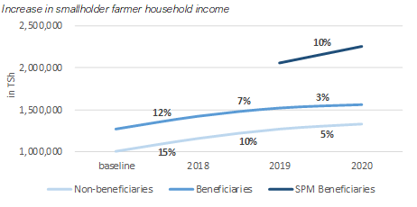

*Source: SAKiRP HH surveys 2017 & 2020*

Income from beans and cassava

After a structural price slump back in 2018, the cassava market started only recovering slowly this year. On the other hand, in 20291-20, bean prices are trending upwards leading to significant income gains at household level. Over the past year, bean prices increased by 57% due to shortages of beans and the consequent increase in demand in neighbouring regions. In October 2020, farm gate prices peaked as high as 2,000 Tsh per kg.

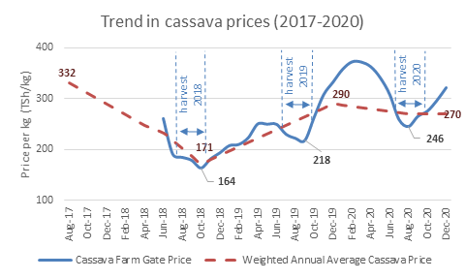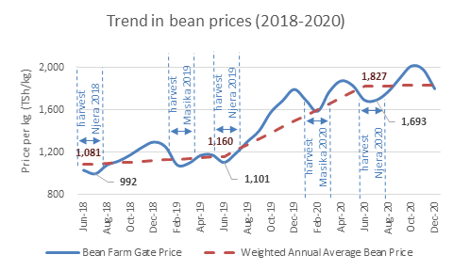

Source: SAKiRP Market Survey (2018-2020)

This translated into a sharp increase of household revenue derived from beans, with beneficiary bean farmers obtaining a 60% revenue increase and SPM beneficiaries achieving a 58% revenue increase from beans in just one year. Sunflower follows in 7th position when ranking crops by their income generating capacity, and as for beans and cassava, some considerable increase in revenue from sunflower was observed.

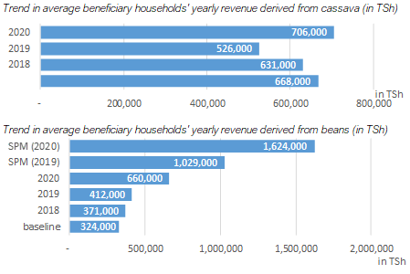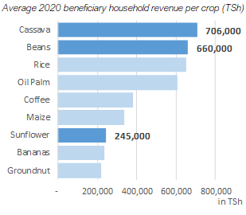*Source: SAKiRP HH surveys 2017-2020*

When also taking cultivation trends into account, i.e., the change in number of beneficiaries cultivating a specific crop, it becomes clear that the sales of beans is the largest contributor having increased the income of beneficiaries by +20.2%, whereas the sales of cassava negatively impacted the average household income by as much a -11.4%. This persisting negative contribution of cassava is mainly explained by the considerable share of beneficiaries that have stopped cassava production, despite the considerable increase in income among those who continued cultivation. Revenue derived from sales of sunflower did not impact the average beneficiary household income (+0.3% regional-wise, and +1.3% in sunflower targeted wards) as the number of farmers cultivating sunflower is still low. Despite low prices, cassava is still retained in the farming system because of its adaptability, low input requirements, tolerance to late planting & adverse weather conditions. It serves as a hedge against growing risks facing farmers.

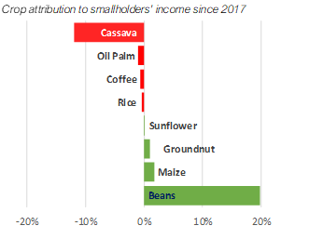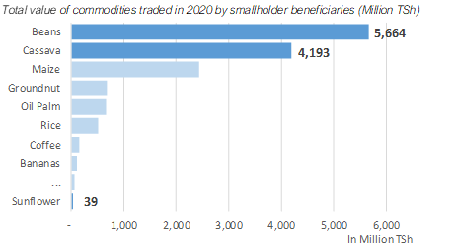

*Source: SAKiRP HH surveys 2017 & 2020*

### Potential Impact

The midterm review identified the following potential impact of SAKIRP beyond its lifespan:

1. Increased production of beans and cassava will contribute to farmers’ income and sufficient commodity volumes to attract more business.
2. Improved rural road network because of the stone arch bridge construction. Enabel’s approach to building bridges, based on a simple aged old technique which can be transferred to local populations will contribute to create local craftsmanship capacities for the future. Seventy bridges constructed will improve access to markets and social services. They will reduce transportation costs, thus contributing to a conducive environment for VC. TARURA has understudied the technology and plans to mainstream it in its annual planning & budget. In this way the SAKIRP experience will be leveraged at national level.
3. With the construction of 70 bridges, SAKIRP will have improved and expanded the rural road network in Kigoma region. A pool of experienced masons and TARURA technicians will ensure the continuity of the stone arch bridges. If TARURA mainstreams the stone arch bridges in its national budget, then considerable costs savings will be made and the its service provision will increase by 80% at national level.
4. Enhanced performance of the local government extension system in the targeted wards of Kigoma region through better training, supervision and working tools. The ward agricultural extension officers will thus potentially benefit agricultural producers for years to come.
5. SAKIRP has developed the capacity of a selected number of AMCOS through hands-on support to production and credit facilities. These commodity aggregation and structured market linkages are at initial stages. They will need to be consolidated and scaled up for them to have a significant and sustainable effect on beneficiaries. The impact of these structured market linkages depends heavily on the integrity and business orientation of the AMCOS leadership. SAKIRP aims to contribute to strengthen the AMCOS management through external oversight, internal checks and balances and growing the trade and aggregation experience in the exit phase.

In addition, the SAKIRP experience is expected to be transformative with regards to:

* If the sunflower production and sales season of 2020/21 will be positive, then AMCOS in Kigoma region will become a major trading partner for Pyxus and other sunflower oil industries. The large-scale integration of sunflower in the farming system of Kigoma region will contribute to local value addition, climate change resilience and building the Tanzanian vegetable oil sector.
* The introduction of Kobo-toolbox set an example of mobile data collection and 2-way communication to improve the management of agricultural departments. Kigoma Region will be an example on which the Ministry of Agriculture can build.
* Farming as a business training and the accompanying agribusiness interventions will orientate smallholder producer groups towards commercial farming and competitiveness.
* The demonstration of the strengths and weaknesses of the value chain development concept for smallholder farming in a remote region.
* Leveraging community-based savings and lending activities to mainstream value chain financing sources to create a blended financing landscape that is both adaptive, affordable and responsive to the needs of resource-constrained farmers.

## Performance output 1: value chain coordination.



### Progress of indicators

|  |  |  |  |  |  |  |  |  |  |
| --- | --- | --- | --- | --- | --- | --- | --- | --- | --- |
| Result 1: VC management & coordination mechanisms are installed & steer VCD | | | | | | | | | |
| INDICATORS | Project   Baseline | | Overall Target | 2018 | | 2019 | | 2020 | |
| Date | Value | **Actual** | Target | **Actual** | Target | **Actual** | Target |
| I1.1a - % of farmers reporting/perceiving  cassava buyers as trustful business partners | 2017-2018 | **24%** | 30% | **28%** | 16% | **14%** | 18% | **6%** | 20% |
| *MALE* |  | **27%** |  | **26%** |  | **17%** |  | **6%** |  |
| *FEMALE* |  | **22%** |  | **30%** |  | **12%** |  | **6%** |  |
| I1.1b - % of farmers reporting/perceiving bean buyers as trustful business partners | 2017-2018 | **24%** | 50% | **27%** | 26% | **13%** | 30% | **13%** | 36% |
| *MALE* |  | **25%** |  | **28%** |  | **15%** |  | **13%** |  |
| *FEMALE* |  | **24%** |  | **27%** |  | **11%** |  | **13%** |  |
| *SPM* |  | **0%** |  | - |  | **37%** |  | **40%** |  |
| *SPM-MALE* |  | **0%** |  | - |  | **38%** |  | **44%** |  |
| *SPM-FEMALE* |  | **0%** |  | - |  | **36%** |  | **36%** |  |
| I1.1c - % of farmers perceiving their sunflower buyers as trustful business partners | 2019 | **3%** | 50% | - | - | **3%** | **-** | **0%** | 15% |
| *MALE* |  | **4%** |  |  |  | **4%** |  | **0%** |  |
| *FEMALE* |  | **0%** |  |  |  | **0%** |  | **0%** |  |
| I1.2a - % of trader reporting/perceiving cassava farmers as reliable suppliers | 2017 | **100%** | 85% | **100%** | 80% | **82%** | 80% | **100%** | 80% |
| I1.2b - % of trader reporting/perceiving beans farmers as reliable suppliers | 2017 | **100%** | 85% | **100%** | 80% | **82%** | 80% | **92%** | 80% |
| I1.2c: % of processors perceiving their sunflower farmers as reliable suppliers | 2019 | **29%** | 85% | - | - | - | - | **100%** | 80% |

*Source: SAKIRP household surveys 2017- 2020 & call-back surveys 2017-2020*

### Progress of main activities

|  |  |  |  |  |
| --- | --- | --- | --- | --- |
| Progress of main activities | A1 | B | C | D |
| 1. *M&E & capitalization framework for VCD are elaborated* |  |  |  |  |
| Monitoring by region |  | X |  |  |
| Conduct annual household survey |  | X |  |  |
| Develop monitoring matrix and data collection tools |  | X |  |  |
| -Train agricultural extension officers on data collection and M&E |  | X |  |  |
| Periodic data collection, analysis and progress tracking. |  | X |  |  |
| Pilot Integration of Mobile data collection into ARDS |  |  | X |  |
| 1. *Forums for enhancing VC management & coordination are conducted* |  |  |  |  |
| Establish innovation platforms |  |  | X |  |
| Regional stakeholders meeting |  | X |  |  |
| District coordination meetings agriculture |  | X |  |  |
| Project steering committee |  | X |  |  |
| 1. *Project capitalisation products are produced & disseminated* |  |  |  |  |
| Develop capitalization products and channels for use of mass media (radio, video, website, brochure etc.) |  | X |  |  |

### 

### Analysis of progress made

**Indicator assessment**

|  |  |
| --- | --- |
| I1.1a - % of farmers reporting/perceiving cassava buyers as trustful business partners | This indicator dropped from 28% in 2018 to 6% in 2020. The long marketing chain with multiple intermediary levels squeezes margins leading to smallholder farmer dissatisfaction. The deterioration is generally blamed on traders who are the visible face of the market; farmers are of the perception that traders are responsible for the decline in prices though this is not accurate. |
| I1.1b - % of farmers reporting/perceiving bean buyers as trustful business partners | This indicator dropped from 27% in 2018 to 13% in 2020. In the season 2019-2020, AMCOS were set up to deal directly with WFP, prop up trust among smallholder bean producers, with as much as 40% of SPM beneficiaries reporting to be satisfied with their business relationships. |
| I1.2a - % of trader reporting/perceiving cassava farmers as reliable suppliers | 100% of traders perceive farmers as reliable suppliers. This is reflective of the confidence that traders have in the capacity of farmers to deliver volumes required. The contrast in the way these two value chain actors perceive each other suggests a need for more dialogue to bridge information gaps which lead to different evaluation basis. |
| I1.2b - % of trader reporting/perceiving beans farmers as reliable suppliers | The 92% confidence exhibited by traders in smallholder farmers mirrors the differential perception basis observed with the cassava value chain. The productivity of both bean and cassava value chains is so low such that a farmer is always in a difficult position to get a better return on invested resources. |
| I1.2c - % of processors reporting/perceiving sunflower farmers as reliable suppliers | Albeit based on a small sample, 100% of processors are satisfied with the reliability of smallholder farmers as suppliers of unprocessed sunflower grain. This could be attributed to the fact that smallholder farmers are supplying improved sunflower varieties which yield more oil for the processors. |

**Value chain coordination**

Value chain coordination has remained a critical objective of the project as the project seeks to scale proven initiatives, bolster sustainability and foster ownership by primary value chain actors. Under the patronage of the regional agricultural office, the project closely coordinates its interventions with other development partners operating within the agriculture sector. The regional cooperative office has become an integral partner as it uses its official mandate to direct efforts to consolidate smallholder farmer action at the level of agricultural marketing cooperative societies (AMCOS). AMCOS have emerged as a central institution for fostering horizontal coordination at farmer level whilst playing a linchpin role in coordinating with input suppliers on the upstream side and large-volume commodity buyers on the downstream.

The enlisting of Pyxus as a value chain partner has created a system in which vertical coordination of the sunflower value chain is well-elaborated. Efforts to crowd in financial service providers to this value chain are underway as the Tanzania Agricultural Development Bank (TADB) has already expressed a need to fund future expansion.

The business membership organisation of crop traders and processors has been initiated as a platform for strengthening horizontal coordination within the trading segment of the value chain. The affiliation of the business membership organisation to TCCIA provides vast scope for improving networking and advocacy on agricultural trading issues.

Together with the above-stated coordination actions, the SAKIRP project is leveraging its robust M&E system and mobile data collection system to generate field-level insights which highlight opportunities and identify opportunities for strengthening value chain-wide collaboration.

The SAKIRP regional stakeholders’ forum meetings continue to be the largest gathering for sharing value chain development progress, best practices and emerging lessons. Despite the slow-down caused by the COVID-19 pandemic, the project still managed to host two stakeholder meetings within the year 2020. Recommendations from the stakeholder meetings were incorporated into project strategies which were approved by the joint local partners committee.

**Monitoring & evaluation**

The MTR commended the SAKIRP mobile M&E system which is seen as an example Kigoma region.

Data related to agriculture, price and markets are collected through:

|  |  |  |  |
| --- | --- | --- | --- |
| Data sources | sample | Data collected / application | Data collection  Tools used |
| 1. Network ward extension workers | 62 | monthly activity monitoring, indicator progress tracking, logistical planning, capacity building, learning | Kobo toolbox, QGIS  WhatsApp |
| 1. Trader and sunflower processor network | 19 | Market information: price, quantity, demands for beans & cassava | WhatsApp groups  Direct phone calls |
| 1. Bimonthly beneficiary tracking | 483 | Agricultural data cassava & beans, market, production costs, technology adoption | Kobo toolbox, |
| 1. Annual HH survey | 1334 | Agricultural, market, credit, HH income, technology adoption, progress | Kobo toolbox,  Call backs |
| 1. Annual call-backs survey | 436 | Government extension, lead farmer & farming as a business services satisfaction |  |
| 1. Capacity Performance Index producer groups | 474 | Accountability, professionalism executive, income diversification, strategic potential, participation, production management, marketing, advocacy | Kobo toolbox,  CPI methodology |

A variety of smartphone applications and software packages are used. Kobo Toolbox has been serving as the main tool for monthly activity monitoring, indicator progress tracking, logistical planning, capacity

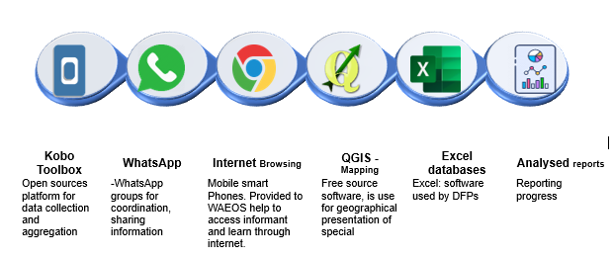

The M&E unit is moving towards server hosting of a web-based dashboard using R and Shiny R with a PostgreSQL backend (moving more of the data management away from Excel), and the use Git for version control. The move to R will allow for automation of data tasks such as Extract-Transform-Load tasks and speed up routine reporting.

The move to PostgreSQL will move the project towards a single source of truth, with a relational database linking project entities logically. This will reduce the common problems faced with data management reliant on spreadsheet tools, such as multiple versions of files which can get out of sync with each other, human error and data quality management as well as ease of data consolidation and accidental data loss, to name a few.

The move to a web based Shiny R powered dashboard will allow for stakeholders to have access to current ad hoc reports, data downloads (again from a single source of truth) and interactive and informative data visualizations, from any location.

**Capitalisation**

The pilot of supporting mobile data collection in ARDS unfortunately aborted due to a lack of formal mandate. The M&E unit produce several radio broadcasts and 3 video documentary modules. bean & sunflower brochure. The manual of stone arch bridges was translated into Kiswahili and is now being reviewed by TARURA and Ministry of Works.

The M&E unit is moving towards server hosting of a web-based dashboards using R and Shiny R with a PostgreSQL backend (moving more of the data management away from Excel), and the use Git for version control. The move to R will allow for automation of data tasks such as Extract-Transform-Load tasks and speed up routine reporting.

## Performance output 2: value chain financial services and infrastructure.

### Progress of indicators

For much of the project period, the implementation of this result was significantly held back by the lack of appropriate tools for improving access to finance by farmers and private sector actors in targeted value chains. As a result, the project has been forced to divert from best practices thereby assuming the role of credit provision which should be assumed by banks and microfinance institutions. Interim mechanisms adopted by the project expose it to excessive risk which threatens the sustainability such interventions as structured marketing and adoption of modern production technologies. In 2020, a breakthrough was achieved through the new Enabel modality of supporting existing co-guarantee funds.

Given the Enabel limitations to support the private sector, the value chain investment fund was transformed into a fund for access to markets for the construction of bridges. This component has become very successful in terms of addressing critical rural road infrastructure constraints, local resource mobilisation and developing a sustainable cost model in collaboration with the Tanzanian Rural and Urban Roads Agency - TARURA.

|  |  |  |  |  |  |  |  |  |  |
| --- | --- | --- | --- | --- | --- | --- | --- | --- | --- |
| Result 2: Financial mechanisms are developed & financial organizations are strengthened to support VCD | | | | | | | | | |
| INDICATORS | Project  Baseline | | Overall Target | 2018 | | 2019 | | 2020 | |
| Date | Value | Actual | Target | Actual | Target | **Actual** | Target |
| I2.1a - % of smallholder’s beneficiaries with access to informal agricultural finance by gender | 2017-2018 | 24% | 35% | 26% | 25% | 24[4]% | 27% | **29%** | 30% |
| *MALE* |  | 3% |  | 20% |  | 24% |  | **29%** |  |
| *FEMALE* |  | 2% |  | 32% |  | 24% |  | **28%** |  |
| *SPM BENEFICIARIES* |  |  |  |  |  | 52% |  | **63%** |  |
| *SPM-MALE* |  |  |  |  |  | 54% |  | **65%** |  |
| *SPM-FEMALE* |  |  |  |  |  | 49% |  | **62%** |  |
| I2.1b - % of smallholder’s beneficiaries with access to formal agricultural finance by gender | 2017-2018 | 1% | 10% | 1% | 2% | 0% | 3% | **0%** | 5% |
| *MALE* |  |  |  | 4% |  | 0% |  | **0%** |  |
| *FEMALE* |  |  |  | 1% |  | 1% |  | **0%** |  |
| *SPM BENEFICIARIES* |  |  |  |  |  | 1% |  | **0%** |  |
| *SPM-MALE* |  |  |  |  |  | 1% |  | **0%** |  |
| *SPM-FEMALE* |  |  |  |  |  | 0% |  | **0%** |  |
| I2.2a - Value of loans provided to AMCOS under guarantee fund [Billions TZS] | 2020 | 0 | 1 | - | - | - | - | **0** | 0 |
| I2.2b - Value of loans provided to crop traders and processors under guarantee fund [Billions TZS] | 2020 | 0 | 0.8 | - | - | - | - | **0** | 0 |
| I2.3 - % of participating traders with access to formal finance | 2019 | 30% | 75% | - | 35% | 29% | 40% | **32%** | 50% |
| I2.4a - % repayment of revolving loans for agricultural inputs | 2018 | 65% | 90% | 65% | 70% | 51% | 75% | **89%** | 80% |
| I2.4b - % repayment rate of loans provided under guarantee fund | 2020 | 92%[5] | 95% | - | - | - | - | **92%** | - |
| I2.5a: Cost reduction achieved through construction of stone arch bridges | 2019 | 0% | 80% | - | - | - | - | **80%** | 80% |

*Source: SAKIRP household surveys 2017- 2020 & call-back surveys 2017-2020 & cost monitoring bridges*

|  |  |
| --- | --- |
| Indicator | Explanatory comments |
| I2.1a - % of smallholder beneficiaries with access to informal agricultural finance by gender | Grassroots savings and lending activities remain the main source of credit for smallholder farmers. 90% of beneficiaries rely on village community bank association loans. |
| I2.1b - % of smallholder groups with access to agricultural finance | This indicator refers to the proportion of groups that have access to formal and semi-formal formal of agricultural credit. This includes concessional loans like the SAKIRP agricultural in-kind loan scheme. |
| I2.3 - % of participating traders with access to agricultural finance | The introduction of the warehouse receipt system by NMB bank has led to a jump in the reach and value of loans accessed by local crop traders. The collateralisation of aggregated crops eliminated the need for stringent collateral requirements which have traditionally constrained loan access. |
| I2.4 - % of participating farmer groups with access to storage facilities | All the groups participating in structured have access to either their own or a rented storage facility. This is because access of a storage facility is used as a criterion for participation in structured marketing arrangements |
| I2.5a: Cost reduction achieved through construction of stone arch bridges as compared to reinforced concrete bridges. | The cost reduction varies between 73-85% (on average 80%) depending on the site and the bridge span. The reliance on locally available materials makes this cost saving possible. |

### Progress of main activities

|  |  |  |  |  |
| --- | --- | --- | --- | --- |
| Planned activities*[6]* | Progress status | | | |
| A | B | C | D |
| Improving financial products & services by banks and improving access to finance by VC actors | | | | |
| Provide and recover in-kind input loans for continual investment |  | X |  |  |
| Design and deploy a credit co-guaranteeing facility |  | X |  |  |
| Provide technical advice to FSPs in developing and adapting products to meet needs of chain actors. |  | X |  |  |
| Promote service linkages between FSPs and chain actors |  | X |  |  |
| Direct investments to support value chain development | | | | |
| Access to markets – construction bridges |  | X |  |  |
| Construction and rehabilitation of village commodity aggregation centres |  |  | X |  |

### Analysis of progress made

Some significant progress was registered in improving the availability of value chain financing credit and services. The implementation of the in-kind agricultural input loan scheme for the bean value chain value chain was hugely successful. Out of the ~€100.000 invested during the 2019/2020 season, 98% was recovered for re-investment in revolving agricultural input facilities managed by the farmer cooperative organisations. The recovered funds were used to purchase inputs for the 2020/2021 agricultural season. Combined with a fresh injection of ~€50.000 the size of the active in-kind loan portfolio for the 2020/2021 season stands at ~€150.000. The total number of farmers with access to in-kind loans stands at just under 1.500 for the current season. A major development has been the roll-out of a credit co-guarantee grant facility implemented the Private Agriculture Sector Support (PASS) Trust. To date, this facility has undertaken to underwrite commodity aggregation loans to the value of ~€750.000. The existence of the co-guarantee facility has also attracted high interest from the Tanzania Agriculture Development Bank (TADB) which is ready to provide aggregation credit to agricultural cooperatives involved in structured bean production and marketing. Consultative meetings with local banks have led to a shared understanding of opportunities and constraints within Kigoma region. On the overall, the outlook for smallholder access to value chain financing services is positive but contingent upon better organisation and capacity-building of cooperative entities that have been established.

The construction of stone arch bridges linking smallholder production areas and commodity trading hubs has picked momentum in 4 districts with a total of 21 bridges completed and 17 being constructed so far.

**Overall agricultural credit access situation**

The recently concluded beneficiary follow-up survey shows that VICOBA groups remain the predominant source of loans for smallholder producers. As much as 52**%** of beneficiary smallholders applied for loans through the VICOBA system. Comparing to the baseline of 2017, not much has changed, apart from the loans that were facilitated by projects being non-existent at baseline level, and accessed by 8% of beneficiaries and by 55% of SPM beneficiaries today.

Figure 1: Sources of credit for **average beneficiaries (left)** and **SPM beneficiaries (right)**

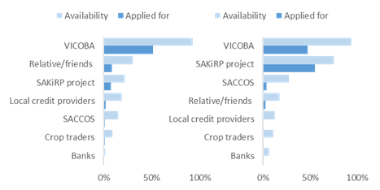

*Source: HH survey 2020*

Credit, mainly applied for through VICOBA groups, is increasingly devoted to agricultural input supply.

In 2020, 60% of beneficiaries that applied for loans, at least partially allocated it to agricultural input supply, compared to 46% in 2017. 64% of this agricultural credit was invested in bean and cassava production, 43% and 21% per crop respectively. A significant increase in investments in bean production must be noted, whereas for cassava some decrease in investments is observed. Other notable changes in credit allocation are the gradual declines in shares of loans reserved for medical bills, school fees and food.

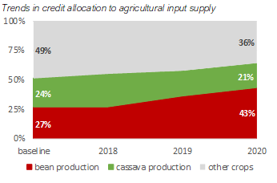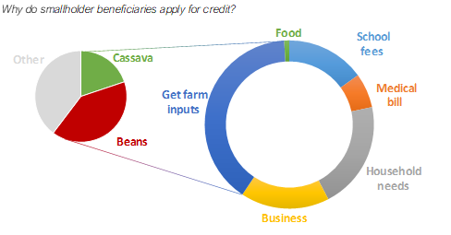*Source: HH surveys 2017-2020*

Lessons from value chain financing initiatives

The value chain support actions anchored on the provision of in-kind loans has yielded several insights and lessons that continual assist the project to adapt and re-pivot its interventions for increased sustainability, impact and outreach. Particularly,

1. De-risking the production node of all value chains is an imperative for attracting private sector investment in smallholder production. A properly functioning production system reduces funding risks for downstream activities like aggregation, trading and processing.
2. Medium-scale farmers are generally more bankable than their smallholder counterparts. Including medium-scale farmers in the portfolio of financed value chain actors mitigates the overall risk for lenders
3. Aggregation lending represents a low-risk entry point for commercial lenders targeting the smallholder farming segment
4. Transitioning smallholder producer groups to legally recognised institutional forms, such as the cooperative, is critical for unlocking access to finance and fostering accountability and sustainability

The following actions will be undertaken to expand and sustain access to value chain financing:

* Put in place mechanisms to leverage invested in-kind loans to build AMCOS resource base and attract additional financing from banks. Specifically, systems for managing the revolving loan funds will be put in place to ensure transparency and accountability in the management of the funds.
* Harmonise structured marketing arrangements with value chain financing provision to mitigate risks and facilitate scaling up. In particular, TADB will be added as a provider of production input financing for the sunflower value chain. This will build on the guaranteed market off-take arrangement that Pyxus provides within this value chain.
* Create a clear link between savings and lending activities of producer groups and the revolving in-kind loans to entrench a culture savings and good credit management

Planned actions for strengthening credit provision to smallholder farmers

* The project is working on a proposal to co-guarantee the provision of loans to smallholder producer groups and crop traders through a call for grants.
* Mobilisation of high-potential SAKIRP-supported farmer groups into AMCOS to build economies of scale and facilitate linkages to formal credit sources
* Providing intensive training and coaching on savings and lending to groups that received in-kind input credit. The objective of these capacity building efforts is to protect and grow the invested funds to strengthen community-based value chain financing
* Sharing of experiences and lessons with the mainstream credit institutions (banks and microfinance institutions)

#### ****Direct investment in public infrastructure “Access to markets”.****

Construction of bridges

This SAKIRP component “access to markets” has gained a lot of popularity amongst the local government and the regional authorities. The community demand for bridge construction is strong but not always matched by the required local contribution. The stone arch bridges are a heavy-duty technology that rely on local resources, present considerable costs savings (80%) and offer the village governments the opportunity to develop their own road network. In 2020, 9 bridges were completed, raising the total of completed structures to 21. A further 17 have been under construction. More than 80 additional sites have been requested by village governments and surveyed. Due to the reduced use of industrial building materials and less need for far distance transport, the carbon footprint of stone arch bridges is 80% less than conventional reinforced concrete bridges.

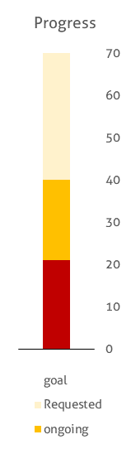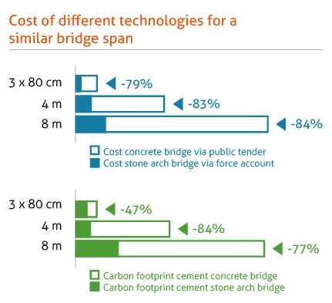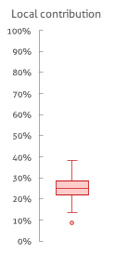

*Source: enumerator call back survey Feb 2020*

**Highlights stone arch bridge construction**

* Reduced construction costs: -80%
* based on a case study analysis:
  + reduction transport cost per 100 kg bag: 50%
  + 170% increase in traffic density
* households reporting to benefit directly from bridge in wards where bridges are constructed: 100%
* households report increased agri-business opportunities (97%) and better transport services (78%) in wards where bridges are constructed
* local resource mobilisation for bridge construction: 20%
* reduced carbon foot print -80%

The collaboration with TARURA was strengthened in 2020. Four districts are firmly on board in Kigoma. TARURA delegations came to Kigoma to understudy the appropriate technology and started construction in districts outside Kigoma. The Kiswahili manual is being reviewed by a TARURA. The TARURA CEO aims at mainstreaming the stone arch bridges in its annual plan and a working committee was constituted for that purpose. A pool of masons has been established but need to be expanded to cope with the demand. The large number of bridges require a lot of follow-up by the project, but it is a worthwhile investment given the local priority of the roads network, strengthening the nascent TARURA agency and the community mobilisation. The slow mobilisation of stones (influenced by the elections in 2019-20) affected the annual planning and budget turn-over. During the SAKIRP exit phase, it will be required to reduce the local contribution and focus on own implementation to achieve full budget absorption.

Warehouses for crop aggregation

Despite the high expectations during the formulation, the construction of warehouses has not taken off as the storage demand is by traders and not producer groups. In 2020, new implementation modalities were designed focusing on AMCOS that are able to aggregate 100 tons, eligible for bank loans and have participated successfully in crop trading. These conditions will ensure that the godowns are used after construction. During the SAKIRP exit phase, the construction of 8 godowns with a total capacity of 250 tons is planned.

## Performance output 3: chain supporters render effective services.

The focus of this result area is on mobilising and developing the capacity of private and public value chain service providers to support farmers, processors and traders. Under the category of public service chain supporters, the project is working with agricultural extension and cooperative departments of local government authorities. The project is working with 56 agricultural extension agents who are involved in providing production and agronomic advice to smallholder farmers. The District Cooperative Officers take the lead in mobilising and building the capacity of agricultural marketing cooperative societies. Within the private value chain service support, the project works with local service providers who take a lead in training and coaching farmers on farming as a business. In addition, the project collaborates with the Tanzania Chamber of Commerce, Industry and Agriculture (TCCIA) and the Small Industry Development Organisation (SIDO) in supporting value chain actors involved in crop processing and commercial trading.

### Progress of indicators

|  |  |  |  |  |  |  |  |  |  |
| --- | --- | --- | --- | --- | --- | --- | --- | --- | --- |
| Result 3: Public and private chain supporters provide functional services to value chains actors | | | | | | | | | |
| INDICATORS | Project Baseline | | Overall Target | 2018 | | 2019 | | 2020 | |
| Date | Value | Target | Actual | Target | Actual | Target | Actual |
| I3.1 - % of farmers reporting to have received useful government extension services | 2017 | 50% | 90% | 70% | 83% | 80% | 91% | 90% | 96% |
| *MALE* | 2017 | 60% | 90% | 70% | 81% | 80% | 97% | 90% | 98% |
| *FEMALE* | 2017 | 40% | 90% | 70% | 85% | 80% | 86% | 90% | 93% |
| I3.2 - % of farmers reporting to have received useful agronomic support from their lead farmers | 2018 | 74% | 90% | 75% | 74% | 80% | 94% | 85% | 87% |
| *MALE* | 2018 | 76% | 85% | 75% | 76% | 80% | 94% | 85% | 89% |
| *FEMALE* | 2018 | 72% | 85% | 75% | 72% | 80% | 94% | 85% | 84% |
| I3.3 - % of traders satisfied with business development support services | 2017 | 0% | 90% | 90% | 100% | 90% | 92% | 90% | 97% |
|  |  |  |  |  |  |  |  |  |  |
| I3.4: % of farmers in participating wards with access to farming as a business service | 2017 | 0% | 80% | - | 24% | - | 19% | - | 36% |
| *MALE* |  | 0% | - | - | 73% | - | 23% | - | 51% |
| *FEMALE* |  | 0% | - | - | 37% | - | 17% | - | 26% |
| I3.5: % of farmers satisfied with the quality of farming as a business service | 2017 | 0% | 80% | - | - | - | - | 80% | 83% |
| *MALE* |  | - | - | - | - | - | - | 80% | 80% |
| *FEMALE* |  | - | - | - | - | - | - | 80% | 93% |

*Source: SAKIRP call-back surveys 2017- 2020*

**-**

### Progress of main activities

|  |  |  |  |  |
| --- | --- | --- | --- | --- |
| Planned activities | Progress | | | |
| A | B | C | D |
| On-the-Job training of Farming as business (FAAB) coaches |  | X |  |  |
| Gender mainstreaming based on midterm review recommendations |  |  | X |  |
| Refresher trainings local government extension staff (extension, diseases, seed systems) |  | X |  |  |
| Supervision and on-the-job coaching of WAEOs and DFPs – monthly performance reports |  | X |  |  |
| Integrated Pest Management for beans - Field training ward extension officers |  | X |  |  |
| Post-harvest management - bean quality - field based |  | X |  |  |
| Agricultural annual ward shows | X |  |  |  |
| Personal demo ward extension officers |  |  | X |  |
| Equipping DFPs and ward extension workers with working & transport gear- laptops |  | X |  |  |
| Monitoring by Local government & DC of SAKIRP activities |  | X |  |  |
| Quarterly District focal person meetings |  | X |  |  |

### Analysis of progress made

|  |  |
| --- | --- |
| I3.1 - % of farmers reporting to have received useful government extension services | This indicator improved further from the baseline 50% > 83% (2018) > 91% and > 96% (2020). The number of useful services increased as well from 2.2 baseline figure to 3.3 (2018) to 5.6 (2019) and 6 in (2020). The heavy investment in capacity building and performance monitoring of WAEOs by SAKIRP improved the extension service delivery. An in-depth analysis is made in the narrative text. |
| I3.2 - % of farmers reporting to have received useful agronomic support from their lead farmers | This indicator improved further from the baseline 50% to 87% in 2020. male farmers systematically reported a higher number of useful services (89% versus 84% for female farmers). An in-depth analysis is made in the narrative text. |
| I3.3 - % of traders satisfied with business development support services | 97% of the traders reported to be satisfied with the BDS services. This is a slight drop from 100% in 2018. |
| I3.4: % of farmers in participating wards with access to farming as a business service | 36 % of farmers reported to have access of FAAB service in 2020 to 0% from the baseline |
| I3.5: % of farmers satisfied with the quality of farming as a business service | 83% of the farmers reported to be satisfied with the FAAB services. This is an increase from 0% in the baseline |
| Gender | Indicators for female farmers are only slightly smaller -pointing to the strong female representation of the beneficiaries. |

The beneficiaries’ appreciation of WAEOs services is much better than the technical review given the different assessment standards. This discrepancy indicates the low level of extension service provision without external support.

**Strengthening local business development services** - **FAAB coaches**

During this period, the project maintained a contingent of nine (9) local service providers who serve as Farming as a Business (FAAB) coaches. To align with the project strategy of consolidating smallholder organisations into agricultural marketing cooperatives, FAAB coaches have specifically been tasked to provide administrative and secretarial backstopping to AMCOS boards. FAAB coaches also play an instrumental in monitoring and advising farmers on group-based savings and lending activities. The farmers’ satisfaction with the usefulness of FAAB coaching services by smallholder farmer stands at 83%.

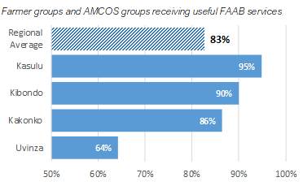

*Source: Call-back survey 2020*

The modest FAAB assessment by the beneficiaries in Uvinza is directly related to his strict handling of the recovery of outstanding loans. From a technical perspective, this FAAB coach should have obtained a higher-than-average score.

Sustaining the provision of farming as a business coaching

Continued provision of farming as a business services beyond the end of the project is essential for the sustainability of structured marketing linkage arrangements. The project is considering gradual monetization of some aspects of FAAB support services. The retention of FAAB coaches is also dependant on the availability income generating opportunities hence the need to create broader opportunities for this category of service providers. In this regard, the project is encouraging the current cohort of FAAB coaches to come with a formal institutional structure/vehicle to enable them to bid for jobs beyond the framework of SAKIRP.

**Local government extension services**

The main service provider is the local government extension service as better production remains the critical bottleneck to the improvement of smallholders’ income. Based on the results of the random call-back survey, the strong SAKIRP investment in the LG extension system has paid off. Smallholder beneficiaries reporting to have received useful extension services increased significantly from the baseline value of 50 to 96% in December 2020. The number of services received per year increased significantly from 1 to 6.

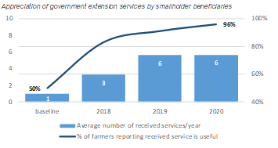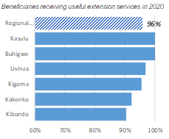

*Source: Call-back surveys 2017-2020*

There was a slightly better appreciation by beneficiary farmers involved in structured marketing. The non-beneficiary group reported a lower satisfaction rate of 74%. The improvement is even larger for benefitting female farmers: from the baseline value of 40% to 85% in 2018 and this is linked to the selection of VICOBAs as benefiting groups.

In 2020, the total SAKIRP has covered 56 wards which is about 54% of the rural wards in Kigoma region. The MTR recommended that the project should look for quality and result consolidation and not further expand. Expanding to more wards has challenges: overlap with other projects and in many remaining wards there is often no extension worker that can meaningfully absorb the assistance provide by a development project. SAKIRP provides 70% of the functional motorcycles for agricultural extension in the intervention zone and 100% of the smart phones. On average, an extension worker is coaching 8 farmers groups and 200 farmers. There are 9 female WAEOs (16%).

**WAEO own personal demo plots**

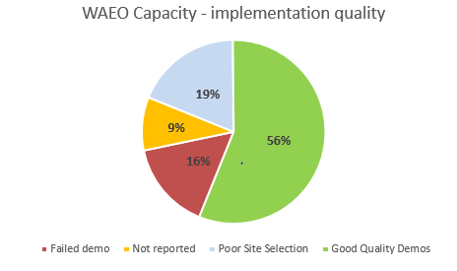

*Source: SAKIRP M&E 2020*

The quality of the personal demonstration plots serves as a proxy WAEO performance indicator. Conducting a demo remained a challenge for a number of extension workers. While all extension workers were facilitated, only 56% implemented a bean demo according to standards sufficient to promote the technology. 19% were unable to establish a useful demo while 25% totally failed. This is an improvement compared to last year when only 26% of WAEOs conducted a quality demo.

**Overall extension performance**

|  |
| --- |
| The extension workers’ performance was systematically evaluated on a monthly basis and reported to the DAICO. Factors contributing to the success of local government agricultural extension |
| 1. Personal commitment and professional ethics of the agricultural extension officer. 2. Good communication between WAEO and community and setting a personal example through enthusiastic hands-on demonstration. 3. Regular on the job supervision and coaching by the direct supervisor. 4. Effective human resource management of the DAICO’s office / DED. 5. Well organised producer groups demanding quality extension services from WAEO 6. Profitable agricultural value chains that generate household income 7. Facilitation of extension officers with transport and communication. |

Challenges that remain under this result area include the following:

* Lack of effective demand for agribusiness development services. This discourages experienced service providers from locating in Kigoma region.
* Limited local government budgets impact on provision of services as mobility is limited. Crop cess is not reinvested in agricultural extension. It is unlikely that the WAEO facilitation in transport and communication will continue beyond the SAKIRP lifespan.
* Limited human resources are available at the district agricultural departments. The majority of districts is headed by an acting DAICO and staffs have to combine several functions to deal with the workload and on the job backstopping of WAEOs. Some agricultural extension officers double as ward executive officers. The quality of district reporting needs improvement.
* The quality of the services rendered by consultants needs constant supervision.

## Performance output 4: smallholder farmers & production strengthened.

### Progress of indicators

|  |  |  |  |  |  |  |  |  |  |  |  |  |
| --- | --- | --- | --- | --- | --- | --- | --- | --- | --- | --- | --- | --- |
| Result 4: Stronger position of smallholder’s farmers in VC is enhanced through improved productivity, economic integration & empowerment | | | | | | | | | | | | |
| INDICATORS | Project   Baseline | | | Overall Target | 2018 | | | 2019 | | | 2020 | |
|  | Date | | Value | **Actual** | Target | | **Actual** | | Target | **Actual** | Target |
| I4.1a - Smallholder gross margin per hectare of cassava [Tsh] – *growing season >18month* | 2017 | | **657.000** | 680.000 | **106.400** | 660.000 | | **106.386** | | 660.000 | **267.000** | 660.000 |
| I4.1b - Smallholder gross margin per hectare of beans [Tsh] -  *growing season 4 months* | 2017 | | **-146.830** | 680.000 | **19.857** | 50.000 | | **191.000** | | 120.000 | **454,500** | 250.000 |
| I4.1c - Smallholder gross margin per hectare of sunflower (grain) [Tsh] - *growing season 4 months* | 2020 | | **210.000** | 300.000 | **-** | - | | **210.000** | | - | **210.000** | 250.000 |
| I4.2a - % adoption of **cassava** improved GAP by smallholder beneficiaries | 2017-2018 | | **10%** | 40% | **13%** | 12% | | **23%** | | 15% | **30%** | 20% |
| *MALE* |  | | **-** |  | **15%** |  | | **24%** | |  | **33%** |  |
| *FEMALE* |  | | **-** |  | **12%** |  | | **21%** | |  | **27%** |  |
| I4.2b - % adoption of beans improved GAP by smallholder beneficiaries | 2017-2018 | | **18%** | 50% | **29%** | 20% | | **35%** | | 25% | **44%** | 35% |
| *MALE* | |  | **-** | |  | **34%** |  | **40%** | | |  | **50%** |  |
| *FEMALE* | |  | **-** | |  | **22%** |  | **31%** | | |  | **39%** |  |
| I4.2c - % adoption of sunflower improved GAP by smallholder beneficiaries | 2019 | | **19%** | 40% | **-** | - | | **19%** | | - | **0[7]** | 20% |
| I4.3a - Yield of dried cassava [MT/Ha] | 2017-2018 | | **2,9** | 4 | **3,1** | 3,0 | | **3.4** | | 3,2 | **3,6** | 3,5 |
| *MALE* |  | | **3,1** |  | **4,0** |  | | **3.7** | |  | **3,8** |  |
| *FEMALE* |  | | **2,7** |  | **3,4** |  | | **3.2** | |  | **3,5** |  |
| I4.3b - Yield of beans [Kg/ha] | 2017-2018 | | **440** | 700 | **570** | 500 | | **542** | | 575 | **536** | 635 |
| *MALE* |  | | **411** |  | **568** |  | | **573** | |  | **560** |  |
| *FEMALE* |  | | **469** |  | **588** |  | | **511** | |  | **513** |  |
| *SPM BENEFICIARIES* |  | | **533** |  |  |  | | **533** | |  | **545** |  |
| *SPM-MALE* |  | | **558** |  |  |  | | **558** | |  | **613** |  |
| *SPM-FEMALE* |  | | **504** |  |  |  | | **504** | |  | **473** |  |
| INDICATORS | | Project   Baseline | | | Overall Target | 2018 | | | 2019 | | | 2020 | |
|  | | Date | | Value | **Actual** | Target | | **Actual** | | Target | **Actual** | Target |
| I4.3c - Yield of sunflower [Kg/ha] | 2019 | | **523** | 750 | **-** | - | | **523** | | - | **588** |  |
| *MALE* |  | | **555** |  |  |  | | **555** | |  | **655** |  |
| *FEMALE* |  | | **488** |  |  |  | | **488** | |  | **413** |  |
| I4.4a: % of smallholder beneficiaries engaging in collective marketing of **cassava** | 2017-2018 | | **8%** | 10% | **10%** | 15% | | **5%** | |  | **6%** | 10% |
| *MALE* |  | |  |  | **12%** |  | | **5%** | |  | **8%** |  |
| *FEMALE* |  | |  |  | **8%** |  | | **4%** | |  | **4%** |  |
| I4.4b - % of smallholder beneficiaries engaging in collective marketing of beans | 2017-2018 | | **5%** | 10% | **10%** | 3% | | **6%** | | 4% | **21%** | 6% |
| *MALE* |  | | **3%** |  | **12%** |  | | **8%** | |  | **23%** |  |
| *FEMALE* |  | | **6%** |  | **8%** |  | | **5%** | |  | **19%** |  |
| *SPM-BENEFICIARIES* |  | | **0%** |  |  |  | | **88%** | |  | **100%** |  |
| *SPM-MALE* |  | | **0%** |  |  |  | | **88%** | |  | **100%** |  |
| *SPM-FEMALE* |  | | **0%** |  |  |  | | **88%** | |  | **100%** |  |
| I4.4c: % of smallholder beneficiaries engaging in collective marketing of sunfloweramong participating sunflower producers | 2019 | | **1%** | 15% | **-** | - | | | **1%** | - | **6%** | 2% |
| *MALE* |  | |  |  |  |  | | | 2% |  | **5%** |  |
| *FEMALE* |  | |  |  |  |  | | | 0% |  | **11%** |  |
| I4.5: % of sunflower farmers adding value through processing | 2019 | | **51%** | 60% | **-** | - | | | **51%** | - | **70%** | - |
| *MALE* |  | | - |  | - |  | | | 58% |  | **77%** |  |
| *FEMALE* |  | | - |  | - |  | | | 40% |  | **52%** |  |
| I4.6: % of farmer groups transitioning to professional organizations | 2018 | | **12%** | 30% | **13%** | 15% | | | **22%** | 20% | **34%** | 25% |
| *SPM* | 2019 | | **-** | - | **-** | - | | | **-** | - | **63%** | - |
| I4.7: Number of producers involved in contract farming | 2017 | | **123** | 1.500 | **558** | 250 | | | **457** | 500 | **993** | 750 |
| *MALE* |  | | **-** |  | 40% |  | | | 42% |  | 55% |  |
| *FEMALE* |  | | **-** |  | 60% |  | | | 58% |  | 45% |  |

*Source: SAKIRP household surveys 2017- 2020 & bi-monthly beneficiary monitoring*

### Progress of main activities

|  |  |  |  |  |
| --- | --- | --- | --- | --- |
| **Progress of main activities** | **Progress:** | | | |
| A | B | C | D |
| 1. Empowering farmers through farmer business schools |  | X |  |  |
| Capacity assessment of farmers' organisations CPI tool |  | X |  |  |
| Train farmer groups on farming as a business |  | X |  |  |
| Through clusters of farmer groups, facilitate collective action regarding producer organisation, crop marketing, input supply and contract farming |  |  | X |  |
| 1. Supporting farmers’ organisations for improved integration and empowerment in the value chain |  | X |  |  |
| Coach and guide farmer groups on group marketing and sustainable trade relationship |  | X |  |  |
| Organize market linkage meeting between group leaders and traders/aggregators to establish aggregation volume and plan for collective supply |  | X |  |  |
| Lead farmers: capacity building/ motivation and outreach |  | X |  |  |
| Facilitate adoption Savings & Credits schemes non VICOBA groups |  |  | X |  |
| 1. Improved cassava, sunflower & bean productivity and production to improve smallholder income |  | X |  |  |
| Train and coach farmers on improved agronomic practices |  | X |  |  |
| Facilitate participatory screening of improved cassava varieties |  | X |  |  |
| Support community multiplication plots and cutting supply system of disease tolerant cassava varieties |  | X |  |  |
| Post-harvest management practices cassava: on farm testing & farmer training |  | X |  |  |
| Facilitate participatory & market driven screening of new bean varieties |  | X |  |  |
| Soil analysis and fertilisation recommendations |  |  | X |  |
| Post-harvest conservation beans: test & demonstrate technology options – sieving tables, fumigation, moisture monitoring |  | X |  |  |
| Facilitate participatory screening of improved sunflower varieties |  | X |  |  |
| On farm demos: good agronomic practices & integrated pest/ disease management |  | X |  |  |
| Organize field-days & facilitate exchange visits |  |  | X |  |

### Analysis of progress made

|  |  |
| --- | --- |
| Indicator | Progress |
| I4.1a - Smallholder **gross margin** per hectare of cassava – *growing season >18month* | An improvement in the yield per hectare and average farmgate price of cassava has seen cassava gross margin rise 267,000 in 2019 to 314,000 in 2014. This increase also co-occurs with an improvement in cassava GAP adoption (Indicator 4.2a below) |
| I4.1b - Smallholder gross margin per hectare of beans  *growing season 4 months* | Although bean yields have maintained at a similar level to 2019 yields, the biggest change is the average bean selling price in 2020, which has risen significantly. |
| I4.1c - Smallholder gross margin per hectare of sunflower [grain] *growing season 4 months* | This is a new indicator with a baseline value of 210,000 TZS derived from desk research. Progress metrics will be measured against this as new data from the 2021 sunflower growing season gets underway in SAKiRP wards and up-to-date data is collected in the field. |
| I4.2a - % **adoption** of cassava improved **GAP** by smallholder beneficiaries | GAP adoption in cassava reached 30% (up from 10% baseline) mainly through improved varieties, correct spacing and uprooting diseased cuttings. |
| I4.2b - % adoption of beans improved GAP by smallholder beneficiaries | GAP adoption in beans achieved 44% and exceeded the annual target mainly through correct spacing and fertilizer use. For the SPM/ AMCOS sub-group, the adoption of improved varieties (Calima & Lyamungu) was 63% compared to 0% of non-beneficiaries who prefer Kigoma Yellow. Input revolving funds set up with the help of SAKIRP made the difference for fertilizer and variety adoption. Pesticide use only increased slightly. |
| I4.2c - % adoption of sunflower improved GAP by smallholder beneficiaries | The % adoption of GAP has fallen from 19% in the baseline year to 0%. However, only a small sample of sunflower farmer was obtained in the annual household survey, and project interventions begin in 2021. We expect to see an increase in the adoption of GAP by smallholder beneficiaries in 2021 data. |
| I4.3a **- Yield** dried cassava [MT/Ha] | beneficiaries report an increase of 733 kg/ha (25%) compared to the 2017 baseline. The average reported yield is 3.643 kg dry chips/ ha but still short off the target. Rainfall was favourable for cassava cropping in 2020. |
| I4.3b - Yield of beans [Kg/ha] | Bean yield slightly dropped from 542 to 536 kg/ha due to heavy rainfall in 2020. There was no yield difference for the SPM/ AMCOS sub-group. |
| I4.4a - % of smallholder beneficiaries engaging in collective marketing of cassava | This cassava indicator only marginally increased to 6% - still far off the target of 25%. The informal character of the cassava trading does not allow for in-kind revolving funds that would be a big inducement for collective marketing. |
| I4.4b: % of smallholder beneficiaries engaging in collective marketing of beans | Contrary to cassava, the collective bean marketing indicator rose spectacularly from 6% to 21% in 2020. This is a consequence of the successful trade season with WFP and the heavy capital & capacity building efforts made by SAKIRP in AMCOS. |
| I4.6 % of farmer groups transitioning into professional organizations | This indicator rose to 34% and exceeds the target of 30%. Groups participating in SPM have a much better CPI score than non-participating groups: 51% in cat III versus 18%. The hands-on aggregation and credit management is the best capacity building exercise. |
| I4.7 Number of producers involved in contract farming | The number rose to 993 farmers from 123 baseline level. This was achieved through heavy AMCOS support, FAAB coaches, revolving funds and the trade WFP perspective. All contract farming is in beans. |
| Gender | The indicators for female farmers followed the same positive trend as for male farmers. However, the gender discrepancy remained the same over the years. |

**Capacity strengthening of producer groups indicator I4.6 and I4.7**

On a yearly basis, Capacity Performance Indices (CPI) of producer groups have been assessed, to evaluate their capacity development potential. In 2020, 388 out 474 (82%) farmer groups were covered. The CPI (Capacity Performance Index) tool is based on the following 8 key indicators: accountability, professional capacity, income diversity, strategic potential, production management, marketing, participation and advocacy. Progress has been achieved with about 23% of groups reaching the highest level (CPI ≥ 70), compared to only 7% at baseline level. The majority of groups (55%) however remain merely weak associations expecting government and donor subsidies.

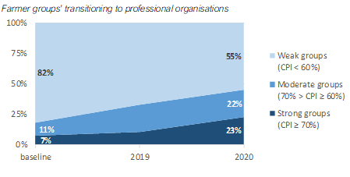

*Source: CPI Surveys 2018-2020*

The cluster approach at ward level is used as a platform for experience sharing and planning between producer groups. The aim is to enhance collective action: produce marketing, aggregation, acquiring bulk agricultural inputs, trade and service provision. A total of 149 clusters (an average of 25 clusters/ district) covering about 474 groups. The ultimate aim is to scale up the cluster of groups as agricultural marketing cooperative society (AMCOS), to professionalise the groups and reach economies of scale that are required for more effective value chains. So far, the model worked in 5 clusters (Nyakitonto, Nyamnyusi, Kitagata, Mugunzu and Kanyonza).

In 2020, in line with MTR recommendations the focus was on AMCOS (agricultural marketing cooperative societies). As outlined in graphs below, the SPM groups ie AMCOS scored substantially better for the CPI index than the non SPM (51% strong groups versus 18%). Given the targeted approach and hands-on coaching, impressive progress was made regarding production improvement, income increase, business plans, credit access and technology adoption. In order to sustain these achievements, the habitual governance and management risks of cooperative societies need to be addressed through the mobilisation of AMCOS own resources, increased supervision and robust internal checks and balances. Scaling up the experience has its limitations, as there are few additional eligible AMCOS with minimum capacity. As a consequence, there will be a big impact differences between AMCOS involved in structured production and marketing and ordinary beneficiary groups.

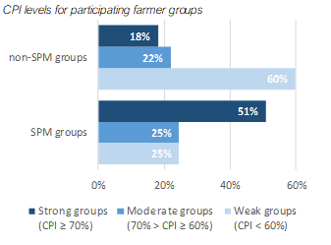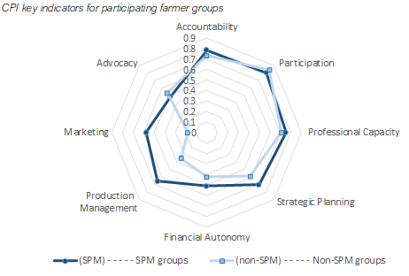

*Source: CPI Survey 2020*

The technology adoption and reported increase of bean production was considerably better for AMCOS member as outlined in the graphs below. The better technology adoption and production are explained by a stronger technical follow-up by the FAAB coach and WAEO and by the input revolving fund made available to the best AMCOS.

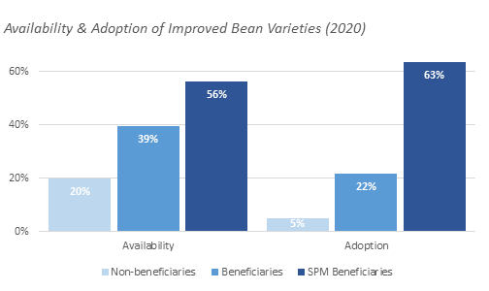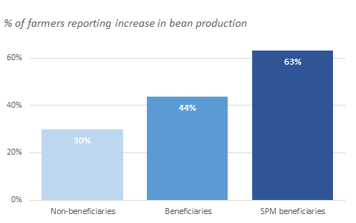

*Source: HH Survey 2020*

**Lead farmers – grassroots facilitators to complement local government extension**

Groups selected lead farmers (LF) according to a set of criteria who collaborate with WAEOs. Lead farmers help on a voluntary basis with the group management, the logistics, record keeping, farm demo management, group farming activities and recommendations for the best agronomic practices. 47 LFs are working with their groups; 41% are female. Lead farmers are monitored by the groups and WAEOs. A performance assessment was done in 2019. 20% of best performing lead farmers were awarded an input package for bean production. 10% of the lead farmers were replaced and the new ones trained in 2020.

The appreciation of the beneficiaries of the services of the lead farmers has improved from 74% in 2017 to 87% in 2020 but varies between the districts. The average support increased from 3 in 2018 to 6 in 2020.

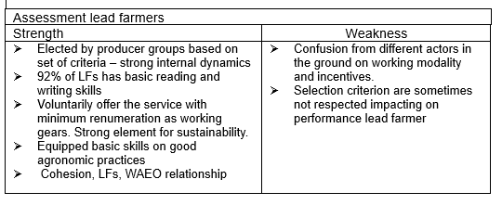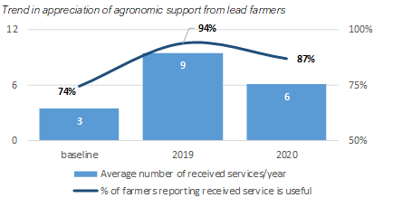

*Source: Call-back Surveys 2018-2020*

**Cassava production and income**

Cassava yields production – indicator I4.1a & I4.3a

Productivity of cassava cultivation is reported to have increased steadily over the past years, whereby beneficiaries are reporting an increase of 733 kg/ha (25%) compared to the 2017 baseline (see graphs below). Nevertheless, the average reported yield is 3.643 kg dry chips/ ha – still 40% short of the original target. Cassava yields in Kibondo, Kasulu and the southern wards of Uvinza district are higher. In these areas virgin land is cultivated for cassava production (see map below). A similar increase in cassava yields was also observed among non-beneficiaries. The steady increase in cassava yields is also reflected in total production. It is assumed this increase is attributable to 2 factors:

* a spill-over of the project's efforts of promoting disease tolerant varieties.
* many farmers stopped marketing cassava, with as of today only **53%** of beneficiaries generating income from cassava, compared to **79%** at baseline level (2017). This occurrence could be a contributing factor to the observed trend of production and productivity increase, as only the most successful cassava producers continued.

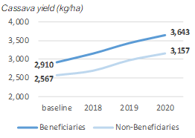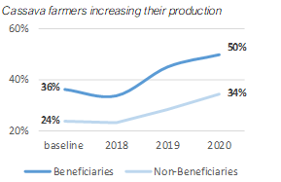*Source: HH Surveys 2017-2020*

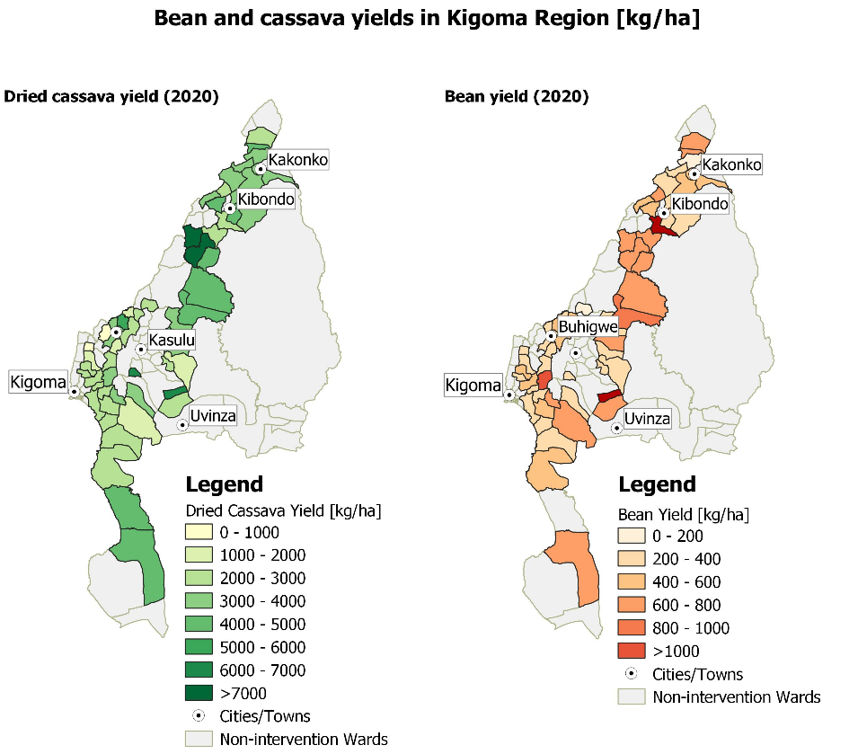

*Source: HH Survey 2020*

Improved technology adoption indicator I4.2a

The observed increase in productivity is further reflected in the adoption of improved technologies and GAP practices, with as of today an overall adoption level of 30% compared to 10% at baseline level. Especially the adoption of improved varieties, destroying diseased planting material and correct spacing increased significantly. The use of fertilizer in cassava is negligible as it serves as a low investment crop in the farming system.

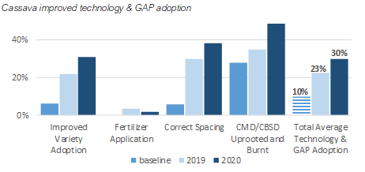

*Source: Beneficiary Tracking 2017-2020 + HH Surveys 2017-2020*

Availability and adoption of cassava improved varieties indicator I4.2a

Currently 58% of beneficiary farmers are reporting to have access to improved varieties, compared to merely 13% at baseline level. Close to one-third (31%) of beneficiaries is also cultivating improved varieties. Interestingly enough, similar findings were observed for non-beneficiaries – this can be attributable to a spill over of the project's efforts of promoting improved varieties.

The varieties with the best disease tolerance for Kigoma - Tz130 and chereko - are fast multiplied in micro propagation units.

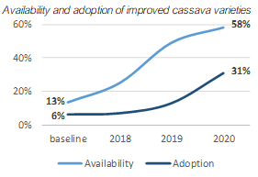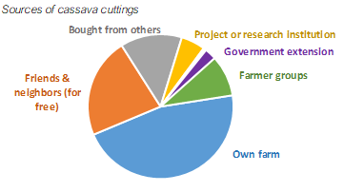

*Source: HH Surveys 2017-2020*

Origin of cassava cuttings

More and more beneficiary farmers tend to get their cuttings from projects and research institutes (**9%** against **1%** in 2017) and farmer groups (**16%** against **0%** in 2017). This progress is 100% attributable to the project, as no changes were observed in the non-beneficiary control group (DID). Buying cuttings from commercial seed entrepreneurs however remains an uncommon practice (**1%**).

Virus diseases

The factors considered most troublesome to cassava production are with no doubt the Cassava Mosaic Disease (CMD) and the Cassava Brown Streak Virus Disease (CBSD). The adoption of improved cassava varieties and uprooting diseased cuttings, a trend of slightly decreasing prevalence of CMD is observed among beneficiaries (**86%** in 2018, against **81%** today).

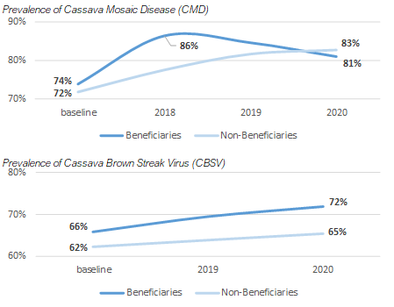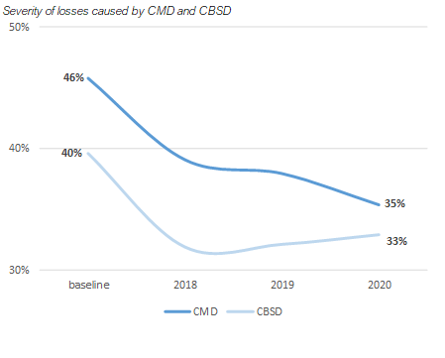

*Source: HH Surveys 2017-2020*

For CBSD this decreasing trend was not observed, which can be explained by the fact that the lion's share of adopted improved cassava varieties was Mkombozi, a CMD-resistant variety, but vulnerable to CBSD. Whether this reflects an actual increase in spread of CBSD is doubtful, as it may be attributable to the many awareness raising activities that have taken place. Furthermore, the project has shifted its efforts towards promoting double tolerant varieties, so a decrease of CBSD prevalence is expected over the next coming years.

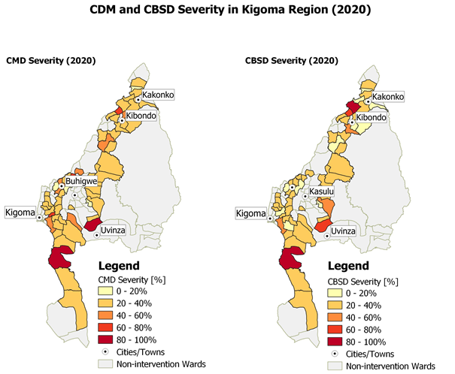

*Source: HH Survey 2020*

Cassava trading and markets

Since 2018, the cassava market in Kigoma Region experienced a steep decrease in demand, causing excess supply and the price to fall. However, over the past year, the cassava market seems to recover, resulting in a trend of increased quantities sold per beneficiary household.

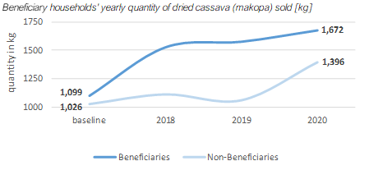

*Source: HH Surveys 2017-2020*

**Bean production and income**

Production and yield of beans- indicator I4.3 b

Over the past 2 years, bean production in Kigoma Region continued to increase, as reported by 44% of beneficiaries and up to 63% of beneficiaries under structured marketing, compared to only 30% of non-beneficiaries. However, the increase in bean production is less significant than reported in 2019 and an increasing number of beneficiaries see their bean production decrease (36% in 2020, compared to 29% in 2019). High rainfall caused the decline of bean yield in 2020. Average yields have improved from 440 kg/ha (2017) to) an average yield of 536 kg/ha for beneficiaries and 545 kg/ha comparable average yield achieved under structured marketing. The yield increase is attributed both to the increased adoption of improved bean varieties and good agricultural practices. Bean yields in Kakonko, Kibondo and Kasulu are systematically better than other districts (see map below) due to early rains, midlevel altitude and committed extension support.

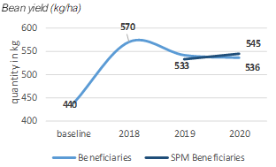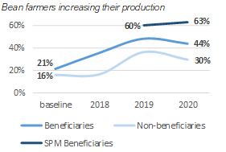

*Source: HH Surveys 2017-2020*

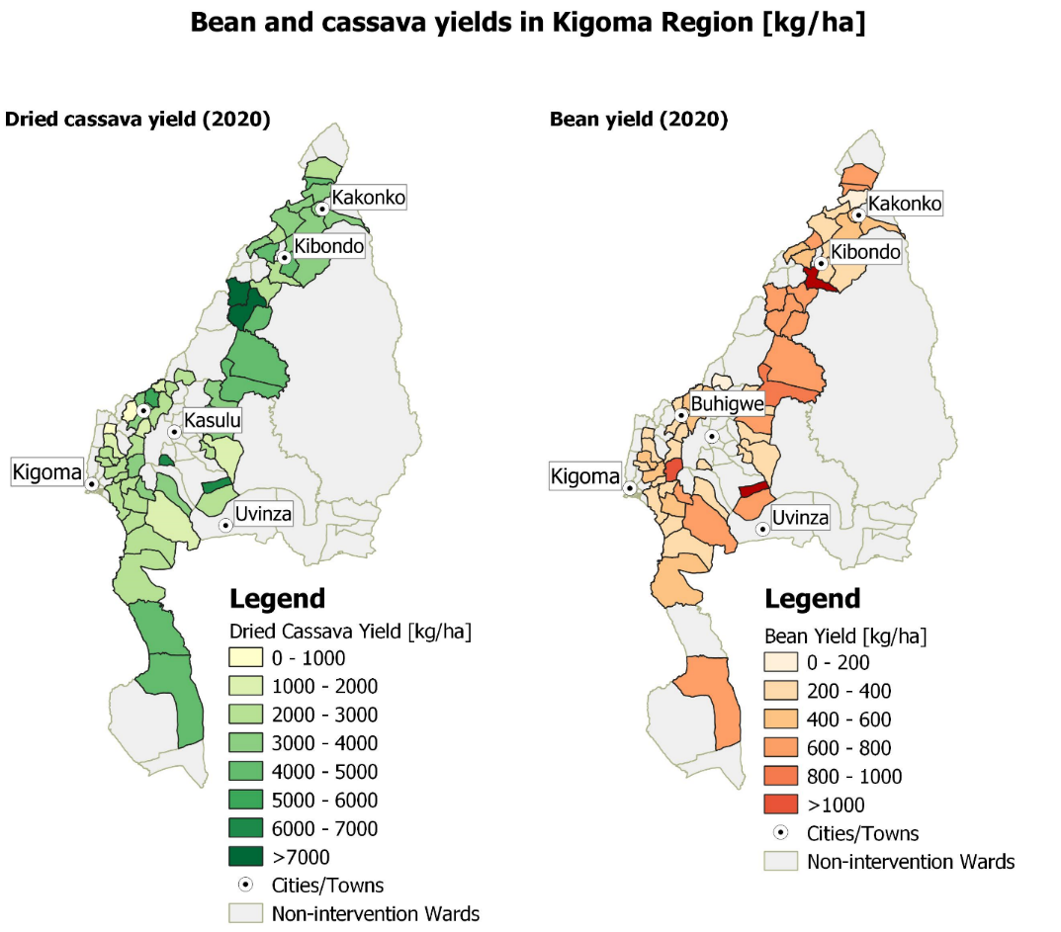

*Source: HH Survey 2020*

Technology adoption – indicator I4.2b

Over the past 2 years the overall improved technology & GAP adoption increased from **18%** to 44**%**. The 2020 increase is attributed to an increase in improved variety and correct spacing adoption. Pesticide application experienced only a slight increase. Improved varieties adoption experienced a slight decrease, as the majority of beneficiaries prefer to stick to the production of the local Kigoma Yellow variety. The availability of improved bean varieties has increased from 4% at baseline in some areas of the region in 2017, to an average availability of 39% today among smallholder farmers. Similarly, adoption levels rose from no adoption at all to 63%, 22% and 5% by SPM beneficiaries, beneficiaries and non-beneficiaries, respectively.

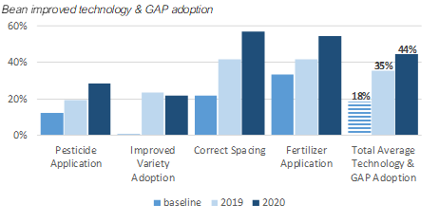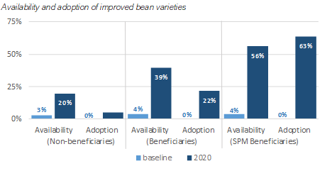

*Source: Beneficiary Tracking 2017-2020 + HH Surveys 2017-2020*

Seed sources for beans

Positive changes are observed in the trend of bean seed sources. Today fewer beneficiary farmers get their seed for free from friends & neighbours (16% against 40% in 2017), local shops (7% against 12% in 2017) or from weekly markets (42% against 64% in 2017). More and more beneficiary farmers tend to get their seeds from projects and research institutions and government extension workers (18% against 0% in 2017) and farmer groups (18% against 0% in 2017). This progress is 100% attributable to the project, as no changes were observed in the non-beneficiary control group. However, additional efforts are key in order to cross the chasm to reach adoption of improved bean seed purchase by the majority.

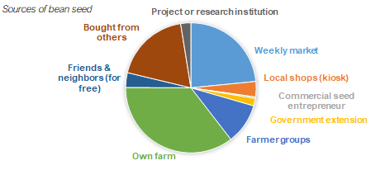

*Source: HH Survey 2020*

**Sunflower production and income**

In 2020, sunflower was piloted year in 2 districts: 128 tons of sunflower grain were produced by 342 farmers. Farmers appreciated the performance of sunflower, the low production costs, income diversification and the possibility to have a second crop after maize or beans. Cashflow challenges have been the impediments for the uptake of the crop. Delayed bean payments prevented farmers from paying for inputs in time. Local millers struggled to absorb the entire delivered crop as farmers rushed to sell the sunflower during the harvest time.

The sunflower market study was finalised and provided further guidelines for the implementation of the sunflower VC development strategy. The local processing offers a good potential for value addition and employment in Kigoma. Grain or raw oil sold to the large industrial plants in Dodoma or Arusha offer a guaranteed market for extra production that will not be absorbed by local processing in the future. These mills are currently only working at 20-40% of their capacity and provide a back-up market albeit at a lower profitability for producers.

In contrast to cassava, sunflower offers good opportunities to deploy the value chain approach as the collaboration with the private sector (seed producers, large and local millers) is excellent. The target for the next season is to support 3.000 smallholder farmers to produce sunflower for structured marketing arrangements with credit facilities. Processors will be able to access aggregation credits through the PASS/ SAKIRP co-guarantee facility while Pyxus will provide agronomic support and an assured market through contract farming. It is expected that sunflower will become a permanent feature of Kigoma farming system. To encourage and test models on local value addition, the project procured and deployed 2 sunflower expelling machines to Kasulu district. Apart from augmenting the processing capacity, the use of the equipment will enable the project to get more precise data on the viability of local sunflower oil processing models.

Availability and Adoption of Improved Sunflower Varieties[8]- indicator I4.2c

The open pollinated variety Record was available and adopted at baseline level (29% and 22% of beneficiaries respectively) and significant progress seems to have been made over the past year, with availability and adoptions levels raising up to 81 ± 10% and 75 ± 11% respectively. The most available and popular varieties are Record and Supersun 66.

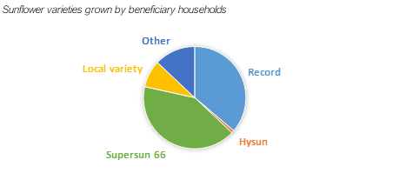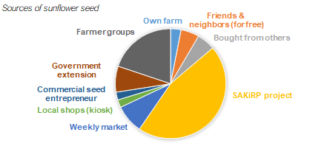

*Source: HH Survey 2020*

Origin of sunflower seeds – indicator I 4.2c

Supply for sunflower seed is still a challenge. The seed origin remains diverse for smallholder farmers. Most beneficiaries (62 ± 12%) obtained their seeds this year through the SAKiRP project, whereas last year seeds were mostly obtained from their farms and neighbours, as is the case for non-beneficiaries. Government extension workers (10 ± 7%) and the farmer groups (27 ± 11%) also played a significant role in the distribution of sunflower seeds (the project linked up extension workers and farmer groups with commercial seed firms such as Silverlands and ASA).

Sunflower yield – indicator I4.3c

With 70 ± 12% reporting their sunflower production to have increased, against only 10 ± 7% reporting a decrease in production level, along with the increased availability and adoption level, an increase in sunflower yield can be expected. Few changes were observed in non-beneficiary yields, it can, despite the limited sample size, confidently be concluded that, over the past year, sunflower yields having increased from 528 kg/ha to 588 ± 112 kg/ha.

Sunflower trading and marketing

The observed trends of increased sunflower production and yields, along with the increased availability and adoption of improved sunflower varieties, could presumably result into larger quantities of sunflower products sold. Due to the limited sample size, only figures regarding sales of sunflower oil could be reported, where we noticed an increase from 71 litres of sunflower oil sold in 2019 to 111 ± 29 litres sold in 2020, among beneficiary households. Sunflower oil remains the most frequently sold product by far, with up to 70% of beneficiaries investing in processing and selling sunflower oil.

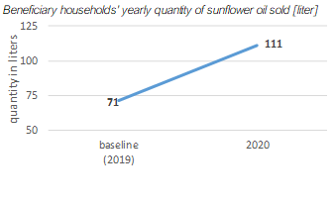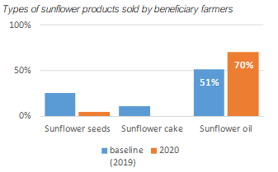

*Source: HH Survey 2020*

## Performance output 5: marketing & trade.

In 2020, SAKIRP intensified its efforts to increase farmers’ access to markets and promote sustainable trade within the targeted value chains. The structured production and marketing arrangement for beans was scaled up through an off-taker arrangement entered with the World Food Program (WFP). Nearly 1000 smallholder farmers directly sold about 370 metric tons of beans to WFP. This linkage represented a major breakthrough for farmers who have traditionally relied on informal channels to sell their produce. In line with the new strategy to promote the sunflower value chain, the project undertook a market assessment which culminated in the development of a value chain development strategy. To implement the strategy, the project has signed an MoU with Pyxus which will be the off-taker for unprocessed sunflower seed. Pyxus has a sunflower processing factory located in Dodoma. Structured bean production and marketing arrangements have been stepped to nearly 1500 farmers during the 2020/2021 season. Open marketing arrangements have been adopted to allow farmer cooperatives maximum flexibility in negotiating prices one the produce has been aggregated.

### Progress of indicators

|  |  |  |  |  |  |  |  |  |  |
| --- | --- | --- | --- | --- | --- | --- | --- | --- | --- |
| Result 5: Improved market access and sustainable trade | | | | | | | | | |
| INDICATORS | Project   Baseline | | Overall Target | 2018 | | 2019 | | 2020 | |
| Date | Value | Actual | Target | Actual | Target | Actual | Target |
| I5.1a - % of smallholder producer groups participating in structured cassava market relationships | 2017 | 5% | 30% | 0% | 2% | 0% | 5% | 0% | 10% |
| I5.1b - % of smallholder producer groups participating in structured bean market relationships | 2017 | 4% | 25% | 1% | 2% | 3% | 4% | 13% | 8% |
| I5.1c - % of smallholder producer groups participating in structured sunflower market relationships[[1]](https://euc-word-edit.officeapps.live.com/we/wordeditorframe.aspx?ui=en%2DUS&rs=en%2DUS&wopisrc=https%3A%2F%2Fenabelbe.sharepoint.com%2Fsites%2FPRJ_TZA_SAKIRP%2F_vti_bin%2Fwopi.ashx%2Ffiles%2F4aec08c46e6e4c21973efb9f9291553b&wdenableroaming=1&mscc=1&hid=00000000-0000-0000-0000-000000000000&wdorigin=Sharing&jsapi=1&jsapiver=v1&newsession=1&corrid=7aa9e9ac-462b-452a-abb0-eb986cb97466&usid=7aa9e9ac-462b-452a-abb0-eb986cb97466&sftc=1&mtf=1&instantedit=1&wopicomplete=1&wdredirectionreason=Unified_SingleFlush&rct=Medium&ctp=LeastProtected#_ftn1) | 2019 | 0% | 15% | - | - | - | - | - | - |
| I5.2a - Value of cassava sold through structured marketing by smallholder producers (cumulative Million TZS) | 2017 | 28 | 1.500 | 32 | 60 | 217 | 100 | 927 | 300 |
| I5.2b - Value of beans sold through structured marketing by smallholder producers (cumulative Million TZS) | 2017 | 21 | 1,600 | 133 | 100 | 301 | 200 | 1,050 | 400 |
| I5.2c - Value of sunflower sold through structured marketing by smallholder producers (cumulative Million TZS) | 2020 | 0 | - | - | - | - | - | - | - |
| I5.3a - % increase in sales by local cassava traders | 2017 | 0% | 50% | -5% | 50% | -3% | 50% | 0% | 50% |
| I5.3b - % increase in sales by local bean traders | 2017 | 0% | 50% | 53% | 10% | 86% | 25% | 87% | 50% |
| I5.3c - % increase in quantity processed by local **sunflower** processors | 2019 | 0% | 50% | - | - | - | - | 26% | 20% |

|  |  |  |  |  |  |  |  |  |  |
| --- | --- | --- | --- | --- | --- | --- | --- | --- | --- |
| INDICATORS | Project   Baseline | | Overall Target | 2018 | | 2019 | | 2020 | |
| Date | Value | Actual | Target | Actual | Target | Actual | Target |
| I5.4a - % of farmers accessing objective sources of cassava market information | 2017-2018 | 41% | 50% | 33% | 50% | 25% | 50% | 29% | 50% |
| *MALE* |  | 44% |  | 35% |  | 27% |  | 29% |  |
| *FEMALE* |  | 39% |  | 32% |  | 23% |  | 29% |  |
| I5.4b - % of farmers accessing objective sources of bean market information | 2017-2018 | 29% | 50% | 32% | 35% | 23% | 40% | 30% | 50% |
| *MALE* |  | 28% |  | 35% |  | 26% |  | 32% |  |
| *FEMALE* |  | 31% |  | 28% |  | 19% |  | 29% |  |
| I5.4c - % of farmers accessing objective sources of sunflower market information | 2019 | 7% | 50% | - | - | 7% | - | 18% | 10% |
| *MALE* |  | 8% |  |  |  |  |  | 21% |  |
| *FEMALE* |  | 4% |  |  |  |  |  | 1% |  |
| I5.5a: % of SME reporting benefits from business association membership | 2019 | 0% | 75% | - | - | - | - | 79% | 75% |
| I5.5b: % of SME reporting benefits from sunflower processing association membership | 2019 | 0% | 75% | - | - | - | - | - | - |
| I5.6a - % reduction of transport costs to the nearest weekly market where bridges were constructed | 2019 | 0% | 35% | - | - | - | - | 51% | 35% |
| Indicator I5.6b - % traffic **increase** by motorcycles and cars during the weekly market days | 2019 | 0% | 50% | - | - | - | - | 271% | 50% |
| Indicator I5.6c - % assured all season river crossing for vehicles where bridges were constructed | 2019 | 0% | 70 | 3 | 5 | 8 | 15 | 9 | 30 |
| I5.7a - % population that reports that the bridge benefits their household in those villages where bridges are completed | 2019 | 0% | 100% | - | - | - | - | 100% | 60% |
| Indicator I5.7b - % population that reports that the bridge benefits their village in those villages where bridges are completed | 2019 | 0% | 90% | - | - | - | - | 99% | 80 |

*Source: SAKIRP household surveys 2017- 2020 & call-back surveys 2017-2020*

[[1]](https://euc-word-edit.officeapps.live.com/we/wordeditorframe.aspx?ui=en%2DUS&rs=en%2DUS&wopisrc=https%3A%2F%2Fenabelbe.sharepoint.com%2Fsites%2FPRJ_TZA_SAKIRP%2F_vti_bin%2Fwopi.ashx%2Ffiles%2F4aec08c46e6e4c21973efb9f9291553b&wdenableroaming=1&mscc=1&hid=00000000-0000-0000-0000-000000000000&wdorigin=Sharing&jsapi=1&jsapiver=v1&newsession=1&corrid=7aa9e9ac-462b-452a-abb0-eb986cb97466&usid=7aa9e9ac-462b-452a-abb0-eb986cb97466&sftc=1&mtf=1&instantedit=1&wopicomplete=1&wdredirectionreason=Unified_SingleFlush&rct=Medium&ctp=LeastProtected#_ftnref1) New indicator with data being available from 2021

**Explanation of selected indicators**

|  |  |
| --- | --- |
| Indicator | Comments |
| I5.1a - % of smallholder producer groups participating in structured cassava market relationships | The cassava trading business has mainly remained informal and farmers rely on spot transactions which are conducted directly with intermediary itinerant traders. The aggregation and collective selling have been hindered by the lack of financial capacity by farmer cooperatives to pay any advance payment; this situation is expected to change with the introduction of aggregation loans that are co-guaranteed by PASS Trust and Enabel. |
| I5.1b - % of smallholder producer groups participating in structured bean market relationships | 13% of the project’s direct beneficiaries participated in this intervention. The outreach of this intervention is limited by the availability of concessional loans which are the most vital input for structured marketing arrangements. The interest shown by some banks in supporting input financing will translate into an increase in the number of farmers reached through this intervention. |
| I5.2a - Value of cassava sold collectively by smallholder producer groups (Million TZS) | This indicator has not progressed as anticipated due to lack of incentives and resources to enable aggregation and collective marketing arrangements by farmers. Initiatives done so far have been experimental and insignificant in impact. |
| I5.2b - Value of beans sold through structured marketing by smallholder producer groups (Million TZS) | The value of beans sold to WFP in 2020 had a market value of 750 million shillings. The targeted value of I billion could not be reached due to a shortfall in production. The value of marketed produce is highly sensitive to price changes. |
| I5.3a - % increase in sales by local cassava traders | one of the traders reported an increase in the volume of cassava traded. This is he general slump in cassava trade. Thin profit margins that have become characteristic of this commodity have motivated most traders to diversify from trade in cassava or reduce the crop’s share in their trading portfolio. |
| I5.3b - % increase in sales by local bean traders | An increase of 87% in the volume of beans traded by local traders is indicative of the upswing experienced in bean market conditions in 2020. Prices of beans firmed up amid an increase in domestic (national) demand triggering an increase in trade. Some traders in Kigoma took advantage of the arbitrage opportunities between bean prices in Burundi and Tanzania to import beans which they off-loaded to local markets. |
| I5 - % of farmers accessing objective sources of cassava and bean market information | The proportion of farmers reporting increased to market information from objective sources rose by 5 percentage points to about 30% for both cassava and beans. The low performance on this indicator is linked to the project’s strategy of consolidating the provision of farming as a business services to a few wards that exhibit high potential. The intensive use of social network applications to disseminate information to farmers via the agricultural extension network. |
| I5.6a - % reduction of transport costs to the nearest weekly market where bridges were constructed | Transport costs have been reduced by 51% where bridges have been completed. The reduction of the transport costs exceeds the indicator because the data are based on a limited sample of highly strategic bridges. These conditions will not apply to the larger sample of bridges. |
| I5.6b - % traffic increase by motorcycles and cars during the weekly market days | Based on a limited sample of not representative bridges, the traffic density increased drastically to 271% and exceeds the indicator. It is anticipated that for a larger number of bridges the indicator will be much lower in the future. |
| I5.6c - % assured all season river crossing for vehicles where bridges were constructed | This indicator is below the target (9 versus 30%) as some bridges still need backfilling by TARURA to become functional. |
| I5.7a - % population that reports that the bridge benefits their household in those villages where bridges are completed | There is a 100% appreciation that the bridge benefits the household albeit the local contribution that is provided. |
| I5.7b - % population that reports that the bridge benefits their village in those villages where bridges are completed | There is a 99% appreciation that the bridge benefits the community albeit the local contribution that is provided. |

### Progress of main activities

A significant improvement in access to structured markets was witnessed during the reporting period. About 10% of the project’s direct beneficiaries participated in the bean structured marketing arrangement established with WFP. The proportion enrolled in structured bean production and marketing arrangements increased to nearly 15% for the 2020/2021 season. Following the sunflower pilot production, the market linkage arrangement entered with Pyxus covered 14% of registered direct beneficiaries. Structured marketing access arrangements for cassava still trail set targets but the situation is expected to change as the aggregation financing bottleneck is resolved for both smallholder farmer cooperatives and crop traders.

|  |  |  |  |  |
| --- | --- | --- | --- | --- |
|  | Progress | | | |
| A | B | C | D |
| Conducting market surveys |  |  |  |  |
| National market research and intelligence gathering |  | X |  |  |
| Supporting collectors, processors and traders in VCD initiatives and facilitate market linkages | | | | |
| Market linkage and promotional support to SMEs |  | X |  |  |
| Business development support to SME aggregators |  | X |  |  |
| Business development support to SME processors |  | X |  |  |
| Strengthening the existing market information system(s) for the major crops | | | | |
| Collect, collate and disseminate market information |  | X |  |  |
| Supporting public infrastructures and sale points |  |  |  |  |
| Equipment and material support to village aggregation centres |  | X |  |  |
| Technical support to aggregation management committees |  | X |  |  |
| Strengthening advocacy capacities regarding trade issues and other issues with the value chain | | | | |
| Support the development of an effective Business Membership Organisation of SME aggregators and processors |  | X |  |  |
| Training and capacity development on cross-border trading |  |  | X |  |

### Analysis of progress made

**Structured marketing collaboration between farmer cooperatives and WFP**

During the reporting year the project supported smallholder farmers to produce and directly sell beans to WFP for feeding the refugee population which is based in Kigoma region. Farmers were able to aggregate and sell about 370 tons of high-quality beans which were equivalent to 73% of what WFP had committed to buy from SAKIRP-supported farmers. Despite failing to meet the quantities required by WFP, the linkage was largely successful as farmers realised a price that was about 30% above the average market price. The total volume of beans collectively sold by smallholder farmers sharply increased during the reporting period to reach a cumulative 550 metric tons.

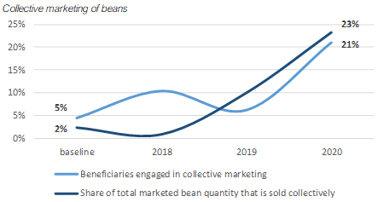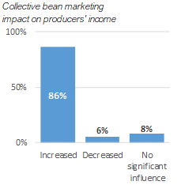

The proportion of beans and beneficiaries in collective marketing action peaked up during the reporting period due to the increased investment in supporting structured production of beans. The slightly higher proportion of collectively marketed beans in comparison to proportion of beneficiaries is a reflection of the better productivity associated with improved input use by beneficiaries that have access to loan facilities. The top right graph shows that collective bean marketing increased incomes for 86% of surveyed beneficiaries; this is mainly due to the effect of better prices that are realised in the context of collective price bargaining and better commodity quality management.

As illustrated in the graph below, structured marketing arrangements have significantly shifted the perceptions between quality and price trade-offs which were generally perceived to be too low at the inception of the project. However, the pre-dominance of informal spot market traders continues to weigh down on farmers’ perceptions of trader reliability. The increase in the price of food beans in 2020 also accounts for the better rating for fair price perceptions. The direct procurement of beans by WFP also significantly contributed to fair price perceptions by the cohort of beneficiaries who participated in the structured market linkage. However, it is important to note that the perception of fair pricing is often reported in relation to the cost of production per unit; the consistently low yields engender feelings of unfairness on the part of farmers.

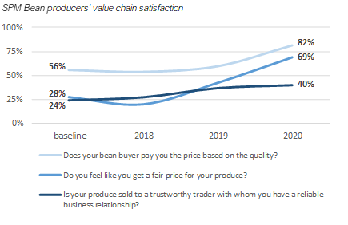

Main lessons from structured marketing arrangements

* The consolidation of smallholder producer groups into cooperative societies serves to increase efficiency, mitigate risks and pave way for farmer integration to more structured and formal markets
* With adequate guidance and support, farmers are able to upgrade to meet exacting quality standards
* Direct involvement of the project in market linkages tends to reduce ownership by smallholder farmer organisations and creates a dependency syndrome which undermines long-term sustainability
* While the role of intermediary firm in smallholder value chains is often disparaged, intermediary firms still account for the large volume of transactions. Building the technical and financial capacities of intermediary firms is consistent with the concept of creating responsive and resilient market systems.

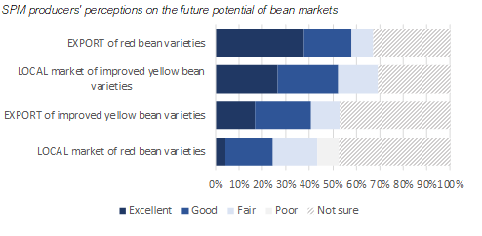

*Source: HH Surveys 2020*

**Access to markets – construction of stone arch bridges**

The highlights of the household survey with regards to stone arch bridges are the following:

* The target of 80% benefit appreciation is exceeded
* Increased agribusiness opportunities are considered important benefits
* Women are slightly more positive about the benefits.

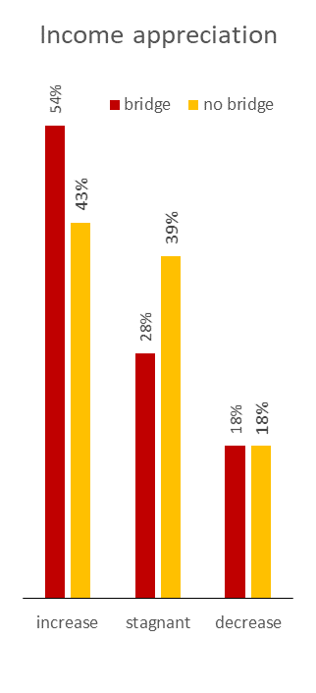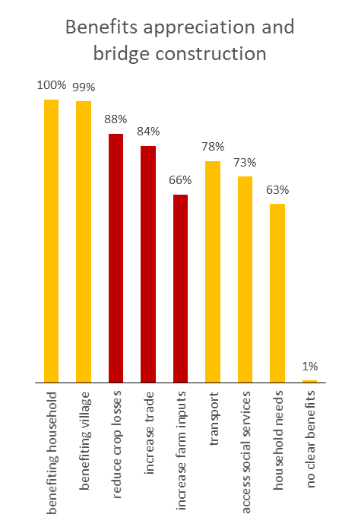

Next to the economic advantages, women appreciate the access to social services especially dispensaries and maternity wards. Children can access schools during the peak rainy season. In some villages, there is anecdotic evidence how prior to construction, lives were lost because people waded through the river during floods.

**General challenges constraining access to markets**

Progress under the market access and sustainable trade result has been slowed by several factors as detailed below.

* The continued dominance of the informal marketing system undermines efforts to develop more structured marketing arrangements. The informal crop traders tend to fuel side-selling activities and this discourages more formal buyers from entering into contract marketing arrangements
* The level of bean yields remains low and this leads to low returns on input investments whilst making it difficult to mobilize commodity volumes that are commercially attractive to big buyers.
* The progression of producer groups to legally-constituted and functional cooperatives has been slow; this retards their integration into structured marketing systems.

# Budget monitoring

By 31st December 2020, the overall SAKIRP budget turnover was 54,7% for 60 % of the extended project period till Dec 2022. While the expenditures for operational costs match the budget, the situation is different for activities. This is a general trend of agricultural development projects and SAKIRP is no exception.

|  |  |  |  |  |  |  |  |  |
| --- | --- | --- | --- | --- | --- | --- | --- | --- |
| **In Euros** | **Total Budget** | **PERIOD** | | | | **SUMMARY** | | |
|  |
| **2017** | **2018** | **2019** | **2020** | **Total Expenditures** | **Budget Balance** | **Disbursement Rate 2020** |  |
| **Total General** | **8 000 000** | **1 293 891** | **889 272** | **1 048 091** | **1 147 885** | **4 379 139** | **3 620 862** | **55%** |  |
| **A - Activities** | **4 260 000** | **346 980** | **367 794** | **468 619** | **667 169** | **1 850 563** | **2 409 437** | **43%** |  |
| A01 - Value chains management and coordination mechanisms are installed and steer cassava and beans value chain development. | 312 000 | 113 705 | 15 867 | 20 270 | 56 781 | 206 623 | 105 377 | 66% |  |
| A02 - Sound financial mechanisms are developed and financial organizations are strengthened to support value chains development. | 2 030 000 | 26 850 | 26 538 | 179 990 | 389 883 | 623 262 | 1 406 738 | 31% |  |
| A03 - Public and private chain supporters provide effective services to value chains actors. | 585 000 | 86 330 | 147 969 | 98 007 | 100 837 | 433 142 | 151 858 | 74% |  |
| A04 - Stronger position of smallholders in the value chains | 852 000 | 41 381 | 162 541 | 146 310 | 86 294 | 436 525 | 415 475 | 51% |  |
| A05 - Improved market access and sustainable trade | 481 000 | 78 715 | 14 880 | 24 043 | 33 374 | 151 011 | 329 989 | 31% |  |
| **B - Technical staff** | **2 054 400** | **519 732** | **360 341** | **349 042** | **313 093** | **1 542 208** | **512 192** | **75%** |  |
| **X - Reserve** | **93 050** | **-** | **-** | **-** | **-** | **-** | **93 050** | **0%** |  |
| **Z - General means** | **1 592 550** | **427 178** | **161 137** | **230 429** | **167 623** | **986 367** | **606 183** | **62%** |  |

The budget turn-over of 55% has been modest. The following are the explanations: biggest expenditure shortfalls are related to focused on A02 financial services (micro finance fund and business innovation fund). The low budget turn-over can be explained by the following factors:

* SAKIRP has developed a cost-efficient approach. An example is the construction of stone arch bridges that allow for 80% cost saving and rely on local contribution of the community. This approach does not spend a lot of money. If the bridges would have been built in the standard way, the entire SAKIRP budget would have been exhausted and there would be no scope for extension.
* Micro finance grant was vetoed (17% activity budget). It was only recently that the new Enabel co-guarantee modality unblocked the stalemate in micro-finance support.
* The TFF anticipated a much higher absorption capacity of producer groups with strong business orientation and sufficient management skills. However, only 15% of the groups meet minimum criteria. The same applies to grant agreements with NGOs. The direct collaboration with the local government extension service was much more cost effective.
* Enabel disposes not yet of tools to support private sector. The anticipation was the business innovation fund (30% of the activity budget) would allow for investments in private firms and producer organisations. To overcome the problem, the fund was converted in a public infrastructure fund for access to markets.
* The demand for processing equipment investment anticipated during the formulation did not materialise because of a structural slump of the cassava market, the consumer preferences for unprocessed cassava and weak producer groups.
* While the local contribution for bridges built local ownership and helped priority setting, it also delayed implementation considerably affecting the largest budget vote.

The cost-efficient approach allowed for a no-cost project extension till June 2023. Nevertheless, special efforts will be needed to come to full budget absorption: proactive construction management and reduced local contribution for bridges and warehouses, additional processing capacity in sunflower and 6 pilots of cassava phytosanitary zones.

# Risk & issue management

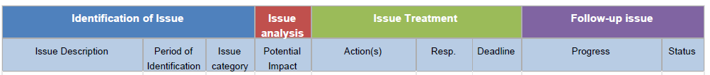

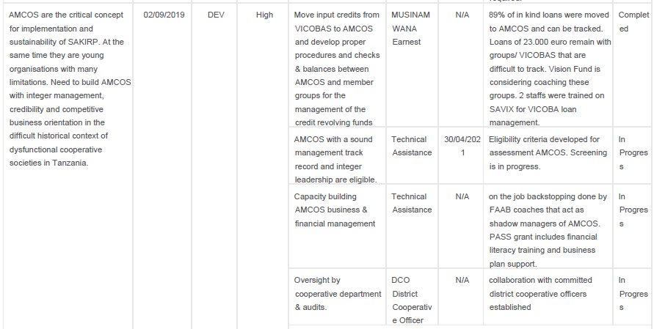

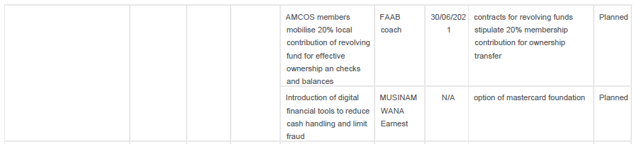

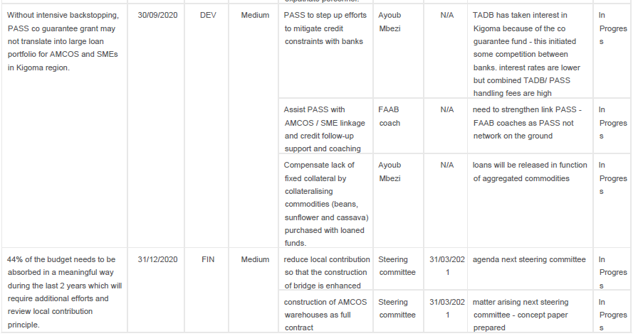

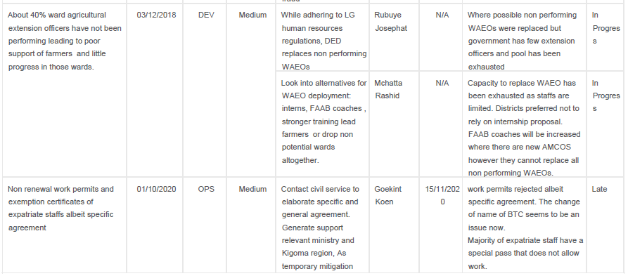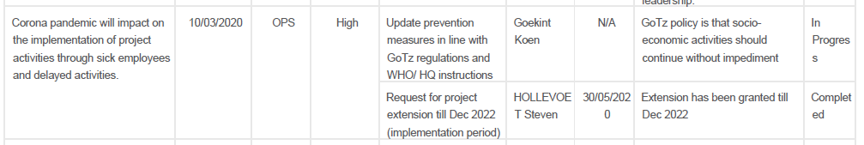

# Synergies and complementarities

## With other interventions of the Portfolio

The portfolio focuses on other Enabel projects. There is currently only one other Enabel project in Tanzania: WASKIRP. The Natural resources for economic development project – Kigoma and the Maisha Bora pastoralist project – Arusha were closed in 2020-Q1.

WASKIRP – Water sector – Kigoma

Demographical growth and agricultural activities are contributing a lot to the destruction of watershed areas and the pollution of surface water. SAKIRP does not support the cultivation in watershed areas. The water project benefited from the SAKIRP bridge component: one bridge is used for pipe laying across the river. The water project could further build on the principle of local contribution initiated by SAKIRP. Villagers contribute the digging of water pipe channels. WASKIRP and SAKIRP share finance and administrative staff & transport pool in an effort to reduce overhead costs.

Belgian Tanzanian Study and Consultancy Fund

The Belgian Tanzanian Study and Consultancy Fund has funded a Feasibility study for construction of stone paved roads to increase the income of Women and Youth in Kigoma municipality. This is linked to the experiences of Enabel in Burundi and Rwanda. The Fund is available for studies and consultancy initiatives from government institutions.

### With third-party assignments

A new beekeeping national project funded by EU will be implemented in 2020 and the administrative staffs will be shared.

## Other synergies and complementarities

Kigoma region hosts several agricultural and economic development projects targeting both refugees and host communities. The main projects with a link to value chain development are MEDA and UN Kigoma Joint Programme. SAKIRP has systematically reached out to new projects to agree collaboration mechanisms. All these projects participate in the SAKIRP regional stakeholders’ meetings and the sponsored district agricultural sector meetings. A challenge encountered in this process is that implementation is often outsourced to different local partners who do not have sufficient appreciation of the modalities for collaborating in a complimentary way. There is an overlap in the value chains (beans & cassava) and in some districts the targeting of smallholder farmer groups.

SAKIRP leverages resources availed by other projects within the region. For instance, aggregation of beans produced by SAKIRP-supported farmers is done in go-downs that were refurbished and equipped by AGRA TIJA Project. This collaboration has also seen quality management and weighing equipment purchased by the AGRA project being used by farmers supported by SAKIRP. Further, AGRA and Enabel have jointly funded the printing of the Farming as a Business Manual which is used across both projects. In the area of post-harvest management, SAKIRP uses training materials produced by the UN Kigoma Joint Program. The UN one project is now requesting to bring on board the AMCOS for structured production and marketing.

The delivery of smallholder beans to the WFP procurement system is being piloted by SAKIRP. The aim is to deliver at least 500 T quality beans produced by smallholder farmers tor the refugee camps in Kigoma. The Belgian government is one of the donors of UNHCR/WFP supporting the Burundian refugee camps.

The project actively works to leverage local capacity and an example of this are the two MoUs entered with TCCIA and SIDO. The project works with TCCIA to promote cross-border business coordination and works with SIDO to promote adoption and utilisation of value adding technologies.

Collaboration with the national road agency TARURA is close for operational issues of contract management of stone arch bridges. The agency is currently mainstreaming the stone arch bridge technology.

## Transversal Themes

### Gender

The SAKIRP project implementation is steered by a number of strategic choices which are aimed at ensuring that gender equity and women economic empowerment considerations are taken into account at all levels. The most significant choice made by the project has been the decision to using village savings and lending groups as an entry point for value chain development. To that end, the inclusion of women the direct beneficiary population has been deliberate; 65% of the direct beneficiaries are women. The design of intervention-level strategies has also prioritised the specific needs of women. Notably, the decision to promote local aggregation of beans has served to bring markets closer to women who are often when farmers rely on private intermediaries to reach remotely-located markets.

Despite the strategies put in place, the progression of women towards farming as a business has lagged behind that of men. Overall, 55% of farmers who are engaged in structured marketing arrangements are men. The number of women in structured marketing arrangements dropped from 58% in 2019 to 45% in 2020. This is largely attributable to the stricter screening for credit worthiness. Since participation in structured production is tied to credit arrangements, the reduced women participation could also be linked to credit-averse behaviour or inferior credit eligibility status.

Graph: Participation of women in groups, by group type

*Source: SAKIRP diagnostic survey*

*Source: SAKIRP Structured Bean Production and Marketing Data*

The project is continually working to address identified gender disparities and constraints across all the three value chains. The following are some of the specific actions the project is implementing to ensure gender equity and equality within the framework of value chain development:

* The provision of simple bean quality management technologies which facilitate a fair division of responsibilities between man and women. The supply of bean sorting tables has made it easier for men to participate in bean cleaning and sorting; traditionally this role is undertaken by women and children.
* Deployment of female farming as a business coaches who act as role models to women farmers.
* Criteria for support and participation of farmer collective organisation in more advanced linkages emphasise the need for adequate female representation at all levels. This is especially essential given that women may be unconsciously excluded from more value-added services that accrue to farmers who advance from subsistence to more commercial forms of production.
* Women have a strong appreciation of bridges for labour saving and better access to medical facilities. They often provide anecdotical evidence of how the new bridges have prevented maternal deaths due to better dispensary access.

The SAKIRP interventions allow for strengthening qualitative participation of women in the value chain and in decision-making in the farmer producer groups. Gender considerations were mainstreamed in the “farming as a business” manual. SAKIRP data collection tools are gender-segregated. The gender mainstreaming manual was prepared and all lead farmers received special training on gender mainstreaming.

At the level of output, some results are already obtained. See the table below:

|  |  |  |
| --- | --- | --- |
| Output Indicator | Female | Male |
| General engagement with project | 65% | 35% |
| Lead Farmers (extension service by farmers) | 41% | 59% |
| Group chairperson | 44% | 56% |
| Group secretary | 47% | 53% |
| Training participation | 72% | 28% |
| Farmers participating in contract farming/ structured markets | 45% | 55% |
| Ward extension officers | 16% | 84% |
| FAAB coaches | 22% | 78% |

Gender equity and participation concerns have been considered in the choice of end markets. In combination with external, domestic market segments were included for both value chains as they are more accessible to women. The project M&E system produce gender disaggregated data in a consistent and regular way. The table below shows the gender discrepancies. Cassava & beans yields and access to informal loans converge. For other indicators especially collective cassava marketing and land cultivated the differences are striking and even more pronounced for female headed households (FHH)

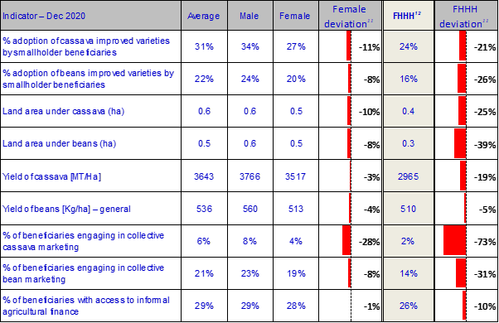

*Source: SAKIRP household survey 2020*

### Environment and climate change

Climate change

The effects of climate change in the agricultural system of Kigoma region is increasingly becoming evident. High weather variability makes it difficult for project beneficiaries to properly time their activities as seasonal calendars shift and become more unpredictable. Weather extremes of excess, too little and unevenly distributed rain increase the risk of crop failure and undermine the execution of structured production and marketing linkages. Weather risks have also consistently affected yields and, consequently, the viability of crop production and marketing.

To mitigate the above, the project is undertaking the following actions:

* The introduction of sunflower increases farmers’ chances of getting a successful crop during the second and short farming season. This is because sunflower is more drought resilient and can still do well despite the unreliable rains that are now characteristic of the second rainy season.
* Climate-smart agricultural practices are consistently mainstreamed in farming practices for all the three value chains; capacity building training is conducted at the level of extension workers who cascade the training to their smallholder farmer constituencies.
* Systematic promotion of contour lines as a good agronomic practice.
* No collaboration with producer groups that
* The project is promoting new bean & cassava varieties which have a short maturity period and can withstand stressful weather conditions.
* Promote stone arch bridges as a low carbon alternative to conventional reinforced concrete bridges. Due to lower use of industrial materials and local sourcing, carbon emissions are reduced by 80% compared to equivalent reinforced concrete bridges.

Environment

The project pro-actively works to conserve the environment and minimize the environmental footprint of project activities. From an agribusiness point of view, the project has engaged WFP as an off-taker of beans for consumption by the refugee population within Kigoma region. Such a production and marketing setup eliminates the need to hauling food commodities over long distances thereby helping to reduce greenhouse gas emissions. By promoting good agronomic practices which increase productivity of available farmland, the project pre-empts the need for farmers to encroach on conserved forest lands. Intensification of production will help reduce the clearance of forests to make way for new and fertile farmland. To ensure that existing farmlands are optimally used and remain provide productive for longer periods, the project is establishing linkages between smallholder farmers and suppliers of improved agricultural inputs. Thus, in-kind loan mechanisms put in place by the project are expected to increase the application of fertilizer on existing farmland instead of clearing new pieces of land on a frequent basis

|  |  |
| --- | --- |
| Issue | Mitigation effort |
| 1. Encroachment conservation zones (national parks, watershed areas, forest reserves, game reserves) by farmers | * Pre-condition for support – no fields in conservation zone or wetlands * Sensitisation producer groups and monitoring by village government & SAKIRP * Promote good agronomic practices (including liming and fertilizers) so that the productivity of already cultivated soils is maintained leading to less pressure on conservation zones. * Do not support construction of bridges in ecologically sensitive areas. |
| 1. Soil erosion – especially in cassava production as canopy closes only after 3 months. | * Promote cultivation on closed ridges along contour lines * Promote use fertilizer & manure for better crop growth. |
| 1. Pesticide contamination – biggest threat is insecticide impact on bees. Excessive use of agro pesticides can also contaminate groundwater but this level has not been achieved. | * Train farmers on integrated pest management, correct use pesticides and destruction containers * Promote tobacco that is easily broken down and has less residues * Do not promote atrazine and simazine as pre-emergence herbicide * Collaborate bee user associations, honey companies & district bee officer to identify susceptible areas where tobacco should not be used. * Collaborate district water engineer to identify sensitive zones. |

### Digitalisation

SAKIRP is leveraging digital tools to improve its project implementation and service delivery process whilst facilitating the integration of value cain actors into the digital economy. The digital M&E system based on the Kobo Toolbox is proving to be an effective system for managing the delivery of extension services, collection of data and dissemination of information to the broad spectrum of value chain facilitators. The project is actively applying digital social network applications, like WhatsApp, to disseminate market information to both farmers and intermediate value chain actors (crop traders and processors). The highly interactive and real-time nature of this WhatsApp makes it an ideal platform to sharing information and initiating market exchanges in a non-bureaucratic and cost-effective way. Similarly, WhatsApp groups have been used by the project to provide remote extension support and promote peer-to-peer learning by agricultural extension agents. Indeed, social applications have an emerged as a cost-effective way of coordinating service delivery, sharing information and connecting farmers and other value chain actors to markets

## Decent work

Local economic development, markets for the poor, promotion of small and medium enterprises and public-private partnerships are important concepts which complement the value chain approach to make economic growth inclusive and provide trade and employment opportunities for the poorer sections of the population. The value chains of cassava and beans are highly informal and so are the (self) employment conditions in agriculture. Casual wages and return to labour are low; but this is a general reflection of the smallholder agriculture in East Africa. Seasonal casual labourers of Burundi sustain agriculture in Kigoma Region especially for tillage and weeding. Without this source of seasonal labour, many family farms would be even less profitable and not be able to maintain their current levels of production. Formalising employment conditions in agricultural smallholder enterprises would lead to the closure of many. Children are usually not employed in agriculture in Kigoma. The third-party marketing contracts (Casibeans, WFP) stipulate explicitly the prohibition of child labour. SAKIRP has not come across the use of child labour in activities related to market linkage and production.

# Lessons Learned

|  |  |
| --- | --- |
| **Lessons learned** | **Target audience** |
| 1. **Production**    1. Low productivity is currently the main constraint to value chain transformation for beans and cassava. Increasing productivity is an absolute pre-condition for attaining price competitiveness and increased household income    2. The alignment of agricultural extension workers’ incentives to actual production outputs presents an opportunity for increasing productivity within smallholder production systems. | Min Agriculture  VCD projects |
| 1. **Local government extension service.**   For reasons of sustainability the collaboration with LG extension officers is the preferred model. On the other hand, on average only 40% of the ward extension workers have been able to fully absorb the opportunities offered by a development project like SAKIRP. Rigorous preselection of wards with committed WAEO’s and incentives linked to production will make the involvement of LG extension officers more result bound. | Local government  VCD projects |
| 1. **Value chain financing**  * Value chain financing risk remains concentrated on the production node but risk-sharing arrangements between development projects and market off-takers constitute a transitional arrangement which can assist to attract financing by commercial lenders. Hybrid financing structures present the most feasible strategy for catalysing lending to smallholder farmers by mainstream financial institutions. * The provision of aggregation lending to smallholder organisations carries the lowest risk for lenders and should be considered as the entry point for building credit relationships between smallholder cooperatives societies and banks. | Value chain development projects/financial service providers |
| 1. **Structured marketing arrangements**   Integration of smallholder farmers to structured production and marketing arrangements is predicated on the formation of strong and legally recognizable smallholder apex organisations that can coordinate the production and aggregation of produce. Within the Tanzanian context, Agricultural Marketing Cooperatives present the most credible and acceptable institutional form for championing the integration of smallholder farmers to commercial markets. | Private sector  Development projects |
| 1. **Cassava markets and processing**   Despite the attraction of formal and export-oriented markets for dried cassava chips, the existing informal markets remain more profitable, adaptive and more suitable for the structure of production that exists in Kigoma region. A more viable option would be to upgrade the operations of existing informal marketing actors instead of attracting formal and large-scale buyers from outside. | Agricult projects  Min Agriculture |
| 1. **Bean quality and upgrading**   Kigoma smallholder farmers have the capacity to upgrade their practices and meet stringent quality requirements if price incentives are well-aligned to the additional efforts involved in processing and sorting. | Min Agriculture  Bean trading firms |
| 1. **Digitalisation**   Simple digital technologies that operate within the intersection of informal and formal systems present great potential to bridge the formal-informal divide and integrating smallholder producers into high value marketing systems | Development projects |
| 1. **Rural infrastructure for access to markets**   Stone arch bridges are a tested and strong technology that offer considerable cost advantages as compared to reinforced concrete and allow for local resource mobilisation. With the budget of 1 reinforced concrete bridge, 5 stone arch bridges can be built with a carrying capacity of 40 tons. | TARURA  Reg.road board |

# Steering

## Changes made to the intervention.

The following important changes were made in 2020:

1. The no-cost extension of the project implementation period till December 2022 was approved. The extended project period will allow for consolidation, strengthening of AMCOS and full budget absorption.
2. After the successful pilot of sunflower in 2 districts, the sunflower value chain development was scaled up in all districts and a strategic partnership with the private sector forged (Pyxus and Silverlands).
3. Engage TARURA national level for the promotion of stone arch bridge technology
4. The log frame indicators were reviewed in function of the context and realistic assumptions.

## Decisions taken by the steering committee

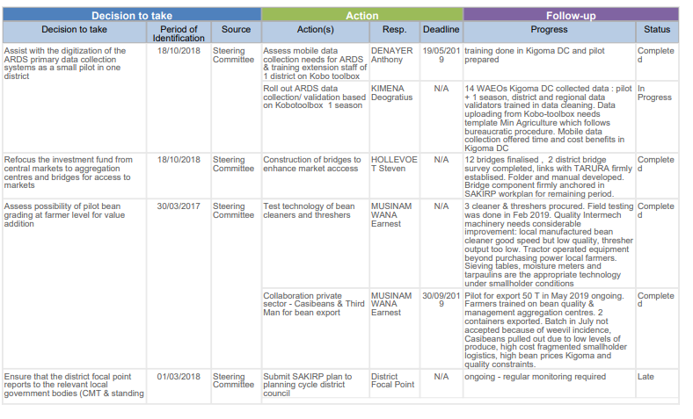

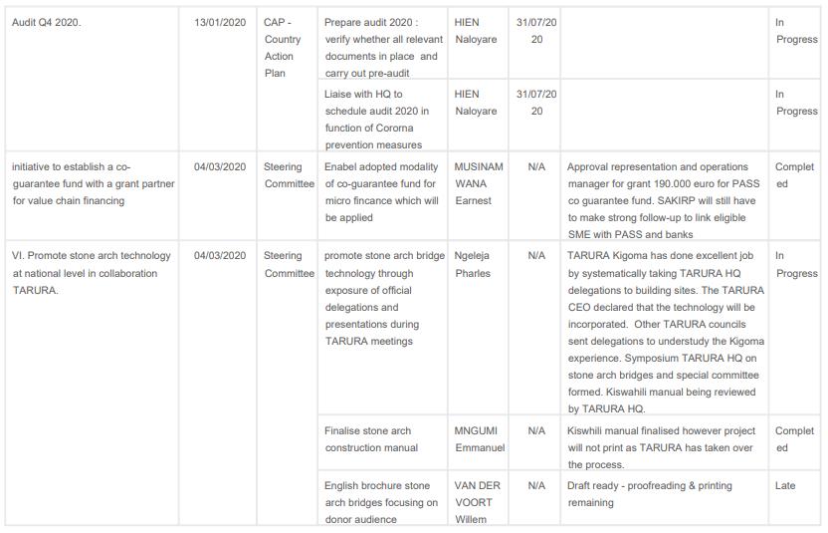

-

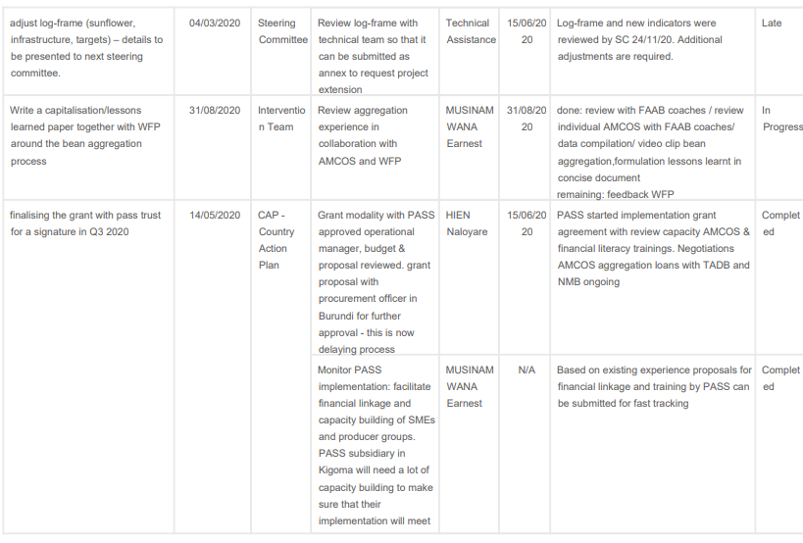

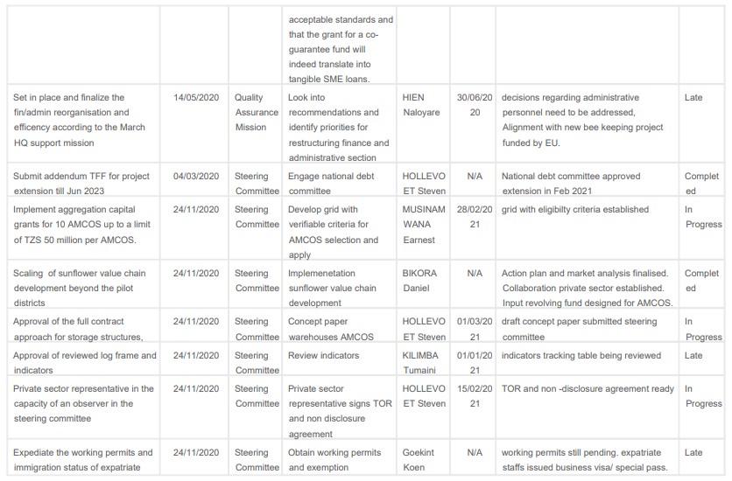

## Strategic re-orientations departures from TFF since 2017.

|  |  |  |
| --- | --- | --- |
| Strategic re-orientations | justification | Approval steering committee |
| 1. More emphasis on production alongside trade and aggregation | The value chain assessment revealed crucial bottlenecks at the level of production. The quantities of beans produced are small in Kigoma region and availability of improved varieties is limited. Viral diseases threaten cassava production and trade as what happened in Lake Zone and Rwanda. | Yes, meeting 13th July 2017 |
| 1. Pluralistic approach of collaborating with producer groups rather than the single focus on farmer field schools | In Kigoma region, FFS are few and they have been dormant waiting for the next round of ASDP funding. The diagnostic survey of village groups identified the VICOBAS and smallholder producer groups as high potential grassroots structures. | Yes, meeting 13th July 2017 |
| 1. Stronger collaboration with the local government extension system | Only the local government has extension staff on the ground in the districts. Enabel grant agreement procedures are very strict and few local organisations can comply with them. Collaboration with government services does not require these elaborated procedures. | Yes, meeting 13th July 2017– but monitoring performance is required |
| 1. Investment fund refocused on public infrastructure | The TTF proposal of an investment innovation fund for the private sector met a procurement challenge as Enabel cannot provide grants to private companies. Private companies can only be assisted through credits and not by a grant fund. As a consequence, the investment fund focuses now on public infrastructure, based priorities by district councils, | Yes, meeting 13th July 2017 |
| 1. Be realistic about targets & improvement service delivery component | Limited available budget. Limited demand for business development services. Few organisations that can effectively provide BDS services | Yes, meeting 13th July 2017 |
| 1. Adoption of input credit   scheme. | The value chain financing grant was vetoed. As an alternative an in-kind credit supply scheme for inputs was developed to kick-start structured market linkages. It is understood that this is a sub-optimal mitigation strategy that deviates from best practice in micro-finance. | Yes, meeting 28th October 2018 |
| 1. The construction of bridges to improve the access from farm to markets/ | The market infrastructure survey showed critical bottlenecks at the majority of sites: no market master plans, no land for expansion, demolishing existing structures would involve compensation and long negotiations, markets are seen as tax enforcement instruments rather than tools to promote trade and employment. In addition, UNCDF made a commitment to construct the same markets. Supporting bridges will improve access to agricultural markets and general service delivery. It is high on the government agenda at regional and local level. | Yes, meeting 28th October 2018 |
| 1. Consolidation of emerging results and not increasing the scope: | MTR recommended to consolidate emerging results in the existing geographical area and with the best groups. The number of groups and wards will not be increased. The focus should on the best 17% groups of the CPI score but with more targeted assistance. As a consequence, the target of 20.000 beneficiary farmers was abandoned in favour of quality, sustainability and long-term impact. The | Yes, meeting 20th September 2019 |
| 1. Adoption of third value chain on a pilot basis in 2 districts | The existing 2 value chains face important constraints: Cassava is in a structural price slump after the recovery of the production in Burundi and Rwanda. The crop is also threatened by CBSV while insufficient tolerant varieties are available. Beans are very vulnerable to climate change – leaving farmers often indebted. As a result, it is difficult to make an impact on the income improvement of smallholders at a regional scale. Sunflower was adopted as a third value chain because:   * Offers a better income than cassava * Is more resilient to drought than beans * Better value addition opportunities (local oil pressing, seed cake for animal concentrates) * Better scope for collaboration with local SMEs * Market risks are smaller (oil consumed locally, strong preference for sunflower oil) * Good fit in crop rotation – use additional season | Yes, meeting 20th September 2019 |

## Recommendations

|  |  |  |
| --- | --- | --- |
| **Recommendations** | **Actor** | **Deadline** |
| 1. Allow flexibility in the project targeting strategy to allow for a hybrid targeting strategy that is inclusive of medium-scale farmers that do not fall into the poor category. | JLPC | JLPC Meeting 2019 Q1 |
| 1. Improvement cassava cuttings supply through:    * Improve logistics of inspecting, harvesting and quality control at ARI Maruku production fields    * Increase the TOSCI resources or delegate more to districts, so that regular and in-dept are too thinly spread over the vast area of Western Tanzania    * Step up the certification of cassava commercial seed entrepreneurs and the verification of the quality of the produced cuttings    * Adhere to minimum standards to contain the spread of cassava brown streak virus i.e., QDS production field | ARI Maruku  TOSCI - MEDA | ongoing |
| 1. Commercialised seed systems work in formalised settings like the sunflower value chain with large processing industries. For smallholder dominated value chains like beans, the strategy should focus on improving local seed systems through on farm selection, phytosanitary measures and seed dressing. | Min Agriculture | Ongoing |
| 1. Belgian development aid will focus more on private sector development in the future. The approval of the tools to support the private sector need to be expediated so that Enabel can fulfil this new mandate. | Enabel HQ  DGD | ongoing |
| 1. SAKIRP is one of the first Enabel projects to experiment with the new grant modality of supporting existing guarantee funds. For reality checks, capitalisation and building expertise within Enabel, the experiences are best understudied in 2022. | Enabel HQ | 2022-Q2 |
| 1. During the exit phase, reduce the local contribution of bridges and warehouses to allow for full budget absorption. | Steering committee | 2021-Q1 |
| 1. In collaboration with TARURA, the roll out of the stone arch bridge technology nation-wide will increase service delivery and constitute an opportunity to expand the Enabel portfolio in Tanzania. | Represent  ation | Ongoing |

# Annexes

## Quality criteria

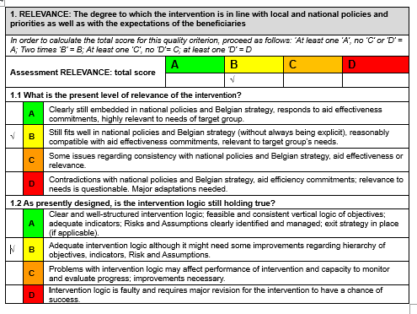

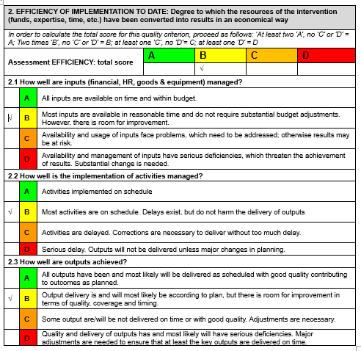

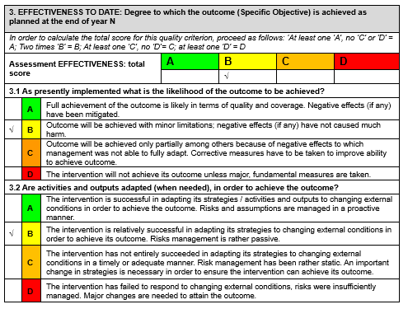

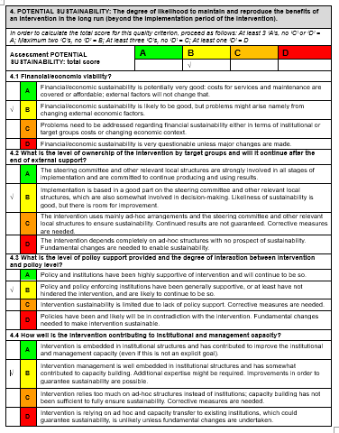

## Updated Logical framework

The logical framework was updated in view of:

1. The recommendations of the midterm review 2019 – including the proposed project extension.
2. The non-approval of the value financing grant that was proposed in the TFF
3. The lack of an appropriate legal framework for Enabel project to support the private sector.
4. The adoption of sunflower as a third value chain.
5. The shift from private investments to public infrastructure notably the construction of bridges for improving access to markets.
6. Making targets more realistic in function of the developments on the ground notably the market dynamics of the cassava value chain and the limited absorption capacity of smallholder producer groups.
7. The data cleaning and the need to align the improved procedures of the annual household surveys.

The changes made are listed in the table below:

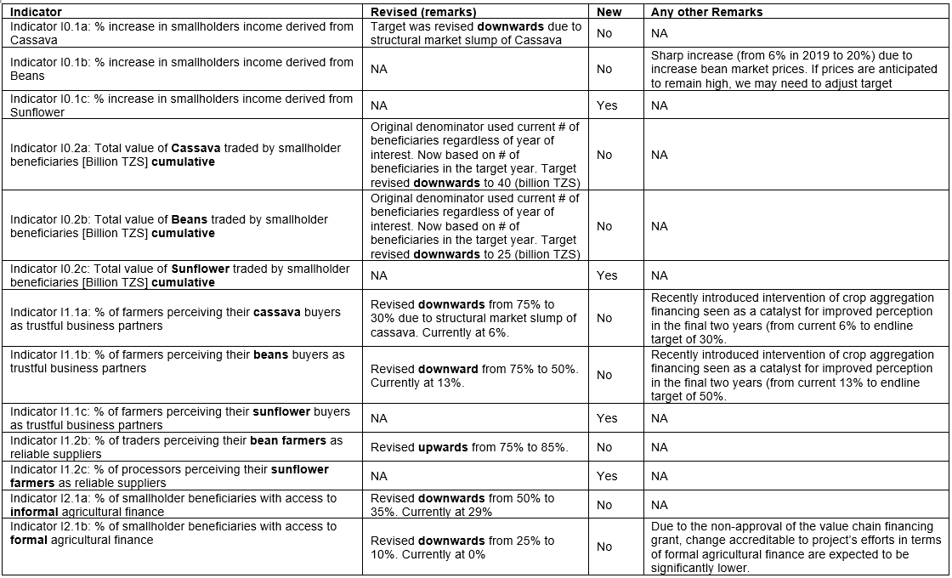

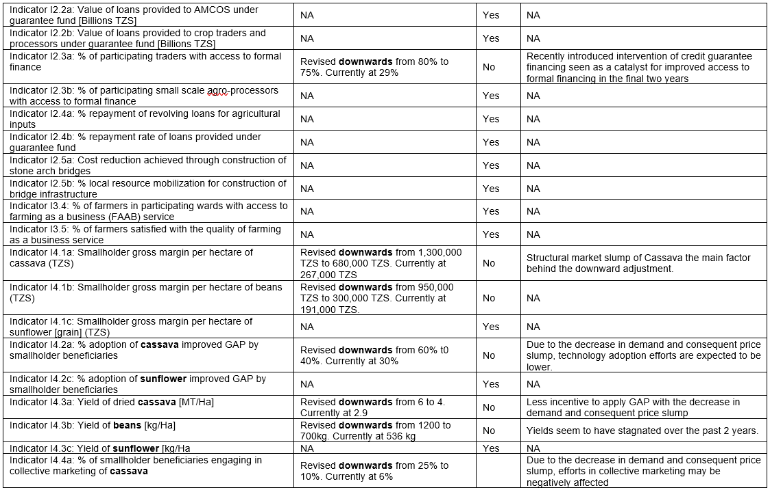

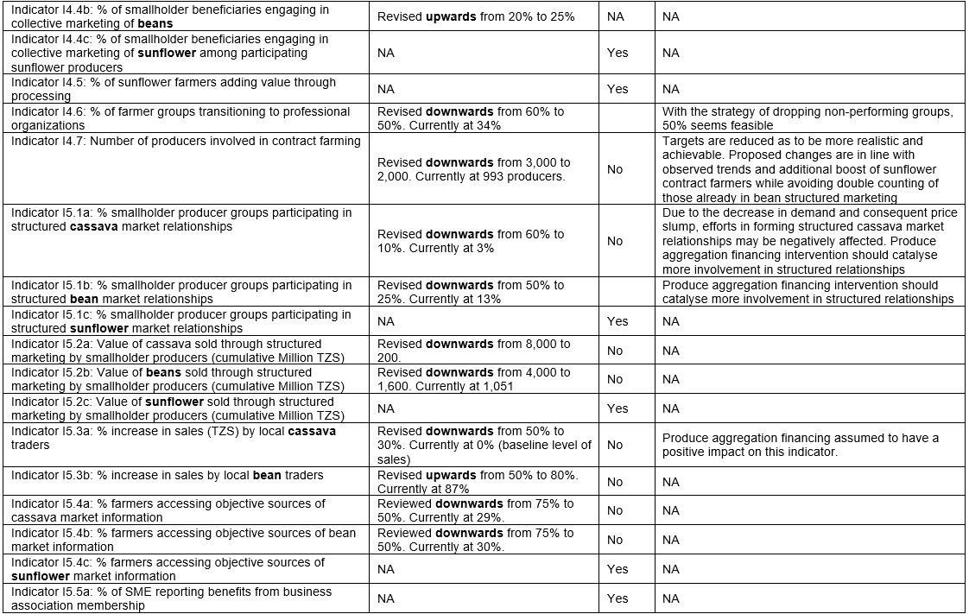

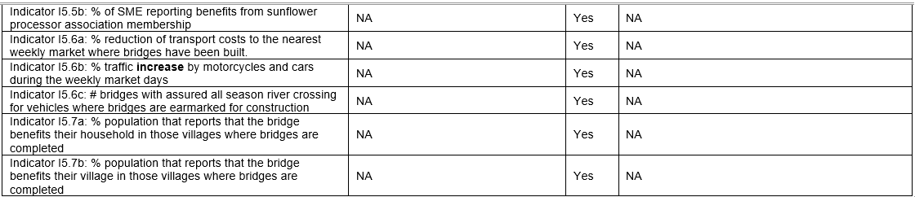

## Summary of More Results

|  |  |
| --- | --- |
| Logical framework’s results or indicators modified in last 12 months? | Yes: indicators were reviewed |
| Baseline Report registered on PIT? | Baseline report was posted on PIT and Go-fast.  There are annual household survey reports posted on PIT |
| MTR (registration of report) | 2019-Q3 |
| Planning ETR (registration of report) | Originally planned for 2021-Q2. However, based on MTR 2019, the steering committee recommended the no cost extension of the project period. The proposed date for the ETR will be extended with that period |
| Backstopping missions since | backstopping missions:  2016 – theory of change  2017-Q2  2019-10 – review MTR recommendations  2020-02: backstopping finance & administration for UBW and accounts closure, no further backstopping missions due to Covid |

## “Budget versus current” December 2020 report

|  |  |  |  |  |  |  |  |  |
| --- | --- | --- | --- | --- | --- | --- | --- | --- |
| **In Euros** | **Total Budget** | **PERIOD** | | | | **SUMMARY** | | |
|  |
| **2017** | **2018** | **2019** | **2020** | **Total Expenditures** | **Budget Balance** | **Disbursement Rate end of 2020** |  |
| **Total General** | **8 000 000** | **1 293 891** | **889 272** | **1 048 091** | **1 147 885** | **4 379 139** | **3 620 862** | **55%** |  |
| **A - Activities** | **4 260 000** | **346 980** | **367 794** | **468 619** | **667 169** | **1 850 563** | **2 409 437** | **43%** |  |
| A01 - Value chains management and coordination mechanisms are installed and steer cassava and beans value chain development. | 312 000 | 113 705 | 15 867 | 20 270 | 56 781 | 206 623 | 105 377 | 66% |  |
| A02 - Sound financial mechanisms are developed and financial organizations are strengthened to support value chains development. | 2 030 000 | 26 850 | 26 538 | 179 990 | 389 883 | 623 262 | 1 406 738 | 31% |  |
| A03 - Public and private chain supporters provide effective services to value chains actors. | 585 000 | 86 330 | 147 969 | 98 007 | 100 837 | 433 142 | 151 858 | 74% |  |
| A04 - Stronger position of smallholders in the value chains | 852 000 | 41 381 | 162 541 | 146 310 | 86 294 | 436 525 | 415 475 | 51% |  |
| A05 - Improved market access and sustainable trade | 481 000 | 78 715 | 14 880 | 24 043 | 33 374 | 151 011 | 329 989 | 31% |  |
| **B - Technical staff** | **2 054 400** | **519 732** | **360 341** | **349 042** | **313 093** | **1 542 208** | **512 192** | **75%** |  |
| **X - Reserve** | **93 050** | **-** | **-** | **-** | **-** | **-** | **93 050** | **0%** |  |
| **Z - General means** | **1 592 550** | **427 178** | **161 137** | **230 429** | **167 623** | **986 367** | **606 183** | **62%** |  |

In 2020, the total expenditure gowned to 4.379.139 Euros and a rate of 55%.

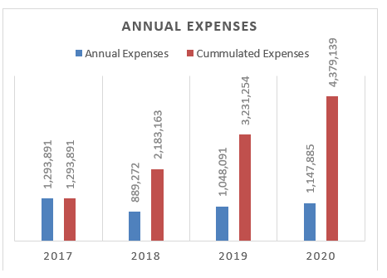

From 2017 to 2020, there is a clear increase of the expenditure. The project is at his maturity stage.

## Communication resources

Extension materials (Kiswahili)

* Posters cassava mosaic virus & brown streak virus (reprinted with permission CRS)
* Leaflets cassava mosaic virus & brown streak virus (reprinted with permission CRS)
* Cassava cultivation (adapted from the original Meda brochure)
* Manual on cassava cultivation + Manual on bean cultivation
* Manual farming as a business
* Gender training manual for lead farmers and extension workers.
* Brochure on the construction of stone arch bridges for village governments
* Manual on Proper seed dressing
* Yield assessment Manual
* Leaflets on cassava processing

Radio clips (Kiswahili)

Bean field days, Nanenane shows, liming for soil fertility, aggregation

Video clips (Kiswahili)

SAKIRP introduction, Bean production and marketing module, Cassava production and marketing module, Stone arch bridge construction, Farmer Field Days + Nanenane Exhibition

Tools

* Diagnostic tools for the assessment of farmer and partner organisations
* Questionnaires for market surveys of beans and cassava
* Written tests and interview questions for the selection of technical advisers
* Kobo toolbox for data collection and performance monitoring of field workers
* Training manual Kiswahili – farming as a business
* Quick survey priority ranking rural markets
* Map Kigoma region
* Template assessment sites proposed for bridge construction
* MoU with village for bridge construction
* Annual Household surveys + bimonthly beneficiary tracking
* Construction manual stone arch bridges – Kiswahili
* Assessment template: eligibility criteria for AMCOS
* CPI tool for diagnostic farmer organisations

Reports

* Value chain assessment beans in Kigoma region
* Value chain assessment cassava in Kigoma region
* Market study: cassava Burundi & Uganda / Rwanda
* Market study: beans in Tanzania
* Household baseline survey Kigoma region 2017
* Household survey Kigoma region 2018
* Quick scan of cassava pest and diseases 2017 & 2018
* Value chain financing assessment for cassava and beans in Kigoma region
* Credit preparedness in Kigoma region
* Evaluation of cassava graters in Kigoma region
* Midterm review report October 2019
* Sunflower marketing study 2020

Technical specifications

* TORs of high quality were developed for the value chain assessment and the market surveys of beans and cassava.
* Criteria for selection of lead farmers.
* Construction stone arch bridges – BOQs, specifications, drawings

1. The self-assessment figure is an average score of the technical staffs (steering committee members, some extensions workers, DFPs, technical advisers & PIU). It is not necessary the score of the signatories of the summary.
2.
3. Impact refers to global objective, Outcome refers to specific objective, output refers to expected result
4. This is the % of farmers who access loans through VICOBA groups
5. Repayment rate of loans backed by PASS credit guarantee scheme
6. A = The activities are ahead of schedule

   B = The activities are on schedule

   C = The activities are delayed, corrective measures are required

   D = The activities are seriously delayed (more than 6 months). Substantial corrective measures are required
7. Small sample size
8. The 2020 household survey covered only 66 sunflower producers. Because of the small sample size, all the reported sunflower data below should be taken with a grain of salt. The confidence intervals are mentioned for all data figures, considering a confidence level of 95%.